Multispectral UAV Image Mosaicking by Improved tiepoint extraction

Minkyu Park¹ , Sung-Joo Yoon¹, and Taejung Kim*²
¹Graduate Student, ²Professor, Department of Geoinformatic Engineering, Inha University
Inha-ro 100, Michuhol-gu, Incheon 22212, Republic of Korea
Email: 22231035@inha.edu, 22181415@inha.edu, tezid@inha.ac.kr

KEY WORDS: UAV; Multispectral Sensor; Mosaicking; Tiepoint

ABSTRACT: Unmanned Aerial Vehicles (UAVs) have gained widespread usage in agriculture, offering economic feasibility and easy access. Equipped with various sensors, UAVs have become indispensable tools. There is also an increasing demand for multispectral sensors utilizing near-infrared (NIR) and red-edge bandwidths. However, the effective utilization of UAV images, especially multispectral ones with limited coverage, necessitates preprocessing steps like image mosaicking. This process involves image registration, bundle adjustment, and image stitching. It is significantly influenced by the quality and quantity of tiepoints. Obtaining high-quality tiepoints in agricultural areas can be challenging since agricultural areas are covered with continuous vegetation without distinctive features. Methods developed for RGB images may not mosaic multispectral imagery seamlessly due to band registration issues and different spectral reflectance characteristics of vegetation. In RGB image processing, a common practice involves converting RGB bands to grayscale before tiepoint extraction to preserve luminance. However, this conversion is not straight forward for multispectral sensors like the MICASENSE Rededge-MX. Additionally, the sensor captures imagery from five different lenses and arises band-to-band registration problems. These challenges can hamper feature extraction performance and tiepoint matching quality. Our approach performs feature extraction within each band separately and employs tiepoint matching among the same band, sidestepping coefficient determination complexities and preserving spectral characteristics. In this study, we employed the GPU CUDA SURF algorithm for feature extraction, the K-Nearest Neighbor (KNN) algorithm for feature matching, and the RANSAC algorithm for tiepoint refinement. We conducted experiments using Micasense RedEdge MX sensors and three distinct datasets over agricultural lands in Taebaek, South Korea, and over agricultural testbeds at the Rural Development Administration, South Korea. Our performance evaluation considered the total number of extracted feature points, matched points, tiepoint quantity, success rates of bundle adjustments, and mosaic image quality. The proposed tiepoint extraction increased feature and match points by approximately 30% and bundle adjustment success rates by around 50%. Image mosaicking with the proposed tiepoint extraction showed improved performance over problematic areas where our previous method did not work successfully.

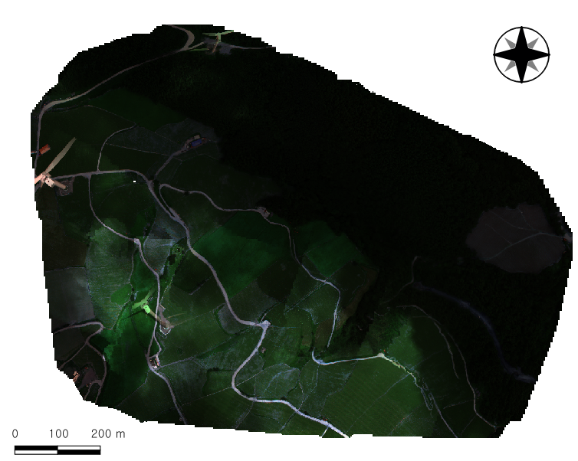 | 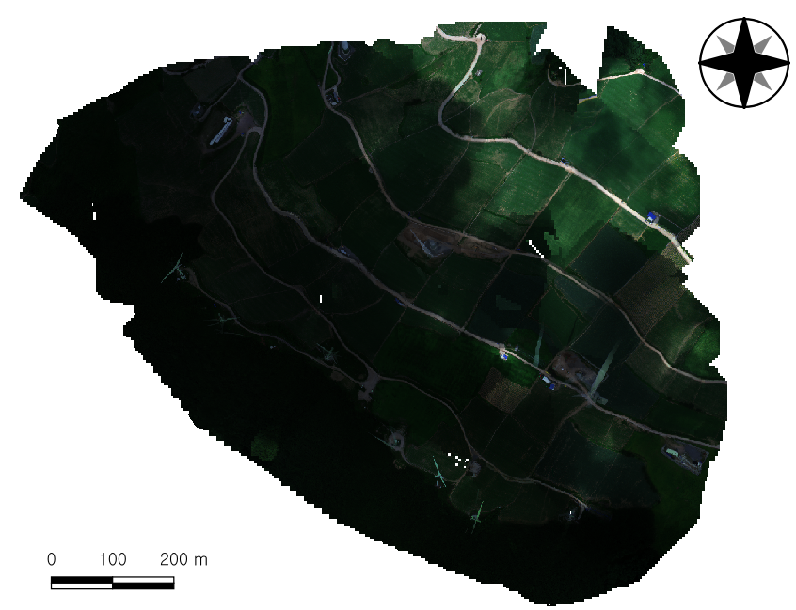 | 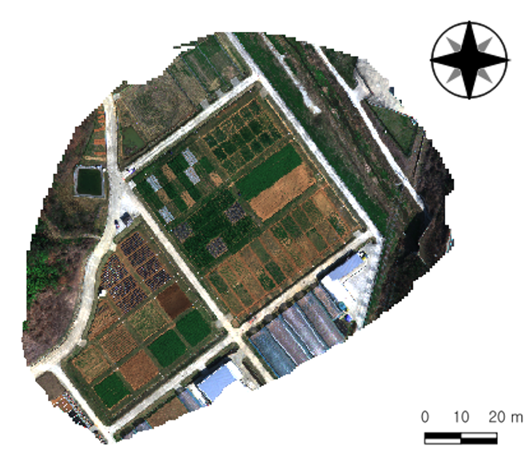
Dataset 1. Taebaek, South Korea  355 images (TP from NIR Band) | Dataset 2. Taebaek, South Korea  376 images (TP from NIR Band) | Dataset 3. RDA, South Korea  87 images (TP from NIR Band)
Table 1. Mosaic Images with Improved Tiepoint

ACKNOWLEDGEMENT: This work was carried out with the support of “Cooperative Research Program for Agriculture Science and Technology Development (Project No. PJ017042)” Rural Development Administration, Republic of Korea.

