DRONE-DERIVED MULTI-SPECTRAL DATA FOR THE DERIVATION OF MAIZE LEAF EQUIVALENT WATER THICKNESS AND FUEL MOISTURE CONTENT IN SMALLHOLDER MAIZE FARMING

Helen S. Ndlovu ¹, John Odindi *¹, Mbulisi Sibanda ², Onisimo Mutanga ¹, Alistair Clulow ¹, Vimbayi G. P. Chimonyo¹ and Tafadzwanashe Mabhaudhi ¹
¹ College of Agriculture Engineering and Science, University of KwaZulu-Natal, Scottsville, Pietermaritzburg 3209, South Africa; odindi@ukzn.ac.za
² Department of Geography, Environmental Studies & Tourism, Faculty of Arts, University of the Western Cape, Bellville, Cape Town 7535, South Africa; msibanda@uwc.ac.za
KEY WORDS: maize, phenology, growing season, spatio-temporal variability, precision farming

ABSTRACT: Maize water stress from rainfall variability is a key challenge in producing rain-fed maize farming, especially in water-scarce regions such as southern Africa. Hence, quantifying maize foliar water content variations throughout the phenological stages is valuable in detecting smallholder maize moisture stress and supporting agricultural decision-making. The emergence of drones or unmanned aerial vehicles (UAVs) equipped with multispectral sensors offers a unique opportunity for robust and rapid monitoring of maize foliar water content and stress. The combination of near-real-time spatially explicit information acquired using UAV imagery with physiological indicators such as equivalent water thickness (EWT), and fuel moisture content (FMC) provide viable options for detecting and quantifying maize foliar water content and moisture stress in smallholder farming systems. Therefore, this study evaluated the utility of UAV-based multispectral datasets and random forest regression in quantifying maize EWT and FMC throughout the maize phenological growth cycle. Results showed that EWT and FMC could be determined using the near-infrared (NIR) and red-edge wavelengths to a relative root mean square error (rRMSE) of 2.27 % and 1%, respectively. Specifically, the spectra acquired during the early reproductive growth stages between silking and milk stages demonstrated a high sensitivity to the variation in maize moisture content. These findings serve as a fundamental step toward creating an early maize moisture stress detection and warning system and contribute to climate change adaptation and resilience of smallholder maize farming.

- INTRODUCTION

Maize (Zea mays L.) is an important and eminent food security crop that also serves as a valuable source of animal fodder, bio-energy and raw industrial material (Ge et al., 2012). However, due to rainfall scarcity and variability, maize moisture stress is a serious abiotic threat to maize production (Ge et al., 2012). Subsequently, water deficit negatively impacts maize productivity and impairs crop growth and development, significantly reducing yield (Ghooshchi et al., 2008). The most widely used physiological indicators of maize foliar moisture content are equivalent water thickness (EWT) and fuel moisture content (FMC).

Recent advances in technology, particularly the Unmanned Aerial Vehicle (UAV), have heralded a new era in remote sensing, mapping and data analytics within precision agriculture (Maes et al., 2019). Using lightweight multispectral sensors mounted on UAVs offers great possibilities for continuous near-real-time crop monitoring at a farm level (Chivasa et al., 2020). UAVs or drones are unique because they can provide high-quality remotely sensed data at unprecedented spatial, spectral and temporal resolutions (Maes et al., 2019). In addition, UAVs mounted with sensors capture imagery at low altitudes, hence minimal atmospheric interference. Furthermore, UAVs provide a cost-effective option to obtain frequent imagery at an ultra-high spatial resolution, often in centimetres, which is necessary for monitoring crop physiology at a plot level (Everaerts, 2008). For example, in a comparative study between UAV-based data and satellite imagery, Matese, et al., (2015) confirmed that UAV-derived datasets can detect even the most subtle variations in crop physiological characteristics, a challenge even for high-resolution satellite imagery such as RapidEye. A study by Tang, et al. (2019) demonstrated the value of UAV-derived multispectral data in predicting maize evapotranspiration with an R² of 0.81 and RMSE of 0.95 mm/day. Nonetheless, the ability of UAV imagery to adequately discriminate maize foliar moisture content variability across the growing stages remains untested. Therefore, the potential application of UAVs equipped with multispectral sensors in characterising smallholder maize moisture status at different growth stages still requires investigation. Random Forest (RF), a machine learning algorithm, has proven to be a valuable regression model and known for its efficiency in handling outliers, its ability to account for non-linear relationships between multiple variables and its capacity to produce credible results, even with a small dataset (Horning 2010). Considering that limited studies have evaluated the feasibility of using UAV-based proximal remotely sensed data in accurately monitoring maize foliar moisture content across all phenological stages (Zhang and Zhou, 2019), there is a need to assess the value of UAV-derived data in mapping crop moisture content variability. This study, therefore, sought to evaluate the utility of UAV-derived multispectral imagery in estimating the spatio-temporal variability of smallholder maize leaf EWT and FMC across the maize growing stages.

MAterials and methods

2.1 Study site description

This study was conducted in Swayimane (29.51667 S, 30.68333 E), uMshwati Municipality, KwaZulu-Natal, South Africa. The study area has a sub-tropical climate, with average annual rainfall between 600 and 1200 mm and an average air temperature between 12 ℃ and 24 ℃ (Brewer et al., 2022). Swayimane is located at 886 m above sea level and has a relatively flat topography. The soil in the area is classified as deep and dark clay loam soils, which indicates high organic matter and soil fertility. The land in Swayimane is predominantly used for commercial and small-scale subsistence agriculture, with the cultivation of several crops, including taro, sweet potatoes, spinach, beans, sugarcane and maize. The area is situated within the moist midlands mist belt bioclimatic region prone to berg winds, extreme clouds, flash floods, seasonal hail and occasional drought. The area has been identified as a climate change hot spot (Keen and Winkler, 2020). Climate projections of the area indicate an increase in temperature and unpredictable variations in annual precipitation resulting in an increased risk of climate-driven events, including an increase in drought.

2.2 Experimental plot and crop management description
Figure 1 illustrates the biophysical condition of maize at the various phenological growth stages. The experimental plot was 50 m long and 30 m wide, and was located on a gentle slope. Maize crops were sown on the 8th of February 2021, and corn kernels were harvested on the 17th of May 2021. Cow urea and manure were manually spread in the experimental field before sowing as a source of nutrients to fertilise the soil. A combination of manual hand weeding and herbicide application was conducted when the maize crops were 21 days old. The experimental plot relied primarily on precipitation as a source of water supply. The study plots were not irrigated nor applied fertiliser during the growing season. Table 1 presents the microclimatic conditions of the study plot during the maize growing period, derived from an automatic weather station located approximately 860 m from the experimental plot.
Figure 1. Field and maize crop conditions at (A), V8 - V10, (B) V14 – Vt, (C) R1-R2, (D) R2-R3 and (E) R3-R4 of the growth stages.

Table 1. Microclimatic condition of maize across the phenological growth period.
Bioclimatic variable | V8-V10 | V14-Vt | R1-R2 | R2-R3 | R3-R4
Total rainfall (mm) | 2,4 | 0,8 | 0 | 0 | 0
Minimum air temperature(℃) | 17,19 | 15,08 | 19,74 | 15 | 12,62
Maximum air temperature(℃) | 23,77 | 22,8 | 31,91 | 30,52 | 27,32
Maximum wind speed (m/s) | 3,76 | 5,09 | 4,07 | 4,14 | 3,76
Total solar irradiance | 1040 | 1043 | 734,1 | 767,9 | 643,2
Maximum atmospheric pressure (mbar) | 918 | 922 | 926 | 921 | 1012
Minimum relative humidity (%) | 67,77 | 67,13 | 28,95 | 16 | 32,93

2.3 Field survey and measurements of maize moisture content
Field measurements were conducted on the 18th of March (V8-V10), 31st of March (V14-Vt), 12th of April (R1-R2), 28th of April (R2-R3) and 14th of May (R3-R4) in 2021. Prior to the field survey, the boundary of the experimental plot was digitised in the Google Earth Pro domain. The digitised polygon was imported into ArcGIS and used to generate sampling points. A stratified random sampling procedure was used to generate 65 random sampling points within the experimental plot (Shen et al., 2015). This method is optimal for acquiring an unbiased representative sample of the experimental maize plot (Shen et al., 2015). A Trimble handheld GPS with a sub-meter accuracy was used to navigate to these sampling points at each stage of the maize growth period. The third fully developed maize leaf from the top of the stalk was sampled at each sample point. Literature states that to obtain reliable maize physiological measurements, fully developed leaf samples should be taken from the top of the canopy as there is maximum reflectance of light energy (Mulla, 2015).
2.4 UAV platform, imagery acquisition and processing
The Altum MicaSense multispectral camera mounted on a DJI Matrice 300 series UAV platform was used to obtain images of the study site at the five phenological growth stages. The main advantage of this UAV platform is its ability to acquire imagery over a range of environmental conditions at high speed (one image captured per second) and to provide imagery with high geolocational accuracy. The UAV platform is equipped with a downwelling light sensor (DLS 2) which improves the reflectance calibration and the georeferencing of the images. The Micasense sensor consists of six spectral bands that capture spectral reflectance in the blue (475 nm), green (560 nm), red (668 nm), red-edge (717 nm), NIR (840 nm), and thermal (8–14 nm) regions of the electromagnetic spectrum (Ndlovu et al., 2021). The boundary of the experimental plot was generated around the plot in the Google Earth Pro domain. The polygon was imported into the UAV’s handheld console as a Keyhole Markup Language (KML) file format to generate the navigation flight plan. The flight was then carried out autonomously at a flight height of 100 m, a ground sampling distance of 9.6 cm (81 cm for the thermal camera) and an 80% image overlap. Before and after each drone flight, the Micasense camera was calibrated using the MicaSense Altum calibrated reflectance panel. This was conducted by acquiring an image of the calibration panel at ambient atmospheric and solar radiation conditions. These images were imported along with the other captured images used into Pix4D Fields photogrammetry software (Pix4 Fields) for pre-processing. Thereafter, radiometric corrections were conducted on the captured images using both the before and after flight images of the calibration panel. The calibration panel has a white balance card with reflectance properties across the electromagnetic spectrum and was used as the target for the radiometric calibration of the images. This allows the Pix4D software to correct the reflectance of the images to account for the dominant atmospheric conditions at the time of image acquisition (Brewer et al., 2022). The raw multispectral data, consisting of approximately 3400 images per flight, were mosaicked to form a single image of the study area using Pix4D Fields. Pix4D Fields were then used in conjunction with the calibration images based on the map function to calculate reflectance as described in Cubero-Castan, et al. (2008). A total of five ground control points were acquired, one at each corner of the experimental plot and a point at the location of the weather station situated at the centre of the maize field. The image was thereafter georeferenced in QGIS 3.4.0 to optimise geolocation accuracy using the five ground control points to an RMSE less than half a pixel (3cm).
2.5 Selection of vegetation indices
The six pre-processed spectral bands, acquired using the Mica sense’s six spectral channels, were used to estimate maize EWT_{leaf} and FMC_{leaf.} These bands were also used to compute vegetation indices (VIs) used to estimate maize moisture indicators in a GIS environment (Table 2). Studies have confirmed the ability of VIs computed from the combination of the visible and NIR channels of the electromagnetic spectrum to detect subtle variations in vegetation water characteristics (Pasqualotto et al., 2018). Based on existing literature, ten moisture content-related VIs were computed based on their correlation with maize moisture content indicators. After computing the vegetation indices, the sampling points were overlaid with all the spectral variables (Spectral bands and VIs) to extract the spectral signatures used for the statistical analysis.
Table 3. Selected vegetation indices (VIs) used for maize moisture content estimations.

Vegetation Index | Equation | Reference
NDWI | (Green - NIR / Green + NIR) |  | [Gao, 1996]
NDVI | (NIR - Red / NIR + Red) |  | [Rouse, et al., 1974]
NGRDI | (Green - red / green + red) |  | [Zarco-Tejada et al., 2001]
NDRE | (NIR - rededge / NIR + Rededge) |  | [Gitelson and Merlyak, 1994]
NDVI_{red-edge} | (Rededge - Red / Rededge + red) |  | [Gitelson and Merlyak, 1994]
CI_{green} | ((NIR/Green) -1) |  | [Gitelson et al., 2003]
CI_{red-edge} | ((NIR/rededge) -1) |  | [Zhang and Zhou, 2019]
SR | (NIR/Red) |  | [Jordan, 1969]
OSAVI | ((NIR - Red)/ (NIR + Red + 0.16)) × (1 + 0.16) |  | [Jin et al., 2013]

2.6 Model validation
The prediction accuracy of the derived RF models was assessed based on the coefficient of determination (R²), the root mean square error (RMSE), and the relative root mean square error (rRMSE). The optimal model for estimating maize moisture content indicators at different phenological stages was determined based on the highest R² and the lowest RMSE and rRMSE.
$RMSE=\sqrt{\frac{\sum{{(predicted-actual)}^{2}}}{n}}$ (1)
$rRMSE=\frac{RMSE}{Mean (actual)}×100$ (2)
where predicted is the modelled variable and actual is the field-measured variable. Lastly, a map illustrating the spatial and temporal distribution of the predicted maize EWT_{leaf} or FMC_{leaf} at every growth stage was generated using the optimal predictor variable derived from the optimal regression model on ArcMap version 10.3.1 software. The RMSE and the rRMSE were calculated based on the above formulas.

RESULTS

3.1 Estimating maize EWT_{leaf} and FMC_{leaf} throughout the maize growing stages

Generally, UAV bands resulted in relatively lower model accuracies at all maize growth stages in relation to VIs. For example, when estimating EWT_{leaf}, UAV bands exhibited the lowest accuracy at the V14-Vt and R1-R2 growth stages, yielding an RMSE of 47.58 gm⁻² and R² of 0.53, and RMSE of 13.13 gm⁻² and R² of 0.59, respectively. Similarly, in estimating maize FMC_{leaf}, the lowest RMSEs were obtained when using UAV bands at the R1-R2, R2-R3 and R3-R4 maize growth stage with RMSE of 1.13 gm⁻² and R² of 0.59, RMSE of 11.05 gm⁻² and R² of 0.53, and RMSE of 3.05 gm⁻² and R² of 0.57, respectively. The use of VIs improved model accuracies of maize EWT_{leaf} and FMC_{leaf}. For example, the EWT_{leaf} model slightly improved by a magnitude of 6.43 from an RMSE of 47.58 gm⁻² to 41.15 gm⁻² at the V14-Vt maize growth stage. Again, in estimating FMC_{leaf}, using VIs improved the model accuracy from 11.05 gm⁻² to 7.94 gm⁻² at the R2-R3 growth stage.

3.2 Estimation of maize EWT_{leaf} using the RF-selected spectral variables throughout the stages

During the early vegetation growth stages, maize EWT_{leaf} at the V8-V10 phenological stage was predicted to have an RMSE of 13.03 gm⁻² and R² of 0.69. The top-most influential predictor variables in estimating EWT_{leaf} at this stage were NDVI_{rededge}, thermal, rededge, NGRDI, CI_{rededge}, NDVI, OSAVI, NDRE, NIR, red, NDWI, CI_{green} and SR, in order of importance. The V14-Vt exhibited the poorest prediction accuracy of maize EWT_{leaf} during the vegetative stages (RMSE = 23.99 gm⁻² and R² of 0.76) using NDVI, CI_{rededge}, red-edge, NDRE, NDWI, CIgreen, NIR, thermal, blue, NDVI_{rededge}, NGRDI, green and red, in descending order of importance. The most optimal maize growth stage for estimating EWT_{leaf} was observed in the early reproductive R1-R2 growth stage, which yielded the highest model accuracy across all phenological stages (RMSE of 5.31 gm⁻² and R² of 0.88) based on NDVI_{rededge}, rededge, NIR, NDVI, NDRE, NGRDI, blue, CI_{rededge}, NDWI, and CIgreen, red, thermal and green, in order of importance. Hereafter, a decrease in EWT_{leaf} model accuracy was observed in all later stages of maize growth. For example, the estimation accuracy of EWT_{leaf} decreased by 4.97 gm⁻² to an RMSE of 10.28 gm⁻² in the R2-R3 maize growth stage, compared to 5.31 gm⁻² from the R1-R2 stage. Nonetheless, an R² of 0.89 was attained from predicting maize EWT_{leaf} during the R2-R3 growth stage. The influential predictor variables on that model included NDVI, NIR, NDWI, CI_{green}, NDVI_{rededge}, red, CI_{rededge}, NDRE and NGRDI, accordingly. Furthermore, the maize EWT_{leaf} model accuracy depreciated at the R3-R4 growth stage yielding an RMSE of 12.66 gm⁻² and R² of 0.77). The influential spectral predictors from this model were NDVI, NIR, NDWI, CIgreen, NDVIrededge, and red, CIrededge, NDRE and NGRDI, in order of descending importance.

3.3. Estimation of maize FMC_{leaf} using the RF-selected spectral variables throughout the growing stages

The estimation of maize FMC_{leaf} at the V8-V10 growth stage yielded a moderate RMSE of 1.13 %. However, it exhibited a low R² of 0.66 based on NDVI, NDVI_{rededge}, thermal, red, SR, rededge, NGRDI, green, NDWI, NIR, NDRE, OSAVI, CI_{rededge}, CI_{green} and blue, in order of importance. Meanwhile, at the V14-Vt growth stage, the estimation of maize FMC_{leaf} yielded an RMSE = 1.44 % and an optimal R² = 0.73. The most suitable predictor variables included NDRE, rededge, CI_{green}, NIR, NDWI, CI_{rededge}, NDVI, NDVI_{rededge}, thermal, green, blue, NGRDI and red, in order of decreasing importance. Meanwhile, the maize FMC_{leaf} prediction accuracy significantly increased in the early reproductive stages of the maize growing stages. For example, the R1-R2 maize growth stage yielded an RMSE of 0.88 % and an R² of 0.87 using NDVI, rededge, NDVI_{rededge}, NIR, NDRE, CI_{rededge}, blue, NGRDI and red, in order of importance. The optimal phenological growth stage for optimally estimating maize FMC_{leaf} was the R2-R3 growth stage, which yielded the highest model accuracy with an RMSE = 0.45 % and R² of 0.76. This optimal maize FMC_{leaf} model was derived based on the NDRE, NIR, NDWI, CI_{rededge}, NDVI_{rededge}, rededge, CI_{green}, blue, thermal, NDVI, red and green predictor variables. Whereas the later reproductive growth stages demonstrated the lowest FMC_{leaf} prediction accuracies. Maize FMC_{leaf} at the R3-R4 growth stage yielded the poorest prediction accuracy with an RMSE of 1.54 % and R² of 0.72. Finally, the most optimal variables that were selected in estimating maize FMC_{leaf} at this growth stage were NDVIrededge, CIrededge, NDRE, NDWI, CIgreen, NDVI, red, green, NIR, NGRDI, red-edge, thermal and blue, in order of importance.

3.4 Comparing the performance of foliar maize moisture content indicators (EWT_{leaf} and FMC_{leaf}) across the growing stages

When comparing the performance of EWT_{leaf} and FMC_{leaf}, the results illustrate that the prediction accuracy of maize EWT_{leaf} and FMC_{leaf} varies for each phenological growth stage. For example, the maize FMC_{leaf} outperformed EWT_{leaf} with an rRMSE of 1.38 % as opposed to an rRMSE of 4.79%. Similarly, the prediction accuracy of maize FMC_{leaf} (rRMSE = 1.88%) was significantly higher than that of maize EWT_{leaf} (13.29 %) by a magnitude of 11.41 %. Again, at the R1-R2 maize growth stage, EWT_{leaf} exhibited an rRMSE of 2.72 %, while FMC_{leaf} of maize had a higher prediction accuracy with rRMSE of 1.08 %. Similarly, model accuracies for predicting maize FMC_{leaf} were marginally higher than EWT_{leaf} at the R2-R3 growth stage, with an rRMSE = 1% and 3.13 %, respectively. Nonetheless, EWT_{leaf} at this stage produced the highest R² of 0.89 compared to FMC_{leaf,} which yielded an R² of 0.76. Finally, FMC_{leaf} produced an rRMSE of 1.91 % at the R3-R4 maize growth stage, compared to the rRMSE of 3.79 % exhibited by the maize EWT_{leaf} model.

3.5. Spatial variability of EWT_{leaf} and FMC_{leaf} across the growing stages

It was observed that maize EWT_{leaf} and FMC_{leaf} were higher in the eastern region and decreased towards the western section of the experimental maize plot (Figure 2, 3 and 4). The EWT_{leaf} illustrated an increase in maize foliar moisture from the V8-V10 growth stage to the V14-Vt growth stage, where EWT_{leaf} was at its highest. Thereafter, there was a slight decrease in maize foliar EWT_{leaf} in the early reproductive growth stage (R1-R2). However, the late reproductive stages (R2-R4) illustrated a lower EWT_{leaf} yet a uniform distribution of maize foliar EWT_{leaf} throughout the experimental plot. There was a progressive increase in maize foliar FMC_{leaf} during the early reproductive stage (R1-R2). Subsequently, there was again a decrease in maize foliar FMC_{leaf} during the late reproductive stages of maize.

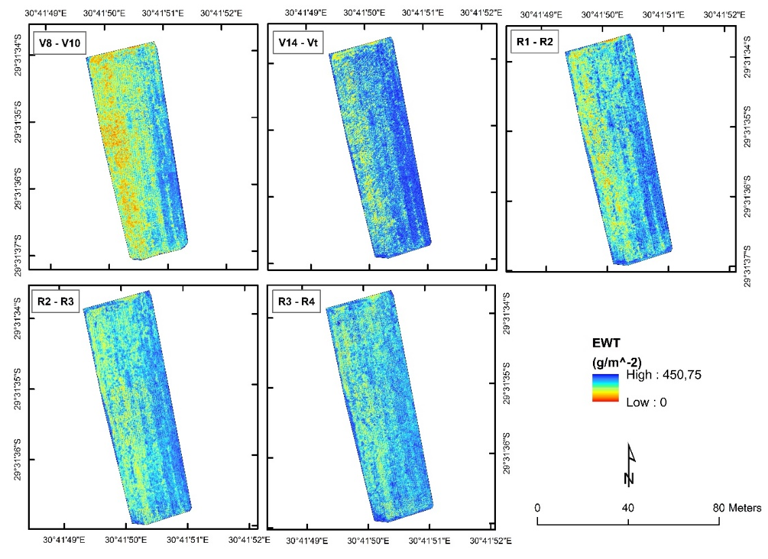
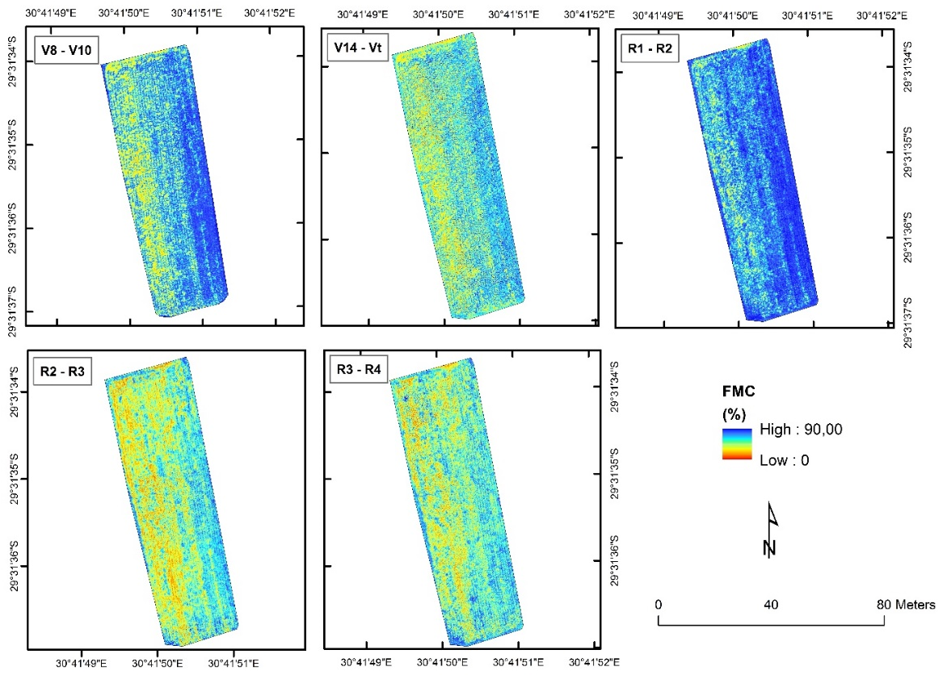
Figure 2. Spatial distribution of modelled maize EWT_{leaf} across the growing stages.

Figure 3. Spatial distribution of modelled maize FMC_{leaf} across the growing stages.

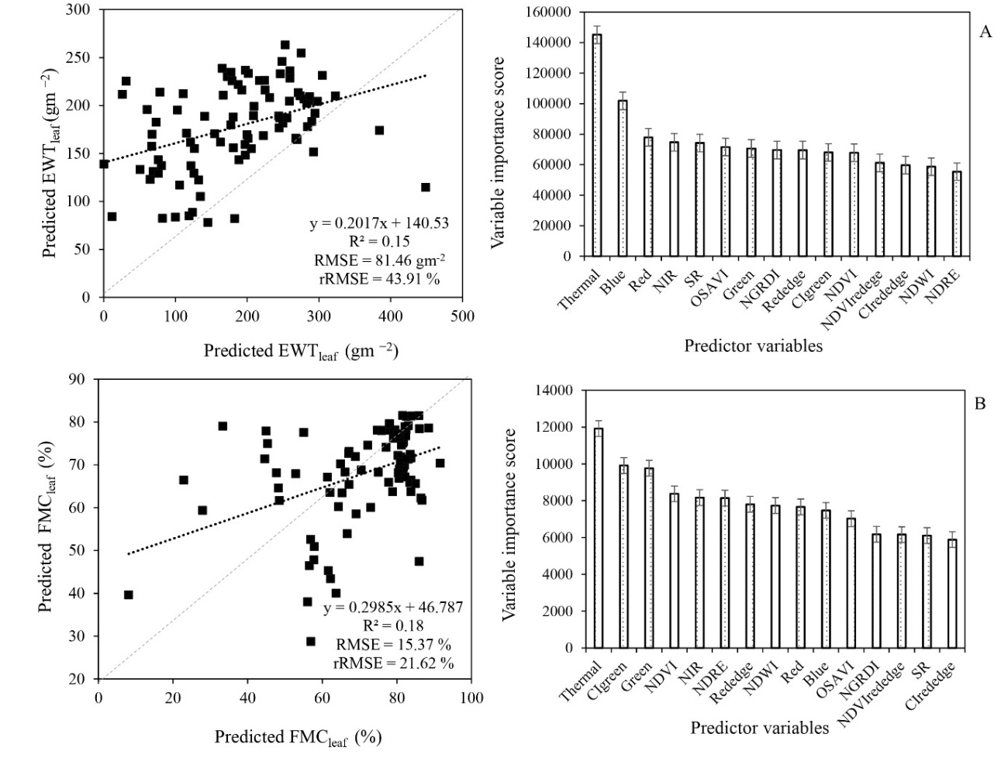

Figure 4. Relationship between the predicted and observed maize EWTl_{eaf} and variable importance score (A) and the predicted and observed maize FMC_{leaf} and variable importance scores (B) throughout the phenological growth stages.
- CONCLUSIONS

This study sought to test the utility of UAV-based multispectral data in estimating leaf EWT and FMC of smallholder maize crops across the growing stages. The results showed that the UAV-derived multispectral data could be useful in quantifying maize moisture variability at a high spatial and temporal resolution. Therefore, it can be concluded that:
- UAV-derived multispectral data can optimally characterise maize EWT (R² = 0.88, RMSE = 5.31 gm⁻² and rRMSE = 2.72 %) and FMC (R² = 0.76, RMSE = 0.45 % and rRMSE = 1 %) variations using spectral variables from the NIR and red-edge wavelengths of the electromagnetic spectrum which demonstrated great sensitivity to the variation in maize moisture content;
- The phases between silking and milk reproductive growth stage are the most optimal growth stages for predicting maize moisture content using UAV-derived data.
- This study demonstrates the potential of UAV-based proximal remote sensing techniques in providing near-real-time and spatially explicit information on maize moisture variability across the growing stages. Finally, this study will allow for optimising marginalised communities' agricultural productivity to improve their livelihoods in light of climate change, thus enhancing food and nutrition security.

References from Journals:
Brewer, K., Clulow, A., Sibanda, M., Gokool, S., Naiken, V. and Mabhaudhi, T, 2022. Predicting the chlorophyll content of maize over phenotyping as a proxy for crop health in smallholder farming systems. Remote Sensing, 14, 518.

Chivasa, W., Mutanga, O. and Biradar, C., 2020. UAV-Based Multispectral Phenotyping for Disease Resistance to Accelerate Crop Improvement under Changing Climate Conditions. Remote Sensing, 12, 2445.

Everaerts, J., 2008. The use of unmanned aerial vehicles (UAVs) for remote sensing and mapping. The International Archives of the Photogrammetry, Remote Sensing and Spatial Information Sciences, 37, 1187-1192.

Gao, B., 1996. NDWI—A normalized difference water index for remote sensing of vegetation liquid water from space.
Remote Sensing of Environment, 58, 257-266.

Ge, T., Sui, F., Bai, L., Tong, C. and Sun, N., 2012. Effects of water stress on growth, biomass partitioning, and water-use efficiency in summer maize (Zea mays L.) throughout the growth cycle. Acta Physiologiae Plantarum, 34, 1043-1053.

Gitelson, A.A., Gritz, Y. and Merzlyak, M.N., 2003. Relationships between leaf chlorophyll content and spectral reflectance and algorithms for non-destructive chlorophyll assessment in higher plant leaves. Journal of Plant Physiology, 160, 271-282.

Gitelson, A., and Merzlyak, M.N., 1994. Spectral reflectance changes associated with autumn senescence of Aesculus
Hippocastanum L. and Acer platanoides L. leaves. Spectral features and relation to chlorophyll estimation. Journal of Plant
Physiology, 143, 286-292.

Ghooshchi, F., Seilsepour, M. and Jafari, P., 2008. Effects of water stress on yield and some agronomic traits of maize (SC301). American-Eurasian Journal of Agricultural and Environtal Sciences, 4, 302-305.

Jordan, C.F., 1969. Derivation of leaf‐area index from quality of light on the forest floor. Ecology, 50, 663-666.

Jin, X., Diao, W., Xiao, C., Wang, F., Chen, B., Wang, K., and Li, S., 2013. Estimation of wheat agronomic parameters
using new spectral indices. PLoS One, 8, e72736.

Maes, W.H. and Steppe, K., 2019. Perspectives for remote sensing with unmanned aerial vehicles in precision agriculture. Trends in Plant Science, 24, 152-164.

Matese, A., Toscano, P., Di Gennaro, S.F., Genesio, L., Vaccari, F.P., Primicerio, J., Belli, C., Zaldei, A., Bianconi, R., and Gioli, B., 2015. Intercomparison of UAV, aircraft and satellite remote sensing platforms for precision viticulture. Remote Sensing, 7, 2971-2990.

Mulla, D.J., 2013. Twenty five years of remote sensing in precision agriculture: Key advances and remaining knowledge gaps. Biosystems engineering, 114, 358-371.

Ndlovu, H.S., Odindi, J., Sibanda, M., Mutanga, O., Clulow, A., Chimonyo, V.G. and Mabhaudhi, T. A, 2021. Comparative Estimation of Maize Leaf Water Content Using Machine Learning Techniques and Unmanned Aerial Vehicle (UAV)-Based Proximal and Remotely Sensed Data. Remote Sensing, 13, 4091.

Pasqualotto, N., Delegido, J., Van Wittenberghe, S., Verrelst, J., Rivera, J.P. and Moreno, J., 2018. Retrieval of canopy water content of different crop types with two new hyperspectral indices: Water Absorption Area Index and Depth Water Index. International Journal of Applied Earth Observation and Geoinformation, 67, 69-78.

Shen, K., Li, W., Pei, Z., Fei, W., Sun, G., Zhang, X., Chen, X. and Ma, S, 2015. Crop area estimation from UAV transect and MSR image data using spatial sampling method. Procedia Environmental Sciences, 26, 95-100.

Tang, J., Han, W. and Zhang, L., 2019. UAV Multispectral Imagery Combined with the FAO-56 Dual Approach for Maize Evapotranspiration Mapping in the North China Plain. Remote Sensing, 11, 2519.

Zarco-Tejada, P., Miller, J.R., Noland, T., Mohammed, G. and Sampson, P., 2001. Scaling-up and model inversion methods
with narrowband optical indices for chlorophyll content estimation in closed forest canopies with hyperspectral data.
IEEE Transactions on Geoscience and Remote Sensing, 39, 1491-1507.

Zhang, F. and Zhou, G., 2019. Estimation of vegetation water content using hyperspectral vegetation indices: A comparison of crop water indicators in response to water stress treatments for summer maize. BMC Ecology, 19, 1-12.

References from Other Literature
Cubero-Castan, M., Schneider-Zapp, K., Bellomo, M., Shi, D., Rehak, M. and Strecha, C., 2018. Assessment of the radiometric accuracy in a target less work flow using Pix4D software. In: Proceedings of the 2018 9th Workshop on Hyperspectral Image and Signal Processing: Evolution in Remote Sensing (WHISPERS), 2018; pp. 1-4.

Horning, N., 2010. Random Forests: An algorithm for image classification and generation of continuous fields data sets. In: Proceedings of the Proceedings of the International Conference on Geoinformatics for Spatial Infrastructure Development in Earth and Allied Sciences, Osaka, Japan, 2010; pp. 1-6.
Keen, S. and Winkler, H., 2020. Enhanced Direct Access finance in South Africa: SANBI and the Adaptation Fund. 2020.

Rouse, J., Haas, J., Schell, J. and Deering, D., 1974. Monitoring vegetation systemsin the Great Plains witherts. In: Proceedings of the Proceedings of the 3rd ERTS Symposium, Washington, DC, USA, 1974.

