COMPARATIVE EVALUTION OF FLAASH (SCALED DISORT) AND QUAC BASED ATMOSPHERIC CORRECTIONS ON AVIRIS-NG HYPERSPECTRAL DATA

Mahesh Kumar Tripathi, Himanshu Govil, Subhanil Guha, Monika, Pralay Bhoumik, Gaurav Misra, Arjun Shahi

¹ Department of Applied Geology, National Institute of Technology Raipur, G.E Road, District Raipur, 492010, India
Email: tripathi.mahesh1@gmail.com

KEY WORDS: AVIRIS-NG, Atmospheric Correction, FLAASH, QUAC, Scaled-DISORT.

ABSTRACT: Hyperspectral remote sensing is a technique to detect and identify the spectral features in various disciplines such as mineral exploration, geology, agriculture, soil, forestry, ecology and marine sciences. Detection and identification of features depend on the spectral and spatial resolution of the hyperspectral image. For instance, in the case of minerals very minute differences in structure or composition of minerals provide distinct spectral features and spectral absorptions. The identification of materials or objects more precisely requires the removal of artifacts and atmospheric correction. The goal of the study to evaluate the comparison of different algorithms and parameters on FLAASH and QUAC based atmospheric correction. Atmospheric corrections of an image have been done in FLAASH and QUAC. Spectra of various minerals of Jahajpur area, Bhilwara, Rajasthan, extracted from atmospheric corrected image of both the models on AVIRIS-NG hyperspectral image. These extracted spectra correlated and compared with spectra of USGS spectral library. Unwanted absorption features and spectral variation in curve lead to wrong interpretation but these effects are distinct in different algorithms and models. On the basis of interpretation of the spectral curve of various minerals with Scaled-DISORT algorithms based atmospheric correction in FLAASH provide more precise and accurate spectral results in comparison to QUAC.

MANUSCRIPT

  - INTRODUCTION

Atmospheric correction in hyperspectral remote sensing data provides accurate spectral information presented on spatial/spectral as well as pixel based identification of minerals (Berk et al.2002);(Ben-Dor et. al., 2013).Transmission of solar energy and radiant flux which is defined as the rate of time from sun to earth, sensor and earth to sensor passes through atmosphere, which is attenuated by atmospheric constituents such as atmospheric gases, aerosols and water molecules (CO₂, O₂, N₂O, CH₄, O₃, H₂O, NH₄ and CO)( Verhoef, 1998).The atmospheric gases covers approximately half of the spectrum from 0.4 µm to 2.5 µm(Gao and Goatz, 1990);(Rani et.al.,2017);(Richter et.al., 2011).Solar radiation absorbs by atmospheric gases, aerosols & clouds scatter and modulate the reflected radiation from the Earth. Spectral composition and intensity attenuated by these atmospheric constituents (Lillesandand Kiefer, 1999).According to (Gao and Goatz, 1990) magnitude of scattering and absorption spatially and temporally vary with respect to concentration of atmospheric constituents. Almost all gases have constant proportion except O₃ and H₂O. Availability of water absorption band are at 0.940 µm, 1.140 µm and 1.880 µm. CO₂ and O2 have also an absorption band 2.080 µm and 0.760 µm respectively in electromagnetic spectrum. Electromagnetic spectrum have some opaque region at wavelength of , 0.940 µm, 1.100 µm, 1.400 µm and 1.880 µm for remote sensing sensors (Rani et.al., 2017). Ozone gas have an absorption at0.35 μm, and 9.6μm, and CO₂ absorbs at 2.01, 2.06, and a weak doublet near 1.6 μm (Clark, 1999). In absence of absorption bands electromagnetic spectrum transmit energy which utilize for extraction or gather information of earth material remotely through transmission region that transmission region is called as atmospheric windows. That transmission region affected by atmospheric constituents which attenuate the reflected radiance. The remote sensing data and sensors have a radiometric distortion and malfunction effects respectively due to scattering of atmospheric particles (Lillesand, and Kiefer, 1999). An atmospheric corrected image provides better visual and spectral interpretation.

GEOLOGICAL SETTINGS

Jahajpur Group of Bhilwara Supergroup occupies major part of the Jahajpur area. Along the great boundary fault, the sandstone, shale and limestone exposed in Jahajpur area which belong Vindhyan Supergroup. Dolomite, phyllite, and quartzite are main rocks and the china clay, talc, iron are abundant minerals. Dolomitic limestone/quartzite belongs to pre-Aravalli which is source rock of soapstone. In Jahajpur two parallel ridges of dolomitic limestones are present in which one of them extended from Ghevaria to Jahajpur. (Geological Survey of India-District Report., 1977).

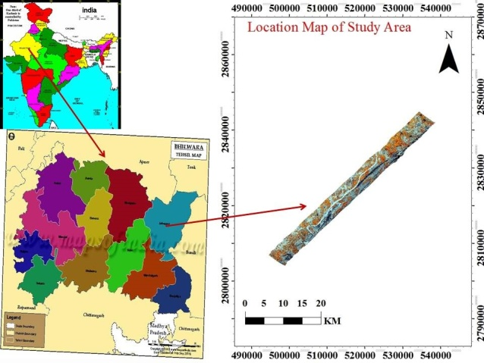(Source:https://www.mapsofindia.com/maps/rajasthan/tehsil/bhilwara.html.)
Figure 1 AVIRIS-NG Hyperspectral Image.
Table 1 Various parameters used in the FLAASH
Site Center Latitude 25.54 E
Site Center Longitude 75.16 N
Pixel Size 8.1 M
Atmospheric Model Tropical
Sensor Altitude 8.39 km
Ground Elevation 0.381 km
Aerosol Scale Height 1.5 km
Initial Visibility 40 km
Sensor Type AVIRIS-NG
Acquisition Date 04/02/2016

DATA AND METHODOLOGY

In this study high spectral/spatial resolution airborne hyperspectral remote sensing AVIRIS-NG data used. The image was acquired in Julian day 04/02/2016.Swath of the AVIRIS-NG image is 4-6 km with spatial/spectral resolution 8.1 m/5nm ± 0.5 nm respectively. Only 376 channels out of 425 channels ranging from 380 nm to 2510 nm in the AVIRIS-NG data are calibrated on 0.1scale factors for all spectral bands.1-425 are applied to calibrate radiance. Feature discrimination, identification, determination and for mapping of the object require different types of image corrections such as radiometric correction, atmospheric correction and geometric correction. Due to satellite and earth rotation, earth curvature, view angle, sensors resolution, atmosphere effect, surface topography, distance between sensors and object causes these types of errors in remote sensing image. The radiometric corrections can be removed by haze, noise, PCA, filtering and band rationing but geometric correction need a projection on planimetric surface with respect to ground control point in Cartesian (latitude, longitude, altitude) coordinate reference system. To remove atmospheric error which is caused by atmosphere of the earth, atmospheric gases such as water vapor, CO₂, CH₄, and O₃. To study on hyperspectral data requires image processing, such as atmospheric correction to gather surface reflectance from measured radiances from sensors. In the remote sensing technology atmospheric correction have two approaches 1) Scene-based known as empirical based approach, 2) Model based/radiative transfer model known as absolute method approach. Among various approaches for this study applying model based FLAASH which is based on radiative transfer model and scene-based QUAC empirical approach. Empirical based approaches have no requirement of any type of field measurement, because this is a scene-based approach. The function of QUAC algorithms is based on diversity of different image spectra or end members. Estimation of baseline spectra QUAC algorithms require sufficient dark pixel in the scene of image. Most of the algorithms or atmospheric compensation software uses radiative transfer code to model and compensate for atmospheric effects (Gao and Goetz, 1990);(Mars and Rowan, 2011). FLAASH coded in MODTRAN4 of radiative transfer code. FLAASH corrects wavelengths in the visible to SWIR region of 3.0 µm. FLAASH uses radiometrically calibrated radiance image, flight date, time, scene center location, ground elevation, pixel resolution, and sensor information and so on.

RESULT AND DISCUSSION

Interpreted various image spectra of various different minerals through raw radiance image and atmospheric corrected reflectance image (AVIRIS-NG), in which major absorptions at 1.4, 1.9, 2.1, 2.2, 2.35, 2.39 µm. Compared extracted spectral signatures of various minerals based on FLAASH (Scaled-DISORT) and QUAC. Then evaluation has taken place on these spectra. AVIRIS-NG raw image shows major absorption at region of VNIR to SWIR due to atmospheric gases. According to (Elvidge,1990) chlorophyll, water, proteins, starches, waxes and structural biochemical molecules like as lignin and cellulose are major basic constituents of vegetation, have major contribution in absorption (Rani et. al., 2017). In comparison of interpreted spectral signature of radiance image, QUAC based and FLAASH based atmospheric corrected image have shown similarity in absorption features. Vegetation water, leaves and pigments water show strong absorption at 1.4 µm, 1.9 µm and 0.46µm, 0.68 µm and weak absorption at 0.98, 1.2 µm respectively. FLAASH and QUAC corrected captured spectra and USGS spectral library spectra show a good correlation of spectra.

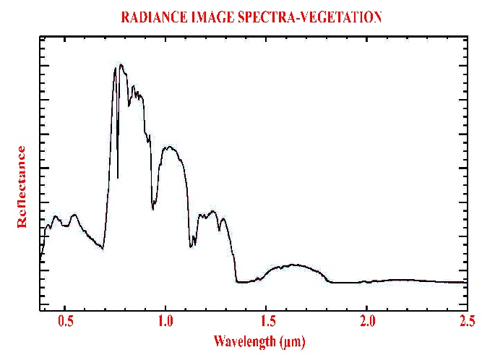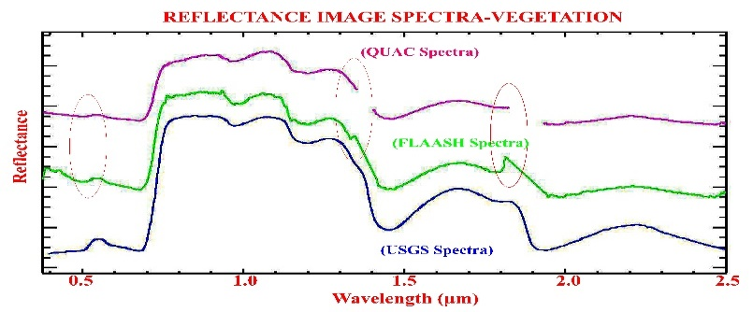
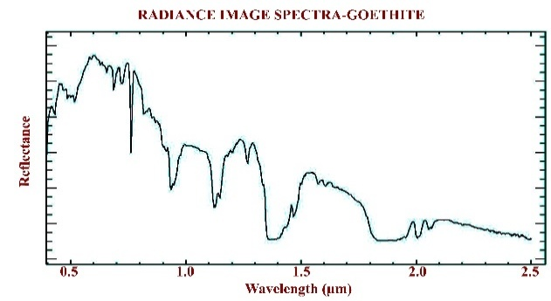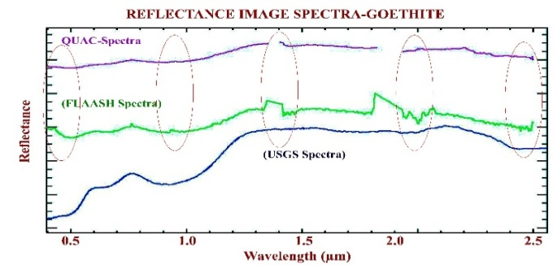
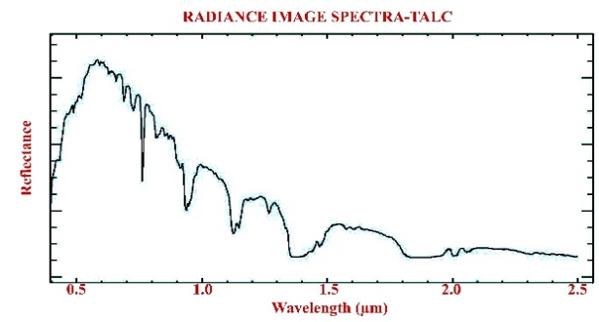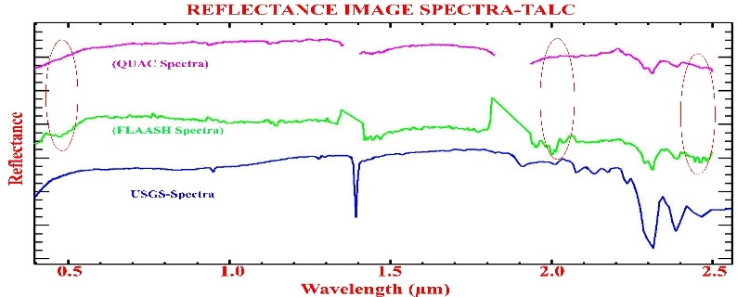
Figure 2 Comparison of radiance image spectra, reflectance image spectra (QUAC and FLAASH) of vegetation and minerals
The SWIR region 2.0 to 2.5 µm provide maximum diagnostic absorption features of all minerals (Meer et. al., 2012). There are various different with distinct alteration styles of minerals can be identified such as Al–OH at 2.2 µm, Mg–OH at 2.3 µm, and CaCO3 at 2.32–2.35 µm (Yokoya et.al., 2012) ;(Rani et.al.,2017).Clay group of minerals and micas exhibit absorption features at approximately 2.2. µm (Magendran and Sanjeevi, 2014).Slight variation in absorption features of rock exposure define variation in mineral composition, grain size, crystal bonding and weathering pattern. So, on the behalf of these characteristics of minerals, evaluated different atmospheric corrected spectra of different minerals and identified mineral compared with USGS spectral library. In this study montmorillonite, kaosmec, talc and goethite identified on absorption features. The talc and goethite mineral have shown diagnostic absorption at 2.3 µm and 0.6 µm, 0.9 µm in QUAC and FLAASH corrected images and raw image of AVIRIS-NG respectively. In QUAC and FLAASH both atmospheric method Talc have shown the effect of atmospheric absorption at sharp doublet near 2.18, 2.21 µm and 2.22, 2.31 and 2.39 µm due to bonding with OH and presence of Mg and Al respectively.

CONCLUSION

Atmospheric correction is an important method to identify the accurate spectral signatures of various minerals/materials. Due to presence of water vapor and gases in atmosphere raw image contain many absorption features. Here applied QUAC and FLAASH models to remove effects of gases and water vapor absorption. The FLAASH corrected talc mineral spectra shows absorption 2.39(dolomite), 2.01(CO2), 0.96 (goethite) and at 0.46 (goethite) but QUAC shows only single minor absorption. On behalf of this result conclusion is that FLAASH have much better capability to discriminate spectral features of the object compare to QUAC based corrected image. The conclusion on the basis of comparison of raw(Radiant), QUAC and FLAASH with respect to USGS spectral library, FLAASH provides better result compare to QUAC.

REFERENCES

A. Berk et al., “Exploiting MODTRAN radiation transport for atmospheric correction: The FLAASH algorithm,” Proc. 5th Int. Conf. Inf. Fusion, FUSION 2002, vol. 2, no. February, pp. 798–803, 2002.
B.-C. Gao and A. F. H. Goetz, “Column atmospheric water vapor and vegetation liquid water retrievals from Airborne Imaging Spectrometer data,” J. Geophys. Res., vol. 95, no. D4, p. 3549, 1990.
E. Ben-Dor, T. Malthus, A. Plaza, and D. Schläpfer, Hyperspectral Remote Sensing. 2013.
W. Verhoef, Theory of radiative transfer models applied in optical remote sensing of vegetation canopies. 1998.
Elvidge, D.E., “Visible and near infrared reflectance characteristics of dry plant materials,” Remote Sens. Environ., vol. 11, p. 1775e1795., 1990.
F. D. V. D. Meer et al., “International Journal of Applied Earth Observation and Geoinformation Multi- and hyperspectral geologic remote sensing : A review,” Int. J. Appl. Earth Obs. Geoinf., vol. 14, no. 1, pp. 112–128, 2012.
J. C. Mars and L. C. Rowan, “assessment of new ASTER SWIR surface re fl ectance data products for spectroscopic mapping of rocks and minerals,” Remote Sens. Environ., vol. 114, no. 9, pp. 2011–2025, 2011.
N. Rani, V. Ravibabu, and T. Singh, “Geoscience Frontiers Evaluation of atmospheric corrections on hyperspectral data with special reference to mineral mapping,” Geosci. Front., vol. 8, no. 4, pp. 797–808, 2017.
N. Rani, V. Ravibabu, and T. Singh, “Evaluation of atmospheric corrections on hyperspectral data with special reference to mineral mapping,” Geosci. Front., vol. 8, no. 4, pp. 797–808, 2017.
N. Yokoya, J. C. W. Chan, and K. Segl, “Potential of resolution-enhanced hyperspectral data for mineral mapping using simulated EnMAP and Sentinel-2 images,” Remote Sens., vol. 8, no. 3, 2016.
R. Richter, D. Schläpfer, and A. Müller, “Operational Atmospheric Correction for Imaging Spectrometers Accounting for the Smile Effect,” IEEE Trans. Geosci. Remote Sens., vol. 49, no. 5, pp. 1772–1780, 2011.
R. W. Lillesand, T.M. and Kiefer, Remote Sensing and Image Interpretation. John Wiley & Sons, Inc. 1999.
R. N. Clark, “Spectroscopy of Rocks and Minerals, and Principles of Spectroscopy,” 1999.
Geological Survey of India-Didstrict Report., “Geology and minerals resources of Bhilwar district,” 1977.
T. Magendran and S. Sanjeevi, “Hyperion image analysis and linear spectral unmixing to evaluate the grades of iron ores in parts of Noamundi , Eastern India,” Int. J. Appl. Earth Obs. Geoinf., vol. 26, pp. 413–426, 2014.

