Algorithm Testing for Subpixel Analysis of Flaming and Smoldering Combustion with Nighttime Satellite Data

Christopher D. Elvidge (1) and Mikhail Zhizhin (1-2)

1 Earth Observation Group, Payne Institute for Public Policy
Colorado School of Mines, Golden, Colorado USA
2 Russian Space Research Institute, Moscow, Russia
Email: celvidge@mines.edu, mzhizhin@mines.edu

KEY WORDS: VIIRS, nightfire, biomass burning, flaming, smoldering, peat fires

ABSTRACT: Biomass burning has two combustion phases – flaming and smoldering. Flaming is hotter and has higher combustion efficiency. Smoldering is cooler and produces larger quantities of smoke and partially oxidized trace gas emissions. In 2014 we demonstrated that the radiant emissions of flaming and smoldering are spectrally displaced in nighttime Landsat data. The shortwave infrared (SWIR) channels sample the leading edge of the flaming phase and the long wave infrared samples the trailing edge of the smoldering phase. In this paper we report results from algorithm testing on discrimination of flaming and smoldering combustion conducted with nighttime VIIRS data collected on a smoldering peat fire in Sumatra, Indonesia. The results indicate that the algorithm producing fewer spurious results involves modeling the flaming phase Planck curve based on the near-infrared and SWIR channels, subtracting the flaming phase radiance from each channel and the performing dual curve Planck curve fitting for the smoldering phase plus background.

1. INTRODUCTION

Smoldering peatland fires are a major source of transboundary smoke and greenhouse gas emissions from the islands of Sumatra and Borneo during drought years ( Tosca et al., 2011; Gaveau et al., 2014). It is well established that smoldering peat soil fires have lower in temperature than flaming phase combustion and produces more smoke and partially oxidized gas (Akagi et al., 2011; Koppmann et al., 2005; Ohlemiller, 1995; Usup et al., 2004; Hungerford et al., 1995; Muraleedharan et al., 2000) Flaming biomass burning temperatures are in the range of 760 to 1400 K (Boonmee and Quintiere, 2002). Smoldering, characterized by an orange glow, has temperatures in the 600 to 760 K range (Boonmee and Quintiere, 2005; Broido and Nelson, 1975). However, the smoldering producing the highest volume of smoke in peatlands is underground, warming the soil surface by conduction, with lower temperatures than the glowing ember smoldering combustion. Peatland surface with underground smoldering lack the orange glow and have temperatures in the 320 to 500 K range (Usup et al., 2004; Hungerford et al., 1995). Having an ability to map smoldering peat soils in near real time would be quite useful for fire managers and in the definition of smoke source areas and deploying fire suppression teams.

Traditional satellite fire “hotspots” rely on the detection of anomalously high mid-wave infrared (MWIR) radiances using a long-wave infrared (LWIR) channel as a reference. The basis of the various algorithms is that biomass burning radiant emissions are stronger in the MWIR than the LWIR. Without multispectral fire detection it is not possible model the IR emitter’s Planck curve, which enables the calculation of temperature, source size, and radiant heat using physical laws (Dozier, 1981; Elvidge et al., 2013). The original nightfire calculations assumed that subpixel IR emitters present in a pixel have a single temperature – leading to a single temperature estimate. Obviously, this is simplistic since there can be both flaming and smoldering present in a VIIRS pixel footprint. For several years we have been researching the subpixel analysis of flaming and smoldering combustion based on the temperature differences between the two phases. The concept is that flaming and smoldering radiant emissions can be unmixed using a “tip-and-tail” strategy. At night the VIIRS NIR and SWIR bands sample the short wavelength end of flaming radiant emissions. The MWIR has radiant contributions from flaming, smoldering and background. The “tail” is the LWIR, which has radiant contributions primarily from smoldering and background, with minimal contribution from flaming. The initial prototype for subpixel analysis of flaming and smoldering combustion was demonstrated with nighttime Landsat data by Elvidge et al., 2015). In this paper we test several algorithms for the spectral unmixing of flaming and smoldering combustion using nighttime VIIRS data collected of a peatland fire in Sumatra in 2014.

2. METHODS

We tested and rated six different algorithms for separating flaming and smoldering combustion for a smolder peatland burn area in Sumatra collected by VIIRS on September 27, 2014 (Figure 1). This was an accidental “day mode” orbit, with all bands collecting at night. Field data collected by the P.I. on smoldering peat fires in Indonesia in 2014 found that the soil surfaces had temperatures in the 320 to 450 K range. We define six VNF detection types. Then we test six algorithm styles for the analyzing the flaming and smoldering components in terms of temperature and source size.
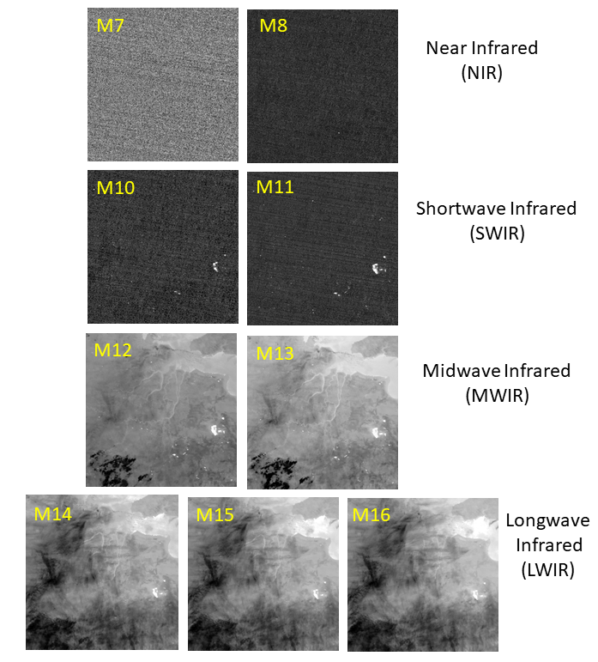
Figure 1. Nine moderate resolution spectral bands collected on a peat fire in Southern Sumatra on September 27, 2014.

2.1 VNF Detection Algorithms: VNF uses two detection algorithms: one for the NIR and SWIR bands (M7,8,10,11) and a second detector for the MWIR (M12-M13). For the NIR and SWIR – these channels are designed for daytime imaging. At night they primarily record the noise floor of the system, which is occasionally punctuated by high radiant emissions from fires and flares. Here we set a detection threshold as the image mean plus four standard deviations. The MWIR signal is a mixture of radiant emissions from clouds and the earth’s surface. The MWIR thermal anomaly detector relies on the fact that M12 & M13 radiances for background land, sea, and clouds are highly correlated, forming a dense diagonal on M12 vs. M13 scattergrams (Figure 2). The algorithm generates the scattergram for a granule of aggregate, locates the diagonal, and detects pixels with thermal anomalies as outliers pulled away from the diagonal.

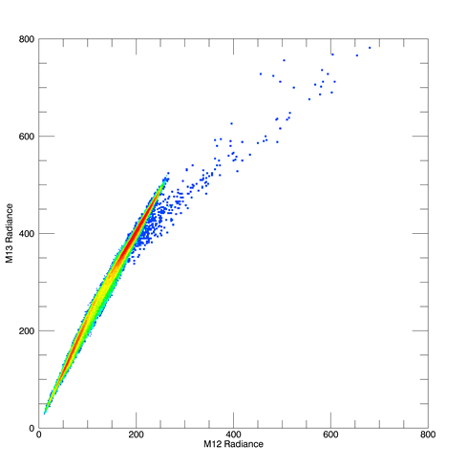
Figure 2. VIIRS has two MWIR channels that are closely spaced near 4 um. This scattergram shows M12 versus M13 radiances. At night there is a prominent diagonal data cloud - representing the temperature variations in the background. The presence of IR emitters pulls pixels away from the diagonal. The VNF MWIR detector locates the diagonal, draws an envelope around it, and labels the pixels outside the envelope as detections.

2.2 Types of VNF Detections: Six types of detections are recognized, based on the spectral bands involved:

Type 0 – Single band detections. Typically M11 (SWIR). In data collected prior to nighttime M11 collections – it was M10. No Planck curve fitting – no temperature can be calculated.
Type 1 – NIR and SWIR detection – no MWIR. The most common is M10 & M11 only. Interpreted as flaming phase only.
Type 2 – M11 and MWIR detection. In the current study these have been analyzed as a Type 4 detection – by assigning a flaming phase temperature of 1000 K.
Type 3 – MWIR only – a rare occurrence.
Type 4 – Has two SWIR bands and MWIR detection. May have NIR detection as well. The flaming vs smoldering unmixing was designed for Type 4 detections.
Type 5 – Pixels that yield spurious flaming / smoldering results revert back to the original dual curve Planck curve fitting with a single temperature IR emitter.

2.3 Planck Curve Fitting: The Planck curve fitting is accomplished using a simplex algorithm to optimize the fit to the radiance data. Type 1 and 3 detections are fit for an IR emitter and a background. This is referred to as “dual-curve” fitting. The initial temperature of IR emitter is 1000 K and background 300K. No difference from the current operational VIIRS nightfire processing. Type 2 and 4 detections are analyzed for three temperature phases: flaming, smoldering and background with initial temperatures of 1000, 500, and 300 K respectively.
Type 5 detections revert back to Type 1 style of dual Planck curve fitting. The Planck cureve are then used to calculate temperature using Wien’s Displacement Law. Source size based on the “emissivity” term in Planck’s Law multiplied by the pixel footprint size. Radiant heat is calculated with the Stephen Boltzmann Law.

2.4 Flaming subtractive: Here the NIR and SWIR detection radiances are used to model the Planck curve of the flaming phase. The flaming phase radiance is then subtracted from all spectral
bands. Then dual Planck curve fitting is run on the residual radiances to derive the smoldering
and background temperatures and source areas. Two varieties of flaming subtractive algorithms
have been tested:

A. Smoldering modeled with residual MWIR and LWIR.
B. Smoldering modeled with residual SWIR, MWIR and LWIR

2.5 Triple curve: Simultaneous Planck curve fitting for flaming, smoldering and background. Four varieties have been tested:

C. Unconstrained – observed radiances only.
D. Constrained by the flaming temperature.
E. Constrained by the background temperature derived from the standard dual curve VNF.
F. Constrained by the flaming and background temperature.

2.6 Rating: The six methods were rated based on the number of “misfit” detections. Misfits are recognized based on implausible results. Examples include unrealistically low background temperatures, smoldering temperatures near 300 K, extremely large or small source areas. Based on the results we will develop a set of misfit criteria and rate the methods.

3. RESULTS

3.1 Misfit pixels: Figure 3,4 and 5 show scattergrams of the standard dual curve VNF, the flaming subtractive, and the triple curve temperatures and source areas. The top scattergram shows temperatures versus source area. With this scattergram it is possible to identify pixels with anomalously low temperatures or implausible source areas. The lower scattergram shows IR emitter temperature versus background temperature- which reveals pixels with implausibly low background temperatures. Labels and arrows are added to point out misfit pixels having implausible temperatures or source sizes.

3.2 The good, the bad, and the ugly: Figure 6 shows Planck curve fits, temperatures and source sizes for three sample pixels. The top panel shows a good fit – with plausible results for all three phases – flaming, smoldering, and background. The middle panel shows an example of a pixel where the smoldering has absorbed about half of the background radiance, resulting in an implausibly low smoldering phase temperature and the background temperature dipping well below the nominal 300 K that is typical of Sumatra land surfaces at night. The bottom panel shows an extreme case, where the smoldering phase Planck curve has absorbed nearly all the background radiance.

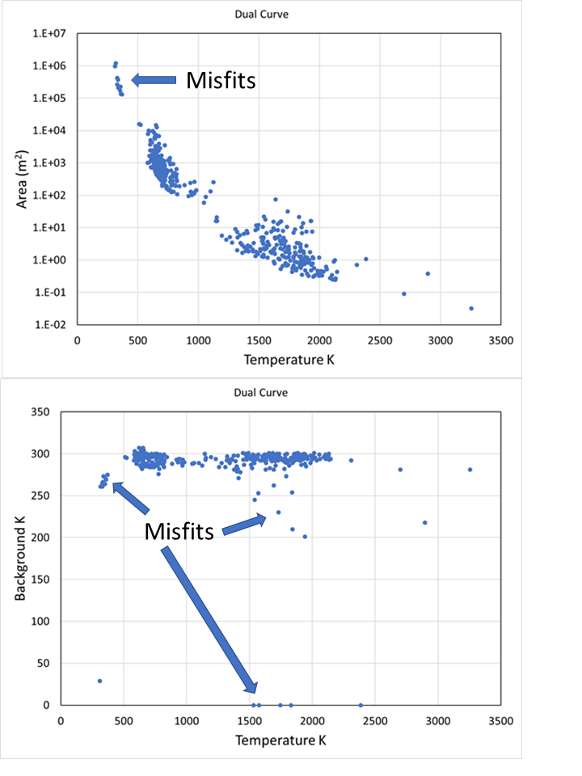
Figure 3. Scattergrams from the standard dual curve VNF processing
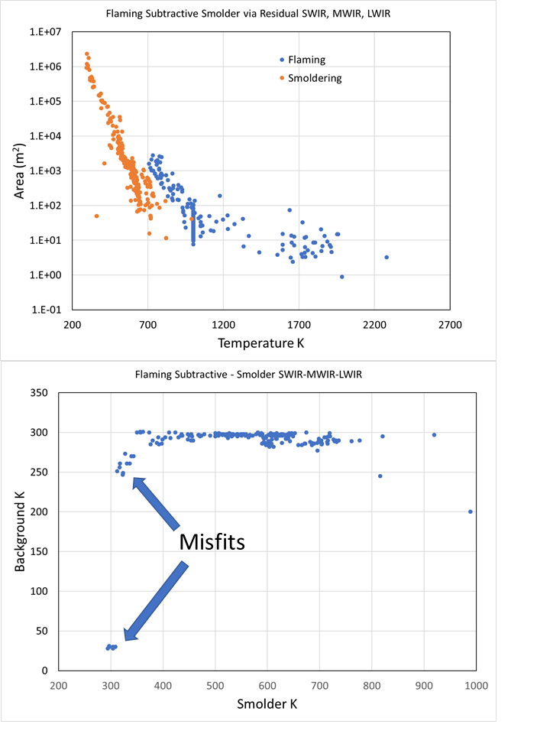

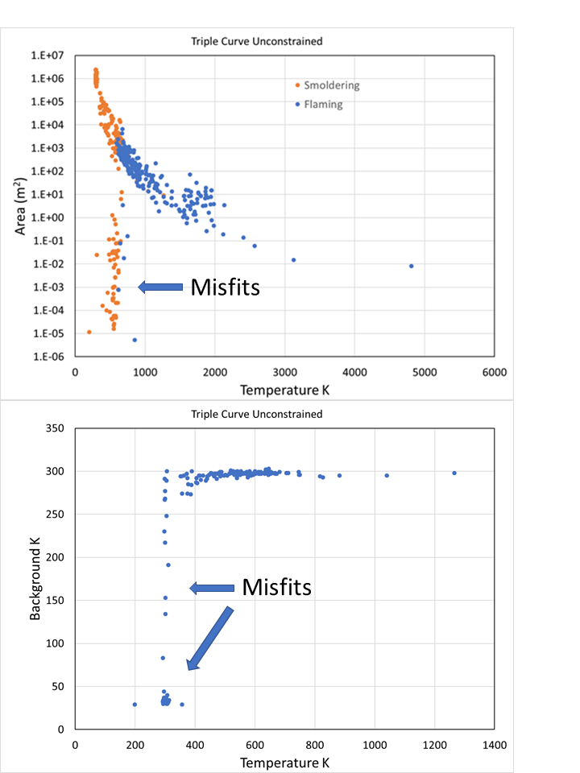

The primary cause for misfit pixels is the misallocation of background radiance as a component of the smoldering. We take this as an indication that pixel only contains a single combustion phase and is then switched to Type 5 – to be processed with the standard dual curve VIIRS nightfire algorithm.

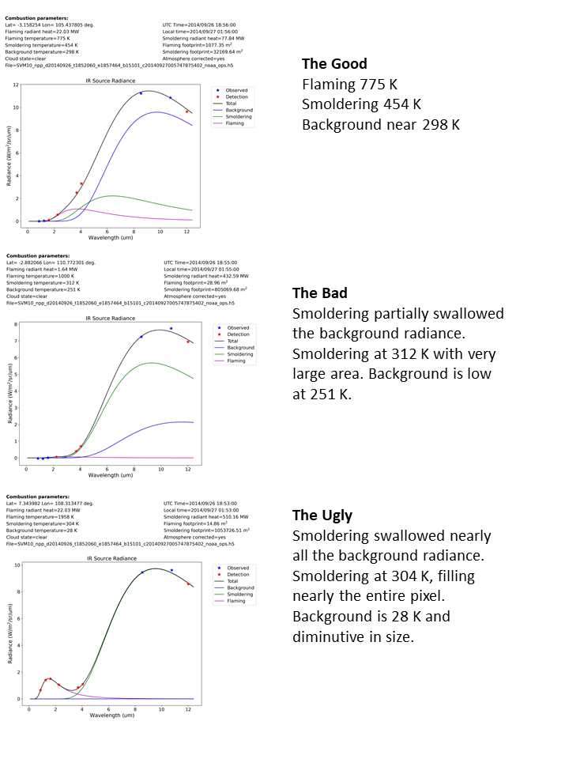
Figure 6. Examples of good and implausible analysis outcomes. The top panel shows good results, with flaming, smoldering and background temperatures falling in expected ranges. The middle panel shows a case where the smoldering phase has mistakenly absorbed about half of the background radiance. The lower panel shows and extreme case where the smoldering phase has mistakenly absorbed nearly all the background radiance.

3.3 Scoring based on misfit numbers: Tallies were made of the following for use in scoring the algorithms:
A = Detection numbers
B = Background below 50 K (negative factor)
C = Background 50 to 285 K (negative factor)
D = Smolder under 320 K (negative factor)
E = Smolder over 1000 K (negative factor)
F = Smolder 320-500 K (positive factor). The expected temperature in smoldering peat burning.
G = Smolder under 10 m^2 (negative factor)
H = Flaming under 1 m^2 (negative factor)

The scoring is A/(B+C+D+E-F+G+H). The results are shown in Table 1. The method with the highest score is flaming subtractive with smoldering Planck modeled via residual SWIR, MWIR and LWIR.

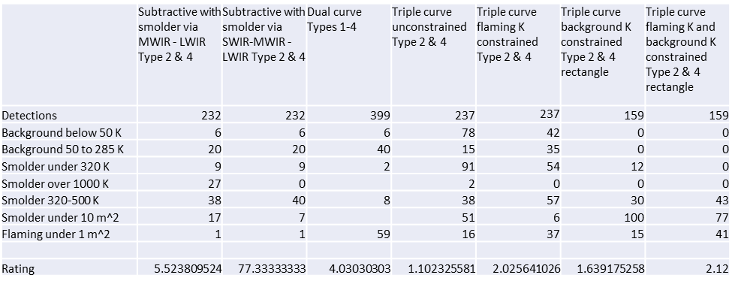

4. Conclusions

The seven algorithm options were scored based on the proportion of spurious results – which we call misfits. The primary cause for misfit pixels is the misallocation of background radiance as a component of the smoldering. We take this as an indication that pixel only contains a single combustion phase and is then switched to Type 5 – to be processed with the standard dual curve VIIRS nightfire algorithm.

The method scoring the highest is the flaming subtractive methods where the smoldering Planck curve is modeled using the residual SWIR, MWIR and LWIR radiances following the subtraction of the flaming phase radiances. This method produced fewer misfit results. It is possible to filter out the misfits using the following tests:

1) Background below 50 K – smoldering has absorbed nearly all the background radiance.
2) Background 50 to 285 K – smoldering phase has partially absorbed the background radiance.
3) Smolder under 320 K – Smoldering has absorbed background radiance.
4) Smoldering temperature either exceeds 1000 K or the flaming temperature.
5) Smolder source area under 10 m².
6) Flaming source area under 1 m².

The next test of these methods is already underway for mid-latitude forest fires in California. Later we plan to add the flaming versus smoldering analysis to the operational VNF nightly product generation.

5. Acknowledgements
This study was funded by the NOAA Joint Polar Satellite System (JPSS) proving ground program.

References:
Akagi, S. K., Robert J. Yokelson, Christine Wiedinmyer, M. J. Alvarado, J. S. Reid, Thomas Karl, J. D. Crounse, and P. O. Wennberg. "Emission factors for open and domestic biomass burning for use in atmospheric models." Atmospheric Chemistry and Physics 11, no. 9 (2011): 4039-4072.
Boonmee, N., and J. G. Quintiere. "Glowing and flaming autoignition of wood." Proceedings of the Combustion Institute 29, no. 1 (2002): 289-296.
Boonmee, N., and J. G. Quintiere. "Glowing ignition of wood: the onset of surface combustion." Proceedings of the Combustion Institute 30, no. 2 (2005): 2303-2310.
Broido, A., and Maxine A. Nelson. "Char yield on pyrolysis of cellulose." Combustion and Flame. 24: 263-268 24 (1975): 263-268.
Dozier, J. A method for satellite identification of surface temperature fields of sub-pixel resolution. Remote Sens. Environ 1981, 11, 221–229.
Elvidge, C.D., Zhizhin, M., Hsu F.C. and Baugh K.E. 2013 VIIRS nightfire: satellite pyrometry at night Remote Sensing 5 4423–4449.
Elvidge, C. D., Zhizhin, M., Hsu, F. C., Baugh, K., Khomarudin, M. R., Vetrita, Y., ... & Hilman, D. (2015). Long-wave infrared identification of smoldering peat fires in Indonesia with nighttime Landsat data. Environmental Research Letters, 10(6), 065002.
Gaveau, David LA, Mohammad A. Salim, Kristell Hergoualc'h, Bruno Locatelli, Sean Sloan, Martin Wooster, Miriam E. Marlier et al. "Major atmospheric emissions from peat fires in Southeast Asia during non-drought years: evidence from the 2013 Sumatran fires." Scientific reports 4 (2014): 6112.
Hungerford, Roger D., William H. Frandsen, and Kevin C. Ryan. "Ignition and burning characteristics of organic soils." In Tall Timbers Fire Ecology Conference, vol. 19, pp. 78-91. 1995.
Koppmann, R., von Czapiewski, K. and Reid, J.S. 2005 A review of biomass burning emissions, part I: gaseous emissions of carbon monoxide, methane, volatile organic compounds, and nitrogen containing compounds Atmos. Chem. Phys. Discuss. 5 10455–516.
Muraleedharan, T. R., Miroslav Radojevic, Allan Waugh, and Anthony Caruana. "Emissions from the combustion of peat: an experimental study." Atmospheric Environment 34, no. 18 (2000): 3033-3035.
Ohlemiller T J 1995 Smoldering combustion SFPE Handbook of Fire Protection Engineering Edited by MA Quincy, P J DiNenno, CL Beyler, R L P Custer and WD Walton, 2nd edition (Quincy, MA: National Fire Protection Association) section 2, chapter 11, pp 171–179.
Tosca, M.G., Randerson, J. T., Zender, C.S., Nelson, D.L., Diner, D.J. and Logan, J.A. 2011 Dynamics of fire plumes and smoke clouds associated with peat and deforestation fires in Indonesia. Journal of Geophysical . Research—Atmospheres 116, 1–14.
Usup A, Hashimoto Y, TakahashiHandHayasakiH 2004 Combustion and thermal characteristics of peatfires in tropical peatland in Central Kalimantan, Indonesia. Tropics 14 1–19.

