ASSESSMENT THE IMPACT OF CLIMATE CHANGE ON THE DEGRADATION OF MANGROVE FORESTS USING SPOT AND VNREDSAT IMAGERY: A CASE STUDY IN DONG RUI, QUANG NINH PROVINCE, VIETNAM

Hang Le Minh (1), Do Thi Hoai (2)

¹ Le Quy Don Technical University, 236 Hoang Quoc Viet Street, Bac Tu Liem District, Hanoi, Vietnam
2 Vietnam Institute of Geodesy and Cartography, 479 Hoang Quoc Viet Street, Bac Tu Liem District, Hanoi, Vietnam
Email: leminhhang81@gmail.com; hoaivo1976@gmail.com

KEY WORDS: mangrove forest, degradation, climate change, multispectral imagery

ABSTRACT: Mangroves play an essential role in human sustainability and livelihood, such as food and timber supplies, protection from the tidal bores, and shoreline erosion. However, climate changes (sea-level rise and altered rainfalls) and human activities threaten and degrade the mangrove forest ecosystem. In the article, the authors present the assessment of mangrove degradation in Dong Rui district, Quang Ninh province, Vietnam using multitemporal satellite images such as SPOT5 and VNREDSat-1 images in 2008, 2013, and 2017. The SVM (Support vector machine) method was applied for the classification images. The classification accuracy achieved over 85%. According to the classification images, the ​​mangroves in Dong Rui, Quang Ninh, decreased in the period 2008-2013. The changes in ​​the water and the intertidal zone features in 2008, 2013, and 2017 proved the land cover changes caused by climate change in 2008-2017. Climate change is also one reason for the degradation of mangrove forests in Dong Rui district, Quang Ninh province, Vietnam.

1. INTRODUCTION
Vietnam has a land area, long coastline, and sizeable average rainfall with large river systems, forming a green coastal mangrove forests cover from Quang Ninh province to Ha Tien province. Mangrove forest ecosystems are of great ecological and economic importance. Coastal provinces that realize mangrove forests' role have been paying attention to protect, so the forest area increases for about ten years. The mangroves offer protection from catastrophic events, such as tsunami, tropical cyclones, and tidal bores, and can dampen shoreline erosion, helping to reduce up to 50% of impact energy sea ​​waves, preventing a sea-level rise. In Vietnam, mangrove forests are distributed in 4 main areas, including Quang Ninh to Hai Phong; Hai Phong to Thanh Hoa; Thanh Hoa to Vung Tau; and Vung Tau to Ha Tien.
Currently, remote sensing technology is developing strongly with multi-resolution, multi-time, multi-sensor to help monitor Vietnam's mangrove forests. Mangrove forest grows at the intersection of land and sea. Therefore, the three main components contributing to the pixel composition in satellite images are vegetation, soil, and water. At the same time, the mangrove forests are always influenced by seasonal tides and diurnal tides. These natural conditions greatly influence landcover features' spectral properties and are the obstacles in determining mangrove forests by using spectral reflectance.
The ability to classify mangrove species in the 380 and 750 nm wavelengths, based on the leaf pigment's spectral reflectance characteristics, was relatively weak because of the similar number of pigments on most species (Vaiphasa and others, 2005). (Vaiphasa and others, 2005) hypothesize that the difference in spectral reflectance caused by other leaf components that interact with electromagnetic radiation in the near -infrared and mid-infrared. Near-infrared reflects the different spectrum due to the structure of mangrove species (Jones and others, 2004). Besides, tidal and soil type affects the spectral reflection of mangrove forests on satellite images (Blasco, 1998; Meza Diaz, 2003). The low intensity of mangrove forests on the satellite image is significantly affected by the tide-water effect. Hence, the reflection of the mudflats in the medium resolution image can confuse built-up areas classified by the spectral reflectance (Gao, 2010).
Medium resolution satellite images provide land-cover information over wide areas. Commercial satellite data that has been available data for three decades are beneficial for change detection applications. Change detection is a powerful tool for monitoring, measuring, and analyzing the mangrove forest ecosystem trends. It allows us to evaluate the changes over long periods (trends) as well as to identify sudden changes due to nature or human impact (e.g., destruction of a tsunami or transition to shrimp farms) (Coppin and others, 2010). The changes in distribution, condition, and increase/decrease of the area are commonly used to detect the changes in mangrove forests and find the reason degradation of mangrove forest (Béland and others, 2007; Binh and others, 2005; Chatterjee, 2008; Conchedda and others, 2008; Giri and others, 2007; Giri, 2008; Ramasubramanian and others, 2006).
Remote sensing data used in analysis the changes of mangrove forests are SPOT (Blasco, 2002; Blasco, 2001; Conchedda and others, 2008; Ramasubramanian and others, 2006), Landsat TM, Landsat-7 ETM + (Thu and Populus, 2007; Wang, 2003). Natural and human impacts influence the mangrove forest canopy density. (Tong and others, 2010) used SPOT images from 1995 to 2001 to assess shrimp farming's impact on the Mekong Delta mangrove forest system. (Blasco, 1992) proved the importance of mangrove forest as a protective shield against flooding after two tornadoes in Sundarbans, Bangladesh, using satellite image SPOT XS. However, the time resolution of the satellite image data plays an important role in analyzing natural disasters' effects. The time for cloudless satellite imagery is from 5 to 10 weeks after the storm, so it is difficult to analyze exactly the effects areas by flood (Blasco, 1992). (Sirikulchayanon and others, 2008) examined the impact of the 2004 tsunami on the mangrove species in Phangnga Bay, Thailand, about its function as a wave barrier. The area with great damage (average change of 26.87%) occurred in all four sub-regions where the mangrove forest cover is low near the coast.
In contrast, the area with less damage (average change of only 2.77%) was evident in sites with high cover of mangrove forest (Sirikulchayanon and others, 2008). According to the investigators, a 1,000–1,500 mangrove forest belt parallel to the coastline would be optimal to weaken tsunamis' destructive impact on inland areas. (Selvam, 2003) presented the successful effect of mangrove forest rehabilitation and reforestation conditions on degraded areas. They used LandsatTM and Indian remote sensing satellite IRS 1D LISS III acquired in 1986 and 2002 to survey the Pichavaram mangrove wetland in India. As a result, mangrove forest cover increases by about 90% over the 15 years, supported by the Government of Tamil Nadu and communities that live off mangrove forests' benefits. Many studies have found an increase in ​​mangrove forests is related to assisting localities in conservation planning tasks. (Seto and Fragkias, 2007) presented a method for systematic monitoring based on the context of the Ramsar Convention on Wetlands. The Landsat MSS and TM time-series data of the Red River Delta, Vietnam between 1975 and 2002, were used to calculate the salinity and create a land-cover map using neural network classification in which input data was the properties of land-cover and sample data. Research results indicate that the Ramsar Convention may not reduce aquaculture development, but the total area of ​​mangrove forest remains unchanged due to extensive reforestation efforts (Seto and Fragkias, 2007).

2. STUDY AREA AND MATERIA

2.1. Study area
Tien Yen district is in Quang Ninh province, which is in the Northeast of Vietnam (Figure 1b). The topography of Tien Yen district has many hills, valleys, and many river branches. It is a mountainous monsoon tropical climate with the winter cold and summers cool and rainy. The average annual rainfall is 2,427mm, and the average temperature 22.4ºC.
Dong Rui mangrove forest is a commune in Tien Yen district. Geographic coordinates 21º13’25.18N and 107º24’16”E (Figure 1c). Mangroves in Dong Rui are typical ecosystems for sub-zone 1 (from Mong Cai to Cua Ong) on the northeastern coast from Mui Ngoc to Do Son area. This mangrove ecosystem has high biodiversity due to the complex abundance of geomorphological, hydrological, and climatic features. The flora in this area is relatively high salinity tolerant species and no typical brackish water-loving species. The species composition characteristics are quite specific such as Đâng (Rhizophora stylosa), Vẹt dù (Bruguiera gymnorrhiza), Trang (Kandelia obovata), and Mắm biển (Avicennia marina). In recent years, the mangrove ecosystem in Dong Rui has been under pressure due to socio-economic development planning through human activities and climate change, which has affected the quality and regeneration, and rehabilitation of mangroves.
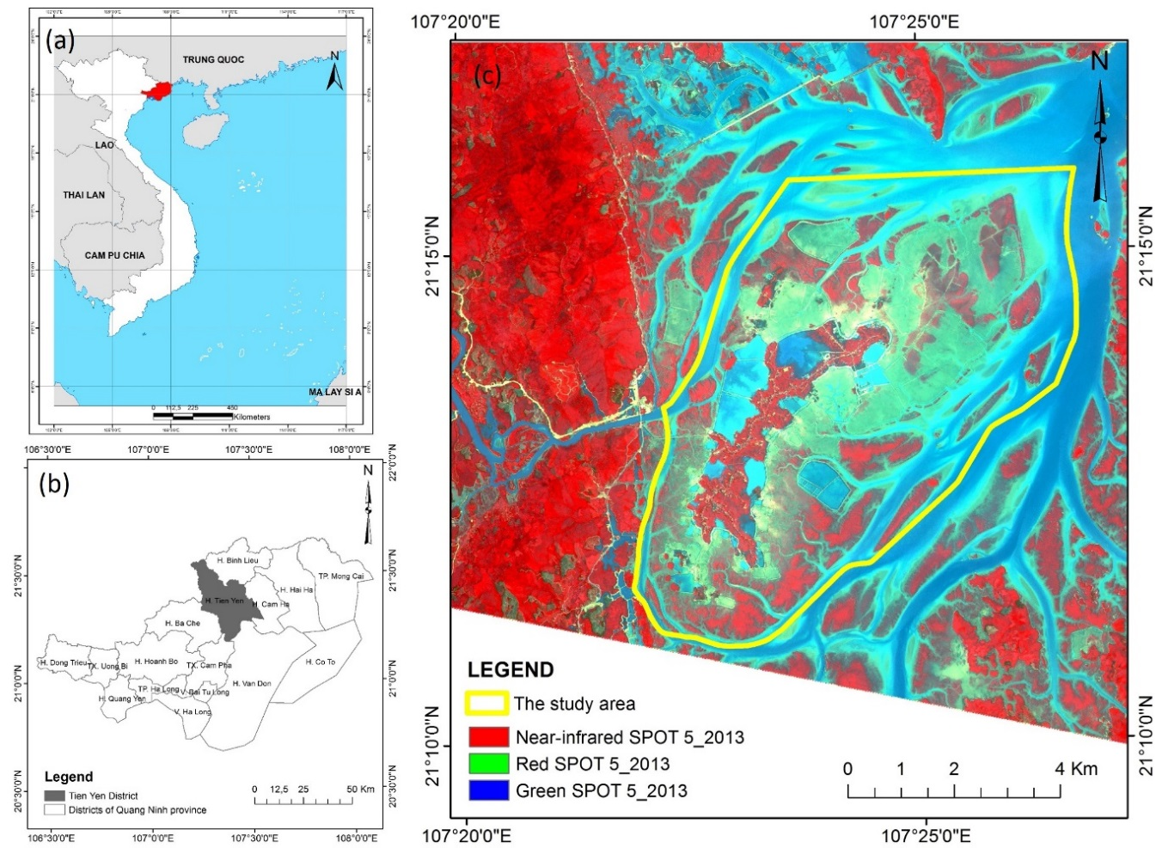
Figure 1. Location of the study area. (a) Quang Ninh province in Vietnam; (b) Location of Tien Yen district in Quang Ninh province; (c) Boundary of Dong Rui in RGB composite of SPOT 5

2.2. The material
The materials are the satellite images that were acquired in 2008, 2013, and 2017. In the article, the authors experienced SPOT 5 satellite images and VNREDSat-1 satellite images. SPOT 5 satellite was successfully launched into orbit on May 4, 2002. The SPOT5 sensor has five bands, including a panchromatic band (5m resolution), three multi-spectral bands (Green, Red, Near-infrared) with 10m resolution, and a SWIR band with 20m resolution and has a wide swath path. The 2.5m resolution of the panchromatic band is processed from 2 scenes with 5m resolution. VNREDSat-1A satellite (Vietnam Natural Resources, Environment and Disaster-monitoring Satellite-1A) is Vietnam's optical Earth observation satellite, successfully launched on May 7, 2013. The VNREDSat-1 sensor has five bands, including a panchromatic band, four multi-spectral bands (Blue, Green, Red, and Near-Infrared). The revisit time is three days. The spatial resolution of the panchromatic band is 2.5m, and that of the multi-spectral bands is 10m.
The characteristics of the material are shown in Table 1. The images acquisition period was selected in August to assist in comparing mangroves forest on multi-temporal data.
Table 1: The characteristics of the experience data
Satellite images | Resolution | Spectral bands | Acquisition date
SPOT 5 | 10m | Red, Green, Near-Infrared | 08/2008
 | 2.5m | Pan
SPOT 5 | 10m | Red, Green, Near-Infrared | 08/2013
 | 2.5m | Pan
VNRedSAT-1 | 10m | Red, Green, Blue, Near-Infrared | 08/2017
 | 2.5m | Pan
The current land use map in 2014 was used to choose the samples in the classification image process and assess the change of mangrove forests in the study area.

3. METHODOLOGY
The analysis method of mangrove degradation in Dong Rui, Quang Ninh, is based on assessing the change of landcover over the years 2008, 2013, and 2017 using a multi-temporal satellite image.

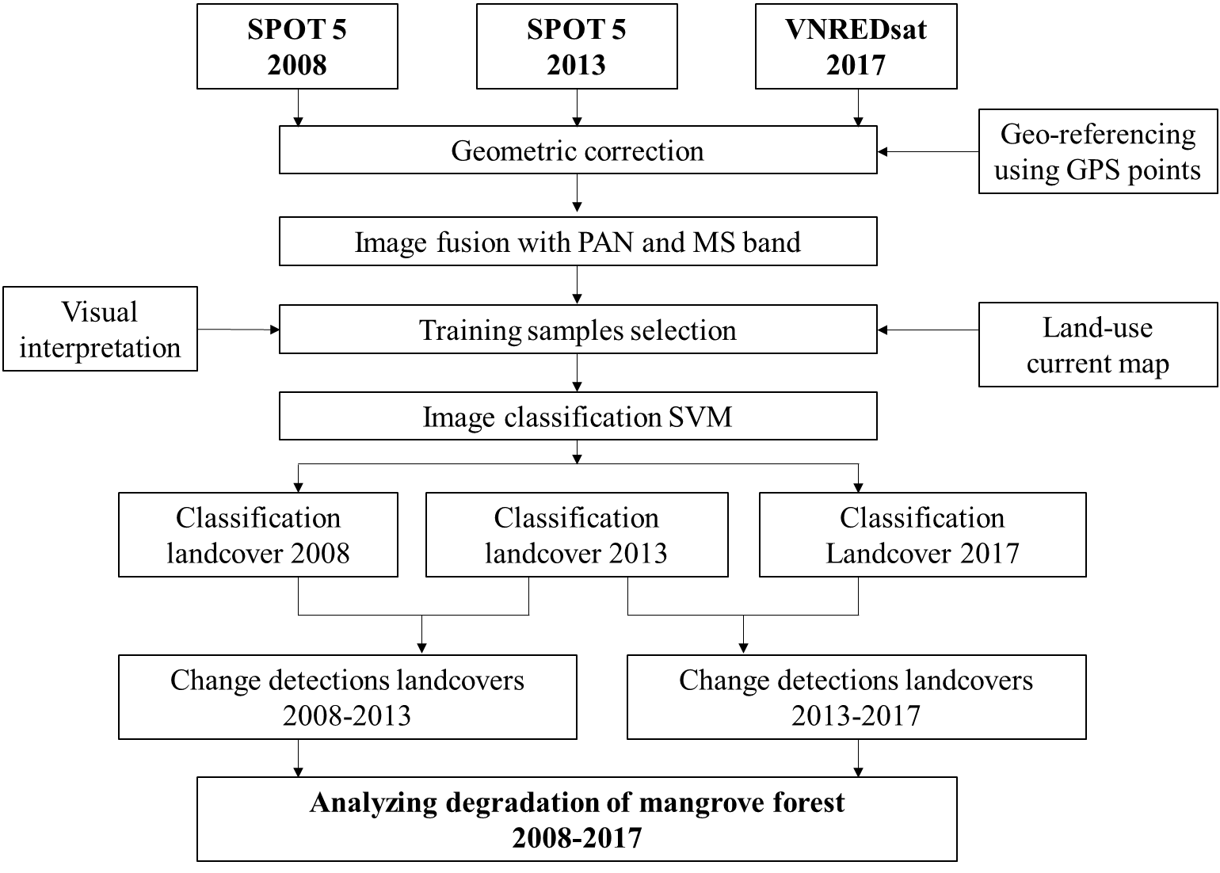
Figure 2. The flowchart of the analyzing of mangrove forest degradation
The process of analyzing mangrove forest degradation using satellite images included in three main steps:
- Pre-processing of satellite image data
- Classification landcover of satellite images in 2008, 2013, and 2017
- Analysis of changes in mangrove ecosystems
Firstly, the pre-processing images data included geometric correction, cutting by the boundary of Dong Rui, Quang Ninh, and image fusion processing to enhance multispectral images. The data is corrected geometry based on GPS control points. Next, the Brovey method of image fusion, which integrated the panchromatic band and multispectral band, is used to enhance and improve the multispectral images.
Secondly, the landcover of Dong Rui is classified by using the pre-processed images. According to the land use current map of the Dong Rui area, the study area consists of 7 main landcover features: cropland, built-up, water, mangrove, barren land, forest, and intertidal zone. The classification samples were selected based on visual interpretation of the false-color combination the bands of satellite image (Figure 1c) and landuse current map in 2014. The SVM method was used to classify the landcover of Dong Rui, Quang Ninh in 2008, 2013, and 2017. The landcover maps are shown in Figure 3.
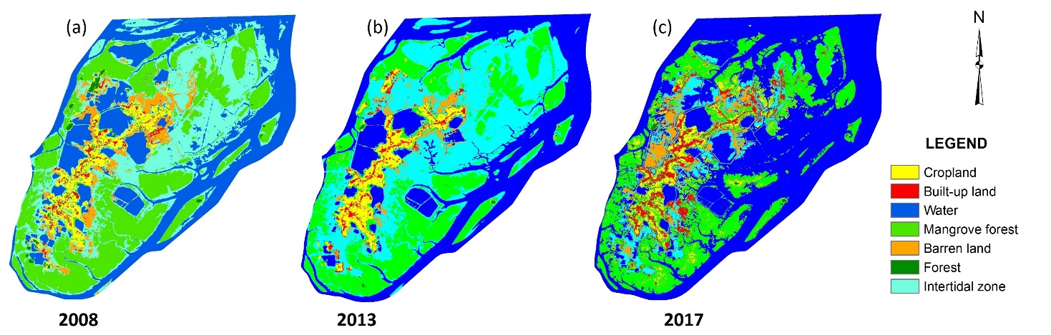

Figure 3. The landcover maps of 2008, 2013 and 2017
The assessment of classification accuracy is shown in Table 2. According to Table 2, the land cover classification accuracy in 2008, 2013, and 2017 is high over 85%. These classified images are the input data to analyze mangrove ecosystems' degradation.
Table 2. The assessment of classification accuracy of Dong Rui, Quang Ninh
Year | 2008 | 2013 | 2017
Overall accuracy (%) | 99.23 | 96.5 | 87.1
Kappa index | 0.99 | 0.9583 | 0.845

RESULTS AND DISCUSSION
The changes in mangrove forests during the period 2008-2013 and 2013-2017 were determined using two different post-classification images. The changes area of the land cover features in 2008-2013 and 2013-2017 are shown in Table 3 and Figure 3.
Based on the graph of Figure 3, in the period 2008-2013, the area of ​​mangrove forests has been reduced to 120.85ha. During 2013-2017, the mangroves’ area has increased by 16.07ha but slightly because of the policies for protecting mangrove forests and support mangrove planting. There are many causes of mangrove degradation, including sea-level rise and altered rainfall. The water areas in the period 2008-2013 decreased by 22.18ha, while the intertidal zone area increased 294.18ha. As a result, the amount of water in the mangrove area of ​​Dong Rui, Quang Ninh decreased in 2008-2013. Changing tidal level conditions are also responsible for the degradation of mangrove forests.
From 2013-2017, the water area increased rapidly by 1042.47 ha. One of the reasons for changing the water area is the sea level rise phenomenon. The increased water surface area leads to a significant reduction in the intertidal zone area with ​​1301.14ha (Figure 2c). The residential areas increased so that the built-up land area raised to 136.10ha and the cropland area to 34,194 ha. The increase of population is also the pressure on the mangrove forest ecosystem.
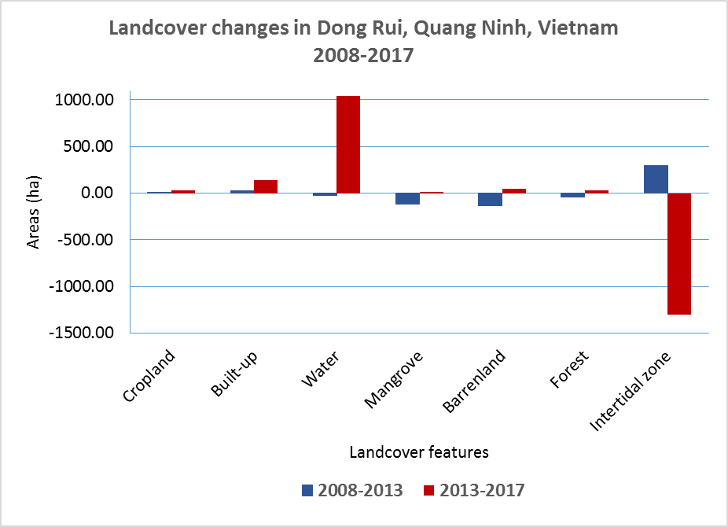
Figure 3. Landover changes areas in Dong Rui district, Quang Ninh province, Vietnam during the period 2008-2013 and 2013-2017
Table 3. Evaluation of land cover change areas in Dong Rui, Quang Ninh province, Vietnam during the period 2008-2013 and 2013-2017
Types of land cover | Area in hectares
 | 2008-2013 | 2013-2017
Cropland | 1.591 | 34.194
Built-up | 29.597 | 136.103
Water | -22.179 | 1042.468
Mangrove | -120.854 | 16.073
Barren land | -137.157 | 45.240
Forest | -45.173 | 27.061
Intertidal zone | 294.175 | -1301.138
According to that, climate change's impact dramatically impacts the changes of the mangrove forests of Dong Rui, Quang Ninh, Vietnam. Simultaneously, landcover changes have affected the people who depend on mangrove forests ecosystem and natural conditions.Table 3. Evaluation of land cover changes areas in Dong Rui district, Quang Ninh province, Vietnam during the period 2008-2013 and 2013-2017.

CONCLUSION
In conclusion, the changes in mangrove forests of Dong Rui, Quang Ninh, Vietnam were monitored by satellite image SPOT5 and VNREDSat-1 images. In the period 2008-2013, the mangrove forest area of ​​Dong Rui has severely degraded because the intertidal zone increases and the water area decreases. In the period 2013-3017, the mangrove area increased but not significantly. Especially in this period, the water area increased rapidly, flooding the intertidal zones. It proves that climate change has impacted mangrove areas, changing the living conditions of plants. Besides, the increase of urban areas, ​​cropland, and aquaculture areas will also narrow the mangroves' area. Therefore, ​​mangroves should be regularly monitored with remote sensing data, and the government should have the policy to protect and support mangrove planting.

REFERENCES
Béland M, Goïta K, Bonn F, Pham TTH. 2007. Assessment of land‐cover changes related to shrimp aquaculture using remote sensing data: a case study in the Giao Thuy District, Vietnam. International Journal of Remote Sensing 27(8):1491-1510.
Binh TNKD, Vromant N, Hung NT, Hens L, Boon EK. 2005. Land Cover Changes Between 1968 and 2003 In Cai Nuoc, Ca Mau Peninsula, Vietnam. Environment, Development and Sustainability 7(4):519-536.
Blasco FA, M. . 2002. Mangroves along the coastal stretch of the Bay of Bengal: Present status. Ind J Mar Sci 31:9-20.
Blasco FA, M.; Gers, C. 2001. Depletion of the mangroves of continential Asia. Wetlands Ecol Manage 9:245-256.
Blasco FB, M.F.; Chaudhury, M.U. . 1992. Estimating the Extent of Floods in Bangladesh—Using SPOT Data. Remote Sens Environ 39:167-178.
Blasco FG, T.; Rasolofoharinoro, M.; Denis, J.; Aizpuru, M.; Caldairou, V. 1998. Recent advances in mangrove studies using remote sensing data. Mar Freshwater Res 49:287-296.
Chatterjee BP, M.C.; Hussin, Y.A. Assessment of Tsunami Damage to Mangrove in India Using Remote Sensing and GIS; 2008.
Conchedda G, Durieux L, Mayaux P. 2008. An object-based method for mapping and change analysis in mangrove ecosystems. ISPRS Journal of Photogrammetry and Remote Sensing 63(5):578-589.
Coppin P, Jonckheere I, Nackaerts K, Muys B, Lambin E. 2010. Review ArticleDigital change detection methods in ecosystem monitoring: a review. International Journal of Remote Sensing 25(9):1565-1596.
Gao J. 2010. A hybrid method toward accurate mapping of mangroves in a marginal habitat from SPOT multispectral data. International Journal of Remote Sensing 19(10):1887-1899.
Giri C, Pengra B, Zhu Z, Singh A, Tieszen LL. 2007. Monitoring mangrove forest dynamics of the Sundarbans in Bangladesh and India using multi-temporal satellite data from 1973 to 2000. Estuarine, Coastal and Shelf Science 73(1-2):91-100.
Giri CM, J. 2008. Mangrove forest distribution and dynamics in Madagascar (1975–2005). Sensors 8:2104-2117.
Jones J, Dale PER, Chandica AL, Breitfuss MJ. 2004. Changes in the distribution of the grey mangrove Avicennia marina (Forsk.) using large scale aerial color infrared photographs: are the changes related to habitat modification for mosquito control? Estuarine, Coastal and Shelf Science 61(1):45-54.
Meza Diaz BB, G.A. . 2003. Remote sensing of mangrove biophysical properties: Evidence from a laboratory simulation of the possible effects of background variation on spectral vegetation indices. Int J Remote Sens 24:53-73.
Ramasubramanian R, Gnanappazham L, Ravishankar T, Navamuniyammal M. 2006. Mangroves of Godavari – Analysis Through Remote Sensing Approach. Wetlands Ecology and Management 14(1):29-37.
Selvam VR, K.K.; Gnanappazham, L.; Navamuniyammal, M. 2003. Assessment of community-based restoration of Pichavaram mangrove wetland using remote sensing data. Curr Sci 85:794-798.
Seto KC, Fragkias M. 2007. Mangrove conversion and aquaculture development in Vietnam: A remote sensing-based approach for evaluating the Ramsar Convention on Wetlands. Global Environmental Change 17(3-4):486-500.
Sirikulchayanon P, Sun W, Oyana TJ. 2008. Assessing the impact of the 2004 tsunami on mangroves using remote sensing and GIS techniques. International Journal of Remote Sensing 29(12):3553-3576.
Thu PM, Populus J. 2007. Status and changes of mangrove forest in Mekong Delta: Case study in Tra Vinh, Vietnam. Estuarine, Coastal and Shelf Science 71(1-2):98-109.
Tong PHS, Auda Y, Populus J, Aizpuru M, Habshi AA, Blasco F. 2010. Assessment from space of mangroves evolution in the Mekong Delta, in relation to extensive shrimp farming. International Journal of Remote Sensing 25(21):4795-4812.
Vaiphasa C, Ongsomwang S, Vaiphasa T, Skidmore AK. 2005. Tropical mangrove species discrimination using hyperspectral data: A laboratory study. Estuarine, Coastal and Shelf Science 65(1-2):371-379.
Wang YB, G.; Nugranad, J.; Traber, M.; Ngusaru, A.; Tobey, J.; Hale, L.; Bowen, R; Makota, V. . 2003. Remote sensing of mangrove change along the Tanzania Coast. Marine Geodesy 26:35-48.

