Design of a light and small multispectral camera

Mengxu Zhu(1), Guohong Li(1), Yunfeng Zhao(1)

¹North China Institute of Aerospace Engineering LangFang, Hebei, 065000,China

Email: 765700663@qq.com; ht_guohongli@sohu.com; 53438672@qq.com

Abstract:In this paper, a 600g level multi spectral camera is designed based on the characteristics of light and small UAV load requirements, combined with the needs of water and vegetation monitoring. The camera is designed to take into account the red, green, blue and near-infrared four spectral segments, according to the need to use the corresponding wavelength filter to achieve the image acquisition of specific spectral segments. The design mainly includes image acquisition unit, storage unit, communication unit and UAV communication interface, and uses embedded core board for system control, which has the characteristics of low cost, short development cycle and simple replacement spectrum. The test results show that the camera is suitable for monitoring water bodies, plant growth pests and diseases, etc.
Keywords: Multispectral camera，Embedded，Image acquisition

- introduction
  - Application areas of multispectral cameras
As a multi-spectral remote sensing sensor, a multi-spectral camera can shoot multiple images of the same area and different bands at a time, and record multiple band information of features in the target area. [1] The light and small UAV has the advantages of simple operation, flexible maneuverability and low cost. The space-time resolution of space-borne multispectral cameras is low, and it is difficult to meet the requirements of high-temporal-resolution multispectral remote sensing. In large-scale aerial remote sensing, the flying altitude of an aircraft is usually around 4000 meters, which is extremely susceptible to the influence of weather and clouds. The light and small UAV remote sensing system composed of multispectral cameras and light and small UAVs can effectively make up for the shortcomings of large aerial remote sensing systems and spaceborne remote sensing systems that are insufficient in time and space resolution and are greatly affected by cloud thickness[2]. The light and small airborne multispectral camera can collect color images and grayscale images in the visible light band. These images have a wide range of applications in vegetation, water bodies, agriculture, forests, disasters and other fields[3]. Therefore, the multispectral camera system of light and small UAVs has very broad application prospects in remote sensing with high spatial and temporal resolution, such as black and odorous water monitoring, smart agriculture, and environmental monitoring[4].
  - Research status and significance of multispectral cameras
Multi-spectral cameras acquire information in the visible and near-infrared bands, and can be divided into single-lens plus spectroscopic systems and multi-lens plus spectroscopic systems according to different spectroscopic strategies. The single-lens plus spectroscopy system uses grating prisms for spectroscopy, so that one lens of the camera can collect information of different spectral bands[5]. The multi-lens plus spectroscopy system is to install filters of different spectrum bands in front of different lenses. Each lens collects different spectrum information. The entire camera system can collect multiple spectrum information. The single-lens and spectroscopic system of the multispectral camera is the AD-130GE multispectral camera developed by the Danish camera manufacturer JAI. It uses a prism to split the light to obtain images of multiple spectrum bands with a resolution of 1296×966 pixels. The frame rate is 31fps. Restricted by the factors that make the camera system complicated and the size of the camera increased due to the beam splitting prism, the multispectral camera of the light and small UAV uses a multi-lens plus beam splitting system. The multi-spectral camera adopts the method of placing a filter in front of the lens. At the same time, several lenses shoot the same feature, obtain images of different spectrum bands of the same feature, and process the images to obtain the spectral information of the corresponding spectrum[6].
This multi-spectral camera is designed based on the needs of water body and vegetation monitoring. It can collect images in the four spectrum bands of red, green, blue and near-infrared, and can use filters of corresponding wavelengths to achieve image collection in specific spectrum bands as needed[8]. In addition, the camera can also meet the conditions for carrying light and small UAVs, and running on a small UAV can obtain the spatial information and spectral information of the features, and then obtain the complete information of the target features[7].
2The overall design of the system
2.1 Basic parameters of the multispectral camera system
The core board of the multi-spectral camera uses RK3288 CPU with quad-core A-17 architecture, which supports up to 1.8GHz, USB interface supports 4 sets of USB2.0 interfaces, memory supports Micro SD card, wireless network supports WiFi 2.4GHz/5GHz dual frequency . The red, green, blue and near-infrared band data collection of the multi-spectral camera system uses the 8 million pixel color drive-free camera module DYSMT805 of Daying. The interface protocol of this camera is USB2.0, the resolution is up to 3246×2448 in MJPG format, the photosensitive element is Sony back-illuminated 1/3.2” color CMOS, the photosensitive size is 4592μm*3449.6μm, and the pixel is 1.4μm* 1.4μm, shutter exposure mode is electronic rolling shutter line exposure, exposure time is 16-2000 milliseconds manual exposure or automatic exposure. The power supply of the drone is 12v, and the power module converts the 12v of the drone battery into 5v to supply power to the circuit core board.
2.2 The composition of the multispectral camera system
The multi-spectral camera system includes the core circuit board of the RK3288 CPU. Four cameras collect data in the four spectrum bands of red, green, blue and near-infrared. The four cameras are connected to the core board of the RK3288 CPU via USB. The core board of the RK3288 CPU reserves an interface for communicating with the drone, and the data collected by the four cameras is stored in the Micro SD card. The communication module uses WiFi to transfer the data stored in the Micro SD card to an external device for further processing. The multi-spectral camera system is powered by the drone's battery. The power module converts the drone's 12v power into 5v and 3.3v power and provides it to the circuit core board. This design not only ensures that the total mass of the multi-spectral camera is within 600 grams, but also reduces the complexity of the entire system. The multi-spectral camera system is shown in Figure 1:
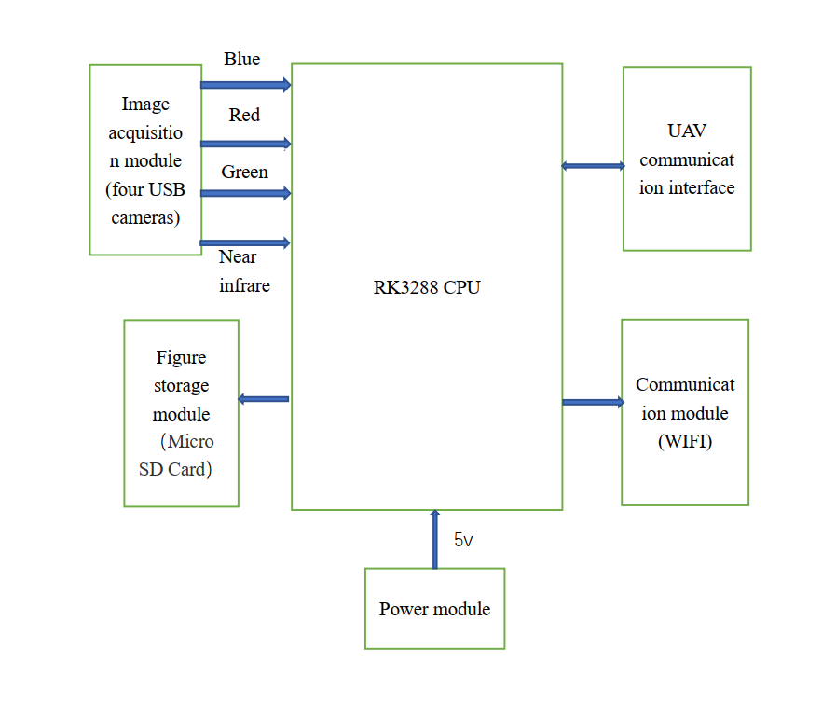
Figure 1 The multi-spectral camera system
3 Optical image acquisition
3.1 The choice of filter
Filters are a kind of optical components that specifically select the transmission, reflection, cut-off, and attenuation of spectral wavelengths. According to their functions, they can be divided into band-pass filters, long-wave filters, short-wave filters, and so on. The transmission band of the band-pass filter is surrounded by two cut-off bands. It allows only part of the wavelength in the spectrum to pass through, and is used to transmit a part of the spectrum while cutting off all other wavelengths[11]. Choose four different bandpass filters to filter out the information of the four bands of red, green, blue, and near infrared respectively. The center wavelength of the blue band filter is 460nm and the bandwidth is 40nm. The center wavelength of the filter in the green band is 540nm, the center wavelength of the filter in the red band is 675nm and the bandwidth is 50nm. The center wavelength of the near-infrared filter is 810nm and the bandwidth is 90nm[13].
The camera lens filters light through filters in the red, green, blue, and near-infrared bands, collects information in the red, green, blue, and near-infrared bands, and transmits the relevant information to the core board for processing.
3.2 Calibration of the camera
The multi-spectral camera system uses the DYSMT805 of Big Shadow Image. Since this camera is not a measurement camera, the distortion parameters are unknown, and the distorted images taken will affect the difficulty of subsequent band registration. Therefore, it is necessary to calibrate the camera, and use the calibration to obtain the distortion parameters of the camera to correct the distortion of the image[9].
The distortion of the camera is divided into radial distortion and tangential distortion. Radial distortion is because the light is more curved away from the center of the lens than near the center. Tangential distortion is caused by the camera's production and assembly is not precise enough. Nowadays, the assembly process has made great progress, and the main factor affecting camera distortion is radial distortion. The radial distortion formula of the camera is:
$$x_{0}=x(1+k_{1}r^{2}+k_{2}r^{4}+k_{3}r^{6})$$
$$y_{0}=y(1+k_{1}r^{2}+k_{2}r^{4}+k_{3}r^{6})$$
Where（$x_{0}$，$y_{0}$）is the position of the distorted image, （$x$，$y$） is the position of the distorted image after correction[10].
The camera's radial distortion parameters can be solved by Zhang Zhengyou calibration method. The Zhang Zhengyou calibration method is a camera calibration method based on a single plane checkerboard. This method is between traditional calibration and camera self-calibration. This method does not require additional equipment, the camera and calibration board can be placed arbitrarily and have high accuracy[12]. The process of solving the camera's internal parameters using Zhang Zhengyou calibration method is shown in Figure 2:
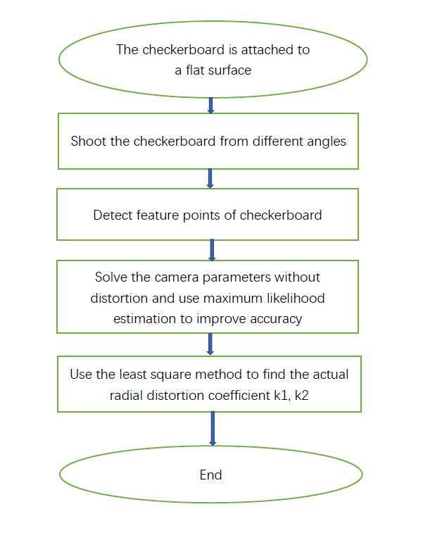
Figure 2 The process of solving the camera's internal parameters using Zhang Zhengyou calibration method
4 Hardware circuit design
4.1 Image acquisition unit design
The multispectral camera collects data of four bands, and the data collected by the four-channel USB camera is transmitted to RK3288. Use GL850G to expand the host2 interface in RK3288 to four USB interfaces. The data collected by the four cameras at the same time is transmitted to RK32888 through this device.
GL850G is a 4-port standard USB hub controller, which complies with the USB2.0 standard and can be connected to usb2.0_host. GL850G has the advantages of low power consumption, low temperature and reduced number of pins. The GL850G under the USB2.0 standard can transfer the data collected by the four cameras to the core board in time. The schematic diagram of GL850G to achieve four-way USB extension is shown in Figure 3 Figure 4 and Figure 5:
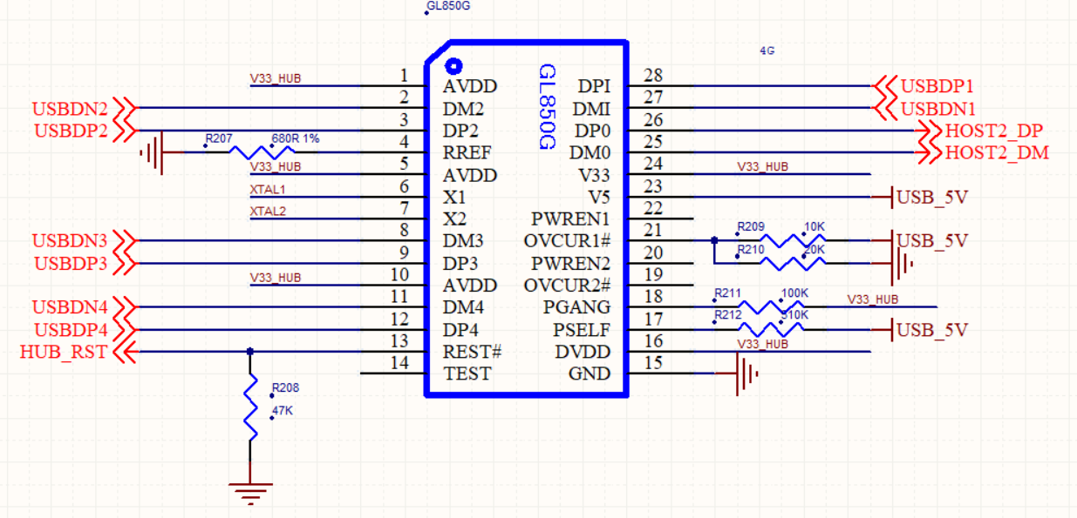
Figure 3 Schematic diagram of GL850G realizing four-way USB extension
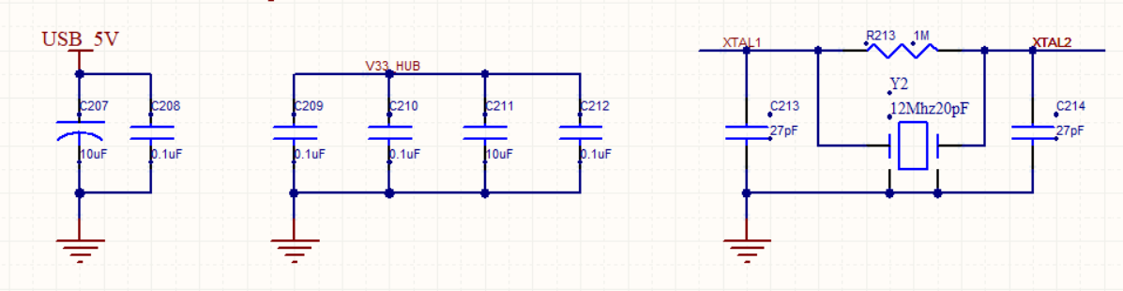
Figure 4 Schematic diagram of USB 5V, V33 HUB and 12MHz crystal oscillator wiring
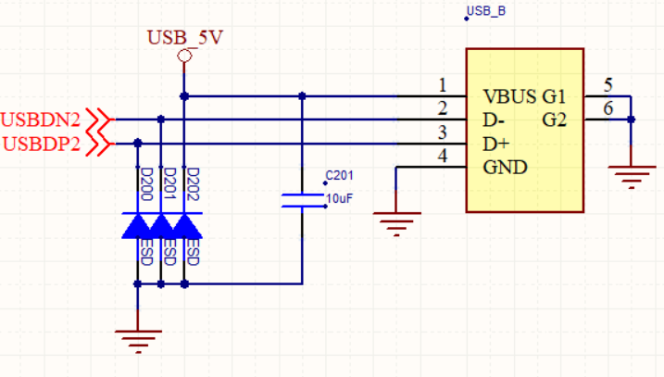 Figure 5 Schematic diagram of external USB port wiring
4.2 Storage unit design
The design of the storage unit of the multi-spectral camera must not only ensure that the storage space can meet multiple multi-spectral data collections, but also ensure the convenience of multi-spectral data migration. The Micro SD card is used as the storage unit of the multi-spectral camera. The data collected by the multi-spectral camera is stored in the Micro SD card. After the data collection is completed, the data in the Micro SD card can be exported to an external device to facilitate the next processing of the data. At the same time, the Micro SD card can also use the installed linux image as the boot card of the system as a multi-spectral camera installation system. A Micro SD card slot needs to be installed on the core board.
The wiring schematic diagram of the Micro SD card slot is shown in Figure 6:
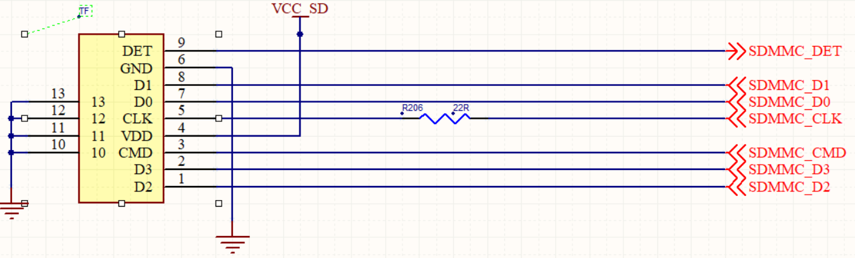
Figure 6 Wiring schematic diagram of Micro SD card slot
4.3 Communication unit design
The communication unit of the multi-spectral camera is the medium through which the multi-spectral camera communicates with external devices. The communication unit of the multi-spectral camera can communicate with an external device, and can transmit the data collected by the multi-spectral camera to the external device in time, and the data can be further processed in the external device. The communication unit of the multi-spectral camera can receive external instructions to complete specific tasks.
The communication unit of the multi-spectral camera adopts WiFi and Bluetooth. This design can avoid the reserved interface on the core board and reduce the volume of the multi-spectral camera. The communication unit uses the AP6212 chip, which is a low-cost, low-power module that integrates WiFi, Bluetooth and FM functions. This module that integrates WiFi + BT + FM technology is specially developed for smart phones and portable devices and can meet the communication needs of multi-spectral camera systems.
The WIFI and Bluetooth connection of AP6212 is shown in Figure 7:
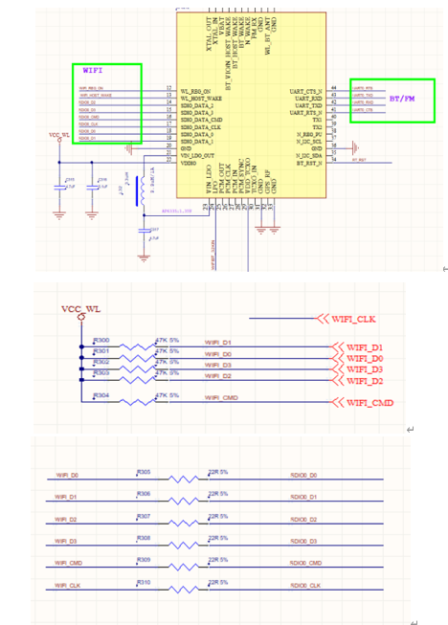
Figure 7 Wiring schematic diagram of WIFI and Bluetooth part of AP6212
AP6212 uses a 26MHz passive crystal to input from PIN10 and pin11. The crystal connection principle of AP6212 is shown in Figure 8:
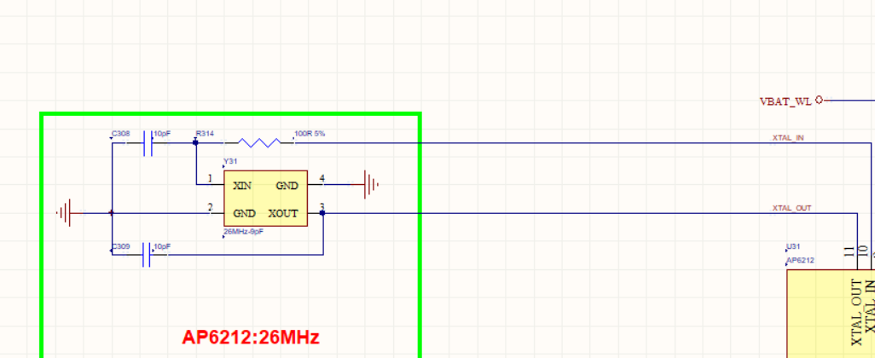
Figure 8 AP6212 crystal oscillator wiring schematic diagram
4.4 UAV communication interface design
The UAV communication interface is responsible for the transmission of information between the multispectral camera and the UAV. The UAV communication interface can control the shooting of the multispectral camera and the focus of the multispectral camera. The 10-pin HOT-SHOE_A of the UAV communication interface is connected to the 40-pin SPI1-RXD of the core board. The wiring principle of the UAV communication interface is shown in Figure 9:
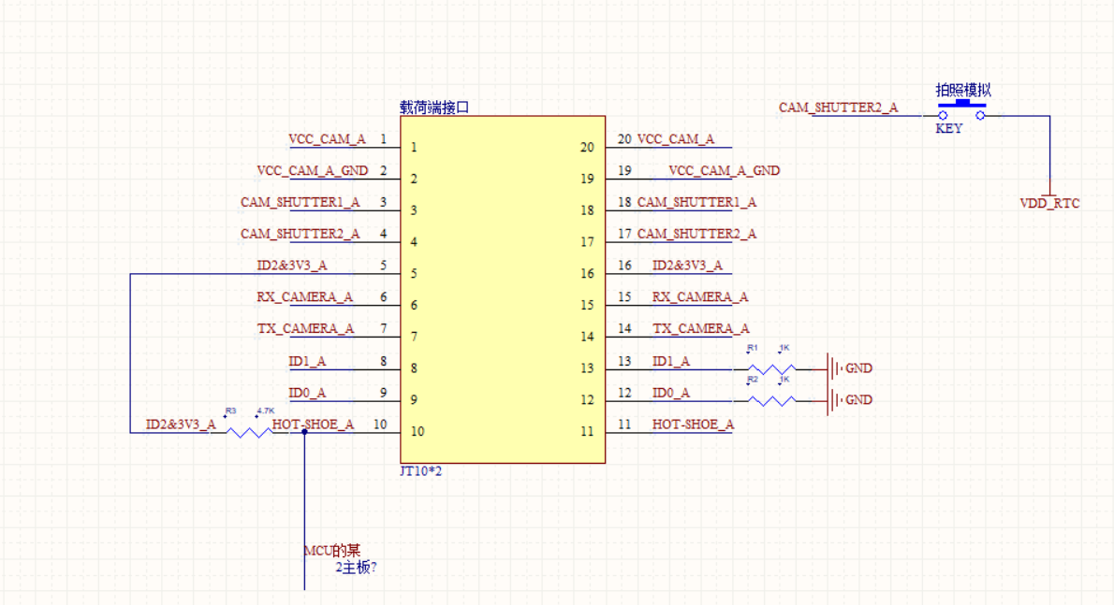
Figure 9 Wiring schematic diagram of UAV communication interface
4.5 Design of the core board
The circuit core board takes RK3288 as the core. RK3288 is the central processing unit of the entire system. There are also image acquisition unit, storage unit, communication unit and UAV communication interface on the core board. These parts together form a multi-spectral camera system. In addition to the above parts, the core board also reserves an interface for system debugging.
There is an OTG debug serial port on the circuit core board. The OTG debug serial port is mainly responsible for system debugging, and it can also burn the system image to a multi-spectral camera. There is a short-circuit button on the circuit core board. When the system is programmed, it needs to be short-circuited for a few seconds before the OTG debug serial port can establish a connection with the multi-spectral camera system.
The wiring principle of the short-circuit programming button is shown in Figure 10:
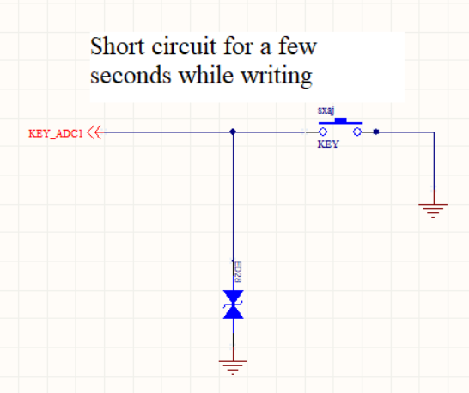
Figure 10 The wiring principle of the short-circuit programming button is shown in the figure
The PCB circuit board of the multispectral camera system is shown in Figure 11:
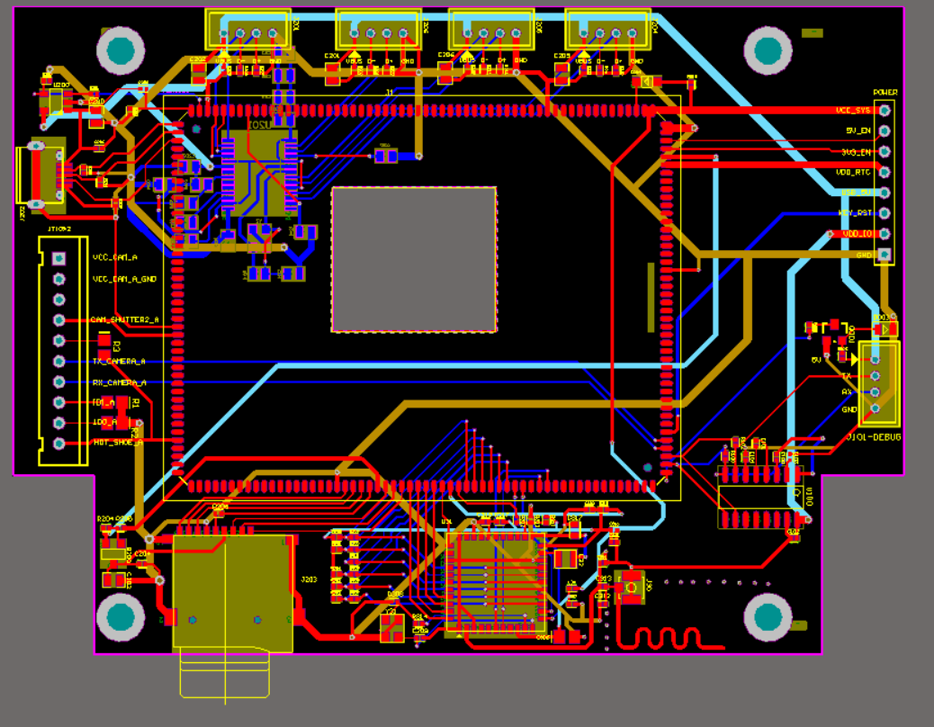
Figure 11 The PCB circuit board of the multispectral camera system
5 Conclusion
Multispectral cameras can collect information in the four bands of red, green, blue and near infrared. Multispectral cameras can freely change the filter to collect information of different wavelengths. The overall mass of the multi-spectral camera is within 600 grams, which can be carried by light and small drones. The multi-spectral camera of the light and small UAV is designed to meet the multi-spectral information collection of vegetation, water bodies and other ground objects. As light and small UAV multispectral cameras are more and more widely used in the field of remote sensing detection, the light and small UAV multispectral cameras designed in this paper will play a more important role in the field of high-resolution multispectral detection.

References
[1] Zhou Lijuan,Wang Jing.A fast correction method for large-sequence UAV image distortion[J].Geospatial Information, 2020,18(08):10-13+6.
[2] Li Yinguo, Cheng Cheng. Distortion correction method of wide-angle camera based on nonlinear spline interpolation[J/OL].Journal of Intelligent Systems: 1-7[2020-10-11].
[3] Feng Shan, Zeng Xiangzhong. The design of four-channel visible light spectrum camera[J]. Applied Optics, 2019,40(03):393-398.
[4]Sun Gang, Huang Wenjiang, Chen Pengfei, Gao Shuai, Wang Xiu. Application progress of multispectral remote sensing technology for light and small drones[J]. Transactions of the Chinese Society of Agricultural Machinery, 2018, 49(03):1-17.
[5]He Yong, Cen Haiyan, Li Yijian, He Liwen. Farmland information acquisition technology and its airborne equipment based on UAV remote sensing[J]. Agricultural Engineering Technology, 2018, 38(09): 28-32.
[6] Cao Congfeng, Fang Junyong, Zhao Dong. Development of UAV-borne multispectral camera based on filter array spectroscopy[J]. Optics Technology, 2018, 44(01): 51-55.
[7] Cao Congfeng. Research on UAV-borne multispectral camera system based on filter array spectroscopy[D]. University of Chinese Academy of Sciences (Institute of Remote Sensing and Digital Earth, Chinese Academy of Sciences), 2017.
[8]Bian Xue. Research on vegetation coverage in the visible light band based on low-altitude remote sensing images of drones[D]. Nanjing Agricultural University, 2017.
[9] Zhang Jing, Qin Wenjian, Jia Liang. Review of research on camera distortion correction [J]. Science and Technology Innovation Herald, 2011(07): 5+7
[10]Ji Ye. Research on Internal Distortion Correction Algorithm and Application of UAV Remote Sensing Image[D]. Electronics [University of Science and Technology, 2010.
[11]Sun Xin, Bai Jiaguang, Wang Zhonghou, Bai Qinglan, Huang Min. The optical system design of an airborne multispectral camera[J]. Acta Photonica Sinica, 2009, 38(12): 3160-3164.
[12] Han Xiuli, Wu Lifang, Guo Jiang, Yang Peng. Camera self-calibration method based on two vanishing points [A]. Signal Processing Branch of Chinese Institute of Electronics, Signal Processing Branch of Chinese Institute of Instrumentation. The 13th National Signal Proceedings of the Annual Conference on Processing (CCSP-2007) [C]. Signal Processing Branch of Chinese Institute of Electronics, Signal Processing Branch of Chinese Society of Instrumentation: Signal Processing Branch of Chinese Institute of Electronics, 2007:4.
[13] Da Xuanfu, Zhang Boheng, Bian Chuanping, Qu Youshan. Design of electronic system for high-resolution multispectral digital camera[J]. Optics Technology, 2006(04):521-523.

