A review of characteristics influencing factors, mechanism, characteristics of heavy metal pollution in farmland in China
Xuqing Li（1,2*） Chen Li(3), Yongtao Jin(1,2),Di Liu(1,2), Yuanping Liu(1,2),Shuai Wang(1,2),Ruoyu Wang(1,2),Hong Chen(1,2),Zhengjie Wu(1,2),

¹Department of Computer and Remote Sensing Information Technology, North China Institute of Aerospace Engineering, Langfang 065000, China：E-Mail：meililixuqing@163.com;
²Hebei Collaborative Innovation Center for Aerospace Remote Sensing Information Processing and Application, Langfang 065000, China
³Beijing Institute of Space Mechanics & Electricity，Aeronautical Optical Remote Sensing laboratory, Beijing 100076, China; lichen2004301@126.com

Keywords: heavy metal pollution in farmland; remote sensing monitoring; spatial characteristics of heavy metal pollution in China

Abstract: In this paper, the characteristics and current situation of heavy metal pollution in farmland in China, the influencing factors and mechanism of heavy metal pollution in crops, the summary of remote sensing monitoring methods for heavy metal pollution in farmland and the research prospect are discussed. Farmland non-point source pollution monitoring is an important issue related to national security and stability and people's livelihood. At present, the characteristics of heavy metal pollution in farmland in China mainly include:①Heavy metal pollution is prevalent in soils.The three major rice dominant areas in China (the rice dominant area in the northeast plain, the rice dominant area in the Yangtze river basin, and the rice dominant area in the southeast coast) are all polluted by heavy metals to varying degrees. ②Heavy metal pollution is serious in farmland. The pollutants are mainly As, Cd, Pb, Hg, Ni, Cu, DDT and pahs.③Heavy metal contamination of grain occurs frequently. Heavy metal polluted farmland may cause crop diseases. In this paper, the spatial distribution characteristics of As, Cu, Cd, Cr, Pb and Zn in China are summarized. The content of heavy metal elements in crops largely depends on the characteristics and types of crops as well as the growing environment.

Characteristics of heavy metal pollution in farmland

Soil heavy metal pollution refers to the phenomenon that the heavy metal content in soil is obviously higher than the soil background value due to human production and living activities, which leads to the deterioration of the ecological environment quality[1-3]. Due to the rapid development of economy and the relative lag of environmental protection measures, soil heavy metal pollution is becoming more and more serious[4]. According to the survey, heavy metal pollution ranked the first among many sources of soil pollution. In recent years, it is not hard to find that heavy metals such as cadmium(Cd), mercury(Hg), arsenic(As), lead(Pb), chromium(Cr), copper(Cu), zinc(Zn) and Ni dominate the soil pollution events in China, and manganese(Mn), cobalt(Co), selenium(Se), vanadium(V), antimony(Sb), thallium(Tl) and molybdenum(Mo) still exist in some areas. Mining and smelting can lead to Cd contamination in nearby soil. Cd is usually discharged into the environment through waste water and then into food through irrigation. Rice is typical of the many "affected crops". Chronic consumption of foods containing Cd can cause painful pain (bone cancer) or kidney failure. Pb poisoning affects the functioning of the nervous and digestive systems, usually through ingestion and breathing. Children, by contrast, are more likely to absorb Pb, which can lead to permanent intellectual impairment and behavioural abnormalities. Soil heavy metal pollution is hidden, lagged, accumulated and difficult to be reversed, which poses a serious threat to the ecological environment and food safety. The characteristics of heavy metal pollution in Chinese farmland mainly include the following aspects：(1) Soil contaminated by heavy metals has a wide range. From April 2005 to December 2013, China conducted its first national soil pollution survey (the actual survey area was about 6.3 million square kilometers). The overall exceeding rate of soil in China is 16.1%, and the number of inorganic pollutants exceeding the standard, such as Cd, Ni, As and Cu, accounted for 82.8% of the total[5]. According to the latest research results in 2018, the point excess rate of heavy metals in cultivated soil in major grain-producing areas in China was 21.49%, with mild pollution as the main cause. The proportions of mild, moderate and severe pollution were 13.97%, 2.50% and 5.02%, respectively[6]. (2) Farmland is seriously polluted by heavy metals. Human factors such as mining, industrial "three wastes" emissions, household coal burning, sewage irrigation, automobile exhaust emissions and the use of heavy metal products lead to the entry of heavy metals or their compounds into water sources or farmland soil environment. Heavy metal content in farmland soil and agricultural water exceeds the standard, which directly leads to the phenomenon of excessive heavy metal content in rice, vegetables and other agricultural products. In the pearl river delta, Yangtze river delta, Beijing-Tianjin-Tangshan economic zone and other economically developed areas, the problem is particularly prominent due to the relatively high degree of industrialization, urbanization and agricultural production intensification. (3) Heavy metal contamination occurs frequently（table）. In China, the phenomenon of poisonous rice and vegetables caused by the contamination of crops with heavy metals is quite common and serious.

Table 1 The major heavy metals pollution accidents in China
Year | Event | Basic Situation | Main Reason | Pollution Factor
1998 | Metal exceeding standard | A 1998 survey of Beijing's four major vegetable wholesale markets found that 10 types of daily vegetables, including potatoes, Chinese cabbage, and Chinese cabbage, all exceeded heavy metal standards. The content of Cd in "sewage irrigation" beans in Harbin is about 10 times that of "sweet water irrigation"; the cucumber content of "sewage irrigation" is about 20 times that of cucumbers in "water irrigation". | Sewage irrigation | Cd
2002 | Wanshan pollution | According to the survey report, 117.4 hectares of soil in Wanshan County of Guizhou were contaminated with Hg in 2005. 66 hectares of soil with a tribute above 200 mg / ha must be urgently treated. | Hg mining | Hg
2004 | Blood Pb poisoning in children in Shaoxing, Zhejiang | The blood Pb poisoning incident of 500 children in Changxing, Zhejiang, caused a sensation throughout the country. The pollution source was Tianli Battery Co., Ltd. in Lincheng Town, Changxing County, Zhejiang Province. | Illegal sewage disposal | Pb
2008 | Shenfu Pb content exceeds standard in Liaoning Province | A 2008 study by Panzhihua University in Liaoning Province showed that the Pb content of rice in Shenfu Irrigation District of Liaoning Province exceeded the standard. | Sewage irrigation residue | Pb
2008 | Pb and As in Fenghuang Pb-Zn mine in Hunan Province exceeded standards | A 2008 study by the Institute of Geographical Sciences and Natural Resources of the Chinese Academy of Sciences showed that the levels of Pb and As in rice in the Phoenix Pb-Zn Mine in western Hunan Province were seriously exceeded. | Illegal sewage disposal | Pb、As
2009 | Cd pollution in Shuangqiao Village, Zhentou Town, Liuyang City, Hunan Province | In August 2009, a Cd pollution incident was reported in Shuangqiao Village, Zhentou Town, Liuyang City, Hunan Province. Urine testing of 509 people found that Cd exceeded the standard. Investigation found that this was caused by illegal production in Changsha Xianghe Chemical Plant. | Illegal production | Cd
2009 | Children Pb poisoning incident | Fengxiang County in Shaanxi, Wugang City in Hunan Province, Shanghang County in Fujian Province, and Qingyuan County in Guangdong Province were all found to have collective Pb poisoning. After investigation, these Pb poisoning incidents were related to the pollution emissions of local enterprises. | Illegal sewage disposal | Pb
2010 | Pb poisoning incident | Nine incidents of Pb poisoning occurred in Dafeng, Jiangsu, Longchang, Sichuan, Jiahe, Hunan, Guazhou, Gansu, Chongyang, Hubei, and Huaining, Anhui. | Illegal sewage disposal | Pb
2010 | Water pollution in Shaoguan | The Shaoguan smelter imported high radon content ore from Australia. During the production process, nearly 300kg of radon was discharged into the Beijiang River, causing serious water pollution. | Illegal sewage disposal | Tl
2010 | Zijin Mining Dam Break Event | In July 2010, Cu acid water leaked from the sewage pond of a subsidiary of Zijin Mining. About 9,100 cubic meters of sewage flowed into the Tingjiang River, causing thousands of tons of fish to die. The reason is that the drainage well of the tailings pond was elevated without authorization during the construction process, and the company's responsibility for the safety management of the tailings pond operation was not implemented. | Cu acid water leakage | Cu
2010 | Heavy metal pollution in farmland around Hangzhou | The survey team specifically surveyed 2.365 million hectares of agricultural land in northern, central and eastern Zhejiang. The survey data are a bit shocking. The area of cultivated land that is not suitable for planting green crops is 472,000 hectares, accounting for 20%. Both have been badly affected. The investigation also found that industrial "three wastes" and the discharge of urban living pollutants caused heavy metals to contaminate farmland, and the pollution of heavy metals to the soil on the outskirts of Hangzhou, mainly man-made pollution, would directly threaten people's life and health. | Illegal sewage disposal | Hg、Cu、Pb、Zn
2010 | Pb pollution incident in Huaining County, Anqing, Anhui | In 2010, 307 children in Bayi Village, Gaohe Town, Huaining County, Anqing City, Anhui Province, found that 228 children had excessive blood Pb levels during a blood Pb check. After investigation, the incident was illegally produced by Anqing Borui Power Co., Ltd. and associated with the county. It was shocking due to factors such as the department's illegal examination and approval, inadequate supervision, and fraud in the EIA unit. | Illegal production | Pb
2011 | Taizhou "Blood Pb" | In mid-March 2011, in Fengjiang Street , Luqiao District , Taizhou City, Zhejiang Province , a "Taizhou Suqi Battery Co., Ltd." (referred to as "Suqi Battery Company"), which was built in the center of a residential area, was exposed to Pb pollution that had caused it. The blood Pb of 168 local villagers exceeded the standard. | Scrap metal dismantling | Pb
2011 | Cd residue pollution in Qujing, Yunnan | In order to save the freight, Yunnan Luliang Heping Chemical Co., Ltd. sent the highly toxic waste to a professional processing plant and discarded it at various locations in Qilin District, Qujing City. The total amount reached 5,222.38 tons, and the soil at the dumping point was 9,130 ​​tons. The Hechachong Reservoir has about 43,000 cubic meters of water and killed nearby livestock. Next to the Nanpan River, the source of the Pearl River, the Luliang Heping Chemical Plant piled up 17 years of highly toxic chemical waste Cr slag, up to 280,000 tons. The contaminated ponds contain about 10 billion cubic meters of water, and the color of the residual water is shocking. | Illegal disposal of highly toxic waste | Cd
2012 | Cd pollution event in Longjiang, Guangxi | In January 2012, the Longjiang River in Guangxi was suddenly polluted by Cd. The content of Cd in the water was about 20 tons, and the polluted reach was 300 kilometers long. The main enterprises involved are Guangxi Jinhe Mining Co., Ltd. and Hechi City Jinchengjiang District Hongquan lithopone material factory. | Illegal sewage disposal | Cd
2012 | Water pollution incident in Xinghua City, Jiangsu Province | In Xinghua City, Jiangsu Province, some small scrap metal business owners directly stack the scrap metal purchased in the streets of Shibao village, while some villagers know that the water quality of xitangkou river is polluted and still wash vegetables, rice and clothes in the water. | Industrial pollution | Pb
2013 | Water pollution incident in Hejiang | In July 2013, dead fish appeared in the waters from he street to he Mian lion. The water quality of Fulong monitoring point at the junction of Hezhou City and Guangdong Province is 1.9 times higher than the standard of Cd and 2.14 times higher than the standard of Tl. | Illegal sewage disposal | Cd、Tl
2013 | Heavy metal in excess of the standards of the food in Guangzhou Province | Guangzhou food and Drug Administration released the results of the first quarter of food and beverage sampling. After sampling 18 batches of rice and rice products, it was found that the content of Cd in 8 batches of rice exceeded the standard, accounting for 44.4%. According to statistics, unqualified rice came from Jiangxi, Guangdong, Hunan, Guangxi and other places. | Industrial pollution | Cd
2013 | Illegal pollution events of Jiangxi Cu Industry | The waste water of Dexing Cu Mine under Jiangxi Cu industry has caused different degrees of pollution and ecological damage to the lower reaches of Dawu River, Le'an River and the water of Poyang Lake involved, thus affecting the health of people on both sides of the river. The enterprises involved are Jiangxi Cu industry. | Illegal sewage disposal | Cu
2014 | Heavy metal pollution in Shimen County, Hunan Province | The As content of soil in Heshan village, Ma'an village and Shengli village near the mining area of Shimen County, Hunan Province is 84.17-296.19mg/kg. The As content of river water reaches 0.5-14.5mg/l. The As intake of the residents is 195-1129g / D, the median As content of the hair is 0.972-2.459 μ g / g, and the hair As value increases with age. | Illegal sewage disposal | As
2014 | Wanshan Hg pollution incident | The area of cultivated land polluted by Hg in Wanshan district is about 100000 mu, involving about 100000 people. The concentration of Hg in soil was 0.207-255mg/kg, and the maximum excess was 572.3 times. | The residue of Hg | Hg
2014 | Pollution incident of Taoyuan aluminum plant in Hunan Province | In April 2003, the first production line was put into operation, but the related environmental protection supporting facilities were not perfect and the pollution was serious, which had an impact on the surrounding planting industry. In the valley between Zoushi town and Jianqiao town of Taoyuan County, there are coal cinders and ash produced by thermal power plants, and toxic and dangerous solid wastes produced by the overhaul of electrolyzers. The enterprise involved is Changde Industrial Park of Shengtong group. | Industrial pollution | Pb
2014 | Pollution event of qianzhangyan reservoir | In August 2014, the pyrite ore dressing wastewater of Jianshi fengchangping Mining Co., Ltd. directly discharged to pollute qianzhangyan reservoir in Wushan County, affecting the drinking water of about 50000 people in four towns of Wushan County and Fengjie County, which is a cross provincial pollution event. | Illegal sewage disposal | Fe
2014 | Blood Pb incident of Hengyang children in Hunan Province | More than 300 children in Hengyang, Hunan Province have exceeded the blood Pb standard due to chemical pollution. Later, CCTV investigated children's blood Pb, polluted enterprises, polluted farmland and other aspects, and found that the local soil Pb pollution was serious. In Dapu town of Hengdong County alone, more than 300 children's blood Pb exceeded the standard. | Illegal sewage disposal | Pb
2015 | Sb pollution in Gansu Province | In November 2015, the overflow well of the tailings pond of the dressing plant of Gansu Longxing Sb Industry Co., Ltd. in Xihe County, Longnan City ruptured, resulting in a large number of tailing slurry leakage, resulting in the concentration of Sb in the water body of about 23 km reach of the Taishi River in Gansu, about 125 km reach of the Xihan River in Gansu and Shaanxi, and about 196 km reach of the Jialing River in Shaanxi and Sichuan exceeding the standard. | Tailings pond leakage | Sb
2016 | Water pollution of Fairy Lake in Xinyu City | In April 2016, dead fish were found in the waters near the fairy lake spring pond. The Cd concentration in Xinyu No.3 water plant water source from fairy lake exceeded the standard by 2.6 times. | Illegal sewage disposal | Cd
2017 | Tl pollution in Guangyuan section of the jialing river | In May 2017, the discharge of Hanzhong Zn mine in Ningqiang County, Shaanxi Province caused Tl pollution in Guangyuan section of Jialing River, Sichuan Province. The Tl concentration in the drinking water source of Xiwan water plant exceeded 4.6 times. | Illegal sewage disposal | Tl
2018 | Three industrial solid waste dumping sites were found in hebin street, xianyang town and liantang town of pucheng county | The sulfuric acid plant of Zhejiang jinju chemical co., LTD., which belongs to juhua group, discharged acid sludge and calcium carbide slag. Three industrial solid waste dumping sites were found in hebin street, xianyang town and liantang town of pucheng county, with a total dumping volume of about 4820 tons, all from zhejiang jinju chemical co., LTD. According to the inspection by the qualification department and the provincial and municipal environmental protection technicians and experts, 131.76 tons of them are toxic hazardous wastes and 4667.6 tons are heavy metal pollutants. | Illegal dumping of solid waste | Cd
2018 | The pipeline was secretly connected to discharge 33393.8 tons of wastewater with excessive heavy metals into oujiang river. | The pipeline was secretly connected to discharge 33393.8 tons of wastewater with excessive heavy metals into oujiang river. Qingtian county zhongxin sewage treatment co., LTD. Entrusted operation of Wenzhou zeyuan environmental engineering co., LTD. After being exposed by the media, it has caused a great negative impact. Through the on-site waste water collection and detection, it is far beyond the discharge standard of electric-discharge pollutants.The total chromium concentration reached 913 times of the national emission standard, the total nickel concentration reached 492 times of the national emission standard, and the total copper concentration reached 1,300 times of the national emission standard. | Illegal sewage disposal | Cr,Ni,Cu

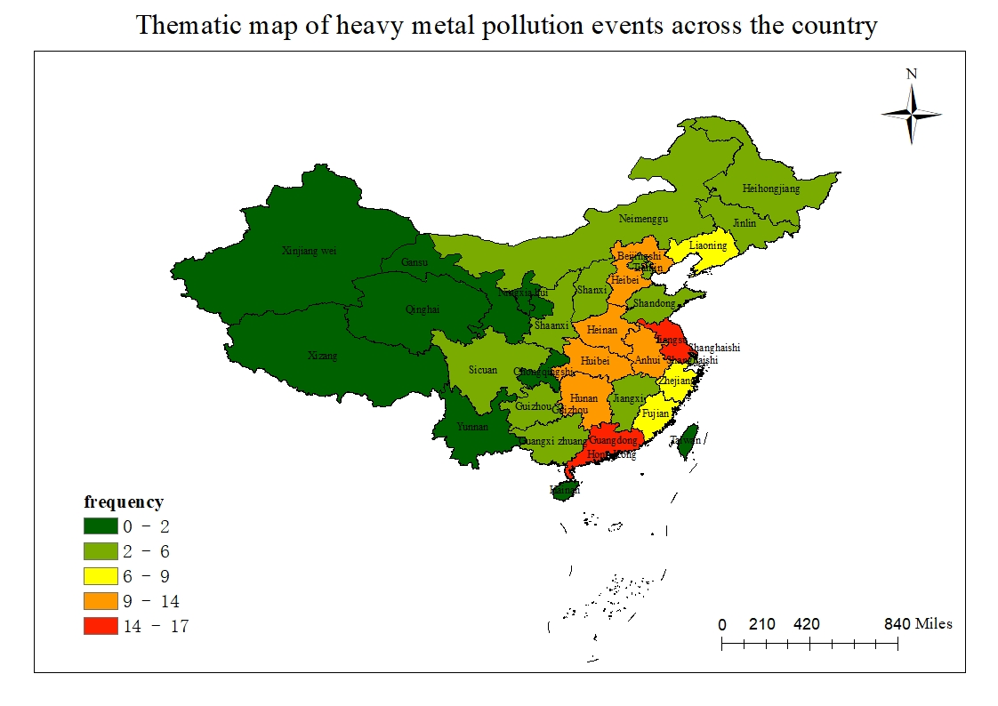
Figure 1 Thematic map of heavy pollution events across the country

2. Current situation of farmland soil pollution in China
By downloading relevant literature on non-point source heavy metal pollution of farmland soils in cities across the country, we collected a total of 463 research data on heavy metal Cr, 521 research data on heavy metal Cd, 466 research data on Cu heavy metal, 568 research data on Pb heavy metal, 345 research data on Zn heavy metal, 409 chemical elements Data on As, 368 data on heavy metals, and 226 data on heavy metals Ni. After that, we extracted data on heavy metal contamination,and find the geographic location of the pollution point. Then,using the mapping software, the collected data of national soil heavy metal pollution was subjected to kriging difference, and the spatial distribution map of national soil heavy metal pollution index was made based on the difference result. From the statistics in Table 2, we can learn that the content of Cr in the soil ranges from 4.30 mg/kg to 349.7mg / kg, with an average value of 63.41 mg/kg and a median value of 58.49 mg/kg; the content of heavy metal Cd in the soil ranges from 0.0013 mg/kg to 31.10 mg/kg, with an average value of 0.96 mg/kg and a median value of 58.49 mg/kg; the content of Cu in the soil ranges from 0.35 mg/kg to 620.49 mg/kg, with an average value of 47.19 mg/kg, median value is 26.90 mg/kg; soil heavy metal Pb content ranges from 1.70 mg/kg to 360.40 mg/kg, with an average of 47.12 mg/kg and a median of 32.70 mg/kg; soil heavy metals The content of Zn ranges from 3.2 mg/kg to 988.08 mg/kg, with an average value of 111.00 mg/kg and a median value of 85.10 mg/kg. The content of soil heavy metal As ranges from 0.05 mg/kg to 132.60 mg/kg, average value is 12.04 mg/kg, median value is 9.53 mg/kg; soil heavy metal Hg content range is 0.006 mg/kg to 15.61 mg/kg, average value is 0.24mg / kg The median value is 0.09 mg / kg; the content of Ni in the soil ranges from 4.3 mg/kg to 361.00 mg/kg, with an average value of 34.23 mg/kg and a median value of 2.81 mg/kg. According to the soil collected in the literature, the measured pH value is between 6.5 and 7.5. According to the Soil Environmental Quality Standard of the Environmental Protection Law of the People's Republic of China, the exceeding standard rate of Cr is 0.22%, the exceeding standard rate of Cd is 39.35%, The exceeding rate is 6.87%, the exceeding rate of Pb is 1.41%, the exceeding rate of Zn is 6.12%, the exceeding rate of Hg is 4.89%, and the exceeding rate of Ni is 10.18%. According to the statistics in Table 1, the national heavy metal Cd pollution is the most serious, while the heavy metal Ni pollution status is the second, and the Cr pollution degree is the smallest.
Table 2 Statistics of heavy metal content in soil
metal element | Heavy metal content（mg/kg） |  |  |  | National secondary standard  PH(6.5~7.5) | Over-standard rate /%
 | average | Max | Min | Median
Cr | 63.41 | 349.70 | 4.30 | 58.49 | 300 | 0.22
Cd | 0.96 | 31.10 | 0.0013 | 0.22 | 0.3 | 39.35
Cu | 47.19 | 620.49 | 0.35 | 26.90 | 100 | 6.87
Pb | 47.12 | 360.40 | 1.70 | 32.7 | 300 | 1.41
Zn | 111.00 | 988.08 | 3.2 | 85.10 | 250 | 6.12
As | 12.04 | 132.60 | 0.05 | 9.53 | 25 | 6.13
Hg | 0.24 | 15.61 | 0.006 | 0.09 | 0.5 | 4.89
Ni | 34.23 | 361.00 | 4.3 | 28.1 | 50 | 10.18

2.1 Current situation of heavy metal pollution

Figure 2 shows the spatial distribution of soil heavy metals in China. As shown in Figure 2 (a), the country's heavy metal Cd is relatively high, and high-value areas appear in the southern and central and western regions, especially in Tibet, Hunan and Guangxi provinces. In nature, Cd exists in a compounded state. Cd often coexists with Pb and Zn. Therefore, comparing with Figure 2 (e) and Figure 2 (h), we find that heavy matal Pb and Zn are higher in places where the content of Cd is higher. The levels of Cd in the regions with high levels of industrialization such as Jiangsu, Zhejiang, Shanghai, and Guangdong are also higher, while the heavy metals in soils are lower in Heilongjiang, central Inner Mongolia and eastern Guizhou. It can be seen from Figure 2 (b) that the heavy metal Cr in soils is relatively large in Gansu, Hebei, Shanghai and surrounding areas, and Guangdong. Metal Cr is used for auto parts and stainless steel. A large number of domestic automobile manufacturers are concentrated in the Beijing-Tianjin-Hebei region, Shanghai, and Guangdong. Although Xinjiang, Tibet, and central Inner Mongolia have most of the national Cr mines, Due to the harsh climate and geographical environment, the difficulty of mining is increasing, so the content of Cr in the soil is still small, and the rest of the Hg distribution is relatively Cr and the change is not obvious. It can be seen from Figure 2 (c) that there are many high-content areas of soil heavy metal Hg in different parts of the country. The areas with high levels of concentration are concentrated in eastern Inner Mongolia and western Heilongjiang, the border area of Qinghai and Tibet, and areas around Guizhou. The soil Hg content in the remaining areas is low and the changes in these areas are not very obvious. As shown in Figure 2 (d), compared with other heavy metals, the content of Ni in soils in the country is low, and only a small part of the region has high values, and the content is higher in Gansu and western Inner Mongolia. The main reason is that the country contains less Ni ore and can not meet the demands. The amount of Ni ore stored in Gansu Province is 61.9% of the country's, and Gansu Province contains the country's largest Ni ore, the second largest in the world. It can be seen from Figure 2 (e) that high-value areas have appeared in Guangdong Province, at the junction of Guizhou Province in Yunnan Province and Guangxi Province, and in Shaanxi Province. Higher values have appeared in many regions of the country, indicating that pollution sources have appeared in these places. The physical and chemical properties of Pb are excellent, so the amount of Pb in the country is huge. Large-scale Pb smelting and processing producing areas have been formed in the northeast, Guangdong, Guangxi, Sichuan, Yunnan, and the northwest of China. As shown in Figure 2 (f), the content of As is relatively high in Yunnan and Gansu regions, and low values of As in soils occur in other places, especially in central Inner Mongolia and northwestern Xinjiang. The rest is more evenly distributed. Although As is a non-metallic substance, its toxicity is similar to that of heavy metals. The main sources of soil As pollution are pesticides, herbicides, pesticides and their conductive circuit boards. Figure 2 (g) shows that there are large areas of high Cu content in soils throughout the country, mainly in the western regions, and high values appear at the junction of Yunnan, Sichuan and Guizhou, Hainan and Anhui while the content of Cu in the soil of Heilongjiang Province was the lowest. The spatial distributions of Cu and Zn have some similarities. Figure 2 (h) shows that the heavy metal Zn appeared high vlue at the junction of Hebei, Liaoning and Inner Mongolia, and at the junction of Guangxi, Hunan and Guangdong. However, the overall situation is less from west to east, and the content of heavy metal Zn is low in Jiangsu, Zhejiang and Shanghai regions and Heilongjiang province. On the whole, regions with higher levels of industrialization have higher levels of pollution, such as Jiangsu, Zhejiang, Shanghai and Guangdong, where the content of various heavy metals is relatively high. In the early stage of development, a large number of paper mills, printing plants and chemical plants were established. These factories will produce a large amount of heavy metal-containing wastewater and waste gas, which will cause soil pollution. Jiangsu, Zhejiang, Shanghai, and Guangdong regions were the earliest places of development. In addition, taking Gansu as an example, containing a large amount of heavier metal ores, has led to a higher content of various heavy metals in the soil in Gansu Province.
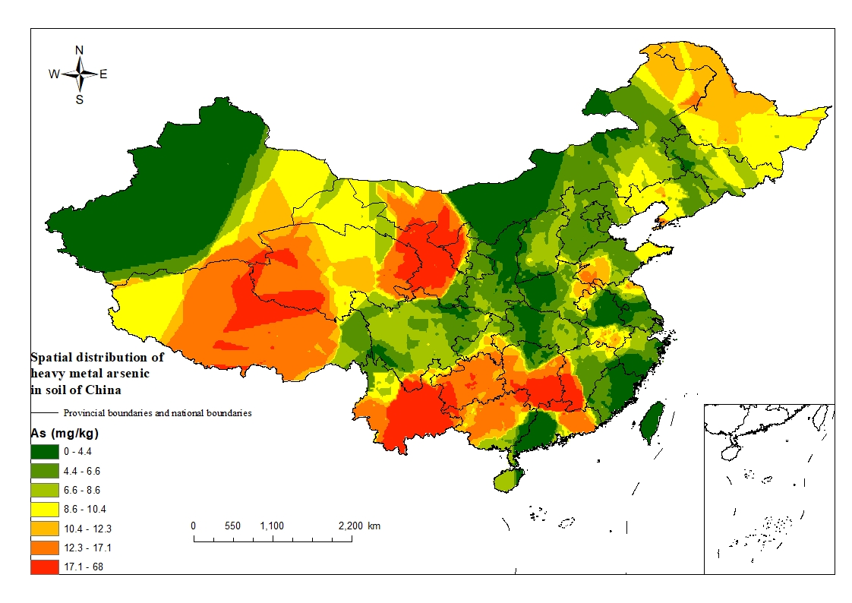
(a)Spatial distribution of heavy metal As in soil of China
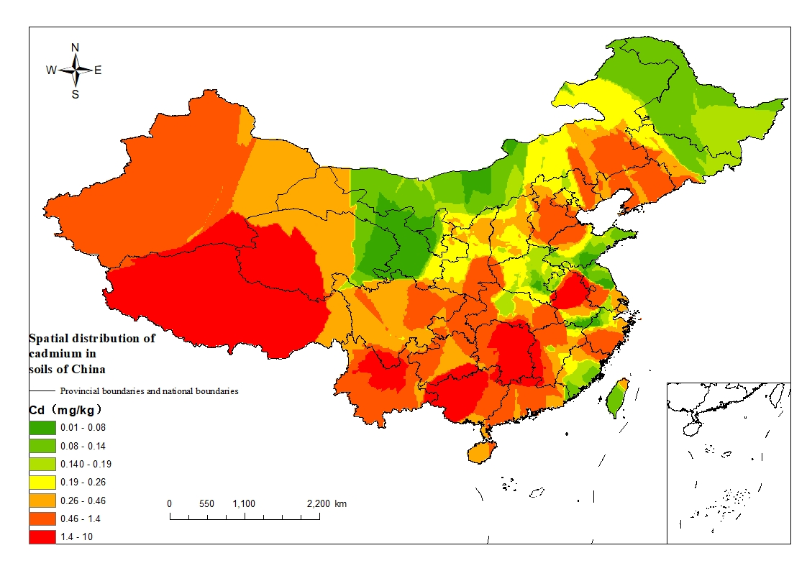
(b)Spatial distribution of heavy metal Cd in soil of China
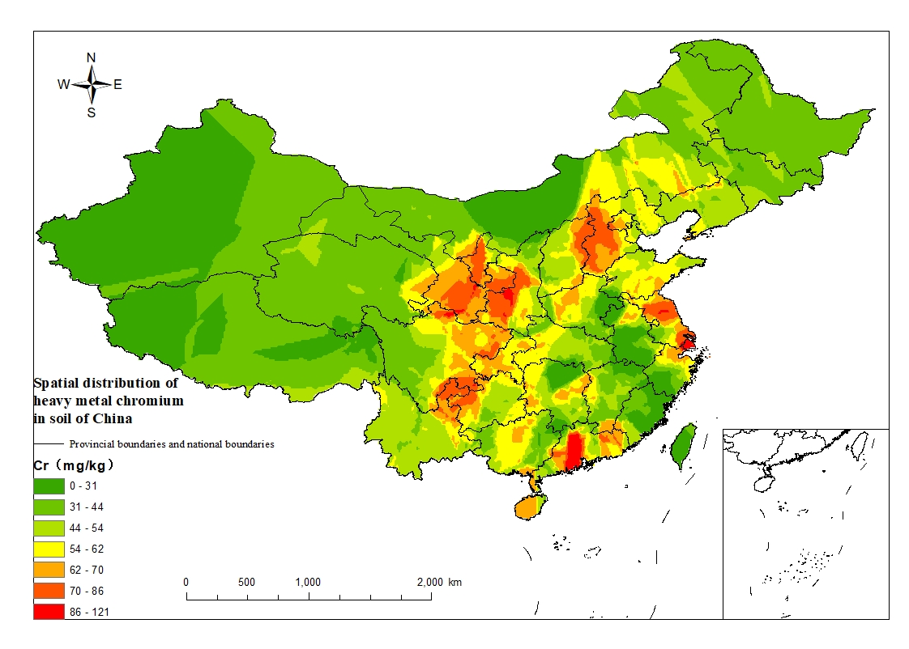
(c)Spatial distribution of heavy metal Cr in soil of China
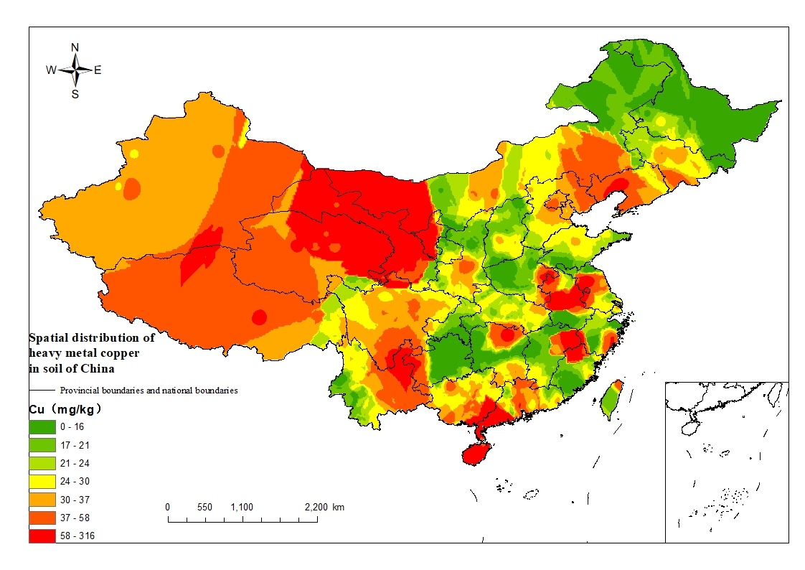
(d)Spatial distribution of heavy metal Cu in soil of China

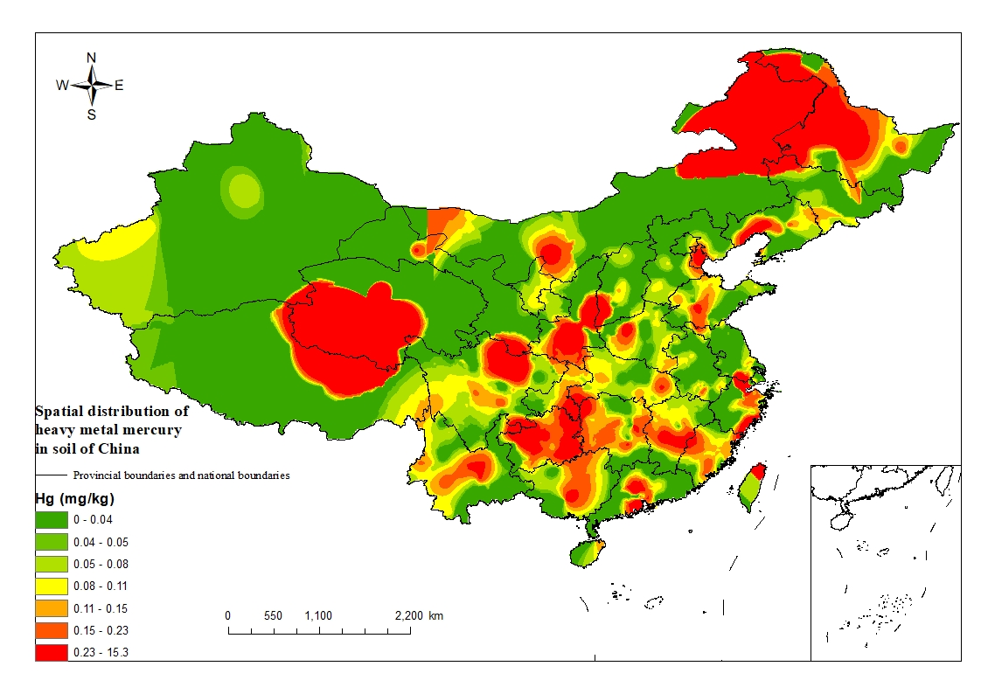
(e)Spatial distribution of heavy metal Hg in soil of China
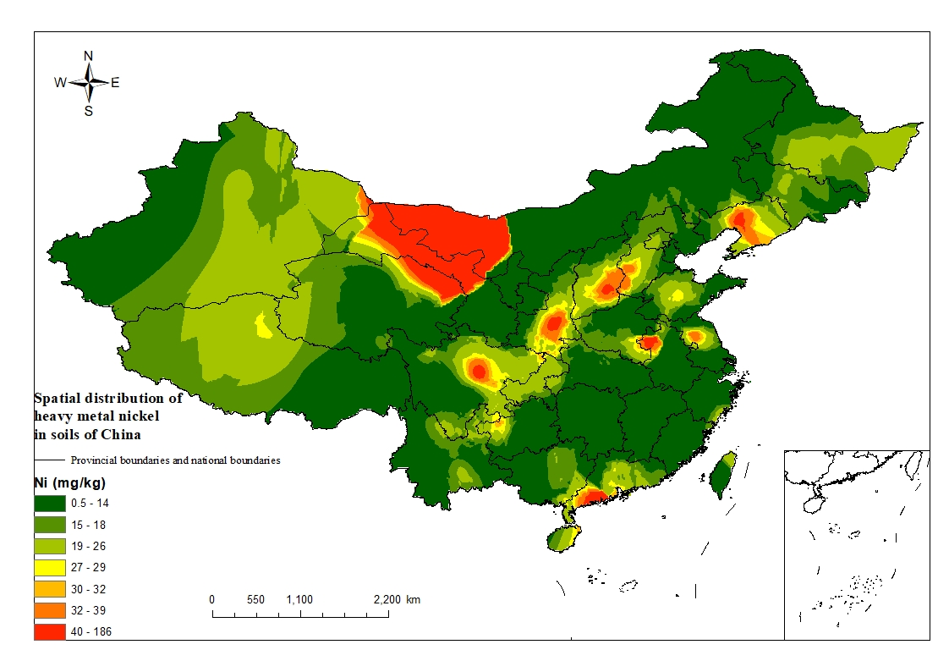
(f)Spatial distribution of heavy metal Ni in soil of China
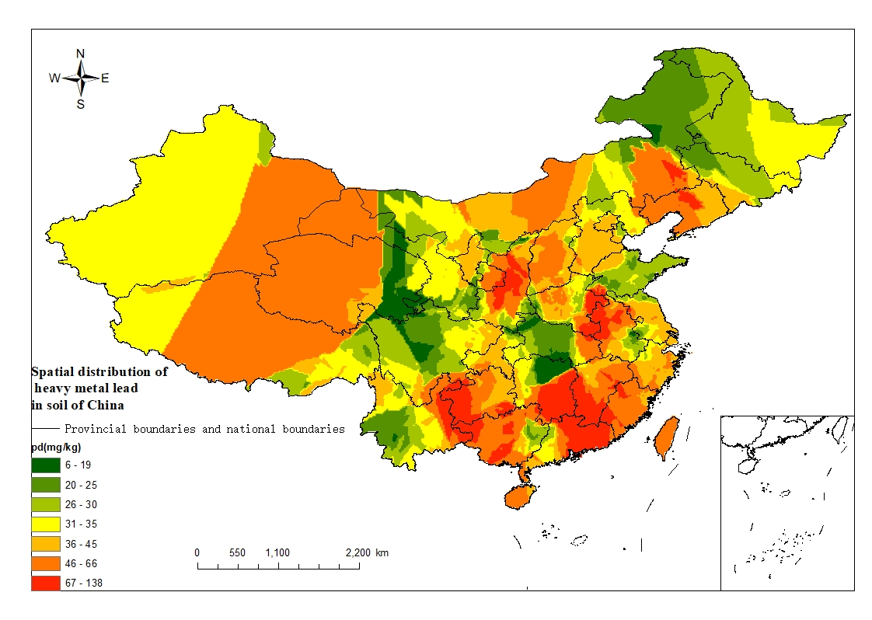
(g)Spatial distribution of heavy metal Pb in soil of China
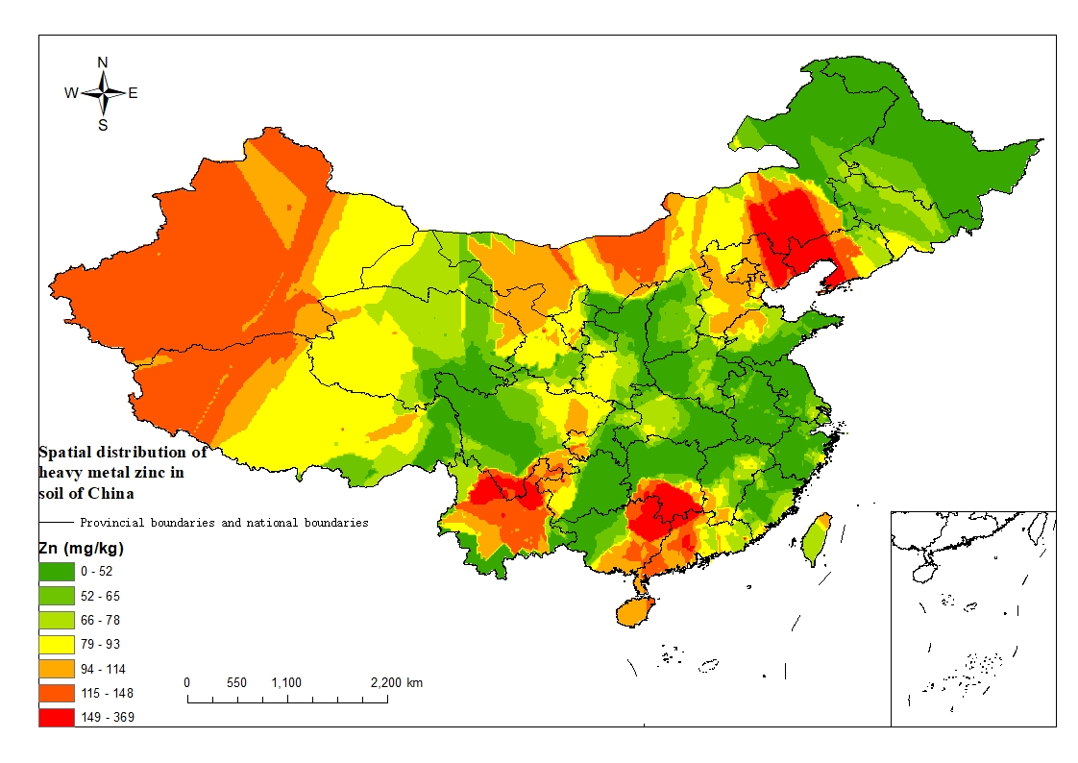
(h)Spatial distribution of heavy metal Zn in soil of China
Figure 2 Distribution of eight kinds of soil pollution in China

2.2 Distribution space of various heavy metal pollution

According to statistical data, we analyzed the distribution law. The red ones are the pollution points and the size of the pollution points also changes. As shown in Figure 3 (a), it is known that the content of metal Cd in soils exceeds the standard rate. According to statistics, the point of the metal Cd exceeding the standard is up to 39.35%, and the pollution points are widely and densely distributed. Among them, Guizhou and Hunan are the hardest hit areas in the news. In nature, Cd is often present at the same time as Pb and Zn. Therefore, the main causes of excessive Cd pollution in Yunnan, Guangdong, Guangxi (Hechi and Laibin), Hunan (Hengyang, Yiyang and Huaihua), Sichuan and Jiangxi are mainly due to the availability of a large amount of Pb-Zn ore resources in these areas. There are a large number of chemical plants, electroplating plants, and electronics industries in Jiangsu, Zhejiang, Shanghai, and Anhui. These plants are major sources of pollution for Cd. The source of pollution in North China is that there is a large amount of farmland in the area around the plant and the mine. Figure 3 (b) is the analysis result of Cr metal. According to the soil environmental standard value of "Environmental Protection of the People's Republic of China", the heavy metal Cr content in the soil exceeds 300 mg/kg. From the data point of view, only one point located in Guangdong Province exceeded the standard value, and the point exceeding standard rate was 0.22%. This shows that the pollution status of heavy metal Cr in soils is low and the possibility of heavy metal Cr harming the human body is very low. Figure 3 (c) shows the analysis results of Hg. The pollution of heavy metal Hg is relatively scattered. Only in Shaanxi, Henan, and Zhejiang provinces have concentrated pollution points. The main sources of Hg pollution are Hg vapor emitted from fuel combustion and garbage combustion. There are also excessive use of pesticides, etc. In general, the pollution status and degree of Hg are relatively light, and the rate of exceeding the standard point is 4.89%. Figure 3 (d) is the analysis of Ni metal. Ni pollution is mainly concentrated in Guangdong ,Anhui and Jiangsu provinces. According to statistics, the point exceeding rate of Ni is 10.18%. Among all the points, Jinchang, Gansu and Yangjiang, Guangdong are the most polluted. The content of Jinchang in Gansu exceeds 7 times the maximum value. The pollution in Anhui and Jiangsu is due to the collection around the factory. Figure 3 (e) is the analysis result of Pb. The pollution points of Pb are scattered and there are fewer pollution points. Liupanshui, Guizhou, Qinghai Haixi Mongolia Autonomous Region, Tongchuan, Shaanxi, Liaoning Jinzhou, Luzhou, Anhui, and Hengyang, Hunan are the hardest hit areas . Figure 3 (f) is the analysis chart of As results. According to the distribution map, As pollution sites are concentrated, and most of the pollution is in Yunnan, Guangxi and Hunan provinces. Among them, Liuzhou City in Guangxi and Guigang City, and Luzhou City in Hunan Province are the most polluted cities. Moreover, the largest As content in Luzhou soil is five times the standard, and Hunan has many As mineral resources. Figure 3 (g) is the analysis result of Cu. The pollution points of Cu are widely distributed, starting from Tibet in the west, to Liaoning Province in the east, Inner Mongolia in the north, and the coastal boundary of Guangdong in the south. There are relatively concentrated pollution sources in Pingliang City, Gansu. The highest pollution value is more than 6 times the standard. Among all the collected points, Luzhou City, Anhui Province has the highest soil content. Figure 3 (h) is the analysis result of Zn. The pollution of Zn is mainly concentrated in Yunnan, Guizhou, Guangdong and Liaoning. Among them, the highest point of Zn pollution in the country appeared in Yongzhou City, Hunan Province, because Hunan Province has the country's higher Zn ore resources. Almost all Zn ore and Pb ore are mixed together, so at the point where the soil Pb exceeds the standard, a large part of the coincidence rate is also exceeded.
According to the analysis of the spatial distribution of eight heavy metals, it can be found that the most serious pollution of soil in China is Cd, and the pollution range is wide, and the lightest pollution degree is metal Cr. The places where all kinds of heavy metal pollution are serious are Hunan and Gansu. These two provinces have more metal mines in the country. In Jiangsu, Zhejiang, Shanghai, and Guangdong, the degree of industrialization is relatively high compared to other places, so the soil is heavily polluted by heavy metals. According to the spatial distribution of data points, the total number of points collected in the east is much larger than that in the west. This is because China's universities are concentrated in the eastern coastal areas.
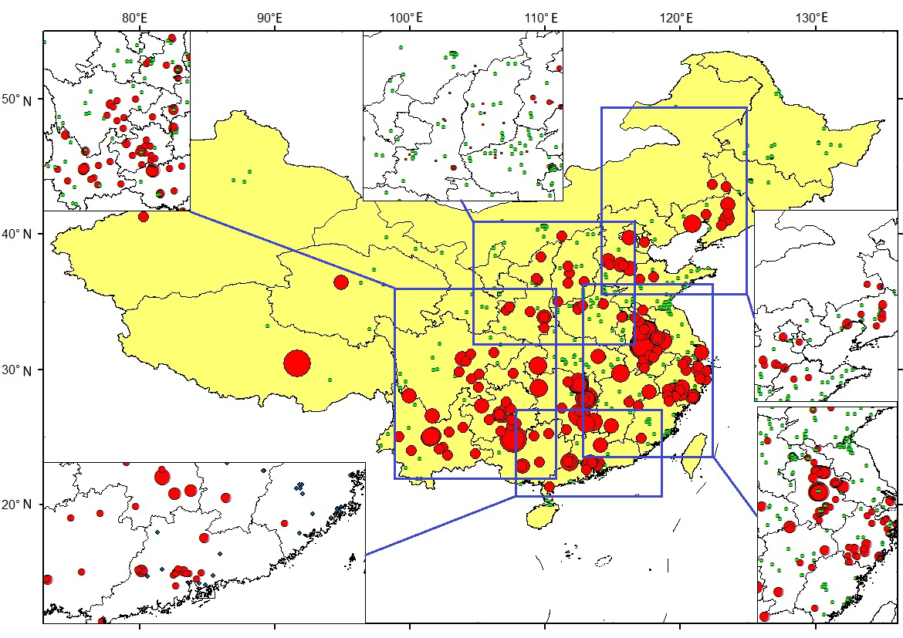
（a）Analysis of spatial distribution of Cd
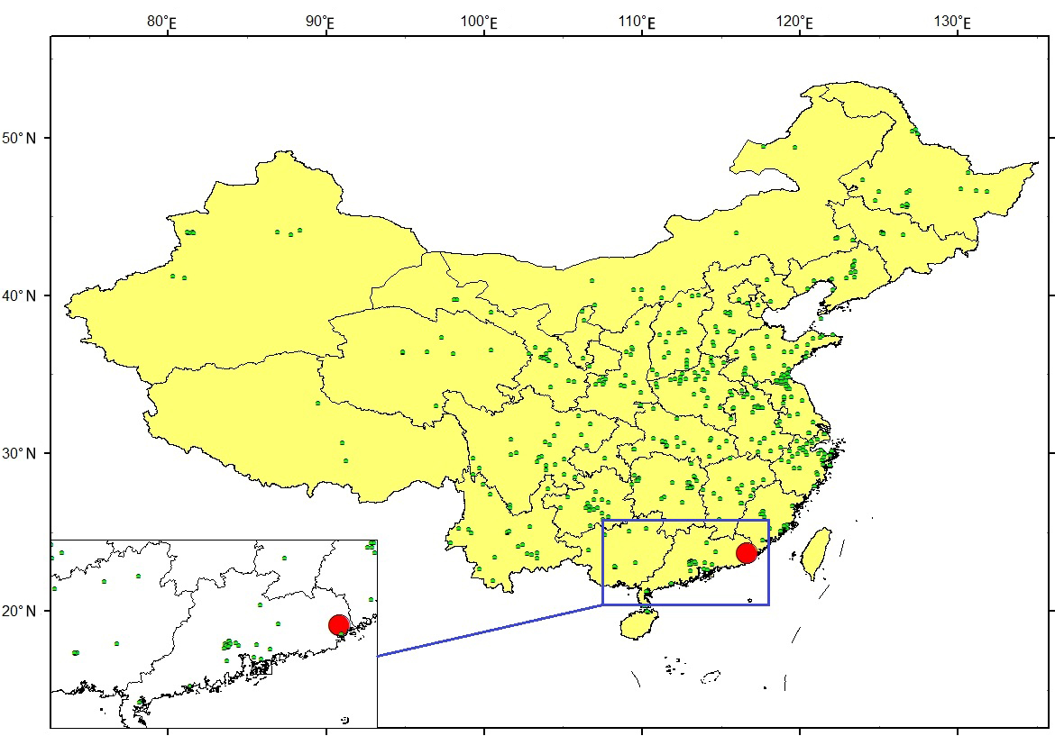
(b)Analysis of Cr Spatial Distribution
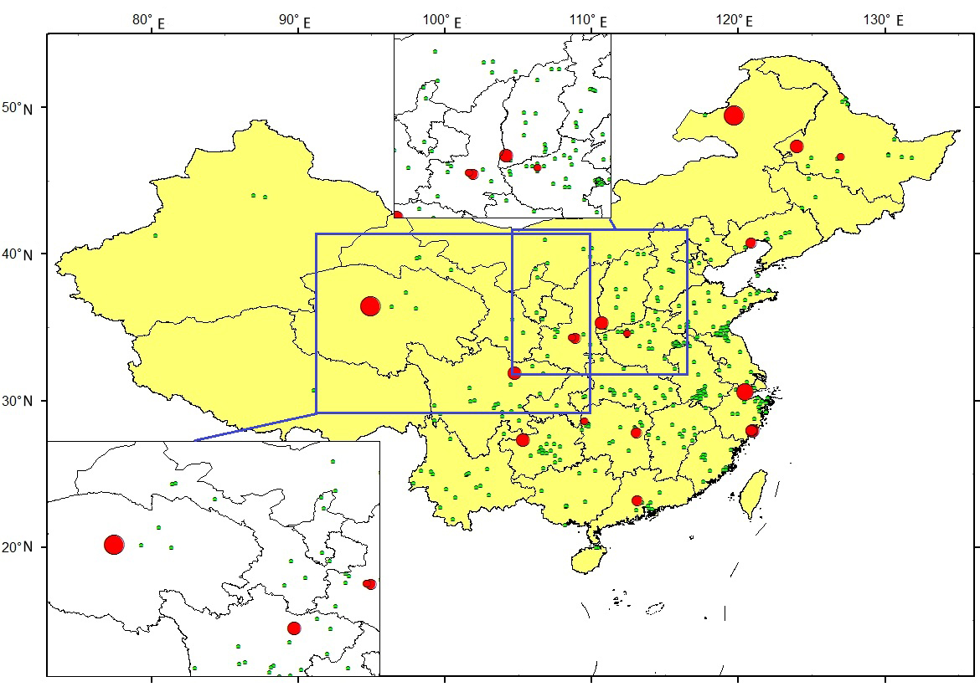
(c)Analysis of Hg spatial distribution results

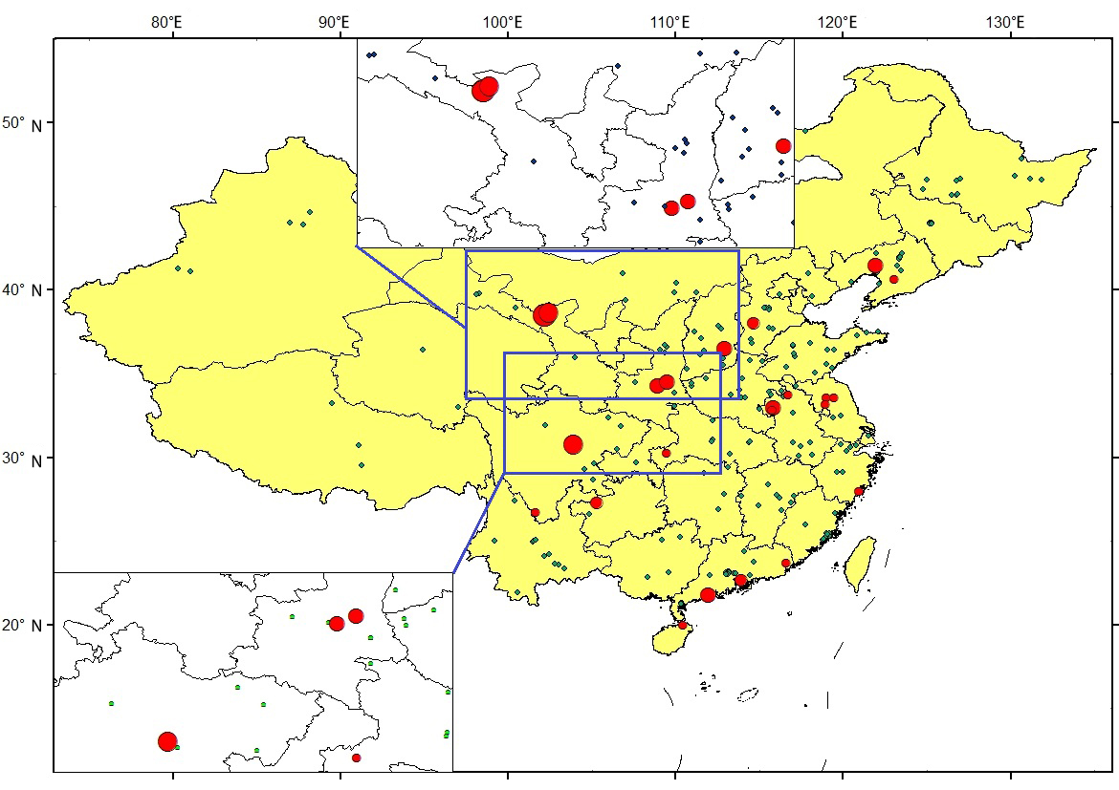
(d) Analysis of Ni spatial distribution results
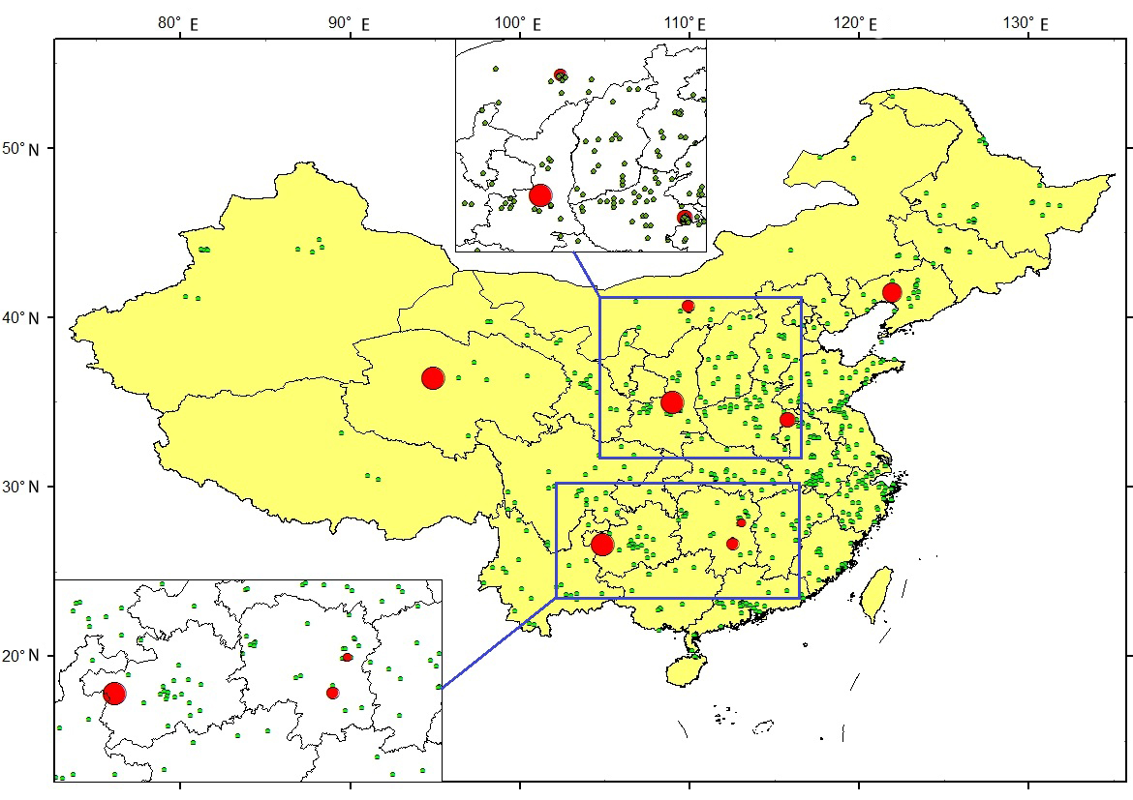
(e)Analysis of Pb spatial distribution
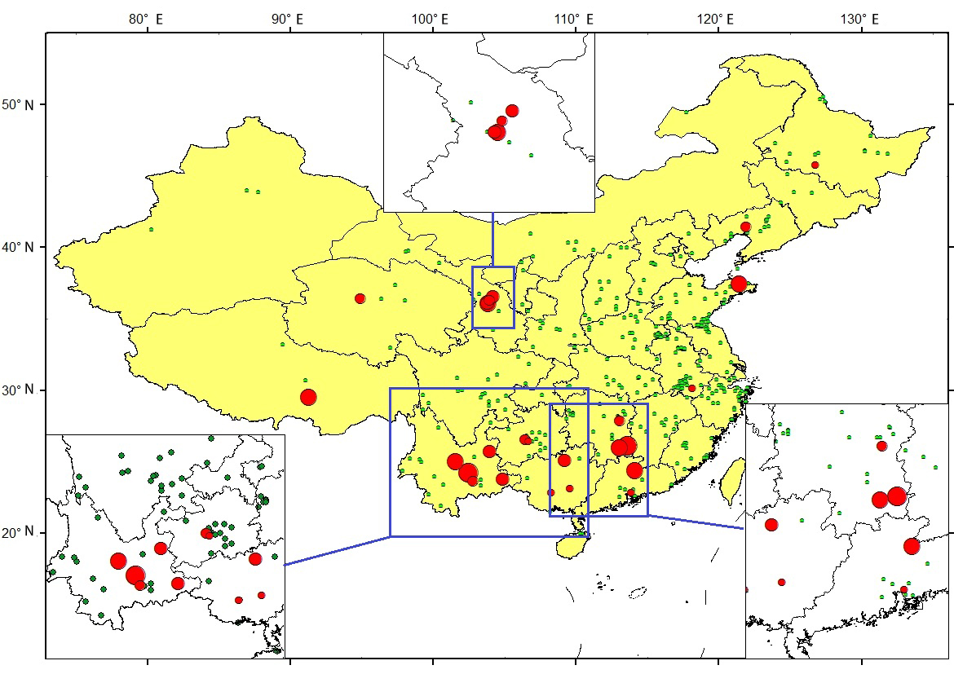
(f)Analysis of As Spatial Distribution Results

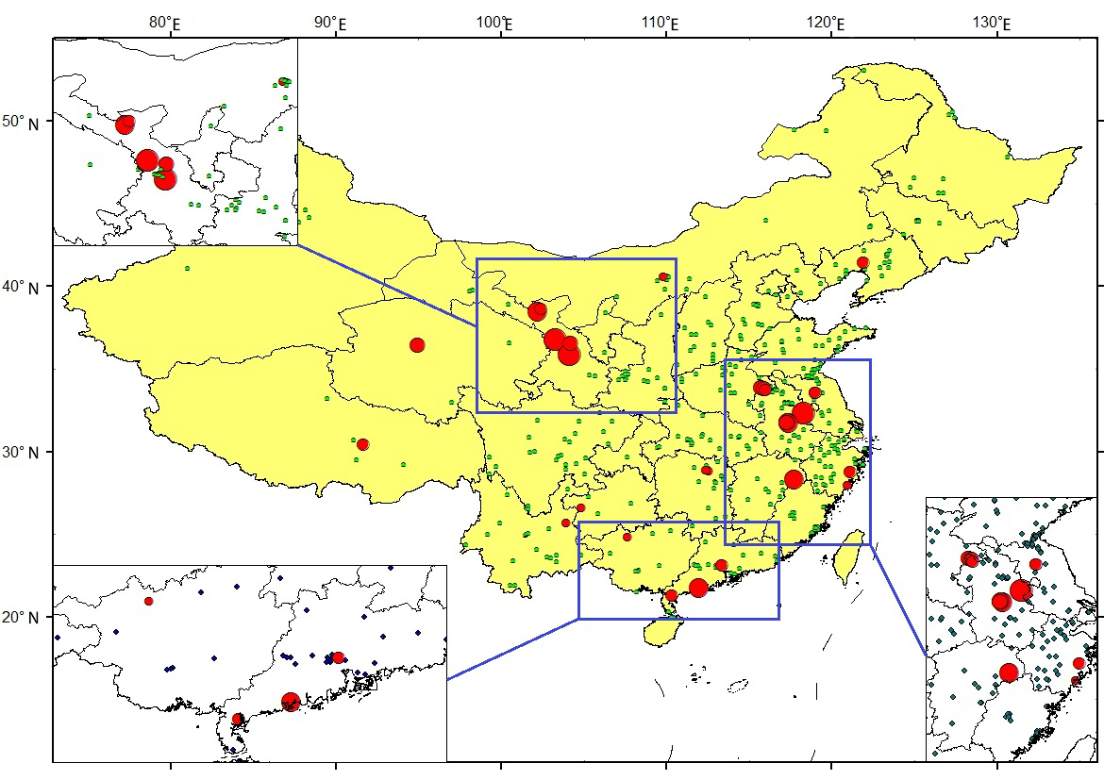
(g)Analysis of results of Cu spatial distribution
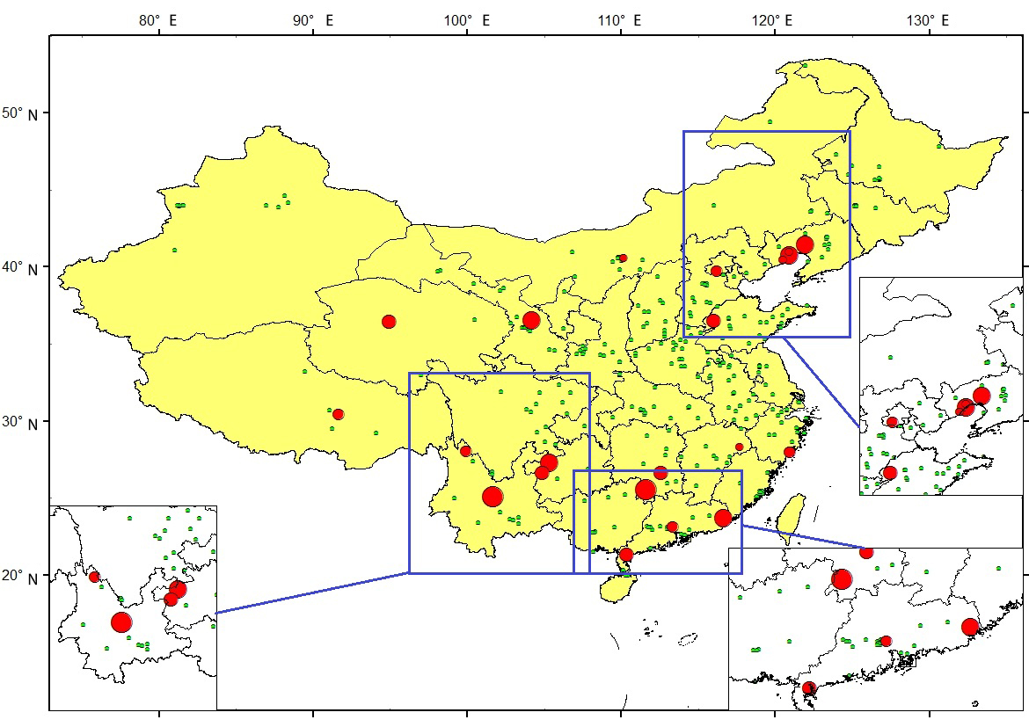
(h)Analysis of Zn spatial distribution
Figure 3 Spatial Analysis Results of Eight Heavy Metals Pollution

3. Factors and mechanism of heavy metal pollution in crops

3.1 Analysis and selection of absorption and accumulation factors of heavy metal pollution in crops

Heavy metal element content in crops greatly depends on the nature of the crop and the crop species, but also depends on the crop growth environment, including soil physical and chemical characteristics (heavy metal content in soil, soil PH, Eh, CEC and its chemical form, texture, organic matter, etc.) and climate factors (temperature, light, etc.). The physical and chemical properties of soil affect the bioavailability of heavy metals, thus affecting the accumulation and distribution of heavy metals in crops. Climate factors affect the accumulation of heavy metals in crops by affecting transpiration.

3.1.1 Soil factors that affect the absorption of heavy metals by crops
Soil provides a place for crops to grow. The physical and chemical properties of soil will inevitably affect the absorption of heavy metals by crops. Due to the difference of soil environment, the content of the same element in the same crop may be significantly different in different areas. A large number of studies have shown that soil organic matter content, Eh value, PH value, total content of heavy metals in soil and soluble content of heavy metals will affect the content of heavy metals in crops【7-8】. The change of soil PH value will affect the activity of heavy metal elements and the solubility of compounds in the soil, thus affecting the absorption and accumulation of heavy metals by crops[1]. In the acidic environment, the activity of most heavy metal elements increases, and the absorption capacity of crops to heavy metals also increases. When the PH value decreases, it is favorable for the reaction to go to the left. From the perspective of the mechanism of obligate adsorption, the dissolution of heavy metal ions is always accompanied by the increase of hydrogen ions, so the decrease of PH value will facilitate the transfer of heavy metals from adsorption to solubility. A large number of studies have shown that soil PH value has a significant negative correlation with the mobility and bioavailability of heavy metals[9-11], which significantly affects the morphological changes, migration and effectiveness of heavy metals in soil. The bioavailability of heavy metals in soil is largely determined by soil PH and organic matter content[12].
The PH value of soil has the greatest effect on bioavailability, followed by soil organic matter content. Organic matter mainly through various forms of heavy metals affecting the biological availability of heavy metals. The main component of soil organic matter is humus, which has strong complexation or adsorption to heavy metals. However, humus contains soluble organic matter (such as fulvic acid) and insoluble organic matter (such as humic acid).The effects of organic matter with different properties on the morphological transformation of heavy metals were different. At the same time, the effect of soil organic matter on the morphology of heavy metals is also affected by soil PH value. When the PH value is high, due to the low concentration of heavy metals in the solution, the increase of organic matters promotes the dissolution of heavy metals; However, when the PH value is low, the adsorption of humus to heavy metal ions is increased due to the high concentration of heavy metals in the solution, thus reducing the concentration of heavy metals in the soil solution[13]. In addition, the effects of organic matter on different heavy metals also vary[14-17]. In summary, the effect of organic matter on heavy metals depends on the heavy metal atoms themselves and the soil PH value.
Soil REDOX potential (Eh) has a significant impact on the activity of variable-value heavy metal elements, such As Cu, As, Cr, and so on, thus affecting the absorption of crops. In the reduction environment, that is, when the Eh value is low, the activity of most low-priced elements is improved and the absorption capacity of crops is enhanced. In the oxidizing environment, that is, when the Eh value is high, the activity of high-value elements decreases, and the absorption capacity of crops decreases accordingly. However, some elements (such As As and Cr, etc.) are easy to generate complex anions when Eh value is high, which, on the contrary, makes them more active, thus enhancing the ability of crops to absorb heavy metals[18].
The richness of heavy metal content carried by different soil texture is different. Generally, fine soil (such as clay and loam) has a strong ability of absorbing heavy metal, and its heavy metal content is often several times higher than the corresponding heavy metal content in sandy soil. The heavy metal content in sandy soil is low, and the heavy metal element in sandy soil is easy to leach out, so the heavy metal element content in crops is generally low. Because clays and loam are rich in heavy metal elements, the crops growing on them generally do not lack of heavy metal elements and even lead to excessive heavy metal content in crops. For peat soils, heavy metals are often immobilized by organic matter and are difficult to be absorbed by crops. Generally speaking, the heavy metal element content in soil is higher, and the chances of heavy metal element entering crops are more, and the crops growing in some polluted soil are more obvious. However, there is no obvious correlation between the content of heavy metal elements in crops and the content of elements in soil, because heavy metal elements exist in the soil in various forms such as residual state, organic binding state, precipitation state, exchange state and water soluble state, while the exchange state and water soluble state are the main forms that can be absorbed by crops. Many studies have shown that the amount of heavy metals absorbed and accumulated by crops mainly depends on the available content in the soil rather than the total amount[19-20].

3.1.2 Climatic factors that affect the absorption of heavy metals by crops
Climatic conditions affect the metabolism and transpiration of crops, which in turn affect the absorption and transport of heavy metal ions by crops. Therefore, the content of heavy metals in the same crops is different under different climatic conditions[21]. Little research has been done on how climate factors affect crop uptake of heavy metals. Pan[7] studied the correlation between Pb and Cd content in flue-cured tobacco in southern and northern China and five climate factors, including sunshine duration, average daily relative humidity, average daily temperature, average daily ground temperature of 10cm and rainfall. The results showed that sunshine duration and precipitation were strongly correlated with Pb content in flue-cured tobacco, while sunshine duration, daily relative humidity and daily air temperature were strongly correlated with Cd content in flue-cured tobacco. Jung[22] found that temperature was an important factor affecting the ability of rice to absorb heavy metals. Climate could affect the growth, development and material absorption of crops, thus affecting the absorption of heavy metals in crops.
According to the influence of climate on the growth and development of crops, the climatic factors affecting the absorption of heavy metal elements in crops may mainly include the following aspects: temperature, sunshine hours, precipitation and humidity. Temperature and sunshine are very important factors in the process of crop growth. They affect the photoform, photoperiod, transpiration and enzyme activity of crops. Too high temperature may affect crops under high temperature stress, obstruct photosynthesis or even interrupt photosynthesis. In addition, too high temperature may lead to accelerated evaporation and improved water utilization rate, which may lead to water stress of crops. All these will affect or terminate the normal growth process of crops and thus indirectly hinder the absorption of heavy metals by crops. Low temperature and insufficient light make it difficult to stimulate the enzyme activity in crops, which will also affect the normal growth of crops and hinder the absorption of heavy metals. The absorption of heavy metals is facilitated only when the temperature and sunshine are maintained throughout the growth cycle. According to Xia Zenglu[23], the heavy metal concentration in early rice was generally much higher than that in late rice due to the influence of climate. This is because the temperature of early rice (in July) during the panicle formation period was higher than that of late rice (in October), and the higher temperature led to the enhanced transpiration rate of crops, which was conducive to the formation of complexes of heavy metals and small molecular organic matter, which were transported up in large quantities with transpiration flow and accumulated in stems, leaves and seeds. Humidity includes relative humidity and absolute humidity. Relative humidity in the air affects transpiration. If the relative humidity is too high, the transpiration will slow down, thus affecting the transfer of heavy metals from the roots of crops to stems and leaves. The effects of precipitation on dry and aquatic crops vary. Some studies have shown that average relative humidity and average precipitation have a great influence on the accumulation and transportation of dry matter in the reproductive growth period of maize. If water is sufficient and air relative humidity is appropriate, this kind of environmental condition can promote the growth of crop stalk obviously[24]. Crops can only grow properly if they have the right amount of water to absorb heavy metals.

3.2 Other factors that affect the absorption of heavy metals by crops

The difference of crop types directly determines the difference of heavy metal absorption capacity. The ability to absorb and enrich different heavy metal elements in the same crop is different, and the ability to absorb and enrich the same heavy metal elements in different crops is also different. Many international studies have been conducted on the difference of heavy metal absorption and accumulation in different crops since 1980s. The results showed that there was a significant difference in the content of heavy metal elements in soil due to the selective absorption of heavy metal elements by different crop types. Wang's research[25] showed that Cd content in wheat, rice, soybean and corn grains varied in fields contaminated with Cd. Zhang's study[26] showed that the Cd content in grains in the long-term sewage irrigation area was from rice to maize to tomato. Under the same soil Cd content, Guo[27] studied the absorption and accumulation of Cd in kidney beans and maize under the same environment. The selective absorption of heavy metal elements in soil by different varieties of the same crop type (within species) is also significantly different[28]. Huang[29] analyzed 6 different rice gene types contaminated by Cu and Cd, and found that Cu and Cd contents in rice were different. The accumulation of Cd, Cu, Pb and Zn in vegetables such as carrots and peas was also significantly different in the same soil contaminated by heavy metals[30].
According to Li[31], there were significant differences in the ability to absorb and accumulate heavy metals between rice genotypes, and the contents of heavy metals in rice plants and grains of different genotypes were several times different. The bioavailability of heavy metals varies in different growing periods of crops. Many experiments showed that the accumulation of heavy metal in rice root was very low in rice seedling stage and maximum in tillering stage. With the advance of time, the accumulation of heavy metals in the root was less and less, and the accumulation of heavy metals in the stem was also very low in the rice seedling stage, maximum at tillering stage, minimum at jointing stage, and then gradually increased[32]. Through a lot of experimental data, Liu[33] also obtained the research results consistent with previous studies, the heavy metal concentration in rice leaves was very low at seedling stage, while the heavy metal concentration in tillering stage increased rapidly and reached the maximum, and the accumulated heavy metal concentration in leaves at subsequent tillering stage, jointing stage, flowering stage and mature stage gradually decreased. This kind of change rule could be considered as a reason that rice grows vigorously at tillering stage, the absorption function was strengthened, making the leaves absorb the heavy metals transmitted from soil and roots rapidly. During the jointing stage, the tolerance and metabolic mechanism of heavy metals in rice leaves were strengthened, so that the absorption and accumulation of heavy metals significantly reduced. In the following period from flowering to maturity, heavy metals were constantly metabolized in rice leaves, so that the heavy metals absorbed and accumulated in the leaves were gradually reduced. The analysis showed that tillering stage could be used as the best period for detecting heavy metal stress in rice.

4. Mechanism of heavy metal pollution in farmland
The heavy metals in rice seeds come mainly from soil[34-35], irrigation water[36], the atmosphere and agricultural machinery production. In a certain range, the content of heavy metals in rice seeds was positively correlated with the content of heavy metals in soil[37]. If the heavy metal content in soil is too high, it will affect the normal physiological function of rice root system and cause cell damage. Root system: The water content, fresh weight and volume of root decreased to different degrees; Overall situation: plant growth is poor, vegetation coverage is reduced, vegetation leaves are yellow, leaf pigment and chloroplast show vacuolating, leaf pigment synthase activity is inhibited, chlorophyll content is reduced; Crop response mechanism: ultrastructure and cell membrane are dissolved, DNA repair is inhibited, and cell structure is destroyed; Spectral response mechanism: blue shift or red shift occurs at the red edge, the red valley becomes shallower, the infrared reflectance plateau increases, the comprehensive remote sensing vegetation index changes, the absorption feature point shifts and the spectral anomalies occur. Laboratory experiments and spectral analysis show that plants have characteristic spectral responses to heavy metal stress.The concentration of heavy metals in vegetation was correlated with spectra. At present, the heavy metal elements that attract people's attention mainly include Cd, Hg, Pb, Zn, Cu, etc. Different crops have different tolerance degrees to the same heavy metal elements, and the influence degrees of different heavy metal elements on the same crop are also different. However, the effects of heavy metals on crops are all reflected in the changes of physiological and functional characteristics of crops. Different heavy metals may have slightly different effects on various physiological parameters, but their effects on crops in general are not different. It mainly results in the decrease of chlorophyll content, the dechlorination of leaves, the decrease of water and nutrient absorption by roots, the inhibition of root growth, the inhibition of photosynthesis, transpiration and other physiological functions, and even the withering and death in severe cases. The change of crop physiological parameters is the basis of monitoring heavy metal pollution stress by remote sensing technology,therefore, it should be firstly sorted out. The physiological changes of crops under heavy metal stress were analyzed from the two aspects of physiological factors and physiological functions. Most of the studies have mainly discussed the remote sensing monitoring methods of heavy metal stress from the perspective of physiological factors, but few have reported from the perspective of physiological functions.

4.1 Changes of crop physiological parameters under heavy metal stress
Crop pigments include fat-soluble pigments (chlorophyll, xanthophyll, carotene, safsafin and capsaicin) and water-soluble pigments (such as anthocyanins). Crop pigment is mainly divided into leaf pigment content and canopy pigment content, the latter is defined as the product of leaf pigment content and leaf area index. When crops are stressed by heavy metals, heavy metal atoms will replace Fe2+, Zn2+ and Mg2+ plasma in chloroplast proteins, resulting in changes in the composition of chlorophyll protein center ions and thus inactivation. The activity of enzymes needed for chlorophyll formation is also inhibited, so the chlorophyll formation process is blocked and the chlorophyll content is decreased, leading to chlorosis symptoms in crops[38-41].Studies have shown that heavy metal pollution not only has an effect on chlorophyll content, but also can cause changes in pigment ratio. At low concentrations, all the three heavy metal ions led to the increase of chlorophyll a/b, and chlorophyll a showed stronger tolerance than chlorophyll b. With the increase of heavy metal concentration, the value of a/b decreased gradually and the content of chlorophyll a decreased rapidly, which indicated that the destruction effect of heavy metal on chlorophyll a was greater than that of chlorophyll b, and the most important action center was some chlorophyll a molecules[42]. Cd stress can lead to the change of pigment content, which is closely related to the change of visible light reflectance[43].
Leaf area index (LAI), which can represent the growth of crops, is one of the most important parameters in ecosystem research and an important indicator of plant population growth. Heavy metal pollution may lead to some changes in crop morphology, such as withered and yellow leaf tips and curling of leaves, and reduced LAI. If the pollution is serious, it will lead to the decrease of fallen leaves, branches, necrotic patches or even death on the leaves, etc., and LAI will decline faster. Biomass refers to the total dry weight of living organic matter per unit area, usually expressed by kg/m2 or t/hm. Vegetation biomass directly reflects the growth status of vegetation. When LAI is inhibited, the nutrient growth of crops can not get enough photosynthetic products. Meanwhile, the toxicity of heavy metals will also affect the ability of all organs to accept and transform photosynthetic products, thus resulting in short growth of plants and reduce biomass, and then show a vicious cycle. High concentration of Pb stress treatment will result in weak root growth and reduced biomass.The results of the biomass test of impatiens balsamina under the stress of three different concentrations of Pb showed that the low concentration of Pb stimulated the growth of impatiens, while the high concentration inhibited the growth of impatiens, and the stimulation of the root was significantly higher than that of the stem. When the concentration of Pb in nutrient solution was greater than 1.0 mol/m3, the relative proportion of plant root biomass decreased to about 60%. When the concentration was as high as 10.0 mol/m3, the relative proportion of leaf biomass was close to 60%[23]. Under Pb stress, Pb tended to be distributed to aboveground biomass with the increase of Pb stress concentration. Pb stress would lead to the change of root and aboveground biomass concentration first increasing and then decreasing[23]. Chen[1844] found that biomass of rice seedlings in Pb-contaminated soil decreased with Pb concentration.
(3)The toxicity of heavy metals first affects the development of crop roots. Heavy metal elements in farmland soil can be absorbed by crop roots in the form of solid or liquid, and enter other organs such as stems and leaves with transpiration. Therefore, the content of heavy metals in the root system is often higher than that in aboveground stems, leaves, fruits and other organs, which are also most affected by the toxicity of heavy metals. The root system is the primary site of heavy metal contact. Under heavy metal stress, the root system usually presents as follows:root growth is inhibited, taproot can not elongate, root volume decreases, root water content decreases, root weight decreases, root hair decreases and even dies[14] [45-50]. At the same time, the stress of heavy metals will also hinder the absorption of water and nitrogen by the root system, weaken the metabolism of nitrogen, phosphorus and other nutrients, cause root discoloration, lead to plant growth retardation, and eventually cause death. The soil Pb pollution stress will affect the growth and development of plants, and some physiological changes, such as crop leaves wilting. Under the stress of Pb pollution, the growth ability of root system is usually inhibited, and the volume, fresh weight and water content of root system are also reduced. The roots of crops absorb Pb in the soil as a solid or liquid. With transpiration, the Pb absorbed by the roots also enters other organs. Therefore, the root system is also the most affected by Pb pollution, and the Pb content in the root system is often higher than that in leaves, fruits and other organs. The trend of Pb pollution in rice is gradually decreased from roots, stems, leaves, ears and grains. The average concentration of Pb in mature grains is only 1/1121 of the root, 1/180 of the stem, and 1/63 of the leaf. This result is consistent with the result of Kang and Wang[51-52]. The uptake capacity of Pb in soil by different plant organs varies greatl53-55]. Pb is transported to various organs and absorbed in the root of rice. The accumulation capacity of Pb in the former organ decreases after the accumulation of Pb in the organ. In roots, stems and leaves of plants, Pb binds to cell walls or is stored in vacuoles, leading to decreased tissue activity and poor mobility[56-58]. Roots, stems and leaves are transported and accumulated in a similar manner[59]. Therefore, Pb fixation in the first organ has a significant effect on the accumulation of Pb in the next organ.

4.2 Changes of Physiological function characteristic
As a stress factor, heavy metal ions can cause stress on various physiological processes and functions of crops and inhibit their growth. Photosynthesis is sensitive to heavy metal ions. Under heavy metal stress, photosynthesis of crops decreased, and the degree of decline was closely related to the species and concentration of heavy metals, and positively correlated with the degree of stress. Zhou[60] studied the photosynthetic changes of Koelreuteria paniculata and Elaeocarpus decipiens?Hemsl under different heavy metal pollution levels, and the results showed that the photosynthetic rate of Elaeocarpus decipiens?Hemsl under the treatment of four pollution levels increased successively was 73%, 83%, 72.7% and 57% respectively under the condition of no pollution, indicating that the photosynthetic rate was inhibited. Wang's study[61] on the effects of Pb and Cd stress on photosynthesis of herbaceous plants also reached a similar conclusion.
The influence of heavy metal ions on photosynthesis and photosynthetic rate is mainly through the following ways:①Chlorophyll content decreases. Chlorophyll is the material basis of crop photosynthesis, and its content directly affects the intensity of photosynthesis and the rate of material synthesis. When crops are stressed by heavy metals, the content of chlorophyll decreases, the structure of chloroplast membrane is damaged, the content of photosynthetic enzyme in chlorophyll decreases, and the intensity of photosynthesis decreases. ②The chloroplast structure is destroyed, and heavy metal ions can change the ultrastructure of the chloroplast, such as causing chloroplast expansion and deformation, chloroplast bilayer membrane fracture, granule thylakoid lamellar loose disintegration and membrane system damage. Chloroplasts are the photosynthetic organs of higher plants, and the destruction of chloroplast structure will inevitably affect photosynthesis. ③The electron transport activity of thylakoid membrane is inhibited. Photosynthetic electron transport activity, Hill reactive activity and photosystem II activity are severely inhibited when crops are subjected to heavy metal stress[62-65]. On the one hand, the decrease of photosynthetic intensity under heavy metal stress will lead to the decrease of photosynthetic products.On the other hand, the toxicity of heavy metal ions will hinder the transportation of photosynthetic products to various organs, and also affect the ability of various organs to convert photosynthetic products into dry matter, resulting in the slow accumulation and distribution rate of dry matter[14]. Dias[62] studied the changes of a series of physiological parameters, such as photosynthetic rate, transpiration rate and biomass, in 4 kinds of Cd concentrations(0, 1, 10, 50 M Cd(NO3)2) medium, and found that Cd stress could inhibit crop photosynthetic rate and reduce biomass. These two effects sometimes do not occur at the same time. When the concentration of Cd is low, photosynthesis is not affected, but the biomass will be reduced due to the influence of heavy metal ion toxicity when photosynthetic products are converted to dry matter. Therefore, one of the important effects of heavy metal stress on crops is to inhibit the efficiency of photosynthate conversion to dry matter. Sometimes dry matter conversion efficiency is affected before the photosynthetic rate changes.
Heavy metal pollution can affect the respiration of plants, which has been proved by many studies[66]. Ge[67] studied the effect of heavy metals in the medium of Cd2+, Cu2+ and Hg2+ at concentrations of 0.025, 0.05, 0.1, 0.5, 1.0 and 2.0 mmol/L on the respiration rate of rice by using indoor medium. It was found that the respiration rate of rice leaves increased first and then decreased with the increase of heavy metal concentration. This indicated that the heavy metal concentration at a low level could promote the respiration of rice leaves, but as the concentration increased further, the respiration would be inhibited. For the root system, the respiration rate of rice root continued to decrease with the increase of heavy metal concentration. In the experiments on the effects of heavy metals on respiration rate and related enzyme activities of rice leaves and roots, different concentrations of heavy metals Cu, Cd and Hg ions inhibited the enzyme activities to different degrees. Heavy metals inhibited respiration of rice leaves and roots by inhibiting the activity and functional expression of related enzymes.
The effects of heavy metal stress on crop transpiration are obvious. A small amount of heavy metal elements can stimulate cell expansion, reduce stomatal resistance and accelerate transpiration. However, when the concentration exceeds a certain limit, the stomatal resistance will increase obviously due to the decrease of the water potential of leaves, and even result in stomatal closure[68-69]. The transpiration rate will then decrease significantly[70-71]. The influence of heavy metals on transpiration of leaves of different crops is not only related to the concentration of heavy metals and the duration of stress, but also related to the tolerance of crops at different growth stages. Studies have shown that the temperature of the leaves or canopy of stressed vegetation is often higher than that of the leaves or canopy of healthy vegetation[72]. When crops are stressed by heavy metals, their root growth capacity is often inhibited, resulting in reducing root volume, root weight and root moisture content. Once the water supply of root system is insufficient, crop stomata will automatically close to reduce transpiration to maintain water content. At the same time, it will weaken water evaporation and cooling, reduce the heat consumption of leaf transpiration and increase sensible heat energy. In addition, some studies have shown that crop canopy temperature is closely related to photosynthetic performance. When photosynthetic performance is weak, canopy temperature is higher[73]. Therefore, canopy temperature can comprehensively reflect the changes of multiple physiological functions of crops under the stress of heavy metals.

Reference
- Chen, H.M.. Heavy Metal Pollution in Soil-Plant Systems, Science Press, Beijing, China, 1996,210-223.
- Zhao, H.R.; Xia, B.C.; Fan, C.; Zhao, P.; Shen, S.L.. Human health risk from soil heavy metal contamination under different land uses near Dabaoshan Mine, Southern China. Sci. Total. Envir. 2012,417-418,45-54.
- Moataz, K.; Ahmed, G.. Assessment of Heavy Metals Contamination in Agricultural Soil of Southwestern Nile Delta, Egypt. Soil & Sediment Contamination. 2018,27,619-642.
- Yu, H.; Ni, S.J.; He, Z.W..Analysis of the spatial relationship between heavy metals in soil and human activities based on landscape geochemical interpretation. J. Geochem. Explor. 2014,146,136-148.
- National survey bulletin on soil pollution, Ministry of environmental protection & Ministry of land and resources, China, 2014.
- Shang, E.; Xu, E.; Zhang, H.; Huang, C. Spatial-temporal trends and pollution source analysis for heavy metal contamination of cultivated soils in five major grain producing regions of China. Environ Sci. 2018,39,4670-4683.
- Pan, W.J.; Jiang, C.Y.; Tang, Y.J.. Lead and cadmium content in flue-cured tobacco and its relationship with environment. Soils. 2007,39,369-374.
- Cheng, J.M. The Effect of Soil Environment on the Content of Microelements in Crops. Guangdong Tr Elem Sci. 2015,12,12-15.
- Sukreeyapongse, O.; Holm, P. E.; Strobel, B. W.; Panichsakpatana, S; Magid, J; Hansen, H.C. pH-dependent release of cadmium, copper, and lead from natural and sludge-amended soils. J Environ Qual. 2002,31,1901-1909.
- Bang, J.; Hesterberg, D. Dissolution of trace element contaminants from two coastal plain soils as affected by pH. J Environ Qual. 2004,33,891-901.
- Laing,G.D.; Vanthuyne,D.R.J.; Vandecasteele, B.; F.M.G.Tack; M.G.Verloo. Influence of hydrological regime on pore water metal concentrations in a contaminated sediment-derived soil. Environ. Pollut. 2007,147,615-625.
- Crommentuijn, T.; Doornekamp, A.; VanGestel, C.A.M. Bioavailability and ecological effects of cadmium on Folsomia candida (Willem) in an artificial soil substrate as influenced by pH and organic matter. Appl Soil Ecol. 1997,5,261-271.
- Zhong X.L.; Zhou S.L.; Huang M.L.; Zhao Q.G.. Chemical form distribution characteristic of soil heavy metals and its influencing factors. Ecol. Environ. Sci. 2009,18,1266-1273.
- Das, P.; Samantaray, S.; Rout, G.R.. Studies on cadmium toxicity in plants: A review. Environ Pol. 1997,98,29-36.
- Fu, J.; Zhou, Q.; Liu, J.; Liu, W.; Wang, T.; Zhang, Q.; Jiang, G.. High levels of heavy metals in rice (Oryza sativa L.) from a typical E-waste recycling area in southeast China and its potential risk to human health. Chem. 2008,71,1269-1275.
- Liao, F.; Zhou, S.; Zhang, H.; Wu, S.; Zhao, Q.. Spatial distribution and changes of heavy metals of agricultural lands in typical pregrading coast in Dongtai City, Jiangsu Province, China. Chin Geogr Sci. 2008,18,276-283.
- Hang, X.; Wang, H.; Zhou, J.; Ma, C.; Du, C.; Chen, X.. Risk assessment of potentially toxic element pollution in soils and rice (Oryza sativa) in a typical area of the Yangtze River Delta. Environ Pollut. 2009,157,2542-2549.
- Wang,Q.; Zeng,Y.; Li, L.. Research progress on physiological and ecological effects of cadmium poisoning on rice. North rice. 2007,4,12-16.
- Li, F.Y.; Fu, B.R.; Wang, X.J.. Cadmium and Zinc Transfer from Soil to Plant: Potential Use of Two Mathematical Models. J. Liaoning Uinv. 2004,31,193-198.
- Hu, W.. Heavy metal bio-availability an its affecting factors in soil-plant system. Doctoral dissertation, BJFU:Beijing,China,2008.
- Reber, H.. Threshold levels of cadmium for soil respiration and growth of spring wheat (Triticum-Aestivum L), and difficulties with their determination. Biol Fert Soils. 1989,7,152-157.
- Jung, M. C.; Thornton, I.. Environmental contamination and seasonal variation of metals in soils,plants and waters in the paddy fields around a Pb-Zn mine in Korea. Sci. Total Environ. 1997,198,105-121.
- Xia, Z.; Mu, C.; Meng, W.; Li, S.; Shen, R.; He, R.. The effects of Cadium, Zinc and Lead in the soil on tobacco and wheat. Acta ecologica sinica. 1984,4,231-236.
- Yuan, H.; Zhang, X.; Kang, Y.. The relationship between stem diameter of corn and relative humidity,sunlight and precipitation in Ningxia irrigation area. J Agr Sci. 2006,27,9-12.
- Wang, X.; Wu, Y.Y.. Study on the absorption characteristics of heavy metal compound pollutants in different crops, Agro Environ. Prot. 1998,17,193-196.
- Zhang,N.M.; Zhang,S.P.; Wu, W.W..Ecological Benefits and Losses of Sewage Irrigation. Agr Environ Prot. 1999,18,22-24.
- Guo, Y.; Marschner, H. Genotypic differences in uptake and translocation of cadmium in bean and maize inbred lines. J Plant Nutr Soil Sci. 1996,159,55-60.
- Song, Y.F.; Qu, Z.Q.; Sun, T.H.. Analytical method of polycyclic aromatic hydrocarbons (PAHs) in soil and plant samples. Chin. J. Appl. Ecol. 1995,6,92-96.
- Huang, Y.; Hu, Y.; Liu, Y.. Combined toxicity of copper and cadmium to six rice genotypes (Oryza sativa L.). J Environ Sci. 2009,21,647-653.
- Alexander, P. D.; Alloway, B. J.; Dourado, A. M. Genotypic variations in the accumulation of Cd, Cu, Pb and Zn exhibited by six commonly grown vegetables. Environ Pollut. 2006,144,736-745.
- Li, K.; Liu, J.; Lu, X.; Yang, J.; Zhang, Z.; Zhu, Q. Uptake and distribution of Cadmium in different rice cultivars. J Agr-Environ Sci. 2003,22,59-532.
- Guan, G.; Xu, S.; Huang, J. The Regularity of distribution, change and migration of heavy metals in soil-rice plant system. Ecol Environ. 2006,15,315-318.
- Liu, M.L.; Liu, X.N.; Li, T.; Xiu, L.N.. Analysis of hypersprectral singularity of rice under Zn pollution stress. Trans. CASE. 2010,26,191-197.
- Wang, K.R.. Effects of heavy metal pollution on rice quality. Agr Environ Protect. 1993,12, 254-257.
- Lin, J.; Du, Z.X.; Chen, J.A.; Zhang, Q.; Qiu, Q.R.; Zhang, Z.C. Distribution of Cadmium and Lead in Soil and Rice Along Road Polluted by Traffic Exhaust. J. Environ. Health. 2002,19,119-121.
- Zheng, H.L.. Effects of different sewage on soil heavy metals, crop yield and quality. Tianjin Agr Sci. 2001,7,17-22.
- Han, A.M.. Relationship between heavy metal content in rice and soil quality. Environ Mon Manage Technol. 2002,14,27-28,32.
- Azizur Rahman, M., Hasegawa, H., Mahfuzur Rahman, M... Effect of arsenic on photosynthesis, growth and yield of five widely cultivated rice (Oryza sativa L.) varieties in Bangladesh. Chem. 2007,67,1072-1079.
- Irfan, M., Hayat, S., Ahmad, A... Soil cadmium enrichment: Allocation and plant physiological manifestations. Saudi J Biol Sci. 2013,20,1-10.
- Monteiro, M.S., Santos, C., Soares, A.M.V.M... Assessment of biomarkers of cadmium stress in lettuce. Ecotoxic Environ Safet. 2009,72,811-818.
- Pereira, G.J.G., Molina, S.M.G., Lea, P.J.; Azevedo R.A. Activity of antioxidant enzymes in response to cadmium in Crotalaria juncea. Plant Soil. 2002,239,123-132.
- Wang, Z.G.; Luo, J.F.; Liu, C.. Effects of heavy metal pollution on photosynthetic characteristics of rice leaves. Shanghai Environ Sci. 2004,6,240-243.
- Rosso, P.H.; Pushnik, J.C.; Lay, M.. Reflectance properties and physiological responses of Salicornia virginica to heavy metal and petroleum contamination. Environ Pol. 2005,137,241-252.
- Chen, Z.G.; Liu, X.H.; Hou, J.; Liu, S.H.; Chi, G.G.; Cui, B.S.; Yang, Z.F.. Spectral response of Chinese cabbage leaves under heavy metal and zinc stress. Spectrosc Spectr Anal. 2007,27,1797-1801.
- Daud, M.K.; Sun, Y.Q.; Dawood, M.. Cadmium-induced functional and ultrastructural alterations in roots of two transgenic cotton cultivars. J Haz Mater. 2009,161,463-473.
- Liu, H.Q.; Hu, A.R.. A feedback based modification of the NDVI to minimize canopy background and atmospheric noise. IEEE Trans Geos Remote Sens. 1995,33,457–465.
- Liu, J.; Li, K.Q.; Xu, J.K.. Interaction of Cd and five mineral nutrients for uptake and accumulation in different rice cultivars and genotypes. Field Crops Res. 2003a,83,271-281.
- Liu, J.U.; Li, K.Q.; Xu, J.K.. Lead toxicity, uptake, and translocation in different rice cult Plan Sci. 2003b,165,793-802.
- Rosas, I.; Carbajal, M.E.; Gomezarroyo, S.. Cytogenetic effects of cadmium accumulation on water hyacinth (eichhornia-crassipes). Environ Res. 1984,33,386-395.
- Singh, R., Jwa, N.S. Understanding the Responses of Rice to Environmental Stress Using Proteomics. J Prot Res. 2013,12,4652-4669.
- Kang, L.J.; Zhao, C.A.; Li, N. Pollution effect and the accumulative rules of lead in the loam soil/rice system. J Jilin A gric Univ. 2002,22,68-70.
- Wang, X.; Wu, Y.. Behavior property of heavy metals in soil2rice system. Chin J Eco. 1997,16,10-14.
- Yang, J.R.; Bao, Z.P.; Zhang, S.Q.. The distribution and binding of Cd and Pb in plant cell. China Environ Sci. 1993,13,263-268.
- Liu, J.; Li, X.E.; Wang, T.. Chemical form and distribution of lead in medical plants. Agro Environ Prot. 2002,21,143-145.
- Zhang, Z.W.; Takao, W.; Shinichiro S.. Lead and cadmium contents in cereals and pulses in north2eastern China JR. Sci Total Environ. 1998,220,137-145.
- Li, H.F..Heavy metals pollution in rhizosphere. Rev China A gric Sci Technol. 2000,2,54-59.
- Liu, X.M.;Nie, J.H.; Wang, Q.R. .Ecophysiological response of several crops to lead. Agro Environ Prot. 2002,21,201-203.
- Xu, J.L.; Bao, Z.P.; Yang, J.R.. Chemical forms of Pb , Cd and Cu in crops. Chin J A ppl Ecol. 1991,2,244-248.
- Malone, G.; Koeppe, D.E.; Miller R.J.. Localization of lead accumulated by corn plants. Plan Phys. 1974,53,388-394.
- Zhou, R.F.; Li, X.H.; Fang, X.. Effects of heavy metal polluted soil on photosynthesis of luan shue and duying in manganese ore area. J Cent South Univ For technol. 2010,30,110-116.
- Wang, T.H.. Effects of lead and cadmium pollution on photosynthesis of eupatorium. Anhui Agr Sci. 2013,41,7149-7152.
- Dias, M.C.; Monteiro, C.; Moutinho-Pereira, J.. Cadmium toxicity affects photosynthesis and plant growth at different levels. Acta Phys Plantarum. 2012,35,1281-1289.
- Ekmekci, Y.; Tanyolac, D.; Ayhan, B. Effects of cadmium on antioxidant enzyme and photosynthetic activities in leaves of two maize cultivars. J Plan Phys. 2008,165,600-611.
- Krupa, Z.; Siedlecka, A.; Kleczkowski, L.A. Cadmium-affected level of inorganic phosphate in rye leaves influences Rubisco subunits. Acta Phys Plan. 1999,21,257-261.
- Lin, J.. Distribution characteristics of cadmium and lead in road traffic contaminated soil and rice . J Environ Health. 2002,19,119-121.
- Padua, M.; Aubert, S.; Casimiro, A.. Arrest of mitochondrial biogenesis is copper-treated sycamore cells. Feb Let. 1997,398,248-252.
- Ge, C.L.; Luo, J.F.; Liu, C.. Effects of heavy metals on respiration rate and related isozymes in rice.J Agr-Enviro Sci. 2005,24,222-226.
- Barcelo, J.; Poschenrieder, C. Plant water relations as affected by heavy-metal stress - a review. J plan nut. 1990,13,1-37.
- Farooqui, A.; Kulshreshtha, K.; Srivastava, K.. Photosynthesis, stomatal response and metal accumulation in Cineraria maritima L. and Centauria moschata L. grown in metal-rich soil. Sci Total Environ. 1995,164,203-207.
- Bazzaz, F.A.; Carlson, R.W.; Rolfe, G.L. The effect of heavy metals on plants: Part I. Inhibition of gas exchange in sunflower by Pb, Cd, Ni and Tl. Environ Pol (1970). 1974,7,241-246.
- Carlson, R.W.; Bazzaz, F.A.; Rolfe, G.L. The effect of heavy metals on plants: II. Net photosynthesis and transpiration of whole corn and sunflower plants treated withPb,Cd,Ni,and.Tl. Environ.Res. 1975,10,113-120.
- Idso, S.B. Non-water-stressed baselines: a key to measuring and interpreting plant water stress.Agr Meteorol. 1982,27,59-70.
- Hu, D.; Wang, F.F.. Relationship between canopy temperature and photosynthetic performance of barley. Acta Agr Boreali-Occidentalis sinica. 2011,20,62-67.

