IMPLICATION OF SPECTRAL RESOLUTION IN IRON OXIDES/HYDROXIDES DISCRIMINATION AND MAPPING:
AN APPLICATION OF AVIRIS-NG HYPERSPECTRAL DATA

Mahesh Kumar Tripathi, Himanshu Govil, Subhanil Guha, Monika, Pralay Bhoumik, Gaurav Misra, Arjun Shahi

¹ Department of Applied Geology, National Institute of Technology Raipur, G.E Road, District Raipur, 492010, India
Email: tripathi.mahesh1@gmail.com

KEY WORDS: AVIRIS-NG, Talc, Clay, Ampura, Jahajpur.

ABSTRACT: Hyperspectral image has immense application for discriminations of multiple altered and weathered minerals due to higher spectral resolution. But due to the low signal to noise ratio, it has very little chance to identify the iron-bearing minerals. The discrimination and differentiation of various varieties of iron oxides/hydroxides vary due to very minute variation in absorption and reflection of iron ores such as limonite, goethite and hematite. AVIRIS-NG (Airborne Visible-Infrared Imaging Spectrometer New Generation) is the Airborne Hyperspectral mission which has improved spectral and spatial resolution with good signal to noise ratio. In this research work, the AVIRIS-NG (Airborne Visible-Infrared Imaging Spectrometer New Generation) data has been used for the identification and mapping of iron-bearing minerals. Multiple sites in the Jahazpur, Rajasthan, India (Bonai Kheda, Meera Nagar, Itwa, Omkarpura and Kanti) were processed using AVIRIS-NG hyperspectral data. Multiple preprocessing and post-processing techniques were implemented for the processing of the hyperspectral data. Pure Spectra extracted from the hyperspectral data were matched with the library spectral as well as with the field spectra and found satisfactory with the geology of the area. The AVIRIS-NG image spectra of various varieties of iron-bearing minerals such as hematite, goethite and limonite were found in this area. It can be concluded by this study that there is a high possibility to discriminate and map the different varieties of iron minerals by application of AVIRIS-NG hyperspectral image.

MANUSCRIPT

  - INTRODUCTION

Through applications of geological conventional techniques various researchers and geologists such as(A. M. Heron, 1935)(Heron, 1953)(Srivastava, 1968a) (Devapriyan, G. V., Sahai, 1984) (Malhotra, 1988)(Sinha-Roy, Malhotra and Mohanti, 1998)(O. P. Yadav et al., 2001)(Yadav and Rao, 2009) (Yadav and Rao, 2009)(Saxena and Pandit, 2012)(Govil et al., 2018) mentioned the deposition of iron oxides and hydroxides in form of banded iron formation (BIF) in dolomites. There are five location have observed in different stratigraphic sequences such as some are situated in Mangalwar Complex zone and some in Jahajpur group. So the drastic change in lithological sequence of indicates about the signature of different erosional, weathering and hydrothermally developed outcrops of iron ores such as gossans and sulphide deposits(Tripathi, Govil and Chattoraj, 2020). According to (Tripathi and Govil, 2020) “change in behavior of hydrological, weathering and geomorphic process produces mosaics of different regolith units which affects geochemical expression on surface regolith(gossans)” (Tripathi and Govil, 2020). The presence of iron mineral (hematite, limonite, goethite and jarosite) define the erosion and weathering conditions of hydrothermally developed sulphide deposits which have various different absorptions in VNIR/SWIR regions(Clark, 1999) (van der Meer et al., 2012)(Tripathi, Govil and Chattoraj, 2020). The mineral discrimination and identification the electromagnetic spectrum(EMR) (0.4-2.5 µm) of visible shortwave infrared (VNIR-SWIR) divided into two major spectral intervals in range of 0.4-1.1 0.4-1.1µm (VNIR) and 1.1-2.5 0.4-1.1 µm (SWIR) of EMR spectrum(Govil et al., 2018)(Tripathi, Govil and Chattoraj, 2020) .The multispectral absorptions related to electronic transitions of 0.4-1.1 µm of VNIR region are ubiquitous Fe²⁺and Fe³⁺ (Clark, 1999)(van der Meer et al., 2012) (Govil et al., 2018). At around 0.6 µm band width the Fe²⁺, Fe³⁺ have shown charge-transfer absorptions (Clark, 1999). Limonite and Goethite have multiple distinct electronic absorption features near 0.6 µm and 0.9 µm (Govil et al., 2018).The Fe3+ have shown absorption at 0.43, 0.5 and 0.6 µm, and Fe²⁺ have shown absorption features in 0.9 -1.2 µm(Tripathi and Govil, 2019). (Tripathi, Govil and Chattoraj, 2020) stated in the research that “The absorption at 0.63–0.71 μm and 0.85–1.00 μm in Limonite/Goethite and hematite by crystal field and by charge transfer absorption at 0.48 μm and 0.55 μm respectively”.

This study is focused on discrimination of genesis of iron ores in the study area Jahajpur through application of AVIRIS-NG hyperspectral remote sensing data.

  - GEOLOGICAL SETTINGS

The Jahajpur group of rocks of Bhilwara Gneissic complex (Bhilwara super group) have archaean basement (Banded Gneissic Complex of Heron,1953) with Proterozoic cover(A. Heron, 1935)(Heron, 1953) (Gupta et al., 1997); (Saxena and Pandit, 2012). According to (Rajendra Prasad, Rao and P.R., 1999) the archaean basement (3.3 Ga) having two successive outcrops which are 1)Aravali (Palaeoproterozic) and 2) Delhi (Meso-Neoproterozoic) sediments (Rajendra Prasad, Rao and P.R., 1999) (Saxena and Pandit, 2012)”.

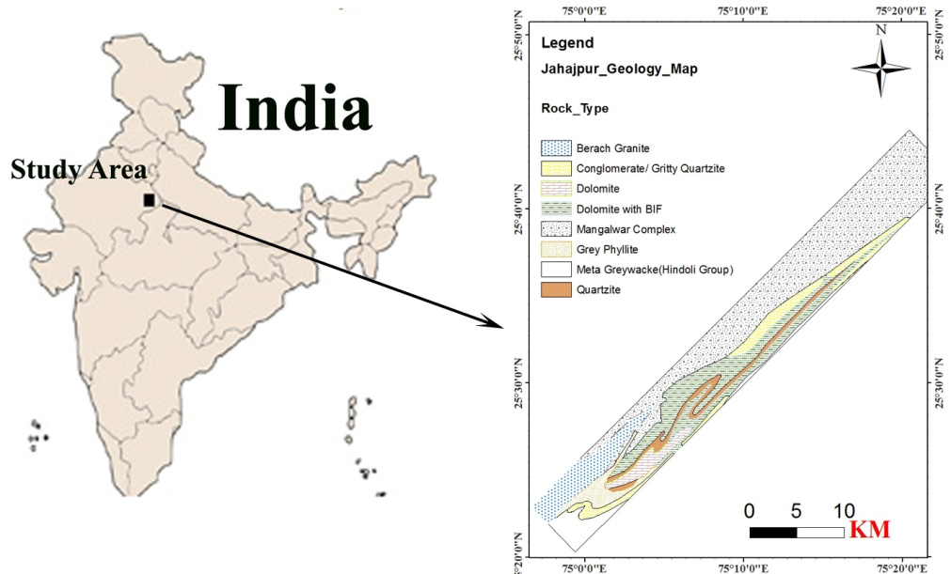
Figure 1 Lithology of the study area Jahajpur, Bhilwara, India
According to Heron (1953) the Delhi and Aravali Super group have mutual tectonic contact designated NE trended fringe of Aravali fold belt of Jahajpur group (Heron, 1953); (Saxena and Pandit, 2012), which are bounded by the Great Boundary fault in east separating to Vindhyan super group. The Jahajpur Group is surrounded by basement rocks of Hindoli Group in the east and Mangalwar Complex in the west (Sinha-Roy, 1984); (O.P. Yadav et al., 2001); (Tripathi, Govil and Prabhat, 2019a); (Tripathi and Govil, 2019) (Tripathi, Govil and Prabhat, 2019b). The two meta sedimentary litho-packages of green shiest facies have made inclusion in Jahajpur (Palaeoproterozic) and Hindoli (Late Archaean/Palaeoproterozic) (Saxena and Pandit, 2012). The associated rocks of Jahajpur Group are dolomites, quartzite, and phyllite of chronological age of 1.5 Ga (Tripathi and Govil, 2019). (Srivastava, 1968b);(Sinha-Roy, 2001);(Sinha-Roy, 1984);(Dey, B. et al., 2016); (Tripathi, Govil and Chattoraj, 2020). The chronological age of these rocks are around 1.5 Ga (O.P. Yadav et al., 2001); (Yadav and Rao, 2009); (Malhotra, 1988); (Sinha-Roy, Malhotra and Mohanti, 1998).

DATA AND METHODOLOGY

In this study high spectral/spatial resolution airborne hyperspectral remote sensing AVIRIS-NG data used(Tripathi and Govil, 2019) (Tripathi, Govil and Chattoraj, 2020) (Tripathi, Govil and Prabhat, 2019b).

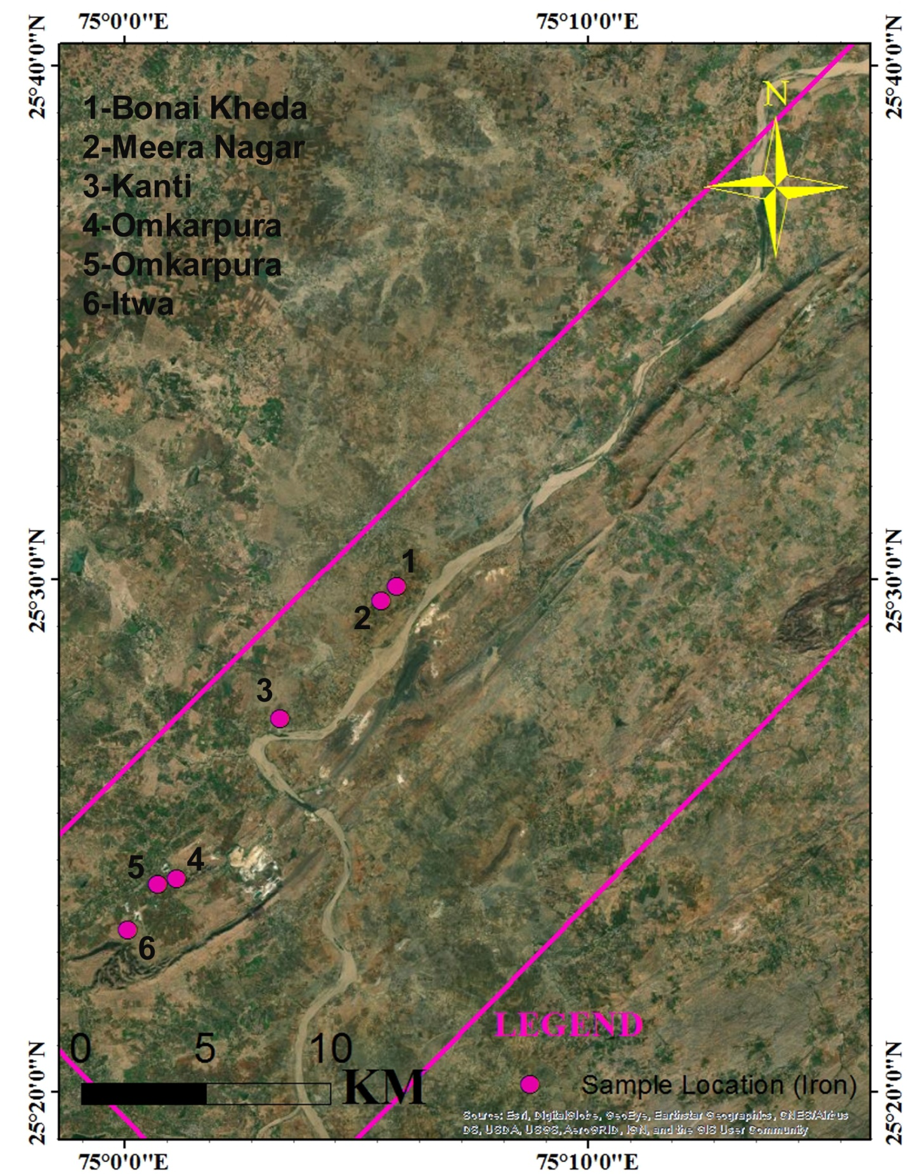
Figure 2 Location of the iron mineral samples in the study area Jahajpur, Bhilwara, India
To discriminate the various varieties of iron ores in different localities of BIF outcrops applied spectral/spatial resolution airborne hyperspectral remote sensing AVIRIS-NG hyperspectral remote sensing data. The image was acquired in Julian day 04/02/2016(Tripathi, Govil and Prabhat, 2019b)(Tripathi and Govil, 2019) (Tripathi, Govil and Chattoraj, 2020).Swath of the AVIRIS-NG image is 4-6 km with spatial/spectral resolution 8.1 m/5nm ± 0.5 nm respectively(Tripathi and Govil, 2019). Only 376 channels out of 425 channels ranging from 380 nm to 2510 nm in the AVIRIS-NG data are calibrated on 0.1scale factors for all spectral bands.1-425 are applied to calibrate radiance. There are several steps involved in AVIRIS-NG image processing such as band removal, atmospheric corrections, minimum noise fraction, pixel purity index, end member selection and mapping. To map the iron oxides /hydroxides applied spectral angle mapper (SAM) algorithms. In discrimination of genesis and formation of banded iron formation collected samples of Fe outcrops of the study area on various locations such as Bonai Kheda, Meera Nagar, Kanti, Omkarpura and Itwa. The adopted methodology included with several stages of sample preparation and analysis.

RESULT AND DISCUSSION

- Iron mineral discrimination and mapping

To discriminate the various varieties of iron ores through AVIRIS-NG hyperspectral remote sensing data involving two significant steps such as identification and mapping. In the different locations of study area five major BIF identified such as Meera Nagar, Omkarpura, Itwa, Kanti and Bonai Kheda of Jahajpur. The Jahajpur BIF map and spectral absorptions features have shown below in the figures (3 & 4) and tables (1 & 2).

In the regions of Jahajpur iron oxides/hydroxides (Limonite) and clays (Kaosmec, Montmorillonite) are showing reflection and absorption features at 0.50-0.55, 0.67-0.70, 0.91-0.93 and 2.20 μm(Figure 3), respectively. The absorption at 0.67-0.70 μm and 0.91-0.93 μm in “Limonite/Goethite and hematite by crystal field and by charge transfer absorption at 0.48 μm and 0.55 μm respectively” (Mahesh et. al., 2020)(Table 1 and 2).

Table 1 Extraction of major absorption features of iron minerals spectra through AVIRIS-NG hyperspectral image
Location | Mineral Name | Major Absorption
 |  | Fe³⁺⁺ | Fe³⁺⁺ | Fe²⁺⁺ --- Fe³⁺⁺ | OH | H-O-H | Al-OH
Itwa | Goethite/Limonite | 0.5517 | 0.7020 | 0.9274 | 1.4132 | 1.9341 | 2.20
Omkarpura 1 | Goethite/Limonite | 0.5067 | 0.7020 | 0.9174 | 1.4132 | 1.9341
Kanti | Goethite/Limonite | 0.5067 | 0.6870 | 0.9274 | 1.4132 | 1.9341
Meera Nagar | Goethite/Limonite | 0.5567 | 0.6870 | 0.9174 | 1.4132 | 1.9341
Bonai Kheda | Goethite/Limonite | 0.5317 | 0.6719 | 0.9174 | 1.4132 | 1.9341

Table 2 Extraction of major absorption features of iron minerals spectra through Spectroscopy
Location | Mineral Name | Major Absorption
 |  | Fe³⁺⁺ | Fe³⁺⁺ | Fe²⁺⁺ --- Fe³⁺⁺ | OH | H-O-H | Al-OH
Itwa | Goethite/Limonite | 0.47 | 0.683 | 0.90 | 1.41 | 1.93
Omkarpura1 | Goethite/Limonite | 0.4730 | 0.65 | 0.91 | 1.43 | 1.93
Kanti | Goethite/Limonite | 0.4760 | 0.6670 | 0.9030 | 1.4130 | 1.91 | 2.20
Meera Nagar | Goethite/Limonite | 0.5510 |  | 0.8730 | 1.4120 | 1.929 | 2.21
Bonai Kheda | Goethite/Limonite | 0.4840 | 0.6670 | 0.8980 | 1.4120 | 1.93

- Iron Ores

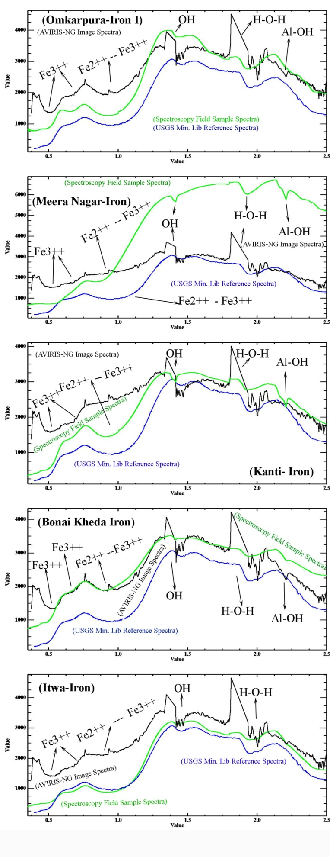
Figure 3 Spectral response curves of the iron minerals of Jahajpur
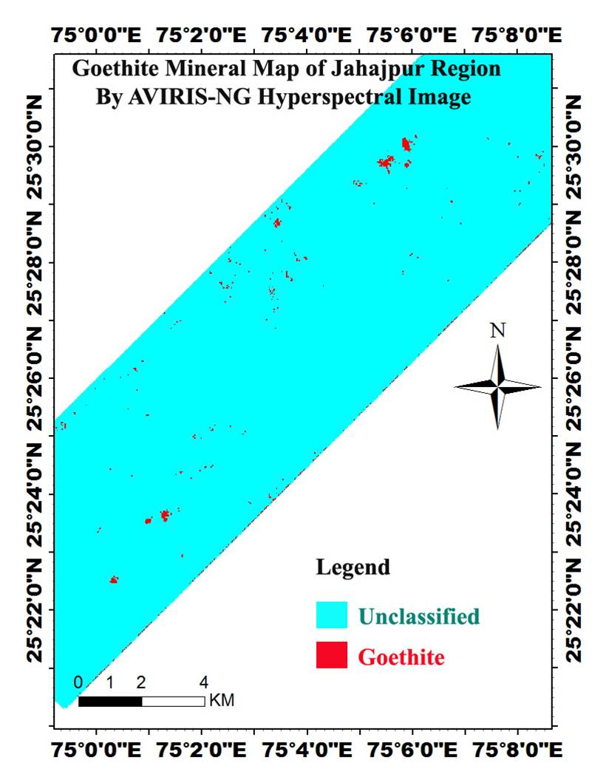
Figure 4 Iron map of the study area
The classifications of iron ores are descriptive which based on the presence of iron oxides/hydroxides(hematite, goethite and limonite). The predominant minerals are goethite and hematite. The goethite ores are massive and compact with abundant ganged minerals quartz and kaolinite but hematite is coarser and loose in presence of less abundant ganged minerals such as quartz and kaolinite. At Omkpura location the preexisting silicon layer within BIF replaced by iron oxides/hydroxides(Keyser et al., 2018).

VERIFICATION

- Petrography-Mineralogical characterization

There is a significant application of petrographic microscope in study of identification and measurement of rocks and minerals in thin sections in field of optical mineralogy and petrology. The specifications of polarizer and analyzer of microscope more significant for identification and visibility of optical anisotropic character of samples in polarized light. In the positioning of the polarizer putting the light path before samples position and the position of analyzer at optical pathway between the objective rear aperture and the observation tubes or camera port. The interaction of plane-polarized light with doubly refracting (birefringes) is able to generate two separate waves such ordinary and extraordinary wave which are polarized in mutually perpendicular planes and vary with propagation direction through the samples. The absorption color and optical path boundaries can be measure in polarized light microscopy significantly among minerals of distinct refractive indices and isotropic, anisotropic substances (https://www.microscopyu.com.)(An et al., 2016).

Interpretation of different microscopic thin sections shows various compositions of minerals. Quartz shows subhedral to anhedral, medium to coarse grains. There are various distinct pockets identified with quartz and limonite/goethite during the study of field investigation. Previously above as discussed about limonite/goethite and montmorillonite/Kaosmec clay minerals interpreted in VNIR-SWIR under spectroscopy study.

Bonai Kheda: The Bonai Kheda region associated with Goethite/Limonite grade of iron ore. The petrographic analysis defines the association of clay, quartz and iron ore minerals. The iron minerals leached out and quartz minerals remain as previous. The quartz minerals are distributed roughly with intercalations of clay minerals which are in combination of blue and red colors with colorless quartz grains (gray to white). The iron ore minerals are in dark reddish brown color (Figure 5(a)).

Kanti:The Kanti region of iron ore minerals are associated with coarser quartz grain minerals (Grey to White color) in combination of clay minerals (varying color combination of pink, violet, blue and orange)(Figure 5(b)).

Meera Nagar:The Meera Nagar region of iron ores associated with Hematite (Black color) and Goethite (Reddish brown color) minerals. The Hematite minerals transformed into Goethite in association of Quartz (Grey to White color) and clay minerals (Violet, Blue and Orange color. The presence of clay minerals defines the signature of acidic environment. The transformation of Hematite minerals into Goethite indicating the weathering and erosion under redox environment (Figure 5(c)).

Omkarpura-I: Goethite show amorphous, flow accumulation, uneven shape under microscopic observation and interpretation along with quartz, clay and grunerolite phenocryst groundmass (Lebrac, 2007) and botryoidal structures described by physical characteristics under macroscopic study. The iron bearing mineral, which are product of weathering and process of oxidation product. The iron containing minerals such as limonite/goethite have capability as clues for exploration (Figure 5(d)).

Omkarpura-II: Coarse grains of quartz are associated with uneven fractures occurs as porphyroblast. The leaching process of goethite minerals have shown in the thin section. Isotropic under crossed nickols, in transmitted light, it is yellow, through shades of brown to red, appears brownish red in reflected light (Figure 5(e)).

Itwa-I and II: Uneven coarse to fine grain of quartz (grey color) included with uneven fractures. The leaching process is prominent in the thin section. The reddish brown color representing the goethite mineral (Figure 54(f & g)).

The higher silica and lower alumina content in hydrothermal fluids dissociates iron hydroxides and amorphous silica during diagenesis. The silica removal from the banded iron formation (BIF/protore)is the principal control of enrichment. The strong subtropical weathering implies the iron redistribution and loss of (Roy and Venkatesh, 2009).

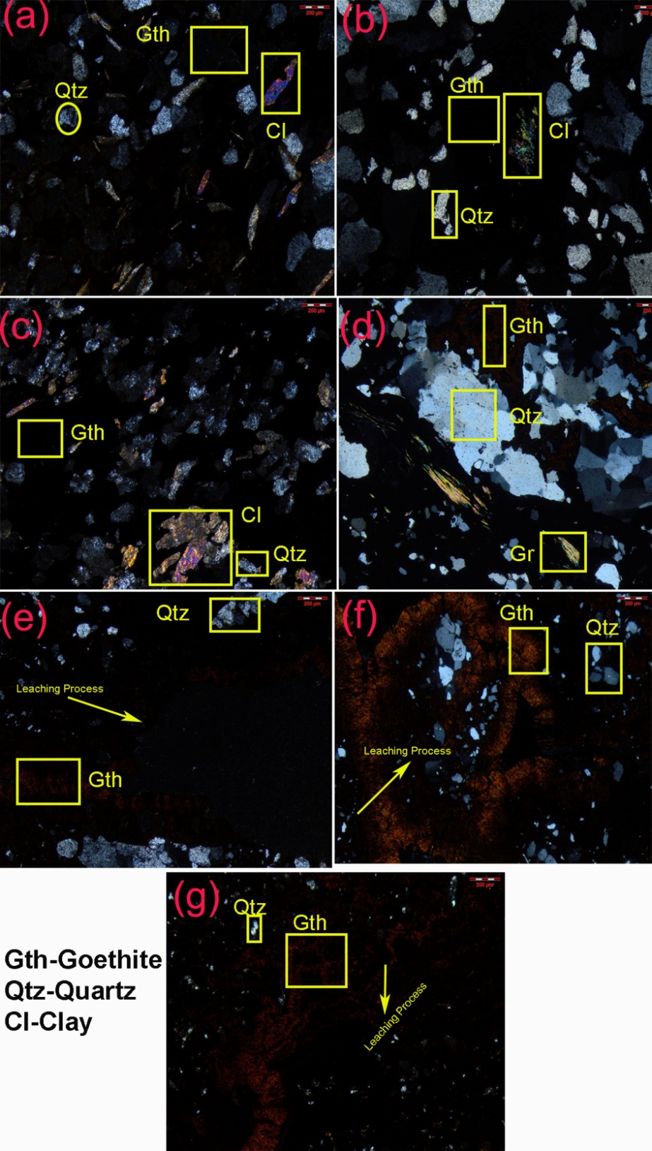
Figure 5 Petrographic interpretations of iron ores

The sequential removal and replacement of gangue minerals produce the high grade ore of iron (BIF) such martite–goethite by hydrothermal and supergene process. Goethite is secondary precipitated form of hydrated iron. The second stage of supergene process responsible for hard laminated ore where deep burial upgrades hydrous iron oxides into hematite. Under the sequence of processing the precipitation of iron leaching in spaces as martite-goethite and hard laminated ores formed by (final stage) deep burial upgrades. The soft laminated iron ores have found where either partial precipitation or absent and leached out space remains, which make it fragile in between the laminee. Generally the presence of kaolinite and gibbsite in the interstitial spaces makes it low grade(Roy and Venkatesh, 2009). The structurally controlled hydrothermal alteration and proximal alteration zone represents the formation of higher grade of iron ores such as hematite and martite. There are lack of lamination in hard massive ores of iron which also associated with small and large scaled faults and folds. Generally massive ores are composed of hematite and martite iron ore types(Roy and Venkatesh, 2009). The redox independent transformation precipitation is responsible for formation of massive iron ores(Otake et al., 2007).

- Field Validation

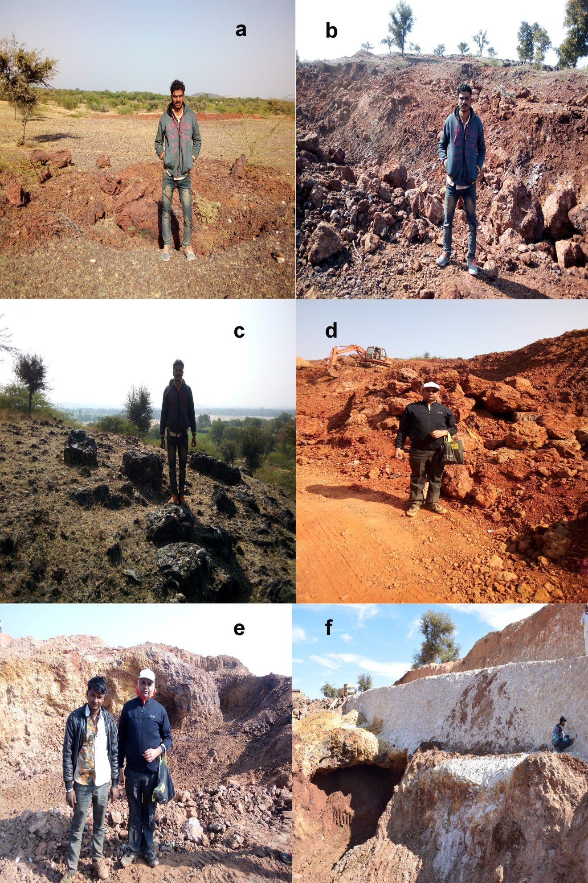

Figure 6 Field locations of iron ores in the study area

CONCLUSION

In the applications of iron mapping AVIRIS-NG hyperspectral remote sensing data results shows robust performance. The spectral response feature of the iron oxides and hydroxides have shown intercalations of clays and quartz minerals. The presence of clays minerals also identified with iron minerals through image spectra, spectroscopic spectra and petrographic interpretations. The random distributions of quartz and clays indicating acidic, redox, weathering and erosional conditions for iron oxides and hydroxides minerals. The conclusion is that AVIRIS –NG have potential to map and discriminate the iron minerals.

REFERENCES

An, A. et al. (2016) G UIDE TO Second Edition, Geochimica et Cosmochimica Acta. doi: 10.1016/j.gca.2017.06.026.
Clark, R. N. (1999) Spectroscopy of Rocks and Minerals, and Principles of Spectroscopy.
Devapriyan, G. V., Sahai, T. N. (1984) A report on test drilling for lead and zinc in the Jhikri area, Bhilwara district, Rajasthan. Progress report for FS. 1972-74, GSI Unpublished report.
Dey, B. et al. (2016) Zircon U-Pb SHRIMP dating of the Jahazpur granite and its implications on the stratigraphic status of the Hindoli-Jahazpur group, Seminar Abstract Volume: Developments in Geosciences in the Past Deca.
Govil, H. et al. (2018) ‘Identification of iron oxides minerals in western Jahajpur region, India, using AVIRIS-NG hyperspectral remote sensing’, in The International Archives of the Photogrammetry, Remote Sensing and Spatial Information Sciences, Volume XLII-5, 2018 ISPRS TC V Mid-term Symposium “Geospatial Technology – Pixel to People”, 20–23 November 2018, Dehradun, India, pp. 20–23.
Gupta, S. N. et al. (1997) ‘The Precambrian Geology of the Aravalli Region Southern Rajasthan and North-eastern Gujarat Mem.’, Geol. Surv. India, 123, p. 262.
Heron, A. . (1935) ‘Heron, A.M (1935) Synopsis of the pre-Vindhyan Geology of Rajputana.’, Trans. Nat. Instt. Sci. India., I, pp. 17–33.
Heron, A. . (1953) ‘The Geology of Central Rajputana.’, Geol. Surv. India, 79, p. 389.
Heron, A. M. (1935) ‘“Synopsis of the pre-Vindhyan geology of Rajputana”’, Transactions of the National Institute or Sciences of India, 1(2), pp. 17–35.
Keyser, W. et al. (2018) ‘Petrography and trace element signatures of iron-oxides in deposits from the Middleback Ranges, South Australia: From banded iron formation to ore’, Ore Geology Reviews, 93(December 2017), pp. 337–360. doi: 10.1016/j.oregeorev.2018.01.006.
Lebrac (2007) Limonitausfällung am Grund eines Baches in der Caldera de Taburiente, La Palma, Wikipedia. Available at: https://wikivisually.com/wiki/File:La_Palma_Limonit.jpg#file.
Malhotra, G. (1988) Gelogy and basement potential s of the Jahazpur belt in parts of Bhilwara and Bundi districts, Rajasthan (Progress Report for Field Season 1984-88.
van der Meer, F. D. et al. (2012) ‘Multi- and hyperspectral geologic remote sensing: A review’, International Journal of Applied Earth Observation and Geoinformation. Elsevier B.V., 14(1), pp. 112–128. doi: 10.1016/j.jag.2011.08.002.
Otake, T. et al. (2007) ‘Experimental evidence for non-redox transformations between magnetite and hematite under H 2 -rich hydrothermal conditions’, 257, pp. 60–70. doi: 10.1016/j.epsl.2007.02.022.
Rajendra Prasad, B., Rao, V. V. and P.R., R. (1999) ‘Seismic andmagnetotelluric studies overa crustal scalefault zone for imaging a metallogenic provinceof Aravalli-Delhi Fold Belt region’, CURRENT SCIENCE, 76(7), pp. 1027–1031. Available at: http://www.currentscience.ac.in/Downloads/article_id_076_07_1027_1031_0.pdf.
Roy, S. and Venkatesh, A. S. (2009) ‘Mineralogy and geochemistry of banded iron formation and iron ores from eastern India with implications’, (6), pp. 619–641.
Saxena, A. S. H. A. and Pandit, M. K. (2012) ‘Geochemistry of Hindoli Group Metasediments , SE Aravalli Craton , NW India : Implications for Palaeoweathering and Provenance’, Journal geological society of India, 79(March), pp. 267–278. Available at: http://mecl.gov.in/Reports/EXE_SUMM_BANERA.pdf.
Sinha-Roy, S. (1984) ‘Precambrian folded unconformity in Rajasthan.pdf’, CURRENT SCIENCE, 53(22), pp. 1205–1207.
Sinha-Roy, S. (2001) ‘Neotectonically controlled catchment capture: An example from the Banas and Chambal drainage basins, Rajasthan’, Current Science, 80(2), pp. 293–298.
Sinha-Roy, S., Malhotra, G. and Mohanti, M. (1998) ‘Geology of Rajasthan’, Geol. Soc. India, p. 278.
Srivastava, R. P. (1968a) Geological survey of India-systmatic geological mapping in parts of Ajmer,Bhilwara and Udaipur districts, Rajsthan included in topo-sheet nos. 45 K/1 & 5. (Progress Report for the field-season 1966-67).
Srivastava, R. P. (1968b) Geological Survey of India.
Tripathi, M. K. and Govil, H. (2019) ‘Evaluation of AVIRIS-NG hyperspectral images for mineral identi fi cation and mapping’, Heliyon. Elsevier Ltd, 5(11), pp. 1–10. doi: 10.1016/j.heliyon.2019.e02931.
Tripathi, M. K. and Govil, H. (2020) ‘Regolith mapping and geochemistry of hydrothermally altered, weathered and clay minerals, Western Jahajpur belt, Bhilwara, India’, Geocarto International. Taylor & Francis, 0(0), pp. 1–17. doi: 10.1080/10106049.2020.1745302.
Tripathi, M. K., Govil, H. and Chattoraj, S. L. (2020) ‘Identi fi cation of hydrothermal altered / weathered and clay minerals through airborne AVIRIS-NG hyperspectral data in Jahajpur , India’, Heliyon. Elsevier Ltd, 6(January 2019), p. e03487. doi: 10.1016/j.heliyon.2020.e03487.
Tripathi, M. K., Govil, H. and Prabhat, D. (2019a) ‘Lithological Mapping using Digital Image Processing Techniques on Landsat 8 OLI Remote Sensing Data in Jahajpur , Bhilwara , Rajasthan’, in 2nd International Conference on Intelligent Communication and Computational Techniques (ICCT) Manipal University Jaipur, Sep 28-29, 2019, pp. 43–48.
Tripathi, M. K., Govil, H. and Prabhat, D. (2019b) ‘Petrography , XRD Analysis and Identification of Talc Minerals near Chhabadiya Village of Jahajpur Region , Bhilwara , India through Hyperion Hyperspectral Remote Sensing Data’, in 2nd International Conference on Intelligent Communication and Computational Techniques (ICCT) Manipal University Jaipur, Sep 28-29, 2019. IEEE Explorer, pp. 75–78.
Yadav, O. P. et al. (2001) ‘Note on the first report of quaternary sedimentation and its significance in West Jahajpur basin, Bhilwara District, Rajasthan’, Journal of the Geological Society of India.
Yadav, O.P. et al. (2001) ‘Short communications and its significance in west Jahajpur basin, Bhilwara district, Rajsthan’, Journal geological society of India, 58(DEC), pp. 0–3.
Yadav, S. K. and Rao, R. S. (2009) ‘Assessment of Iron ore potentiality of Jahazpur belt, Central Rajasthan - a case study’, Geological Survey of India, 128(3239), pp. 885–886. doi: 10.1038/128885a0.

