SPATIAL ANALYSIS OF URBAN BICYCLES FACILITY AND THE SURROUNDING NEIGHBORHOOD

Jessica, Dyah Lestari Widaningrum

Industrial Engineering Department, Faculty of Engineering, Bina Nusantara University, Jakarta, Indonesia, 11480
Email: jessica024@binus.ac.id; dwidaningrum@binus.edu

KEYWORDS: Bicycle Facility; Urban Area; Spatial Analysis; Neighborhood

ABSTRACT: More than half of the world's population currently lives in cities, and this is also happening in Jakarta, as the only megacity in Indonesia. Based on the United Nations data, 55.3% of Indonesia’s population occupied urban areas in mid-2018. Various modes of transportation and their infrastructure are developed to support the mobility of urban communities. Mass transportation for long-distance trips to locations for activities such as work, education, leisure, and shopping, is needed. However, access to mass transportation facilities is not always close to the origin location, whether it is from home, office, and so on. Therefore, various alternatives are also available for people to reach the mass transportation facilities, such as minivans with certain routes (called Angkot - Angkutan Kota), online car/motorcycle, and another interesting alternative is by bicycle. There are various positive things by using bicycles as a mode of transportation, such as less pollution and increasing health for cyclists. These positive things can be achieved by synergies from various parties, especially providers of cycling facilities (bike parking and bike-sharing) as well as safe infrastructure for cycling (such as providing special lanes or boulevards for cyclists) as well as cyclists' concern for their safety. This paper aims to examine the spatial characteristics of the existing cycling facility and the surrounding neighborhood. The interaction between cycling facilities and surrounding facilities will be explored considering that city growth encourages a complex network of interacting daily service activities. The results are presented as paired neighborhood relationships between cycling facilities with other public facilities. The spatial data were collected, managed, processed, and presented as visual information using QGIS Desktop version 3.1.8. PostGIS is used as an extension of PostGreSQL for importing/exporting shapefiles. ST_Distance function and ST_Dwithin function of PostGreSQL database/SQL queries are applied for proximity analysis of all instances that occur. This study can be used to better understand the spatial characteristics of cycling facilities so that facility and infrastructure providers know a basis for better urban development planning.

INTRODUCTION
Population growth is the main indicator of the growth of a city. The number of people who urbanize from rural to urban areas is increasing. Based on data from the United Nation, people living in cities around the world reach 55% of the current population (United Nations, 2018). The growth of the urban population in the world increased rapidly from 1950 by 751 million people and to 4.2 billion people in 2018. Several regions in the world experience a high level of urbanization, such as 82% of the population living in urban areas in North America, in Latin America and the Caribbean as many as 81% of the population lives in cities, Europe at 74%, Oceania at 68%, Asia approaching 50%, and Africa at 43% (United Nation, 2018). Indonesia is also a country experiencing the impact of urbanization, the Megacities Jakarta. This urbanization extends to areas around Jakarta or commonly called Jakarta Greater Area, where this area is a combination of Jakarta, Bogor, Depo, Tangerang, and Bekasi (Rahmatulloh, 2017; Shatkin, 2019). According to the data of Badan Pusat Statistik (BPS), the total population in Indonesia in 2018 was 265 million people (BPS, 2019). Meanwhile, on the island of Java, where there are many developed urban areas among other islands, it has a population of 149.6 million in 2018 (BPS, 2019). This indicates that the majority of Indonesia's population (56%) lives in urban areas. The rapid growth of the city is followed by the need for the development of supporting facilities, from infrastructure development, transportation, education, health services, and socio-economy (Rahmatulloh, 2017).
The most rapidly growing facility is seen in infrastructure development in the transportation sector. Several studies have focused on the relationship between urban forms and the transport system. The key to sustainable urban development is where the center of activity can occur in the same location between housing, work, education, and others (Bai & Krumdieck, 2020). Currently, access to housing, school, and work areas is not possible by simply walking and cycling, which leads to long trips to work and housing sites. For example, residents who live outside the city of Jakarta have to travel by car or train to get to work locations. The population mostly chooses to use private vehicles to travel long distances to work locations, especially residents who live outside urban centers. This indicates the importance of transportation in everyday life, where transportation makes it easy for users to minimize the duration of moving from one place to another. The choice of transportation is also a consideration for residents to get to their destination quickly and safely (De Vos & Witlox, 2013).
Currently, there are quite some transportation options available in urban areas. Starting from the use of private cars, busways, taxis, electric trains, planes, boats, MRT, LRT, motorbikes, to bicycles (BPS Provinsi DKI Jakarta, 2018). The use of transportation that is used every day turns out to have an impact on the environment, the biggest impact is air pollution. According to the Ministry of Environment and Forestry (KLHK), the use of motorized vehicles is the biggest contributor to pollution in the capital city of Jakarta (Nisa, 2019). Also, the high use of private transportation has a severe impact on congestion in urban areas. According to the Union of Concerned Scientists (2014), pollution and contamination that occurs in cities in the United States are mostly caused by the transportation used by its residents (Bai & Krumdieck, 2020). The high number of car use has resulted in a greater impact on environmental disruption, high congestion, limitations in economic growth, and uncontrolled population growth for decades (De Vos & Witlox, 2013).
The government has recently produced a document that contains policies on strategies to reduce congestion and the burden that the transportation sector causes to the environment. One of them is improving facilities for active travel (pedestrians and cyclists) and public transportation (De Vos & Witlox, 2013). One of the facilities provided for active travel is to improve sidewalks, create bicycle lanes, and provide bike share facilities for urban areas. Bike-sharing is a service that provides a means of transportation in the form of bicycles for public use with access via smartphones. The bike-sharing system is that the user can use the bicycle to various places and the bicycle can be returned to the special bicycle park that has been provided, and charged according to the distance traveled by the cyclist. The bike-sharing system is considered good for the wider community because it has a positive impact on the environment. One of them is that bicycles produce less air pollution and noise pollution than motor-based vehicles, such as cars and motorbikes (Du et al., 2019).
In Indonesia, bicycle facilities are starting to be found in various urban areas, one of which is megacities in Indonesia, the city of Jakarta. The development of bicycle facilities in Jakarta is increasing along with the interest in cycling that arises among the community. The facilities built are in the form of special cyclist lanes, updated bicycle parking, the emergence of bike-sharing services, and policies regarding bicycle transportation. As a city develops, daily activities are increasingly diverse, so there is a need for comprehensive mobility to make it easier for residents to move from one location to another. Bicycle facilities can be a suitable alternative to facilitate this mobility. However, its uneven distribution is an obstacle in the development of this environmentally friendly transportation facility. Bike-sharing locations are currently only available in public transportation areas, such as near bus stops and MRT stations, so if you want to use these services, you can only use them in certain locations. Through this research, a study was carried out on the spatial characteristics of the existing cycling facilities and the surrounding environment. The interaction between cycling facilities and surrounding facilities will be further explored given the urban growth that encourages complex daily activities to interact with each other.
.

LITERATURE REVIEW
  - Urban Mobility
According to the central place theory, when the fulfillment of daily needs is limited by markets, transportation, and administration, residents tend to visit nearby cities to buy goods and services to meet their needs (Zhen et al., 2019). Today, the city is one of the places that provide various needs for its residents, from housing to employment. The daily activities of residents in urban areas are increasingly complex considering continuous developments, such as urban growth and urban sprawl (Widaningrum et al., 2020). One of the cities in Indonesia that is experiencing urbanization is Jakarta. The increasing population in the capital city, the more problems that arise, including unorganized settlements, garbage, congestion, and unemployment (Rahmatulloh, 2017).
One of the problems that have become the focus of the government is in the transportation sector. The urban growth rate is accompanied by the development rate in the transportation sector. The number of private transportation continues to increase and causes problems, in addition to causing congestion, which has resulted in increased environmental disturbance, limited economic growth, and the spread of urban sprawl in many western countries (De Vos & Witlox, 2013). Congestion has been the biggest problem in Jakarta for the last few years. The result of congestion in Jakarta has reduced the quality of life and competitiveness of the population. The growth of the financial and service sector increased population growth, and the relatively unchanged capacity of the public transportation system in the Jakarta Greater area has led to the use of vehicles such as motorbikes and private cars (Initiative, 2011). Therefore, the current government's focus is to reduce the number of congestion by building more road access. Nevertheless, in reality, the use of private vehicles is increasing and the level of congestion is getting higher, other influences have an impact on economic inefficiency, pollution, and other environmental damage (Initiative, 2011).
Currently, the steps taken by every country in dealing with congestion are improving mobility. One example of a successful country is Singapore (Initiative, 2011). Singapore is focused on changing the way people use roads and providing classy and affordable public transportation facilities. Many countries have implemented improving mobility to reduce problems in the transportation sector, such as Brazil, France, India, China, and countries in Europe. Improving urban mobility focuses on movement between people and goods rather than the movement of vehicles. The goal is to create an urban mobility system that is highly efficient, flexible, safe, responsive, and affordable for people and goods (Initiative, 2011). This means increasing the use of public transport, improving the lane for pedestrians, and reducing the number of car and motorcycle users to travel.
Increasing urban mobility is the right step for the Jakarta government to take in dealing with this transportation problem. Prioritizing the use of public-private vehicle transportation by improving public transportation services to be more efficient and affordable, providing safe and comfortable walking paths, and providing environmentally friendly transportation facilities, such as bicycles with a sharing system Increasing urban mobility is the right step for the Jakarta government to take in dealing with this transportation problem. Prioritizing the use of public-private vehicle transportation by improving public transportation services to be more efficient and affordable, providing safe and comfortable walking paths, and providing environmentally friendly transportation facilities, such as bicycles with a sharing system (Du et al., 2019; Initiative, 2011). Innovations in mobility have now also penetrated the field of technology, for example through applications, social networks, and economic sharing practices.
Nowadays, multiple sharing devices provide an effect that offers innovative solutions to support mobility supplies. These sharing tools use a tool that can be used by all users, with new systems that can generate knowledge and services, and by supporting symmetrical information in the urban mobility market. Innovations in mobility have now also penetrated the field of technology, for example through applications, social networks, and economic sharing practices (Vecchio & Tricarico, 2019).

Proximity Analysis
Proximity analysis is a technique used to analyze the closeness between two elements. In its application, proximity analysis helps analyze how the relationship of an element with other elements are related (Beames et al., 2018). One application is to analyze the potential access to health care with the environment (Bissonnette et al., 2012). This analysis used GIS (Geographical Information System) software to process the spatial data used. Some of the features that can be used in GIS, e.g. supports the creation of buffer zones, determining the distance of a point from another, allocating certain points to an area, and analyzing the travel path along with the network (Beames et al., 2018).
In this study, proximity analysis is used to analyze the relationship between bicycle facilities and other public facilities. Determination of the location of the bicycle facility is very concerned about the surrounding facilities so that it is easily accessible by residents. According to Tobler, the first law of geography states that "Everything is related to everything else, but things that are closer are more related than things that are far away" (Tobler, 1970). That is, the service facilities that are built are related to other facilities that are close to the location of the facility providers so that the interactions that occur will determine whether these facilities are suitable for their location (Widaningrum et al., 2020). The proximity analysis of this study uses GIS assistance to review the relationship between the location of bicycle facilities and other public facilities to determine a strategic location. GIS is very helpful for researchers to determine suitable locations that can later be used in decision making (Beames et al., 2018). This decision making will determine the location of the bicycle facility provider which is strategic and easily accessible to residents.

DATA SOURCES AND METHODS

Data
In analyzing the interaction between bicycle facilities and other public facilities, the data used are in the form of the location of the distribution of bicycle facilities in Jakarta Greater Area, a map of the Jakarta Greater area, and POI (Point of Interest) locations. The Jakarta Greater Area location was taken as the research location because of the development of mobility which continues to grow and develop in line with population growth which is increasingly increasing. Bicycle facilities are obtained from geocoding of the distribution of bike-sharing, bike parking, and bicycle rental through Google Maps. The distribution of the coordinates of this bicycle facility is taken for Jakarta, Bogor, Depok, Tangerang, and Bekasi areas. The map used is sourced from tanahair.indonesia.go.id (www.tanahair.indonesia.go.id/portal-web) and used map data for the area of Jakarta, Bogor, Tangerang, Depok, and Bekasi (Jakarta Greater Area). Public facilities or POIs come from OpenStreetMap (www.openstreetmap.id) by downloading public facilities available throughout Indonesia.
The first stage is to download a map from tanahair.indonesia.go.id which contains maps of the areas of North Jakarta, West Jakarta, Central Jakarta, South Jakarta, East Jakarta, Depok, Bogor City, Bogor Regency, Tangerang City, South Tangerang City, Tangerang Regency, Bekasi City, and Bekasi Regency. The base map was then inputted as a vector layer into QGIS Desktop version 3.14.15, and the layers were merged so that it became a complete Jakarta Greater Area base map. The second stage is to input the geocoding result data obtained from Google Maps in the .csv file type. The input results will later be changed to the location points of the bike-sharing facility. After getting a new layer for bike-sharing, export the file in the form of .shp (shapefile). The creation of a new layer was also carried out on the POI location for public facilities in Jakarta Greater Area. The result is the layers for each facility grouping that will be processed using PostgreSQL.

Methods
The base map that was downloaded earlier was inputted as a vector layer into QGIS Desktop version 3.14.15, and the layers were merged so that it became a complete Jakarta Greater Area base map. In the use of QGIS software, the previous base map is edited using the tools available in QGIS, such as setting the projection system, merged, and clipped features as well as creating new layers with different CRS. In addition to the Jakarta Greater Area map, data in the form of geocoding of bicycle facilities and POI locations can be processed using QGIS into a new layer which will be exported as shapefiles into the PostgreSQL software.
Furthermore, the data that has been processed by QGIS is then exported to PostgreSQL using PostGIS Shapefile Import/Export Manager, a spatial data extender used in PostgreSQL. PostgreSQL is used as a database to process and analyze interactions between bicycle facilities and other public facilities using the ST_Distance function available in PostgreSQL. The results obtained are in the form of Participation Ratio (PR) and Participation Index (PI) values ​​between 2 facilities. The value of PR and PI will later show the relationship and closeness between bicycle facilities and other public facilities.

RESULTS AND DISCUSSION

Before the construction of a facility, we need to analyze the other factor around the facility. For this research, bicycle facilities are closely related to public transportation. Based on the literature, 6 major attributes are proximate in bicycle facilities. Public transportation, parks, and green area, educational area, commercial and office areas, and hospital are the six factors that influence the construction of bicycle facilities (Du et al., 2019). In each major attribute, there are minor attributes that have been divided into Table 1.

Table 1. Data for Major Attribute and Minor Attribute Related to Bike Share Facility
Major Attribute | Minor Attribute | Major Attribute | Minor Attribute
Parks And Green Area | Park | Public Transportation | Bike Sharing Station
 | Picnic Site |  | Bicycle Rental
 | Theme Park |  | Bus Station
 | Stadium |  | Bus Stop
Residential Area | Hotel |  | Car Rental
 | Hostel |  | Parking
 | Motel |  | Parking Bicycle
Commercial And Office Area | Bank |  | Parking Multistorey
 | Commercial Tower |  | Parking Underground
 | Convenience |  | Railway Station
 | Department Store |  | Taxi
 | Mall | Educational Facility | College
 | Post Office |  | School
 | Public Building |  | University
 | Supermarket | Hospital | Hospital
 | Courthouse

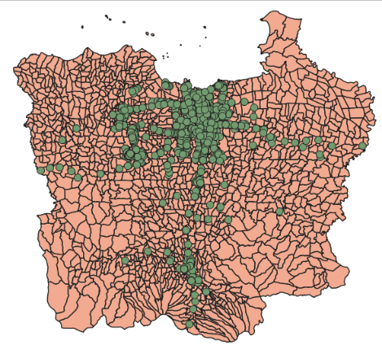
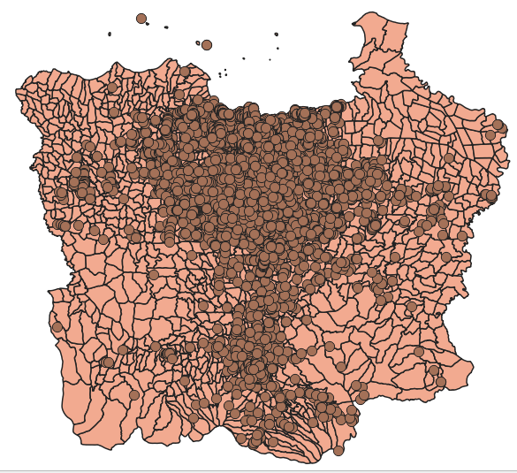
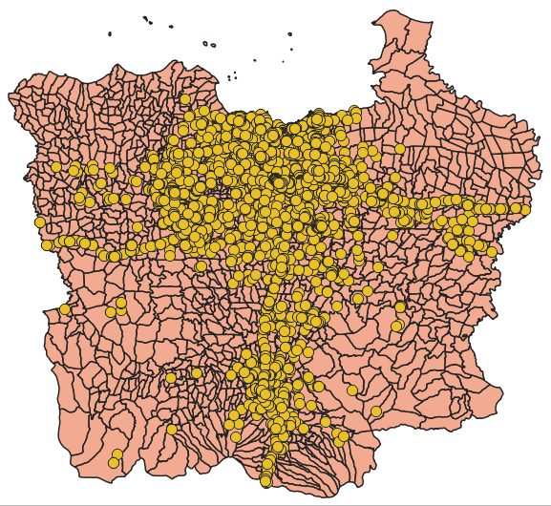
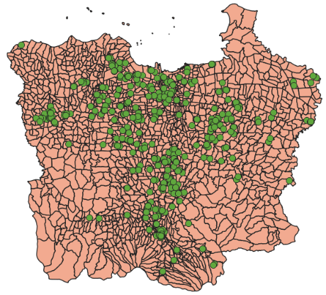
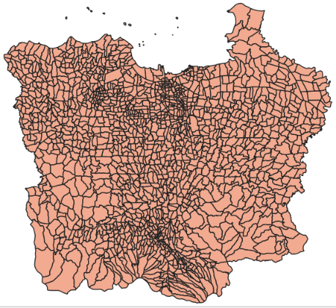
- (b) (c)
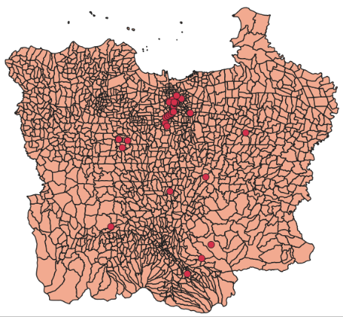
(d) (e) (f)
Figure 1 (a) Jakarta Greater Area Map, (b) Worship Point, (c) Traffic Point, (d) Transport Point, (e) Bike Sharing Point, (f) Public Transportation Point

The first stage is preparing data for Jakarta Greater Area maps, public facilities in the form of POI’s (Point of Interest), and geocoding for bike-sharing facilities in Jakarta Greater area. The raw data of the Jakarta Greater Area map is processed and visualized using the QGIS software. The first step, input the layer of North Jakarta map, South Jakarta map, West Jakarta map, East Jakarta map, Center Jakarta map, Bekasi City map, Bekasi district map, Bogor city map, Bogor district map, Depok map, Tangerang city map, South of Tangerang city map, and Tangerang district map become a Jakarta Greater Area map (www.tanahair.indonesia.go.id/portal-web). After merging the entire map with the merged method in QGIS, the next step is to clipped between POI public facilities and the Jakarta Greater Area map. The POI facilities are obtained from OpenStreetMap (www.openstreetmap.id). Clipped facilities consist of public facilities, transportation, traffic, and places of worship. Processed public facilities have been grouped based on the literature review into major and minor attributes. The next step was to input a new layer of geocoding of bike-sharing facilities in Jakarta Greater Area, then clipped it with Jakarta Greater Area map. The clipped results in Figure 1. from each facility will show a new layer on the map. These layers will be used to be processed into PostgreSQL and analyzed using spatial proximity analysis techniques.
After the layers already finished processing using QGIS, the next step is to perform a query using PostgreSQL with PostGIS. These layers form QGIS are imported to PostgreSQL using PostGIS software. Previously, it was necessary to prepare a database for storing files to be uploaded to PostgreSQL. Before importing into PostGIS, the CRS (Coordinate Reference Systems) value of the layer must be changed from WGS 84 to UTM Zone 48S via QGIS. Then the SRID value for all layers is changed to 32748 before importing into PostgreSQL. After the modification is complete, import the data into the PostgreSQL database.
Layer data that has been imported into PostgreSQL will be turned into a table. Furthermore, analyzing the proximity relationship between 2 facilities in the major attribute. The major attribute table is divided into 6 types according to the literature, later each facility will be combined with public transportation facilities to analyze the proximity relationship between 2 facilities within a predetermined distance. The distance measures range from 1 to 10 km. Queries used in PostgreSQL use the ST_Distance function provided in PostgreSQL. This distance division is done to calculate the probability of an attribute interacting with other attributes within a distance of 1 km to 10 km. The wider the specified distance, the greater the probability of the attributes meeting each other.
For each major attribute tables between 2 facilities that have been made, the number of facilities that interact with each other is calculated with a predetermined distance. For example in 1 km, public facility and park and the green area have 157 numbers of facilities that are close to each other. At a distance of 1 km, transportation facilities and commercial and office area facilities have the largest number of facilities close to each other, namely 44,008 facilities. This indicates that transportation facilities are closely related to commercial and office areas. Meanwhile, public transportation and hospital facilities are the facilities with the least interaction within 1 km with a total of 345 facilities. The overall results can be seen in Figure 2. The next step is to calculate the value of PR (Participation Ratio) and PI (Participation Index) for the facilities. The PR value is divided into 2, namely the PR value for facility A and facility B. Facility A combined with facility B will be calculated the PR value to determine the percentage of proximity between facility A to facility B and vice versa. For example, in Table 3, the major attribute for facility A is a residential area and the major attribute for facility B is public transportation, and the distance between the two facilities is 1 km. After the PR value is obtained from the two facilities, the PI value is determined by taking the lowest percentage of the two PRs. Based on the results obtained, the PI value is 65%.
The purpose of the resulting PR and PI values is to show the interaction between bicycle facilities (transportation facilities) with 5 other public facilities and vice versa. The facilities are then paired into 2 co-locations and the results are 15 tables for a total of 6 facilities. There are 10 distances analyzed for each table so that the total table created is 150 rows. The value of the proximity between transportation facilities and other public facilities can be seen in the participation index (PI) column. Within 1 km, the percentage of PI above 50%, there are transportation facilities with educational areas, residential areas, and commercial and office areas. This shows that within 1 km on public transportation, we can find facilities that are close to each other with public transportation, namely office areas, commercial areas, residential areas, and education areas. Public transportation which is located close to these three facilities makes it easier for urban residents to reach the areas where they are active. Meanwhile, for park and green areas and hospitals, it is below 50%, which means that within 1 km, public transportation, park, and green area and hospital are not close to each other and have further access than the previous three facilities.
The PI value of transportation facilities and park and green areas has the lowest PI value, namely 7%, which means that the two facilities are within 1 km of not much interaction. The park area is located further away from transportation facilities to reduce air pollution arising from motorized vehicles. Meanwhile, the hospital area with a PI value of 20% is located far from transportation facilities which aim to avoid air pollution and noise pollution produced by motorized vehicles. The hospital area needs to create a calm atmosphere to maintain the comfort and mental health of the patient. The highest PI value is the interaction between the commercial and office area and public transportation facilities (78%), which indicates that there is a close relationship between the two facilities. This is like the fact, for commercial and office areas it is always close to public transportation where the aim is to facilitate the mobility and access of urban residents to their places of activity, where the majority of residents of urban areas work as office employees. The most common use of transportation may occur in commercial and office areas, this is because residents who work in the city center partially live far from their activities, so transportation access is needed.

Figure 2. Number of Public Facilities That Interact with Public Transport Facilities

At a distance of 2-3 km, the lowest PI value is between the relationship between park and green area facilities and public transportation. Meanwhile, the relationship between hospital facilities and public transportation is above 50% at a distance of 3 km. This shows that the distance between the construction of hospital facilities and public facilities is separated by a minimum of 2 to 3 km. Meanwhile, for park and green areas and public transportation facilities, the construction of the facilities is within 3 to 4 km. For commercial and office area and public transportation facilities, the PI value is always above 50% for a distance of 1 to 10 km, this shows that the construction of transportation facilities is closely related to the commercial and office area.
Based on the results of the analysis conducted, commercial facilities and office areas, educational areas, and residential areas have the highest interaction with public transportation facilities. The three facilities are very strategic locations to build a bike sharing facility because it will support the activities of the population to make it more effective and efficient.

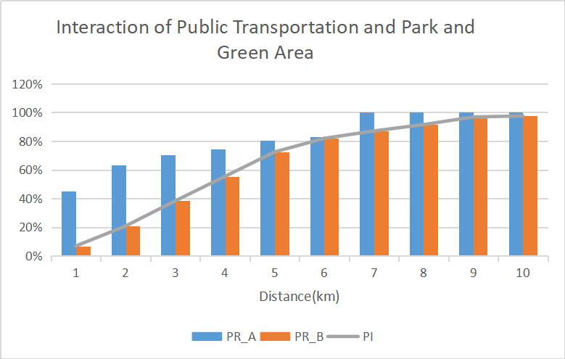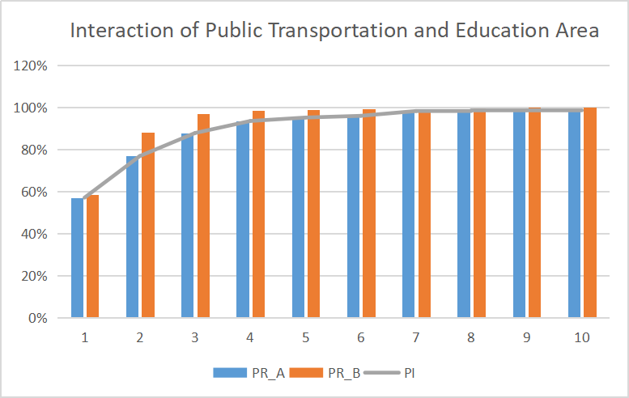
- (b)

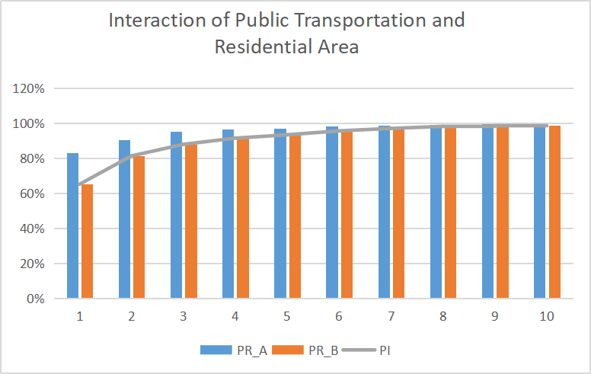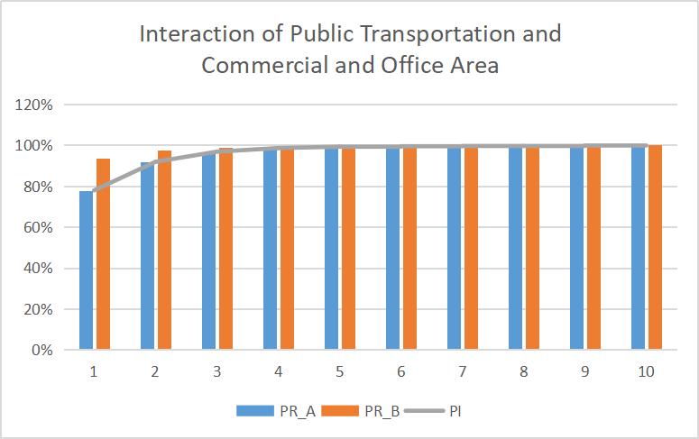
(c) (d)

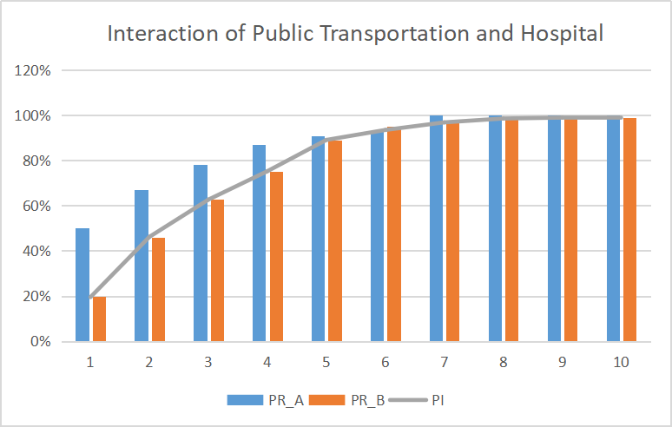
(e)
Figure 3. The Interaction of Public Transportation with Others Public Facilities Presented by Participation Ratio (PR) and Participation Index (PI)

CONCLUSION

Urbanization that occurs in the big city in Indonesia, namely Jakarta, has developed very rapidly from year to year. The population that continues to grow has created a need that is also increasing. Therefore, infrastructure development is being carried out in various sectors, one of which is transportation. Transportation is an inseparable need for residents, traveling from home to work, school, hospital, to returning home, all using assistance from transportation to get to their destination quickly. The transportation used consists of public transportation and private transportation. However, the number of use of private transportation is increasing, causing various problems to occur, such as congestion, air pollution and noise pollution.
The solution developed in overcoming this problem is to start inviting people to use public transportation by renovating various public transportation facilities, providing bicycle lanes, making sidewalks for pedestrians, and various other innovations. One possible solution is the availability of bike sharing facilities. Bike sharing, which is available in various locations, is expected to be easily accessible by residents and at a lower cost it can be used by various groups.
The bike sharing facility development needs to pay attention to the interaction with the surrounding public facilities. Based on the research results, public facilities that are closely related to public transportation facilities are commercial and office areas, residential areas, and educational areas. The three locations are considered strategic because they are the center of community activity which is always crowded with visits at any time. Placing the bike sharing facility in a busy location and close to the activity center can make it easier for users to reach it, thereby increasing the interest of the population to cycle, creating an urban area that is free from pollution and congestion.

REFERENCES

Bai, M., & Krumdieck, S. (2020). Transition engineering of transport in megacities with case study on commuting in Beijing. Cities, 96(September 2019), 102452.
Beames, A., Broekx, S., Schneidewind, U., Landuyt, D., van der Meulen, M., Heijungs, R., & Seuntjens, P. (2018). Amenity proximity analysis for sustainable brownfield redevelopment planning. Landscape and Urban Planning, 171(March), 68–79.
Bissonnette, L., Wilson, K., Bell, S., & Shah, T. I. (2012). Neighbourhoods and potential access to health care: The role of spatial and aspatial factors. Health and Place, 18(4), 841–853.
BPS. (2019). Statistik Indonesia. Jakarta: Badan Pusat Statistik Indonesia.
BPS Provinsi DKI Jakarta. (2018). Statistik Transportasi DKI Jakarta 2018. DKI Jakarta: Badan Pusat Statistik Provinsi DKI Jakarta .
De Vos, J., & Witlox, F. (2013). Transportation policy as spatial planning tool; Reducing urban sprawl by increasing travel costs and clustering infrastructure and public transportation. Journal of Transport Geography, 33, 117–125.
Du, Y., Deng, F., & Liao, F. (2019). A model framework for discovering the spatio-temporal usage patterns of public free-floating bike-sharing system. Transportation Research Part C: Emerging Technologies, 103(April), 39–55.
Initiative, I. I. (2011). Urban Mobility. Prakarsa, 6.
Nisa, K. (2019). KUALITAS UDARA DI PROVINSI DKI JAKARTA. Jakarta: Portal Statistik Sektoral Provinsi DKI Jakarta. Retrieved from http://statistik.jakarta.go.id/kualitas-udara-di-provinsi-dki-jakarta/
Rahmatulloh. (2017). Dinamika Kependudukan di Ibukota Jakarta (Deskripsi Perkembangan Kuantitas, Kualitas dan Kesejahteraan Penduduk di DKI Jakarta). Genta Mulia, VIII(2), 54–67.
Shatkin, G. (2019). Financial sector actors, the state, and the rescaling of Jakarta’s extended urban region. Land Use Policy, May, 104159.
Tobler, WA. (1970). Computer movie simulating urban growth in the Detroit Region. Economic Geography, 46, 234-240.
United Nation. (2018). 68% of the world population projected to live in urban areas by 2050, says UN. United Nations, Department of Economic and Social Affairs. New York: Population Division of the United Nations Department of Economic and Social Affairs.
Vecchio, G., & Tricarico, L. (2019). “May the Force move you”: Roles and actors of information sharing devices in urban mobility. Cities, 88(November 2018), 261–268.
Widaningrum, D. L., Surjandari, I., & Sudiana, D. (2020). Discovering spatial patterns of fast-food restaurants in Jakarta, Indonesia. Journal of Industrial and Production Engineering, 00(00), 1–19.
Zhen, F., Qin, X., Ye, X., Sun, H., & Luosang, Z. (2019). Analyzing urban development patterns based on the flow analysis method. Cities, 86(October 2018), 178–197.

