MONITORING THE SEASONAL LAND SURFACE TEMPERATURE CHANGES IN BORYEONG, KOREA USING THE MULTI-TEMPORAL MODIS SATELLITE IMAGES

Yun-Jae Choung (1), Yu-Yeon Lee (1), Yeong-Cheol Choi (1)

1 Geo C&I Co., Ltd., 435 Hwarang-ro, Dong-gu, 41165, Daegu
Email: chyj@geocni.com; yylee@geocni.com; ycchoi@geocni.com

KEY WORDS: MODIS SATELLITE IMAGE, LAND SURFACE TEMPERATURE

ABSTRACT: This research monitored the seasonal land surface temperature changes in Boryeong, South Korea Using the MODIS Satellite images through the following procedure. First, the seasonal land surface temperature images were acquired through the website of EarthExplorer. Then, the land surface temperature changes were calculated in Boryeong areas. This research proved that the land surface temperatures in Boryeong were relatively higher in Summer than other seasons.

INTRODUCTION
MODIS (Moderate Resolution Imaging Spectroradiometer) satellite images are widely used in detecting the NDVI (Normalized Difference Vegetation Index) and LST (Land Surface Temperature) changes in the selected areas. This research used the seasonal LST bands derived from the MODIS satellite images for monitoring the seasonal LST changes in Seoul, South Korea.

METHODOLOGY
MODIS (Moderate Resolution Imaging Spectroradiometer) satellite images are widely used in detecting the NDVI (Normalized Difference Vegetation Index) and LST (Land Surface Temperature) changes in the selected areas (National Aeronautics and Space Administration (NASA), 2020). This research used the seasonal LST bands derived from the MODIS satellite images for monitoring the LST changes in Seoul, South Korea through the following steps. Fist, the seasonal LST bands derived from the MODIS satellite images were downloaded through the website of EarthExplorer (https://earthexplorer.usgs.gov/). Figure 1 shows one scene of the LST bands derived from the MODIS satellite image.

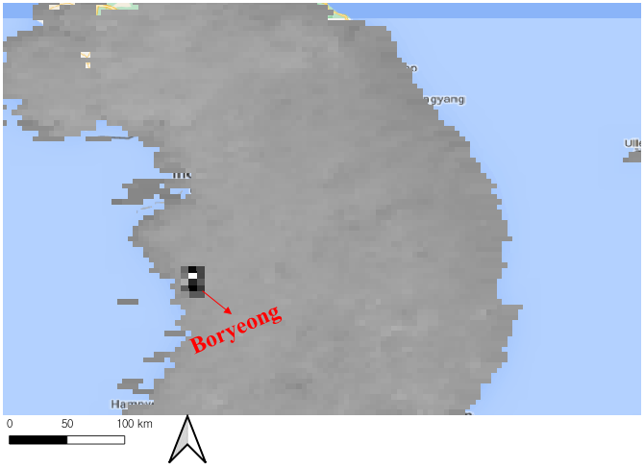
Figure 1. One scene of the LST band derived from the MODIS satellite image

As can be seen in Figure 1, then the LST of Boryeong areas was extracted from the given LST bands. Finally, the statistics of the seasonal LST in Boryeong were calculated.

RESULTS AND CONCLUSION
Table 1 shows the average LST in Boryeong in Spring, Summer, Autumn and Winter, 2017.

Date | LST
2017.04.07 (Spring) | 22.98
2017.08.05 (Summer) | 29.68
2017.10.20 (Autumn) | 20.72
2017.12.20 (Winter) | 3.44
Table 1. Average LST in Boryeong in Spring, Summer, Autumn and Winter, 2017.

As can be seen in Table 1, the LST in Boryeong is higher in Summer than other seasons. In future research, the relationship between LST and air temperature would be carried out.

ACKNOWLEDGEMENTS
This work was supported by KOREA Environment Industry & Technology Institute (KEITI) through Water Management Research Program, funded by Korea Ministry of Environment (MOE) (79627).

References from Journals:
National Aeronautics and Space Administration (NASA), 2020. MODIS. Assessed on October 20, 2020. https://modis.gsfc.nasa.gov/

