Urbanization and Population growth in Colombo Municipal Council: Urban Growth Analysis Using Geographical Information System (GIS) and Remote Sensing (RS)
D.S.Matharaarachchi
Department of Geography
University of Colombo, Colombo, Sri Lanka
Email- mataraarachchids@gmail.com
T.S Rathnayake
Computer teaching Unit,
University of Colombo, Sri Lanka

Abstract- As an Island Sri Lanka include in Developing country category. With the increasing of total population of country several semi urban areas become a city. The Maharagama, Homagama, Kadawatha and Nugegoda areas are some example for this situation. Urbanization is major problem in several countries of developing world, especially Asian countries. Major issues are; high population density, traffic congestion, environment pollution etc… The Colombo city is major and economical center of the Sri Lanka. It has two Divisional Secretariats as Colombo and Thimbirigasyaya and also had forty seven (47) Gramaniladari Divisions. According to the 2012 population census total population is 561,314.
According to this study the main objective is to analysis of population growth and urbanization. Basically Geographical Information System and Remote Sensing techniques were used for the goal that main object. Landsat TM and Land sat 8 (ETM+) images were used for the investigate urbanization and identify its geographical distribution. 1981 to 2012 census data were used for the analyze population growth. Raster analysis tool in ArcGIS 10.1 and image analysis techniques mainly used for this study. Used data are total population, population density, traffic density, land use and land cover of Colombo Municipal Council (MC) area.
According to the results total population and population density of MC area were increase by the year 1981 to 2002. But in year 2012 it was decrease with the exposing of semi urban area. In additionally satellite image analysis was clearly shows increasing of spatial distribution of urban area past decades.
Keywords – Urbanization, GIS and remote sensing, population
Urbanization and Population growth in Colombo Municipal Council: Urban Growth Analysis Using Geographical Information System (GIS) and Remote Sensing (RS)
D.S.Matharaarachchi
Department of Geography
University of Colombo, Colombo, Sri Lanka
Email- mataraarachchids@gmail.com
T.S Rathnayake
Computer teaching Unit,
University of Colombo, Sri Lanka

INTRODUCTION
Over the past century, world has been an increasing trend towards urbanization. In that case many people living close to town areas. Urbanization and environmental pollution connected with together. Man had so many needs. They tried to achieve their needs. In that case increase in environmental pollutions. In additionally the world had a largest history of urban growth. The term of urbanization originate from the Latin. It was created with interconnection of “Urbs” and “Action” (Manawadu.L, 2008). The Urbanization has had important consequences for many aspects of social, political, and economic life (Kleniewski & Thomas, 2011). Urbanization can be defined as the process by which rural communities grow to form cities, or urban centers, and, by extension, the growth and expansion of those cities (Mark.J, 2014). The world population less than 250,000 people and also cities population not exceeded over twenty thousand citizens were in around thousand years ago. But it was increased around sixteenth century with the population explosions. In 1900, only a handful of cities had populations over one million. At the beginning of the twenty-first century, roughly half of the world's population lived in urban areas. Anyhow the 2009 revision World Urbanization Prospects confirmed that the level of world urbanization crossed the 50 percent mark in 2009. According to the report, between 2009 and 2050, the world population is expected to increase by 2.3 billion, passing from 6.8 billion to 9.1 billion. At the same time, the population living in urban areas is projected to gain 2.9 billion, passing from 3.4 billion in 2009 to 6.3 billion 2050. In additionally in both Africa and Asia percent of the population continued to live in rural areas also.
Furthermore, the Colombo is largest city of the Sri Lanka. The city population was increase during the past four decades at the area. Majority of people comes as migrate for find good job and more facilities such as good schools for their child, good health facilities, transport availability etc… This research mainly focused to analyzed Urbanization and Population growth in Colombo Municipal Council using Geographical Information System (GIS) and Remote Sensing (RS).

STUDY AREA
Sri Lanka is an island situated in the tropics, between the latitudes of 6 and 10 degrees north just at the southern tip of India. It covers an area of 64,454 km² including the large inland water bodies, which constitute about 1,156 km². The island is pear-shaped, the maximum north-south distance being 435 km and the greatest east-west width being 225 km. The mountainous area in the south-central region, which rises to 2,500 meters, is surrounded on all sides by coastal plains, narrow in the west, east and south, but broadening to an extensive area in the north. The coastline of the country is about 1,600 km long (Mendis, 1998).
Colombo, the commercial capital of Sri Lanka is located on the southwestern coast of the island just south of the Kelani River. Colombo Municipal Council Area is situated between 78° 50׳– 79° 54׳ Eastern longitude and 6° 50’– 6° 60’ Northern latitude (Figure 1). The Study area falls within the Colombo district of the Western Province. The Colombo Core-Area (CCA) comprises the three contiguous Municipal Councils of Colombo; Colombo, Dehiwala-Mt.Lavinia and Kotte. Colombo Municipal Council Area (CMC) which has 47 municipal wards was selected for this study. It is bounded to the North by Kelani River, to the South by the Dehiwala Channel, to the East by the Kelaniya, Kolonnawa and Sri Jayawardhanapura Kotte Pradeshiya Sabha area and to the West by the Indian Ocean.

Figure 1: Study area
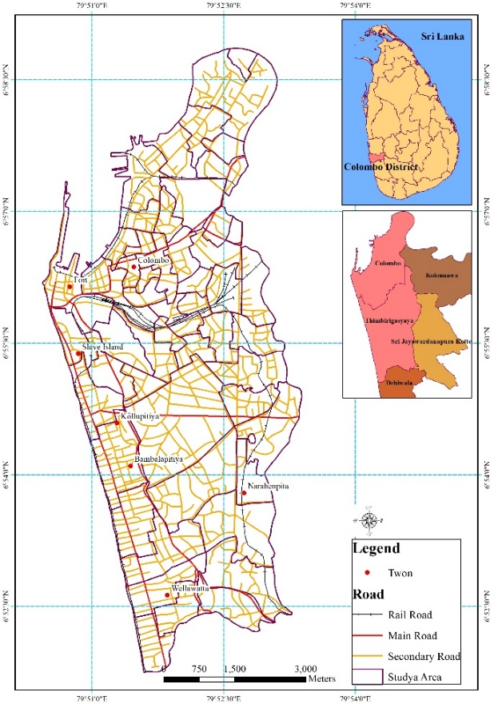

Data source: Survey Department, Sri Lanka, 2015
Prepared by Author based on Geographical Information System, 2018

The Colombo Municipal Council administrative area is extended over 3,729 Ha. According to preliminary estimates, the CMC reported a population of 1,000,000 in 2010. Table 1 shows total population and population growth in CMC area from 1871 to 2010.
Table 1: Population density and growth in Colombo
Census Year | Extent (Ha ) | Population | Density  (P/Ha ) | Growth Rate
1871 | 2,448.6 | 98,847 | 40 | -
1881 | 2,448.6 | 110,509 | 45 | 1.18
1891 | 2,448.6 | 126,825 | 52 | 1.48
1901 | 2,720.6 | 154,691 | 56 | 2.2
1911 | 3,091.1 | 211,274 | 68 | 3.66
1921 | 3,350.3 | 224,163 | 73 | 0.61
1931 | 3,368.4 | 284,155 | 84 | 2.67
1946 | 3,438.4 | 362,074 | 105 | 1.83
1953 | 3,593.9 | 425,081 | 118 | 2.48
1963 | 3,710.4 | 511,639 | 138 | 2.08
1971 | 3,711 | 562,430 | 152 | 1.24
1981 | 3,711 | 587,647 | 158 | 0.45
1994 | 3,729 | 721,443 | 193 | 1.75
2010 | 3,729 | 1,000,000 | 268 | 2.42
Source: Colombo Municipal Council, 2012

Anyway, with the increase of urban facilities many people attract to the city and they migrate to the city. The urbanization process was making environmental pollution at the city, specially air pollution and sound pollution.

OBJECTIV OF THE STUDY
The main objective of this study is to assessment of the urbanization and population growth in Colombo Municipal Council: Urban Growth Analysis Using Geographical Information System (GIS) and Remote Sensing (RS). In additionally describe the relationship between urban growth and land use change and increase of urban heat at the CMC Area.

DATA COLLECTION AND METHODOLOGY
This study was conceded using both primary and secondary data. The data collected from deferent government agencies, nongovernment agencies and online data basses. The satellite images were collected from www.usgs.org online data base. The image characteristics vivid in table 2.
Table 2: The satellite image characteristics
Year | Path and row | Sensor
1975 | p152r55 | Multispectral Scanner (MSS)
1992 | p141r55 | Thematic Mapper TM
2001 | p141r55 | Enhanced Thematic Mapper Plus (ETM+)
2013 | p141r55 | Operational Land Imager (OLI) and the Thermal Infrared Sensor (TIRS)
Source: www.usgs.org; prepared by author, 2018

Identification of Land cover and land surface temperature using landsat image
Land use pattern was identified using Normalize Difference Vegetation Index (NDVI). Equation 1 was used for the classification of NDVI. The Normalized Difference Vegetation Index (NDVI) is a measure of the amount and vigour of vegetation at the surface.
NDVI = (NIR — VIS)/(NIR + VIS)
NDVI = (Band 4 — Band 3)/(Band 4 + Band 3) (eq 1)
In additionally supervised classification techniques with Maximum Likelihood Classification algorithm also used to classify land cover category. The classification errors corrected with collected Global Positioning System (GPS) locations, identified locations of Google earth images. The accuracy assessment was done based on ERDAS IMAGINE 2014 software. All images were classified under the overall classification accuracy of 92% under the ERDAS IMAGING 2014.
In additionally Land Surface Temperature (LST) was calculate using Digital Number (DN) conversion and spectral radiation convention (equation 2) to black body temperature (equation 3) in Landsat images.
Conversion of Digital Number (DN) to Spectral Radiance

$Li=\frac{\left(Lmax-Lmin\right)DNi }{Range of Values }+Lmin$ (eq 2)
Li = Radiance of pixel
Lmax = Highest radiance measured by the detector/ Wm-2 sr-1
Lmin = Lowest radiance measured by the detector/ Wm-2 sr-1
DNi = DN value of pixel i
Conversion of the Spectral Radiance to Black Body Temperature
$T=\frac{K2}{\ln{[\frac{K1}{Lλ}+1]}}$ (eq 3)

T = Temperature in K
K1 = calibration constant 1 in W m-2 sr-1 (666.09)
K2 = calibration constant 2 in K (1282.7)
Lλ = spectral radiance in W m-2 sr-1
All the data analyzed by using ArcGIS 10.1 and ERDAS IMAGINE 2014 software.

RESULTS
According to the analysis of land cover classification area were classified three classes of land covers such as built up area, vegetation and water features also. The built-up area was increase temporally 1975 to 2013. In the vegetation areas were shows descries pattern in Colombo MC Area. Figure 2 shows spatial and temporal changes of the land use in Colombo MC Area. According to the analysis of land use changes of the area were identified built up area was increased gradually at the area and it was 45% to 85% increased during the 1975 to 2013 time period. In the other hand vegetation cover was decreased at the area. It is 40% to 10% above mention time period.
Furthermore, to the analysis of LST of the area were recorded between 22°C to 33°C. Figure 3 shows the spatial and temporal changes of LST at the Colombo MC Area. Some of the high temperature zones are shows in Fort, Maradana area. Generally, there was high building density (commercial and industrial) and traffic density in while the day. LST was an increasing past two decade. In 1987 high temperature recorded close to Fort and Maradana area. But it is increase step by step to the other area. Impact of that LST distribute to the South part of the CMC. In 2013 all the area of CMC generally LST was passed minimum 30°C while the day. In this situation called heat island effect.
With the increased of population at the area land used were changed gradually. Especially local government area of Modara, Maligawatta, Maradhana, Jindupitiya and Kotahena Gramaniladhari Divisions were identified as distribute of highest density of population. Figure 4 shows spatial distribution population density in the Colombo MC Area.
Finally, can conclude as land cover/ land use were change in past four decade in CMC Area. The general trend was observed in the built-up areas increase temporally. The vegetation cover was decrease step by step in this commercial area. In effect of this case there was no natural filtration in Carbon particles.
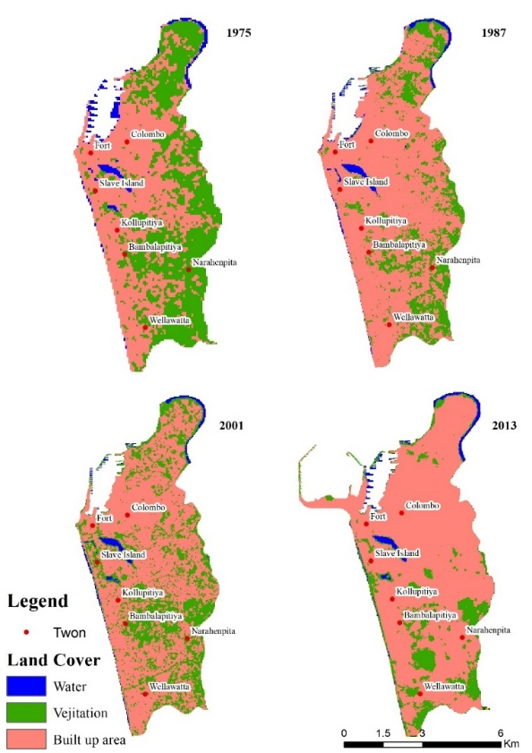
Figure 2: Temporal changes of land use in Colombo MC Area
Vegetation

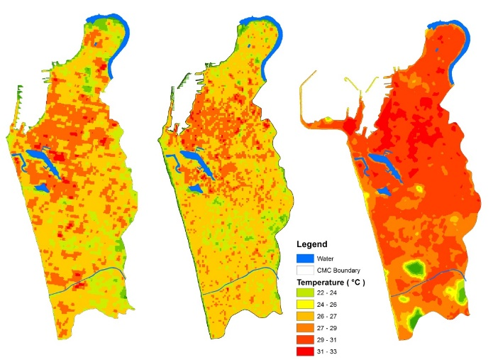

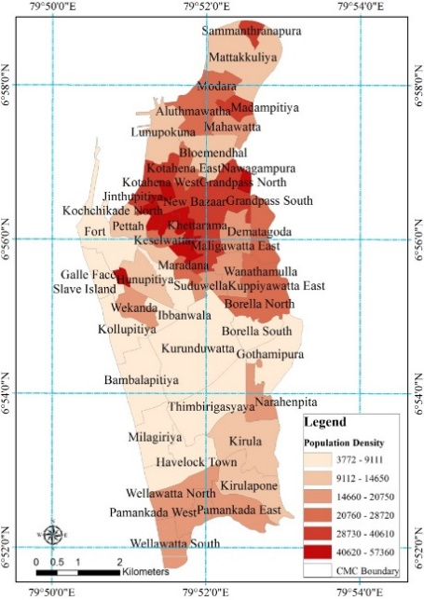
Figure 3. The spatial and temporal changes of land surface temperature (LST) in Colombo MC Area

Figure 4. The spatial and temporal changes of land surface temperature (LST) in Colombo MC Area

REFERENCES
L. Manawadu and L. Nirosha, “Third world urbanisation”, Colombo, Sri Lanka, 2008.
N. Kleniewski and A.R.Thomas, Cities, change, and conflict (4th ed.). Belmont, CA: Wadsworth. 2011.
Joshua J. Mark, “Urbanization”, https://www.ancient.eu/urbanization/, 2014. Last accsess 23.09.2018.
Wicramasinghe H. Rohan, “Contemporary Enviroment Challenges”, Institute of Environmental Studies. Pg 9-21. 1998.

