GROUND VALIDATION OF IMERG MONTHLY RAINFALL PRODUCT OVER INDONESIA

I Wayan Andi Yuda (1)(4), Rakhmat Prasetia (1), Abd. Rahman As-syakur (2), Takahiro Osawa (3), Masahiko Nagai (4)

¹ The Agency for Meteorology, Climatology, and Geophysics of the Republic of Indonesia (BMKG), Jalan Leli No. 9 B.B. Agung, Negara, Bali 82212, Indonesia
² Environmental Research Center (PPLH), Udayana University, P.B. Sudirman Street, Denpasar, Bali, Indonesia
³ Center for Remote Sensing and Ocean Sciences (CReSOS) Udayana University, Indonesia
⁴ Graduate School of Sciences and Technology for Innovation, Yamaguchi University, Japan
Email: andiyudaiwayan@gmail.com; assyakur@unud.ac.id

KEYWORDS: Rainfall, IMERG, Validation

ABSTRACT: The Integrated Multi-Satellite Retrieval for GPM (IMERG) final rainfall product was validated using ground rainfall data in the Indonesian territory for five years from 2015 to 2019. This study evaluated IMERG's performance in describing monthly characteristics of rainfall variation over two major spatial approaches: elevation and rainfall pattern regions in the study area. Statistical validation is employed in the form of linear correlation coefficient (r), Mean Bias Error (MBE), and Root Mean Square Error (RMSE). The analysis, which concentrated on April 2014 to March 2019, showed that 96% of 154 total validation locations have a high correlation score between IMERG and rain gauges (r = 0.5 – 0.97). IMERG consistently overestimated rainfall on all elevation classes except on common plains area. In this hilly area, RMSE tends to become more substantial, and MBE becomes negative. IMERG correctly identified monthly time series patterns and monthly mean patterns of rainfall in Indonesia's three distinct rainfall regions. However, the overestimated condition tends to occur in the dry season period.

INTRODUCTION

Rainfall is an essential meteorological element in the tropics such as Indonesia's maritime continent and observed by observers at weather observation stations every day. The data and information on rainfall need various kinds of human activities such as agriculture, plantations, fisheries, transportation (land, sea, air), and others (Prawirowardoyo, 1996). Many Indonesian region locations are very vulnerable to rainfall conditions (BMKG, 2003; Swarinoto, 2006). Normal rainfall conditions often cause floods and landslides, and in the opposite situation, below-average rainfall causes dryness. Both conditions result in a decrease in food production. For areas prone to these conditions, water management is vital to be provided (Swarinoto, 2001).

The interaction between the atmosphere and the sea around Indonesia, such as the El Niño-Southern Oscillation (ENSO) and Indian Ocean Dipole (IOD) events, affects the rain variability in Indonesia (Aldrian and Susanto, 2003; Aldrian et al., 2007; Saji et al., 1999). With the high level of atmospheric variability, the analysis of rainfall in Indonesia requires long observations with adequate representation of data distribution. Rain gauges in each rain observation station are useful and relatively accurate in describing rain conditions in a place. However, the rainfall station is not evenly well distributed, especially in areas with rugged topography, uninhabited areas, and ocean, resulting in reduced accuracy, especially in the distribution of spatial rainfall patterns. This condition affects the prediction of rain by using various climate model applications (Feidas, 2010). The possibility of obtaining rainfall data needed in various scientific applications could receive from meteorological satellites. Rainfall products from the satellite are essential precipitation data in hydrology, climatology, and meteorology studies for the last few decades. Applications of satellite rainfall products are rapidly increasing due to their extensive spatial coverage, continuous measurement, the fact that they are free of charge, and some products' availability in nearly real-time via the internet. Most importantly, the satellite precipitation product could overcome the spatial coverage limitation of point-based ground observations in less accessible mountainous and oceanic regions (Tan et al., 2017).

The new generation of weather observatory satellites, namely Global Precipitation Measurement (GPM), is an international mission to provide next-generation observations of rain and snow after the Tropical Rainfall Measurement Mission (TRMM) era. NASA and the Japan Aerospace Exploration Agency (JAXA) launched the GPM Core Observatory satellite on February 27th, 2014, carrying advanced instruments to set a new standard for precipitation measurements from space. The Integrated Multi-satellite Retrievals for GPM (IMERG) products provide better spatial (0.1°) and temporal (30 min) resolutions than the TRMM and Multi-satellite Precipitation Analysis (TMPA) products. Besides, the coverage of the IMERG (60°N–60°S) is also more extensive compared to the TMPA products (50°N–50°S). IMERG is presently available from mid-March 2014 to the present (with access delay in the order of about three months for the final run version).

The performance of IMERG in depicting precipitation features over various areas have been examined. In the United States, Sungmin and Kirstetter (2018) showed that IMERG precipitation estimates could be a reliable alternative to ground-based measurements even at the sub-daily scale, IMERG substantially overestimates normalized amplitude of diurnal precipitation in the central U.S., while it tends to underestimate diurnal variations over the mountain regions. Gaona et al. (2017) found that IMERG underestimation bias is small enough to propose it as a reliable source of precipitation data in a mid-latitude country such as the Netherland. In Singapore, IMERG correlated well with gauges measurements monthly but moderately on a daily scale (Tan and Duan, 2017). They also identified that IMERG overestimated moderate precipitation events (1–20 mm/day). Xu et al. (2017) highlighted the superiority of GPM to TRMM in the southern Tibetan Plateau region. Also, they recommended that further improvement of the rainfall retrieval algorithm is needed by considering topographical influences for both GPM and TRMM rainfall products. In the India monsoon area, Prakash et al. (2017) showed that the IMERG estimates represent the mean monsoon rainfall and its variability more realistically. However, rainfall estimates show an exceptionally smaller correlation coefficient, larger RMSE, more considerable negative total bias over northeast India, where orographic effects dominate precipitation.

Other areas such as Ethiopia (Sahlu et al., 2016), Taiwan (Huang et al., 2018), and Brazil (Salles et al., 2019) have also validated the IMERG product. However, the capability of IMERG in illustrating precipitation variations over the Indonesian maritime continent (i.e., the area of interest in this study) has not been evaluated in detail by these documented studies or by other classes; therefore, this subject examined herein.

METHODOLOGY

  - IMERG Rainfall data

The Integrated Multi-satellite Retrievals for GPM (IMERG) is an algorithm to combines information from the GPM satellite constellation into precipitation estimates over the majority of the Earth's surface (Huffman et al., 2018). IMERG uses the GPM constellation configuration to inter-calibrate precipitation data from all constellation radiometers. Temporal and spatial gaps in the IMERG microwave precipitation estimates are filled by morphing the estimates in between the microwave overpasses and incorporating infrared satellite imagery (I.R.) estimates with a Kalman-filter where the gaps are too long (over about 3 hours) to produce 0.1°x 0.1° half-hour global products (Jackson et al., 2017). IMERG products are available in the form of IMERG-E, IMERG-L, and IMERG-F. Those three terms are explained as follows: "Early" multi-satellite product is produced 4 hours after observation time, "Late" multi-satellite product is delivered 12 hours after observation time, and once after the monthly gauge analysis is received "Final" satellite-gauge product is available three months after the observation. The IMERG-F or research products are produced by The NASA Precipitation Processing System (PPS) when all the required high-quality ancillary and geolocation data are received with the objective of accuracy, completeness, and consistency. The detailed characteristics of IMERG-F (Huffman et al., 2018) used in this study were shown in Table 1 below.

Table 1 IMERG Level 3 Final Run specification used in this research
Algorithm | Integrated Multi-satellite Retrievals for GPM
Basic acronym | IMERG
Data sets | 3IMERGHH/3IMERGM Final Run multi satellite-gauge combination
Spatial grid; Coverage | 0.1°x0.1° lat/lon; 14°S - 8°N/ 90°E - 142°E
Version | 06A
Time interval; span | • daily; April 2014-March 2019  • monthly; April 2014-March 2019
Latency | Final 3.5 month after the month's end

  - Ground rainfall observation data

This study covers an area between 14°S to 8°N and 90°E to 142°E (Figure 1). Geographically, the site belongs to Indonesian territorial (colored map). Rainfall data on 154 locations of rain gauges obtained from the Agency for Meteorology, Climatology, and Geophysics of the Republic of Indonesia (BMKG) spread across 34 provinces in Indonesia. The monthly data were accumulated from daily observations by standard manual (Observatory) and automatic (Hellmann) rain gauges. The analysis concentrated on the period of April 2014 to March 2019. The months that contain missing value were removed and were not used in the validation process. Some of these rain gauge locations are on Indonesia's large islands. Some others are on small islands. In addition to variations in island size, the rain gauge location varies according to the elevation, as shown in Figure 1.
Most of these rain gauge locations represent the three significant groups of rain patterns in Indonesia (Figure 2). Region A has one peak of wet season around December-February and one peak of the dry season around June-August, and it forms U-shape. This region experiences strong influences of two monsoons, namely the wet northwest (N.W.) monsoon from November to March (NDJFM) and the dry southeast (S.E.) monsoon from May to September (MJJAS). Region B has two peaks of rainfall in October–November (ON) and March to May (MAM). This Equatorial pattern is caused by the sun's annual movement, which the equator has twice in the past year. The convection center point's movement brings about a cross-continent convective cloud formation area known as Inter-Tropical Convergence Zone (Bayong, 1999). Besides, the Indian Ocean's westerly wind also carries water vapor toward the Maritime Continent, especially in spring and autumn (Wyrtki 1961, Hastenrath and Lamb 2004). Region C has one peak from June to July (J.J.) and one trough (November–February). According to Aldrian and Susanto (2003), this pattern anomaly is more caused by ocean currents in the area called Indonesian Through Flow (ITF). In the middle of the year, warm ocean currents flow from the warm pool area north of Irian Island into the north Maluku sea. As a result, this area experiences the peak of the rainy season. So with these field data, IMERG's rainfall product accuracy will be tested based on location elevation and three different rainfall regions in Indonesia. Further explanation will be given in the validation method section.

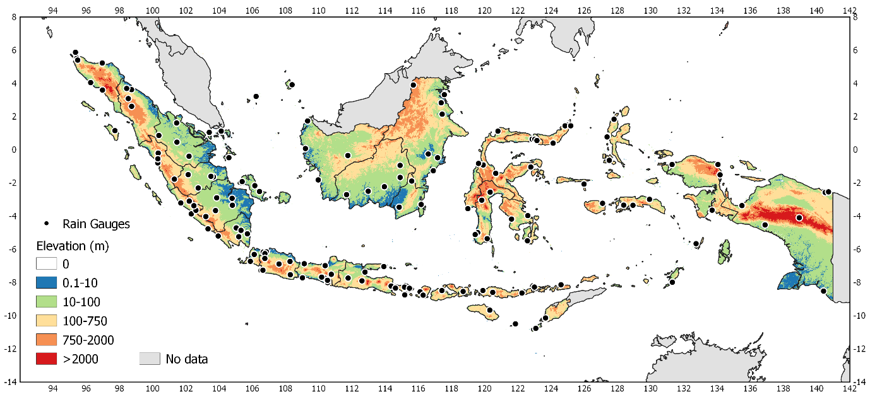
Figure 1 Research area

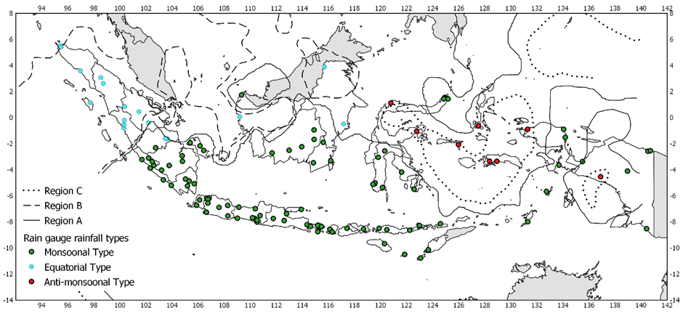
B
A
C
Figure 2 Distribution of rain gauge locations based on three rainfall pattern types in Indonesia

  - Validations

Statistical validations are used for validating IMERG rainfall product in this research are:
Linear Correlation Coefficient (r): this analysis was performed to determine the relationship between rainfall from IMERG and in situ data. The cross-correlation analysis can identify how the validity of rainfall data from IMERG. The equation (Feidas, 2010) used in the study is the linear correlation coefficient (r).
(1)

Mean Bias Error (MBE) and Root Mean Square Error (RMSE): this analysis used to find out how much the average error value between the data from IMERG and in-situ data. The equation (Feidas, 2010) used are:
(2)

(3)

Where $S_{i}$ are the estimated values (satellite data), $G_{i}$ are the reference gauge values, ${}_{S}$ and ${}_{G}$ are their standard deviations (respectively), and n is the number of data pairs. The correlation coefficient (r) measures the degree of linear association between the estimated and observed distributions. The MBE represents the systematic component error by overestimating or underestimating the gauge data by the satellite estimates. The RMSE involves the departures' square from reality and, therefore, is sensitive to extreme values.

The validation was conducted based on two major approaches: topographical and rainfall pattern zoning on the study area. The elevation classification was based on the rain gauges' location and the consideration of the number of rain gauges available in each class (Table 2). Besides the elevation based validation, IMERG data was also validated to rainfall data in three types of Indonesian rain patterns. Not all observational data were used for this purpose because several rain gauge locations were located between two areas of rainfall pattern, from 154 rain gauge stations on existing data selected to only 119 stations that match the location criteria and rain patterns. The distribution of validation locations is 94 stations located in parts of Indonesia, which covers the monsoonal types (A), 17 stations located at the Equatorial types (B), and eight stations located at anti-monsoonal types (C). Figure 2 showed the rain gauge station's distribution according to monsoonal type, semi-monsoonal type, and anti-monsoonal type of rainfall. Point-by-point analysis and spatial analysis were applied to the monthly data (As-syakur et al. 2011). The point-by-point analysis consisted of a comparison between gauge data coordinates with satellite data corresponding pixel. The average spatial analysis consisted of a spatial average of all rain gauge locations compared to all corresponding pixels of satellite data based on the Indonesia rainfall region.

RESULTS

Monthly point by point time-series validation

Figure 3 shows the Time series of monthly rainfall points between IMERG and rain gauge data based on 154 locations in five-year records. In general, point-by-point analysis results indicate that the relationship between IMERG with rain gauge is medium to very high (0.41 to 0.96). The time series of monthly rainfall showed 128 point gauges have a very high correlation (r > 0.7), 20 point gauges with high Correlation (r=0.5-0.699), and only six rain gauge locations have medium correlation (r = 0.43 – 0.499). It can be boldly stated that 96% of total validation locations show a high compatibility level between IMERG and rainfall observations in the field. The point-by-point error statistical results show RMSE of 154 point gauges varied between 22% – 205%. The majority of validation locations (98 rain gauges) have RMSE less than 50% from their monthly rainfall average. Fifty point gauges have RMSE between 50% - 100%, and only 6 locations have RMSE more than 100% from their monthly rainfall average.

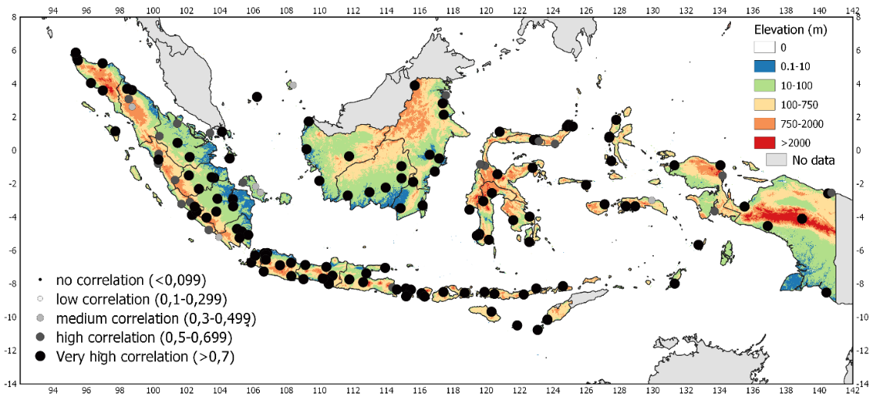
Figure 3 Monthly point by point correlation between IMERG and rain gauge data period April 2014 to March 2019

Table 2 shows statistical scores of validation adapted to the rain gauge locations elevations. Slightly varying results in the accuracy of IMERG in distinct elevation classification was discovered. The best accuracy of IMERG occurs in low land areas with a very high correlation score (r=0.80), and the RMSE score was 88.09 mm/month. The characteristic of the IMERG rainfall value on lowland rainfall observation shows an overestimated trend. Nearly similar results were obtained in rainfall data near the coast and medium plains area. The corresponding correlation values were 0.79, and 0.80 with RMSE were 93.42 mm/month and 106.17 mm/month, respectively. The statistical error value in the coastal area has a similar character to the lowlands.
Furthermore, the lowest correlation value found in the highland area with an R score was 0.75. The recorded statistical error values were 99.79 mm/month for RMSE and 17 mm/month for MBE, which indicate an overestimation of rainfall condition. In contrast, significant differences were found in the medium plains' IMERG data characteristics, which has a lower value than the observed value (MBE = -17.31 mm/month).

Table 2 Validation of IMERG in Indonesia based on elevation
Elevation (m) | Classification | Number of rain gauge | r | MBE | RMSE
0.1 - 10 | Coastal area (very low land) | 41 | 0.79 | 21.47 | 93.42
10.1 - 100 | Lowland | 78 | 0.80 | 19.77 | 88.09
100.1 - 750 | Medium plains | 22 | 0.80 | -17.31 | 106.17
750.1 - 1656 | Highlands | 13 | 0.75 | 8.53 | 99.79

Monthly rainfall spatially averaged validation on three rainfall regions in Indonesia

The second result of the validation processes was comparing averaged rainfall data spatially within each rain type. Figure 4 showed the average time series monthly rainfall measured by IMERG and rain gauges in region A, region B, and region C. The pattern of averaged time-series monthly rainfall from IMERG was quite similar to gauge data in Indonesia's unique rainfall region. Table 3. showed statistical validation results. In Monsoonal type (region A), the average monthly rainfall from IMERG was 212.09 (mm/month). Meanwhile, the average monthly rainfall from the rain gauge time series was 201.99 (mm/month). The spatially averaged time-series monthly rainfall relationship between IMERG and rain gauge has a very high correlation (r=0.99) with RMSE was 8.34%, and the MBE score was 5.08%. In the Semi-monsoonal type (region B), the average monthly rainfall from IMERG and rain gauge were 212.09 (mm/month) and 201.99 (mm/month), respectively. The spatially averaged time-series monthly rainfall relationship between the two datasets has a very high correlation (r=0.99), and RMSE was 8.34%. The MBE score was 5.08%, indicating overestimation slightly from IMERG data to ground references. In the Anti-monsoonal type (region C), the same as other regions, the rainfall pattern was almost identical, although IMERG average rainfall was higher than rain gauge average rainfall. IMERG averaged data was 221.44 mm/month while ground observation rainfall average in Region C was 203.7 mm/month. Statistical scores indicated a very high Correlation (r = 0.93) between satellite data and ground reference data. The score of RMSE and MBE was 19.77% and 9.04%, respectively.

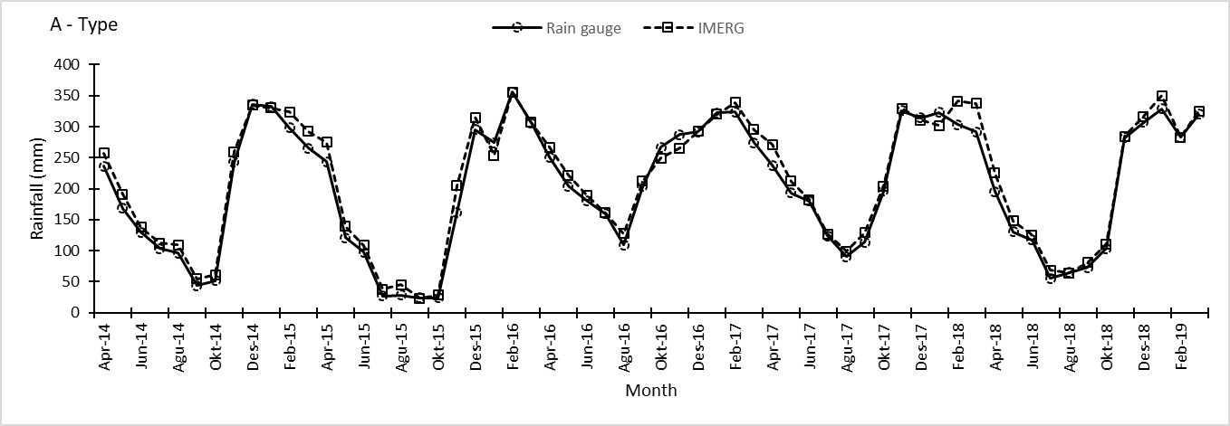
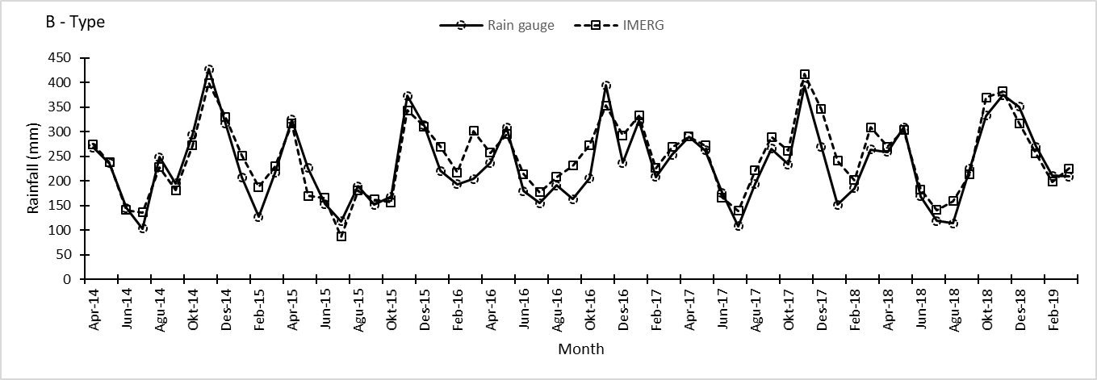
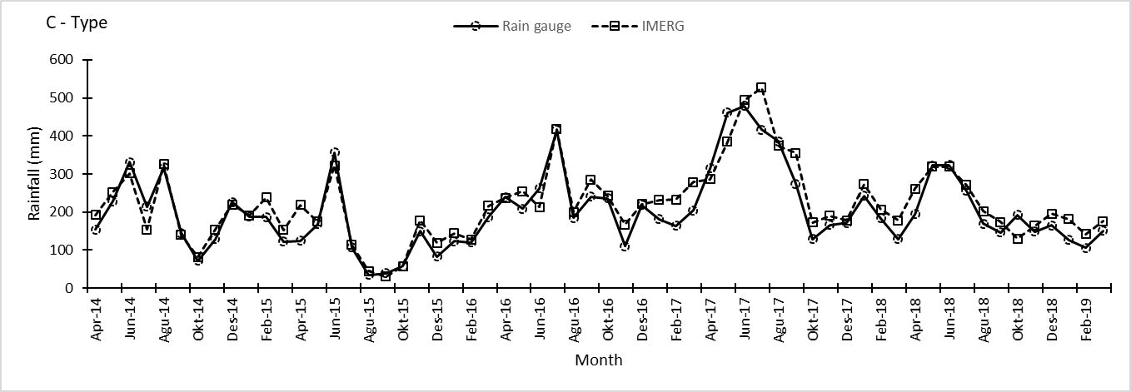
Figure 4 Comparison of monthly rainfall spatially averaged time series from IMERG and rain gauges in Monsoonal type (A), Semi-monsoonal type (B), and Anti-monsoonal type (C) on period April 2014 to March 2019

Figure 5 shows the monthly relationship between measured by IMERG and rain gauge in regions A, B, and C for five years averaged. This analysis shows the ability of IMERG to describe the annual rainfall pattern in the Indonesian territory. In region A, IMERG data showed perfect agreement with the ground reference giving a very high Correlation (r=0.997), and RMSE was 13.0 mm/month (table 4). Statistical mean bias error value (10.55 mm/month) indicates that IMERG data was higher than average rainfall on ground references. This condition dominantly occurred from February to September. In region B, which has two peaks of rainfall in a year, IMERG followed this double peaks rainfall pattern well (Figure 5). The Correlation was very high (r=0.976) and RMSE only 20.69 mm/month (Table 4). Almost the same as region A, monthly mean IMERG data in this region also higher than ground observation (MBE = 14.05 mm/month) but the period of significant gap occurred from December to March and July to October. The annual pattern of area C from IMERG has produced a similar pattern to the rain gauge rainfall annual data pattern (Figure 5). The Correlation was very high (r=0.97), and RMSE was 25.62 mm/month (Table 4). The Mean Bias Error showed a positive score (18.36 mm/month), indicating overestimation from IMERG to ground rainfall observation. The period of significant deviation between these two data occurred from November to April.

Table 3 Statistical monthly time series validation results between IMERG and rain gauge data, spatially average based on Indonesian Rainfall Pattern
Type | Rainfall Average (mm/month) |  | r | MBE (%) | RMSE (%)
 | Rain gauge | IMERG
A | 201.59 | 212.09 | 0.99 | 5.21% | 8.60%
B | 233.58 | 247.56 | 0.92 | 5.99% | 14.67%
C | 203.07 | 221.44 | 0.93 | 9.04% | 19.77%

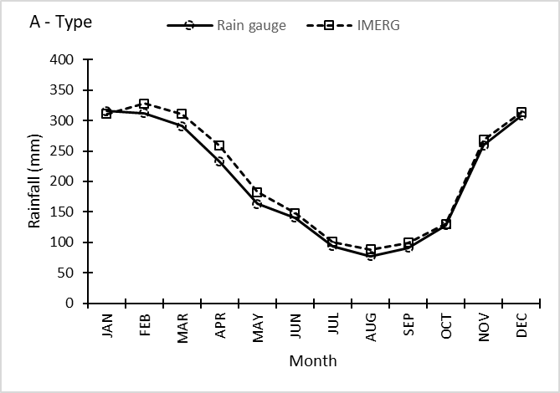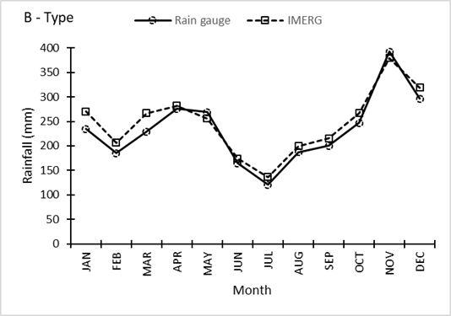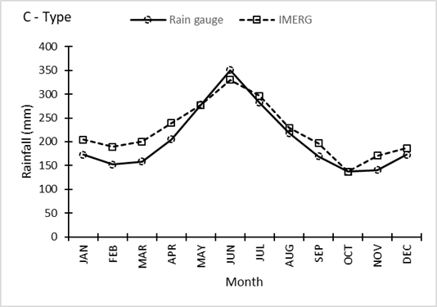
Figure 5 Comparison of annual pattern of IMERG and rain gauge rainfall data in Monsoonal type (A), Semi-monsoonal type (B), and Anti-monsoonal type (C) averaged on period April 2014 to March 2019

Table 4 Statistical annual pattern validation results between IMERG and rain gauge data
Type | r | MBE | RMSE
A | 0.996 | 10.48 | 13.27
B | 0.976 | 14.05 | 20.69
C | 0.970 | 18.36 | 25.62

SUMMARY

The distribution of monthly rainfall by satellite data showed high compatibility with ground references almost in all validation areas. The IMERG data depicted rainfall conditions on the local site (point by point) in Indonesia, which has many islands, variations in the topography, and the seas' influence around Indonesia. Only a few local areas where rainfall could not be adequately captured by IMERG (only 4%). Based on the elevation approach, the result described that the IMERG product did not show a significant difference in estimating monthly time series rain patterns in a coastal area, lowland, medium plains, and highlands by ranging the high correlation result. Furthermore, IMERG consistently overestimated rainfall on all elevation classes except on medium plains area. In this hilly area, RMSE tends to become more extensive, and MBE becomes negative. This result indicated that the IMERG product encountered difficulties estimating rainfall on the hilly area or mountain foothill. Prakash et al. (2018) also showed that IMERG has a larger RMSE and more massive negative total bias over Himalayan foothills and northeast India. Satellite precipitation estimates are still somewhat uncertain in areas where precipitation is dominated by the orographic effect (Navarro et al., 2019).

A further step in evaluating the performance of IMERG was the analysis of monthly time series data spatially averaged in three distinct rainfall pattern regions in Indonesia. The distribution of monthly rainfall by satellite data showed an overestimated condition in monsoonal type (region A), equatorial type (B), and anti-monsoonal type (C). Based on the statistical results, the satellite performed a better estimation of rainfall for the wet season than the dry season period. The distribution of satellite rainfall was mostly underestimating during the wet season whereas overestimating during dry seasons. This pattern has also been found in Singapore (Tan and Duan, 2017), and a similar result in Brazil (Salles et al., 2019). IMERG encountered difficulties in estimating rainfall in the dry period, when rainfall events characteristics were generally less intense, lower volume, and more sparsely distributed across the territory.

The annual pattern from spatially averaged rainfall provided by IMERG indicated the near-perfect capability of this data to figure out the main ways of monthly rainfall, which significantly similar to ground data. This situation indicates that IMERG products can use to determine annual climatic characteristics. The monthly average rainfall relationship measured by IMERG and rain gauge showed good agreement with the ground reference giving very high Correlation (r=0.97-0.99), and RMSE was less than 25 mm/month. These results indicated that IMERG data has good prospects as a source of rainfall data for remote areas that are difficult to reach or locations that do not yet have rain observation network infrastructure. Furthermore, the IMERG product can be used to find rainfall patterns in areas with a rain gauge.

ACKNOWLEDGMENTS

This research was supported by Agency for Meteorology, Climatology, and Geophysics of the Republic of Indonesia (BMKG) Centre for Remote Sensing and Ocean Sciences (CReSOS) Udayana University, and Yamaguchi University. The authors are thankful to GPM‐IMERG data providers for making it available to carry on this study (https://pmm.nasa.gov/gpm).

REFERENCES

Aldrian, E., and Susanto R.D., 2003. Identification of Three Dominant Rainfall Regions within Indonesia and Their Relationship to Sea Surface Temperature. International Journal of Climatology 23, pp. 1435–1452.
Aldrian, E., Gates LD., and Widodo FH., 2007. Seasonal variability of Indonesian rainfall in ECHAM4 simulations and the reanalyses: The role of ENSO. Theoretical and Applied Climatology. 87, pp. 41–59.
As-syakur, AR., Tanaka T., Prasetia R., Swardika IK, Kasa IW., 2011. Comparison of TRMM multi-satellite precipitation analysis (TMPA) products and daily–monthly gauge data over Bali. Int J Remote Sens. 32, pp. 8969–8982
Bayong, T.H.K., 1999. Klimatologi Umum (General Climatology). Institut Teknologi Bandung, Bandung
BMKG, 2003. Prakiraan Musim Untuk Pertanian Di Kabupaten Indramayu. Laporan Penelitian TA 2003. Jakarta: PUSAT SISDATIN Klimatologi dan Kualitas Udara BMKG
Feidas, H., 2010. Validation of Satellite Rainfall Products Over Greece. Theoretical and Applied Climatology 99 (2010), pp. 193–216.
Gaona, MFR., Overeem A., Leijnse H., Uijlenhoet R., 2016. First-year evaluation of GPM rainfall over the Netherlands: IMERG day 1 final run (VO3D). J. Hydrometeorol. 2016, 17, pp. 2799–2814
Hastenrath, S., and Lamb PJ., 2004. Climate Dynamics of Atmosphere and Ocean in The Equatorial Zone: A Synthesis. Int. J. Climatol. 24, pp. 1601-1612
Huang, WR., Chang YH., Liu PY., 2018. Assessment of IMERG precipitation over Taiwan at multiple timescales. Atmos. Res., 214, pp. 239-249
Huffman, GJ., Bolvin DT., and Nelkin EJ., 2018. NASA Global Precipitation Measurement (GPM) Integrated Multi-satellite Retrievals for GPM (IMERG). Retrieved April 1st, 2020
from https://gpm.nasa.gov/sites/default/files/document_files/IMERG_ATBD_V5.2_0.pdf
Jackson, G.S., and Coauthors., 2017. The Global Precipitation Measurement (GPM) Mission for Science and Society. Bull. Amer. Meteor. Soc., 98, pp.1679–1695
Navarro, A., Garcia-Ortega E., Merino A., Sanchez JL., Kummerow C., Tapiador FJ., 2019. Assessment of IMERG Precipitation Estimates over Europe. Remote Sens. 2019, 11(21), pp. 2470
Prakash, S., Mitra AK., AghaKouchak A., 2018., A preliminary assessment of GPM-based multi-satellite precipitation estimates over a monsoon dominated region. Journal of Hydrometeorology, 556, pp. 865–876.
Prawirowardoyo, S., 1996. Meteorologi. Institut Teknologi Bandung, Bandung
Sahlu, D., Nikolopoulos EI., Moges SA., Anagnostou EN., Hailu D. 2016. First evaluation of the day-1 IMERG over the upper Blue Nile Basin. J. Hydrometeorol. 2016, 17, pp. 2875–2882
Saji, NH., Goswami BN., Vinayachandran PN., and Yamagata, T., 1999. A Dipole Mode in the Tropical Indian Ocean. Nature 401 (1999), pp. 360-363
Salles, L., Satgé F., Roig H., Almeida T., Olivetti D., Ferreira W., 2019. Seasonal Effect on Spatial and Temporal Consistency of the New GPM-Based IMERG-v5 and GSMaP-v7 Satellite Precipitation Estimates in Brazil's Central Plateau Region. Water, 2019, 11, pp. 668.
Swarinoto, YS., 2001. Downscaling of wind and precipitation over Indonesia. Report of an intensive course on dynamical downscaling of seasonal to interannual climate prediction. Ward M.N. & Sun L. (Ed.). The International Research Institute for Climate and Society, Palisades, New York, USA, pp. 85-101.
Swarinoto, YS., 2006. Analisis Pola Spasial Curah Hujan Jawa Barat Bagian Utara dan Prediksinya. Tesis Magister. Depok: Jurusan Geografi, FMIPA-UI.
Tan, ML., and Duan Z., 2017. Assessment of GPM and TRMM Precipitation Products over Singapore. Remote Sens., 2017, 9, pp. 720.
Tan, ML., Tan KC., Chua VP., Chan NW., 2017. Evaluation of TRMM product for monitoring drought in the Kelantan River Basin, Malaysia. Water, 2017, 9, pp. 57.
Wyrtki, K., 1961. Physical oceanography of the Southeast Asian waters. In Scientific Results of Maritime Investigations of the South China Sea and Gulf of Thailand 1959–1961. Naga Report 2. University of California/Scripps Institute of Oceanography, pp. 195.
Xu, R., Tian F., Yang L., Hu H., Lu H., Hou A., 2017. Ground validation of GPM IMERG and TRMM 3B42V7 rainfall products over southern Tibetan plateau based on a high-density rain-gauge network. J. Geophys. Res. Atmos. 122, pp. 910–924

