APPLICATION OF GIS AND REMOTE SENSING FOR LANDSLIDE DISASTER RISK ASSESSMENT IN MASINLOC, ZAMBALEZ, PHILIPPINES
A.M. Paz-Alberto (1), E.E. Camaso (1), K.M. Mapanao (2) and C.R. Genaro (2)
¹Institute for Climate Change and Environmental Management, Central Luzon State University. Science City of Muñoz, Nueva Ecija, Philippines (anniealberto@clsu.edu.ph, eecamaso@clsu.edu.ph)
²Project Technical Staff, Institute for Climate Change and Environmental Management, Central Luzon State University. Science City of Muñoz, Nueva Ecija, Philippines (mapanao.kathrina@gmail.com, christophergenaro@clsu.edu.ph)

KEYWORD: Hazard Assessment, Landslide Mapping, Vulnerability
ABSTRACT: Landslide hazard potentially damage and quantifying area and population, particularly of severely affected rural communities in remote areas is difficult. This study provides valuable insights into landslide risk and vulnerability analyses. The vulnerability and landslide disaster risk assessment was performed using Geographic Information System (GIS) and remote sensing. The landslide hazard map used in the current work is obtained from Project NOAH. Subsequently, the vulnerability value was computed using different parameters, and then an integration of vulnerable areas at risk and the hazard map was conducted to determine the expected area that would likely be under direct risk. Results showed that approximately 66.04 hectares were found to be at risk by landslide hazard with a total of 2738 household. The results showed the capability of the method to approximately predict the area and the population under landslide risk in data-scarce environments. The communities will be resilient to the changing climate by being informed on their environmental conditions.

INTRODUCTION
Mountains can be dangerous places. Many mountain communities live under the threat of earthquakes and rainfall-induced landslides transform into debris flows as they travel down steep slopes. Population growth, climate change and unsustainable natural resource management practices are putting dangerous pressure on the mountain ecosystems and making mountain communities increasingly vulnerable to disasters (FAO, 2015).
United Nation Framework Convention on Climate Change (UNFCCC) emphasizes that change of climate is attributed directly and indirectly to human activities that alter the composition of the global atmosphere. The frequency of destructive events related to atmospheric extremes (such as floods, drought, cyclones, and landslides) is also increasing (EM-DAT, 2009).The starting point for reducing disaster risk lies in the knowledge of the hazard and vulnerability and of the ways in which these are changing in the short and long term, followed by action taken on the basis of that knowledge (UNISDR, 2005).

Landslide hazard is the probability of occurrence of a potentially damaging landslide of a given magnitude within a specified period (temporal) and area (spatial) (Glade et al. 2005). Rainfall-triggered landslides are amongst the most frequent types, as well as the most devastating hazards, which cause extensive devastation to lives, properties and infrastructures worldwide [9–13]. Landslides affect exposed populations worldwide, causing damage, fatalities and injuries. Quantifying economic losses, particularly of severely affected rural communities in remote areas, is generally difficult (Sassa & Canuti 2008). Landslide risk mapping should be aimed to reduce the disaster risk. Risk results from the combination of hazards, conditions of vulnerability and insufficient capacity or measures to reduce the potential negative consequences of risk (O'Keefe, Westgate and Wisner, 1976).
In this framework, the system of hazard mapping, vulnerability and risk assessment have to be properly developed in an efficiently manner for better management of the landslide disaster in the future.

METHODOLOGY
Data
The following data were gathered from the municipalities of Masinloc, Zambales: a) Municipal agricultural profile; b) Population; c) Disaster risk reduction and mitigation plans; d) History of destructive events in the municipality such landslide; e.) Comprehensive Land Use Plan (CLUP); f) Areas (barangays) that are affected by the natural hazards. These data were used to establish the profile of the municipality and were used for the vulnerability assessment. The total study area was measured using a virtual fishnet square grid.
Hazard Assessment
Landslide hazard susceptibility maps were obtained from Project NOAH. Hazard assessment was done to identify the hazards that occurred in the past and may occur in the future for various coastal ecosystems and coastal communities. This element of the methodology is an imperative procedure to determine the risk. The assessment was the basis for prioritization of projects and programs and the implementation of appropriate adaptation measures.

Vulnerability Assessment

The data required for vulnerability mapping are Settlements, Extent of cultivated agricultural lands, Awareness of exposed population, Alert and preparedness system for seismic activity and etc. that overall represents their coping capacity.

This study adopted the methodology developed by Espaldon et al. (2016). Vulnerability index score was computed using equation devised by Hoeurn (2013) (Equation 2):

$V_{i}=\frac{E_{i}+S_{i}+{AC}_{i}}{3}$
Equation 1

Where:
Vi = vulnerability index score in grid i
Ei = exposure index score in grid i
Si = sensitivity index score in grid i
ACi = adaptive capacity index score in grid i

Disaster Risk Assessment

Disaster risk index score of each grid was computed using Equation 2:

DRi= Hi x Vi
Equation 2

Where:
DRi = disaster risk index score in grid i
Hi = hazard susceptibility index score in grid i
Vi = vulnerability index score in grid i

RESULTS AND DISCUSSION
- General characteristics of the study area

The municipality of Masinloc lies on a coastal plain between the Zambales Mountains to the east, and the South China Sea to the west. Masinloc is bounded on the north by the municipality of Candelaria, also of Zambales province; on the east by Mount Masinloc; on the south by the Municipalities Palauig and Iba; and on the west by Oyon Bay and Masinloc Bay. Also found in the bay are the cooling pond and the jetties of the 600-MW coal-fired power plant of the National Power Corporation. The coastal barangays of Masinloc, Zambales is endowed with different natural resources particularly fishes, coral reef, seagrass, mangrove, beach forest and uphill or mountains (ICMP Masinloc, 2015-2017).
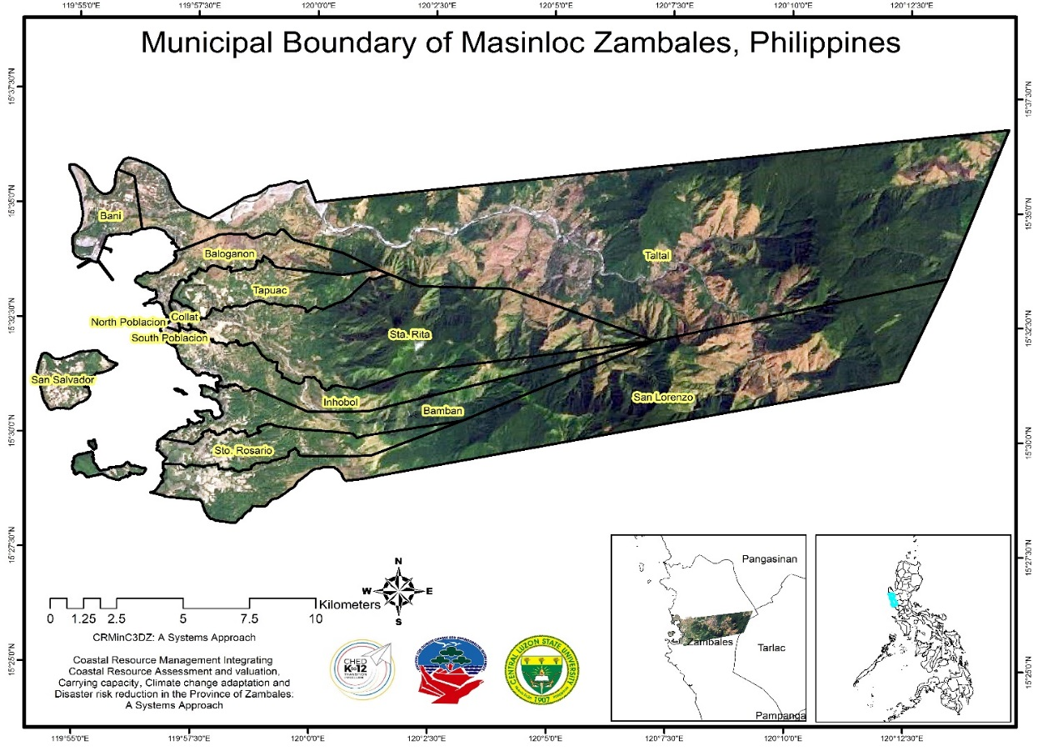

Figure 1. The administrative boundary of the municipality of Masinloc.

- Hazard Assessment

Figure 2 shows the landslide map of Masinloc, Zambales. It can be observed that barangays situated near and on highly elevated areas of the municipality are highly susceptible to landslide while the remaining barangays have no to moderate susceptibility. The highly susceptible barangays are Bamban (38.6%), San Lorenzo (45.90%), Sta. Rita (42.7%) and Taltal (43.7%) (Table 1).
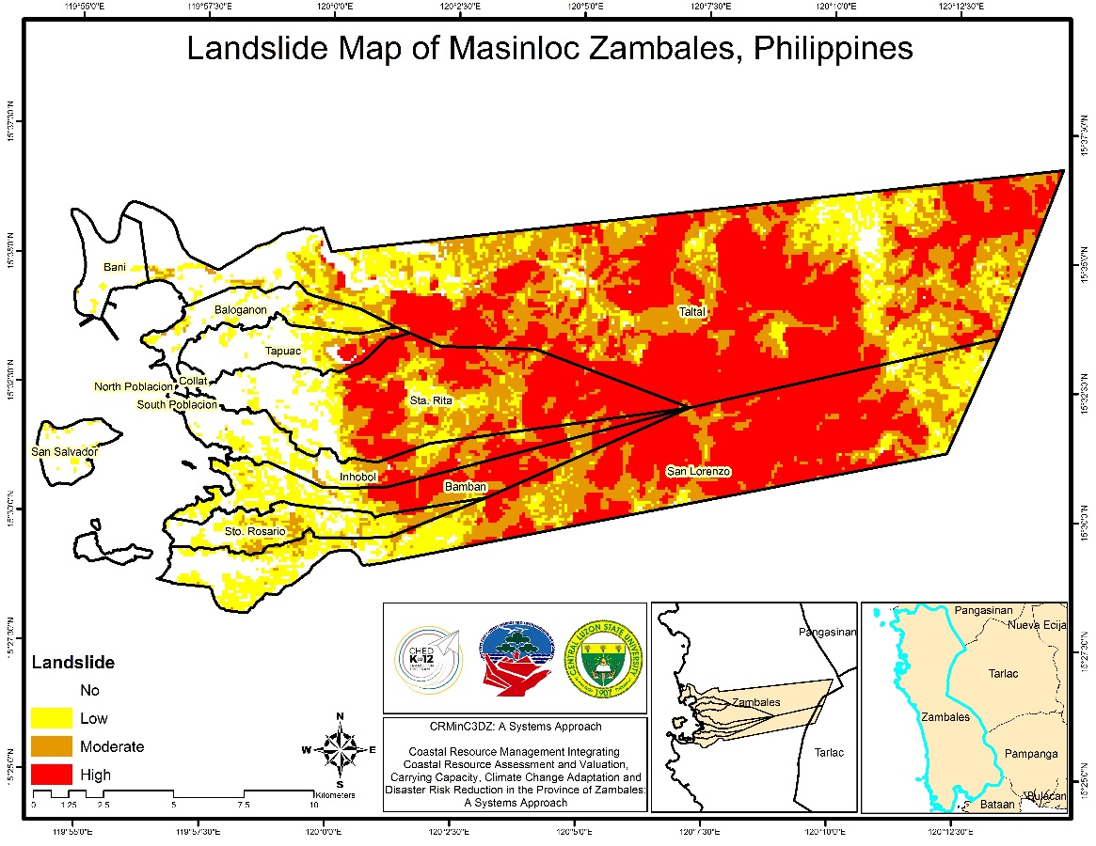

Figure 2. Landslide susceptibility map of Masinloc, Zambales

Table 1. Landslide assessment of the Municipality of Masinloc, Zambales
Barangay | Landslide%
 | Affected Land Area
 | Not Affected | Low | Moderate | High
Baloganon | 56.5 | 32.1 | 11.1 | 0.3
Bamban | 17 | 28.6 | 15.8 | 38.6
Bani | 94.7 | 4.7 | 0.6 | 0
Collat | 100 | 0 | 0 | 0
Inhobol | 34.5 | 19.2 | 21.5 | 24.8
North Poblacion | 100 | 0 | 0 | 0
San Lorenzo | 10.9 | 20.4 | 22.8 | 45.9
San Salvador | 87.2 | 9.9 | 3 | 0
South Poblacion | 100 | 0 | 0 | 0
Sta. Rita | 18.9 | 15.4 | 23 | 42.7
Sto. Rosario | 30.2 | 47.6 | 20.1 | 2.1
Taltal | 10.4 | 17.2 | 28.7 | 43.7
Tapuac | 64 | 17.2 | 9.2 | 9.6

Hazard Map Validation

The hazard map validation was conducted and identifying five (5) random validation points in each barangay of the study area. The accuracy of the maps as a result of the validation is 89.23%.

Landslide Vulnerability Assessment
Figure 3 presents the landslide vulnerability map of Masinloc, Zambales. It can be observed that only Barangay Taltal has moderate vulnerability to landslide due to higher value of sensitivity and exposure to landslide with 0.72 and 0.53, respectively (Table 2) while the rest of the barangays have low vulnerability to landslide. Masinloc has low vulnerability to landslide because the agricultural areas, houses and residents are very far from the mountains which are the landslide prone areas. Moreover, no presence of construction/extraction activities and charcoal making were found in the forest of Masinloc and in fact, its disaster plans are well prepared and coordinated throughout the municipality.
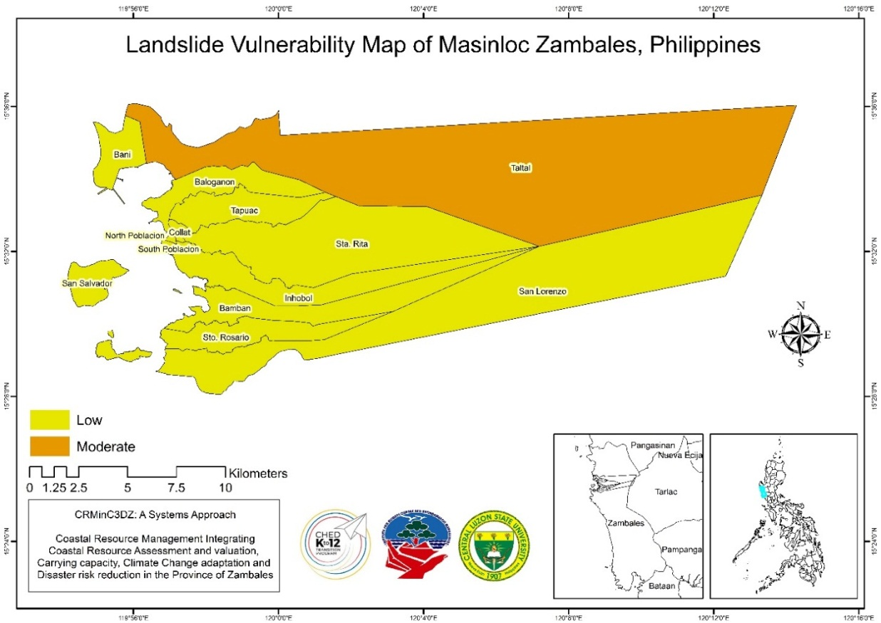
Figure 3. Landslide vulnerability map of Masinloc, Zambales

Table 2. Landslide vulnerability assessment of the municipality of Masinloc, Zambales
Barangay | LS | LE | LAC | LV | SCALE: | VA
Baloganon | 0.56 | 0.33 | 0.60 | 0.49 | Low | 0.20-0.50
Bamban | 0.56 | 0.33 | 0.60 | 0.50 | Moderate | 0.51-0.70
Bani | 0.48 | 0.27 | 0.60 | 0.44 | High | 0.71-1.0
Collat | 0.48 | 0.20 | 0.60 | 0.42
Inhobol | 0.56 | 0.20 | 0.63 | 0.46 | SCALE: | AC
North Poblacion | 0.48 | 0.20 | 0.60 | 0.42 | Low | 0.71-1.0
San Lorenzo | 0.48 | 0.20 | 0.60 | 0.42 | Moderate | 0.51-0.70
San Salvador | 0.44 | 0.20 | 0.60 | 0.41 | High | 0.20-0.50
Santa Rita | 0.56 | 0.20 | 0.60 | 0.45
Santo Rosario | 0.52 | 0.20 | 0.60 | 0.44
South Poblacion | 0.48 | 0.20 | 0.60 | 0.42
Taltal | 0.72 | 0.53 | 0.60 | 0.61
Tapuac | 0.52 | 0.20 | 0.60 | 0.44

S-Landslide Sensitivity; LE- Landslide Exposure; LAC-Landslide Adaptive Capacity; LV- Landslide Vulnerability; VA- Vulnerability Assessment; AC-Adaptive Capacity

Disaster Risk Assessment

Disaster risk is not just about the likelihood and severity of the hazard event but also about what is exposed to that hazard and how vulnerable that exposure is. Disaster risk assessment is a process to determine the nature and extent of such risk, by analyzing hazards and evaluating existing conditions of vulnerability that together could potentially harm and expose the people, property, services, livelihoods and the environment (UNISDR, 2017).

Disaster risk assessment was done to identify the areas that were affected by landslide and to classify the percentage affected in each of the barangays of Masinloc. Figure 4 shows the landslide disaster risk map of the municipality of Masinloc, Zambales. It can observed that only Barangay Taltal is moderately affected by landslide disaster risk with an estimated affected land area of 43.9% as shown in Table 3. Barangays Collat and North Poblacion are 100 % not affected by landslide disaster risks. However, the rest of the barangays have low landslide disaster risks. Although Barangays Bamban, Inhobol, San Lorenzo and Sta. Rita have mountainous parts but they are also affected by low landslide disaster risks because their vulnerability to landslide is low. Moreover, their adaptive capacity to landslide is high, disaster plans are well prepared and coordinated throughout the municipality. IPCC (2001, 2014) defines adaptation as adjustment in natural or human systems in response to actual or expected climatic stimuli or their effects. Results showed that approximately 66.04 hectares were found to be at risk by landslide hazard with a total of 2,738 household or 11,931 affected population.

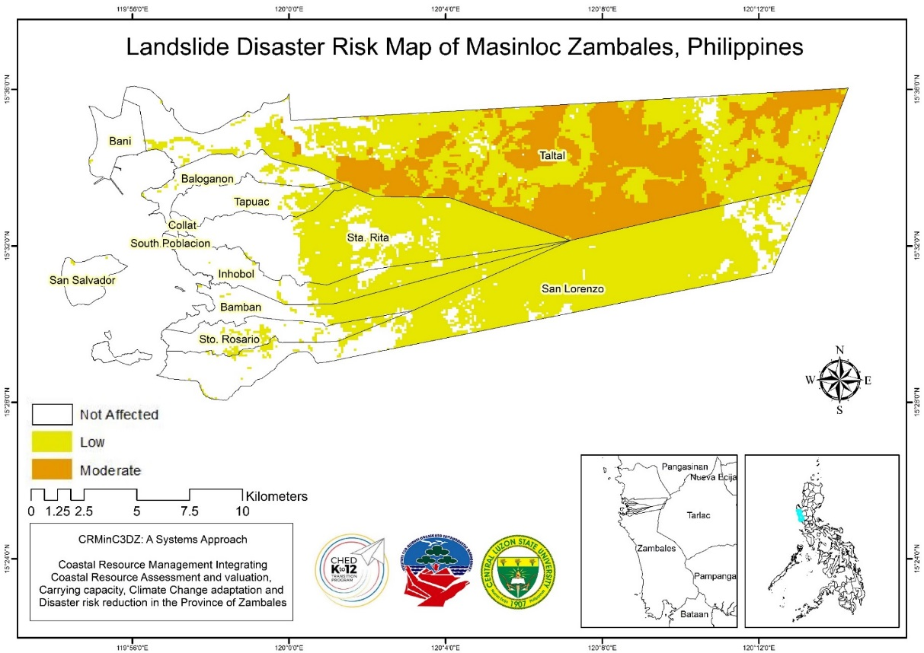
Figure 4. Landslide disaster risk map of Masinloc, Zambales

Table 3. Landslide disaster risk assessment of Masinloc, Zambales
Barangay | LANDSLIDE%
 | Affected Land Area
 | Not Affected | Low | Moderate | High
Baloganon | 88.4 | 11.6 | 0 | 0
Bamban | 45.3 | 54.7 | 0 | 0
Bani | 99.4 | 0.6 | 0 | 0
Collat | 100 | 0 | 0 | 0
Inhobol | 54.4 | 45.6 | 0 | 0
North Poblacion | 100 | 0 | 0 | 0
San Lorenzo | 30.7 | 69.3 | 0 | 0
San Salvador | 98.6 | 1.4 | 0 | 0
South Poblacion | 100 | 0 | 0 | 0
Sta. Rita | 34.3 | 65.7 | 0 | 0
Sto. Rosario | 78.7 | 21.3 | 0 | 0
Taltal | 12.86 | 44 | 43.1 | 0
Tapuac | 81.8 | 18.2 | 0 | 0

Table 4. Population Risk Levels - Landslide

Barangay | Population | No. of HH | Affected Area (in ha) |  | Affected Pop. | Affected HH | Risk Score | Risk Level
Baloganon | 6,364 | 1420 | LL | 13.26 | 2432 | 543 | 9.29 | Moderate
Bamban | 2,324 | 527 | LL | 1.03 | 183 | 41 | 6.19 | Moderate
 | 2,324 | 527 | ML | 3.85 | 683 | 155 | 6.19 | Moderate
 | 2,324 | 527 | HL | 0.20 | 36 | 8 | 6.19 | Moderate
Bani | 4,693 | 1297 | LL | 3.30 | 730 | 202 | 6.90 | Moderate
Inhobol | 9,069 | 2080 | LL | 15.28 | 3247 | 745 | 9.76 | Moderate
 | 9,069 | 2080 | ML | 2.13 | 454 | 104 | 6.43 | Moderate
 | 9,069 | 2080 | HL | 0.99 | 210 | 48 | 6.43 | Moderate
 | 9,069 | 2080 | VHL | 0.01 | 2 | 1 | 6.43 | Moderate
San Lorenzo | 3,296 | 749 | LL | 2.73 | 559 | 127 | 6.19 | Moderate
 | 3,296 | 749 | ML | 2.29 | 469 | 107 | 6.19 | Moderate
San Salvador | 2,345 | 515 | LL | 4.65 | 663 | 146 | 6.90 | Moderate
Sta. Rita | 2,794 | 651 | LL | 4.26 | 462 | 108 | 6.43 | Moderate
 | 2,794 | 651 | ML | 0.05 | 5 | 1 | 6.43 | Moderate
Sto. Rosario | 2,442 | 558 | LL | 1.15 | 246 | 56 | 6.19 | Moderate
 | 2,442 | 558 | ML | 1.75 | 373 | 85 | 6.19 | Moderate
Taltal | 5,336 | 1192 | LL | 6.49 | 855 | 191 | 6.43 | Moderate
 | 5,336 | 1192 | ML | 0.63 | 82 | 18 | 6.43 | Moderate
 | 5,336 | 1192 | HL | 0.27 | 35 | 8 | 6.43 | Moderate
 | 5,336 | 1192 | VHL | 0.01 | 1 | 0 | 6.43 | Moderate
Tapuac | 2,645 | 573 | LL | 1.35 | 204 | 44 | 6.43 | Moderate

CONCLUSION
Disaster risk assessment was done to identify the areas that were affected by landslide and to classify the percentage affected in each of the barangays of Masinloc. A GIS can facilitate assessment methods. Results showed that approximately 66.04 hectares were found to be at risk by landslide hazard with a total of 2738 household. It can also observed that some barangays like Bamban, Inhobol, San Lorenzo and Sta. Rita are mountainous parts but they are also affected by low landslide disaster risks because their vulnerability to landslide is low and their adaptive capacity to landslide are high.

ACKNOWLEDGMENT
We gratefully thank the Commission on Higher Education (CHED)-DARE-TO K12 Program for financial support. Sincere gratitude also to LGUs and coastal communities in Masinloc, Zambales for the support and secondary data provided in conducting the study.

REFERENCES
Amod Sagar Dhakal, Takaaki Amada, and Masamu Aniya. 2000, “Landslide Hazard Mapping and its Evaluation Using GIs: An Investigation of Sampling Schemes for a Grid-Cell Based Quantitative Method https://www.asprs.org/wp-content/uploads/pers/2000journal/august/2000_aug_981-989.pdf
EM-DAT (2009). The OFDA/CRED International Disaster Database, Université Catholique de Louvain,Brussels, Belgium. http://www.emdat.be
FAO (2015). Disaster Risk Management.
http://www.fao.org/mountain-partnership/our-work/focusareas/naturalhazards/en/

Glade T, Anderson M, Crozier MJ. 2005. Landslide hazard and risk. Chichester: John Wiley & Sons Ltd

IPCC (2001) ‘Climate change 2001: impacts, adaptation, and vulnerability’, in J.J. McCarthy, O.F. Canziani, N.A. Leary, D.J. Dokken and K.S. White (Eds.): Contribution
of Working Group II to the Third Assessment Report of the Intergovernmental Panel on Climate Change, Cambridge University Press, Cambridge, UK [online] https://library.harvard.edu/collections/ipcc/docs/27_WGIITAR_FINAL.pdf

IPCC (2014) ‘Climate change 2014: impacts, adaptation, and vulnerability. part a: global and sectoral aspects’, in Field, C.B., V.R. Barros, D.J. Dokken, K.J. Mach, M.D. Mastrandrea, T.E. Bilir, M. Chatterjee, K.L. Ebi, Y.O. Estrada, R.C. Genova, B. Girma, E.S. Kissel, A.N. Levy, S. MacCracken, P.R. Mastrandrea and L.L. White (Eds.):

O'Keefe, P., Westgate, K. and Wisner, B. (1976). Taking the naturalness out of natural disasters. Nature 260, 566-567
Remote Sensing and GIS for Natural Hazards Assessment and Disaster Risk Management Cees J. van Westen Faculty of Geo-Information Science and Earth Observation (ITC), University of Twente Hengelosestraat 90 7500 AA Enschede, The Netherlands Tel: +31534874263, Fax: +31534874336 E-mail: westen@itc.nl
Sassa K, Canuti P. 2008. Landslides: disaster risk reduction. Germany: Springer Verlag, Berlin Heidelberg
UNISDR (2017). Words into Action Guidelines: National Disaster Risk Assessment. In support the Sendai Framework for Disaster Risk Reduction 2015-2030.

