GENERATING MULTI-TEMPORAL LANDSLIDE INVENTORY USING THE NDVI TEMPORAL TRAJECTORY IN NANTOU COUNTY, TAIWAN

Thanh Duy Nguyen (1), Van Trung Chu (2), Shou-Hao Chiang (2)
¹ International Master Program in Environment and Sustainable Development, College of Engineering, National Central University, No. 300, Zhongda Rd, Zhongli District, Taoyuan City, 32001, China Taipei.
² Center for Space and Remote Sensing Research, National Central University, No. 300, Zhongda Rd, Zhongli District, Taoyuan City, 32001, China Taipei.
Email: ntduygeology@gmail.com; chuvantrung@tuaf.edu.vn; gilbert@csrsr.ncu.edu.tw;

KEYWORDS: SPOT image; landslide detection; earthquake; rainstorm; temporal trajectory;

ABSTRACT: In Taiwan, landslide usually appears in orogenic mountain belts after earthquake and typhoon events. In this paper, we aim to assess the temporal trajectory of Normalized Difference Vegetation Index (NDVI) time series by using SPOT images to carry out the landslide mapping from 1999 to 2009 in Nantou County, Central Taiwan. By quantifying the temporal change of NDVI index, we can identify the extent, location, and timing of the landslide. Preliminary results reveal different temporal patterns of landslide activities through potential disturbances of vegetation recovery index refer to earthquakes with magnitude M_{w} over 6 and typhoons with precipitation higher than 200mm/day. We expect that our proposed method can contribute to the generation of multitemporal landslide inventory more efficiently.

- INTRODUCTION

Earthquake and typhoon-triggered landslide are related to dangerous hazards that threaten both property and life. They usually occur on specific aspects of hillslopes. The distribution of landslides is controlled by the intensity of triggers and rock strength at the regional scale. After an earthquake event, landslides occur preferentially on the hillslope of specific orientation to the earthquake’s epicenter or fault (Tibaldi et al. 1995). The preferential aspect may be associated with the moving direction of the fault block (Lee 2013), with the amplification of peak ground accelerations on the ridge flank facing away from the wave source (Meunier et al. 2008; Wu and Chen 2009). During typhoon events, landslide trend to occur in windward hillslopes and areas precipitation over 200 mm/day. Thus, the response of landslide to different triggers on terrain attributes should be clarified (Wu and Chen 2009). Taiwan, located at the juncture between the Philippine and Eurasian tectonic plates and also in the path of tropical cyclones, is a hotspot for landslide induced by both earthquake and typhoon. Thus, a high rate of erosion and sediment transport were well-documented (Chen et al. 2013; Dadson et al. 2003; Lin et al. 2008; Milliman et al. 2007). Previous studies in Taiwan have demonstrated that the location and size of landslides induced by earthquakes and rainstorms may differ (Huang and Montgomery 2014; Lin et al. 2005). However, they did not show definitely which events that had impacted on inducing, extending landslides by location, and timing of landslide areas. This article used satellite images from SPOT images to cover the greenness canopy in Nantou County from 1999 to 2009. The identification of differencing of NDVI values to detect landslide areas after earthquake and typhoon events at the same time.

- MATERIALS AND METHODS

2.1. Study area

The study area is located in the Nantou county region along the Chelungpu Fault, where was suffered the major damage of the Chi-Chi earthquake on September 21, 1999. During the Chi-Chi earthquake occurred, the fault stretched along the foothills of the central mountains in Nantou county. Areas along the fault were lifted to 7m. In the northern end part of the fault, the earthquake created a waterfall with nearly 7m in height due to the surface rupture offset the channel of the Daiia River. The total surface rupture was about 100 km in length. The climate data obtained from the Taiwan Central Weather Bureau illustrated that not only earthquakes but also typhoons changed dramatically, followed by time and space, the efficient magnitude generally decreasing with the distance from the event’s epicenter. From 1999 to 2009, Nantou county experienced two earthquakes with magnitude Mw ≥ 6 (Table 1), the best-known being the Chi-Chi earthquake (September 21, 1999), and its major aftershock (October 22, 1999). However, earthquake is not used for the main cause of landslide in Taiwan, typhoon is also the representing factor triggering landslides. The average annual precipitation in Taiwan is around 2500 mm. The rain season from May to October concentrates over 70% precipitation total amount of a year. Between the period of 1999 and 2009, Nantou county had been attacked by 16 typhoons (Table 2) with the maximum one-day rainfall, was occurred by the Morakot typhoon (August 5-10, 2009), counted to 1600mm/day.

Table 1. Earthquakes with magnitude M_{w} ≥ 6 in Nantou county from 1999 to 2009
 |  | Epicenter
Name | Date | Depth | Longitude | Latitude | Magnitude
Chi-Chi | September 21, 1999  October 22, 1999 | 8.0  12.1 | 120.82 | 23.85 | 7.6  6.4
Chiayi | March 31, 2002 | 9.6 | 122.17 | 24.24 | 6.8

Table 2. Typhoons with maximum rainfall per day > 200mm/day
in Nantou county from 1999 to 2009
Typhoon | Date | Maximum rainfall per day (mm/day)
Bilis | August 21-23, 2000 | 255.5
Xangsane | October 30 – November. 01, 2000 | 241.5
Toraji | July 28-31, 2001 | 757
Nari | September 13-19, 2001 | 371
Haitang | July 16-20, 2005 | 683.5
Matsa | August 3-6, 2005 | 418
Talim | August 30 – September 1, 2005 | 634.5
Bilis | July 12-15, 2006 | 412.5
Sepat | August 16-19, 2007 | 426.5
Wipha | September 17-19, 2007 | 278.5
Krosa | October 4-7, 2007 | 987.5
Kalmaegi | July 16-18, 2008 | 607
Fung-wong | July 26-29, 2008 | 542.5
Sinlaku | September 11-16, 2008 | 790.5
Jangmi | September 26-29, 2008 | 720
Morakot | August 5-10, 2009 | 1623.5

  - Image selection

We selected satellite images from SPOT 4 and SPOT 5 (with the spatial resolution of 10m and 5m for panchromatic; 20m and 10m for multi-spectral respectively) with cloud-free which were taken before and after earthquake and typhoon events were supported to by the Space and Remote Sensing Research Center, National Central University, Taiwan from 1999 to 2009 to map the efficient change of landslide areas.

  - Landslide change detection

Differencing coupled images with establishing a change threshold method is widely used for land cover change detection studies. This technique involves image preprocessing, calculating the differences between images, and determining a change threshold (Jensen et al. 1993). SPOT images are composed of four spectral bands while LANDSAT images are acquired in 7 spectral bands. The observation that vegetation is reflected by the combination of red energy and strongly forms for near-infrared energy determining loss or grain greenness canopy areas. Many previous researchers showed that the multi-temporal normalized difference vegetation index (NDVI) is satisfied with monitoring forest seasonal dynamics (Birky 2001), describing temporal and spatial vegetation dynamics (Senay and Elliott 2000), and classifying land cover (Tsai and Philpot 2002). The formula of NDVI calculation can be derived as follows:

$NDVI= \frac{NIR - Red}{NIR+Red}$ (1)

where NIR is the reflectance of the near-infrared wavelength, and Red is the reflectance of the visible red wavelength. For landslide change detection, the NDVI values of multi-temporal images were calculated and then normalized by applying regression equations to the post-event images to minimize the effects due to sun angle, atmospheric conditions, and varying soil moisture conditions (Eckhardt et al. 1990; Hall et al. 1991). The procedures of normalization were applied by using unchanged pixels from a reference NDVI image. After that, we created a linear regression diagram to re-calculate each NDVI images during the analysis period from 1999 to 2009.
Image differencing is expressed by the variation of angles between pre- and post- events NDVI images, resulting in the smallest angle value represents the occurrence of landslide and the changes of landslide areas after earthquakes and typhoons in the processing period. This operation can be formed mathematically by:

$ɸ = atan (\frac{{post}_{NDVI}-{pre}_{NDVI}}{post-pre})$ (2)

where ɸ is the angle between post-event NDVI image and pre-event NDVI image, post_{NDVI} is the NDVI value of the post-event image, pre_{NDVI} is the NDVI value of the pre-event image, and post – pre is a duration from the pre-event NDVI image to the post-event NDVI image.

- PRELIMINARY RESULT AND DISCUSSION

NDVI temporal trajectory for landslide detection was carried out by using the mathematical formula to calculate different angles between a pair of NDVI images before and after events to define the change of landslide areas in Nantou county for ten years. As shown in Figure.1 and illustrated in Figure.2, the landslide site located in the North of the study area, effected by the Chi-chi earthquake on September 21, 1999. Three years after the Chi-chi earthquake, this landslide area experienced a recovery of vegetation and stayed stable at the same time. From 2003 to 2004, two typhoon events with precipitation over 200mm/day affected to this landslide area, the Morakot typhoon on October 19, 2003, and the Nanmadol typhoon on December 3, 2004. In 2008, the Jangmi typhoon from 26 to September 29 caused a landslide in this area with the measurement of precipitation counted to 720mm/day.
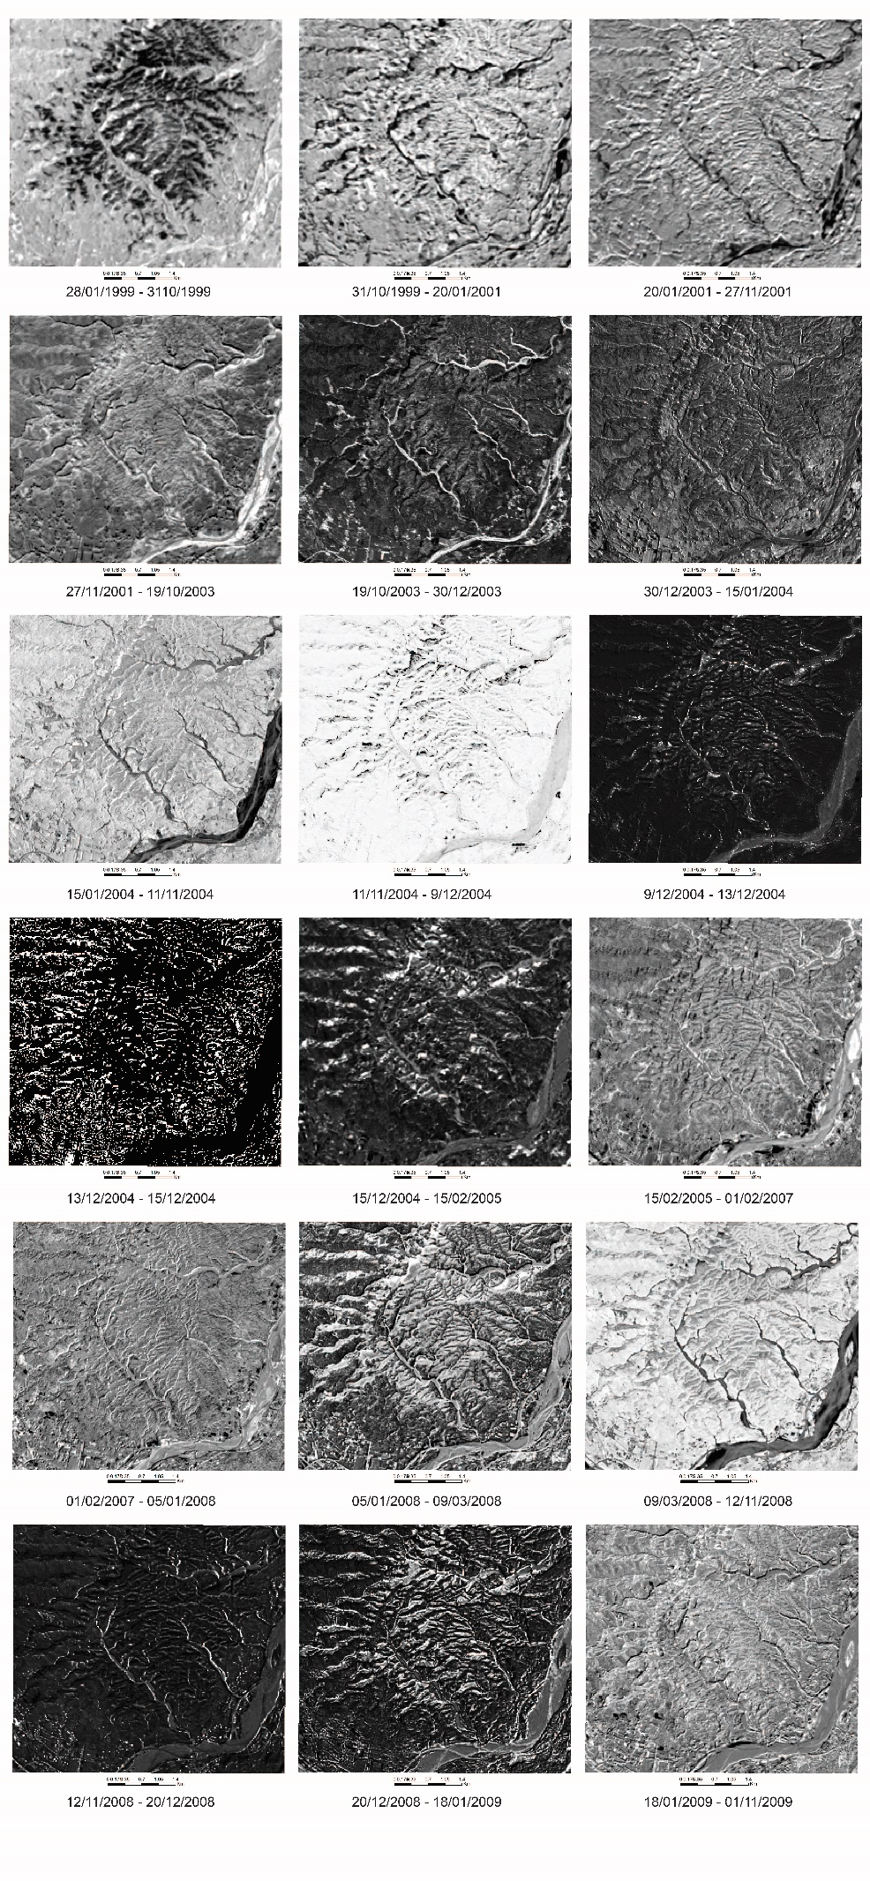
Figure 1. The results of angle differences from NDVI images from 1999 to 2009
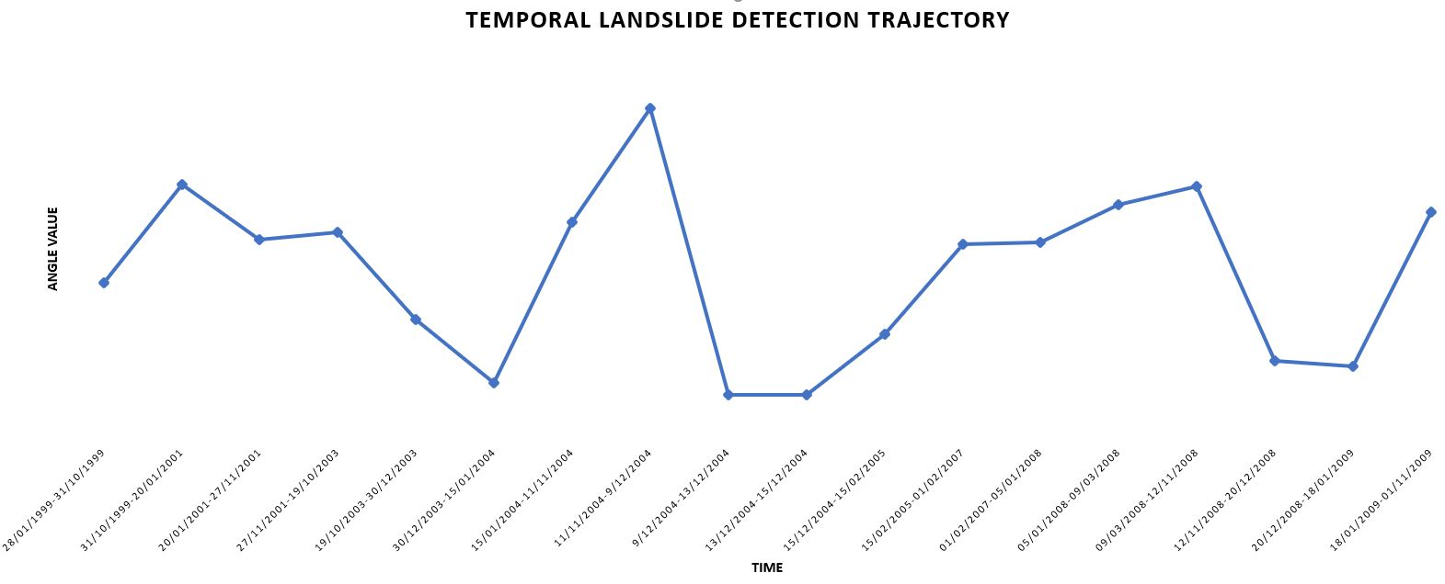
Figure 2. The temporal landslide trajectory from 1999 to 2009

- CONCLUSION AND DISCUSSION

This paper presents the preliminary result of the detection of landslide through the temporal trajectory. By measuring different angles between NDVI images from 1999 to 2009 in Nantou county, we can identify the earthquake- and typhoon- induced landslide, also the change of each landslide site at the same period about timing and location. Conclusively, the preliminary results may contribute useful views for detecting earthquake- and typhoon-triggered landslide by generating image processing.

- REFERENCES

Birky, A.K. 2001. NDVI and a simple model of deciduous forest seasonal dynamics. Ecological Modelling, 143, 43-58
Chen, Y.C., Chang, K.t., Chiu, Y.J., Lau, S.M., & Lee, H.Y. 2013. Quantifying rainfall controls on catchment‐scale landslide erosion in Taiwan. Earth Surface Processes and Landforms, 38, 372-382
Dadson, S.J., Hovius, N., Chen, H., Dade, W.B., Hsieh, M.-L., Willett, S.D., Hu, J.-C., Horng, M.-J., Chen, M.-C., & Stark, C.P. 2003. Links between erosion, runoff variability and seismicity in the Taiwan orogen. Nature, 426, 648-651
Eckhardt, D.W., Verdin, J.P., & Lyford, G.R. 1990. Automated update of an irrigated lands GIS using SPOT HRV imagery. Photogrammetric Engineering and Remote Sensing, 56, 1515-1522
Hall, F.G., Strebel, D.E., Nickeson, J.E., & Goetz, S.J. 1991. Radiometric rectification: toward a common radiometric response among multidate, multisensor images. Remote Sensing of Environment, 35, 11-27
Huang, A.Y.L., & Montgomery, D.R. 2014. Topographic locations and size of earthquake‐and typhoon‐generated landslides, Tachia River, Taiwan. Earth Surface Processes and Landforms, 39, 414-418
Jensen, J., Cowen, D., Althausen, J., NARUMALANI, S., & WEATHERBEE, O. 1993. An evaluation of the CoastWatch change detection protocol in South Carolina. Photogrammetric Engineering and Remote Sensing, 59, 1039-1044
Lee, C.-T. 2013. Re-evaluation of factors controlling landslides triggered by the 1999 Chi–Chi earthquake. Earthquake-Induced Landslides (pp. 213-224): Springer
Lin, G.W., Chen, H., Hovius, N., Horng, M.J., Dadson, S., Meunier, P., & Lines, M. 2008. Effects of earthquake and cyclone sequencing on landsliding and fluvial sediment transfer in a mountain catchment. Earth Surface Processes and Landforms: The Journal of the British Geomorphological Research Group, 33, 1354-1373
Lin, W.-T., Chou, W.-C., Lin, C.-Y., Huang, P.-H., & Tsai, J.-S. 2005. Vegetation recovery monitoring and assessment at landslides caused by earthquake in Central Taiwan. Forest Ecology and Management, 210, 55-66
Meunier, P., Hovius, N., & Haines, J.A. 2008. Topographic site effects and the location of earthquake induced landslides. Earth and Planetary Science Letters, 275, 221-232
Milliman, J., Lin, S., Kao, S., Liu, J., Liu, C., Chiu, J., & Lin, Y. 2007. Short-term changes in seafloor character due to flood-derived hyperpycnal discharge: Typhoon Mindulle, Taiwan, July 2004. Geology, 35, 779-782
Senay, G., & Elliott, R. 2000. Combining AVHRR-NDVI and landuse data to describe temporal and spatial dynamics of vegetation. Forest Ecology and Management, 128, 83-91
Tibaldi, A., Ferrari, L., & Pasquarè, G. 1995. Landslides triggered by earthquakes and their relations with faults and mountain slope geometry: an example from Ecuador. Geomorphology, 11, 215-226
Tsai, F., & Philpot, W.D. 2002. A derivative-aided hyperspectral image analysis system for land-cover classification. IEEE Transactions on Geoscience and Remote Sensing, 40, 416-425
Wu, C.-H., & Chen, S.-C. 2009. Determining landslide susceptibility in Central Taiwan from rainfall and six site factors using the analytical hierarchy process method. Geomorphology, 112, 190-204

