Determining the Best Window Size and Structural Index in Estimating Moho Depth Through Euler Deconvolution Method, Case Study: The Zagros Structural Zone in Iran
Soran Parang
Department of Surveying and Geomatics Engineering, College of Engineering, University of Tehran, Tehran, Iran, soran_parang@ut.ac.ir

Identifying features of continental crust and upper mantle is an important goal in geophysical studies. In many cases, crust is divided into 2 or 3 horizontal and homogenous layers but it is aimed to have a more detailed and meticulous view of crustal structure and its complexities, especially depth of Moho discontinuity and its lateral variations. Moho depth is an important parameter in identification of crustal structure and it is also related to geological and tectonic evolution of each zone. Moho lateral variations have an essential role in seismic wave propagation. Among methods to estimate Moho depth and also analyzing crustal structure some methods are as follows: Analysis of surface and body waves of recorded earthquakes in seismic stations; Zhu and Kanamori method; inversion of terrestrial gravity data and using bouguer gravity anomaly and free air gravity anomaly; spectral correlation analysis of terrain gravity effects; thermal analysis and using elevation data, geoid height and geodetic data; isostatic methods; Parker- Oldenburg method; least square collocation method and using different filters in spatial and frequency domain. This study aims at finding Moho depth in the Zagros structural zone and estimating crustal thickness through Euler Deconvolution method. Euler Deconvolution method is an automatic one to estimate depth, shape and place of magnetic and gravity sources which is based on using field derivatives in Euler`s homogenous equation. In using Euler Deconvolution method it is important to identify structural index and window size of estimator, these parameters strongly affect the final results. In Euler Deconvolution Method, Structural Index (SI) is the rate in which intensity of gravitational or magnetic field becomes zero comparing to distance from source and it is also a yardstick to differentiate between various source shapes. This number for old geological structures is 0-1 while for regions witnessing younger geological phenomenon, it ranges from 0 to 3. Because of high volume of data used in magnetic or gravimetric method and lack of access to high precision in overall processing of data in whole grid, Euler square window has been defined and the process is done inside the window. The window must have the following two characteristics: It must be big enough to include substantial variations of field, It must be small enough so that multiple sources don`t happen. The study first used spherical harmonic coefficients of EIGEN-GL04C geopotential model to calculate free air gravity anomaly in φ=29.25 ͦ - 34.75 ͦ & λ= 48.25 ͦ - 53.75 ͦ region (Figure 1), then Moho Depth was estimated using free air gravity anomaly and Euler Deconvolution method for various structural indices and window sizes. The best structural index and window size were resulted from comparing Moho depth of Euler Deconvolution and of receiver function method (based on seismic studies) in 13 seismic stations of the region and finally the results were compared to CRUST 2.0 model. Results declare that for 0.5 structural index and 40-45 km window size the best Moho depth is estimated for the region. For a window size of 40 km, the mean of Moho depth equals 46±5 km and for a window size of 45 km, it equals 50±4 km. Figure 2 shows the results of Moho depth estimation by Euler Deconvolution method for window sizes of 15 km to 55 km and structural index of 0.5, along AB profile.
Keywords: Euler Deconvolution, Moho depth, Free Air Gravity Anomaly, CRUST 2.0 Model, Window Size, Structural Index
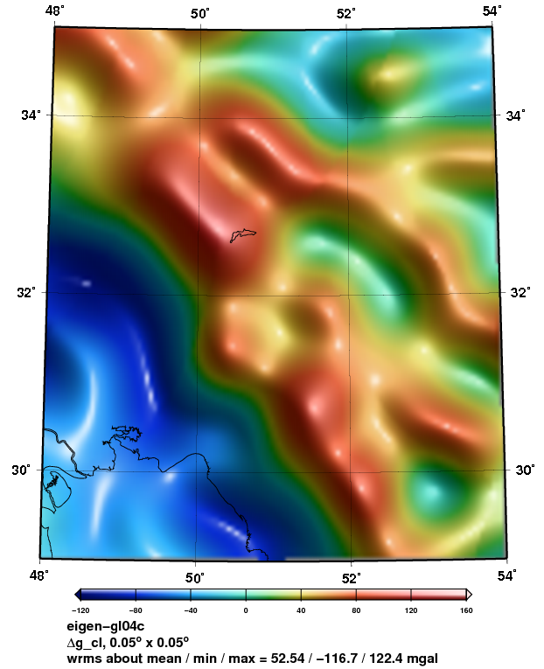
Figure 1. Free air gravity anomaly resulted by EIGEN-GL04C model in the Zagros structural zone
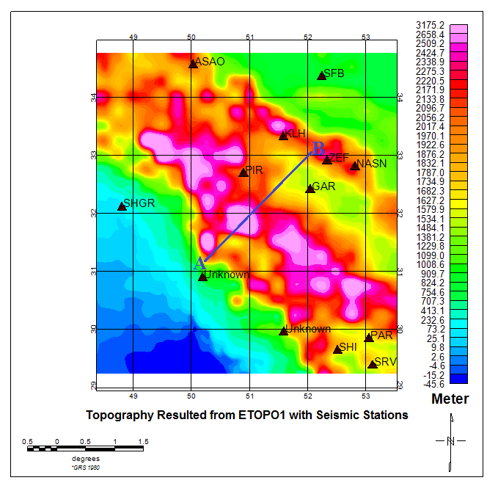
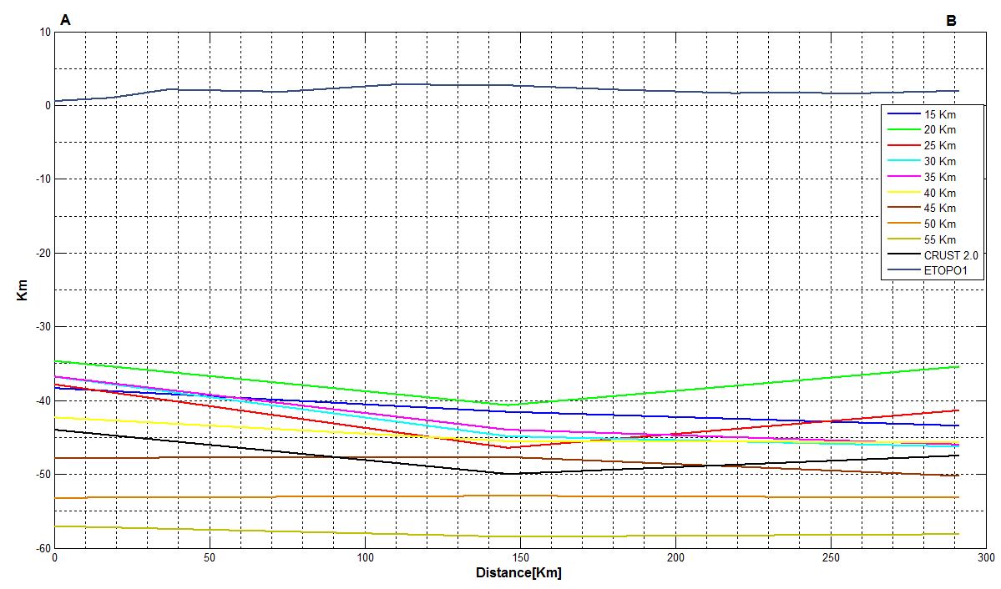
Figure 2. Variation of Moho depth along AB profile

