Study of Surface Temperature with Land cover Change using Landsat

Hoyong Ahn, Jisun Choi, Dongyoon Shin, Chuluong Choi
Department of Spatial Information Engineering, Pukyong National University, Republic of Korea
E-mail: hyahn85@gmail.com

KEY WORDS : Surface Temperature, Land Cover, Landsat, Heat Island Potential

ABSTRACT: The aim of this study is to research spatial distribution of temperature in busan region by using remote sensing technology, and to analyze the relationship between urban high-temperature and landuse by analyzing the change of surface temperature. The urban heat island phenomenon has been intensifying by various factors with the progress of urbanization, but it is known that the largest contribution to the phenomenon is the influence of the artificial heat in the winter and the thermal storage effect caused by artificial structures in the summer. In this background, this study assessed how urban heat island can be intensified as natural environment turns into man-made structures.

INTRODUTION
It is found that the six cities of our country increased about 1.7 ℃ to exceed twice the world average temperature over the past 100 years. In particular, while the duration of the summer and tropical nights has risen 13-17 days and 4-10 days respectively depending on the region, that of winter decreased 22-49 days (Singh, 1995). That confirms that the temperature of the Korean peninsula is increasing at a much faster rate than the world average. It is known the phenomenon is caused not just by global warming due to increasing greenhouse gases in the atmosphere but also effects of urbanization due to land use and changes in the land cover.
Research results were reported on the relation between the urban heat island and changes of metropolis land use since the mid-1980s. As remote sensing techniques were introduced in urban climate research, changes in land cover were quantified and holistic results started to be presented regarding the correlation between such changes and urban thermal environment. As recent thermal environmental problems in urban areas prompted the emergence of the urban heat island issue, multiple studies have been carried out on the differences of the city and suburban regions in the land surface and air temperature. In particular, the surface temperature derived from satellite imagery has been used as a major factor for the identification of the heat island phenomenon and temperature rise. (Voogt and Oke, 2003; Small, 2006). Hence, this study investigates the changes for the past 10 years(2000∼2010) in land cover of Busan which is one of the six metropolitan areas and analyzes land surface temperature in accordance with land coating conditions through the analysis of the meteorological data and satellite images.

METHODS

Study area
Busan, a study area, is facing the sea south east. In the northwest and northeast, there are the mountains of Cheolmasan, Daleumsan, Changshan, Baekyangsan and Hwangryeongsan. In the center, there is city area. Also, in the west, along the Nakdong River, a complex terrain exists in which Gimhae plains situated.

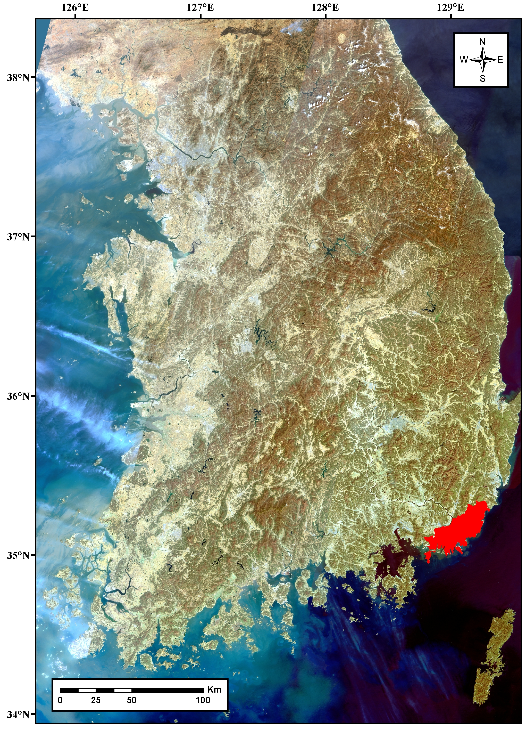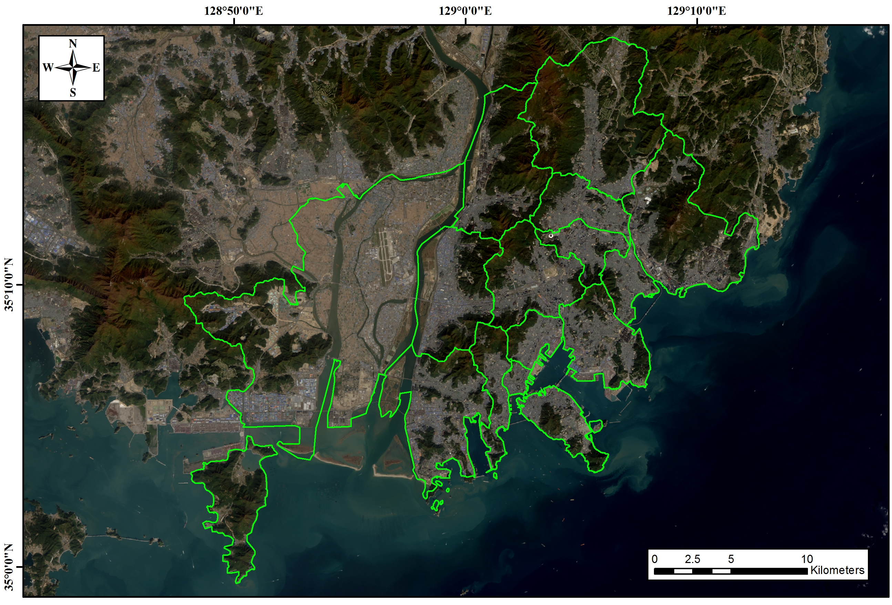
Figure 1. Study area
Data preparation

Land Cover Map
We analyzed the data of 10years Landcover cover changes of 1975, 1990 and 2000 in Busan provided by the National Water Resources Management Information System (WAMIS) using the ArcGIS program. The sensors utilized are Landsat MSS, Landsat TM, and Landsat ETM+ for 1975, 1990 and 2000 respectively,
Landsat Image
The LANDSAT satellite was used in this study. To obtain the surface temperature to grasp the heat island phenomenon, we used satellite thermal infrared bands of each satellite. The band 6(spatial resolution of 120m), band 6(spatial resolution of 60m), and band 10(spatial resolution 100m) were used for Landsat 5, Landsat 7, and Landsat 8 respectively. Tables shows the dimensions of the video and pictures demonstrate utilized satellite images.

Surface temperature extraction
As Landsat provides thermal band, the actual surface temperature can be converted using the numerical thermal band values. For such a conversion the following process is needed.

① converting DN value to Radiance value (Using RESCALING factor)
② converting Radiance to temperature values

To convert DN(Digital Number) into Radiance values, Gain and Bias Method and Spectral Radiance Scaling Method can be used(Yale Center). Gain and Bias method can be used if you have a calibration data provided by the satellite images. Spectral Radiance Scaling Method can be used even if there is no calibration data available. Gain and Bias Method is utilized for analysis in this study as the satellite images to be used for analysis in this study provide the calibration data.

gain (1)
In the second stage for calculating land surface temperature using Landsat satellite imagery, we converted Radiance value to Kelvin through the empirical formula offered by the NASA. In order to convert temperature in Kelvin to that in Celsius, we deducted 273.15 degrees. In general, if you have not done the atmospheric correction, we consider emissivity as 0.95(ε) (Sugawara and Kondo, 2005). The equation is to obtain the temperature of the surface.

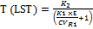 (2)
Heat Island Potential
Heat Island Potential is the method of calculating sensible heat exchange amount between the surface and the atmosphere. This indicates potential surface temperature differences between homogeneous (covered) areas and the air. That means that if heat island potential value is high, the sensible heat released from the surface that is a culprit of heat island phenomenon is high. To measure heat island potential caused by the sensible heat carried into the air from the surface, temperature based on land cover type or that of urban areas with the same structure. The heat island potential based on land cover classification can be obtained through equation.

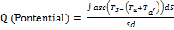 (3)

RESULTS AND DISCUSSION

Land cover
In this study, we classified into six types, including riparian areas, urbanized areas, bare land, grasslands, forested areas, and agricultural areas. It can be seen that there has been a significant expansion of the area covered with artificial structures in 1990 and 2000, compared with 1975. That means a rapid urbanization has taken place over time. We were able to confirm a lot of farmlands were transformed to urban areas and the next in order was forested areas.

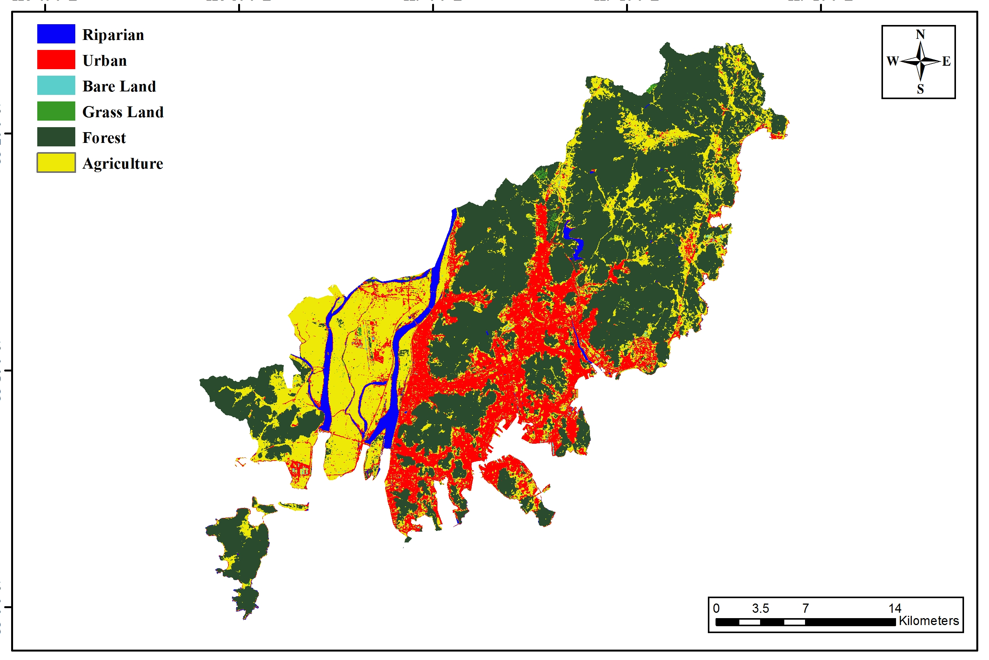
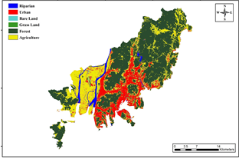

Figure 1. Land Cover Map (2001, 2013)

Surface temperature
Temperature is low around rivers including Nakdong, Suyoung rivers, and Hwedong water resources as well as Gadeokdo's mountain areas, Geumjeongsan, Baekyang mountain, and Youngdo Taejongdae. It can be seen that bare grounds and urban industrial areas that are being developed show high temperature whereas water surface and mountain areas have low temperature, meaning forest areas are the sources of cold temperature. When compared to the results of the last 10 years, there is little change in the surface temperature of the forest or even it became rather lower. Therefore, it can be said the forest has been healthier for the last 10 years.
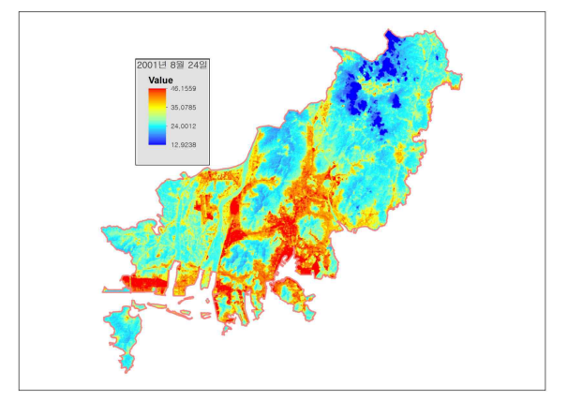
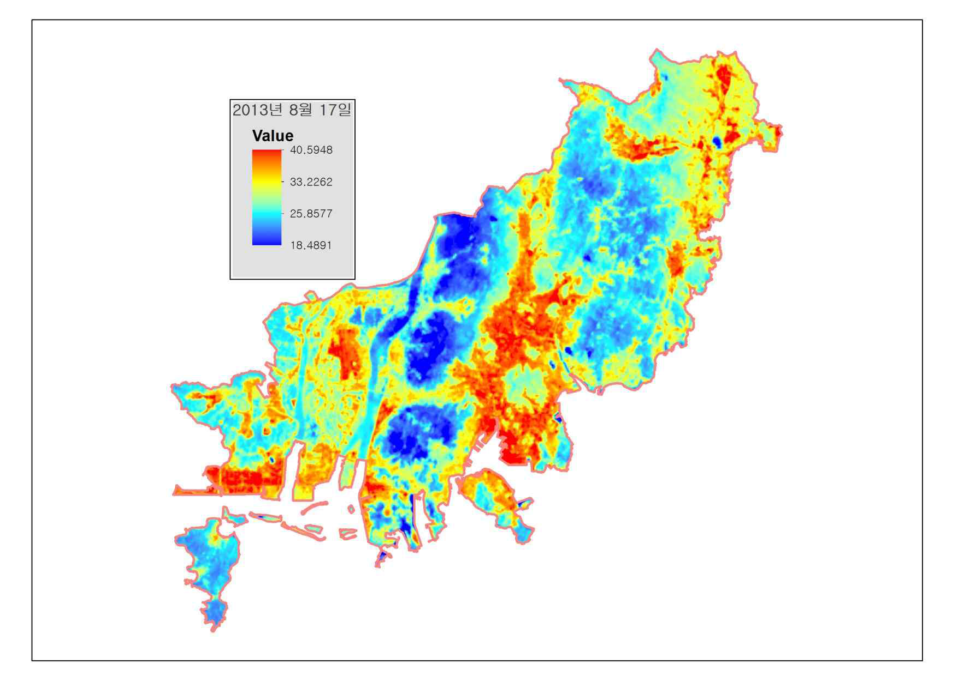

Figure 2. Land Surface Temperature (2001, 2013)

Heat island potential
The heat island potential values are lower in Nakdong River and Baekyang mountain and the top area of Mt. Geumjung and Mt. Gijang but those of most other urban areas exceed 10 ℃. These high values will act as a factor to increase the air temperature by exhausting more heat. When comparing the heat island potential distribution, there were more areas including Nakdong river and areas surrounding it whose heat island potential values are low. This may because green houses were transformed into grasslands through the Nakdong River Land Improvement Project. However, it can be seen that the case of Gangseogu, farmland is being developed as high heat island areas are increasing.
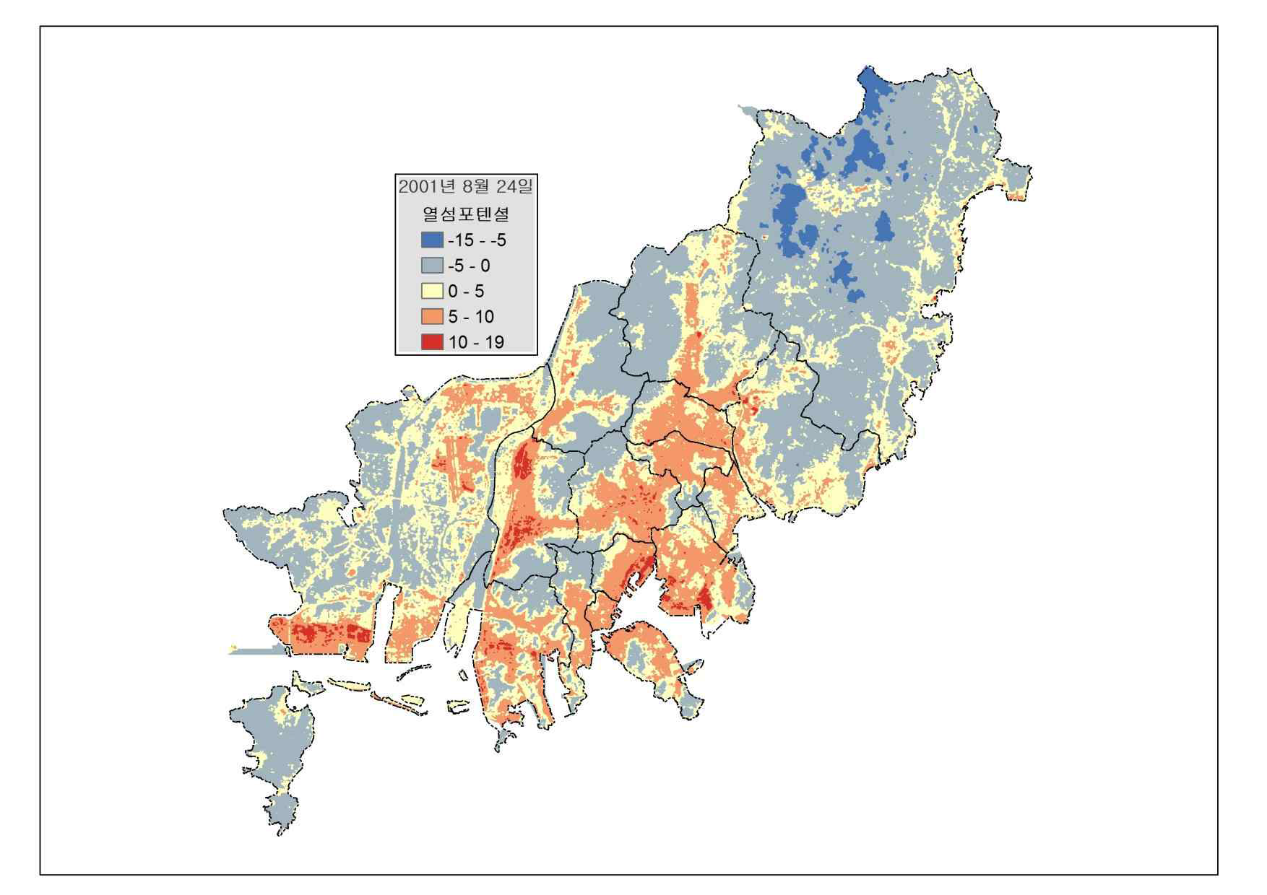
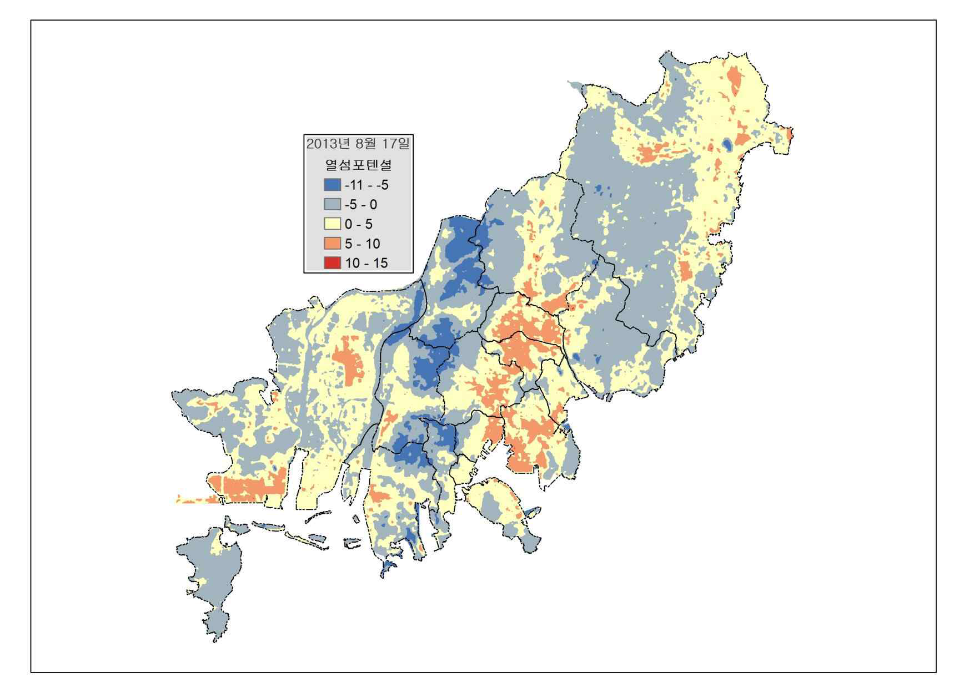

Figure 3. Heat island potential (2001, 2013)

Relationship with land cover and surface temperature changes
Areas with high potential include industrial park such as Noksan and Shinho, factory area such as Samrak and Gamjeon and container terminal areas around North Port area. Most of these areas have concrete and highly reflective roofs. The downtown area also represents a high potential heat island values mainly because of asphalt and concrete buildings.
This represents well the characteristics of surface temperature based on land cover rate. This is the case of the downtown areas which consist of asphalt, concrete buildings and roads which prompt temperature rise. Judging from these results, it will be important to lower the surface temperature of paved areas in order to drop the temperature of city. In particular, we need to reduce the surface temperature by forming the green area in the factory areas and large-scale apartment complex and greening factory parking lots and factory roofs.

CONCLUSIONS
Paved areas in Busan increased more than 2.5 times in the last 25 years from 1975. The dramatic rise in the area of pavement in such a short term is a unique phenomenon unprecedented in other countries. It could be assumed this led to the aggravation of urban heat island phenomenon. For accurate analysis in the future, we believe land cover classification of years after 2000.
Analysis of the surface temperature based on the surface cover found that the temperature of the urban area and that of forest area vary significantly. Factory area in Gangseo, Saha, and Sasanggu showed high surface temperature, especially it went up to 36∼39℃ in factory complex during summer. On the contrary, in Gijanggun, Geumjeonggu, and Bukgu where there are mountain areas in the center of the city, the surface temperature was as low as 22∼24℃.
We found through the heat island potential evaluation based on land cover type that the heat island potential differs according to surface cover type. Paved urban areas show heat island potential of 0∼14℃ while that of industrial areas represented 6∼8℃, 6℃ higher than residential areas. This seems due to surface temperature rise caused by radiance emitted from factories layered by asphalt and concrete. Therefore, we need to lower the surface temperature by expanding green facilities and greening parking lots and roofs in factory areas.
These results demonstrate that the characteristics of land cover have much influence on thermal environment of cities. Moreover, a right plan should be presented to manage each cover type as each land cover type triggers difference in the surface temperature and the heat island potential.

ACKNOWLEDEGEMENT

This work was researched by the supporting project to Korea Aerospace Research Institute.

REFERENCES
Singh, R.B. 1995. Global Environmental Change: Perspectives of Remote Sensing and Geographic Information System. Balkema Publishers. Rotterdam,321pp.
Small, C. 2006. Comparative analysis of urban reflectance and surface temperature. Remote Sensing of Environment 104:168-189.
Sugawara, H. and J. Kondo, 1995. Sensitivity test of urban surface temperature. Tenki 42:813-820.
Weng, Q. 2001. A remote sensing-GIS evaluation of urban expansion and its impact on surface temperature in the
Voogt, J.A. and T.R. Oke. 2003. Thermal remote sensing of urban climates. Remote Sensing of Environment 86: pp.370-384.
Yale Center for the Earth Observation, 2010, Converting Landsat TM and ETM+ thermal bands to temperature
Zhujing Delta, China. International Journal of Remote Sensing 22(10): 1999-2014.

