Recognition of Pedestrians and Vehicles Based on Principal Component Analysis

$${Meng Wu}^{\left[1\right][2]} ,{ Wenzhong Shi }^{\left[1\right][3]}, {Ke Gong}^{[4]}$$
- School of Remote Sensing and Information Engineering, Wuhan University, 430079, China)
- Technische Universität München, 80333, Germany)
- Advanced Research Center for Spatial Information Technology, Department of Land Surveying and Geo-informatics, The Hong Kong Polytechnic University, Hong Kong)
- Universität Stuttgart, 70569, Germany)

KEY WORD: thermal data, HOG, PCA, SVM

ABSTRACT: As one of the important fields in computer vision, object recognition is now being more and more popular. With the development of society, the demand and importance of safe travel and intelligent transportation are increasing, while object recognition plays a great role in these fields as well. This paper at first uses histogram oriented gradient operator (HOG) to extract features of pedestrians and vehicles from thermal video data. However, the dimensions of HOG features will greatly influent the calculation and classification efficiency, thus we introduce principal component analysis (PCA) algorithm in this method to project the original features into a new feature space to realize dimension reduction. At last, we use support vector machine (SVM) to classify the object and accordingly separate pedestrians and vehicles from the background. The first new idea of this method is using thermal data, which includes no RGB information but temperature information instead, and in result eliminates the influence of illumination. Secondly, it uses PCA to get the principal features and rounds minor ones, thus greatly reducing the amount of computation and improving the computational efficiency.

INTRODUCTION
Pedestrian and vehicle detection, as one of the most important branches of object detection, is the hotspot and advanced research direction in computer vision, which plays a great role in intelligent transportation, helping drivers to make prediction and avoid accidents. We firstly use histogram oriented gradient operator (HOG) to get the features of pedestrians and vehicles; considering that high dimensional data needs large amount of calculation, We introduce principal component analysis (PCA) to perform dimension reduction. At last, we take support vector machine (SVM) as classifier to achieve classification and recognition.

HOG, a descriptor of local image gradient histogram features, has been greatly used in feature extraction fields to calculate and analyze human object from video since N. Dalal and B. Triggs put it forward in 2005 [10]. Shenghui Zhou et al. extracted HOG from Region of Interest (ROI) combined with Local Binary Pattern (LBP) [12]; Hanxuan Yang et al. proposed a new descriptor named incremental PCA-HOG (IPHOG) for robust visual hand tracking [3]; Grand-brochie et al. proposed a Robust E-hog for Feature Analysis (REFA) to describe interest points and their neighborhood [8].

PCA, a linear analysis method based on second-order statistical characteristics of the data signal to realize dimension reduction, is proposed by Karl Pearson in 1901. Then Harold Hotelling carried out some further researches [5], since then many specialists applied PCA into different fields and improved it. Chenglin Wen et al. put forward to a more flexible relative PCA (RPCA) [2]; Martin Schmeer et al. applied it into gravity field calculation [9]; Kumar et al. used weighted modular principal component analysis to realize face recognition [1].

Support vector machine (SVM), is proposed between 1992 and 1995 and now widely used. Bell Labs exploits it for postal handwritten digital library experiments [11], and MIT laboratory applied it into face detection, in the meanwhile, SVM plays a great role in remote sensing image interpretation [13].

EXPERIMENT DATA

Normally, object detection utilizes VIS data, the efficiency and accuracy of which depend on illumination, and thus will probably cause errors in the result. Data used in this paper comes from FLIR SC600 handheld series, with the pixel resolution of $640×480$ at 25$μm$ and full frame rate at 30Hz, shown in Figure 1. Thermal infrared image presents the temperature information with grey values. Pedestrian has higher temperature and emits energy, so pedestrians have bright grey values compared to the surroundings. Vehicles have darker values because of their materials, but moving ones are much brighter because the temperature of them increases with the operation of engines.

Thermal image consists of two main advantages:
1. Strong anti-interference ability without position influence;
2. Little illuminated effect [4].

However, thermal infrared data has its drawbacks of blurred edges, in case of which we need a preprocessing procedure before feature extraction [15].

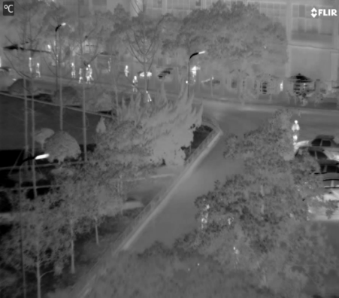
Figure 1. Thermal infrared image

EXPERIMENT PRINCIPLE
There are two principal parts in this method. The first step is image feature extraction, which utilizes operator combining HOG and PCA together. The second step is the recognition part using SVM to realize.

HOG operator separates the sample image into several pixel cells and the gradient directions into nine intervals averagely. Then it counts the gradient direction of each pixel into the gradient histogram, consisting a nine-dimensional feature vector, following combines the neighboring four pixel cells into one pixel block and gets a 36 dimensional vector, at last, scans the image with the pixel block as scanning unit and achieves the final features [6, 7]. Usually, Gamma correction is necessary in advance to remove the impact of illumination and shadow. Considering the characteristics of thermal infrared data, we can scape this part, and calculate and count the gradient values straightly. After projection and normalization, we take the image feature vectors as the original data for PCA. Figure 2 below shows the procedure of HOG operator.

Figure 2. Procedure of HOG operator

Based on digital secondary statistical features, PCA simplifies a number of relevant variables as a linear combination of several unrelated variables, and discards the parts of the less useful information and forms a new low dimensional vector instead of the formal one. Under the principal of minimal loss of information, PCA achieves the goal of reducing dimension and calculation amount [14]. The first step is calculating the mean value and expectations of each dimension of the feature vectors, then building covariance matrix and picking up the principal features by descending the eigenvalues and eigenvectors to compose a new feature space. Figure 3 below shows the entire process of PCA algorithm.

Figure 3. Procedure of PCA

SVM is a supervised learning method, based on the theory of structural risk minimization to construct optimal segmentation hyperplane in the feature space, making the learner global optimized and the expectation of the entire sample space meets a certain upper bound with some probability.

EXPERIMENT PROCEDURE & RESULT ANANLYSIS
Figure 4. Flow chart of the experiment

Figure 4 displays the entire procedure of the experiment, and we separate it into three different parts. In order to make the effect more obviously, we add some Gaussian noise to test the anti-noise capability and robustness of this method.

Figure 5 shows comparison of data before and after adding noise.

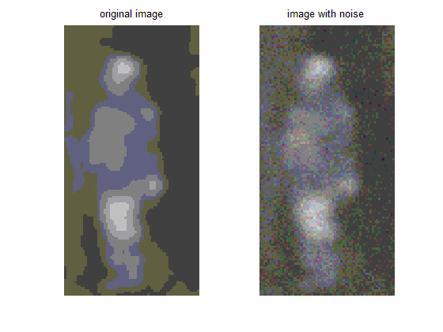
Figure 5. Comparison of data with and without noise

After preprocessing, we use binary data as input data of HOG operator. Given that PCA is not a scalar invariant analysis, the size of HOG cell size will have impact on PCA and the result. Figure 6 presents different feature extraction results with cell size of 2, 4, and 8, from which we can say that cell size 4 is better. When cell size equals to 2, the number of features is too large and many of them are useless, and this leads to unnecessary computation to the next PCA operator. On the contrary, if the cell size equals to 8, the number of features is too much small thus might not be able to present the features of the samples properly. Considering all the factors above, we use $4×4$ cell as the HOG filtering unit. Finally, we obtain the image feature with the dimensional number of 3687. Since we have a sample database with hundreds of sample images, the amount of computation is still large.

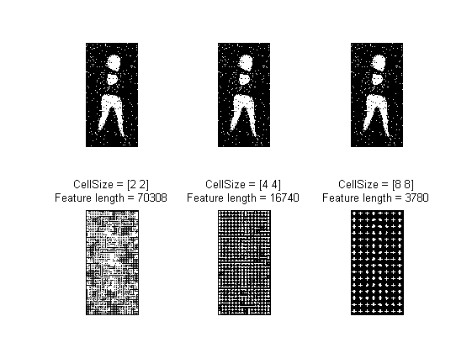
Figure 6. Feature with different cell size

Then goes to the next step, using PCA to achieve dimensional reduction. PCA just maintains the low ordered components and ignore the highly ordered ones. As told before, PCA results depend on the scalar of HOG features and the number of samples as well.

Figure 7 displays the PCA results in the experiment with the sample number 400, with 200 positive samples and 200 negative. Besides, we set another 3 experimental groups as contrast experiment, with the sample number of 100, 200 and 300, all of which are half positive.

Each row of Figure 7 shows the PCA results with the same sample number. Comparing the result of each row, we can clearly find out that with the increasing of the sample number, the distributions of the samples become clearer. Results of row (a) are almost random, but row (d) shows better distribution results.

The column results of Figure 7 compare the results in different dimensions. Column 1 shows the first dimension of the final PCA results in each experiment group; column 2 shows the distribution of the first and second dimensions and column 3 shows first 3 dimensions in a 3D way. After PCA, the original thousand dimensional feature vectors just have 20 dimensions, thus proving that the dimension reduction effect is good. We can tell from the results that the first dimension of PCA result can roughly show the distribution of the samples if the number of samples is properly, and the results are getting better if adding one or two more dimensions to do the analysis.

At last, we use SVM to sort the test samples. We set 200 images as test samples in which there are 100 positive samples and 100 negative samples. At the same time, the training data including 400 images of which 200 are positive and 200 are negative. In addition, we set 3 contrast groups with training data including 100, 200 and 300 images, and all of them have half number of positive samples and half negative. Table (a) records the accuracy and time used of each group, and comparing the result with and without the use of PCA. From Table (a) we can tell that the use of PCA contributes to both the accuracy and efficiency, which proves the advantage of the method in the experiment in recognition of pedestrian and vehicle.

CONCLUSION
In this experiment, we use HOG and PCA together to realize the main image feature extraction. HOG operator gets the gradient statistical features of the sample images, and PCA maintains low ordered ones by removing highly ordered less-important ones. In this way, we ensure the computation accuracy and cut down the computation time at the same time. HOG is much popular in pedestrian extraction, but in this experiment, we expand it into pedestrian, vehicle and background classification and recognition, which prove that HOG and PCA do well job in both parts.

However, a lot of researchers and scientists focus on the development and application of PCA since 1901, and they put forward many new PCA algorithms such as 2D PCA and kernel PCA. In the subsequent experiment, we can try different PCA methods and find the most appropriate approach and the probable improvement in the method.

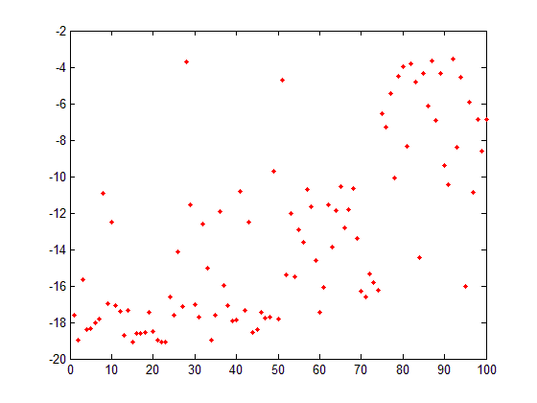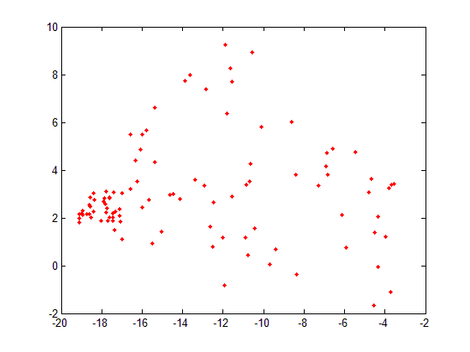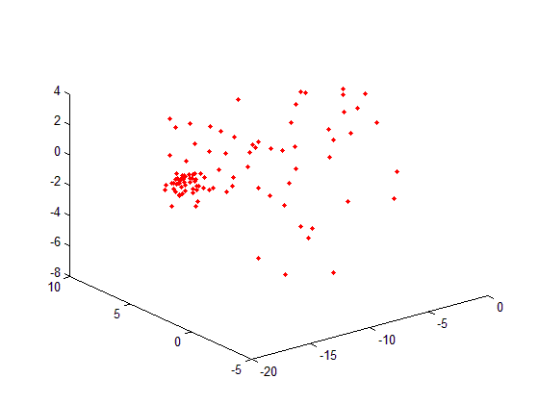
(a-1) N=100, 1-D (a-2) N=100, 2-D (a-3) N=100, 3-D
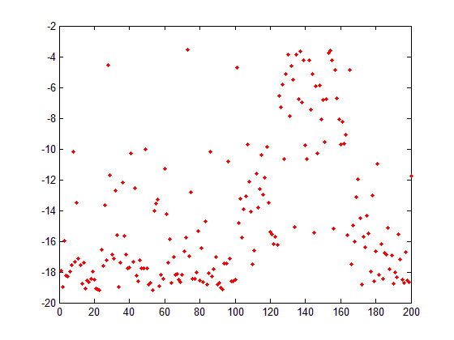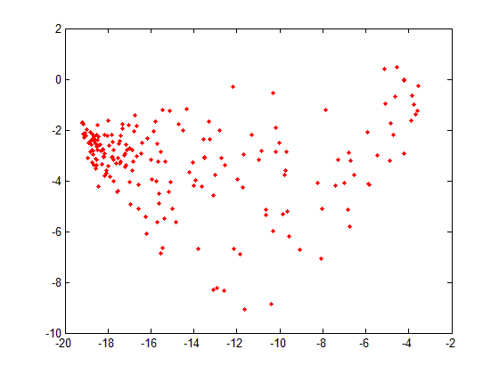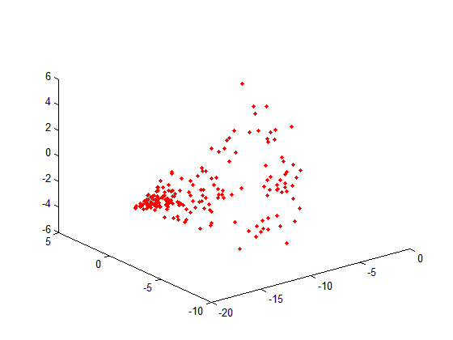
(b-1) N=200, 1-D (b-2) N=200, 2-D (b-3) N=200, 3-D
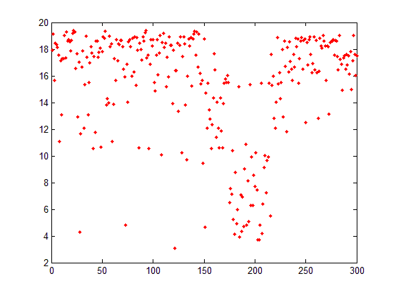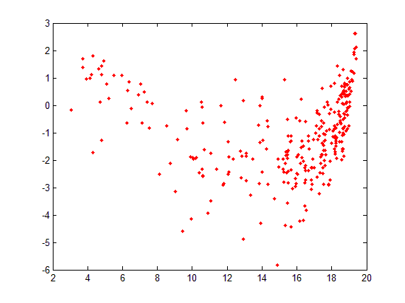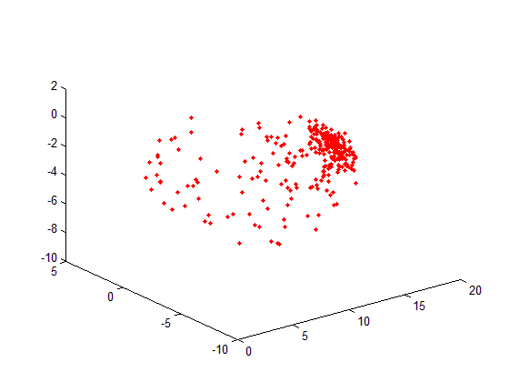
(c-1) N=300, 1-D (c-2) N=300, 2-D (c-3) N=300, 3-D
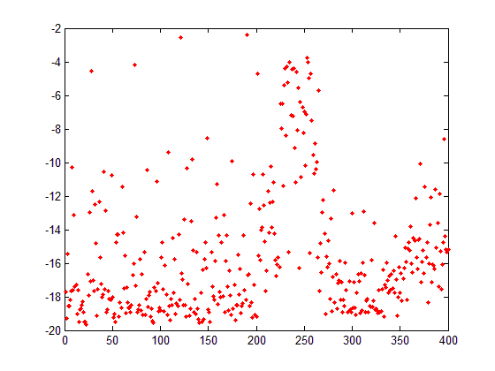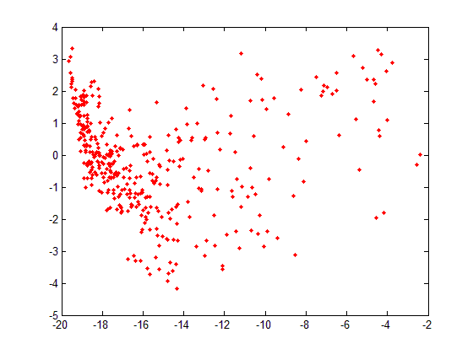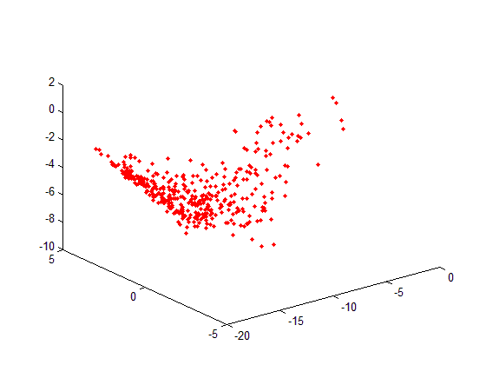
(d-1) N=400, 1-D (d-2) N=400, 2-D (d-3) N=400, 3-D

Figure 7 PCA result visualization

Table (a). Accuracy and time costing of different sample numbers

Sample number | comparison | HOG+PCA+SVM |  | HOG+SVM
 |  | accuracy | time | accuracy | time
50 | pedestrian-background | 0.8650 | 13.8685 | 0.6850 | 15.1945
 | vehicle-background | 0.7900 | 24.6794 | 0.7350 | 21.4969
 | pedestrian - vehicle | 0.8750 | 16.6765 | 0.8500 | 18.1429
100 | pedestrian - background | 0.9150 | 14.2273 | 0.6900 | 15.6937
 | vehicle- background | 0.9400 | 19.1881 | 0.6850 | 20.9977
 | pedestrian - vehicle | 0.8950 | 15.5533 | 0.8650 | 16.6765
150 | pedestrian -background | 0.9300 | 19.8745 | 0.6850 | 21.1069
 | vehicle -background | 0.9800 | 23.0257 | 0.6850 | 26.2706
 | pedestrian - vehicle | 0.9150 | 21.1381 | 0.8500 | 21.9181
200 | pedestrian -background | 0.9200 | 24.1802 | 0.6850 | 26.3174
 | vehicle -background | 0.9950 | 27.8930 | 0.6850 | 34.0862
 | pedestrian - vehicle | 0.9200 | 22.5889 | 0.8250 | 23.3221

Reference

- A. P. Kumar, S. Das, and V. Kamakoti, 2004. Face Recognition Using Weighted Modular Principle Component Analysis. In: Neural Information Processing, vol. 3316, pp. 362-367.
- C.-L. Wen, J. Hu, and T.-Z. Wang, 2007. Relative Principle Component and Relative Principle Component Analysis Algorithm. In Advances in Neural Networks – ISNN 2007, vol. 4492, pp. 985-993.
- H. Yang, Z. Song, and R. Chen, 2010. An Incremental PCA-HOG Descriptor for Robust Visual Hand Tracking, In: Advances in Visual Computing, vol. 6454, pp. 687-695.
- Gang Xie, 2008. Development of Infrared Face Recognition Method Study. Computer Engineering and Design, vol. 29, pp. 4801-4803.
- J. J. E, 1991. A user's guide to principal components. New York.
- Jun Shang, 2012. Target Recognition based on HOG features. Master thesis, Huazhong University of Science and Technology.
- Ke Zhou, 2008. Human Detection Technology Research and Realization Based on HOG Features. Master thesis, Huazhong University of Science and Technology.
- M. Grand-brochier, C. Tilmant, and M. Dhome, 2013. REFA: A Robust E-HOG for Feature Analysis for Local Description of Interest Points. In: Computer Vision, Imaging and Computer Graphics Theory and Applications, vol. 274, pp. 225-239.
- M. Schmeer, M. Schmidtb, W. Boschb, and F. Seitzc, 2012. Separation of mass signals within GRACE monthly gravity field models by means of Empirical Orthogonal Functions. Journal of Geodynamics, vol. 59-60, p. 9.
- N. Dalal and B. Triggs, 2005. Histograms of oriented gradients for human detection. In: IEEE Computer Society Conference on Computer Vision and Pattern Recognition.
- Serdar Iplikci. 2006. SVM Application List, from http://www.clopinet.com/isabelle/Projects/SVM/applist.h http://www.clopinet.com/isabelle/Projects/SVM/applist.htmltml
- S. Zhou, Q. Liu, J. Guo, and Y. Jiang, 2012. ROI-HOG and LBP Based Human Detection via Shape Part-Templates Matching. In Neural Information Processing, vol. 7667, pp. 109-115.
- Xuegong Zhang, 2000. Statistical Theory and Support Vector Machine. Automatica Sinica, vol. 26, pp. 32-42.
- Xuwei Gao, 2009. Research on Kernal PCA Feature Extraction Method and Its Applications. Master thesis. Nanjing University of Aeronautics and Astronautics.
- Yanpeng Chen, 2011. Research on Infrared Image Recgonition. Master thesis, China University of Geosciences (Wuhan).

