Modified method of cloud index estimation for deriving solar irradiance by using Heliosat-II method

Wonseok Choi¹, Ahram Song², Changyeol Yun³, Yongil Kim⁴
Department of Civil and Environmental Engineering, Seoul National University (SNU), Seoul, 151-742, Rep. of Korea,
youn0603@snu.ac.kr, aram200@snu.ac.kr

KEY WORDS: solar irradiance, cloud index, heliosat model, COMS-MI

ABSTRACT: Irradiance estimation model's accuracy is sensitive to regions and climates. Especially, cloud is one of the greatest factor for ensure accuracy of solar irradiance estimation. So, cloud index which specified to particular region and imagery is important to estimation of solar irradiance over particular region. Heliosat-II method is one of the widely used model to estimate solar irradiance, and it's accuracy has been demonstrated by many other studies. But Heliosat-II method cannot be applied directly for estimate solar irradiance around korea. Because basically Heliosat-II method estimate solar irradiance by using Meteosat meteorological satellite imagery which is taken around Europe. In this study, we adjusts Heliosat-II method to the image of COMS MI, regular weather satellite of Korea, and manufactures a more delicate background map by using modified SSG method for making cloud index. As a results, we were able to make background map which is reflected current weather condition. And we were able to make cloud index image in Korea. And it will be used in completing whole heliosat-II method which is used to estimate irradiance in Korea

1. INTRODUCTION
Estimation of solar radiation is a very important basic research available for diverse studies such as estimation and mapping of solar energy resources, prediction of crop yields, etc. Accordingly, recently there are diverse researches for estimating solar radiation going on in Korea, too. However, most researches are using foreign satellite images and the estimation model for solar radiation used for research is restricted to particular methods, such as Kawamura model, with a relatively low accuracy of the result.
Heliosat-II method, one of typical methods for estimating solar radiation, is a model that uses European Meteosat weather satellite. This Heliosat-II method shows a relatively high accuracy through model modification continued up to now. Since meteosat satellite does not cover Korea in its photographing range, however, the existing Heliosat-II method is not directly applicable to Korea so there is no research of solar radiation estimation yet using Heliosat-II method in Korea.
In the meantime, the cloud is one of the elements that have the biggest effects on the accuracy of estimated solar radiation. Heliosat-II method calculates the effect of cloud on solar radiation by drawing cloud index using a virtual background map. Background map is the value of ground albedo in assumption of clear sky condition and Heliosat-II method estimated the ground albedo at clear sky through statistical method using satellite images between 1985 and 1997. However, such existing method is hard to reflect either the atmospheric and surface condition at the wanted moment of drawing solar radiation or a big change occurring on earth.
Thus, in this study, we adjusts Heliosat-II method to the image of COMS MI, regular weather satellite of Korea, and manufactures a more delicate background map to propose the method of drawing cloud index.

2. EXPLANTION AND MODIFICATION OF HELIOSAT-II METHOD

2.1 Heliosat-II method

The existing Heliosat-II method consists of four processes in all, as shown in Figure 1(a). Process 1 finds apparent albedo using meteosat satellite images and I0met value, which means a total solar radiation received by their visible channel (Formula 1).

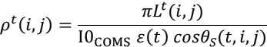 Formula 1

Here, ρ^{t} (i,j) is apparent albedo, i, j represents the coordinates for pixel of satellite images and t, time. Also, L^{t}(i,j) stands for the value of irradiance accepted by COMS MI sensor, ε(t) correction of distance beteen the sun and the earth, and θs, solar zenith angle.
Process 2 makes atmosphere reflectance using the values of I0met and Linke turbidity, which is found through formula 2.

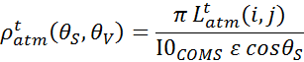 Formula 2

Here, L_{atm} is the value of irradiance in clear sky condition while Dc is diffuse irradiances in clear sky condition. Besides, I₀ is solar constant (1367W/m²) and ρ^{t}_{atm} is reflectance by atmospheric effect.
Process 3 makes ground albedo in clear sky condition using apparent albedo and atmosphere reflectance drawn earlier. This process also draws cloud index using ground albedo in clear sky condition and background map. Below is the fomula that finds cloud index.

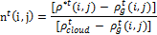 Formula 3
if < 0.01 0.0
if -0.01 < [] < 0.01 0.0
if [] ≤ 0.1 1.2

Here, n^{t} (i,j) is cloud index and ρ^{t}_{cloud} is cloud albedo. Also, ρ*^{t} is ground albedo in clear sky condition while ρ^{t}_{g} is ground albedo shown in background map. Finally, process 4 draws global hourly irradiation.

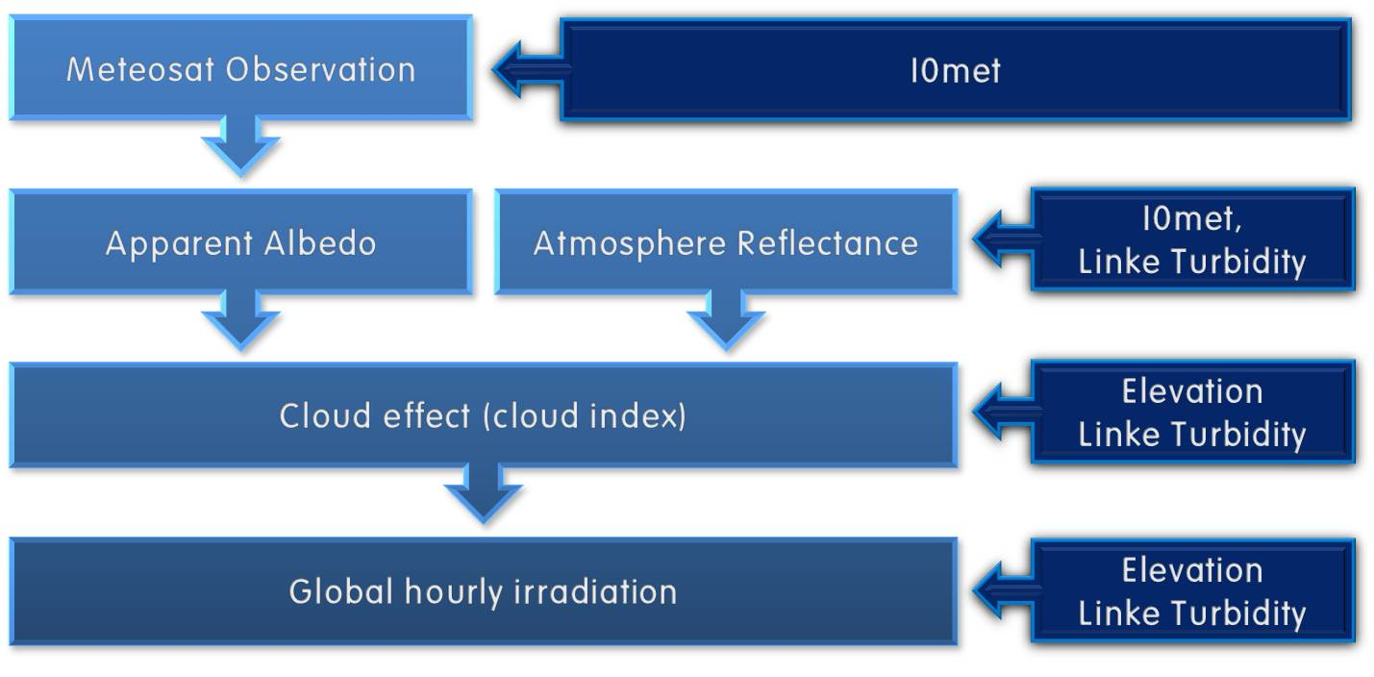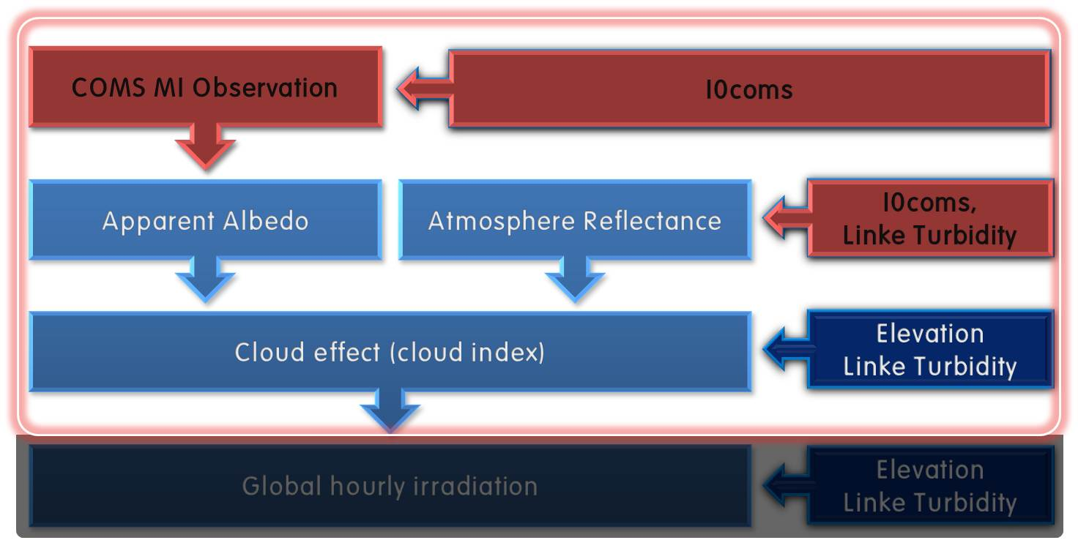
- (b)
Figure 1. Process of Helisoat-II method(a) and modified Heliosat-II method(b)

2.2 MODIFICATION OF HELIOSAT-II METHOD

The present study modified Heliosat-II method for its application to Korea. Then, as shown in Figure 1(b), we carried out research through process 3 for drawing cloud index. First, input satellite images were transformed into COMS MI satellite images. This study used the images of COMS MI visible channel and COMS MI cloud, which were obtained in October 2013 by being given through National Meteorological Satellite Center. COMS MI visible channel images were used for conducting the head end process and drawing apparent albedo. COMS MI cloud images were used for drawing cloud index. In the meantime, I0met is a total solar radiation in the section of visible channel that can be recorded by satellite sensor. As I0met is a value specialized for meteosat, this was changed into the value corresponding to COM MI images using Formula 4 and named I0coms.

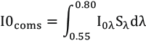 Formula 4

Here, I_{0λ} is solar radiation by wavelength range, for which this study used Wehrli 1985 model. S_{λ} is the value of sensor spectral response and it was provided through National Meteorological Satellite Center of Korea.

4. METHOD OF PRODUCING BACKGROUND MAP

Background map is a virtual ground albedo image for finding cloud index. This study made background map using the images of ground albedo in clear sky condition and COMS MI cloud. We used COMS MI cloud image to remove the cloud existing in the image of ground albedo in clear sky condition and restored the region of removed clouds by modifying the SSG technique proposed by Jin et al. (2013).
Most of the existing cloud restoration algorithm simply did mosaic of reference image in restoring the image. However, for experimental image and reference image, there is limitation in embodying the natural image of restoration because diverse differences such as weather requisite, etc. occur. On the other hand, SSG technique has strength in restoring experimental image by only using coordinate values of the reference image (Byeonghee kim et al., 2014). SSG technique is largely composed of three steps as shown in Figure 2: 1. Find from reference image the value of DN on the same coordinates as the region of removed clouds. 2. From the reference image, find the coordinates showing similar values to the DN values found in step 1. 3. Find DN values on the same position as the coordinates found in step 2 and restore the experimental image using their mean value. At this time, however, exclude the coordinates overlapping with the region of removed clouds from calculation.

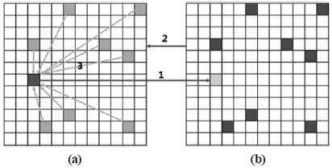
Figure 2. SSG cloud filling method ((a) experimental image, (b) reference image)

Like this, the existing SSG technique used one sheet of reference image without existence of clouds. However, in Korea with a climate of clouds occurring very frequently, we have very few of reference images without clouds. Thus, removing the clouds in the existing method makes a very large gap in time between reference image and experimental image, lowering the accuracy of restored image. For this reason, this study used seven sheets of image at the same time of one to seven days before the experimental image for reference image.
For the technique of modification, process of removing clouds from each of reference images precedes the same as SSG technique. For case of the coordinates with clouds removed from both reference image and experimental image, however, allow DN value for experimental image before removing the clouds. This study calculated cloud index with the background map of experimental image manufactured like this.

5. RESULTS

Apparent albedo images, the result of Heliosat-II method process 1, and atmosphere reflectance images, the result of process 2, show themselves in Figure 3 and Figure 4, respectively. Because time interval between images are very small, there are no noticeable changing in atmosphere reflectance. On the other hand, because apparent albedo is affected by cloud, there are noticeable change in its images.

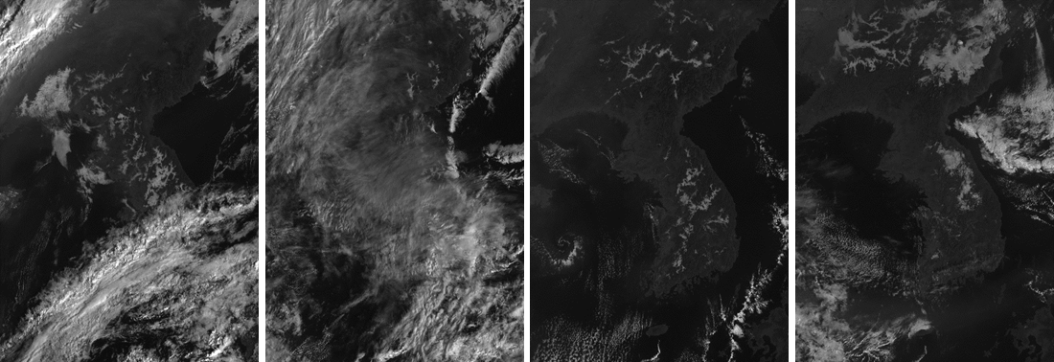
Figure 3. Apparent albedo images ( October, 2013, 00:00(UTC) (from left to right 10th, 19th, 27th, 30th) )
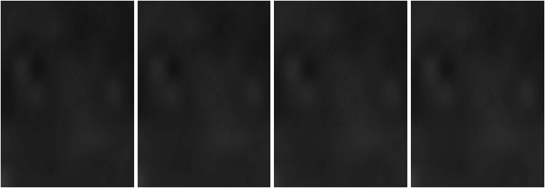
Figure 4. Atmosphere reflectance images ( October, 2013, 00:00(UTC) (from left to right 10th, 19th, 27th, 30th) )

Background map made by using the modified SSG technique is as shown in Figure 5. Gray images are background map and red images are original images which are before cloud removing. This complement was an overall success but failed in accurate correction for regions in which thin clouds exist.

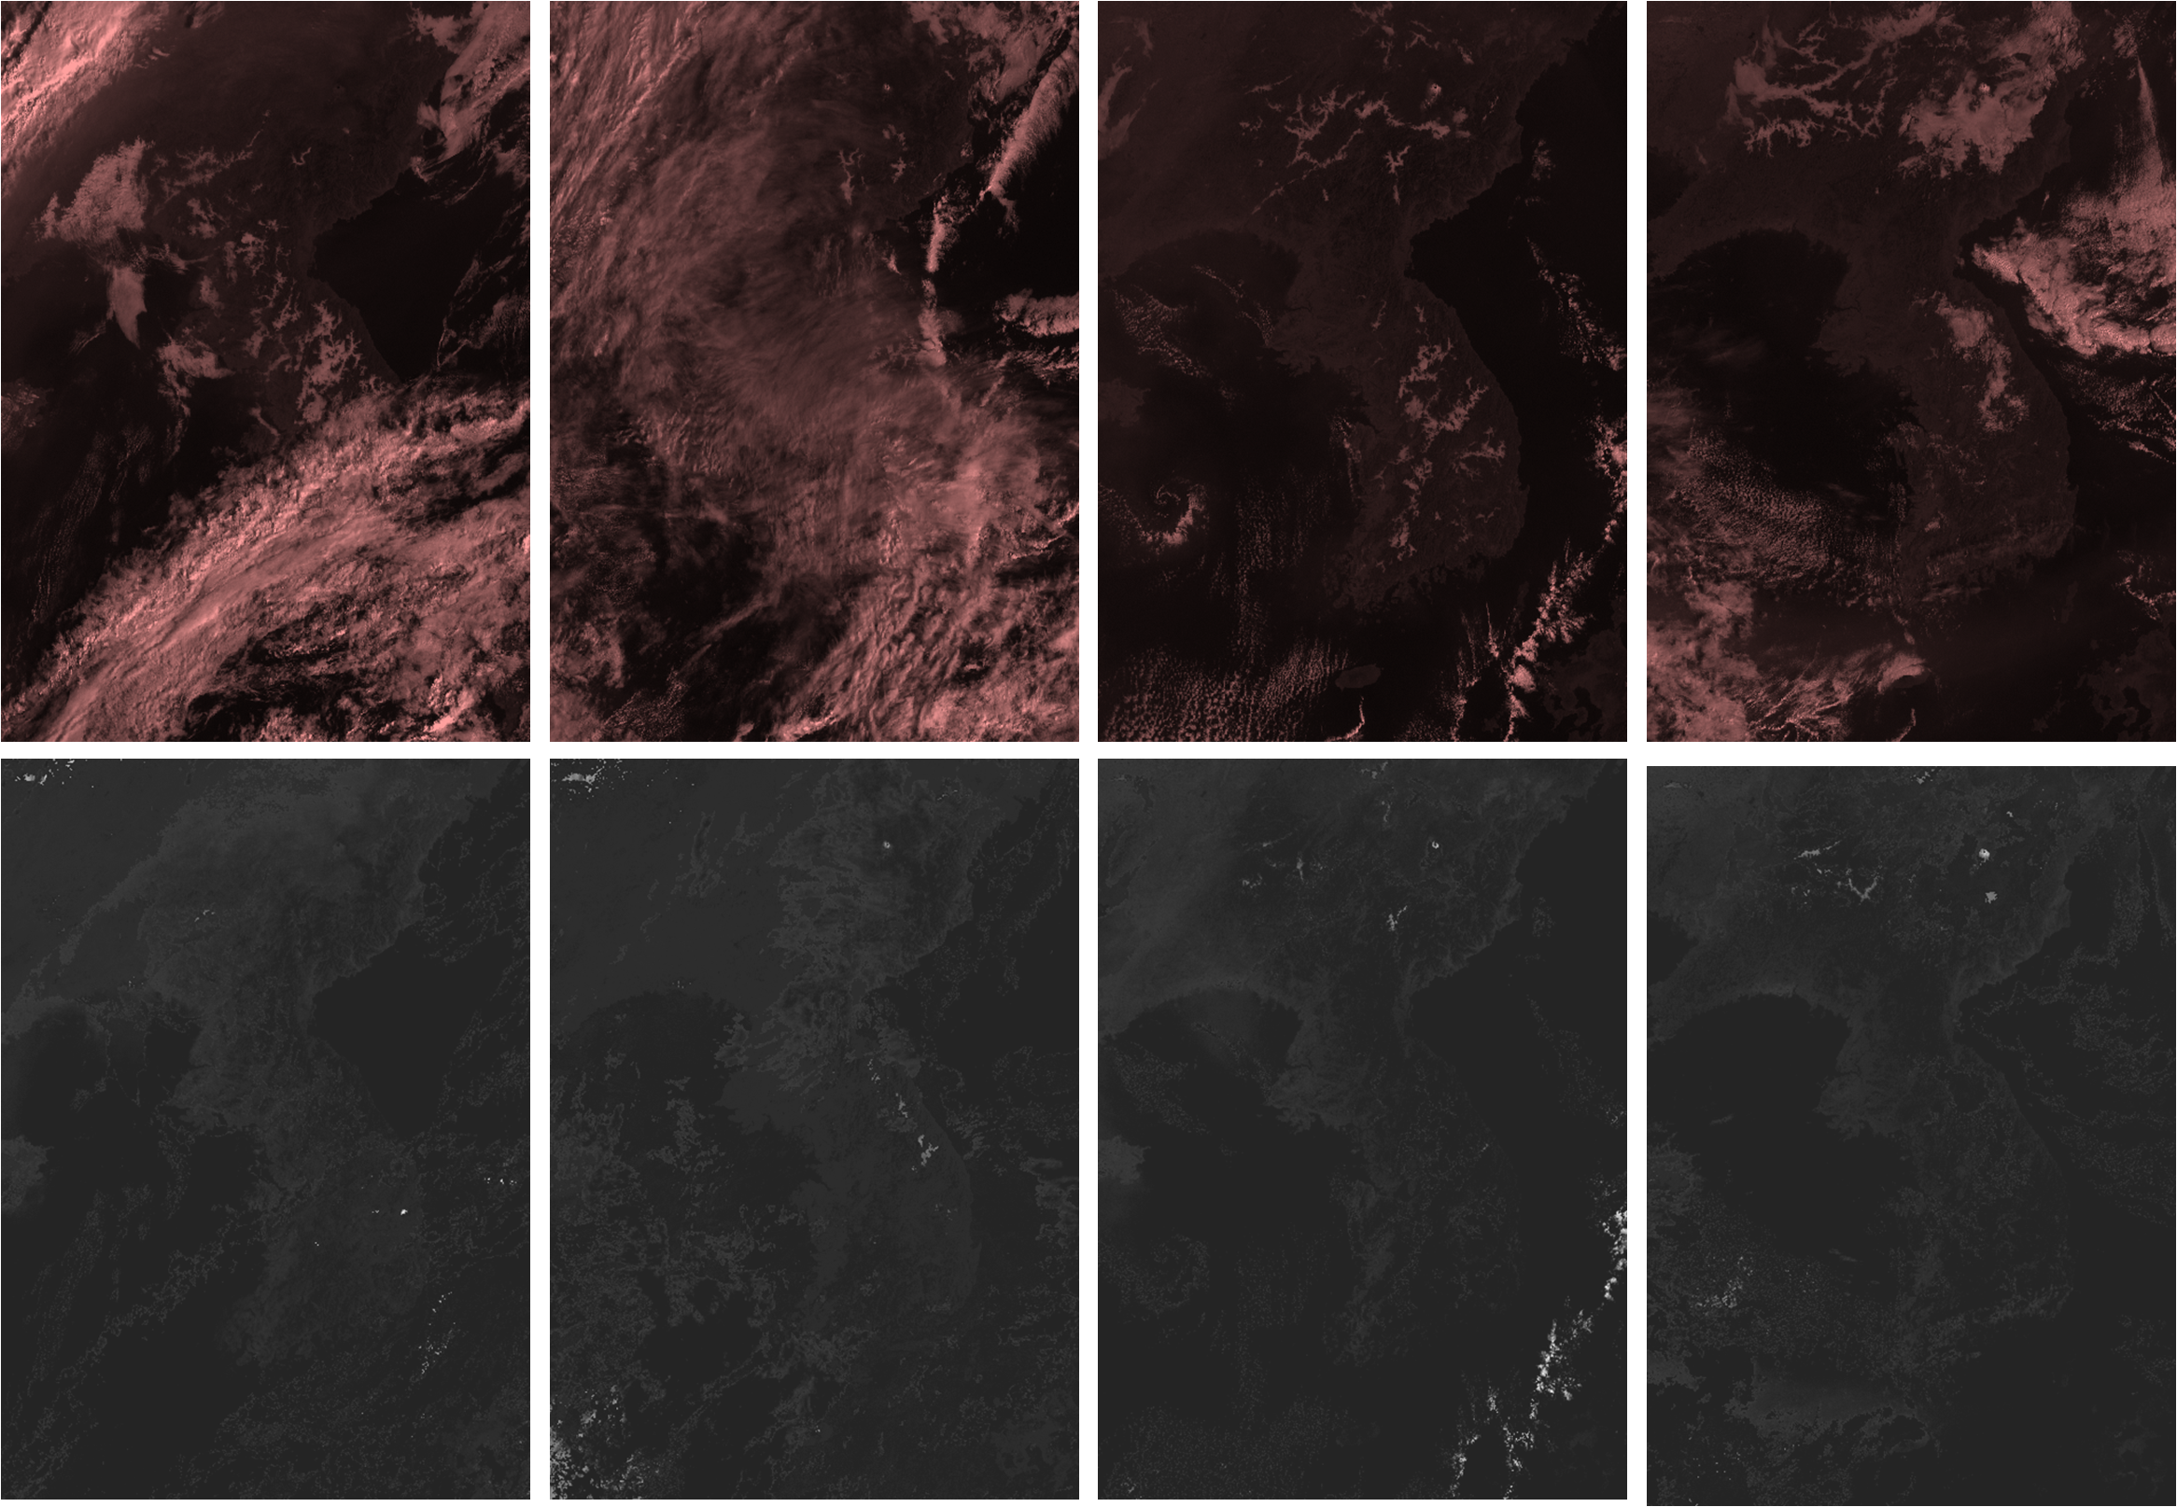
Figure 5. Background maps (gray scale images) and original images (red images)
(October, 2013, 00:00(UTC) (from left to right 10th, 19th, 27th, 30th) )

Finally, cloud index map was drawn using apparent albedo, atmosphere reflectance and background map and Figure 6 shows this result.

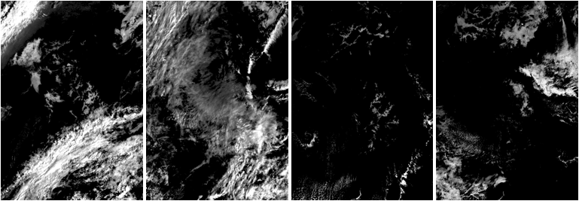
Figure 6. Cloud index images ( October, 2013, 00:00(UTC) (from left to right 10th, 19th, 27th, 30th) )

6. CONCLUSIONS

To estimate the information of Korea’s solar radiation, this study modified Heliosat-II method. Among the input data of Heliosat-II method, we switched things inapplicable to Korea, especially by replacing meteosat satellite image with COMS MI satellite image. Besides, we modified the method of drawing the background map needed for calculating cloud index, a big influence on the accuracy of estimated solar radiation. Through such course, we completed three steps of the four-step process in Heliosat-II method. Later on, we are planning to modify the method of drawing cloud index more suited for Korea, complete the application of the last and the fourth step of Heliosat-II method, and estimate the solar radiation of Korea using this.

ACKNOWLEDGEMENT
This work was supported by The establishment of new and renewable energy resource map and utilization system of The ministry of Knowledge Economy and Korea Institute of Energy Research

REFERENCE
B. Durr and A. Zelenka, 2009, Deriving surface global irradiance over the Alpine region from METEOSAT Second Generation data by supplementing the HELIOSAT method, International journal of Remote Sensing , Volume 30, Issue 22, pp. 5821-5841
Byeonghee Kim, Yonghyun Kim, Youkyung Han, Wonseok Choi and Yongil Kim, 2014, Fully automated generation of cloud free imagery using landsat-8, Journal of the Korean Society of Surveying, Geodesy, Photogrammetry and Cartography, Volume 32, No 2, pp.133-142
C. Rigollier, M. Lefevre, and L. Wald, 2004, The method Heliosat-2 for deriving shortwave solar radiation from satellite images, Solar Energy, Volume 77, pp. 159-169
C. Rigollier, M. Lefevre, S. Cors and L. Wald, 2002, Heliosat 2: An improved method for the mapping of the solar radiation from meteosat imagery, In proceeding of the 2002 EUMETSAT Meteorological setellite conference, Dublin, Ireland, pp 585-592
Christelle Rigollier, Oliver Bauer and Lucien Wald, 2000, On the clear sky model of the ESRA-European solar radiation ATLAS – with respect to the Heliosat method, Solar Energy, Volume 68, No. 1, pp 33-48
Issac Moradi, Richard Mueller, Bohloul Aligani, and Gholam Ali Kamali, 2009, Evaluation of the Heliosat-II method using daily irradiation for four stations in Iran, Solar Energy, Vol. 83, pp. 150-156
Jin, S., Homer C., Yang L., Xian G., Fry J., Danielson P. and Townsed P. A., 2013, Cloud free satellite image mosaics with regression trees and histogram matching, International Journal of Remote Sensing, Volume 34, No. 5, pp. 1540-1560
M. Chaâbanea, M. Masmoudia and K. Medhioubb, 2004, Determination of Linke turbidity factor from solar radiation measurement in northern Tunisia, Renewable Energy, Volume 29, Issue 13, pp. 2065-2076
M. lefever, M. Albusson, and L.Wald, 2004, Description of the software Heliosat-II for the convension of images acquired by meteosat satellites in the visible band maps of solar radiation available at ground level
Remund J., Page J., 2002. Advanced parameters Chain of algorithm: short- and longwave radiation with associated temperature prediction resources, Report to the European Commission, SoDa(integration and exploitation of networked Solar radiation Databases for environment monitoring) project IST-1999-12245, pp.72

