Surface deformation from multi-temporal INSAR methods with ALOS PALSAR in Pingtung Plain

ªChia-Ying Lee, ªWei-Chia Hung, ªCheinway Hwang

ª Department of Civil Engineering, National Chiao Tung University, Taiwan.
Tel: + 886-3-5712121#{54958}; E-mail: {joyokolee@gmail.com; khung@itrige.com.tw; cheinway@mail.nctu.edu.tw}

KEY WORDS: Land Subsidence, TCPInSAR, StaMPS

ABSTRACT: Pingtung Plain is suffering severe subsidence caused by groundwater withdrawal. Extracting groundwater has caused large-scale land subsidence in Pingtung Plain, with the largest cumulative subsidence being 339 cm over 1972-2011. The subsidence has caused that the elevation in coast area is lower than sea level. How to effective monitor land subsidence becomes a major issue in Taiwan. Interferometry synthetic aperture radar (INSAR) technique has proven a useful way for detecting ground displacement. This technique can not only apply to some geohazards such as volcanoes, landslides and land subsidence but also offer ground information with high spatial resolution and centimeter-scale accuracy. In this study, We utilize two Multi-temporal InSAR (MT-InSAR) methods including Temporarily Coherent Point InSAR (TCPInSAR) and Persistent Scatterer InSAR(StaMPS) with 18 ALOS PALSAR acquisitions from 2007 to 2011 to derive land deformation, respectively. Results of this study show that the subsidence region located at Linpien River’s two-side area near coast area in Pingtung Plain and demonstrate the effectiveness of TCPInSAR and StaMPS in monitoring land subsidence.

1.INTRODUCTION
Pingtung Plain which is located at the south-west of Taiwan had served the subsidence several years. The subsidence has caused that the elevation in coast area is lower than sea level. Base on this situation , it is necessary to monitor the land subsidence in this area(Hsieh,2011).

The main industry in Pingtung Plain is Agriculture and Aquaculture. Both of this industries need a lot of water for irrigation. Extracting the groundwater has been the normal way to acquire the water resource which is the main reason that cause the large-scale land subsidence in Pingtung Plain. The land subsidence in the coast area has been over 339cm and continued exacerbation.

There is many ways to monitor the land deformation such as Leveling and GPS is a commen method. Interferometry synthetic aperture radar (InSAR) technique has proven a useful way for detecting ground displacement. InSAR technique can offer ground information with high spatial resolution and centimeter-scale accuracy. DInSAR is widely use in defotmation dective (Zebker, 1994). Ferrett al. propose the PSInSAR technique which is based on DInSAR technique(Ferretti, 2001). Select the stable pixel as persistent scatterers to get the ground deformation.phase unwrapping is a important step in PSInSAR to estimate the phase integer. Zhang proffer the TCPInSAR technique which can avoid phase unwrapping. We use ALOS ALOS PALSAR acquisitions to detect the Pingtung Plain by using TCPInSAR and StaMPS.
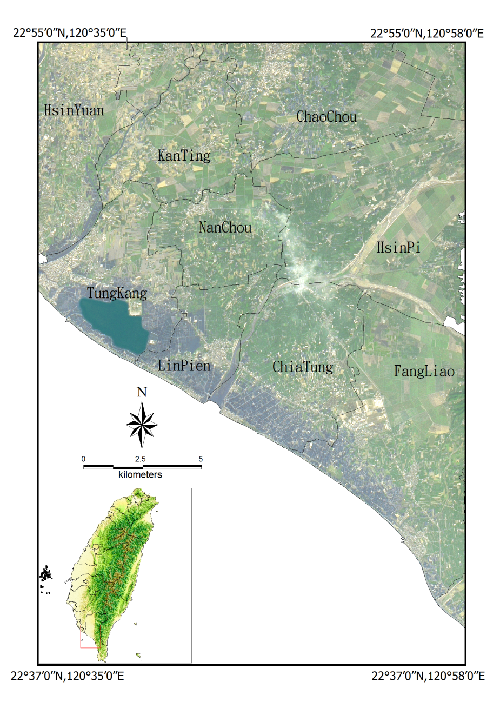
Figure 1 .The satellite image of the study area which is locate at the south-west of Taiwan

2. METHOLOGY
2.1PSInSAR
PSInSAR is methods that use the Persistent scatterer to do the time series analysis. Use the single-master acquisitions paring with another slave image to drive the interference. Persistent scatterer is defined as stability phase characteristics.most of the persistent scatterer point are building, bridge pier, rock (Hooper, 2004). The PS candidate select is rely on pixel amplitude dispersion with time.The amplitude dispersion index, $D_{A}$, is defined as
$$D_{A}≡\frac{σ_{A}}{μ_{A}} (1)$$
$σ_{A}$ is the standard deviation of amplitude dispersion.
$μ_{A}$ is the mean of amplitude values.
After select the PS candidate, use the signal to noise ratio to estimate the PS pixel the signal to noise ratio which is$γ_{x}$.
$${ γ}_{x}=\frac{1}{N}\left|\sum_{i=1}^{N}{exp\left\{\sqrt{-1}\left(ψ_{x,i}-{\tilde{ψ}}_{x,i}-{∆\hat{ϕ}}_{θ,x,i}^{u}\right)\right\}}\right| (2)$$
Where $ψ_{x,i}$is the wrapped phase of pixel x in the ith interferogram.
${\tilde{ψ}}_{x,i}$ is the estimate of the spatially-correlated terms.
${\hat{ϕ}}_{θ,x,i}^{u}$is the estimate of the spatially-uncorrelated look angle error term and N is the number of interferograms.

2.2TCPInSAR
A temporarily coherent point is the coherent point between two SAR acquisitions(Zhang, 2011). It apply the multi-master image and generate the interferograms. Then use the Least squares with ambiguity detector to estimate parameters. TCP is select by the offset estimation. When the pixel in low coherence area with the improper window size will show large bias in the result and the points with high coherence are less sensitive to the size of the patches and to the oversampling factor (Zhang, 2012). TCP identify by the step below. First calculate the initial offset and the estimate the coefficient of the offset parameter which is used as initial input. Second, implement the cross-correlation to every pixel. An offset matrix is containing the estimate parameter.
$${ O}_{l×m}=\left[\begin{matrix}\begin{matrix}O_{1,1} & O_{1,2} \\ O_{2,1} & O_{2,2}\end{matrix} & \begin{matrix}⋯ & O_{1,m} \\ ⋯ & O_{2,m}\end{matrix} \\ \begin{matrix}⋮ & ⋮ \\ O_{l,1} & O_{l,2}\end{matrix} & \begin{matrix} & ⋮ \\ ⋯ & O_{l,m}\end{matrix}\end{matrix}\right] \left(3\right)$$
where $O_{i,j}$, i=1,2…,l; j=1,2,…,m is the offset of pixel (i,j) which contains the offset components in both azimuth and the range directions. Third, the pixel with identical offsets will select as TCP candidate by using the 2-D histogram and change the size of image patch in the cross-correlation. Final, eliminate the TCP candidate which does not fit the polynomial then the rest oft the candidate will be selected as TCP

3. RESULT
In PSInSAR method, we choose 20080722 be a master image. In TCPInSAR method we use the threshold of perpendicular baseline is 700, temporal baseline is form 90 to 1200 and the total image pairs is 37. The leveling is Interpolate by the 177 benchmark. Table 2. will show the comparison of the PSInSAR method, TCPInSAR method and the leveling.

There are total 17 radar image we used from 2007 to 2011.In TCPInSAR method we use 16 images and in PSInSAR method use 17 images. TCPInSAR has the highest point density and leveling has the lowest density. The root mean square of both two method is about the same.The minimum rate and maximum rate of PSInSAR are make a great difference with TCPInSAR. The PS points in mountain area cause this situation.
 | PSInSAR | TCPInSAR | Leveling
Density (point/km²) | 60 | 531 | 0.17
Nomber of pair | 17 | 37 | -
RMS(cm/yr) | 1.29 | 1.30 | -
Min Rate(cm/yr) | -11.38 | -3.33 | -4.19
Max Rate(cm/yr) | 5.5 | -0.18 | 0.58
Table 2. The comparison between PSInSAR,TCPInSAR and leveling
3.1 The vertical displacement and the difference between leveling
The original displacement rat is the light-of-sight displacement, we turn it to the vertical displacement.We produce the vertical displacement map by using the Kriging interpolation method.In this study , we choose the benchmark is located on the Linpien downtown and shift the difference between leveling and SAR.The Figure 2 are the PSInSAR/TCPInSAR/Leveling displacement map of Pingtung Plain. In the coast area has a obvious subsidence area. Although the subsidence patterns are not similar, most of the points, comparing with leveling, are differ within 2cm. Some of the points in the aquaculture area are differ over 3cm.Figure 3. Display the Vertical displacement rate maps of the leveling.
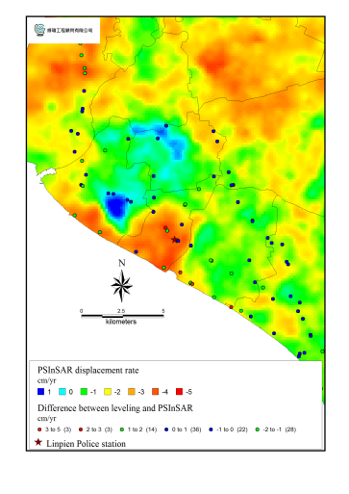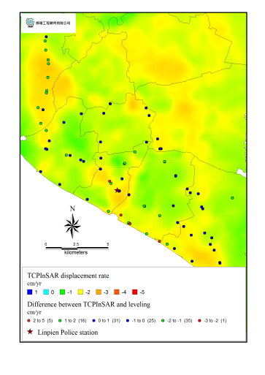
(a)
(b)
Figuer 2 .Vertical displacement rate maps and the difference between leveling.(a)PSInSAR (b)TCPInSAR

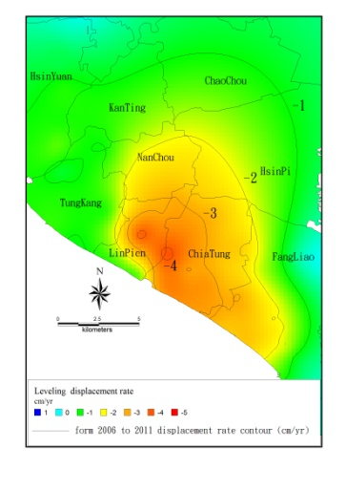
Figuer 3 Vertical displacement rate maps of the leveling

4. CONCULUTION AND FUTURE WORK
In this study, we use 17 ALOS-L band images to dective the land subsidence.PSInSAR and TCPInSAR can dective the deformation. The RMS of PSInSAR and TCPInSAR comparing with leveling is 1.29 and 1.30.The density of PS and TCP is 60 and 531. To improve the result , we can use different parameter in PSInSAR and carefully sieve out the image pair and adjust the threshold in TCPInSAR. We can use difference band radar acquisitions in future.

5. REFERENCE
Ferretti, A., 2001. Permanent scatterers in SAR interferometry. IEEE Transactions on Geoscience and Remote Sensing, 39(1): 8-20

Hooper, A., 2004. A new method for measuring deformation on volcanoes and other natural terrains using InSAR persistent scatterers. Geophysical Research Letters, 31(23).

Hsieh, C.S., 2011. Using differential SAR interferometry to map land subsidence: a case study in the Pingtung Plain of SW Taiwan. Nat Hazards,(58):1311-1322
Zebker, H. A., 1994. On the derivation of coseismic displacement fields using differential radar interferometry: The Landers earthquake. Journal of Geophysical Research, 99(B10): 19617

Zhang, L., 2011. Ground settlement monitoring based on temporarily coherent points between two SAR acquisitions. ISPRS Journal of Photogrammetry and Remote Sensing, 66(1): 146-152.

Zhang, L., 2011. Modeling PSInSAR Time Series Without Phase Unwrapping. IEEE Transaction on Geosciences and Remote Sensing, 49(1): 547-556.

Zhang, L., 2012. Mapping ground surface deformation using temporarily coherent point SAR interferometry: Application to Los Angeles Basin. Remote Sensing of Environment, 117: 429-439.

