Container tracking via AIS satellites

Timo Rolf Bretschneider, Nguyen Thai Dung
Airbus Group Innovations, 110 Seletar Aerospace View, Singapore 797562, Singapore,
Email: timo.bretschneider@eads.net

KEY WORDS: S-AIS, GPS-denied, localisation estimate

ABSTRACT: Current systems for worldwide container tracking use global navigation satellite systems (GNSS) to determine a container’s geographical position and a satellite modem for communicating this information to a central server. However, the communication results in significant operational costs and both services require a large degree of line-of-sight between the container and the corresponding satellites. In particular the latter requirement is difficult to fulfil once containers are stacked. This paper describes an alternative approach based on the automatic identification system (AIS), which in recent years experienced a global boom after several companies launched satellites that can sense the signal remotely from space enabling global remote sensing of AIS signals. Originally derived for the exchange of voyage details among ships in order to reduce the risk of collisions, the described system extends AIS twofold. Firstly, the surrounding transceivers’ transmitted AIS information are used together with additional information to compute a container’s position, thus, forgoing the usage of a GNSS receiver. Secondly, embedded features in the AIS message protocol are used to transmit the container’s position transparently avoiding interference with the original use case. Global coverage is enabled through the availability of numerous AIS-dedicated remote sensing satellites as well as auxiliary AIS payloads onboard of communication satellites. Simulation results and measurements are presented to demonstrate the capability of determining a geographical position for a container in a GPS-denied environment. A strong focus is placed on the spaceborne sensing, which is crucial for global 24/7 availability of the tracking information.

1. Introduction

In today’s just-on-time logistics tracking of assets is crucial for an efficient global supply chain. In particular, shipping containers account for more than 90% of the non-bulk cargo and, hence, are the most relevant transport mode in the maritime environment and on land. Applications using tracking information extend beyond the main intention of geo-referencing a container and comprise examples like the establishment of secure transport lanes in an increasingly global world as well.

One particular aspect of the transport industry is its high degree of vertical defragmentation, i.e. freight forwarders, carrier, ship owners etc. are separate entities. Therefore, very few common standards beyond the physical definition of container formats exist and common infrastructures like communication links cannot be assumed. As a result, solutions that provide container tracking capability need to be self-sufficient in terms of localisation, communication and power.

The majority of current systems for container tracking with global coverage use the global positioning system (GPS) to determine a container’s geographical position. Alternative solutions are based on GLONASS (Russia) and in the future trackers using Galileo (EU) and COMPASS (China) are expected. All provide continuous localisation capabilities with a high degree of accuracy. On the other hand, specialised solutions based on barcodes or radio-frequency identification (RFID) enable localisation at certain gates along the transportation path. However, this localisation is rather discrete and requires specific end-to-end infrastructure. Examples for this model of operation are express package firms like FedEx and DHL. A third group of alternative solutions use triangulation of received signals from the global system for mobile communications (GSM) (Mahlknecht and Madani, 2007; Thrivikrama et al., 2011), wireless local networks (WLAN) and/or FM radio stations (Schmidt et al., 2009). Although some of these approaches achieve adequate localisation accuracy, the disadvantage is the limited range of the signals excluding remote land areas as well as offshore operation.

In terms of communicating the location of a container to a central server, several different technologies can be found in the market with the most suitable solution depending on the expected deployment area of the container. For instance, globally operating trackers use the satellite networks from OrbComm, GlobalStar and Iridium with variable degree of coverage, while systems intended for roads and railways often use GSM and general packet radio services (GPRS). While different technologies have different areas of applications, the trend in an increasingly globalised world is toward systems that are not limited to national standards and providers and which can operate worldwide. Hence, a spaceborne infrastructure is needed for sensing and communication. Hereafter, the paper is limited to consider only such systems.

2. Problem Statement

Profit margins in the shipping industry tend to be relatively low and, thus, tracking systems are often only employed for high-value freight due to the involved costs. Business models in the container tracking industry vary and high ownership costs for the units need to be recovered either directly or indirectly through service agreements. Additionally, operating costs for the subscription services of the satellite communication providers are substantial when related to the profit margins in shipping. Hence, alternative communication means are highly thought after.

On the technical side, the chances for determining a position highly depends on a (near) obstacle free visibility of the sky, i.e. the navigation satellites (Schmidt et al., 2009). However, on board of a container ship the containers are stacked and most of them are obstructed by other containers. The same argumentation as for the localisation applies to some extend to the communication. Iridium and GlobalStar operate in the L- and S-band, respectively (Sturza, 1996), while most GNSS are operating in the L-band. Hence, a successful communication link requires near-line-of-sight between the ground terminal and the corresponding satellite. One exception is OrbComm operating in the very high frequency (VHF) band, which can be received in obstructed environments as well.

In summary, the main issues for globally deployable tracking solutions are the operational costs and the quality of service, which is constrained by the physics of wave propagation. In the following section these problems are addressed in the context of remote sensing by utilising alternative sources of information and satellite communication.

3. Method and System Description

The described system uses AIS for container tracking, i.e. for localisation without a GNSS receiver and communication via AIS messages. AIS is compulsory for large vessels and originally intended for the exchange of voyage details among ships in order to reduce the risk of collisions. Each AIS-equipped vessel broadcasts its identifier set by the International Maritime Organization (IMO) together with longitude, latitude, speed, heading and further voyage relevant information every 2–10 seconds. These messages are received by other vessels in the vicinity and generally overlaid on a chart plotter on the bridge.

Operating on two channels in the VHF range, the transmission range is limited due to the Earth curvature. However, VHF has the advantage that the signal can be received even in a highly cluttered environment, which is beneficial when operating among stacked containers. An experiment was conducted in the port of Singapore and the results are shown in Figure 1 comparing received AIS position messages for an unobstructed and a highly obstructed operation, respectively. Naturally, fewer messages can be received in a setting with partially blocked signal reception, but the remaining messages are still sufficient for the targeted purpose.

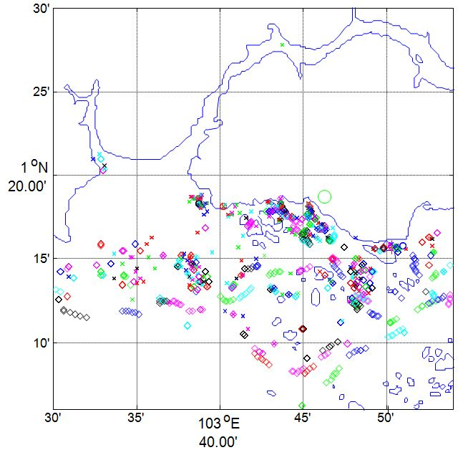 | 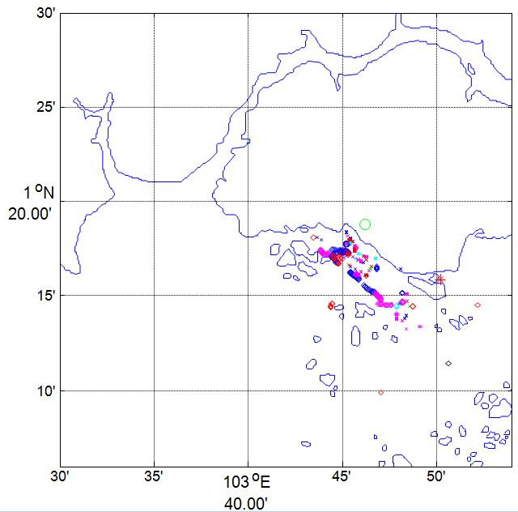
(a) | (b)
Figure 1: Received AIS messages of tracked vessels with the location of the receiver indicated by the green circle on shore; note that the two measurement series were not carried out simultaneously: (a) receiver placed with good visibility of the port, (b) receiver placed in a metal box with a small opening

The original short range tracking capability of AIS with ship-to-ship and ship-to-shore communication is insufficient for obtaining a global tracking picture. As a result, in the past decade this led to the establishment of several governmental and commercial programmes, e.g. exactEarth, OrbComm and SpaceQuest, providing reliable satellite-based AIS (S-AIS) (Cervera and Ginesi, 2008; Graziano et al., 2012; Coleshill et al., 2010).

Several technical challenges have to be addressed in the context of S-AIS. Firstly, the much larger reception footprint of a satellite in comparison to an AIS receiver deployed onboard a vessel can lead to interference between received AIS messages in space since the self-organised time division multiple access scheme can handle only a maximum of 4500 messages per minute using two channels. Two possible solutions to counteract this limitation are to deploy multiple directional antennas and/or to use shorter messages to avoid overlapping messages (Høye et al., 2008). Furthermore, novel processing concepts were suggested to solve this problem to a large degree (Challamel et al., 2012; Zhou et al., 2012). Secondly, attenuation losses as part of the signal’s propagation from the surface to space naturally prioritise the stronger Class A AIS signal (12.5W) over the weaker Class B signal (generally 2W). In particular, Class A AIS is the backbone of the collision avoidance concept for commercial ships and, hence, any AIS usage for other applications like container tracking needs to restrict itself to Class B. However, recent advances utilising a spectrum decollision technique (ABSEA, 2014) enable global coverage from space for Class B as well.

The proposed system for remotely sensing the locations of containers consists of a Class B AIS transceiver without GPS, but an additional computing unit for estimating the position as well as to implement a form of smart communication in order to minimise the additional load of AIS messages on the limited number of available timeslots. An integrated inertial measurement unit (IMU) provides abstract information of the container current state in order to estimate its instance like loading / unloading, underway etc.

3.1 Localisation Estimation

Although AIS messages contain position information of the corresponding vessels that broadcasted the messages, the location of the receiver, i.e. the location of the container, cannot be derived directly. For instance, an average position using all received messages does not necessarily coincide well with the actual position of the receiver as can be seen in Figure 1. Instead the developed system utilises an algorithm that observes all transmitting vessels over time, derives their tracks and relates these information with additional data provided by the IMU. By excluding vessel tracks that are not straight and assuming an omnidirectional signal reception, i.e. the range is identical in all directions, a position can be estimated reliably over time.

An example in the form of a simulation is depicted in Figure 2(a). In total 200 ship tracks and corresponding AIS messages were simulated within the coastal waters of the Strait of Malacca, Strait of Singapore and Southwest Riau Islands. The tracking errors over time for two containers travelling within this scenario are displayed in green and red in Figure 2(b). During the initials simulation steps the localisation algorithm collects information in a learning phase and actual position estimates are achieved after a hypothesis test. It has to be noted that the quality of the estimate highly depends on the encountered situation. The most trivial case is the scenario of a single container ship travelling on an ocean passage. Then only one AIS transmitter can be observed by the container tracking unit and the location estimate is straightforward. More complex cases like at the convergence of shipping routes require the interpretation of the IMU data together with semantic knowledge that container do not change ships when in motion etc.

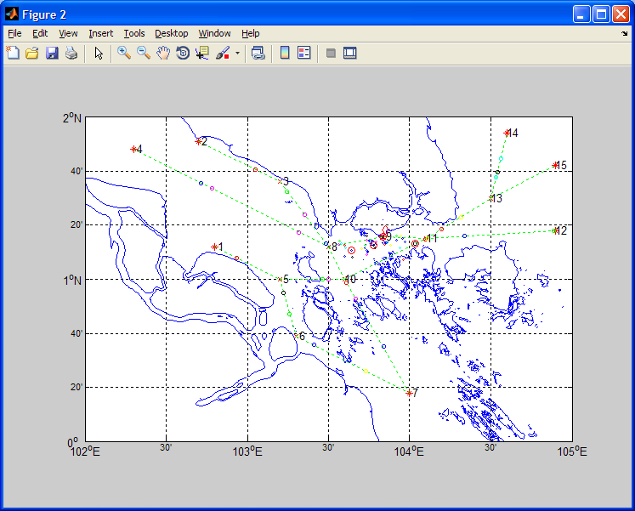 | 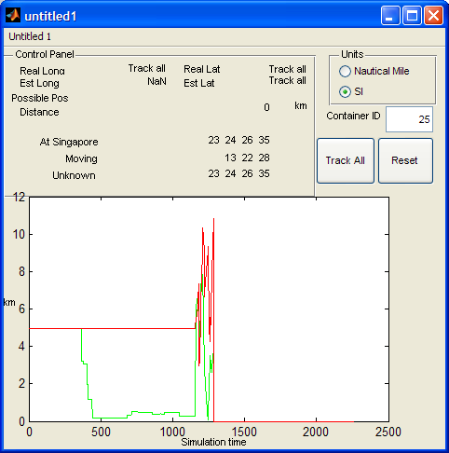
(a) | (b)
Figure 2: Simulation for tracking of containers using AIS: (a) simulation area with 200 ships, (b) tracking error of two different containers

The developed solution cannot estimate the precise location of a container on the corresponding ship, i.e. this holds true for the class of ultra large container vessels (ULCV) with up to 400m in length. Hence the tracking error in the simulation is measured as the shortest distance between the estimated container location and a bounding box around the vessel.

3.2 Communication

The original proposal of using AIS for communication in container tracking (Bretschneider, 2011) emphasised the use of ground-based assets. A low-powered AIS transmission from the unit integrated with the container broadcasts the estimated location, which can either be received by a ship or a shore-based station. Both types of entities act as forwarders using other means of communication or possibly AIS as well. In case of the latter, the received information cannot be forwarded directly, but needs to be repacked in specific AIS messages, which are similar to a SMS on a mobile phone.

In any case, it is essential to avoid overloading the available transmission slots. A low-powered transmission facilitates this aspect since Class A AIS messages superimpose the container’s messages using Class B (possibly with a reduced power output). Moreover, the frequency of communication needs to be restricted strictly. This can be achieved by associating a container with a vessel, i.e. the vessel is tracked thereafter and not the container itself. Only if the tracking units detects a change by associating itself with another vessel or as unloaded, then this information is communicated again. In particular, this approach is beneficial for longer ocean passages reducing the power consumption for transmissions as well as in congested waters with a high density of vessels. A crucial aspect in the outlines approach of association is that the container’s communication is one-directional, i.e. no acknowledgement whether the message was received by a central entity is provided. Thus, infrequent repetition of the container-to-vessel association message is needed to ensure reliable tracking. An overview of the connectivity is provided in Figure 3.
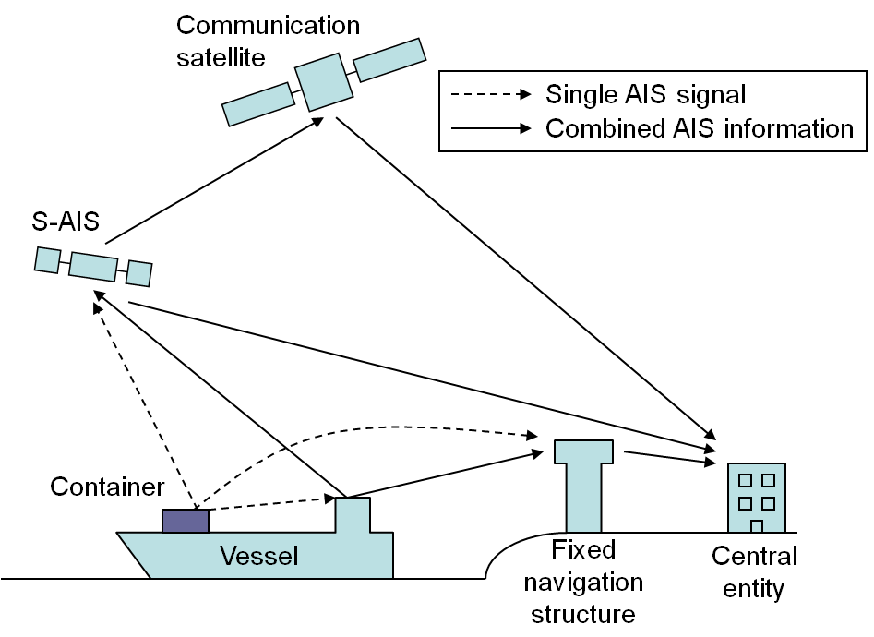
Figure 3: Forwarding of AIS messages through ground- and space-based assets

The main and only global link for sending the localisation data of a container is through S-AIS, which forwards the information either direct or indirect (by means of a communication satellite or relay stations on the ground) to a central entity. However, in congested areas, i.e. littoral waters, with shore-based AIS installations, the tracking data can be relayed without satellite support.

4. Conclusions

The main benefit of the described system is that is can increase the service availability significantly since the line-of-sight requirement for localisation and communication can be eased. However, the conclusion is not to replace existing technology by this new concept, but rather aim for complementary operation. In particular, building upon an existing, trusted and comprehensive solution for ship tracking (i.e. S-AIS), the suggested system operates transparently and, thus, can utilise the existing infrastructure right from the start without a major setup phase. Operational costs can be greatly reduced if only ground-based AIS services are included; however any satellite-based service will come at a cost. Currently, theses costs can be still significant for real-time data since the market is dominated by a single service provider. But changes in the market situation are foreseen with several current satellite developments.

The great operational success of AIS in general and the noticeably increasing demand in S-AIS availability comes with disadvantages as well. For instance, AIS message congestion is already an issue in some parts of the world with load capacities of 64% in the Gulf of Mexico and 40% around Japan (Bober, 2014). However, the next step of the future of AIS has already begun with the rollout of the first prototypes of the VHF data exchange system (VDES), which integrates various technologies in the maritime domain with explicit consideration of spaceborne systems. Operational availability is targeted for 2020.

References

ABSEA, 2014. Technology Whitepaper, SRT Marine Technology and exactEarth. Retrieved in June 2014 from http://softwarerad.com/wp-content/uploads/2014/05/ABSEA-Whitepaper.pdf

Bober, S., 2014: VHF digital data exchange. In VDES Workshop, Tokyo. Retrieved in August 2014 from http://blog.canpan.info/oprf_en/img/VDES-Data20Exchange20System20Overview.pdf

Bretschneider, T., 2011. System for tracking of containers, WO2011070534 A2.

Cervera, M.A., Ginesi, A., 2008. On the performance analysis of a satellite-based AIS system. In: Proceedings of the International Workshop on Signal Processing for Space Communications, pp. 1-8.

Challamel, R., Calmettes, T., Gigot, C.N., 2012. A European hybrid high performance Satellite-AIS system. In: Proceedings of the Advanced Satellite Multimedia Systems Conference, pp. 246-252.

Coleshill, E., Cain, J., Newland, F., and D’Souza, I., 2010. NTS - A nanosatellite space trial. In: Acta Astronautica, vol. 66, pp. 1475-1480.

Graziano, M.D., D’Errico, M, and Razzano, E., 2012. Constellation analysis of an integrated AIS/remote sensing spaceborne system for ship. In: Advances in Space Research, vol. 50, pp. 351-362.

Høye, G.K, Eriksen, T., Meland, B.J., and Narheim, B.T., 2008. Space-based AIS for global maritime traffic monitoring. In: Acta Astronautica, vol. 62, pp. 240-245.

Mahlknecht, S., Madani, S.A., 2007. On architecture of low power wireless sensor networks for container tracking and monitoring applications. In: Proceedings of the IEEE International Conference on Industrial Informatics, pp. 353-358.

Schmidt, R., Gagnon, A., and Allcock, D., 2009. Maritime containers tracking trial results. In: IEEE Aerospace and Electronic Systems Magazine, vol. 24, no. 9, pp. 10-14.

Sturza, M.A., 1996. LEOs – the communications satellites of the 21st century. In: Proceedings of the IEEE Technical Applications Conference Northcon, pp. 114-118.

Thrivikrama, Ashok, V.G., and Srinivas, A., 2011. A novel two-stage self correcting GPS-free localization algorithm for GSM mobiles. In: Proceedings of the IEEE International Conference on Advanced Networks and Telecommunication Systems, pp. 1-6.

Zhou, Z., van der Veen, A.-J., and van Leuken, R., 2012. Multi-user LEO-satellite receiver for robust space detection of AIS messages. In: Proceedings of the IEEE International Conference on Acoustics, Speech and Signal Processing, pp. 2529-2532.

