THE APPLICATION OF SATELLITE REMOTE SENSING TECHNIQUES FOR MONITORING MANGROVE FOREST IN YAMBYE TOWNSHIP, RAKHINE STATE, MYANMAR

Hnin Khaing Aye
Assistant Lecturer, Dr., Department of Geography, Dagon University, Yangon, Myanmar
Email: hninkhineaye@gmail.com

KEY WORDS: Change Detection, Geo-referencing, Image Classification, Landsat, UTM

ABSTRACT

The study area lies between north latitudes 19° 5′ to 19° 25′ and between east longitudes 93° 50′ to 94˚5′. It is located in the northeastern part of Yambye Township, Rakhine State, and southwestern part of Myanmar. Wunbaik mangrove forest is one of the largest mangrove forests in Rakhine State. The purpose of this study was to monitor the changes of mangrove forest cover spatially and temporally from 1990 to 2013. The multispectral and temporal Landsast data of 1990 and 2013 with 30 meter resolution were used for the classification of forest cover in the study area. Visual interpretation techniques were employed in the study for monitoring and mapping mangrove cover changes of this area. The analysis of mangrove forest cover changes were carried out the use of change detection analysis based on ground check survey. Then, presentation of forest cover map and the results of change detection analysis for Wunbaik mangrove area. The result of this study is large amount of mangroves was lost by the encroachment of farming activities and illegal cutting of fuel wood collection in Wunbaik mangrove area. Dense mangrove area in 1990 was 16671.71hectares (45.16 percent of Wunbaik mangrove area) and it decreased to 11893.19 hectares (32.22 percent of Wunbaik mangrove area) in 2013. Therefore, satellite remote sensing techniques can be an effective tool for researchers, planners, and provide important and useful information for many resource management decisions relating to the long term management of mangrove forests.

INTRODUCTION

In Myanmar, like in many other tropical countries, mangrove forest resources are important for socio-economic development and environmental conservation. Mangrove forests of Myanmar are mostly found in the Ayeyarwady deltic region, Rakhine and Tanintharyi coastal areas, offshore islands, tidal estuaries and creeks.
Forest Department estimated that the area of mangrove forests in Myanmar was about 448,976 hectares and mangrove forest of Rakhine State was 22,919 hectares (Table 1). Wunbaik mangrove occupies 76.39 percent of Rakhine State’s mangrove forests and 3.9 percent of Myanmar’s mangrove forest in 2007.
Inhabitants in Wunbaik mangrove area depend almost entirely on mangrove resources. Mangroves have not only provide them with essential products, such as fuel wood, charcoal, fishery grounds, construction materials, food, etc. but also protect the coast from strong wind and surge. It is also assumed that mangrove forests protect them from hazardous tsunamis to some natural disasters.
Table (1): Mangrove forest area of Rakhine, Tanintharyi
and Ayeyarwady Delta in Myanmar (2007)
No. | State and Region | Area (hectares)
1 | Rakhine State | 22,919
2 | Tanintharyi Region | 151,262
3 | AyeyarwadyRegion | 274,795
 | Total | 448,976
Source: Forest Department, Yangon, Myanmar.
STUDY AREA

The study area lies between north latitudes 19° 5′ and 19° 25′ and between east longitudes 93° 50′ and 94˚5′. It is located on the western part of Myanmar and northeastern part of Yambye Township, Rakhine State. It is bounded on the north and northwest by Ann Township, south by other parts of Yambye Township, east by Taunggup Township and west by Kyaukphyu Township. This study area has an area about 91,225.10 acres (36,917.55 hectares) of which reserve forest area has 56,633 acres (17,507 hectares), Figure (1). According to the result of the structured interviews and topographic map, there have 19 villages within six study village tracts are lies adjacent to the Wunbaik reserve forest (Figure 2).

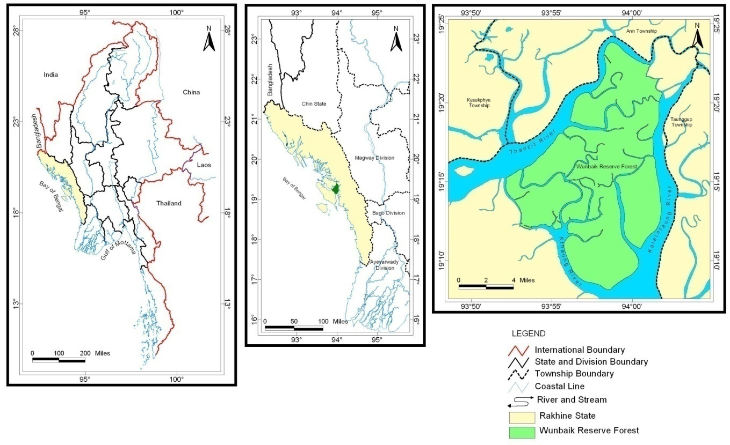
Figure 1. Location map of Wunbaik mangrove area, Yambye Township, Rakhine State.
Source. Index of UTM map numbers 85 E/15, 85 E/16, 85 I/3, 85 I/4.

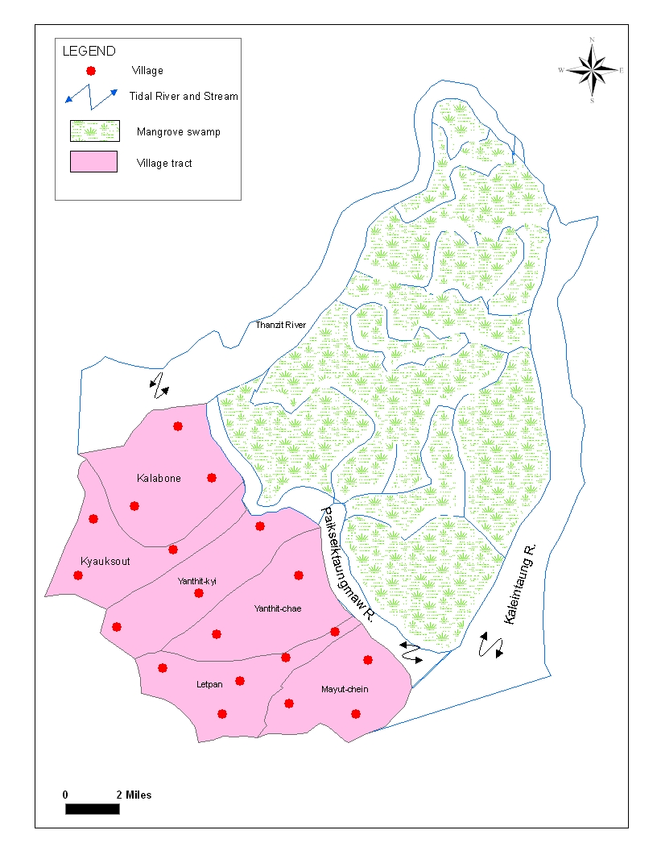

Figure 2: Location of study villages in
Yambye Township, Rakhine State,
Myanmar.
Source: UTM Map No. 85 E 15/16, 85 I 3/4, Township and Village tract boundary map (Yambye).

RESEARCH QUESTION
There have three main research questions and tried to answer in this paper. They are: What are the patterns of forest cover changes in Wunbaik area? How are these land cover and land use changed in space and time? and Why the major causes of these changes occur?

RESEARCH PURPOSE
This research work organizes with the purpose of “To monitor the changes of mangrove forest cover spatially and temporally from 1990 to 2013”and “To analyze the major causes of mangrove cover change”.

MATERIALS AND METHODS

Visual interpretation techniques were employed in the study for monitoring and mapping mangrove cover changes of this area. The index of Landsat TM satellite images 134-47 1990 and 2013 with 30 meter resolution were used for the classification of land use and land cover of study area. Supervised classification was performed by selecting a number of training samples. The analysis of mangrove forest cover changes were carried out the use of change detection analysis based on ground check surveys. Then, presentations of forest cover map and the results of change detection analysis for Wunbaik mangrove area.
For the selection of ground control points (GCP), topographic maps of 85 E/15, 85 E/16, 85 I/3, 85 I/4 with the scale of one inch to one mile were used. Then, village (point), river and stream (line) and village tract boundary (polygon) information were put into GIS system with screen digitization. During the field survey structured interviews to 170 families of seasonal settlement from six study village tracts, open talks and discussions with farmers, fisherman, charcoal producers, firewood cutters, local authorities and other local peoples.

IMAGE DATA PROCESSING

Multi spectral Landsat 7 ETM image (1990, 2013) of Wunbaik area (30 meter resolution) was selected for land cover classification. Landsat images of dates 1990 and 2013 are considered for digital image processing. The flow chart (Figure 3) shows the major steps of the study.
First geo-referencing and rectification of these images and RGB color composite were prepared. Rectification is done in World Geodetic System (WGS 1984 Datum) with Universal Transverse Mercator (UTM Zone 46 North) map projection system. Then training areas were selected based on the six major categories of different land use and land cover classes, such as dense mangrove (dark green), sparse mangrove (light green), paddy field (yellow), shrimp pond (orange), road (red) and water body (dark blue). Each satellite scene was individually classified, focusing first on separating categories, using standard supervise classification techniques with maximum likelihood classifier. Editing was applied using GPS data and UTM maps. Generation of confusion matrix by using ground truth data and ROIs for the validation of results. The overall accuracy for the classification is estimated around 95 percent. Then, change detection analysis was used for the study of changes of land cover and preparation of land use map and change detection map of Wunbaik mangrove area.
Landsat Images
(1990, 2013)
Pre Processing
Accuracy Assessment
Image Classification
Land Use Mapping
(2013)
Land Use Mapping
(1990)

Monitoring Forest Cover Changes
Change Detection Mapping & Statistics

Figure (3). Flow Chart showing the major steps of the study.

RESULTS AND DISCUSSION

Comparison between land cover classification map 1990 and 2013, the agriculture land, especially paddy field is the most dominant type and the second most is shrimp pond. It is occupying largely the southern and south-eastern part of Wunbaik mangrove area because this part lies at the nearest area of villages. The second large extension is found in the north-western part and the third extension is found in the western part of this area. In other parts influenced the sparse mangrove vegetation, especially in the middle part of Wunbaik mangrove area because of illegal cutting of fuel wood (Figure 4).
This vitally important mangrove ecosystem has been degraded due to agricultural encroachment, conversion of mangrove forest into shrimp farming, uncontrolled fuel wood collection. Wunbaik mangrove forest area has to compete with other forms of land use. Major use of mangrove land is for agriculture especially paddy field, the expansion of agriculture is difficult to control due to population pressure and further agricultural development plan by the local authorities. Another type is aquaculture especially shrimp farming in mangrove areas which can give high and quick returns to the local people. In addition, illegal cutting of fuel wood for firewood and charcoal production for commercial purpose is one of the major causes of mangrove degradation. Finally, mangrove areas are being reclaimed for construction purposes especially road construction has been done in this area.
Satellite image records of Wunbaik area showing that about 54 percent of dense mangrove disappeared within 23 years indicated the deforestation rate of mangrove area (1990 to 2013). Therefore, dense mangrove forest area will be totally lost by 2033 under current destruction rate. This is an alarming situation, so the mangrove forests should be saved in time. The decreases in the actual forest area of the study area for the past 23 years were going on at the rate of about 2 percent per year.
The results of this research that monitoring these types of changes might be endanger the surrounding mangrove land in this area. It is crucial to protect and rehabilitate mangrove resources. Therefore, it is urgently needed to implement the sustainable management system for Wunbaik mangrove area.
The area estimated by the change detection analysis for each land cover and land use category is given in Table (2). In 1990 the area of paddy field was 1,507.35 hectares and it has increased to 2921.49 hectares in 2013. Shrimp ponds have not existed in 1990 because shrimp farming entered to this area after 1990. Therefore, shrimp pond areas in 2005 were 1061.88 hectares. Comparison between these two years, dense mangrove has 16671.71 hectares in 1990. It decrease to 11893.19 hectares in 2005. Sparse mangrove area in 1990 was 6695.09 hectares; it increased to 9158.17 hectares in 2013. Land used for road construction is about 326.33 hectares in 2013. This highway road construction was beginning after 1990. The type of forest cover changes were decrease or increase is also shown in Table (3).

Table 2. The result of change detection analysis based on the comparison of image
classification between 1990 and 2013. Unit: Hectare

To 2013  From 1990 | Dense  Mangrove | Sparse  mangrove | Paddy field | Shrimp  pond | Road | Water  body | Total
Dense  Mangrove | 9321.35 | 3926.41 | 2385.38 | 603.46 | 202.02 | 233.09 | 16671.71
Sparse mangrove | 2007.24 | 4200.95 | 139.86 | 106.19 | 77.69 | 163.17 | 6695.09
Paddy field | 416.98 | 269.36 | 388.49 | 344.46 | 41.44 | 46.62 | 1507.35
Water body | 147.63 | 761.45 | 7.77 | 7.77 | 5.18 | 11113.61 | 12043.4
Total | 11893.19 | 9158.17 | 2921.49 | 1061.88 | 326.33 | 11556.49 | 36917.55
Source: Landsat TM image classification (Between 1990 to 2013)

Table (3): Changes of the mangrove cover in Wunbaik area from 1990 to 2013.
Class Name | Area (Hectare) |  | Changes in Area  (Hectare) | Type of Changes
 | 1990 | 2013
Dense Mangrove | 16671.71 | 11893.19 | - 4778.52 | Decrease
Sparse mangrove | 6695.09 | 9158.17 | + 2463.08 | Increase
Paddy field | 1507.35 | 2921.49 | + 1414.14 | Increase
Shrimp pond |  | 1061.88 | + 1061.88 | Increase
Road |  | 326.32 | + 326.32 | Increase
Water body | 12043.40 | 11556.49 | - 486.91 | Decrease
Source: Landsat TM image classification (1990 and 2013).

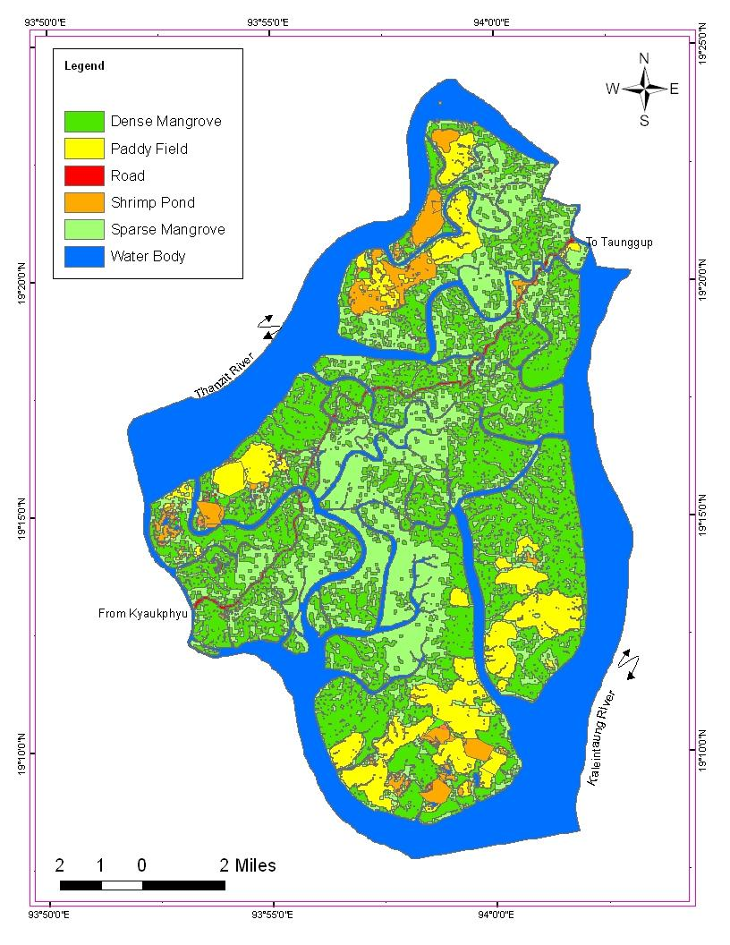
2013
1990
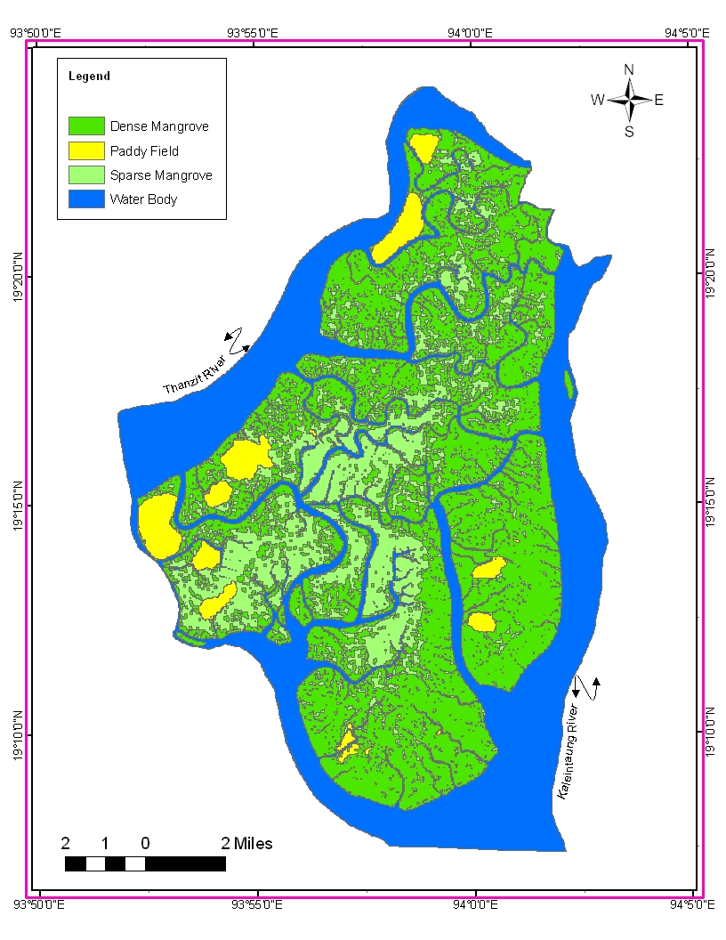

Figure 4. Forest cover classification map of Wunbaik mangrove area (1990 and 2013)
Source: Index of satellite image 134-47, Landsat TM and Ground truth data.

CONCLUSION
1990

The purpose of this study was to monitoring the changes of mangrove forest in Wunbaik area. In this research findings show that the most mangrove area has significant change because, increasing population in study area, inadequate knowledge to understand the mangrove ecosystem, insufficient reforestation programme, illegal encroachment have not been enforced strictly, lack of cooperation between relevant national and international organizations in this area and little awareness among people, regarding the importance of mangrove ecosystem.
In spite of the above factors, Wunbaik mangrove area has better chance for maintaining its mangroves, according to some factors. There is no permanent settlement and only seasonal settlement in Wunbaik mangrove area, the farmers said that the cost of repairing their embankment is lower than further expansion of agriculture especially paddy fields. Therefore, they want to work continuing in these fields for the present and future generations on a long term basis, according to structure interview. Furthermore, rapid natural regeneration is occurring in Wunbaik mangrove area. At present, Forest Department has strictly banned further expansion in this area. In addition, there have many ecotourism potential in this Wunbaik mangrove area.

REFERENCES

David S.Wilkie & John T. Finn, 1996. Remote Sensing Imagery for Natural Resources Monitoring
FAO, Forestry Paper 1431993. Sustainable Management of Tropical Forests in Central Africa.
Forest Department, 2001. Forestry in Myanmar. Ministry of Forestry.
Forest Department, Myanmar and JICA, Japan, 2005. The Study on Integrated Mangrove Management Through Community Participation in the Ayeyarwady Delta, Myanmar.
Nay Win Oo, 2002. Deforestation Due to Mangrove Dwellers in the Ayeyarwady Delta, Myanmar. Ph D Dissertation, The Graduate school of Science, Tokyo Metropolitan University, Japan.
NOAA, Coastal Services Center 2007. Land Cover Analysis_Change Analysis, Frequently Asked Questions, FAQs.

