DETECT LAND COVER CHANGE BY USING NDVI DIFFERENCING AND POST-CLASSIFICATION: A CASE STUDY IN HOA BINH - VIETNAM

NGUYEN THI THUY HANH^{1,*} , TRAN NGOC DIEN²

- Department of Surveying and Cartography, Hanoi University for Natural Resources and Environment
- Geological Remote sensing Centre, General Department of Geological Map in the North of Vietnam

Corresponding author: NGUYEN THI THUY HANH

Mobile: (+84)916104970
Email: hanhntt.hunre@gmail.com
Astract: The article presents results of land cover changes especially forest for 15 years in Hoa Binh by integration of NDVI differencing and post-classification technique. Firstly, the images were converted to Reflectance and radiometrically corrected using the dark object subtraction model .Next, these Landsat TM images were georeferenced and geographically corrected using the first order polynomial transformation, and the nearest neighbour method for resampling. The pre-processed Landsat TM images were used to calculate NDVI, and subsequently for NDVI differencing. Finally, a threshold for vegetation modification detection was identified by visual analysis of Landsat TM RGB band composition, visual comparison of digital aerial orthophotos and field observation. To detect land cover conversion, post-classification is applied. As a results, during the examined period, total regional forest cover increased by 248043.6 ha (54%) while barren soils and agricultures decreased 110570.22 ha (24.1%) and 142620.03 ha (31.1%) respectively.

Keywords: Hoa Binh, forest, NDVI, change dectection, Landsat, post-classification

Topic: Remote Sensing Applications

Sub-topic: Forestry /Ecosystem Destruction
- INTRODUCTION
Monitoring forest dynamic represents a crucial issue to elucidate several processes, including biogeochemical cycles, atmospheric composition related to climate change, and forest carbon uptake, as well as socio-economic processes and issues. Anthropogenic and naturally induced land cover changes affect spatial and temporal distribution and availability of environmental resources, and alter ecosystem composition and productivity. Globally, these processes can be considered the primary catalysts for change in biogeochemical cycling, atmospheric composition, and climate [1, 2]. Forest land-use and land-cover change (LULCC) were recognised as key issues in greenhouse gas emission processes as specified by the Good Practices Guidance for Land Use, Land Use Change, and Forestry (GPG-LULUCF) during the Intergovernmental Panel on Climate Change (IPCC) established at the Kyoto Protocol [3]. Observation and assessment of forest cover changes are crucial to elucidate the complexities inherent in feedback processes between forest distribution and human activities in sustainable forest development, natural resource management, biodiversity conservation, ecosystem functioning, and biogeochemical cycling [4, 5].
Remote sensing imaging is considered one of the main sources of information about the earth‟s cover. They have been widely used in detecting and monitoring vegetation changes at various scales because of the capability of remote sensing technology to provide a broad range of calibrated, objective, repeatable and cost-effective data for large and regional areas[6, 7].

Several proposed vegetation change detection methods are based on the same image pre-processing
to create a time-series dataset, requiring a geometric and radiometric image correction. Coppin & Bauer (1996) and Milne (1988) reported the main methodological approaches for vegetation change detection can be distributed into four broad categories: (i) linear procedures (difference and ratio images); (ii) classification routines (post-classification change, spectral pattern change); (iii) transformed data sets (vegetation indexes,
principal components analysis-PCAs); and (iv) others, such as regression analysis, knowledge-based expert systems, or neural networks [8, 9]. Several literature reviews (Muchoney & Haack 1994, Nordberg & Evertson 2004, 2005) reported the most efficient methodologies in accuracy and cost saving performances were image differencing techniques[5].

The NDVI index is widely used in remote sensing to measure biomass or vegetative vigor, as well as to obtain information about surface characteristics from multispectral measurements. It separates green vegetation from other surfaces because the chlorophyll of green vegetation absorbs red light for photosynthesis and reflects the near-infrared (NIR) wavelengths. The ease of calculation and interpretation of various types of satellite data has made NDVI a popular spectral vegetation index[10]. Categorically, the NDVI is a function of two bands: the red band and the near-infrared spectral band [11, 12]. The NDVI differencing method is common and effective in change detection of vegetation changes [13]. The main idea of this method is vegetation index produced separately, and then the second-date vegetation index is subtracted from the first-date vegetation index. This method has the advantage of emphasizing differences in the spectral response of different features and reduces impact of topographic effects and illumination [14, 15]. Therefore, it may suit Hoa Binh, which has rugged terrain and shadows are the major source of confusion in extracting land cover information from remote sensing data.
The post-classification method is widely used to quantify changes. This method involves comparative analysis of independent spectral classifications of images acquired on two different dates[16, 17]. It is characterized by easy calculation and provides “from-to” change information [13, 18]. It also has equal capability of mapping the kind of landscape transformation that has occurred between the two dates under consideration[19].
In the paper, we propose a vegetation change detection analysis based on the NDVI differencing and post-classification techniques to identify forest cover changes related to some policies: Doi Moi reforms initiated in the 1980s, Five Million Hectare Reforestation Program and allocation of forestry land to households from 1994 through 2009. The objectives were as follows: (i) develop a procedure for pre- processing Landsat TM imagery, NDVI differencing, and identification of a threshold for vegetation change detection; and (ii) determine primary patterns of the forest expansion in Hoa Binh environments.

- MATERIALS AND METHODS
- Study area
Hoa Binh is a mountainous province in the North West, situated 76km from Ha Noi. It borders Phu Tho in the North, Thanh Hoa and Ninh Binh in the South, Ha Tay and Ha Nam in the East and Son La in the West. The natural area of Hoa Binh province is nearly 460 000 ha, and includes: 10 districts, 1 town, 212 communes, precincts, 1896 villages, 136.761 households (farmers make up 80%) with more than 785 000 persons from different ethnicities such as Muong, Kinh, Thai, Tay, Dao, H'Mong and Chinese[20, 21].
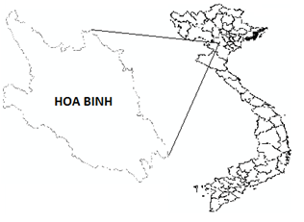
Figure 1. The study area
It is nearly 30 years since the beginning of the renovation policy implementation in the poor mountainous region, in which very many inhabitants’ life depends on shifting cultivation. Nowadays the social, cultural, economic environment and the living standards of the population in Hoa Binh province have considerably increased. Income per capita in 2010 is up to 700$[22] . The economic growth rate is 8.0%/year in the period of 2001 - 2005 and 10.6% in 2010. But because of the province’s low starting point due to a previous division of the province, poor infrastructure, low intellectual standard of the people, and slowness in developing natural advantages – the potential of land, mineral, tourist and labor resources has been insufficiently developed. Like other North - West provinces, mountainous Hoa Binh plays a vital role in conserving the ecological environment for the whole region and Northern, Central Northern Deltas, as well as supplying materials for timber processing, sugar-cane, fruits, industrial trees, milk, meat for domestic consumption and export. Hoa Binh forests continue to be essential in assuring a stable supply of water to Hoa Binh lake, in order to generate a considerable amount of electricity for the country’s industrialization and modernization[20].

- Data
The data selection is a critical step in change detection studies. The acquisition period (i. e., season, month) of multidate imagery is an important parameter to consider in image selection because it is directly related to phenology, climatic conditions, and solar angle. A careful selection of multidate images is therefore needed in order to minimize the effects of these factors [16]. In the North of Vietnam, some types of forests fallen in winter; therefore, two Landsat TM images acquired the same season are used for calculation NDVI indices and classification.
Table 1. Parameters of Landsat TM Table 2. Data set used
Datưa | Acquisition date | Purpose
Landsat TM | 2009/5/11 and 4/6/1994 | Computing NDVI  Producing land cover maps
Topographic maps | 2000 | Geometric correction
Aerial photos | 1993, 1994 | Collecting samples  Validation  Identifying thresholds
Land use maps | 2008- 2010 | Collecting samples  Validation  Identifying thresholds
Field observation | 2013 | Collecting samples  Validation  Identifying thresholds
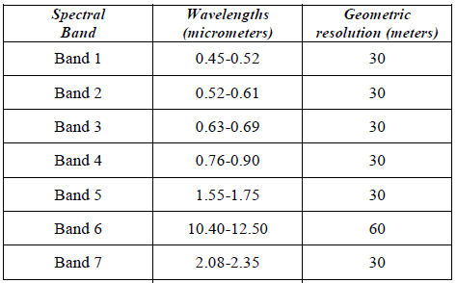

Besides, historical aerial photos and topographic maps, land use maps are referenced for validation and rectification. To classify image and verify, 559 samples are collected from field observation along roads, visualization of aerial photos and the maps in inaccessible areas. The meta-data is given in the table 2.

- METHODOLOGIES
The methodologies used in this study are brief in figure 2

Classification

Change detection

NDVI and ΔNDVI Images

Verification

Field observation, aerial photo and satellite interpretation, other maps
Landsat TM
(DNs): 1994 and 2009

Radiometric correction

Geometric Correction

Topographic map

Landsat TM
(DNs): 1994 and 2009

Radiometric correction

Topographical map

Geometric Correction

Figure 2. The flowchart of methodologies

3.1. Radiometric correction
a. Convert DN to reflectance image
The resulting radiance was the quantity measured by the Landsat sensor without consideration of the position of the sun and the differing amounts of energy output by the sun in each band. NDVI calculation requires to consider the effective reflectance, the fraction of the sun’s energy that is reflected by the surface at specific wavelength values. In this application, Top-Of-Atmosphere (TOA) reflectance was considered: it represents the solar radiation incident on the satellite sensor in standard unit less terms, independent of the position of the sun with respect to the earth. TOA is not the reflectance that would be recorded by a hand-held spectrophotometer on the ground because of the atmospheric effects. In fact the electromagnetic radiation incident on the satellite sensor is significantly distorted by interaction with gases and aerosols in the earth’s atmosphere, both on the way down to the ground, and once more on the way back up to the instrument. Thus, using TOA values rather than DNs better results are achieved.
On the other hand, original Landsat data have already radiometrically and geographically corrected, but fitted in 8 bit files (ranges from 0 to 255),ie, each image was matrix of DNs (Digital Numbers) while to calculate vegetation indices, reflectance values (physical measurements of the part of the solar energy reflected by earth features) were required. This is main reason of conversion from DNs to reflectance[23].
b. Standardize effects of atmosphere
The images were taken from different dates, thus, the atmospheric conditions were different. As the requirements for change detection analysis, it is necessary to standardize the effect of atmosphere. The Dark object subtraction (DOS) method also termed as a histogram minimum method for atmospheric correction, was applied. It is perhaps the simplest atmospheric correction approach for change detection applications [24, 25]. It assumes that the radiance in deep, clear water or shaded area in near infrared bands is zero or close to zero[26].
  - Geometric registration of images
Before comparing differences between images, it is important to make sure that they properly align to each other. This is referred to as image rectification. If they actually align to real world coordinates, these images will also be geo-referenced.
The original Landsat images projected in UTM and Ellipsoid WGS 84 while Vietnam uses VN-2000. ;thus, geometric registration is processed. In the study, the Landsat image was geometrically corrected using 31 well-distributed Ground Control Points (GCPs) extracted from the topographic maps. The GCPs were acquired mainly from the intersection of the drainage lines and sharp, well defined, stable and prominent features in the images. Dates of image acquisition and the map establishment are close; therefore, it was assumed that there was no change in drainage network between the years. The registration was performed to less than 0.5-pixel accuracy using first order polynomial transformation.
  - Image Subsetting
All pre-processing operations were performed with Landsat TM red band (band 3; 0.63–0.69mm) and near infrared band (band 4; 0.76–0.90 mm) that were extracted from original TM data sets because of their vegetation characterization. In order to reduce the size of the scene, the images are subset according to irregular boundary using a vector file.
  - NDVI and ΔNDVI Calculation
The NDVI, as mentioned earlier, is a function of two bands: the red band and near-infrared spectral band. It is calculated for both images using the following relationship [27]:
NDVI = (NIR−RED) / (NIR+RED)
where: NIR= near-infrared band (e.g. TM4) RED = red band (e.g. TM3)
To measure biomass change, the NDVI differencing (ΔNDVI) was performed. This technique compares and computes NDVI values between images acquired on two different dates. In order to apply NDVI image differencing, the individual NDVI image of each date was generated with a range of values from -1 to +1[28, 29]. Then, NDVI difference image (ΔNDVI) is generated through the subtraction of the NDVI image of one date from that on another date [30]. In this study, the NDVI 1994 image was subtracted from the NDVI 2009 image as shown in the equation:
ΔNDVI = NDVI (2009) - NDVI (1994)
The NDVI difference image was also tested to determine its goodness-of-fit to a normal distribution. Mean, mode, median, standard deviation, and specific statistical indexes were generated, including skewness (Kendall & Stuart 1969, Groeneveld & Meeden 1984), kurtosis (Balanda & MacGillivray 1988), and Kolgomorov-Smirnov non-parametric tests (Lilliefors 1967, Justel et al. 1997) were conducted[5]. The difference image NDVI was then reclassified using a threshold value calculated as µ ± n·s; where µ represents the ΔNDVI pixels digital number mean, and s is the standard deviation. The threshold identifies three ranges in the normal distribution: (a) the left tail (ΔNDVI < µ -n·s); (b) the right tail (ΔNDVI > µ + n·s); and (c) the central region of the normal distribution (µ -n·s < ΔNDVI < µ + n·s). Pixels within the two tails of the distribution are characterized by significant vegetation changes, while pixels in the central region represent no change. The n factor defines the range of dispersion around the mean.
Threshold identification for detection of vegetation changes represents a key issue in the NDVI differencing method. The standard deviation (s) is one of the most widely applied threshold identification approaches for different natural environments based on different remotely sensed imagery[16, 31].

Generally, the threshold value is identified by n·s of the NDVI difference image average, where the n value is identified by the trial and test method, and s is the standard deviation of the pixel values density function in the change image. This approach exhibited viable results, and reliability for different forest ecosystems under both human-induced and natural land use changes, with threshold values between 1·s and 2·s supported in the literature[32, 33].

In the present study, the final identification of the best-fitting n·s threshold value was based on visual analysis of aerial photos, Landsat images and field observation. Finally, a change /no change map was created between 1994 -2009 (figure 6).
  - Classification and accuracy assessment
Over the years, a number of image classifiers have been developed. Maximum likelihood classification (MLC) has been found to be the most accurate and commonly used classifier, when data distributional assumptions are met. This classifier is based on the decision rule that the pixels of unknown class membership are allocated to those classes with which they have the highest likelihood of membership [34]. MLC has been used here to produce a number of land cover maps. To verify the results, ground truth ROI used as one of input data to calculate confusion matrix and four criteria: producer’s accuracy, user’s accuracy, overall accuracy and κ coefficient.
IV. RESULTS AND DISCUSSION
4.1. Identify vegetation modification
Firstly, NDVI images two dates are calculated (figure 3), the ranges of NDVI 1994 and 2009 are from -0.18 to + 0.64 and -0.29 to +0.72 respectively. The results of this process were presented in white and green which are close to real vegetation. In Figure 3, areas with healthy vegetation are dark green while little and no vegetation areas are light green and white. Dark green color describes dense and tall trees with large canopy corresponding to NDVI value greater than 0.4. Light green areas show spare vegetation: open planted forests, pastures, food crops, etc. White color indicates no-vegetation areas: water bodies, barren hills, limestone mountains. It is clear those vegetation growths significantly after 15 years.
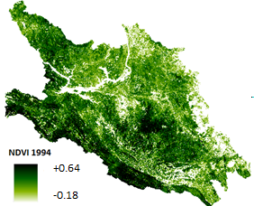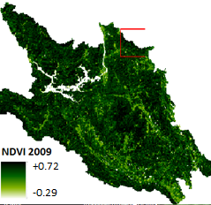

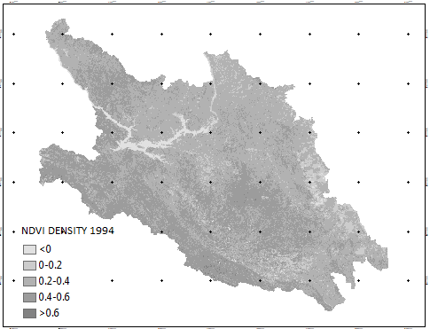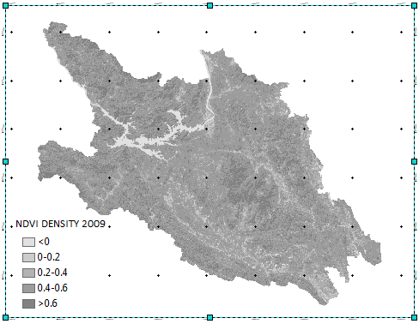
Figure 3. NDVI Images
Next, DN value of NDVI images are categorized as very low density less than 0, low density from 0 to 0.2, medium density from 0.2 to 0.4, high density from 0.4 to 0.6 and very high density greater than 0.6. As it is showed in figure 3 and table 3, the changes have drastically occurred in low, medium, high and very high density classes with plus refer to increase and minus means decrease. In which, the type of low NDVI density decreases 33652.35 ha to 14363.46 ha (fall 4.2 %), medium category goes down rapidly from 2 58866.01 ha to 65466.90 ha (reduce 42.2 %). On the contrary, the high kind increases significantly from 156114.99 ha to 292328.28 ha (29.8%) and very high NDVI density rise from 774.63 ha to 73311.39 ha (15.9 %). Detail data of change are presented in table 3 and figure 4.
Table 3. Changes of NDVI density
NDVI Density | 1994 |  | 2009 |  | Change (ha) |  | Average rate of change
 | ha | % | ha | % | ha | % | ha/year | %/year
<0 | 8506.17 | 1.9 | 12025.26 | 2.6 | 3519.09 | 0.8 | 2346060 | 0.05
0-0.2 | 33652.35 | 7.3 | 14363.46 | 3.1 | -19288.89 | -4.2 | -12859260 | -0.28
0.2-0.4 | 2 58866.01 | 56.5 | 65466.90 | 14.3 | -193399.11 | -42.2 | -128932740 | -2.81
0.4-0.6 | 156114.99 | 34.1 | 292328.28 | 63.9 | 136213.29 | 29.8 | 90808860 | 1.99
>0.6 | 774.63 | 0.2 | 73311.39 | 16.0 | 72536.76 | 15.9 | 48357840 | 1.06
Total | 457914.15 | 100 | 457495.29 | 100

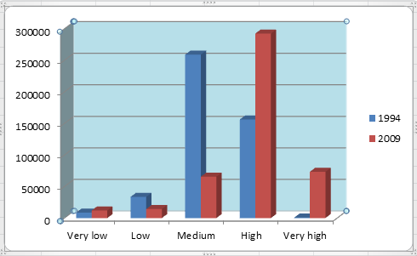
Figure 4. Graph of NDVI density changes
After NDVI images of two years calculation, histogram of ΔNDVI image which is considered as a base to test threshold for change and no-change is portrayed as figure 5. NDVI change maps then are produced, of which no change is presented in light grey, decrease in yellow and increase in green (figure 6).
On the other hand, in order to enhance the changes displayed, the 20%, 40%, 60% and 80% change thresholds were fixed on the resulting values. In Figure 6, the areas with gray colors shows no-change, red color refers to increase and blue is decrease.

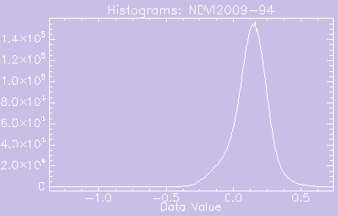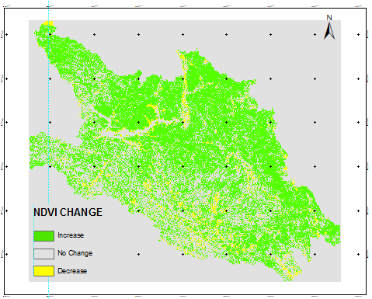
Figure 5. Histogram of NDVI differencing image

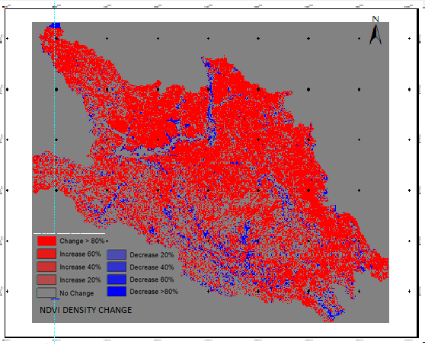
Figure 6. Change and no-change map
4.2. Patern of forest change
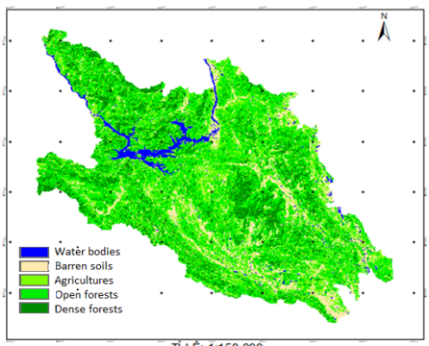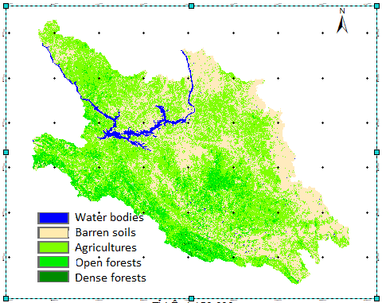
Figure7. Land cover maps
The pattern of the changes between 1994 and 2009 are presented in Table 4 and Figure 7. The spatial extent of open forests and dense forests are significantly increased 171319.68 ha (37.5%) and 76723.92 ha (16.8%); whereas, the barren soils and agricultures are decreased 110570.22 ha (24.1%), 142620.03 ha (31.1%) respectively.
To recognize accuracy of classification results, confusion matrix is calculated based on the ground truth ROI, of which it provides both inclusion (commission error) and exclusion (omission error) for each class as seen in table 5. Land cover categories are classified with high accuracy: water bodies are over 97% and barren soils 90-98%, forests are from 73-97%, agricultures is lower accuracy 67-76% . Overall accuracy of 1994 and 2009 images is 82.24% and 81.13% respectively (table 5).
Table 4. Statistics of land cover conversion
Classes | 1994 |  | 2009 |  | Change |  | Rate of change
 | ha | % | ha | % | ha | % | ha/year | %/year
Water bodies | 9657.36 | 2.1 | 14354.64 | 3.1 | 4697.28 | 1.0 | 313.152 | 0.1
Barren soils | 162310.86 | 35.4 | 51740.64 | 11.3 | -110570.22 | -24.1 | -7371.348 | 1.6
Agricultures | 230950.26 | 50.4 | 88330.23 | 19.3 | -142620.03 | -31.1 | -9508.002 | 2.1
Open forests | 54148.68 | 11.8 | 225468.36 | 49.3 | 171319.68 | 37.5 | 11421.312 | 2.5
Dense forests | 846.81 | 0.20 | 77570.73 | 17.0 | 76723.92 | 16.8 | 5114.928 | 1.1
Total | 457913.97 |  | 457464.60

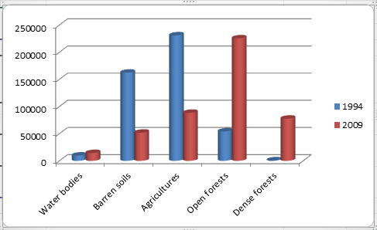
Figure 8. The diagram of land cover conversion
Table 5. Accuracy assessment
Classes | 1994 |  | 2009
 | Prod.Acc | User.Acc | Prod.Acc | User.Acc
Water bodies | 98.75 | 98.75 | 97.37 | 99.02
Barren soils | 92.23 | 89.83 | 90.23 | 98.21
Agricultures | 67.25 | 70.26 | 76.01 | 74.32
Open forests | 81.08 | 82.27 | 80.01 | 73.29
Dense forests | 80.08 | 97.93 | 84.32 | 90.54
 | Overall accuracy: 82.24  Kappa: 0.79 |  | Overal accuracy: 81.13  Kappa: 0.76
The results indicated forests expanded significantly replacing barren soils and agricultures. This has linkage with the set of policies: Doi moi (renovation), forest land allocation to household and Five Million Hectare Reforestation Program.
Specifically, Doi moi in 1986 induced rapid economic growth and the development of the industrial and service sectors [35]. Agricultural and forestry policies changed dramatically. In the agricultural sector, input and output markets were quantity. Thereby, the ‘‘Contract 10’’ policy in 1988 further liberalised rice and input prices, land rights, and crop choices. Households were also allowed to own all their production after subtracting taxes and charges [35]. This promoted significantly quantity of food meeting peoples’ demand; thus, phenomena of massive forest clearing and forest burn for growing food crops is minimized, groups of minor ethnic applied fertilizer and agricultural intensification instead of shifting cultivation.
In the forestry sector, tree planting campaigns were launched via Decree 327 (in 1992) and its successor, the Five Million Hectare Reforestation Program (started in 1998) [36]. The 1993 Land Law also introduced a system for the allocation of forestry land to households [37] to make the beneficiaries assume personal responsibility for protecting forestry land. Several authorities (forest management boards, national park administrations, state forest enterprises) also signed forest protection contracts with households, which imposed more restrictions on household’s rights on forestry land than for allocated land. Generally, participating households were given rights to allocated or contracted land, such as the right to grow crops during the first years of forest regrowth and collect forest products. They also received small cash payments in return for their commitment to preserve and protect forests, and sometimes to plant trees [38, 39]. According to some studies [40, 41], forestry land allocation led to forest recovery by prohibiting hillside cultivation. Forest regeneration was thus driven by agricultural intensification. Sunderlin (2006) also presents ambiguous evidence on the positive impact of forestry policies[42]. Along with agricultural and forestry policies, the Vietnamese government also developed plans to extend protected areas and strengthen their enforcement after signing the Convention on Biological Diversity [43, 44].
V. CONCLUSIONS
The study affirmed how remote sensing -based detection of vegetation change can provide reliable results in the assessment of forests expansion and of forest cover dynamics. Moreover, the relative simplicity of the methodology and the availability of time series Landsat TM images at low cost favors the application of the approach described to large scale forest inventories.
The information on forest cover dynamics provided in this study can be considered a useful starting point to further analyze spatial and temporal patterns of vegetation changes.
In term of practice meaning, the results showed pattern of changes: total of forest expansion is 248043.6 ha from 1994 to 2009, average rate of increase reachs 16536.24 ha/year while the barren soils and agricultures are decreased 110570.22 ha (24.1%), 142620.03 ha (31.1%) respectively. Also, quality of vegetation is improved: the type of low NDVI density decreases 33652.35 ha to 14363.46 ha (fall 4.2 %), medium category goes down rapidly from 2 58866.01 ha to 65466.90 ha (reduce 42.2 %); inversely, the high kind increases significantly from 156114.99 ha to 292328.28 ha (29.8%) and very high NDVI density rise from 774.63 ha to 73311.39 ha (15.9 %). On the ground of this pattern of vegetation transition and modification, it is possible to state that the policies: (Doi moi (renovation), forest land allocation to household and Five Million Hectare Reforestation Programme) have positive effects on forest regeneration and expansion. This is a suitable path of forest protection and development to Hoa Binh in the specific natural and socio-economic condition. Finally, we proposed that the implementation way of the policies should be maintained and adopted in the phrase of the country’s industrialization and modernization.
ACKNOWLEDGMENT

This research was supported by Hanoi University of Science, under Vietnam National University.
REFERENCES

1. Turner BL, Lambin EF, Reenberg A (2007). The emergence of land change science for global environmental change and sustainability. Proceedings of the National Academy of Sciences USA 104 (52): 20666-20671. - doi: 10.1073/pnas.0704119104.
2. Pielke RA (2005). Land use and climate change. Science 310: 1625-1626. - doi: 10.1126/science.1120529.
3. Penman J, Gytarsky M, Hiraushi T, Krug T, Kruger D, Pipatti R, Buendia L, Miwa K, NgaraT, Tanabe K, Wagner F (2003). Good practice guidance for land use, land use change and forestry. Chapter 3: Annex 3A.1 biomass default tables for section 3.2 forest land good practice guidance for land use, land-use change and forestry. The Institute for Global Enviromental Strategies for the IPCC and the Intergovernmental Panel on Climate Change, Hayama, Kanagawa, Japan, pp. 21.
4. IPCC (2007). Climate change 2007: the physical science basis. Contribution of Working Group I to the 4th Assessment Report of the IPCC (SolomonS, Qin D, Manning M, Chen Z, Marquis M, Averyt KB, Tignor M, Miller HL eds). Cambridge University Press, Cambridge, UK and New York, NY, USA.
5. Giuseppe Mancino, A.N., Francesco Ripullone, Agostino Ferrara, Landsat TM imagery and NDVI differencing to detect vegetation change: assessing natural forest expansion in Basilicata, southern Italy. iForest – Biogeosciences and Forestry. iForest (2014) 7: 75-84.
6. J.B. Campbell, Introduction to Remote Sensing, Guilford Press, 2002
7. J.A. Richards, Remote Sensing Digital Image Analysis, Springer, 2012.
8. Coppin PR, Bauer ME (1996). Digital change detection in forest ecosystems with remotely sensed imagery. Remote Sensing Reviews 13: 207-234.- doi: 10.1080/02757259609532305.
9. Milne AK (1988). Change detection analysis using Landsat imagery: a review of methodology. In: Proceedings of the “IGARSS 1988 Symposium”. Edinburgh (Scotland - UK), European Space Agency, Neuilly, France, 13-16 September 1988, pp. 541-544.
10. J.G. Lyon, D. Yuan, R.S. Lunetta and C.D. Elvidge, A Change Detection Experiment using Vegetation Indices, Photogramm.Eng. Remote Sensing 64 (1998), pp. 143-150.
11. R. DeFries and J. Townshend, NDVI-Derived Land Cover Classifications at a Global Scale, Int.J.Remote Sens. 15 (1994), pp. 3567-3586.
12. S. Garrigues, D. Allard and F. Baret, Using First-and Second-Order Variograms for Characterizing Landscape Spatial Structures from Remote Sensing Imagery, Geoscience and Remote Sensing, IEEE Transactions on. 45 (2007), pp. 1823-1834.
13. D. Lu, P. Mausel, E. Brondízio and E. Moran, Change Detection Techniques, Int. J. Remote Sens. 25 (2004), pp. 2365-2407.
14. Y. Li, J. Chen, R. Lu, P. Gong and T. Yue, Study on Land Cover Change Detection Method Based on NDVI Time Series Batasets: Change Detection Indexes Design, Geoscience and Remote Sensing Symposium, 2005. IGARSS'05 Proceedings 2005 IEEE International, 2005.
15. D. Lu, P. Mausel, M. Batistella and E. Moran, Land]cover Binary Change Detection Methods for use in the Moist Tropical Region of the Amazon: A Comparative Study, Int. J. Remote Sens. 26 (2005), pp. 101-114.
16. A. Singh, Digital Change Detection Techniques using Remotely-Sensed Data, Int.J.Remote Sens. 10 (1989), pp. 989-1003.
17. A. Singh, Change Detection in the Tropical Forest Environment of Northeastern India using Landsat, Remote Sensing and Tropical Land Management (1986), pp. 237-254.
18. G.M. Foody, Status of Land Cover Classification Accuracy Assessment, Remote Sens.Environ. 80 (2002), pp. 185-201.
19. Jwan Al-doski, S.B.M., Helmi Zulhaidi Mohd Shafri, NDVI Differencing and Post-classification to Detect Vegetation Changes in Halabja City, Iraq. IOSR Journal of Applied Geology and Geophysics (IOSR-JAGG). Volume 1, Issue 2 (Jul. –Aug. 2013), PP 01-10.
20. Dam, B.N., Report on the Results of Land Allocation and Land Use after Forest Land Allocation in Hoa Binh Province, Hoa Binh Department for Agriculture and Rural Development.
21. Bình, Ủ.b.n.d.t.H., Địa chí Hòa Bình2005.
22. Bình, C.t.k.H., Niên giám thống kê tỉnh Hòa Bình 2010.
23. Parente, C. TOA reflectance and NDVI calculation for Landsat 7 ETM+ images of Sicily. in Electronic International Interdisciplinary Conference September, 2. - 6. 2013- 351.
24. A.S. Mahiny and B.J. Turner, A Comparison of Four Common Atmospheric Correction Methods, Photogramm.Eng.Remote Sensing. 73 (2007), pp. 361.
25. P. Tyagi and U. Bhosle, Image Based Atmospheric Correction of Remotely Sensed Images, Computer Applications and Industrial Electronics (ICCAIE), 2010 International Conference on, 2010.
26. P. Teillet and G. Fedosejevs, On the Dark Target Approach to Atmospheric Correction of Remotely Sensed Data, Canadian Journal of Remote Sensing 21 (1995), pp. 374-387.
27. C.J. Tucker, Red and Photographic Infrared Linear Combinations for Monitoring Vegetation, Remote Sens. Environ 8 (1979), pp. 127-150.
28. P.J. Sellers, Canopy Reflectance, Photosynthesis and Transpiration, Int.J.Remote Sens. 6 (1985), pp. 1335-1372.
29. A. MICHAEL, L.L. Pierce, L.P. DAVID and W. STEVEN, Remote Sensing of Temperate Coniferous Forest Leaf Area Index the Influence of Canopy Closure, Understory Vegetation and Background Reflectance, TitleREMOTE SENSING. 11 (1990), pp. 95-111.
30. H.I. Cakir, S. Khorram and S.A.C. Nelson, Correspondence Analysis for Detecting Land Cover Change, Remote Sens.Environ. 102 (2006), pp. 306-317.
31. Lu D, Mausel P, Batistella M, Moran E (2004). Comparison of land-cover classification methods in the Brazilian Amazonia basin. Photogrammetric Engineering and Remote Sensing 70: 723-731.
32. Yuan D, Elvidge CD, Lunetta RS (1998). Survey of multispectral methods for land cover change analysis. In: “Remote Change Detection. Environmental Monitoring Methods and Applications” (Lunetta RS, Elvidge CD eds). Ann Arbor Press, Chelsea, Michigan, USA, pp. 21-39.
33. Mas JF (1999). Monitoring land-cover changes: a comparison of change detection techniques. International Journal of Remote Sensing 20:139-152. - doi: 10.1080/014311699213659.
34. Foody, G M, Campbell, N A, Trodd, N M and Wood, T F. 1992. Derivation and applications of probabilistic measures of class membership from maximum likelihood classification. Photogrammetric Engineering and Remote Sensing, 5 8, 13 3 5 -13 41.
35. Kerkvliet, B.J., Porter, D.J. (Eds.), 1995. Vietnam’s Rural Transformation. Westview Press, Boulder, Co.
36. De Jong, W., Sam, D.D., Hung, T.V., 2006. Forest rehabilitation in Vietnam: histories, realities and future. Center for International Forestry Research (CIFOR), Bogor, Indonesia.
37. Sikor, T., 1998. Forest policy reform: from state to household forestry. In: Poffenberger, M. (Ed.), Stewards of Vietnam’s Upland Forests. Asian Forestry Network.
38. Bộ Nông nghiệp và Phát triển nông thôn, 2001. Các bên tham gia chương trình trồng 5 triệu ha rừng. Báo cáo kỹ thuật tổng hợp

39. McElwee, P., 2004. You say illegal, I say legal: the relationship between ‘illegal’ logging and land tenure, poverty, and forest use rights in Vietnam. Journal of Sustainable Forestry 19 (1–3), 97–135.
40. Castella, J.C., Boissau, S., Hai Thanh, N., Novosad, P., 2006. Impact of forest land allocation on land use in a mountainous province of Vietnam. Land Use Policy 23 (2), 147–160.
41. Tachibana, T., Nguyen, T.M., Otsuka, K., 2001. Agricultural intensification versus extensification: a case study of deforestation in the northern-hill region of Vietnam. Journal of Environmental Economics and Management 41 (1), 44–69.
42. Sunderlin, W.D., 2006. Poverty alleviation through community forestry in Cambodia, Laos, and Vietnam: An assessment of the potential. Forest Policy and Economics 8 (4), 386–396.
43. Government of Vietnam, 1994. National Biodiversity Strategy and Action Plan for Vietnam. Tech. rep., The Government of the Socialist Republic of Vietnam and Global Environment Facility Project, Hanoi.
44. World Conservation Monitoring Center 1994. 1994 Vietnam biodiversity profile. Technical Report, WCMC, Cambridge.

TÓM TẮT TIẾNG VIỆT
SỬ DỤNG ẢNH CHỈ SỐ THỰC VẬT VÀ PHƯƠNG PHÁP SAU PHÂN LOẠI TRONG GIÁM SÁT TÀI NGUYÊN RỪNG TỈNH HÒA BÌNH

Bài báo trình bày kết quả quan trắc biến động lớp phủ rừng tỉnh Hòa Bình trong vòng 15 năm (1994-2009) bằng phương pháp NDVI differencing và Sau phân loại. Trước tiên, ảnh vệ tinh Landsat TM dạng số (Digital Number-DNs) thu nhận tại hai thời điểm 1994, 2009 được chuyển về ảnh Reflectance và chuẩn hóa ảnh hưởng của khí quyển bằng mô hình loại trừ đối tượng đen. Tiếp theo, hai ảnh này được nắn chỉnh hình học thông qua hàm chuyển đổi tuyến tính bậc nhất với kỹ thuật tái chia mẫu người láng giềng gần nhất. Sau khi hoàn tất công tác tiền xử lý ảnh, chúng tôi tiến hành tính chỉ số thực vật NDVI và NDVI differencing. Để xác định biến động về chất lượng thực phủ, chúng tôi thử nghiệm các ngưỡng đối với ảnh NDVI differencing trên cơ sở phân tích ảnh Landsat tổ hợp màu, ảnh hàng không tỉ lệ lớn và quan sát thực địa. Việc áp dụng phương pháp Sau phân loại cho phép chúng tôi quan trắc sự mở rộng hay thu hẹp của lớp phủ rừng. Kết quả nghiên cứu cho thấy, lớp phủ rừng gia tăng 248043.6 ha tương đương 54%, thay thế cho 110570.22 ha (24.1%) đất trống và 142620.03 ha (31.1%) đất nông nghiệp, các đối tượng khác biến động không đáng kể.

Chủ biên: ThS. Nguyễn Thị Thúy Hạnh
Mobile: 0916104970
Email: hanhntt.hunre@gmail.com

