Deformation Monitoring in the Metro Manila by InSAR technique using PALSAR data

Tomonori Deguchi
Nittetsu Mining Consultants Co., Ltd., 4-2-3, Shiba, Minato-ku, Tokyo 108-0014, Japan,
Email: t_degu@nifty.com

KEY WORDS: Land subsidence, Creep fault, Manila, InSAR, Philippines

ABSTRACT: Excessive pumping of groundwater in the Metro Manila district, the Philippines, has occurred huge land subsidence. The purpose of this study is to investigate the distribution of spatial and temporal change on the earth surface in this area. We measured long-term ground subsidence by InSAR using JERS-1/SAR, ENVISAT/ASAR, Fine-beam, polarimetry and ScanSAR mode of ALOS/PALSAR, and TerraSAR-X data. As a result, we detected apparent subsidence and uplift patterns at eight locations. They have been found to correlate with up-down motion of groundwater level. The largest amount of ground subsidence was measured approximately 600 mm over 6 years (100mm/year).

1. INTRODUCTION

The Metro Manila district where the population more than 10 million is active is a center of politics, economy, and culture of the Republic of the Philippines and has accomplished economic growth with rapid urban development. The securement of water source to serve the increasing water-demand becomes the serious issue. On the other hand, the industrial pollutions such as land subsidence and salinization of groundwater with lowering of underground water level because of excessive water pumping for domestic and industrial use by several thousand wells are held in question.
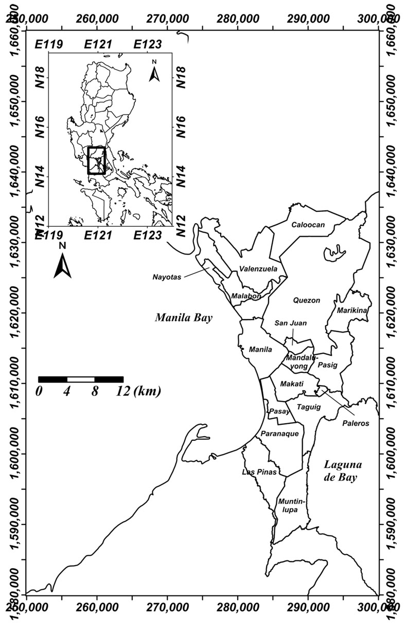
Since the subsidence phenomenon progresses at the very slow speed, it is difficult to recognize its damage directly in daily life. However, there is the risk to damage urban infrastructure facilities by several decades and the possibility that a coast line moves back to the inland and an area below sea level spreads. Particularly, in the Philippines where a typhoon hits almost every year, the possibility that the influence of flood, high tide and the rising of sea surface by the global warming become worse cannot be denied.
From this kind of circumstance, the author measured the long term displacement around the Metro Manila (Figure 1) by DInSAR and time series anlysis using JERS-1/SAR, ENVISAT/ASAR, ALOS/PALSAR (fine-beam, polarimetry and ScanSAR mode) and TerraSAR-X.

2. METHODOLOGY

DInSAR is an unique methodology for measuring ground motions by analyzing phase differences on two SAR images taken at two different times. The phase difference ΔΦ after the removal of the orbit fringe (Δφ_{orbit}) and the topographical fringe (Δφ_{topo}) using orbit records and DEM includes not only the displacement component (Δφ_{def}) but also the noise component (ε) due to atmospheric phase delay and ionospheric disturbance and the phase term due to elevation errors (Δh) in the DEM data, where B_{perp} is the perpendicular component of the orbit distance between two observations, λ is the wavelength, ρ is the slant range length, and α is the incidence angle.
Figure 1 Location of the study area.
(1)
Consider a case where M pairs of interferograms are derived from N+1 scenes of SAR imagery over a single area. Suppose that the land deformation from the first observation (0-th recurrence) is an unknown vector, t_{n}(n=1…N), and that the interferogram of the m-th pair (m=1…M) is obtained from the SAR images on the i-th and j-th recurrence (i=1…N-1，j=2…N，j>i). A smoothness constraint is added to hypothesize that the time wavelength of land deformation is sufficiently longer than the satellite’s revisit period. Specifically, a smoothness constraint condition represents the minimization of the second order difference for t_{n}. By rendering the phase difference of each interferogram, the optimal solutions to t_{n} and Δh, the variables used to provide the minimum value of S, can be estimated based on the least squares method.
(2)

The variable w in the first term on the right side of Equation (2) is the weighting function from Tukey’s biweight. The variable μ² in the second term is a parameter used to control the smoothness of land deformation, and is fixed to 1.0. The t_{n} finally obtained is regarded as a vector representing the land deformation in the line of sight after separating noise components. The value is output as a total of the long-term land deformation from the first observation.

3. SCANSAR-SCANSAR INSAR ANALYSIS

In the case of the data acquisition with the ScanSAR mode of PALSAR, the observation width is increased by transmitting and receiving in 3 to 5 beams for the range direction. The irradiation of the microwave in each beam is called a “burst”. The spatial resolution in azimuth direction becomes worse because of the intermittent burst in the line of the satellite. The important factor in securing high coherence is also baseline distance between master and slave in the DInSAR analysis using ScanSAR data, and can get a good fringe of interferograms so as to have a short distance between the orbits. But it is necessary for the timing of the burst in the data acquisition of slave to synchronize with that of master because the burst in azimuth direction is intermittent. When a burst overlap rate of master and slave decreases, it is impossible to get interference even if the baseline distance is 0m (Figure 2).

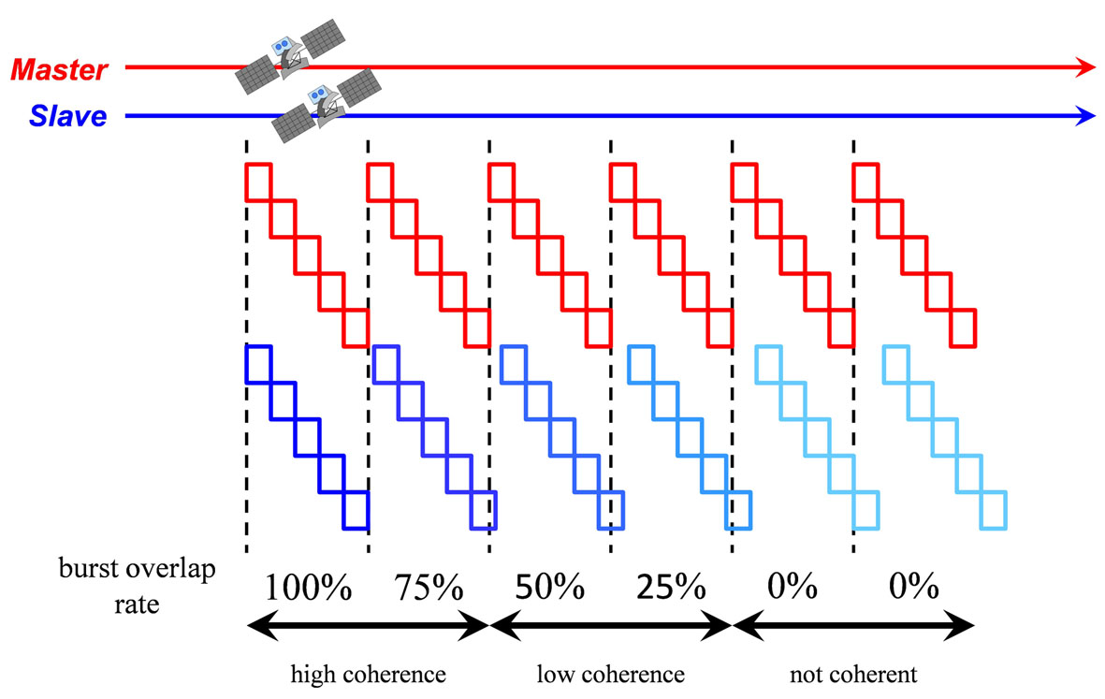
Figure 2 Relation between the burst overlap rate and coherence between master and slave.

4. RESULT OF DATA ANALYSIS

The total of 8 phase anomalies were obviously detected in the Metro Manila and suburban places by DInSAR and InSAR time series analysis using ENVISAT/ASAR, ALOS/PALSAR and TerraSAR-X data (Figure 3). Japan International Cooperation Agency (JICA) measured the groundwater level at 231 existing wells under the project “Study for the groundwater development in Metro Manila” that carried out from 1990 through 1992 and, from the comparison with water level data acquired in 1981, clarified a change pattern of the groundwater level (Figure 4). Figure 5 indicates some examples of temporal surface displacement estimated from InSAR time series analysis.
(1) Valenzuela – Caloocan
The level of groundwater had decreased more than 50m from 1981 through 1990, and it is thought that large-scale groundwater pumping becomes the factor of the subsidence in this area. The maximum quantity of subsidence amounted than 600mm in approximately six years. However, the annual displacement speed presents a tendency to decrease from -130mm/year to -80mm/year. Therefore, as for subsidence in itself, possibility toward the calming was supposed.
(2) Manila – Malabon - south part of Valenzuela
In this area, subsidence and uplift areas are detected, and they correspond to the lowering (-20m) and the rising area (+70m) of the groundwater level respectively. The area where the detected uplift carries out pumping regulation, and recovery of the water level under the ground was confirmed is close, and the relation between a rise of the groundwater level and the uplift phenomenon is suggested. Due to the above reason, it was thought that a decreasing of the groundwater level by the excessive pumping caused the subsidence.
(3) Mandaluyong – Makati – Pasig - Taguig
Land subsidence area uplift are distributed over the east and west of the West Valley fault. The area with the uplift agrees with the site where pumping regulation was carried out, and the relevance with the rising of groundwater level is considered. On the other hand, for an analysis result of TerraSAR-X, the anomaly that a boundary line of subsidence and uplift extends parallel to the West Valley fault is confirmed, and the possibility that a tonic motion of the fault becomes the factor of the surface displacement is guessed. The detailed research such as a seismic prospecting and a trench investigation in the neighborhood of the West Valley fault will be necessary.
(4) Las Pinas – north part of Muntinlupa
Two places of subsidence area were detected in this area. Because the groundwater level decreased more than 60m from 1981 through 1990, it might be supposed that excessive pumping causes subsidence.
(5) Noveleta
Since the decreasing of groundwater level had been observed by the actual measurement in the wells, it is thought that the pumping caused the subsidence. By the analysis result of ENVISAT/ASAR, the maximum land subsidence amounted to approximately 310mm per six years, but the tendency that displacement velocity decreased rapidly from -83mm/year to -17mm/year was apprehended. By the analysis result of TerraSAR-X, it almost becomes no change. From this, it is supposed that subsidence phenomenon in itself faces the calming.
(6) south part of Muntinlupa - Santa Rosa
About 20m decreasing of the groundwater level was observed from 1981 through 1990 in a wide range, and it is considered that an earth surface subsided by groundwater pumping.
(7) east of Dasmarinas
From the analysis result by using ENVISAR/ASAR, ALOS/PALSAR and TerraSAR-X, large-scale land subsidence was detected. Because actual survey data of the groundwater level does not exist in this area, it also remains a matter of speculation, but it is thought that it is related to excessive pumping for agricultural or domestic water because the power image of TerraSAR-X can confirm the distribution of the croplands. Since DInSAR can measure the earth surface displacement remotely, it will hide possibility to detect unexpected displacement and an unknown phenomenon, and it may be understood that DInSAR is the unique measurement technique that can keep the perspective of the ground deformation.
(8) along the coastline of Laguna de Bay between Taguig and San Pedro
Kinugasa et al. (2006) have carried out leveling survey in this area since 1999, and reported that the east side of the West Valley fault had subsided. Arai et al., (2003) conducted the microtremor measurements on the survey line crossing the fault, and caught the structure that the basement of the east side of the fault sunk lower in comparison to that of the west from the spectrum change of the H/V ratio. The phase anomalies that DInSAR by using ENVISAT/ASAR detected showed the tendency that the east side of the fault sunk and it was conformal by a result of the leveling survey. However, in the analysis result by using TerrSAR-X, the anomalies that the east side of the dislocation raised were detected and showed the tendency that ground deformation had reversed after about 2007. It could not be declared about this cause, but Kunugasa et al., (2006) found some cracks in the N-S to NNE-SSW direction on the roads and the vertical displacement around this area, and pointed out possibility of the tectonic movement (creep displacement) of the West Valley fault in addition to groundwater pumping.

Additionally, several linear phase patterns in the NE-SW direction are recognized in the analysis result by using ENVISAT/ASAR, ALOS/PALSAR and TerraSAR-X data. Since a concentric circle-formed change pattern appears obviously in the interferogram if it is normal land subsidence, it is hard to consider with these anomalies caused only by a change of the groundwater. Consequently, it is probably pointed out the possibility that reflected structure under the surface, but the dominant structure of the Metro Manila is regulated in the north and south direction, and the structure of NE-SW is not reported. It is recorded in the Metro Manila that multiple destructive earthquakes were recorded in the past. The detailed understanding of the ground structure is essential in strong motion evaluation and is quite significant in consideration on earthquake disaster prevention. It is recommended that the investigation by geophysical exploration technique such as the seismic prospecting or the microtremor measurement is performed in future.

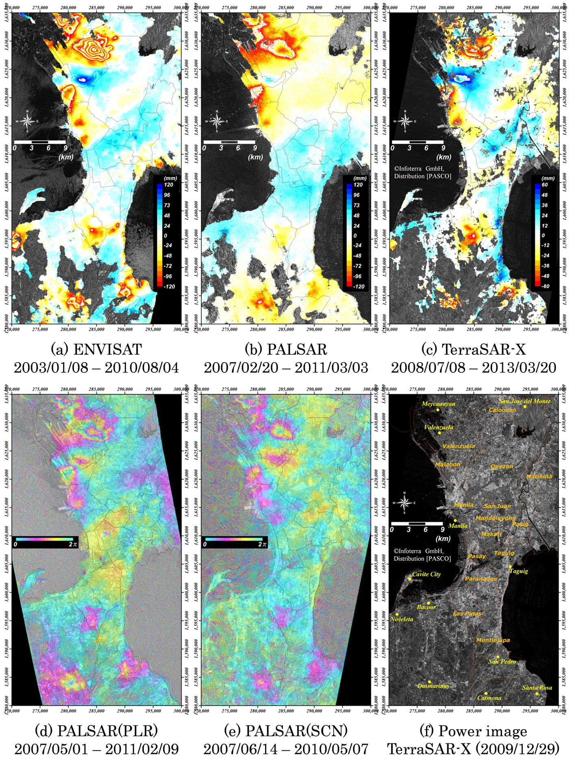
Figure 3 Results of DInSAR and InSAR time series analysis by using ENVISAT/ASAR, ALOS/PALSAR and TerraSAR-X data.

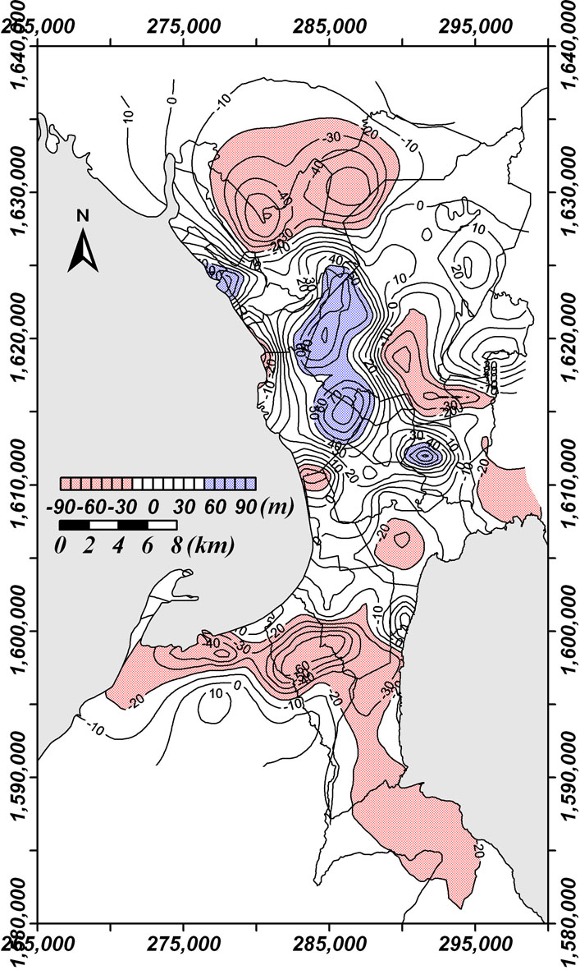
Figure 4 Change of groundwater level from 1981 until 1990 (JICA, 1992).

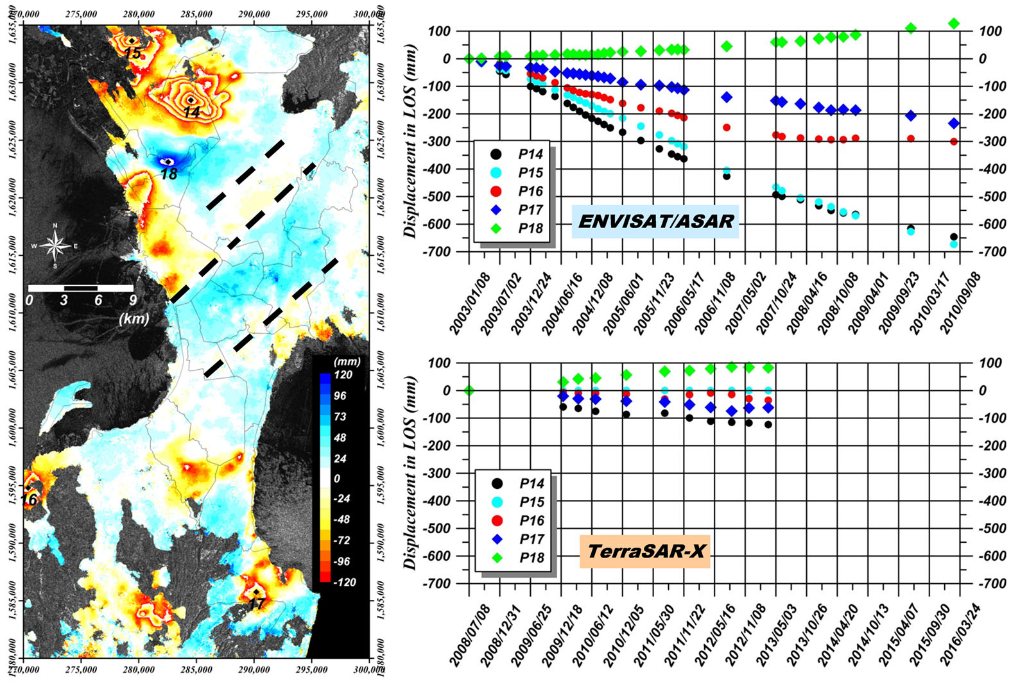
Figure 5 Profile of surface displacement in line of sight.

5. CONCLUSION

In this study, the author applied DINSAR and InSAR time series analysis by using ENVISAT/ASAR, ALOS/PALSAR and TerraSAR-X data to the Metro Manila, Philippines and performed long-term ground deformation measurement. As a result of the comparison with the actual survey data of the groundwater level, most of phase anomalies were interpreted as reflecting the vertical change of the groundwater level to be accompanied by excessive pumping and pumping regulation, but relation some of them with the tectonic movement of the West Valley fault was suggested. PALSAR-2 installed on ALOS-2 satellite was launched on 24th May, 2014, and its data distribution will be started soon. It would be expected to continue the observation and monitoring of the Metro Manila using these data.

References

References from Journals:
Arai H., and Kubo T., 2003, Microtremor Measurements Crossing A Fault Line in Muntinlupa, Philippines, Architectural Institute of Japan.
Berardino P., Fornaro G., Lanari R. and Sansosti E., 2002, A New Algorithm for Surface Deformation Monitoring Based on Small Baseline Differential SAR Interferograms, IEEE TG & RS, vol.40, No.11, pp.2375-2383.
Deguchi T., Kato M., Hakan A., and Hakan S. K., 2006, Automatic processing of Interferometric SAR and accuracy of surface deformation measurement, SPIE Europe Remote Sensing, Stockholm, Sweden.
Deguchi T., Tsu H., Maruyama Y., Kato M., and Hakan A., 2006, Application of L-band InSAR for Measurement of Local Surface Deformation by Underground Coal Mining, Journal of The Remote Sensing Society of Japan, Vol.26, No.5, pp.391-398 (in Japanese).
Deguchi T., Rokugawa S., and Matsushima J., 2009, Long-term Ground Deformation Measurement by Time Series Analysis for SAR Interferometry, Journal of The Remote Sensing Society of Japan, Vol.29, No.2, pp.418-428 (in Japanese).
Ferretti A., Prati C. and Rocca F., 2000, Nonlinear Subsidence Rate Estimation Using Permanent Scatterers in Differential SAR Interferometry, IEEE TG & RS, vol.38, No.5, pp.2202-2212.
Ferretti A., Prati C. and Rocca F., 2001, Permanent Scatterers in SAR Interferometry, IEEE TG & RS, vol.39, No.1, pp.8-20.
Japan International Cooperation Agency (JICA), 1992, Study for the groundwater development in Metro Manila.
Kinugasa Y., Papiona K. and Rimando R., 2006, Creep-slip of active faults in Asia, an example from the Valley Fault System in Metro Manila, Eos Trans. AGU, 87(36), West. Pac. Geophys. Meeting.
Tukey J. W., 1974, Introduction to Today’s Data Analysis, Proceedings of the Conference on Critical Evalution of Chemical and Physical Structural Information.

