Spectral Characterization of Coconut Scale Insect (CSI) from Field Spectroradiometric Measurements and High-resolution Superspectral Imagery

Enrico C. PARINGIT^{1,2}, John Louie FABILA^{1,2}, Mary Joyce ILAGAN², Charmaine CRUZ², Sarah SAMALBURO²

Training Center for Applied Geodesy and Photogrammetry (TCAGP),
Nationwide Disaster Risk and Exposure Assessment for Mitigation (DREAM)
University of the Philippines Diliman, Quezon City, The PHILIPPINES
Email: ecparingit@upd.edu.ph: Tel: +632-981-8770; Fax:+632-981-8771;

Key Words : coconut scale infestation, spectral signature,Worldview-2, spectroradiometer.

Abstract: This paper examines the capability of optical remote sensing spectral techniques to detect the presence of CSI from field spectral measurements high resolution multispectral satellite imagery (HRMI) of coconut planted areas at least for the pilot sites examined. CSI has been observed to be ravaging coconut stands and plantations in Southern Luzon, Philippines and spreading at an alarming rate. The infestation results in coconut mortality and reduced productivity thereby threatening the coconut industry in the country. Remote sensing techniques are explored as a means to rapidly survey and monitor the CSI problem. Field spectral measurements were conducted to analyze the spectral features of coconuts leaves within different levels of infestation (low, moderate and severe), tree trunk and stand understory (e.g. grass). Worldview-2 images of coconut stands taken from two different dates more than a year apart covering the affected area were calibrated, co-registered and analyzed. Spectral signatures of coconuts of various degrees of infestation are fairly distinct and distinguishable in the 8-band Worldview-2 satellite imagery particularly pronounced in the NIR-1 and NIR-2 bands followed by Red Edge band. Ground truth data is consistent with the findings of satellite image analysis. The changes in these particular bands are also pronounced in the December 2012 versus January 2014 imagery. Spectral characteristics of affected coconut plants can be used as indicators to rapidly detect distribution, level and extent of infestation.

Introduction

Coconuts (Cocos nucifera) are a major tree crop throughout the word. A thorough inventory and monitoring the health and well-being of coconuts are of utmost importance in order to support economy a major source of livelihood especially in tropical regions where various products can be derived. Any threat from pests and diseases in coconut would bring about immense interest in efforts to curb the increasing spread of the infestation. The Philippines is the No. 2 producer of coconut products and supplies half of the world’ coconut oil generating export revenues of up to $1Billion a year (PCA, 2013). The first reports of coconut scale infestation (CSI) infestation came on March 2010 when it was first spotted in Tanauan, Batangas province wherein fifteen thousand trees within a 15-kilometer radius were already infested in a span of three (3) months and leaping from moderate to severe condition. This paper reports the efforts done to explore the possibility of utilizing high-resolution remote sensing techniques for examining the appearance of the presence of the A. rigidus.

1.1 Background on CSI and Remote Sensing

Coconut scale insects (Aspditus rigidus) are small plant leaf sucking parasites with waxy scale cover anchored near the midrib in masses on the underside of infested leaflet (Watson et al, 2014). CSI causes yellowing of the leaf or chlorosis, wilting, premature nutfall and low yield because it continuously siphons off the plant sap with their specialized mouthparts. Thick sooty molds grow on the honeydew excreted by CSI, preventing photosynthesis.

CSI are observed on the underside of the coconut leaves of bearing palms and in the fruits and petioles. CSI individuals first establish in the underside or basal portion of fronds of the older leaves. The next generation individuals spread towards the apical portion of the fronds and towards the younger leaves. Yellowing of leaves is often associated with outbreak population level. By the time CSI is on the apical portion of the frond, those on the basal portion are dead.

Multispectral high resolution satellite imagery have proven to be effective in monitoring agri-environmental conditions (Dabrowska-Zielinska et. Al, 2014) including detecting signs of stress, pests and diseases (Mulla, 2011, Usha and Singh, 2013). In this paper we attempt to use images captured by WorldView-2 satellite to detect and analyze presence of CSI. Worldview-2 was launched October 2009, is the first high-resolution 8-band superspectral commercial satellite. Operating at an altitude of 770 km, WorldView-2 provides 46-cm panchromatic resolution and 1.85-superspectral resolution (Digital Globe, 2009) at the following band ranges - Coastal: 400-450 nm; Blue: 450-510 nm; Green: 510-580 nm; Yellow: 585-625 nm; Red: 630-690 nm; Red Edge (RE): 705-745 nm; Near-IR1 (NIR1): 770-895 nm; Near-IR2 (NIR2): 860-1040 nm

OBJECTIVES

The objectives of this paper are as follows:
- Gather field spectral signatures of coconut plants affected by CSI in various stages of infestation.
- Collect High Resolution Satellite Imagery (HRSI) of CSI-affected areas to determine which spectral bands are most responsive to presence of CSI.
- Synthesize the observations and analysis and recommend necessary approach for the conduct of a full-scale assessment using HRSI to cover all areas planted with coconut in the heavily infested area.

Methodology

This study looked at the field and image spectral characteristics of CSI-affected coconut plants. For defining the levels of infestation, the following scales had been used (PCA, 2014): Low scale insect infestation may not be visible at a distance but there are pests adhering like scales underneath the leaves (1-5 fronds) with initial yellow spots as early sign of infestation. Coconut leaves starting to turn yellow and eventual browning already noticeable at a distance with heavy pest formation underneath the leaves (6-10 fronds infested). Coconut leaves appear burnt at a distance with leaves turned dry (more than 10 fronds with scale)

3.1 Field Spectral Measurements

A USB-4000 spectroradiometer (Ocean Optics, Inc.) was used to obtain spectral reflectance of coconut trees at various degrees of CSI infestation (Healthy/Young, Slight, Moderate, Severe). The nominal spectral radiance was sampled 3 times and were filtered moving-window to reduce noise. Sample areas were chosen based on the severity rating of CSI infestation provided by the PCA (2014). The areas of interest are located in the province of Batangas and Laguna provinces.

3.2 Satellite Imagery Analysis

High resolution satellite imagery were used to determine the difference between the different degrees of severity for the CSI-affected areas. Two 8-band multispectral Worldview-2 images obtained in 12 December 2012 and 08 January 2014 and were preprocessed at Level 2A. The imagery digital number values were then converted to radiance and eventually at-sensor reflectance. The images were then cut out to analyse the location of the infested coconut plants only.

Results and Discussion

4.1 Analysis of spectral signatures of CSI-infected coconut leaves

Shown in Figure 1 are the spectral curves of coconut tree fronds with different degrees of CSI infestation: healthy (young), slightly, moderately and severely infested fronds. Overall, there is an observed decrease in reflectance in all of the range from healthy to infected leaves. There is little difference between healthy and affected leaves in the NIR range (700 to 920nm) but the yellowing of leaf become apparent as the red edge (~680nm) loses its dip before sharp gradient. The differences then become drastic when the coconut leaves reach a moderate stage wherein the reflectance in the visible region become lower. The reflectance values increase uniformly in the visible region as the leaf condition become moderate to severe.
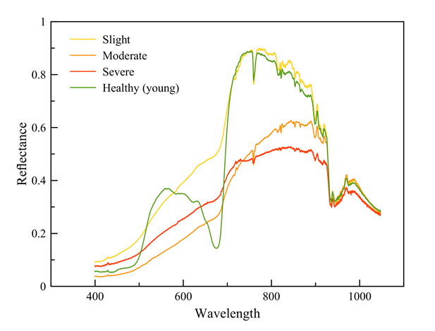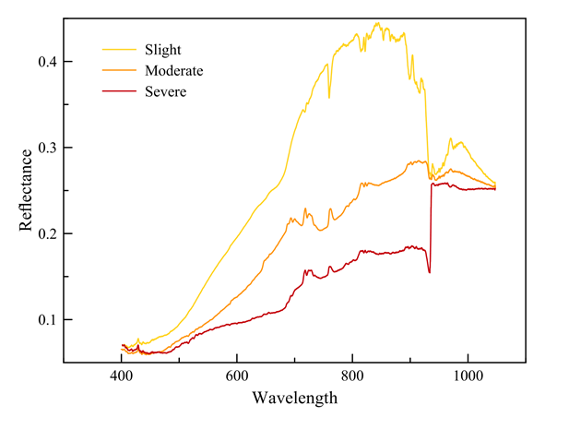
(a) (b)
Figure 1. Spectral signatures of coconut (a) leaves and understorey grass and (b) trunk at various degrees of infestation.

4.2 Analysis of high-resolution satellite imagery of CSI-infected coconut planted areas

Figure 2 shows the difference between the pre-CSI to moderate (December 2012) infestation and severe infestation (January 2014) in true color (Figure 2a & b) and false color (Figure 2c & d) respectively. It can be seen that the affected coconuts (those with regular spaced dotted patterns) appear with a lighter yellowish tone compared to healthier coconuts just over a year before. In the NIR false color composite, the coconut stands appear to be darker. The presence of the CSI are first detected by increase in the yellow bands.

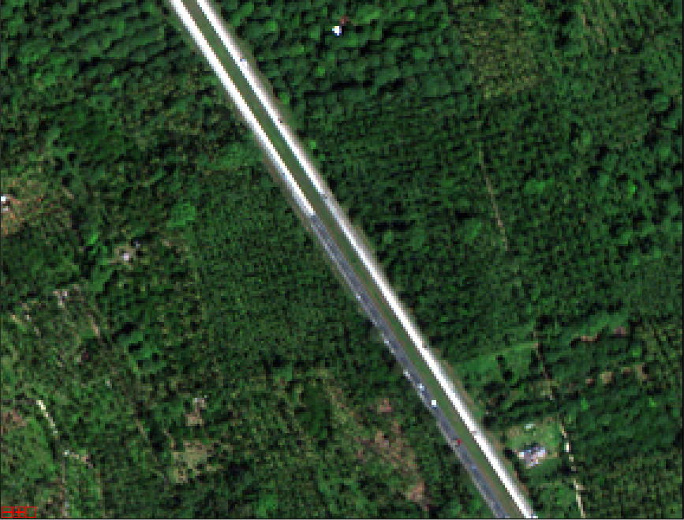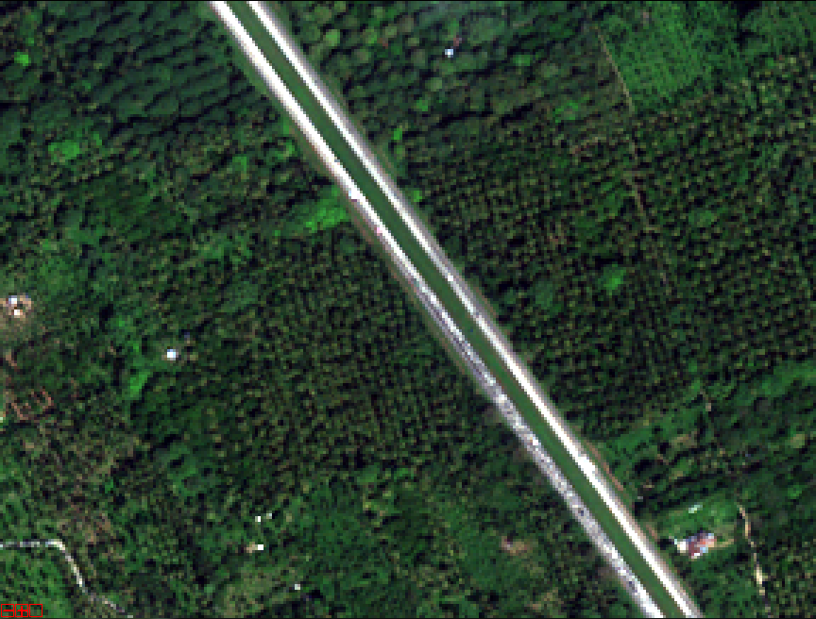
(a) (b)
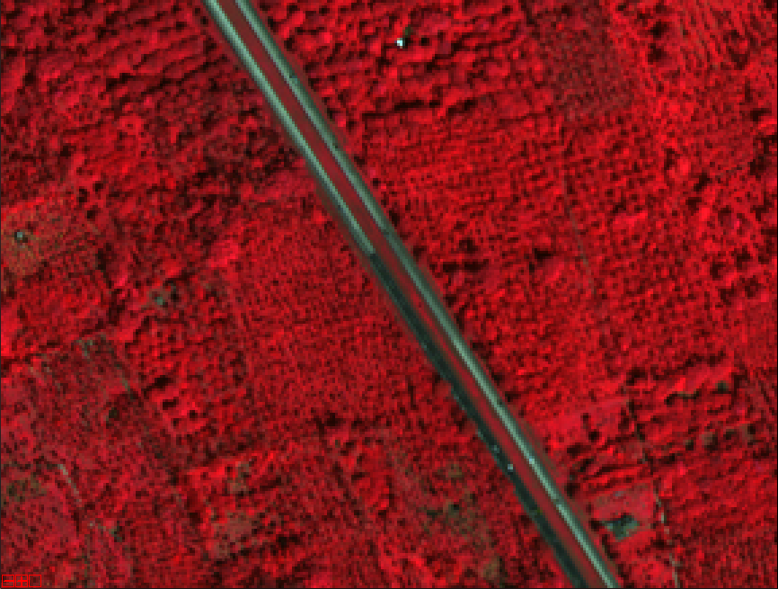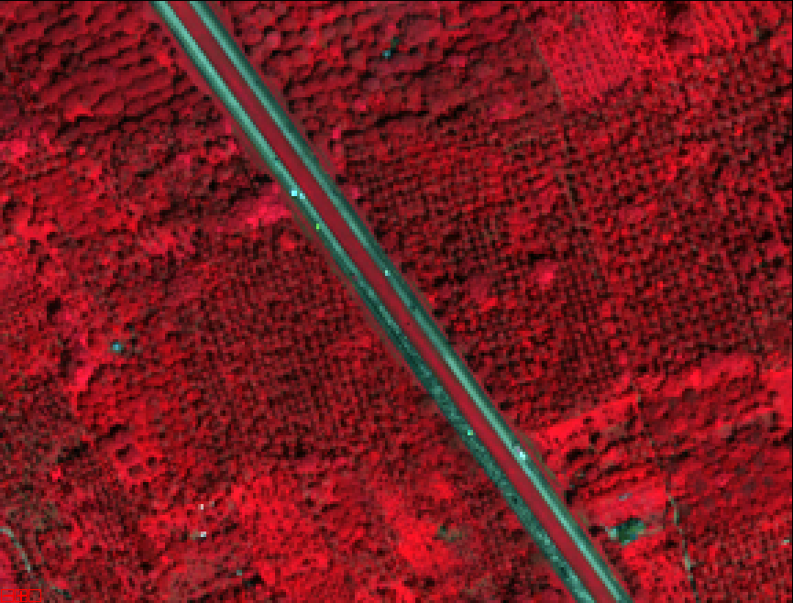
(c) (d)
Figure 2. Worldview-2 images of the same area showing different degrees of infestation.

Spectral signatures of coconuts of various degrees of infestation are fairly distinct and distinguishable in the 8-band Worldview-2 satellite imagery particularly pronounced in the NIR-1 and NIR-2 bands followed by Red Edge band. The spectral signatures of coconut trees infested by CSI provide a useful indicator of coconut health and vigour. This can be observed in both visible and near-infrared (NIR) regions of electromagnetic spectrum, the latter being the most commonly used for vegetation analysis. Given the detectability of CSI in spectral signatures even at slight levels, it can be used to assess effectiveness of control measures (biological and chemical) on experimental target sites by periodically covering them with hyperspectral imageries

The results of the study will be useful in devising and evaluating options to control CSI outbreak populations/areas to non-economically CSI damaging levels. The identification of affected areas will establish boundaries that will define management measures to contain the spread of CSI to non-infested coconut areas to prevent population outbreaks such as, pruning, use of biological control agents (Lopez et al, 2004), insecticides particularly “Dinotefuran,”, which belongs to the neonicotinoid family of pesticides despite safety concerns (Mallari, 2014).

Concluding Remarks

The paper reports the preliminary but fundamental efforts done to explore the possibility of using remote sensing techniques for surveying, assessing and monitoring the extent, distribution and magnitude of coconut scale infestation. Spectral field measurements and analysis suggest that the infestation can be detected at the leaf scale primarily due to the changes in near-infrared reflectance and losses in the chlorophyll levels in the visible range. Observation of high-resolution satellite imagery point to reduced reflectance in the NIR portion as a primary indicator of coconut stress due to presence of coconut scale infestation.

References

Dabrowska-Zielinska, K, Meroni, M., Atzberger, C. and Léo, O. (Guest Eds) (2014) Monitoring agriculture and agri-environmental conditions with Earth Observation, International Journal of Applied Earth Observation and Geoinformation, Special Issue, pp. 01-21.
Digital Globe (2014) Worldview-2 Data Sheet, URL: http://www.digitalglobe.com/sites/default/files/DG_WorldView2_DS_PROD.pdf. Accessed 01 September 2014.
Lopez, V. F. , Kairo, M. T. K. and Irish, J. A. (2004), Biology and prey range of Cryptognatha nodiceps (Coleoptera: Coccinellidae), a potential biological control agent for the coconut scale, Aspidiotus destructor (Hemiptera: Diaspididae), Biocontrol Science and Technology 14(5) 475-485.
Mallari, D.T. (2014), Stop use of pesticides vs ‘cocolisap,’ gov’t urged. Philippine Daily Inquirer, URL: http://newsinfo.inquirer.net/634184/stop-use-of-pesticides-vs-cocolisap-govt-urged, Accessed: 01 September 2014.
Mulla, D.J. (2013) Twenty five years of remote sensing in precision agriculture: Key advances and remaining knowledge gaps. Biosystems Engineering, 114(4), pp. 358-371.
Philippine Coconut Authority (2013), 2013 Outlook for the Philippine Coconut Industry, URL: http://www.philexport.ph/c/document_library/get_file?uuid=fb6d1043-340d-4050-b81e-3f08215b39bb&groupId=127524, Accessed: 21 May 2014.
Watson, G., Adalla, C. B., Shepard, B.M. and Carner, G.R. (2014). Aspidiotus rigidus Reyne (Hempitera Diaspididae): A devastating pest of coconut in the Philippines. Agricultural and Forest Entomology, (DOI: 101111/afe.12074).
Usha, K and Singh, B. (2013) Potential applications of remote sensing in horticulture - A review. Scientia Horticulturae, 153(4) April 2013, Pages 71–83.

ACKNOWLEDGEMENTS

This project is primarily supported through the resources of the Nationwide Disaster Risk and Exposure Assessment for Mitigation (DREAM) Program through the Satellite-based Mapping Assessment of Rehabilitation Efforts in the Typhoon-affected Regions (SMARTER Visayas) Project, the Philippine Council for Agriculture Aquatic and Natural Resources Research and Development (PCAARRD). Digital Globe for providing the Worldview-2 images. We thank the Philippine Coconut Authority for the field monitoring data and for the assistance during the field surveys.

