**MONITORING MEKONG RIVER LEVEL CHANGE BY SATELLITE ALTIMETRY**

Kuo-Hsin Tseng

Center for Space and Remote Sensing Research, National Central University, 300 Jhongda Rd., Jhongli City, Taoyuan County 32001, Taiwan

Email: khtseng@csrsr.ncu.edu.tw

**KEY WORDS:** Envisat, Jason-2, Dam Project, Narrow River, Waveform Retracking

**ABSTRACT**

Mekong River, a major freshwater resource for the mainland Southeast Asia, has a length more than 4000 km with distinct seasonal changes in width and discharge. To react to the possible water resource crisis in this area, some of adjacent countries started to build dams along the Mekong in the last decade for retaining water within the border. The construction of dams has been benefit to some of the collaborated countries in water supply and hydropower generation. However, block of river has induced a conflict within this region due to the altered upstream-downstream connectivity. In this study, we utilized two altimetry satellites, Envisat and Jason-2, to observe the water level variation in the last 12 years (2002–2014) at both upstream and downstream of two lately built Jinghong Dam and Nuozhadu Dam, located in Yunnan Province, China. By using the technique of radar altimetry waveform retracking, the water level variation within steep terrain is clearly detected in terms of both man-made impoundment and seasonal changes. The observation of water level across the whole basin is expected to be a good reference for local authorities to revise modulation of water dynamics and for a timely update of infrastructure planning.

**INTRODUCTION**

The Mekong River, originated from Qinghai Province, China, is the 10th longest river in the world and serves as a major freshwater resource for Myanmar, Laos, Thailand, Cambodia, China, and Vietnam (Birkinshaw et al., 2010). The river width and discharge significantly change in time depending on the glacier/snow melt and seasonal monsoon, while the rainy season is usually between May and October. In recent years, the construction of dams along the Mekong has been a serious issue for neighboring countries since the block of water perhaps induces a serious upstream-downstream conflict (Johnston and Kummu, 2011). The utilization of water resource for hydropower generation or simply for domestic water supply eventually influences resident living downstream in another country. Therefore, by knowing the water dynamics along the river is important for an effective control of water resources and the implementation of water management.

Since the river gauge is hard to be built within the steep terrain of the mainland Southeast Asia and it is also difficult to obtain data from other countries, the observation from space potentially overcome the accessibility problem and could be a good option for basin scale study (Alsdorf et al., 2007). The altimetry satellite has thus become a viable approach to measure water level at certain locations across the whole basin. Although the purpose of altimetry satellite at first was designed for measuring ocean surface with waves (Fu and Cazenave, 2000), however, by means of the radar waveform retracking technology one could also discriminate water bodies over land. Because the water surface, in contrast to bare land or forest or other surface types, has a higher brightness characteristic in radar domain, it usually dominates radar echoes and can be seen clearly in the noisy terrestrial radar waveform. By retracking the waveform from either model-based or empirical approaches, the detection of water level has been demonstrated where the river width is as small as 200 m (Kuo and Kao, 2011).

Based on the 2010 State of the Basin Report published by the Mekong River Commission (Mekong River Commission, 2010), there are currently about 30 dams working within the basin, and more than 30 new dams have been planned, programmed, or under construction. It is usually not an issue during wet season while most dams regulate storage coincident with incoming waters. However, in dry season the countries in lower basin may hardly receive intake along the main stem. Therefore, an overview of the water storage within the basin is needed to balance water supply and fulfill regional requirements. Here, we demonstrate one of many options by using satellite measurements to inspect water level changes in the midstream of the Mekong Rive. By using satellite crossovers at upstream and downstream of two lately built Jinghong Dam and Nuozhadu Dam, which are located near the border of China and Myanmar, we could have a better understanding of the water flows and how hydropower stations influence river level in the downstream.

**STUDY AREA**

In this study, we utilized two altimetry satellites, Envisat and Jason-2, which have crossovers at the Mekong River and near the building sites of Jinghong Dam and Nuozhadu Dam in Yunnan Province, China (Fig. 1). Jinghong Dam was built since 2003 and being fully operated in 2009. One major impoundment of the dam was in 2007, which fills over 60 m of water in 3 months. There was two Envisat passes #97 and #147 that flied near the dam at about 10 km upstream. In the downstream #97 and #147 intersected with the river again at about 140 km and 260 km away, respectively. We used pass #97 as denoted by *b* in Fig 1 as upstream case and used crossovers of both passes denoted by *c* and *d* as downstream examples. Jason-2 had a pass #27 flied across the river in the upstream and #103 in the downstream. These passes that have crossovers at either side allow us to observe the water dynamics in either a natural way or man-made adjustment.

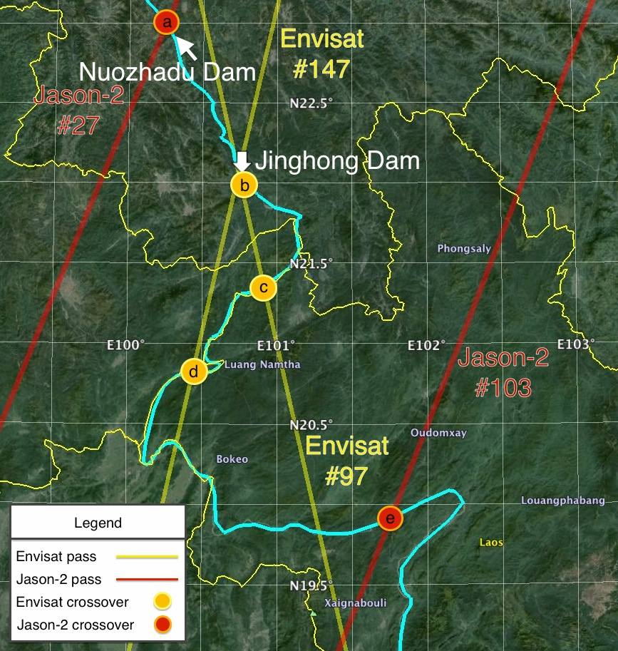

**Figure 1.** Location of the midstream of the Mekong River and study sites, Jinghong Dam and Nuozhadu Dam located in Yunnan Province, China. Three Envisat crossovers near the Jinghong Dam (one upstream and two downstream side) are denoted in yellow circle. Two Jason-2 passes (one side each) are denoted in red circle. Background Landsat image and other geographical information are gathered from Google Earth program.

**METHOD**

Two altimetry satellites, Envisat and Jason-2, were used in this study to generate observation time series of water level at crossovers both upstream and downstream of the Jinghong Dam and Nuozhadu Dam, to reveal the timing of impoundment and to examine the accuracy that altimetry satellite could achieve within steep terrain. Envisat was launched in 2002 at an orbital altitude about 800 km and with an inclination of -89.5° (retrograde). The exact repeat orbit of Envisat is 35 days. It ended in 2012 mainly due to failure of a telecommunication payload. It was operated by the European Space Agency (ESA) and served as a successor of ocean monitoring sensor following two successful missions: European Remote-Sensing Satellite series, ERS-1 and ERS-2. The dual-frequency altimeter worked at Ku band and C band was used to remove ionospheric delay. Here we used the latest version of reprocessed Geophysical Data Record (GDR, V2.1) provided by the Archiving, Validation and Interpretation of Satellite Oceanographic data (AVISO) center of the Centre National d’Etudes Spatiales (CNES) in France. On the other hand, Jaons-2 altimetry mission is one of the Ocean Surface Topography Mission (OSTM) mainly operated by the National Aeronautics and Space Administration (NASA) of the United States and follows two predecessors TOPEX/Poseidon and Jason-1. Jason-2 was launched in 2010 at an altitude about 1336 km with 66° inclination. The frozen orbit of Jason-2 is not sun-synchronous with a revisit period of about 10-day. In this study we used the version ”D” (JA2\_GPS\_2PdP) of the Sensor GDR (SGDR) also provided by AVISO for the extraction of water signal.

The waveform retracking is basically to determine the most likely position in the radar waveform that can be represented as the time delay that an averaged radar impulse has traveled between satellite sensor and the nadir surface. The return waveform has been modeled as a convolution of three major components: an average flat surface (or smooth sphere) impulse response (*FS*), an instrument point target response (*PTR*), and a surface elevation probability density function (PDF) of the specular points. The model can be formulated as below (Brown, 1977):



This model as known as “OCEAN” retracker is usually used for resolving parameters of ocean surface such as surface slope, significant wave height, and surface height. However, for inland application the waveform usually not forms as ideal as from ocean surface. Some other empirical retracker was thus introduced to match a variety of waveform patterns. For example, the Off Center of Gravity (OCOG) retracker (Wingham et al., 1986) is used to fit multi-peak shape of waveform mostly from ice surface and other brighter surfaces. The ICE retracker is a modified OCOG by using a changed value of the threshold while computing the level in the waveform leading edge. The OCOG retracker can be formulated as (Wingham et al., 1986):



where

P(*i*) = power value of the *i*th waveform gate

na = number of aliased gates

k = total number of waveform gates

In this study we chose the ICE retracker in both Envisat and Jason-2 data that had been proved to be applicable for inland water studies (Lee et al., 2011, Tseng et al., 2014).

**RESULT AND DISCUSSION**

Water level measurements at selected sites along the Mekong are given in Fig. 2. All the heights shown here are based on the reference of WGS84 ellipsoid. Subplots (a) and (b) in Fig. 2 clearly show both impoundment events in Nuozhadu Dam and Jinghong Dam in 2012 and 2008, respectively. In the following subplots, although not very clear, some delays of the peak water in rainy season are noticed in the time series. For example, in subplot (c) and (d), we see a few weeks delay of peak in 2008 after the impoundment of Jinghong Dam as shown in subplot (b). Also, in (e) we could observe a somehow prolonged dry season in 2012 probably associated with the impoundment of Nuozhadu Dam in (a). Other than these periods, the seasonal signal seems to be normal before and after the construction of the dams, which means these dams regulate water storage in a way coincident with the nature of the water dynamics. However, the time series shown here had not included some extremely dry years that had occurred in history and probably will be happening in the coming years. A continues observation system established by altimetry satellites at every possible crossovers is thus necessary for a complete inspection during the upstream-downstream debate.

|  |  |
| --- | --- |
| Macintosh HD:Users:StevenTseng:Documents:j2_mekong:j2_1.jpg(a) | Macintosh HD:Users:StevenTseng:Documents:envisat_mekong:env_1.jpg(d) |
| Macintosh HD:Users:StevenTseng:Documents:envisat_mekong:env_2.jpg(b) | Macintosh HD:Users:StevenTseng:Documents:j2_mekong:j2_2.jpg(e) |
| Macintosh HD:Users:StevenTseng:Documents:envisat_mekong:env_3.jpg(c) | **Figure 2**. Water level variation measured by both Envisat and Jason-2 near the midstream of the Mekong River. Subplots *a* to *e* correspond to notations in Fig. 1, in an order from upstream to downstream. Nuozhadu Dam located near site *a* and Jinghong Dam located near site *b*. Both altimetry data had been passed a 15 dB backscattering coefficient (BC) filtering and a regular 2-σ de-outlier process in the time series. |

**CONCLUSION**

The water level change before and after dams’ construction along the Mekong River is revealed in the altimetry satellite measurements. The accuracy, although not as high as measurement over ocean, achieves an acceptable level for large amplitude detection. Two epochs of water impoundment in Jinghong Dam and Nuozhadu Dam has been successfully detected in the time series. Regular seasonal signal is also seen in the 12-year data record. In order to obtain a better picture of the water storage change in basin scale, further studies that thoroughly analyze every possible crossovers along the Mekong River is warranted to investigate all the tributaries that were affected by the intervention of dams.

**ACKNOWLEDGEMENT**

We thank Dr. C.K. Shum and Dr. Yuchan Yi from the Ohio State University and Dr. Hyongki Lee from University of Houston, USA, for their support in altimetry data processing and waveform retracking technologies.

**REFERENCE**

Alsdorf, D. E., Rodriguez, E., & Lettenmaier, D. P., 2007. Measuring surface water from space. *Rev Geophys*, 45(2).

Birkinshaw, S. J., O'Donnell, G. M., Moore, P., Kilsby, C. G., Fowler, H. J., & Berry, P. A. M., 2010. Using satellite altimetry data to augment flow estimation techniques on the Mekong River. *Hydrological Processes*, 24(26), 3811-3825.

Brown, G. S., 1977. The Average Impulse-Response of a Rough Surface and Its Applications, *IEEE T Antenn Propag*, 25(1), 67-74.

Fu, L. L., & Cazenave, A. (Eds.), 2000. Satellite altimetry and earth sciences: a handbook of techniques and applications (Vol. 69). Academic Press.

Johnston, R., & Kummu, M., 2012. Water resource models in the Mekong Basin: A review. *Water Resources Management*, 26(2), 429-455.

Kuo, C. Y., & Kao, H. C., 2011. Retracked Jason-2 altimetry over small water bodies: case study of Bajhang River, Taiwan. *Marine Geodesy*, 34(3-4), 382-392.

Lee, H., Shum, C. K., Tseng, K. H., Guo, J. Y., & Kuo, C. Y., 2011. Present-day lake level variation from Envisat altimetry over the Northeastern Qinghai-Tibetan plateau: links with precipitation and temperature. *Terrestrial, Atmospheric and Oceanic Sciences*, 22(2), 169-175.

Mekong River Commission., 2010. State of the basin report 2010. Phnom Penh: Mekong River Commission.

Tseng, K. H., Liang, S., Ibaraki, M., Lee, H., & Shum, C. K., 2014. Study of the variation of schistosomiasis risk in Lake Poyang in the People's Republic of China using multiple space-borne sensors for the monitoring and modelling. Geospatial health, 8(2), 353.

Wingham, D., Rapley, C., and Griffiths, H, 1986. New techniques in satellite altimeter tracking systems, *Proc. IGARSS Symposium*, Zurich, ESA SP-254.