Analysis of Submarine Physiographic Features in the Bay of Bengal

Myint Myint Khaing¹, Kyaw Zaya Htun², Zin Mar Lwin³
¹Associate Professor, Mandalay Technological University, Myanmar
drmmkhaing@gmail.com
² Assistant Lecturer, Mandalay Technological University, Myanmar
³ Associate Professor, Mandalay Technological University, Myanmar

Abstract
Bay of Bengal is a northwardly extended arm of the Indian Ocean and characterised by a broad inverted U-shaped basin which is open in the south to the Indian Ocean. Digital Terrain Model of the Bay of Bengal and surrounding terrestrial lands has been studied with its generalized geomorphic features.
Bay of Bengal is bounded on the west by the east coasts of India and Sri Lanka, on the north by the deltaic shelf of the Ganges-Brahmaputra-Meghna Rivers system, and on the east by the Rakhine coast and submerged shelf. The abyssal floor of this basin is undulant and occupies almost the entire Bay of Bengal gently sloping southward at an angle of 0.8°-1.0°. Submarine channels dissecting the abyssal plain have been encountered. To the east and northeast, this abyssal plain ascends to continental rise gradually and then arises as a steep continental slope and narrow shelf. The shelf, Rakhine continental shelf is a narrow shelf and bounded on the east by a narrow coastal land and folded mountain ranges. These western folded mountain ranges of Myanmar are known as Naga-Chin-Rakhine Ranges (NCR Ranges) (has been known as Indo-Burman Ranges) and the ranges and coastal land are regarded as the western part of the Myanmar’s territorial land or landmass.
Length of the Rakhine coastline was estimated based on the General Bathymetric Chart of the Oceans (GEBCO) Digital Atlas data which adopted the World Vector Shoreline (WVS) database of the US Defense Mapping Agency (DMA) as the standard coastline. The estimates presented here were calculated using Mapinfo software with a resolution of 1:250,000 and attained as approximately 740 km.
Depth along the shelf break varies between 150 m to 250 m. The isobaths map was generated from the GEBCO Digital Atlas data and ETOPO2 data with Caris Lots Software. GEBCO Digital Atlas data, ETOPO2 data and survey data were used for analysis of submarine physiographic features with the help of Caris Lots Software.

Keywords: Bay of Bengal, Digital Atlas data, submarine physiographic features, isobaths map

Introduction and Background of the Study
This project was come out from the United Nations Convention on the Law of the Sea (UNCLOS).This Convention was implemented on November 14, 1994 and ratified by one hundred and fifty six countries. According to the Convention, coastal state shall establish their maritime zones namely Territorial Sea, Contiguous Zone, Exclusive Economic Zone (EEZ), Extended Continental Shelf and High seas. However, coastal state shall extend its continental shelf limits, that are the legal aspect of the continental shelf beyond 200 Nautical miles or EEZ up to certain limit by the law of the sea.
In accordance with the UNCLOS Article 77, there are the rights of the coastal State over the continental shelf that is the coastal State exercises over the continental shelf sovereign rights for the purpose of exploring it and exploiting its natural resources.

Purpose of Study
- To analyse the physiography of the Rakhine region and Bay of Bengal
- To examine the continental slope and its base
- To provide the determination of outer limit of extended continental shelf

Materials and Method of Study
There are totally four steps which are data acquisition, data processing, data interpretation and documentation for this study. In data processing stage, vessel & equipments specification, QC protocol and geodetic parameter were considered. Data quality & density, processing sequences with output formats have been carried out for data processing step. Limit of uncertainty and types of display have been done for data interpretation stage. Analytical reports with illustration & printing and data storage have been done for last step.

Data Acquisition (January-March 2008)
In Phase I, 2-D Seismic Reflection survey, Magnetic survey, Single Beam Echo-Sounder survey (SBES), Multi-Beam Echo-Sounder survey (MBES) were carried out by survey vessel namely MV.Teknik Pardana, TLGH, Malaysia. And Gravity survey was carried out by survey vessel namely SV.Zephyr-I, DMNG, Russia in Phase II.
For Positioning and Navigation system, Veripos Ultra DGPS system was used in Ground reference stations namely Mumbai, Kolkata, Chennai, Bangkok, Shenzhen, and Kemaman. Lines coordinates, Vessel speed and QC protocol have been considered for each step.

Bathymetric Data Acquisition
Single beam echo-sounder survey was done for to measure sea-floor depths and respective coordinates, to generate the depth profile and to support other type of survey.
Multi-beams echo-sounder survey was done for to measure sea-floor depths and respective coordinates, to generate the 3-D bathymetric image. The maximum water depth in the southern part of the survey area is 10500 feet.

Geophysical Data Acquisition
In Phase I , marine 2-D seismic reflection survey was done for to illustrate the geological structure of the rocks beneath the sea floor down to the 15 km in depth and Marine magnetic survey for to differentiate the continental rocks and oceanic rocks of the sea floor.
In Phase II, marine gravity survey was carried for to determine the density and thickness of layers beneath the sea floor. Survey lines are coincided with those lines in Phase I.

Data Processing
The first step of data processing is data loading to the workstations. Assessments of data quality and data density were done after data loading process. Navigation data, positioning data, corrected SBES and MBES data
have been applied for this purpose. Different processing sequences in different software such as Caris LOTS, MapInfo, Surfer, and ArcGIS have been used. The shot-point coordinates, line position and tide-correction
Transformation of data format were Checked.

Data Interpretation (Analysis on the physiography of the Rakhine region and Bay of Bengal)
The shaded relief map & 3-D models were generated by using additional data from NOAA and superimposing with acquired data. Regional trends of Rakhine Ranges through Coco Is. to Andaman Island were studied and prepared the report. 3-D perspective view of the northern Bay of Bengal showing the Rakhine continental margin and abyssal plain; NCR- Naga-Chin-Rakhine Ranges, RCS- Rakhine Continental Shelf by view direction to the north is as shown in Figure 1.
NCR
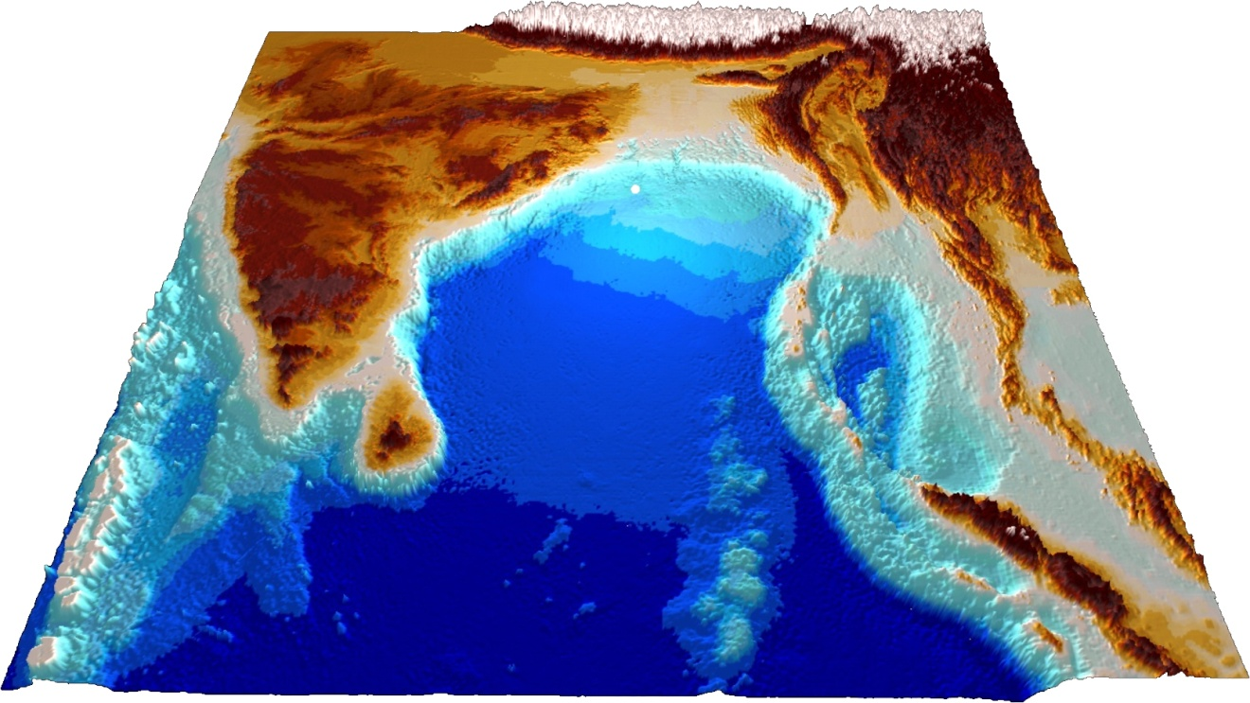
Figure 1. 3-D perspective view of the northern Bay of Bengal
Bang-
ladesh
Andaman Sea
Myanmar
India
Indian Ocean
Bay of Bengal
RCS

Colour shaded relief map shows the regional trend of the Naga-Chin-Rakhine Ranges and its southern extension submerges under the sea and emerged again as the Coco and Andaman Islands. The adjacent Rakhine continental shelf in the west is narrow but widens northward and merges with the Bengal Deltaic shelf. N-Naga Hills, C-Chin Hills and R- Rakhine Ranges is as shown in Figure 2.
RR
RCS

Figure 2. Colour shaded relief map Figure 3. Bay of Bengal showing the position of
200 m isobaths(red)

Morphology of the coastal zones of Myanmar, Bangladesh and India were also examined with different data by using different software. Submarine physiographic features observed in the Bay of the Bengal such as continental shelf of Rakhine offshore which is narrow belt, wider continental shelf of Bangladesh, shelf edge at 200 m depth.
RR
RCS
Map of the Bay of Bengal showing the position of 200 m isobath (red) which is generally demarcates the edge of the continental shelf. Green lines are the position of synthetic profile lines for the physiographic analysis in Figure 3.
Rakhine continental slope, west of the Sittway with slope gradient of 4 degree is as shown in Figure 4.
Rakhine continental slope, west of the Andrew Bay with slope gradient of 4.5 degree is as shown in Figure 5.
Rakhine continental slope, west of the Mawdin Point with slope gradient of 5 degree is as shown in Figure 6.
Rakhine continental slope, west of the Coco Island with slope gradient of 5.5 degree is as shown in Figure 7.
All these profile were generated from the Etopo-2 data by using Caris LOTS software.

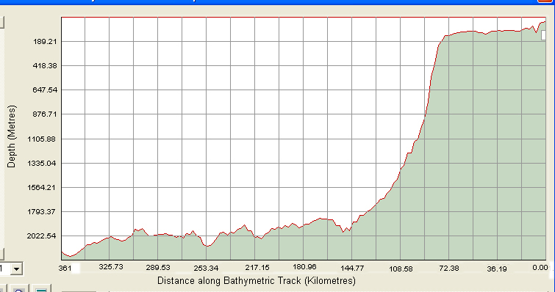
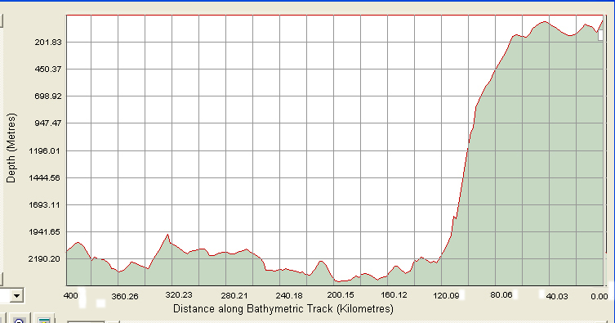

Figure 4. Rakhine continental slope, west of the
Sittway with slope gradient of 4 degree
Figure 5. Rakhine continental slope,west of the Andrew
Bay with slope gradient of 4.5 degree.

Figure 6. Rakhine continental slope, west of the
Mawdin Point with slope gradient of 5 degree
Figure 7. Rakhine continental slope, west of the Coco
Island with slope gradient of 5.5 degree
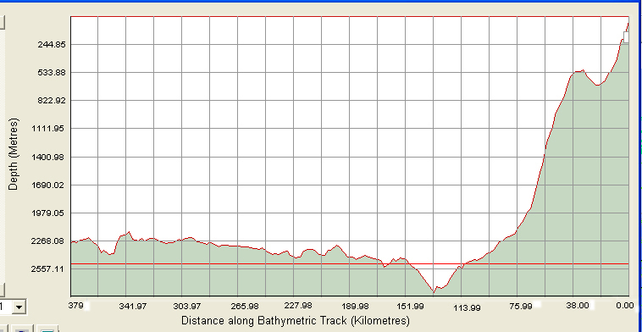
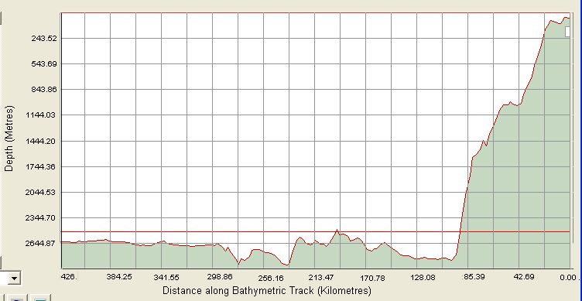

Continental slope is steep with submarine canyons and terraces and continental rise is covered with submarine slumps, lower terraces, slope failure and depression. Submarine elevation is broad and wide, 90 East Ridge is in the south and Bengal submarine fan also found in this area.

Conclusion
Morphologically, the land mass of the Myanmar descending westward can be described in terms of the shelf, the slope and the rise. Beyond the rise lies the deep ocean floor of the Bay of Bengal. As a geologic aspect, the Rakhine continental margin is westward advancing accretionary complex of the Burma Plate. Geologically as well as tectonically, the land territory of Myanmar embraces two tectonic domains and the “Burma Plate (Block)” is westernmost one of them. The Burma Plate and the accretionary complex along its western margin comprise dominantly of marine sedimentary rocks. The abyssal plain in northern Bay of Bengal is underlain by Bengal Submarine Fan System. As a consequence, the accretionary complex is built up with the sediment scraped off from the subducting Indian Plate beneath Burma Plate. Therefore, in this region, the fundamental prolongation between the land mass (accretionary complex) and the deep ocean floor (submarine fan) can be established mainly based on the rock type and continuous tectonic episodes being occurred since hundreds of millions of years ago.
Finally, it can be shown that there is a Natural prolongation of the landmass beyond 200 M in Myanmar Continental Shelf. And it can be proved that there is a demarcation of the outer edge of the Rakhine continental margin (scientific aspect) as well as delimitation of the outer limit of the continental shelf (legal aspect).
Moreover, exploration and exploitation in the extended continental shelf such as natural gas and methene hydrate polymetallic nodules and manganese nodules will be implemented in future.

Acknowledgements
The authors gratefully acknowledge workmates from Counsellor and International Law and Treaty Department, Ministry of Foreign Affairs, Myanmar National Hydrographic Centre, Ministry of Defence, Department of Higher Education, Ministry of Education, Myanma Oil and Gas Enterprise, Ministry of Energy and Remote Sensing Department, Mandalay Technological University, Ministry of Science and Technology for their kind efforts.

References
Bender, F., 1983, Geology of Burma, Beitr. Reg. Geol. Erde, vol. 16, Gebr. Borntraeger, Stuttgart, Germany.
Bird, P., 2003, An updated digital model of plate boundaries, Geochem. Geophys. Geosyst, Volume 4, Number 3.
Brunnschweiler, R. O., 1966, On the geology of Indo-Burman Range, (Arakan coast and Yoma, China Hills, Naga Hills), J. Geol. Soc. Aust., Volume 13, page 137–194.
Curray, J.P., 2003, Tectonics and history of the Andaman Sea region, Journal of Asian Earth Sciences, volume 25, page 187–232

