Landsat 8 investigation of peat fire detection in Sumatra: Preliminary results

Christopher D. Elvidge¹, Mikhail Zhizhin², Feng-Chi Hsu2, Kimberly Baugh², Yenni Vetrita³, Suwarsono³, Muhammad Rokhis Khomarudin³, Dadang Hilman⁴
¹Earth Observation Group, NOAA National Geophysical Data Center, 325 Broadway, Boulder, Colorado 80305 USA
Email: chris.elvidge@noaa.gov
²Cooperative Institute for Research in the Environmental Sciences, University of Colorado, Boulder, Colorado USA
³ National Institute of Aeronautics and Space, Lapan, , Jakarta, Indonesia
⁴ Indonesia Climate Change Center, Jakarta, Indonesia

KEY WORDS: Landsat, fire detection, peat fire, flaming and smoldering phase, planck curve

ABSTRACT: Peatland fires typically have flaming and smoldering phases present simultaneously within pixel footprints typical for satellite remote sensing systems like Landsat and VIIRS. The flaming phase temperature is approximately twice that of the smoldering phase. This temperature differential makes it possible to sample the flaming and smoldering Planck curves at different wavelength ranges. In this paper, we present a method for using nighttime short-wave infrared data from two spectral bands available from the Landsat 8 instrument to model flaming phase fires, with the estimation of flaming phase radiances in the long-wave infrared (LWIR). The persistence of LWIR fire features confirmed the presence of smoldering peat fires.
- INTRODUCTION

Peatland fires in Indonesia are a major source of trace gas and particulate emissions (Tosca et al., 2011; van der Werf et al., 2006, 2008, 2010; Zender et al., 2012). The occurrence of peatland fires is variable from year to year depending on the nature of the annual dry season. Massive peatland fires often occur in El Nino years, when drought conditions set up during the dry season. The occurrence of peatland fires can be largely attributed to two factors: 1) The upper meter (+/-) of the peat is dry and flammable due to an extensive network of maintained drainage ditches. And 2) Ignition sources. The fires are started for agricultural clearing and as a tool in establishing land tenure.
Fires in peatlands can be divided into two components: flaming phase and smoldering phase. Flaming fires have high combustion efficiency, with more CO2 and less smoke. Smoldering fires have higher CO and smoke emissions. 600 K is considered the break point between flaming (above 600 K) and smoldering (below 600 K). Fires in peat tend to fall within the smoldering phase. Once peat fires are established, they may persist in a smoldering phase for extended periods of time. Accurate modeling of peatland fire emissions requires information on the location, timing, spatial extent, quantity of fuel consumed, and relative proportions of flaming versus smoldering combustion.
The literature on the remote sensing of active peat fires is sparse. Siegert et al. (2004) reported peatland fire temperatures in Kalimantan, observed with the BIRD sensor, ranging from 400-800 K. The lower temperature sources were attributed to peat fires and the higher temperature sources to flaming phase dominated fires. Gumbricht et al. (2002) reported on peat fire detections in South Africa with multiple sensors, but with no temperature analyses. Standard fire products from MODIS and AVHRR make no distinction between flaming phase and smoldering fires. The identification of smoldering peat fires is challenging due to several factors:
- Much of the smoldering peat burning is underground – while satellites observe the surface.
- Standard satellite fire detection algorithms rely on detection in a single spectral band at 4 um. Without detection in multiple spectral bands it is not possible to distinguish between flaming and smoldering fires or to recognize pixels that contain both.
- Detection of low temperature sources requires large source areas to yield sufficient infrared emissions.
- Radiant emissions from smoldering fires may be dwarfed by flaming phase emissions due to the T⁴ term in the Stefan-Boltzmann Law.
In this research we explore the possibility that flaming and smoldering phases can be detected and analyzed within individual pixels observed with the Landsat 8 sensor at night. There are several favorable characteristics of nighttime Landsat for fire remote sensing research. The pixel footprints are small compared to systems such as MODIS and VIIRS. With sunlight eliminated, fires can be readily detected in the shortwave infrared (SWIR) bands centered at 1.6 and 2.2 um. In addition, the full observed SWIR radiance can be attributed to the combustion source. The major disadvantage is the lack of 4 um mid-wave infrared spectral bands, the spectral range with peak radiant emissions for biomass burning.
2. PHYSICAL LAWS FOR FIRE REMOTE SENSING

The physical basis for fire remote sensing can be understood through Planck’s Law, which defines the radiant emissions of objects based on the temperature and emissivity. Ordinary Earth objects (land, water, clouds) have temperatures in the range of 260-315 K. The land surface in Indonesia has a typical temperature near 300 K, yielding radiant emissions across a range of wavelengths, forming a characteristic “Planck curve” for a blackbody, with a peak at 9.66 um. Blackbodies are objects that radiate efficiently at all wavelengths, rated with an emissivity = 1.0. Clouds, water and vegetation radiate very nearly as blackbodies. Some rocks and soils have minor departures from blackbody behavior. Objects with uniformly lower radiant emissions than blackbodies are referred to as “graybodies”. Subpixel hot sources appear as graybodies in satellite remote sensing. This concept is incorporated in Planck’s Law as the emissivity term. There are two relevant corollaries to Planck’s Law that are relevant to fire remote sensing. Wien’s Displacement Law states that peak in radiant emissions shifts to shorter wavelengths as the temperature of an object increases. Finally, the Stefan-Boltzmann Law can be used to calculate total radiant output based on the temperature and emissivity.
3. MIXTURE MODELLING OF FLAMING PLUS SMOLDERING PHASE FIRES
Consider a Landsat 8 pixel with a 300 K background and a 800 K flaming phase fire covering 1/1000th of the surface. The presence of the flaming phase can be detected in bands 6 and 7 (Figure 1). Note that the flaming phase signal in the long wave infrared (bands 10 & 11) is negligible. If half of the pixel surface is covered by smoldering phase peat fire burning at 400 K, The Planck curve from the peat fire has nearly the same radiant output (2.56 W/m2) as the background (3.67 W/m2), but its peak is shifted to a shorter wavelength. The presence of the smoldering component enhances the radiances of the pixel by 304% at 4 um and 54% at 11 um. From a remote sensing perspective the best spectral bands for detection of the fire is in the MWIR andLWIR.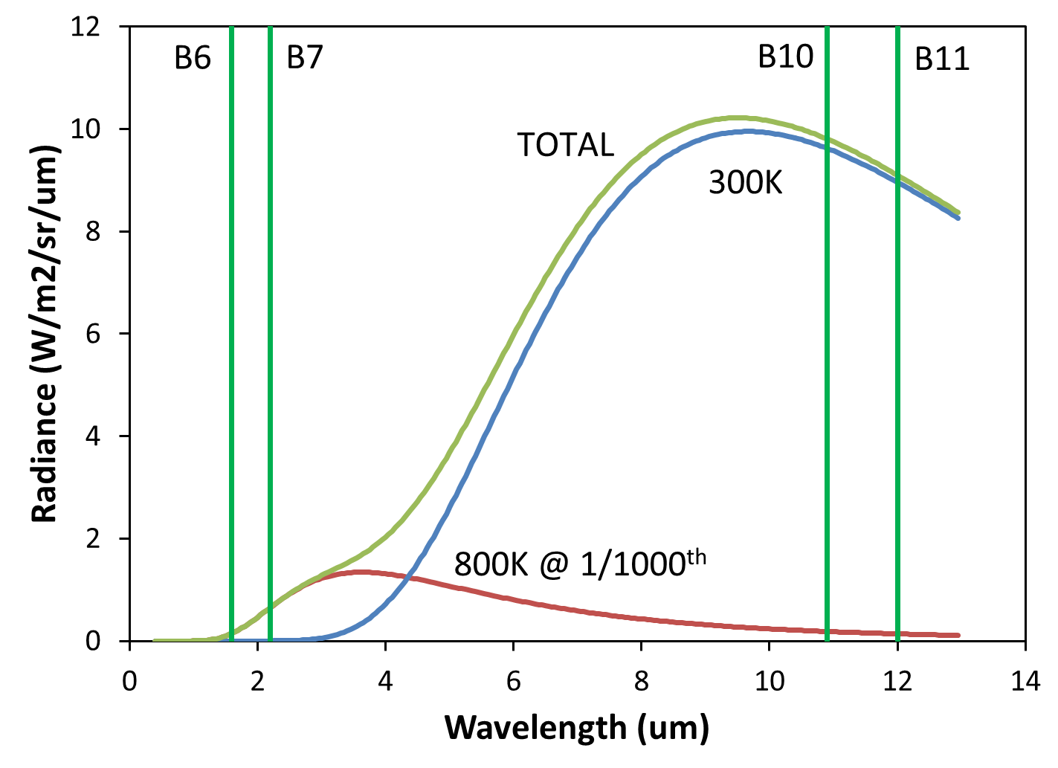
Figure 1. Mixture modeling of a Landsat 8 pixel containing a 300 K background and an 800 K subpixel flaming phase fire covering 1/1000th of the surface.

4. STRATEGY FOR DETECTING SMOLDERING PHASE FIRES
Existing satellite sensors have a reasonable ability to detect hotspot pixels with flaming phase fires. The distinguishing characteristic of peat fires is their low temperature, in the 400-600 K range. The classic MODIS style fire product detects hotspot pixels, but makes no attempt to estimate fire temperature. Remote sensing algorithms capable of calculating the temperature of subpixel fires solve for a single temperature (Dozier, 1981, Siegert et al. 2004, Elvidge et al. 2013). In reality, the peatland fire pixel likely contains a mixture of flaming and smoldering phase fires. Fitting a single Planck curve to the radiant emissions from such a pixel would not yield a valid temperature for either the flaming or smoldering phase burning.

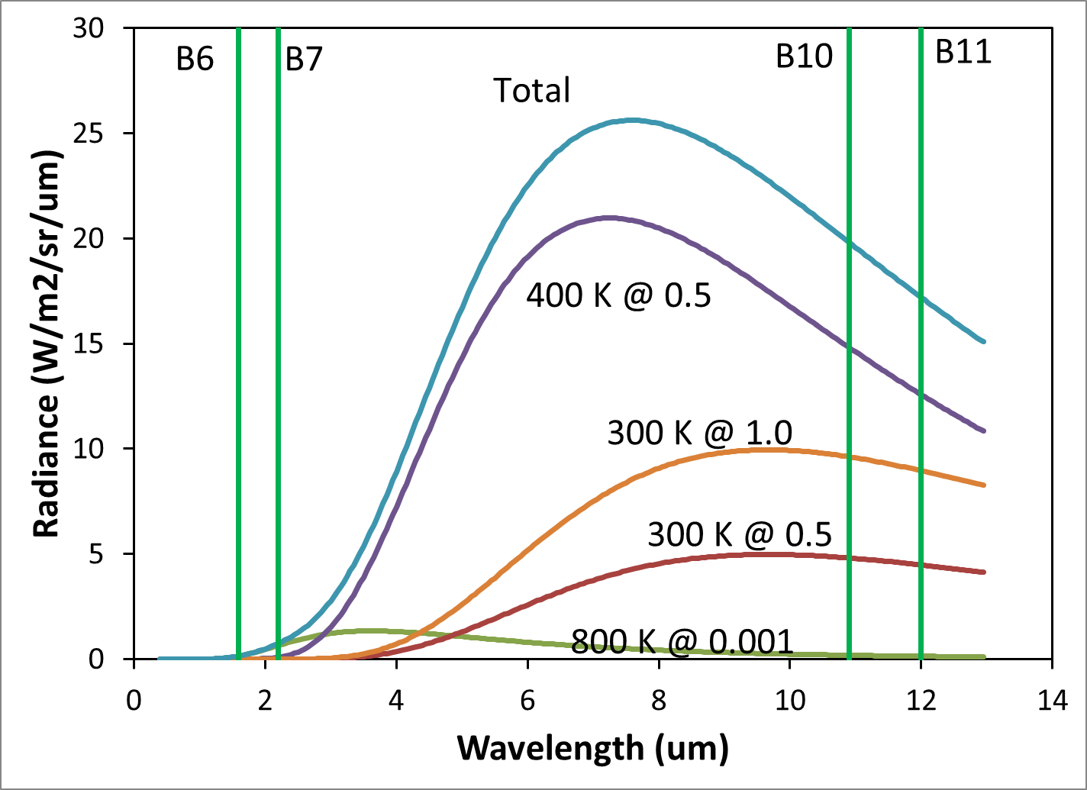

Figure 2. Mixture modeling of a Landsat 8 pixel containing a 300 K background and an 800 K subpixel flaming phase fire covering 1/1000th of the surface.

From Figure 2 it can be seen that flaming phase fires will often have detectable radiances in the SWIR Landsat bands 6 & 7, but the smoldering phase radiances at these short wavelengths will be quite small in comparison. In contrast, the presence of smoldering phase burning will result in thermal anomalies in bands 10 & 11. Based on this, we developed a strategy to search for smoldering phase radiant emissions in MWIR and LWIR by subtracting off the flaming phase radiances estimated from Planck curves generated using NIR and SWIR. The resulting residual images can be examined for thermal anomalies indicating the presence of smoldering phase fires. We call the strategy “fit short and search long” (FSASL) since it involves relying on short wavelength spectral data to search for long-wave infrared anomalies.

5. RESULTS
At our request, the U.S. Geological Survey began collecting nighttime Landsat 8 data on Riau beginning in early March 2014. The area is covered by the Landsat World Reference System (WRS) Path 2, Row 185. We report results from data collected March 28, 2014. Data were collected in all eleven available spectral bands. Fires were detected in four spectral bands: 6,7,10 and 11. Following the peat fire detection strategy (FSASL), the flaming phase Planck curves were modeled using the radiances detected in bands 6 and 7. The Planck curve modeled flaming phase band radiances are subtracted from the observed radiances in band 10 and 11.
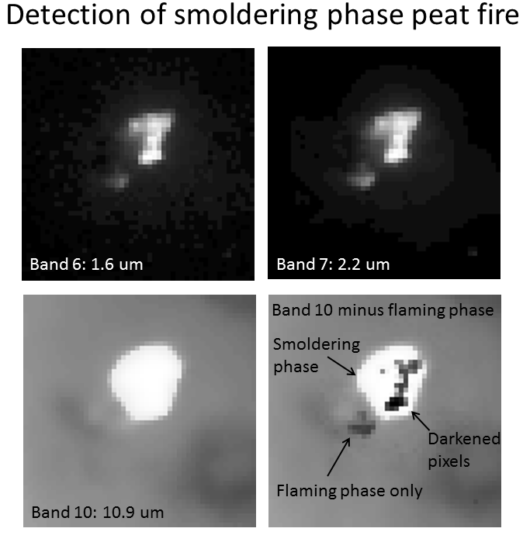Figure 3: Flaming phase Planck curves were modeled using radiances observed in the SWIR bands 6 and 7. The modeled flaming phase radiances were subtracted from the observed LWIR radiances in bands 10 and 11. The presence of residual LWIR signal exceeding the local background indicates the presence of smoldering phase burning. Note that there is a second area of burning evident in B6 & B7, which lacked a B10 anomaly, that turned dark when the flaming phase radiance was subtracted. This appears to be flaming phase burning that is unaccompanied by smoldering phase burning.
The fourth panel on Figure 3 shows the residual radiances in B10 following subtraction of the flaming phase radiances. The presence of radiances exceeding background levels indicates the presence of smoldering phase burning. Note that there are pixels with a darkening, where the radiance estimated from the flaming phase was nearly as large as the entire observed B10 radiance. Our interpretation of this is that it is due to a combination higher temperature smoldering phase burning and larger surface areas than the 400 K and half the pixel area used in the modeling presented in Figure 2. Also, to the lower left of the main fire feature there is a secondary are of burning evident in bands 6 and 7. This area lacked a thermal anomaly in bands 10 or 11. Our interpretation is that this was an area of flaming fire, with no smoldering component.
6. CONCLUSION
Peatland fires typically have flaming and smoldering phases present simultaneously within pixel footprints typical for satellite remote sensing systems like Landsat and VIIRS. Traditional fire remote sensing algorithms are skewed towards the detection of flaming phase fires, which have their peak radiant emissions in the 3-4 um mid-wave infrared (MWIR) region. As a result, there is no algorithm specific to the detection of smoldering peat fires. In this paper we proved that the presence of smoldering phase burning can be positively confirmed in the long wave infrared (LWIR) through isolation and subtraction of flaming phase radiances.
Mixture modeling of flaming, smoldering, and background reveal that the radiant emissions from flaming phase fires extend into the short-wave infrared (SWIR), a spectral range with near zero contribution from background (land, water, and clouds) and minimal contribution from smoldering phase. In contrast, the presence of smoldering phase fires will greatly enhance the radiant emissions in the LWIR. Based on this we developed a “fit short and search long” (FSASL) strategy to confirm the presence of smoldering phase burning in the LWIR. Because this strategy relies on flaming phase Planck curve modeling in the SWIR, the method only work at night. Reflected sunlight dominates the radiance in daytime data. At night the SWIR radiance can be fully attributed to the hot source. Satellite sensors that collect VIR and SWIR data typically only collect data on daytime orbital segments. For this study we requested special data collections in Riau, Sumatra with the Landsat 8 instrument at night.
Analysis of the data revealed fire detections in bands 6,7,10, and 11. Planck curve fits to the band 6 and 7 radiances were used to model flaming phase radiances in bands 10 and 11. The LWIR fire anomalies persist after the subtraction of the flaming phase radiances, confirming the presence of smoldering phase burning.
The procedure induces patches of pixel darkening in the B10 and B11 residual images. We believe that these pixels are evidence that the basic assumption that the SWIR is free of radiant emissions from the smoldering phase burning. As the temperature gap between flaming and smoldering phase narrows, or as the surface area of smoldering phase grows, the smoldering phase contribution to the total radiance observed in the SWIR will increase.
Another interesting phenomenon we found are pixel with flaming phase fires, but no smoldering phase. These are aboveground fires that in some cases are precursors to smoldering peat fires. We searched for, but did not identify pixels with smoldering phase fires with no flaming phase component.
The results to date indicate that the LWIR anomalies found for fires in Landsat data can be attributed to smoldering phase burning. This is an important finding for the purpose of surveying and mapping smoldering peat fires in places like Sumatra and Kalimantan. We are currently investigating the extraction of temperatures and source sizes for Landsat detected smoldering fires. Later, we plan to explore adapting this to nighttime VIIRS data, which includes nighttime collection of data at 1.2 and 1.6 um (Elvidge et al. 2013).
ACKNOWLEDGMENT
This research was funded by the U.S. Forest Service, International Program.

REFERENCES

Dozier, J., 1981, A method for satellite identification of surface temperature fields of subpixel resolution, Remote Sensing of Environment, 11, pp. 221-229.

Elvidge, C.D., Zhizhin, M., Hsu, F.-C., Baugh, K.E., 2013, VIIRS Nightfire: Satellite pyrometry at night, Remote Sensing, 5, pp. 4423-4449.

Gumbricht, T., McCarthy,T.S., McCarthy, J., Roy, D., Frost, P.E., Wessels, K., 2002, Remote sensing to detect sub-surface peat fires and peat fire scars in the Okavango Delta, Botswana, South African Journal of Science, 98, pp. 351-358.

Siegert, F., Zhukov, B., Oertel, D., Limin, S., Page, S.E., Rieley, J.O., 2004, Peat fires detected by the BIRD satellite, International Journal of Remote Sensing, 25(16), pp. 3221-3230.

Tosca, M. G., Randerson, J. T., Zender, C. S., Nelson, D. L., Diner, D. J., & Logan, J. A., 2011, Dynamics of fire plumes and smoke clouds associated with peat and deforestation fires in Indonesia. Journal of Geophysical Research-Atmospheres, 116, pp. 1-14.

van der Werf, G. R., Dempewolf, J., Trigg, S. N., Randerson, J. T., Kasibhatla, P. S., Gigliof, L., 2008, Climate regulation of fire emissions and deforestation in equatorial Asia. Proceedings of the National Academy of Sciences of the United States of America, 105, pp. 20350-20355.

van der Werf, G. R., Randerson, J. T., Giglio, L., Collatz, G. J., Kasibhatla, P. S., & Arellano, A. F., 2006, Interannual variability in global biomass burning emissions from 1997 to 2004. Atmospheric Chemistry and Physics, 6, pp. 3423-3441.

van der Werf, G. R., Randerson, J. T., Giglio, L., Collatz, G. J., Mu, M., Kasibhatla, P. S., 2010, Global fire emissions and the contribution of deforestation, savanna, forest, agricultural, and peat fires (1997-2009). Atmospheric Chemistry and Physics, 10, pp. 11707-11735.

Zender, C. S., Krolewski, A. G., Tosca, M. G., & Randerson, J. T., 2012, Tropical biomass burning smoke plume size, shape, reflectance, and age based on 2001-2009 MISR imagery of Borneo. Atmospheric Chemistry and Physics, 12, pp. 3437-3454.

