CHANGE IN SEAGRASS FRACTIONAL COVER IN BOLINAO AND ANDA, PHILIPPINES DERIVED FROM LANDSAT IMAAGES

Ariel C. Blanco^{1*}, Ayin Tamondong¹, Elaine Tagle¹, Miguel Fortes², Kazuo Nadaoka³
¹Department of Geodetic Engineering, University of the Philippines Diliman,
Melchor Hall, College of Engineering, U.P. Diliman, Quezon City, PHILIPPINES 1101
²Marine Science Institute, University of the Philippines Diliman
³Department of Mechanical and Environmental Informatics,
Graduate School of Information Science and Engineering, Tokyo Institute of Technology, 2-12-1 Ookayama, Meguro-ku, Tokyo, JAPAN, 152-8552

*Corresponding author: ariel.blanco@upd.edu.ph; acblanco.updge@gmail.com

ABSTRACT
Seagrass meadows have been drastically reduced in Bolinao and Anda in the Province of Pangasinan, Philippines. It is imperative to understand the patterns of seagrass cover change in order to be able to protect seagrasses from further loss. Landsat 7 and Landsat 8 images available for years 1993 to 2014 were processed to determine the spatial and temporal distribution of changes in seagrass coverage. The images were corrected for water column effects using the Lyzenga method. Fractional seagrass coverages were estimated using the Mixture Tuned Matched Filtering (MTMF) technique on Minimum Noise Fraction (MNF) images. Pixels with high MTMF scores and low Infeasibility values were identified as seagrasses. Seagrass fractional cover was derived from the MTMF scores. The results were compared to seagrass cover maps derived from high resolution. Zonal analysis was performed to characterize seagrass changes in eight zones. In 1993, seagrasses, in varying densities, cover approximately 71.07 km2 – 30.78 km² in Bolinao and 40.29 km² in Anda. These have been reduced to 14.48 km² (Bolinao) and 8.15 km² (Anda) in 2013/2014. In terms of Equivalent Full Coverage Seagrass Area (EFCSA), seagrass full coverage was reduced from 52.92 km² in 1993 to around 11.25 km² in 2013/2014. EFCSA has been reduced by 66% in Bolinao and 84% in Anda over the 20-year period. The pattern of seagrass changes indicated significant reduction in areas impacted by waters from the mariculture areas. This is evident in the northwestern part of Santiago Island, Bolinao. Seagrasses continue to thrive in areas not impacted by mariculture activities. Seagrasses in the eastern part of Anda Island were almost decimated presumably because of sediments discharged from the Agno River Basin and Alaminos watershed.

Keywords: seagrass, fractional cover, MTMF

INTRODUCTION
Seagrass meadow is one of the coastal ecosystems affected by development and is characterized by its productivity, high biodiversity and several functions. It is the most neglected coastal habitat. There are few researchers whose interest is about seagrass. Priorities for studies are aimed at other resources with immediate economic impacts, i.e., corals, seaweeds, animals, or fish that either live in coastal habitats or are associated with them. In 2000, seagrass meadows globally occupied 177,000 km2. An initial global decline estimate of 900 km2 over 10 years, based on documented losses (Short & Wyllie-Echeverria, 1996; Ferwerda et al., 2007), was corrected towards a decline of 33,000 km2 in twenty years corresponding to 15% of the total (Green & Short, 2003; Ferwerda et al., 2007). The Philippines, with its extensive coastline of more than 32,000 km, is the country with the second most diverse seagrass flora so far recorded (World Bank, 2005). A total of 978 km2 of seagrass bed have been measured from 96 sites in the Philippines. In the last 50 years, seagrass loss amounts to about 30-50% (PNSC, 2004). The largest single seagrass concentration in the northern part of the country is in Bolinao, Pangasinan with 22,500 ha of seagrass. In Cape Bolinao, threats to seagrasses that are given most importance are the following: (1) unsustainable fishing practices such as dynamite fishing, trawling, and overharvesting of associated species (e.g. siganids, urchins); (2) siltation/sedimentation; (3) infestations (fungal, viral, insect); (4) domestic discharges; (5) boat scour (PNSC, 2004).
It is crucial to determine the spatial and temporal variation in seagrass cover over periods of time duing which significant changes in the environment were introduced. While Landsat images have moderate resolution of 30 meters, the available images span several decades, thus providing the opportunity to examine the spatio-temporal variation of seagrass cover. However, more advanced method is needed to extract as much information. In this study, a spectral mapping technique was used to estimate abundance or fraction cover of seagrasses from Landsat images.

MATERIALS AND METHODS
Landsat 7 and 8 images were utilized in this study. Atmospheric correction was carried out using FLAASH implemented in ENVI. Sample atmospherically corrected images are shown in Figure 2. The land areas were masked out to retain only the water areas. The effects of water column were compensated for using the Lyzenga method. Prior to the application of the Mixture Tuned Matched Filtering method, Minimum Noise Fraction (MNF) images were produced. Visual quality checks were performed to remove MNF images with visible artifacts. From the MNF images, seagrass areas with 100% cover were identified and delineated to provide the seagrass spectral signature (image-derived). The average of the spectra obtained from several regions of interest and used as the image-derived seagrass endmember spectal signature.

Figure 2. Atmospherically corrected Landsat images: 1992 (left) and 2014 (right). Greenish areas in the reef areas are seagrass meadows.

Mixture Tuned Matched Filtering
Matched Filtering is one of the mapping methods for finding the abundances of user-defined endmembers using a partial unmixing. This technique maximizes the response of the known endmember and suppresses the response of the composite unknown background in order to match the known signature. It provides a rapid means of detecting specific materials based on matches to library or image endmember spectra. MF does not require knowledge of all the endmembers within an image scene. This is advantageous for rapid mapping of abundances since spectra of all endmembers are not required. Mixture Tuned Matched Filtering (MTMF) performs Matched Filtering (MF) and also quantifies infeasibility (Figure 3). The infeasibility images are used to reduce the number of false positives that are sometimes found when using MF. Pixels with a high infeasibility are likely to be MF false positives. Correctly mapped pixels will have an MF score above the background distribution around zero and a low infeasibility value.

Figure 3. Matched filtering score image (left) and infeasibility images (right) derived from Landsat 8 image acquired on 29 January 2014.

RESULTS AND DISCUSSIONS
Results showed that interband correlations, namely multispectral-to-multispectral, panchromatic-to-multispectral, multispectral-fused were closest or highest for GSS, CNS, CNS, respectively. Cross-correlation, a measure of spatial structure preservation, was high for GSS, CNS, and BCN. CNS best preserves the spectral separability based on the least reductions in the values of the Jeffries-Matusita and Transformed Divergence indices for most of the spectral classes. For OBIA, objects delineated using the CNS and BCN closely resembled, in shape and numbers, those delineated from the combined multispectral and panchromatic image. Object-based correlation of mean values showed that GSS and CNS performed best in preserving relative within-object values while PCS and HSV performed poorly.

Fractional seagrass cover estimates
Figure 4 shows the fractional seagrass cover layers produced using a combination of the MF score and infeasibility images generated by the MTMF. These layers show the dramatic decline in seagrass cover, especially in areas surrounding the Santiago Island and the Anda Island. It is important to note that the performance of MTMF in estimating the abundance or percent/fractional cover depends on the proper selection of seagrass spectra from the image as in the case of this study. Areas of known high density are good sites from which samples (regions of interest) should be taken. The selection of seagrass pixels based on the criteria “high MF score and low infeasibility value” should be carefully performed.
Comparison with Worldview-2 Derived Benthic Cover
Initial comparison with a benthic cover map derived from WorldView-2 image showed striking similarity between the MTMF fractional seagrass estimates and the relatively dense seagrass areas as seen in the high resolution satellite image. The benthic cover map was prepared by applying ISODATA on the atmospherically corrected and water column corrected images.
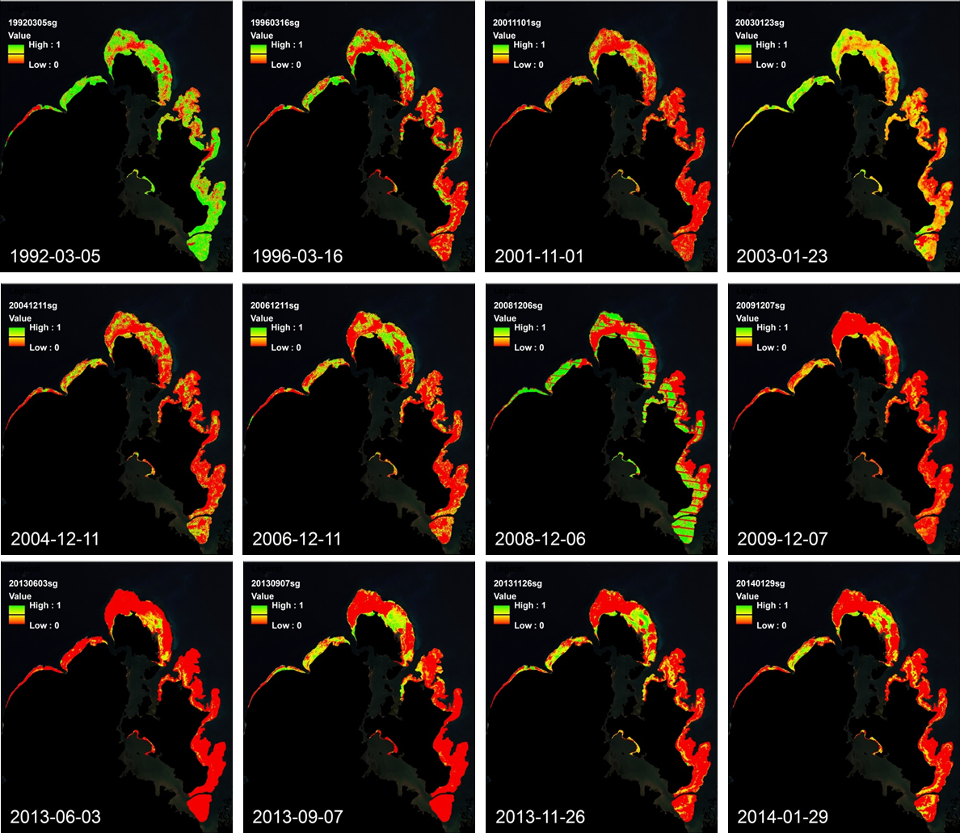
Figure 4. MTMF Fractional seagrass cover in the Bolinao-Anda area from 1992 to 2014. The last four images show the seasonal variation in seagrass cover.
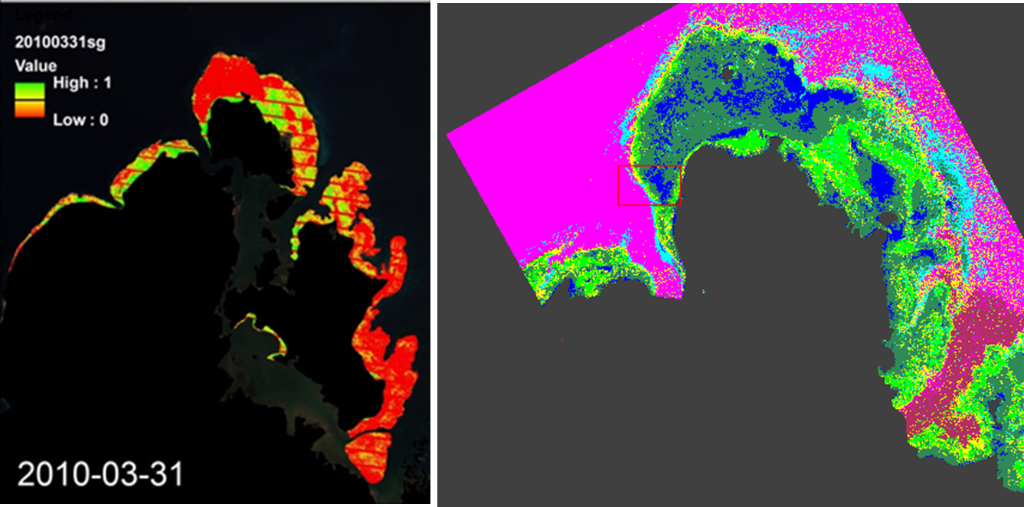
Figure 5. MTMF Fractional seagrass cover in March 2010 (left) and the benthic cover map (“dense seagrass” shown in light green) derived from a WorldView-2 image acquired in March 2010.

Zonal Analysis
Zonal analysis was performed to characterize seagrass changes in eight zones as shown in Figure 6. In 1992/1993, seagrasses, in varying densities, cover approximately 71.07 km2 – 30.78 km² in Bolinao and 40.29 km² in Anda. These have been reduced to 14.48 km² (Bolinao) and 8.15 km² (Anda) in 2013/2014. These figures represent the extent of seagrass cover with varying percent seagrass cover. To elucidate the impacts of seagrasses in terms of the extent considering density, the fractional cover of seagrass were summed for all pixels in a given zone to give the Equivalent Full Coverage Seagrass Area (EFCSA). In terms of EFCSA, seagrass full coverage was reduced from 52.92 km² in 1992/1993 to around 11.25 km² in 2013/2014. EFCSA has been reduced by 66% in Bolinao and 84% in Anda over the 20-year period. The pattern of seagrass changes indicated significant reduction in areas impacted by waters from the mariculture areas. This is evident in the northwestern part of Santiago Island, Bolinao. Seagrasses continue to thrive in areas not impacted by mariculture activities. Seagrasses in the eastern part of Anda Island were almost decimated.

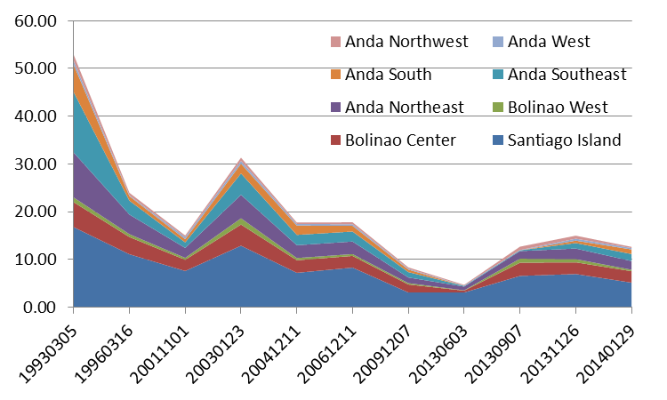

Figure 6. Equivalent Full Coverage Seagrass Area (EFCSA) in square kilometers from 1992 to 2014 evaluated for the eight zones shown in the inset map

CONCLUSION
The MTMF approach to seagrass mapping essentially captures the distribution of relatively dense seagrass areas when applied to Landsat images. Modifications in the calculation or addition of seagrass spectra may improve the estimation of fractional seagrass cover at lower densities. However, it is expected that relatively lower accuracies will be obtained for lower densities of seagrass due to the mixed pixel problem, that is, the spectral response of seagrass is masked by the response of more dominant benthic features or endmembers. Seagrass decline/loss is greatest in areas in close proximity to mariculture areas. This is exemplified by the northwest portion of the reef surrounding Santiago Island.

ACKNOWLEDGEMENT
The authors are thankful for the support of the University of the Philippines (UP) – Commission on Higher Education (CHED) Biodiversity and Resilience (BaR) Program, the Japan International Cooperation Agency (JICA) through the Coastal Ecosystem Conservation and Adaptive Management under Local and Global Environmental Impacts in the Philippines (CECAM) Project and the UP DOST Engineering Research and Development for Technology (ERDT) Program

REFERENCES
Ferwerda, J. G., Leeuw, J. d., Atzberger, C., & Vekerdy, Z. (2007). Satellite-based monitoring of tropical seagrass vegetation: current techniques and future developments. Hydrobiologia , 59-71.
Green, E. P., & Short, F. T. (2003). World Atlas of Seagrasses. London: UNEP-WCMC.
PNSC. (2004). Seagrasses of the Philippines: Country Report/ UNEP/GEF SCS Project: Reversing Environmental Degradation Trends in the South China Sea and Gulf of Thailand. Philippine National Seagrass Committee (PNSC) Publ. Philippines.
Short, F., & Wyllie-Echeverria, S. (1996). A Review of Natural and Human-induced Disturbance of Seagrasses. Environmental Conservation , 17-27.
World Bank (2005). Philippines Coastal & Marine Resources: An Introduction. (2005). Retrieved March 31, 2012, from World Bank Group: http://siteresources.worldbank.org/INTPHILIPPINES/Resources/PEM05-ch1.pdf

