Resolution and MTF Studies for Images of Optical Remote Sensing Satellite
Cynthia Liuª, Kuo-Hsien Hsu ^{b}, Jih-Run Tsai^{c}, Ho-Pen Chang^{d}
ª Senior Engineer, National Space Organization(NSPO),8F, 9, Prosperity 1st Road, Science-Based Industrial Park, Hsin-Chu, Taiwan; Tel: + 886-3-5784208 ext.1186, E-mail: cynthia@nspo.narl.org.tw
^{b} Associate Researcher, NSPO; Tel:+ 886-3-5784208 ext.1082, Email: khhsu@nspo.narl.org.tw
^{c} Research Fellow, NSPO; Tel: + 886-3-5784208 ext.9091;E-mail: jrtsai@nspo.narl.org.tw
^{d} Director of FORMOSAT-5 Program, NSPO; Tel: + 886-3-5784208 ext.1089;E-mail: hpchang@nspo.narl.org.tw

KEY WORDS: MTF (Modulation Transfer Function), FORMOSAT-5, Image Resolution
ABSTRACT: The high-resolution images obtained from sub-meter optical remote sensing satellites such as GeoEye, Worldview, and Pleiades are very welcome in the world image market due to their good image quality. The image quality metric for monochromatic imagery are usually related to the image spatial resolution and system Modulation Transfer Function when the system sensitivity and noise are not considered. Most imaging systems sensitive to NIR (near infrared) and visible light are detector-limited with the detector pixel size greater than diffraction-limited resolution (i.e., 1.22Fλ ; F = focal ratio and λ = wavelength). In other words, the optoelectronic instrument should be designed with appropriate values of focal ratio and detector size in order to get a good image quality with higher MTF and resolution (or cutoff spatial frequency). Statistic data of high resolution image records from FORMOSAT-2, SPOT series and Quick Bird are presented and FORMOSAT-5 simulated images for the quality demonstration are also analyzed in this study.

- INTRODUCTION
.
Technically speaking, the satellite spatial resolution of most optical remote sensing systems is described in terms of the system Modulation Transfer Function (MTF) and Ground Sampling Distance (GSD). The MTF is the ratio of output modulation to input modulation normalized to unity at zero frequency, which is a measure of how well a system will faithfully reproduce the input signal. The GSD is the projection of detector pitch onto the ground (i.e., the distance between two centers of neighboring detector pixels projected onto the ground), which is dependent upon the instrument detector design and the satellite altitude. The derived spatial resolution from GSD has to be examined and compared with the optical diffraction-limited resolution and MTF in order to justify the resolution.
A set of representing satellite system MTFs relative to image resolutions were statistically analyzed and a minimum MTF which stands for an acceptable image quality was identified.
The content of this work is organized in the following sections. The trend between spatial resolution and MTF from images of some representing commercial satellites is derived in Section 2. The imagery simulation method has been developed and a series of experiments using the well-known target of 1951 USAF test chart were conducted in Section 3. The spectral resolution was investigated from information content point of view and is shown in Section 4. Finally, the conclusion of this paper is described in Section 5.

- IMAGE RESOLUTION and MTF STATISTICS

Spatial resolution parameters of various existing satellites such as FORMOSAT-2, FORMOSAT-5, KOMPSAT-2, DubaiSat-2, SPOT-5, IKONOS, Pléiades, and SPOT-6/7 are compared and analyzed as shown in Table 1. The spatial resolution parameters include GSD, Modulation Transfer Function (MTF), imagery product resolution, and related satellite characteristics. Except for IKONOS, the resolution of satellite imagery is higher than or equal to their corresponding GSD obtained from imagery post-processing. The supermode scheme is developed and used by SPOT-5 to generate a single 2.5m-resolution panchromatic imagery by processing two 5m ones mainly through interpolation, de-convolution and noise removal steps. We qualitatively and quantitatively investigated the performance of spatial resolution by systematically evaluating the corresponding GSD, imagery resolution and MTF. The effort can help in designing an electro-optical imaging system when performing the trade analyses among a few design parameters such as aperture size, effective focal length, detector size, spectrum coverage, etc., in the beginning of the design phase.
Table1. Spatial resolution parameters and satellite characteristics
 | Ground Sampling Distance(GSD)  Panchromatic/multispectral band |  | Detector Pixel size  (um) | MTF spec | MTF estimation |  | Altitude | Imagery Product Resolution
FORMOSAT-2  FORMOSAT-5  KOMPSAT-2 | 2m/8m  2m/4m  1m/4m |  | 6.5/26  10/20 | 0.094  0.078  0.08/0.12 |  | 0.12  0.078 | 891 km  720 km  685km | 2m/8m  2m/4m  1m/4m
DubaiSat-2 | 1m |  | 9.5 | 0.07 |  |  | 600km | 1m
SPOT-5 | 5m |  |  | 0.23 | 0.3(with telescope improvement) |  | 832km | 5m
SPOT-5 (super mode) | 2.5m |  |  | 0.09 | 0.15(with telescope improvement) |  | 832km | 2.5m
IKONOS | Pan: 82 cm (nadir) to 100 cm (26° off-nadir)  MS: 3.2 m (nadir) to 4.0 m (26° off-nadir) |  |  | 0.1 |  |  | 682km | 1 m
Pléiades | 0.7m/2.44 m |  |  | 0.08 | 0.15 |  | 694km | 0.5m
QuickBird  SPOT-6/7  Cartosat-1 |  | 0.61m  2m  2.5m |  | 0.19  0.1  0.17 | X-trk: 0.26, ALT: 0.10  0.15 |  | 450km  694km  617.99km | 0.61m  1.5m  2.5m

According to Table 1, the specification MTF of panchromatic band of the listed satellites against the corresponding GSD is depicted in Figure 1. In general, one sees the higher MTF specification is associated with coarse resolution. However, the trend for the 1~ 2m is not clear. In other word, the smallest MTF value for one or two meter resolution is about the same. Figure 1 indicates that the minimum MTF of 0.07 is an acceptable criteria to claim for good image quality of up to one meter resolution.

Figure 1. Specification MTF of panchromatic band against the corresponding GSD.
- IMAGERY SIMULATION APPROACH

This section qualitatively and quantitatively examines the performance of the imagery spatial resolution by not only manually inspecting the simulated imagery, but also analyzing the corresponding MTF. Our analysis will emphasize on the MTF of optical portion instead of the whole remote sensing system. Therefore, we develop an incoherent imagery simulation method based on the block diagram of an incoherent linear shift invariant imaging systems as shown in Figure 2. The main concept proposed in figure 2 is that: Firstly, the magnitude of the electric field (or irradiance) at the imaging plane of a system can be defined as the convolution of the electric field (or irradiance) on the object plane and the free space impulse response (or Point Spread Function). This definition can be generally expressed as
Secondly, taking the fast Fourier transform (FFT) of to obtain . Thirdly, incoherent simulation imagery can be obtained by taking the inverse Fourier transform of .
Figure 2. Block diagram for an incoherent linear shift invariant imaging system [Goodman, Joseph W, 2009]
The experiment was conducted by simulating the well-known target of 1951 USAF Test Chart as shown in Figure 3. And, the Point Spread Function (PSF) for convolution operation uses the values from FORMOSAT-5 optical system. The real imagery of Figure 3 acquired from FORMOSAT-5 telescope during I&T activity is provided in Figure 4.
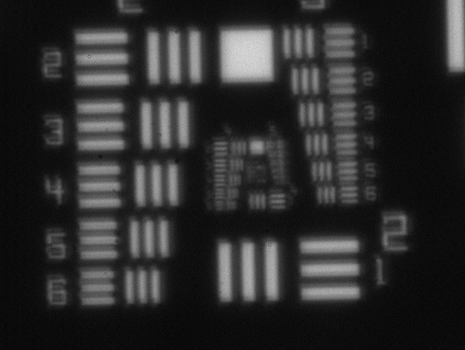
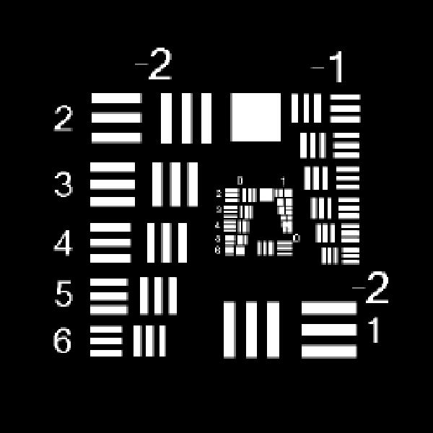

Figure 3. The 1951 USAF test chart Figure 4. The test chart image acquired from FORMOSAT-5 telescope system
  - Mathematical Formulations by Fourier Transform
The linear, space invariant model for imaging of the incoherent illumination of an object is expressed as Eq. (1):
(1)
where u and v are the image plane spatial coordinates;εis the central obscuration ratio of Cassegrain type telescope. h is the coherent impulse response; I_{g} is the ideal or target geometric irradiance image; I_{i} is the incoherent imaging; and a*b means the convolution of functions a and b. The impulse response in the optics subsystem is commonly known as the Point Spread Function (PSF) and given by Eq. (2)
(2)
By taking Fourier Transform of Eq. (1), we have
(3)
Or (4)
where FT(a) represents the Fourier Transform of function a; G_{i} , H² , and G_{g} are the Fourier transforms of I_{i}, , and I_{g}, respectively; f_{u} and f_{v} are the spatial frequency coordinates corresponding to space coordinates u and v. is known as the Optical Transfer Function (OTF), which is defined as a normalization of shown in Eq. (5):

(5)
The normalization amounts to scaling the OTF to have a value of unity at the DC frequency, i.e., (f_{u}, f_{v} )= (0,0), Then the MTF can be obtained as the modulus(positive real part) of the OTF from Eq.(5)
  - Experimental Results
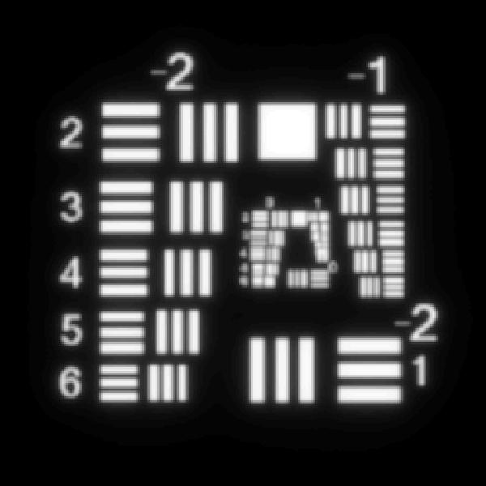
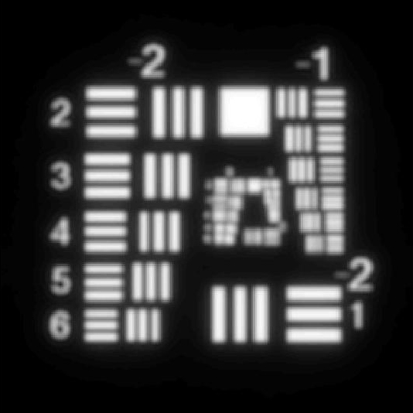
The Point Spread Function for convolution operation uses parameters from FORMOSAT-5 optical system F#=8, and central obscuration (ε = 0.52); the results of central obscured diffraction-limited image (without considering aberrations and assembling degradation) for 1951 USAF Test Chart is shown in Figure 5. The resulting test charts are blurred (compared with the ideal image in Figure 3) and certain part of the three-bar groups is not resolved properly. Figure 6 shows the test image from real FORMOSAT-5 optical system in I&T phase. The bars in red rectangle (group 2) represent the spatial frequency of around 50 lp/mm, which is the Nyquest frequency (note that the FS5 cutoff frequency is 217 lp/mm relative to panchromatic central frequency 575 nm). That means the resolution of FORMOSAT-5 test image, compared with the simulated one, looks better. In other words, the simulation performed so far is too conservative. Therefore, we adjusted the PSF by lessening its obscuration to make the simulation become more realistic, and the result is shown in Figure 6. From the simulation result after adjustment, the spatial frequency of around 100 lp/mm marked in Figure 6 as green rectangle, which means it is resolved and distinguishable within 2 meters.

Figure 5. Simulated FORMOSAT-5 central obscuration image Figure 6. Simulated FORMOSAT-5 central obscuration image with adjustment
- IMAGE INFORMATION CONTENT, EFFECTIVE GROUND SAMPLING DISTANCE and RESOLUTION

The information content standing for how much information embedded in the map belongs to the scope of GIS (Geographic Information System), which mainly is applied for the photo mapping. The information theoretic perspectives provide the important metrics to quantitatively describe the remote sensing image. The image content mainly depends upon the resolution, the radiometric quality and the spectral information. Figure 7 shows the relationship between the information content and image resolution [K. Jacobsen, etc, 1999]
Similar to MTF, information content somewhat also indicates the image resolution. For example, SPOT-5 super-mode image by interpolating dual bands can be claimed for a resolution of 2.5m, doubling the original single band resolution of 5m. However, checking the information content by data volume, super-mode image resolution falls to around 3.5m, which equals to 2.5m times$\sqrt{2}$.
SPOT MS(20m)
SPOT PAN(10m)
KFA 1000(10m)

KVR 1000(2m)
IRS-1C PAN(5.8m)
High altitude photo 1:120000(Aerial photo)

Figure 7. Information content comparison between satellite images with different resolutions
The information content is important when evaluating the scale transformation from map to image. To make the evaluation simple, some researchers just correlate the information content with the effective GSD. As described earlier, GSD is the distance between the centers of neighboring pixels projected onto the ground. The pixel size on the ground is the physical size of the projected pixels. Neighboring pixels may be over-sampled (the projected pixels are overlapping) or under-sampled (there is a gap between neighboring pixels). The user will not see something about over- or under-sampling, but it is only influencing the image contrast. For the user the GSD looks like the pixel size on the ground.

Digitized photos may have differences between the nominal and the effective GSD. The effective GSD can be analyzed by the edge detection, and the MTF is an indicator for the sharpness of the edges during imaging. An object with a sudden change of the grey values will not have the same sudden change in the image. Table 2 gives examples for images with the same or different nominal and effective GSDs.
Table 2. effective GSD determined by edge detection [H. Topan, 2009]
GSD | TK350 | KVR1000 | ASTER | KOMPSAT-1 | IRS-1C | SPOT 5 | IKONOS | QuickBird
nominal | 10m | 1.6m | 15m | 6.6m | 5.7m | 5m | 1m | 0.6m
effective | 13m | 2.2m | 15m | 6.6m | 6.9m | 5m | 1m | 0.6m

- CONCLUSION

In this paper, image resolution of several existing optical remote sensing satellites was investigated by comparing their image quality MTF and information content. This investigation has shown that minimum MTF criteria of 0.07 for the optical remote sensing satellites can justify the quality of up-to one-meter image resolution. Image simulations to inspect the resolution at specific spatial frequency have also been demonstrated. Better system MTF can always be obtained at a higher cost through using larger mirror, better optical design and workmanship, improving on-orbit de-focuring effect, and improving satellite control error & jitter effect etc. The future work can be aimed in making image simulation at system level and more qualitatively.
References
[1]. Jih-Run Tsai, “Resolution Metric of Imaging System Determined by MTF,” NSPO Research Report (Doc. #: MD-RPT-0025).
[2]. Jih-Run Tsai, “Image Simulation with Central Obscuration and Zernike Aberrations by Fourier Transform,” NSPO Research Report (Doc. #: MD-RPT-0024).
[3]. Goodman, Joseph W., Spring 2009. Spatially incoherent imaging, 2.71 / 2.710 Optics, from http://ocw.mit.edu.
[4]. H. Topan, G. Büyüksalih & K. Jacobsen, 2009, Information Contents of High Resolution Satellite Images.
[5]. K. Jacobsen, G. Konecny, H. Wegmann, 1999, High Resolution Sensor Test Comparison with SPOT, KFA1000, KVR1000,IRS-1C and DPA in Lower Saxony

