Phenology-based classification of major crops areas in Central Luzon, Philippines from 2001-2013

Daniel Marc G. dela Torre and Gay Jane P. Perez, Ph.D.
Institute of Environmental Science and Meteorology
University of the Philippines, Diliman, Quezon City, Philippines 1101
Email: delatorredm@gmail.com

KEY WORDS: time-series MODIS NDVI, machine learning classification, agriculture, crop area mapping

ABSTRACT: Annual crops such as rice, corn and sugarcane are the major source of livelihood for a third of the Philippine population. In view of a changing climate and increasing demand for food, information on the spatial extent and distribution of these crops are important for farmers and policymakers alike. This paper will present a method developed to map crop areas in the Central Luzon Region of the Philippines using time-series Normalized Difference Vegetation Index (NDVI) maps calculated from the MODIS 8-day surface reflectance product in 250-m resolution (MOD09Q1) from 2001-2013. Reference points for classifier training and subsequent accuracy assessment were obtained using a 2003 Land Use System map. Phenology or the seasonality of the vegetation was extracted from the training points. The algorithm applied a filter to smoothen the time-series NDVI and removed spikes and outliers. The processed dataset was then used to extract seasonality parameters including start of season, end of season, peak of season, and length of growing season. A supervised classification scheme using the phenological parameters as inputs was implemented using an artificial neural network trained using resilient backpropagation. Annual maps were produced using the algorithm to reflect the changing crop between years. Accuracy assessment yielded 55.9% and 0.56 overall accuracy and kappa statistic, respectively.

INTRODUCTION

Mapping agricultural land is important for farmers and policy makers in view of the variability of climate and increasing demand for food. Croplands are also increasingly converted to residential and other land uses (Malaque & Yokohari, 2007). With this, it is necessary that frequent monitoring of the extent of farmland be performed especially for staple crops such as rice and corn. However, it is costly and impractical to employ traditional ground-based mapping.

Satellite remote sensing, with its frequent revisit times and large spatial coverage, has proven to be a valuable tool and complement to conventional methods. Many sensors have been acquiring data for a significant time period hence interannual maps may be produced from the archive. Phenology has been a useful characteristic in producing land cover maps. Using the Normalized Difference Vegetation Index (NDVI), the greenness of the surface may be observed for a time period and each crop’s development has unique timing and development. Many studies have used NDVI observed from NASA’s Moderate Resolution Imaging Spectroradiometer (MODIS) to produce maps for a variety of land use and land cover applications ranging from forests of Europe (Clerici et al., 2012) to Hebei Plain croplands (Zhang, 2011) to paddy rice fields of the Mekong Delta, Vietnam (Son et al., 2013).

The objective of this study is to map annual crop area using NDVI time-series information and neural network algorithms for rice, corn and sugarcane in the Central Luzon Region of the Philippines from 2001 to 2013. The estimates will be compared with the crop area harvested from the Philippine Statistics Authority - Bureau of Agricultural Statistics (BAS).

DATA AND METHODOLOGY

Study Area

Central Luzon Region or Region III is located in the largest island in the Philippine archipelago and is comprised of seven provinces namely Aurora, Bataan, Bulacan, Nueva Ecija, Pampanga, Tarlac, and Zambales. It has a population of over 10 million and agriculture is the primary industry for its populace, the region being the top producer of rice in the country and second in maize production. It also has a large area in Tarlac for sugarcane. It has a variable topography, containing the largest plain and also mountain ranges such as the Sierra Madre and Caraballos and volcanoes such as Mt. Pinatubo. The climate is predominantly a Type I according to the Coronas Climate Classification scheme, with a dry season from November to May and predominantly wet throughout. Maximum rainfall occurs from June to October (DENR, 2013). The eastern strip of the region, particularly in Aurora, experiences rainfall more or less evenly distributed throughout the year.

Satellite Data

Surface reflectance measurements were obtained from a product of MODIS. The specific product is an 8-day composite, nominal 250 m resolution product (MOD09Q1) and was downloaded from the Land Processes Distributed Active Archive Center (LP DAAC), url: https://lpdaac.usgs.gov/data_access/data_pool. The data were distributed, in Hierarchical Data Format (HDF), as sinusoidal tiles and the specific tile coordinate for the study area was h29v07, covering most of the Luzon area. Using the MODIS Reprojection the HDF files were subset to the study area (Upper Left Corner: 16.51°N, 119.77°E; Lower Right Corner: 14.37°N, 122.29°E) and reprojected to the Universal Transverse Mercator projection, WGS-84 datum and pixels were resampled to 250 m using bilinear interpolation. The MOD44W product was used to mask out the water bodies from land areas. It is an improved land-water mask created from MODIS composite data and Shuttle Radar Topography Mission (SRTM) Water Body Dataset (SWBD) and has a spatial resolution of 250 m.

Ancillary Information

The Philippines Land Use System (PhilLUS) map was produced from the Land Degradation Assessment project jointly implemented by the Food and Agriculture Organization and the Department of Agriculture Bureau of Soils and Water Management. It was based on the 2003 national land cover map produced by the National Mapping and Resource Information Authority (NAMRIA). For comparison of the classified images, area harvested for each crop was obtained from CountrySTAT of the Philippine Statistics Authority-Bureau of Agricultural Statistics (2014).

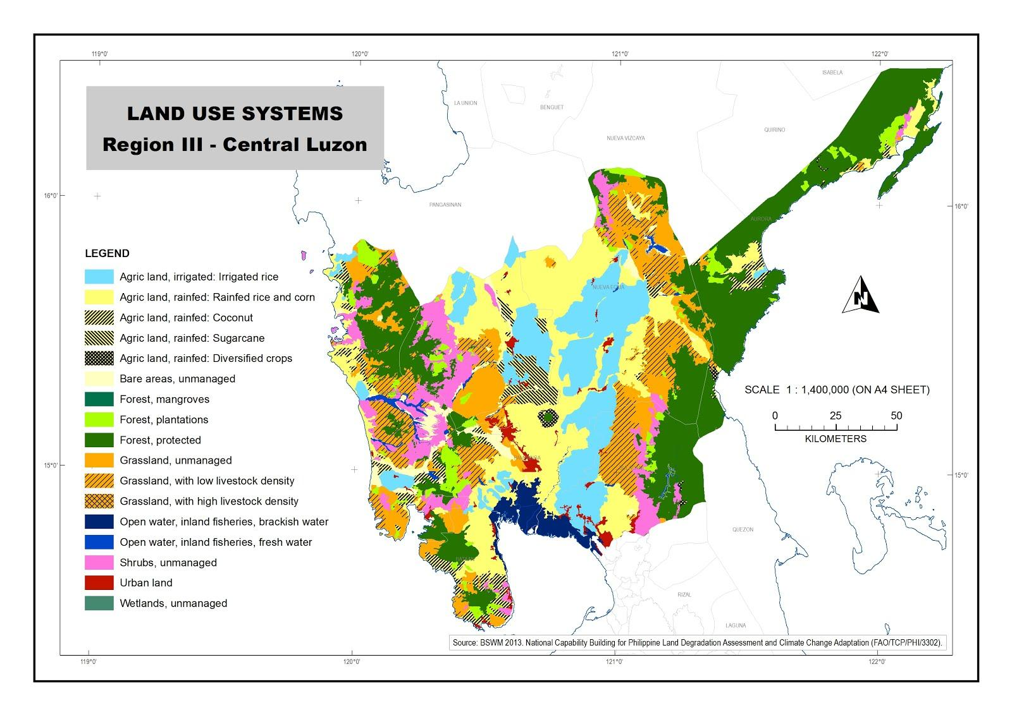
Figure 1. Land use system map of Central Luzon (BSWM, 2013).

Data Pre-processing

After spatially subsetting and reprojection of all the data, the quality control band was applied to only include the highest quality of data free from clouds and from atmospheric contamination. Band 1 and band 2, with wavelengths of 620-670 nm and 841-876 nm respectively, of the surface reflectance product was used to compute for the Normalized Vegetation Difference Index (NDVI) using the formula:

Band 2 - Band 1 / Band 2 + Band 1 = NDVI (1)

NDVI is a measure of greenness and is an indicator of surface characteristics. The values can range from -1 to 1. Typically, values less than 0 are water while bare soil or impervious areas range from 0 to 0.1. Healthy vegetation have values greater than 0.1. Then, a yearly stack of images were produced (~598 scenes or 46 scenes per year) in preparation for time-series analysis and classification.

An inherent problem with the data is the persistence of cloud contamination and other artifacts resulting into noisy signals. To remedy this, the Harmonic Analysis of Time Series or HANTS developed by Roerink et al. (2000) was applied to the data. HANTS uses the Fast Fourier Transform (FFT) in an iterative manner. First, it obtains the mean, yearly and half-yearly frequencies of the data and then applies an inverse FFT to reconstruct a filtered time-series. The data is then compared with the original and if any of the data remains below a user-defined threshold, the original values are replaced with the filtered time-series. This method is performed repeatedly until no more “cloud contaminated” pixels remain. The end product of the algorithm is a smoothened time-series.

Two masks were produced from the HANTS-filtered data, a permanent water mask and urban mask. The water mask included pixels with a mean of 0.7 and a standard deviation of 0.1 when the urban mask had pixels with a mean of 0.3 and standard deviation of 0.1. Each year had a unique mask. Finally, these masks were applied to each scene.

Neural Network Implementation

A neural net was trained using training points selected from the BSWM Land Use System map of 2003. 250 random points in the map were selected for three classes: (a) irrigated rice, (b) rainfed rice and corn and (c) sugarcane. These were then transformed from geographic coordinates to pixel locations of the data. Next, the time-series for each location was extracted from the 2003 NDVI stack and was input into the classifier. The data for each class was divided randomly into 70% training, 15% validation and 15% testing points. The network was trained using resilient backpropagation and the single hidden layer had 42 neurons activated by a logistic function. The resulting neural network was then applied to the whole dataset.

Accuracy Assessment and Comparison with Agricultural Statistics

GIS software was used to analyze the number of pixels per class for each province in the region. For accuracy assessment, random points were generated from the 2003 map and then compared with the BSWM land use map. The crop area from the classified images were also compared with the crop area statistics of the PSA-BAS.

RESULTS AND DISCUSSION

Figure 2. The crop area maps for irrigated rice, rainfed rice and corn, and sugarcane in Central Luzon for 2003.

Thirteen maps were created using the method described above, showing the annual changes throughout the years. Figure 2 shows the crop area map for the region in 2003. Most of the area devoted to temporary crops are irrigated rice, especially in Nueva Ecija, which has a well-developed irrigation system and is the country’s top rice producer. Significant areas also include eastern Pampanga and southwestern Bulacan. Irrigation is well developed in this area, supplied from the Pantabangan Dam and also extensive river systems flows through the plain. There are also large areas dedicated to sugarcane in eastern Tarlac. Most of the rainfed areas are scattered along the fringes of the irrigated areas and in coastal regions in Zambales and Bataan.

Table 1. Error matrix for the 2003 classified map and BSWM LUS reference map.
 |  | REFERENCE
 |  | Irrigated Rice | Rainfed Rice and Corn | Sugarcane | Total
CLASSIFIED | Irrigated Rice | 118 | 30 | 27 | 175
 | Rainfed Rice and Corn | 77 | 133 | 64 | 274
 | Sugarcane | 7 | 3 | 13 | 23
 | Total | 202 | 166 | 104 | 472

Table 2. Accuracy assessment statistics for the 2003 classified map and BSWM LUS reference map.
Overall Accuracy | 55.93 %
Producer’s Accuracy |  | User’s Accuracy
Irrigated Rice | 58.42 % | Irrigated Rice | 67.43 %
Rainfed Rice and Corn | 80.12 % | Rainfed Rice and Corn | 48.54 %
Sugarcane | 12.5 % | Sugarcane | 56.52 %
Kappa Statistic | 0.56

The accuracy assessment yielded (Table 1 and Table 2) an overall accuracy and kappa statistic of 55.93 % and 0.56 respectively. The moderate agreement between the classified map and the reference map may be due to the division of classes and also the training data. It may be improved using a more natural scheme such as single-cropping rice, double-cropping rice, corn and sugarcane. This may be accomplished using in situ data and through visual interpretation of high-resolution images instead of a land use schema.

(a)
(b)
(c)
Figure 3. The changes in crop area from 2001 to 2013 for (a) Irrigated rice, (b) rainfed rice and corn and (c) sugarcane.

Figure 3 shows the area of each class as compared with the statistics from BAS. Generally, there is good agreement of irrigated rice with the ground data albeit usually underestimated and it reflects the upward trend of the area. Rainfed rice and corn area is mostly overestimated and sugarcane is consistently overestimated as well. These show that some of the areas that may have belonged to the irrigated rice class may have been misclassified to the other two classes. Since sugarcane has the least area in the reference data, the classifier may have a lower power to generalize the trends of the class.

CONCLUSIONS
The methods shown above is an initial and experimental attempt to produce crop area classification map. The maps produced had a moderate accuracy. However, this may be further improved using in situ data of crop locations, interpretation of high-resolution imagery and other ancillary information. Also, further improvements to the masking method of the non-crop classes, such as forests, permanent water, impervious surfaces, etc., may also yield much better accuracies. The three classes should also be reformed to exclude the land use scheme and focus more on a biophysical basis. The initial results show that the method is promising once the appropriate classes and training set will be incorporated.

ACKNOWLEDGEMENTS
This study was made possible through the support of the Department of Science and Technology Science Education Institute and Department of Agriculture Bureau of Soils and Water Management.

REFERENCES
Department of Agriculture – Bureau of Soils and Water Management. 2013. Land degradation in the Philippines. 178 pp.
Clerici, N., Weissteiner, C.J., and Gerard, F. 2012. Exploring the use of MODIS NDVI-based phenology indicators for classifying forest general habitat categories. Remote Sensing 4, pp. 1781-1803.
DENR Region 3. 2014. Regional Profile, Retrieved August 31, 2014, from http://r3.denr.gov.ph/index.php/about-us/regional-profile
Malaque III, I.R. and Yokohari, M. 2007. Urbanization process and the changing agricultural landscape pattern in the urban fringe of Metro Manila, Philippines. Environment and Urbanization 19(1), pp. 191-206.
Philippine Statistics Authority – Bureau of Agricultural Statistics. 2014. CountrySTAT, Retrieved August 25, 2014, from http://www.bas.da.gov.ph
Roerink, G.J., Menenti, M., and Verhoef, W. 2000. Reconstructing cloudfree NDVI composites using Fourier analysis of time series. International Journal of Remote Sensing 21(9), pp. 1911-1917.
Son, N.T., Chen, C.F., Chen, C.R., Duc, H.N. and Chang, L.Y. 2013. A phenology-based classification of time-series MODIS data for rice crop monitoring in Mekong Delta, Vietnam. Remote Sensing, 6(1), pp. 135–156. doi:10.3390/rs6010135
Vermote, E.F. and Vermeulen, A. 1999. Atmospheric correction algorithm: spectral reflectances (MOD09), National Aeronautics and Space Administration.
Zhang, S., Lei, Y., Wang, L., Li, H., & Zhao, H. 2011. Crop classification using MODIS NDVI data denoised by wavelet: A case study in Hebei Plain, China. Chinese Geographical Science, 21(3), pp. 322–333. doi:10.1007/s11769-011-0472-2

