Using of GIS software for Mapping the Climatic Data Obtaining by Internet Network
Sabah Hussein Ali
University of Mosul
Remote Sensing Center
e-mail:sabah196004@yahoo.com
Abstract:
Nowadays, the long-term climatic data that supplied by the famous internet website plays important role in analyzing and mapping of various climatic features ( Temperature, Precipitation, Solar radiation … etc.). Precipitation is one of the important elements in agriculture and is a major area in climatological studies. Studying about precipitation is important in identifying precipitation characteristics; temporal and spatial variability.
In the present study, extract for each (0.5*0.5) degree grid cell of the monthly precipitation data for year 2010 (with January as first and December as last month) using the GPCC Visualizer website was applied. Kriging interpolation method within the environment of ArcGIS9.3.1, the average monthly and seasonal precipitation maps were generated. The study revealed the possibility to use the more popular websites sources of historical climate datasets to compensate for the lack of climate data available from the meteorological stations in Iraq, which is often difficult to obtained.

Keyword: Precipitation, GIS, Kriging interpolation, GPCC, Iraq.

- Introduction
Weather plays a critical role in eco-environmental and agricultural systems. Limited availability of meteorological records often constrains the applications of simulation models and related decision support tools. The demand for spatial data sets of weather and climatic information elements in digital form has become very important for the international organizations that interest in the global climatic change. This demand has been supported by the progressing of computer technology enabling a variety of agricultural, hydrological, ecological, geological and natural resource models and expert systems to be linked to geographic information systems (GIS) [ 1 ]. Most of these data include quality controlled daily, monthly, seasonal, and yearly measurements of temperature, precipitation, wind, and degree days as well as radar data and 30-year Climate Normal’s [2, 3]. The ability to better determine the weather conditions at specific locations by the geographical coordinates and their impact on the populations, environment and infrastructures in those areas have improved dramatically through the efforts of the climatic websites. These websites are considered as an important sources of climate data, which is difficult to obtain from the Meteorological stations distributed for example in Iraq, which required exorbitant amount to get it. These sites also often adopted by the international centers, for example, the International Center for Agriculture preservatives in dry areas (ICARAD) in mapping a various climatic elements, as well as a main material in the design of a lot of scenarios for suitability agricultural through a special climatic software [4]. The free download of the climatic data from these websites gives a opportunity to evaluate weather data in significant ways that could help researchers to predict the future climate conditions. In addition, can provide the quantitatively data with high temporal or spatial resolution. Also, Mapping longer-term dataset of precipitation allows an appraisal of how the average climate is actually changing.
In this paper, we will give an outline of the integration between a long-term precipitation data from a well-known climatic website and the GIS application tools that used for modeling and mapping the spatial climatic dataset of precipitation in Iraq at 2010.
- Study Area
The Study area is Iraq, a country located in south-western Asia. It lies in the western part of Asia and occupies mostly the Mesopotamian Plain, located between 29 ⁰ and 38⁰ N latitudes, 39⁰ and 49⁰E longitudes ( small area lies west of 39⁰). Iraq borders Turkey to the north, Syria to the northwest, Kuwait and Saudi Arabia to the south, Iran to the east, and Jordan to the west as shown in figure (1). Iraq divided into four major regions: highlands in north and northeast; alluvial plain in the central and southeast sections; desert in west and southeast sections; and rolling upland between upper Euphrates and Tigris rivers. The north of the country is mostly composed of mountains; the highest point being at 3611m. Iraq also has a narrow section of coastline measuring 58 km on the northern Arab Gulf.

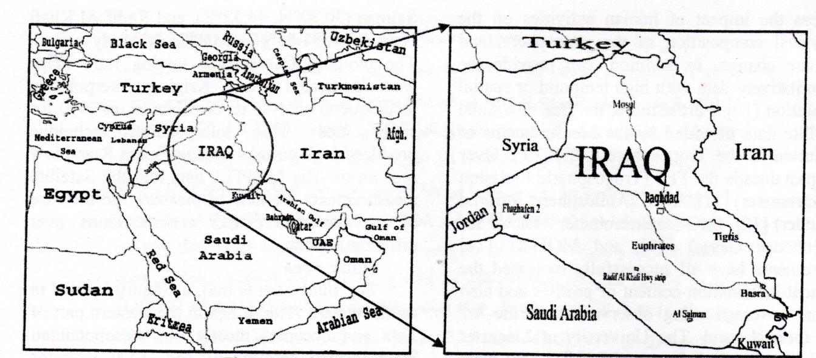

Figure (1): The geographical features of the study area

Most of Iraq has a hot and arid climate with subtropical influence. Typically precipitation is low, the maximum rainfall occurs during the winter months. The northern mountainous regions have cold winter with occasional heavy snows, sometime causing extensive flooding[ 5 ] .
- Weather Stations
Historical climate data that is geospatially explicit is a necessity for many modeling process, especially on a regional scale. For example, crop simulation models typically require large amounts of climatic input data, including maximum and minimum temperature, precipitation, and solar radiation at a daily time step [ 6 ]. These climatic dataset can be provided by few publically available sources include weather station data, interpolated grids based on station data, and satellite derived data.
The methodology applied in the present study depend on the historical climatic data that given by the weather stations through the internet websites. The following provides some websites of the more popular sources of historical climate datasets:

- NCDC
One of the most well known sources of regional weather station data comes from National Climatic Data Center (NCDC) sector of the National Oceanic and Atmospheric Administration (NOAA). Daily observations of temperature, precipitation, winds, pressure, snow, and others can be found for over 15,000 stations worldwide [ 7 ].
- FAOCLIM 2.0
FAOClim 2.0 is a global agroclimatic database containing data from almost 32,000 stations for up to 14 observed and computed agroclimatic parameters. The database includes both long-term averages and time series for rainfall and temperatures. The database is linked to real-time daily meteorological data flow and allows users to browse and retrieve basic data. The user can select data by geographic area, time period and parameter and can export and visualize the information in map and graph form [8].
- WorldClim
It’s a very high resolution dataset which has been developed at an even high resolution for the entire globe, excluding Antarctica. WorldClim contains global estimates of monthly mean, maximum, and minimum temperature and precipitation at a 1-km resolution[9].
- GPCC
The Global Precipitation Climatology Centre (GPCC) provides global precipitation analyses for monitoring and research of the earth's climate. The centre is a German contribution to the World Climate Research Programme (WCRP) and to the Global Climate Observing System (GCOS) [10]. The GPCC provides gridded gauge-analysis products derived from quality controlled station data. the GPCC provides estimates for that error as well as the number of gauges used on the grid.

- Methodology
  - Database:
The historical climatic applied in the present paper have been taken from the internet website for the GPCC of the German Weather Service through the GPCC VISUALIZER [11]. The available data from this website is consists of global grids of monthly precipitation at different period (January1901- December 2010) and resolution( 0.5⁰, 1⁰, 2.5⁰).The GPCC VISUALIZER based on the data of more precipitation stations (up to 45,000 globally) than any other gridded precipitation data set as well as that the dataset does not contain gaps in the record and that all station data have been thoroughly quality-controlled[12].
  - Data extraction and transformation:
All data applied in the present study are related to monthly averages precipitation for the year 2010 as a case study. The main source of the data is the GPCC Visualizer website shown in figure (2). The Extract dataset of the precipitation were selected from the land surface Full Data Product of version 6 mode at the spatial grid resolution of 0.5⁰ latitude x 0.5⁰ longitude (approximately 55.5x55.5 km²) for every month and seasons of the year 2010. Generally, GPCC Visualizer gives the feasibility to global spatial coverage of longitude (-180 to 180 degree) and latitude (-90 to 90 degree) and the output dataset either in ASCII file or ArcView grid. These type of output data can be easily analysis and processing by the ArcGIS desktop software to create the climatic maps. ArcGIS9.3.1 was used for the extracting and mapping of the required precipitation data, as well as the related subsequent processing.
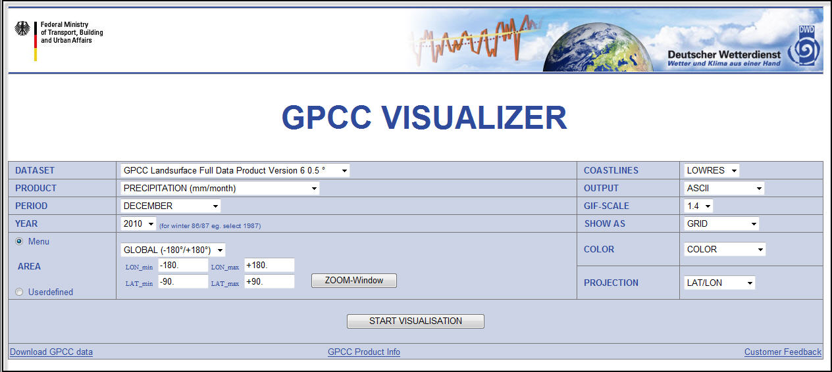
Figure(2): GPCC VISUALIZER screenshot
For Iraq, the spatial coverage of the entire area is defined with the geographical coordinate system (GCS) of 29-38 N; 39-49 E. Therefore, the extraction of the precipitation data in ASCII grid format have been done within the defined geographical boundary. The ASCII files converted to Excel file with the geographical coordinate of each points as shown in figure (3).

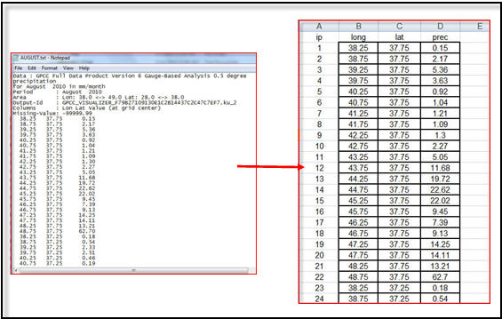

Figure(3): Converted of ASCII file to Excel file
The geodetic system of all dataset adopted in the study are defined as GCS_WGS_1984. The Excel file for each month are then add to ArcGIS9.3.1 and converted to point vector layers (shapefiles) for required interpolation processing. The average monthly and seasonal precipitation maps were generated using kriging algorithm technique. Generally, the interpolation is defined as the estimation of a variable at an unmeasured location from observed values at surrounding locations. Kriging algorithm technique is a geostatistical interpolation method that provides estimates at unsampled points based on the surrounding data collected at precise location as done in the present study. A kriged estimate is a weighted linear combination of the known sample values around the point to be estimated[13]. Also, a unique feature of Kriging is that it provides an estimation of the error at each interpolated point, providing a measure of confidence in the modeled surface. Therefore, the accuracy of the graduated colors in resulted precipitation maps form the downloading grid cell of (0.5 * 0.5 degree) shown in figure (4) below will be more than those data depending on a randomly and limited number of meteorological stations as shown in figure (5).
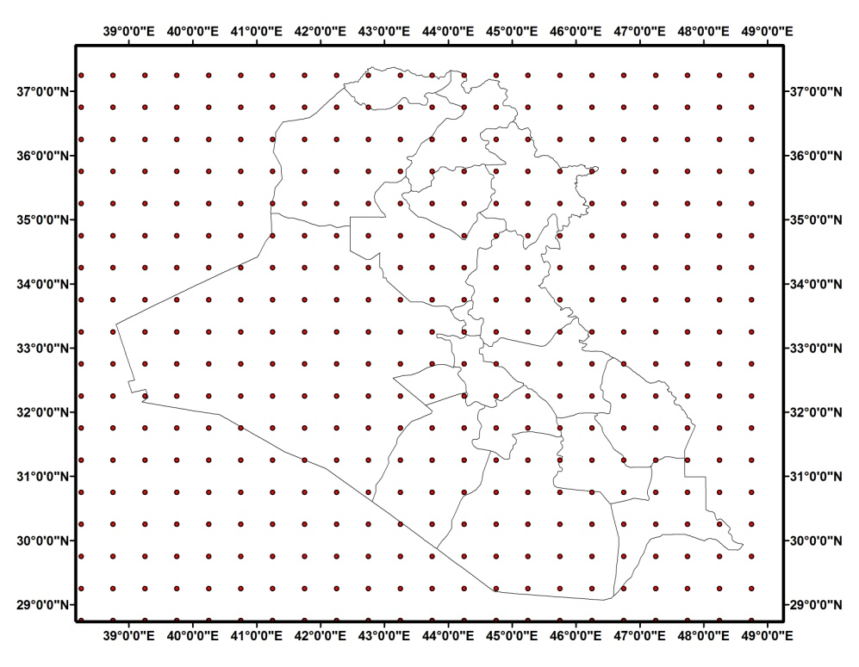

Figure (4): The arranged downloading grid cells

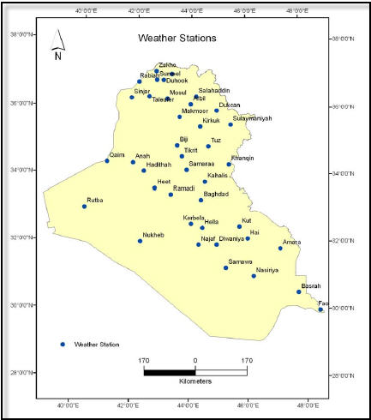

Figure (5): The meteorological stations in Iraq [14]
- Results and Discussion
12 monthly text files and 4 seasonal text files of the precipitation for Iraq boundary were downloaded from GPCC VISUALIZER website for one year from January to December 2010. The seasonal periods were define as winter (Dec., Jan., Feb.: DJF), Spring (March, April, May: MAM), Summer (June, July, Aug.: JJA) and Autumn (Sept., Oct., Nov.: SON). Table (1) gives an overview of the lower and upper range values ​​of the monthly and seasonal precipitation at 2010. The spatial and temporal variation of the monthly precipitation are shown in figure( 6 and 7) below. The figures shows that the majority of the precipitation occurs from December through April and is more abundant in the mountainous region (north and east of Iraq), this result was coincides with the precipitation data readout that taken from the meteorological stations distributed in Iraq and often represents one of the main climatic features as given by ref.[15].
Precipitation and altitude variation are the two main factors influencing the climatic variations in Iraq, as it notes from the figures (6 and 7) and table (1), the increasing of the precipitation in northern and northeast was due to the existence the Zagros Mountains that extend up to 3000 meters in Iraq and form a natural border between the northeast region of Iraq and western Iran and the Taurus Mountains that form the border between northern Iraq and southern Turkey. The middle and southern regions are characterized as an arid or desert with no topographic variation, the precipitation was decrease due to the impact of Arabian Gulf climates on the regions.

Table (1): The average monthly and seasonal precipitation
Months and Seasons | Average range of  monthly and seasonal precipitation(mm)
January | 3.54-127.26
February | 15.79-175.11
March | 0.47-145.19
April | 0.84-139.58
May | 0.75-90.19
June | 0.65-9.45
July | 0.02-1.79
August | 0.67-15.25
September | 0.02-2.34
October | 0.5-41.40
November | 0.1-38.94
December | 7.34-117.99
Winter | 10.14-136.23
Spring | 0.78-121.48
Summer | 0.40-8.41
Autumn | 0.6-43.50

The seasonal precipitation also shows that the north and northeast of Iraq usually receive higher amount of precipitation than the south as illustrates in figure (8). The increasing in the precipitation occurs almost in winter, autumn, spring and disappears in summer. This result was coincides with the seasonal precipitation data readout that taken from the meteorological stations distributed in Iraq by ref.[14]. Generally, the monthly and seasonal precipitation in Iraq shows much spatial and temporal variability. Across locations and time the amounts of precipitation that can be expected are not constant ( especially in the last years) and, within bounds determined by the 'average' climate, they fluctuate randomly. Figures (9 and 10) illustrates the monthly and seasonal variation of the precipitation at 2010, respectively. It notes, that the maximum values of precipitation occurs at February, March, April, January and December (see table (1)), while maximum
seasonal precipitation was occurs at Winter, Spring and Autumn.

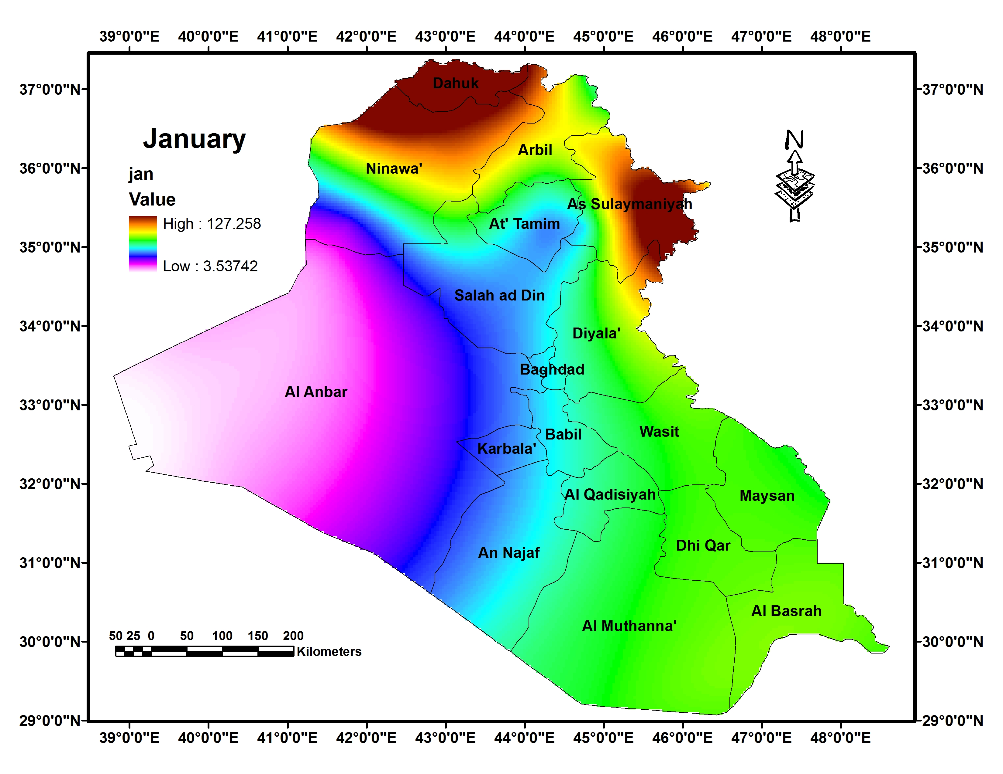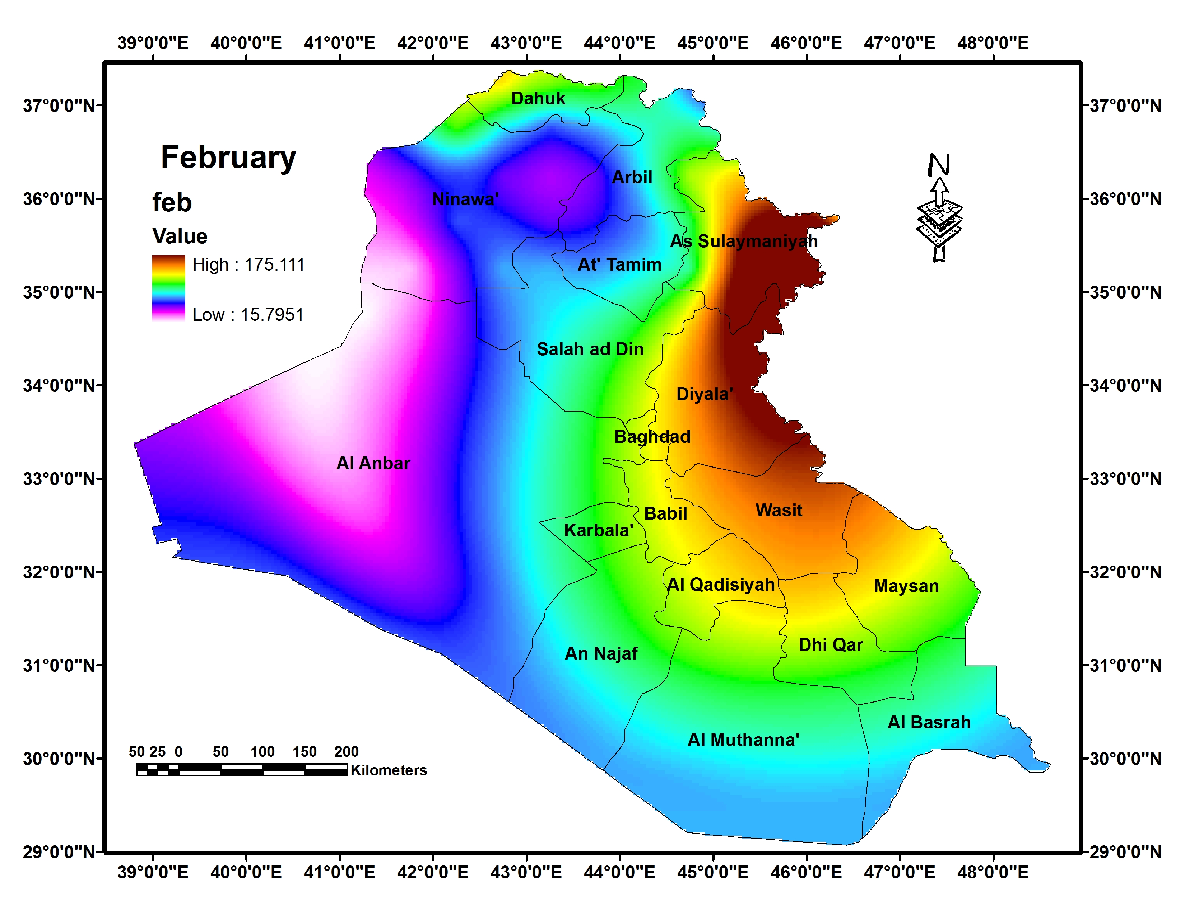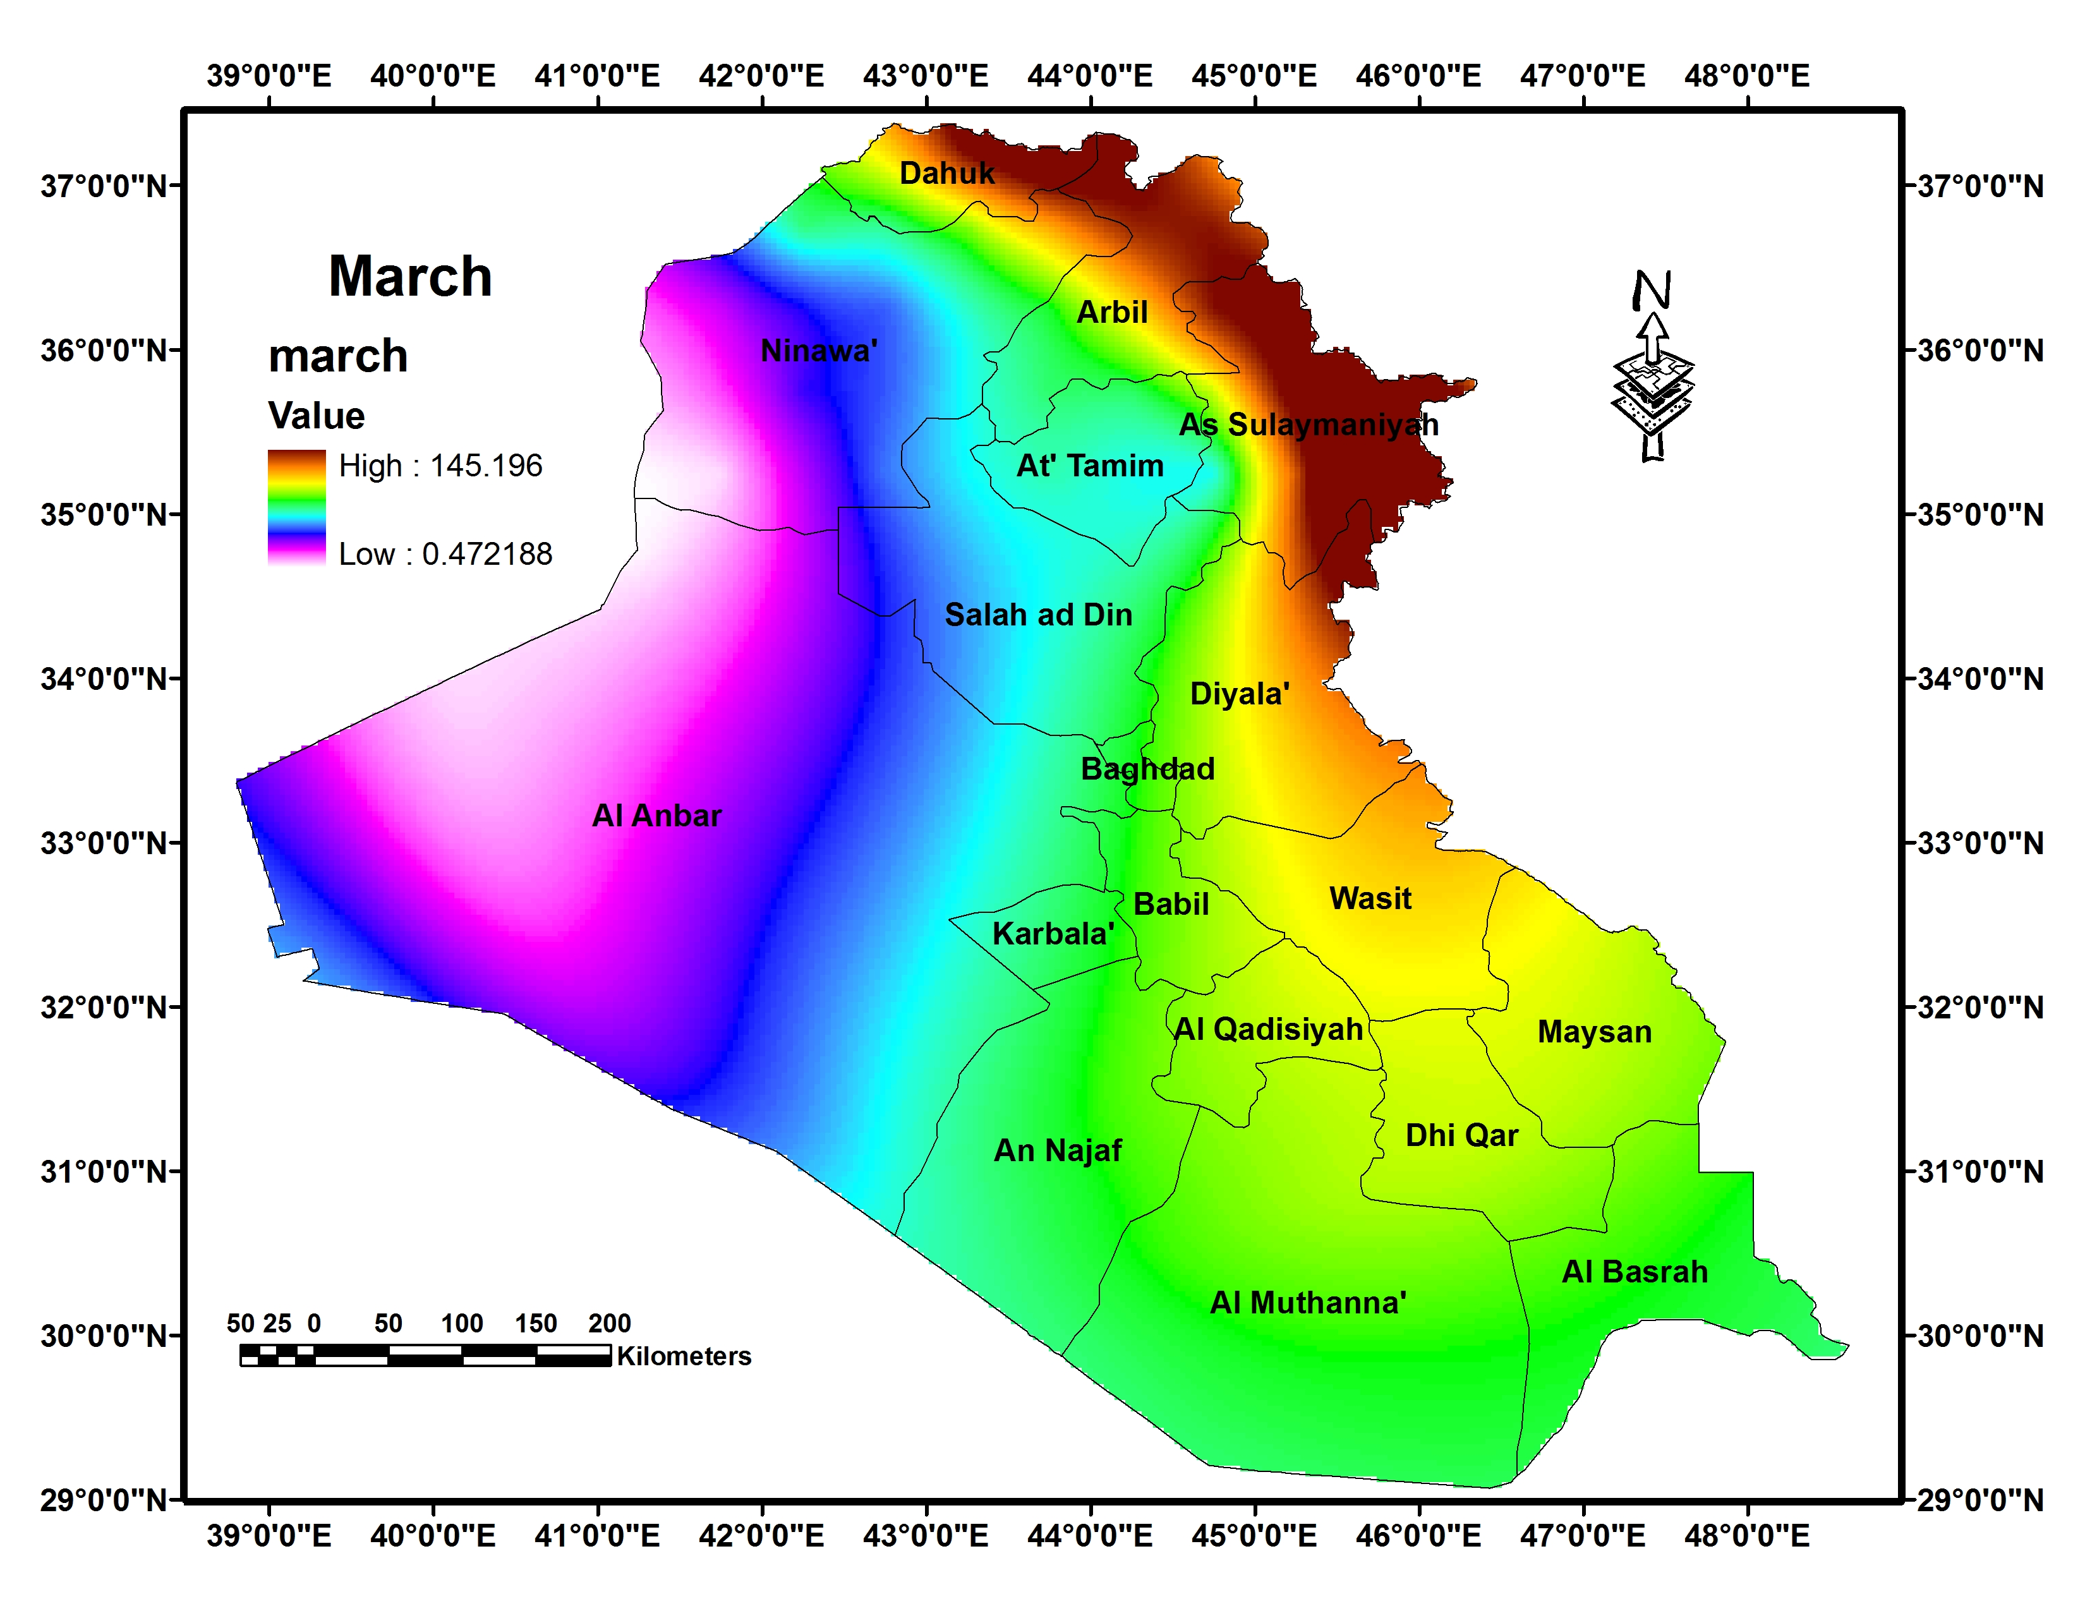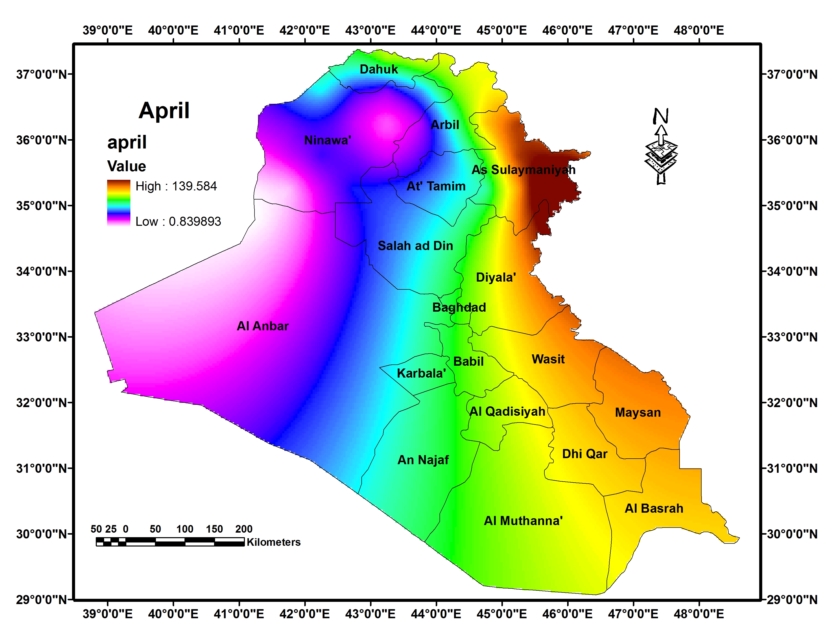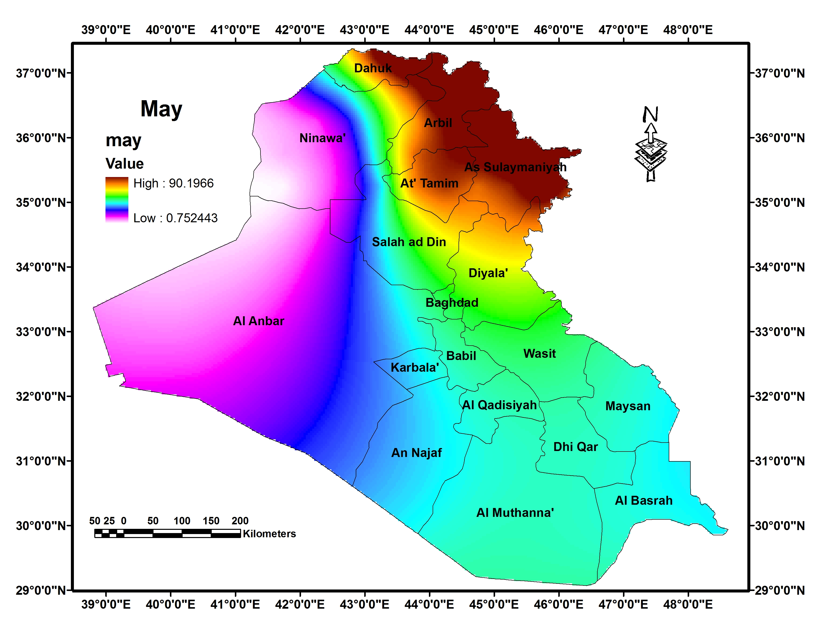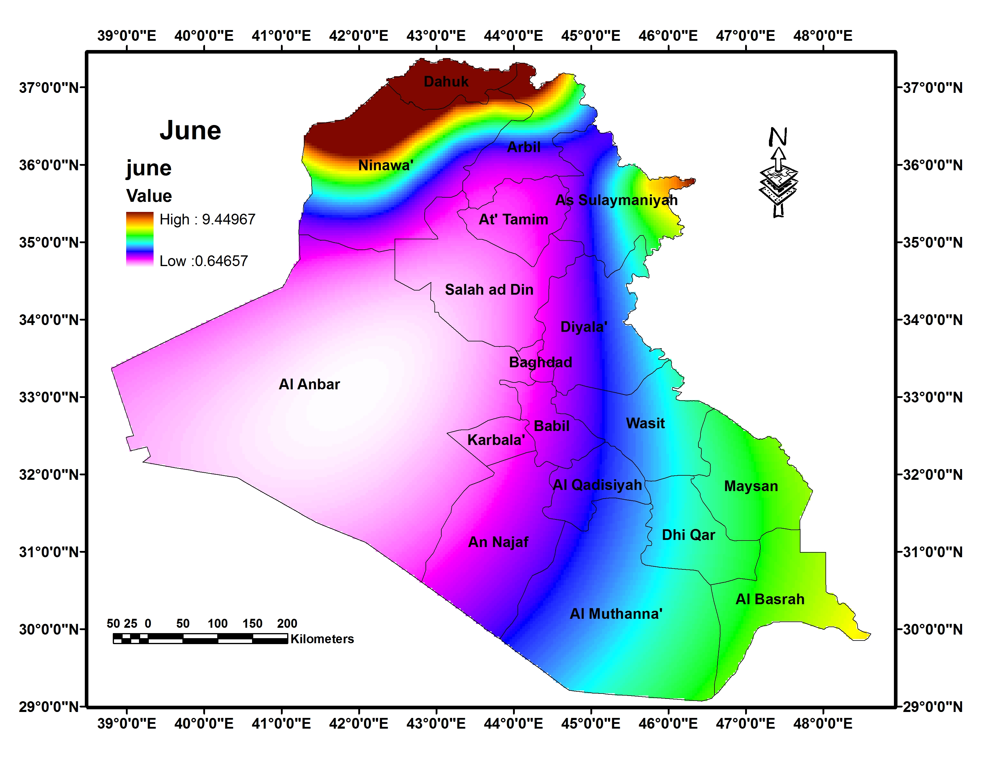

Figure (3): The average monthly

Figure (6): Monthly precipitation (January to June)
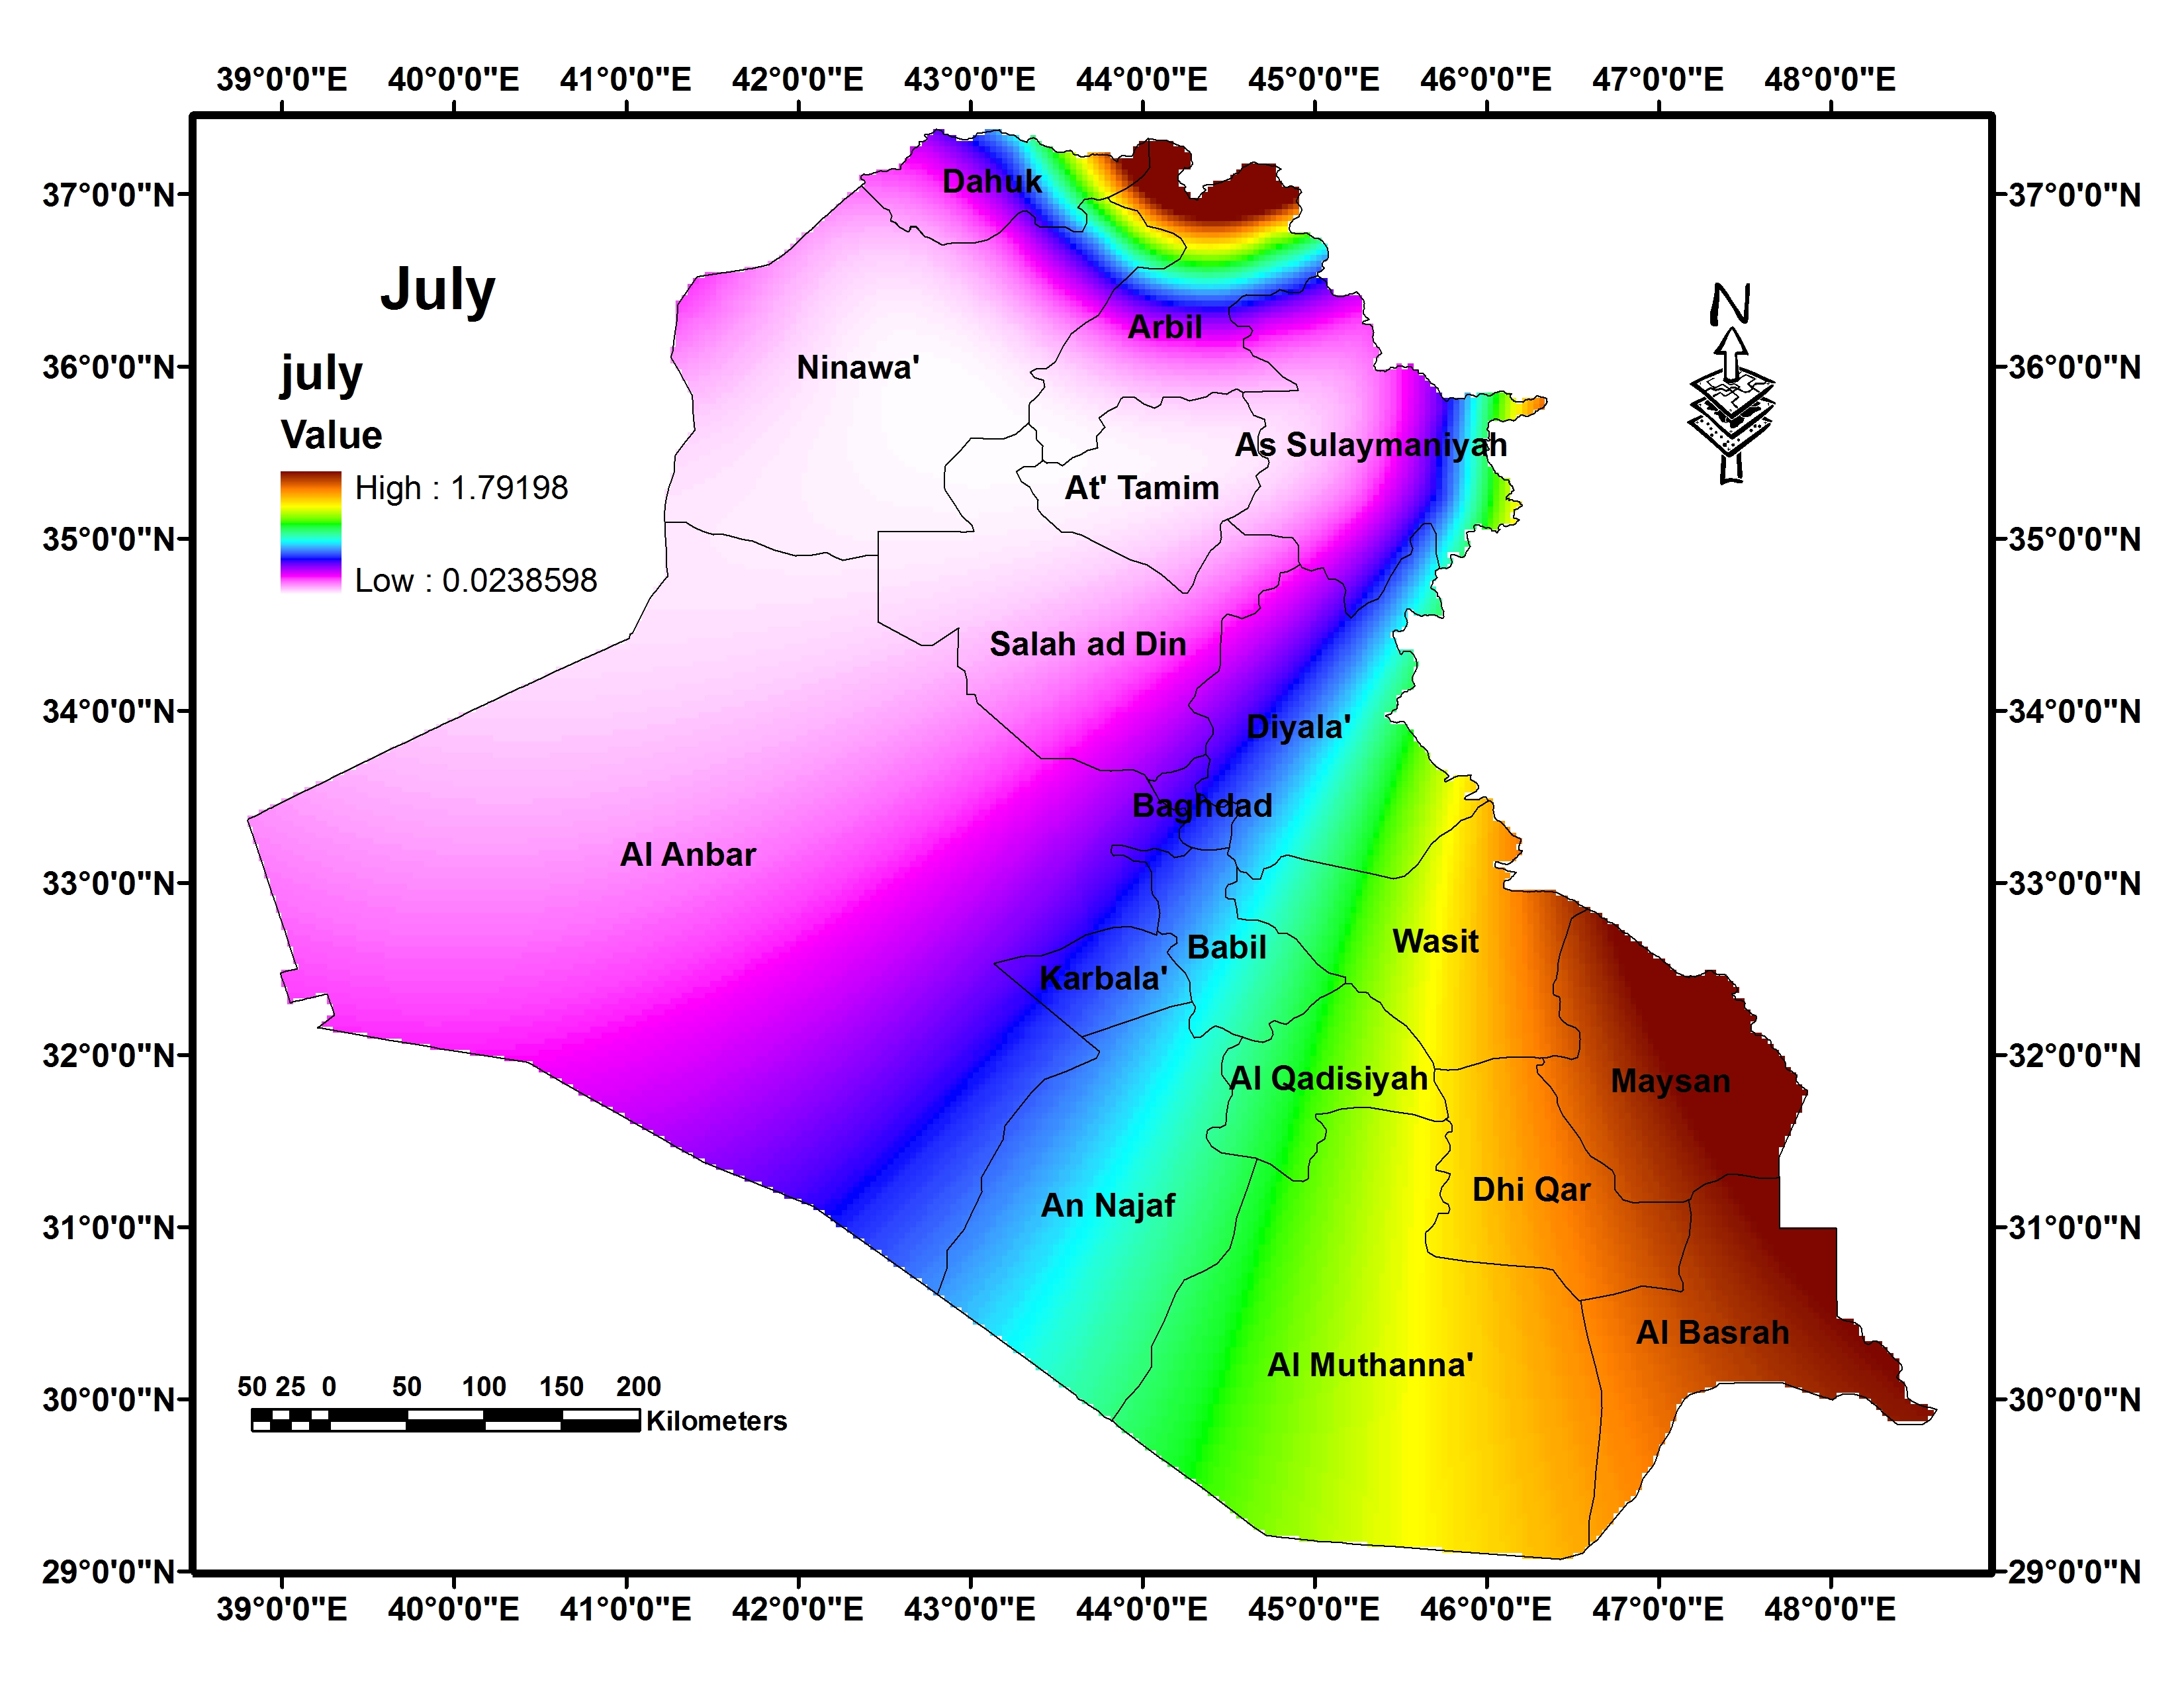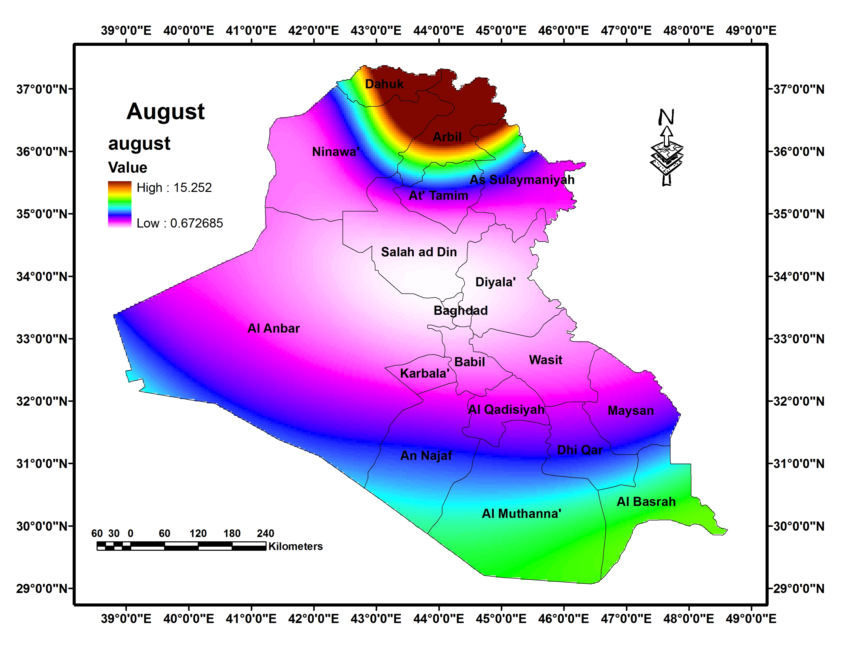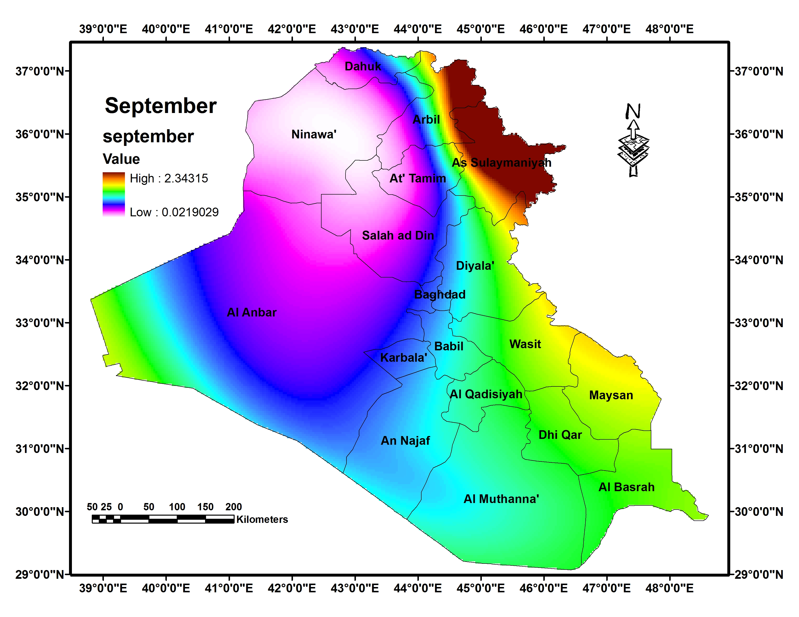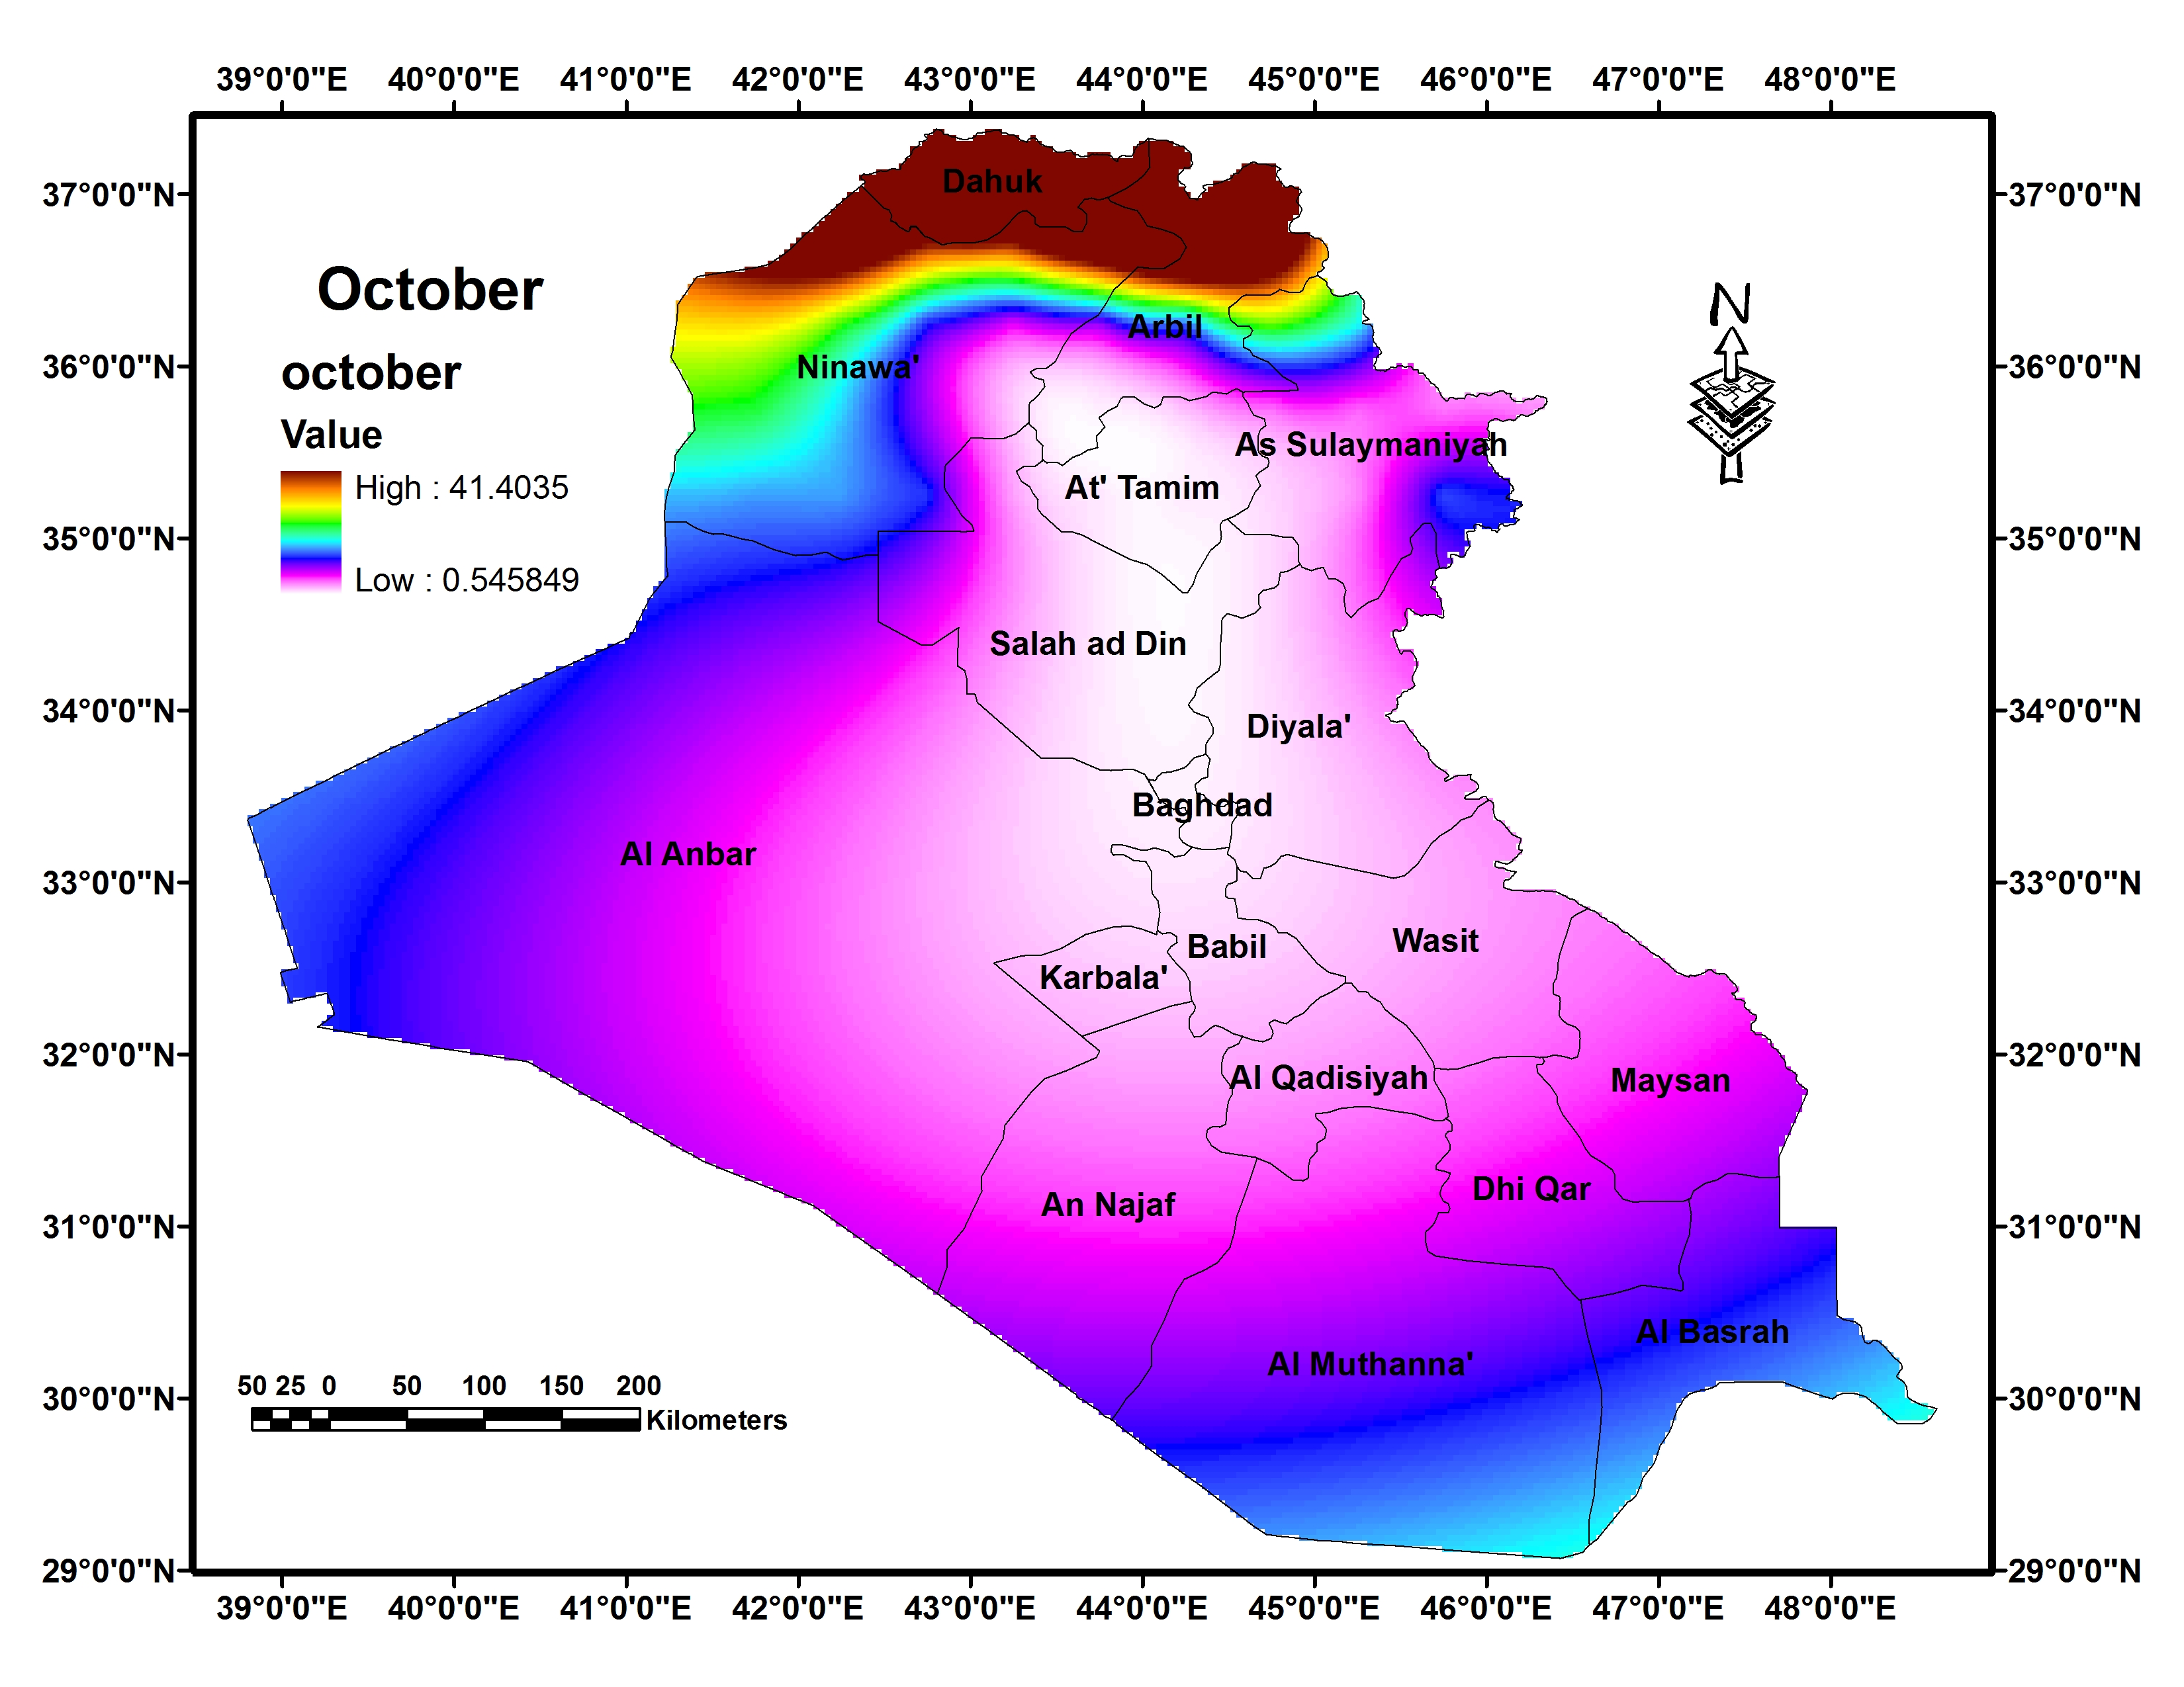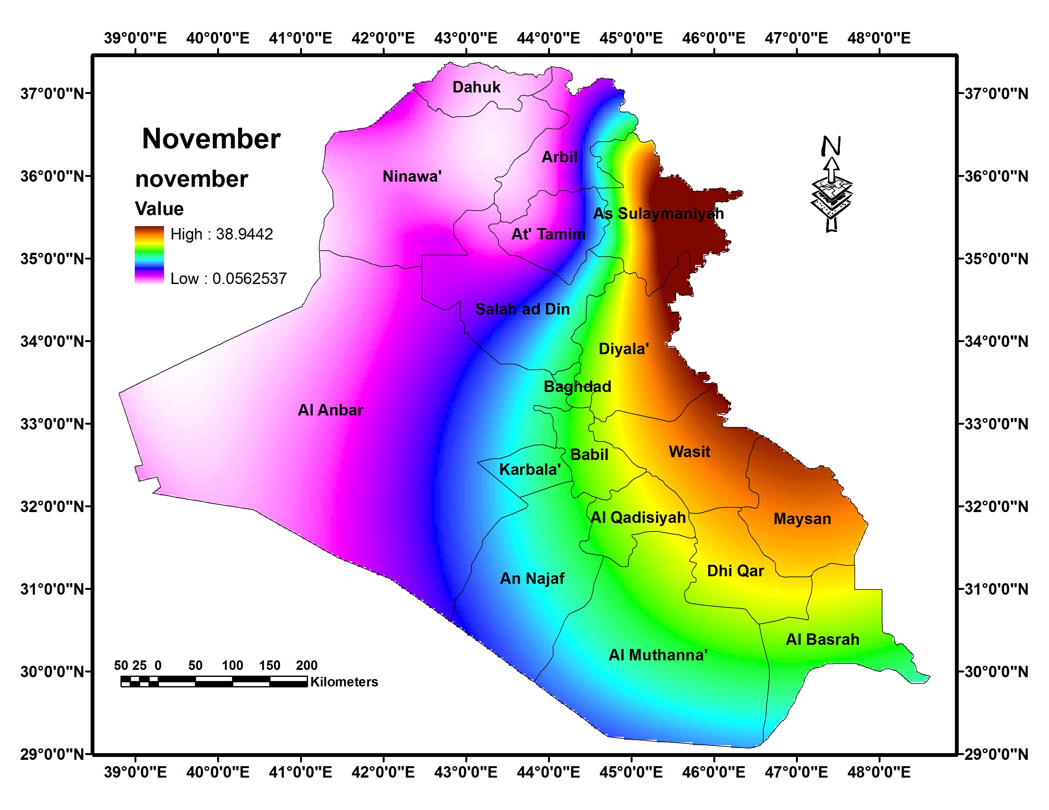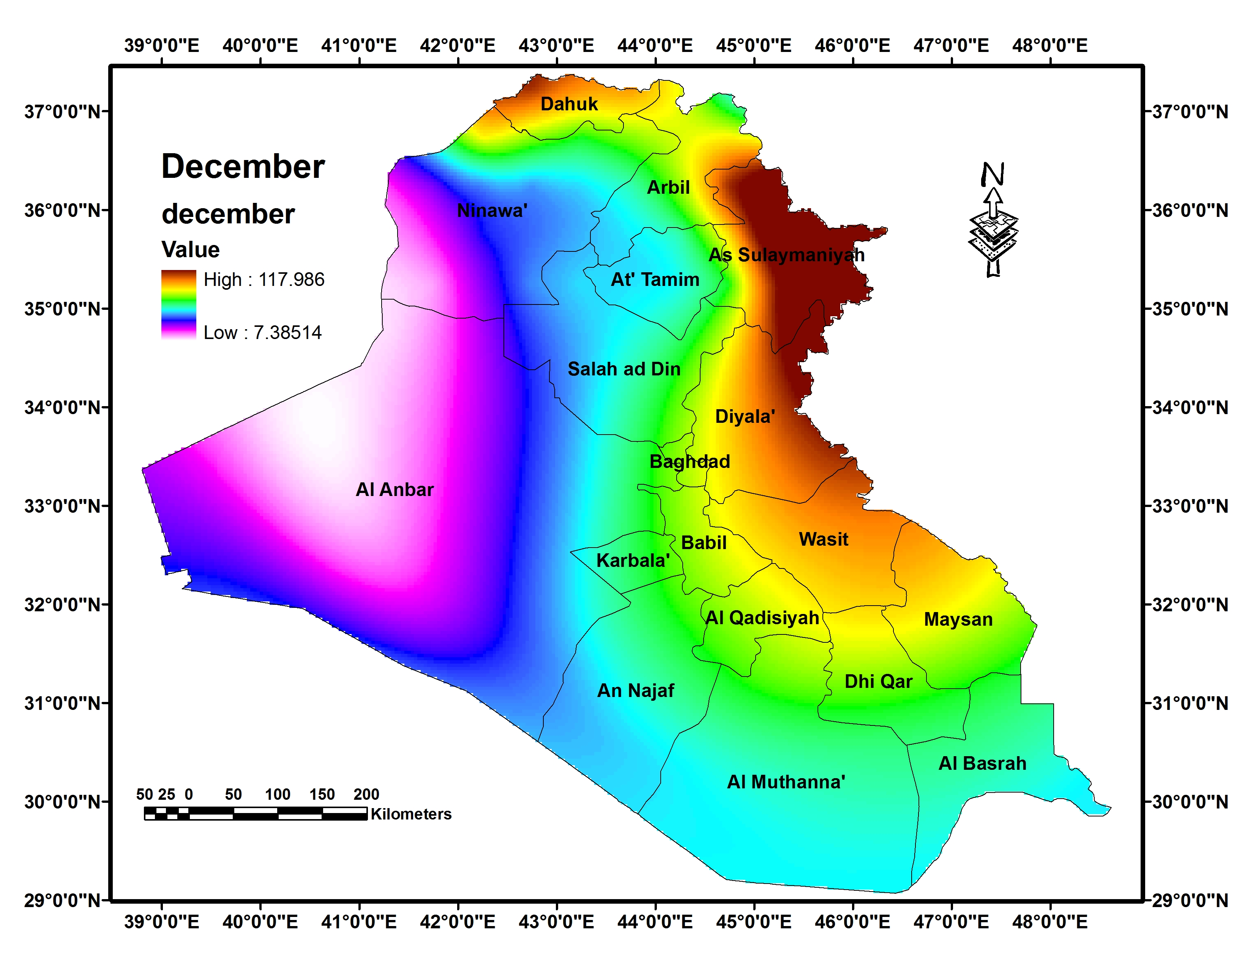

Figure (7): Monthly precipitation (July to December)
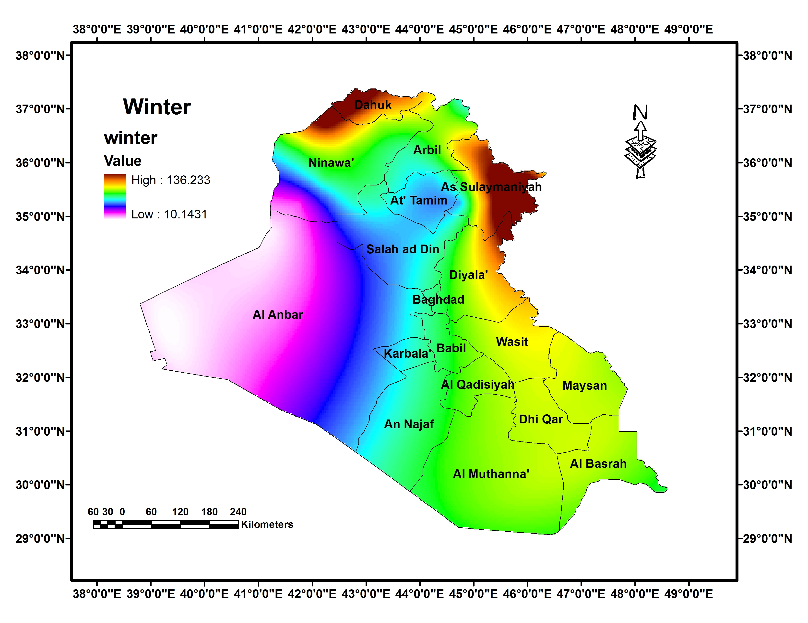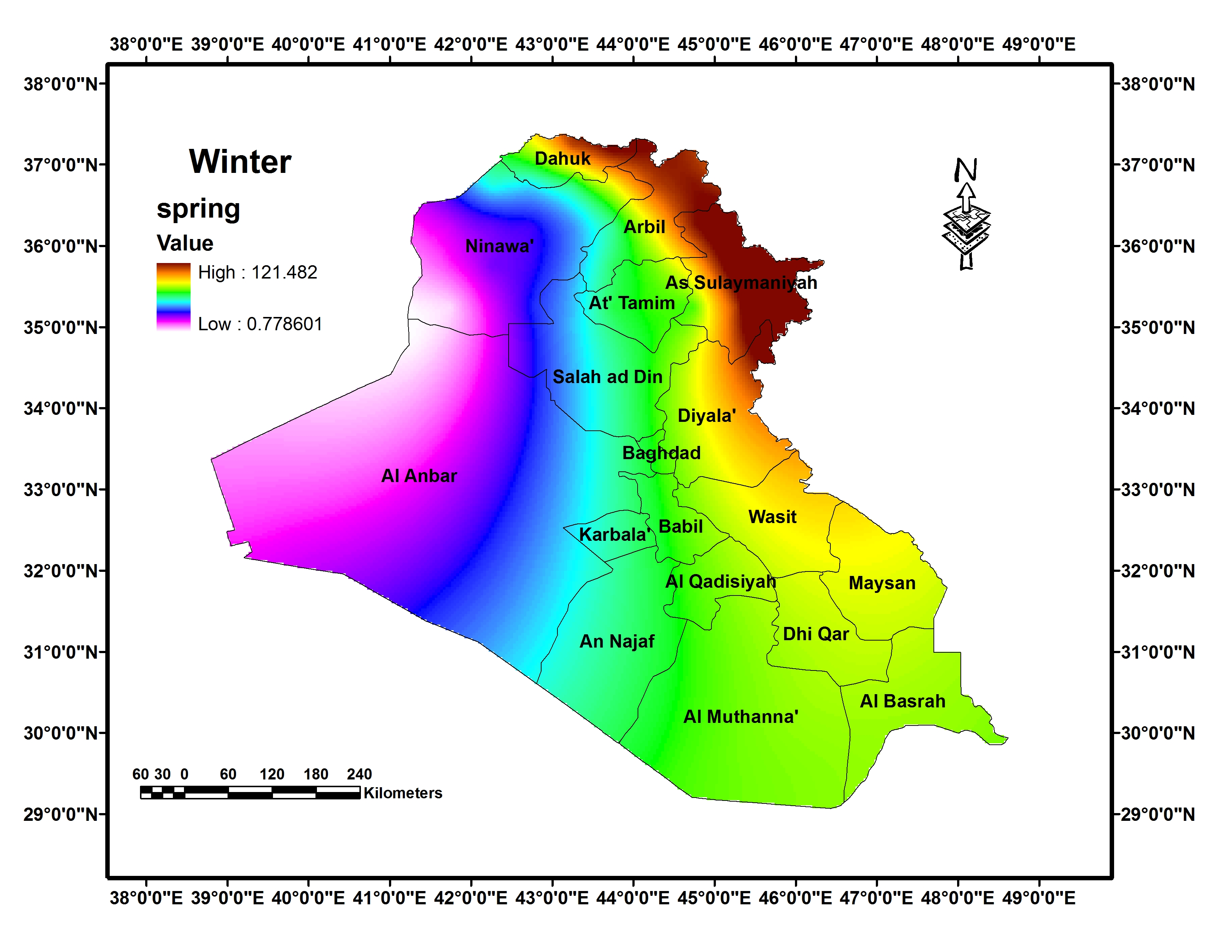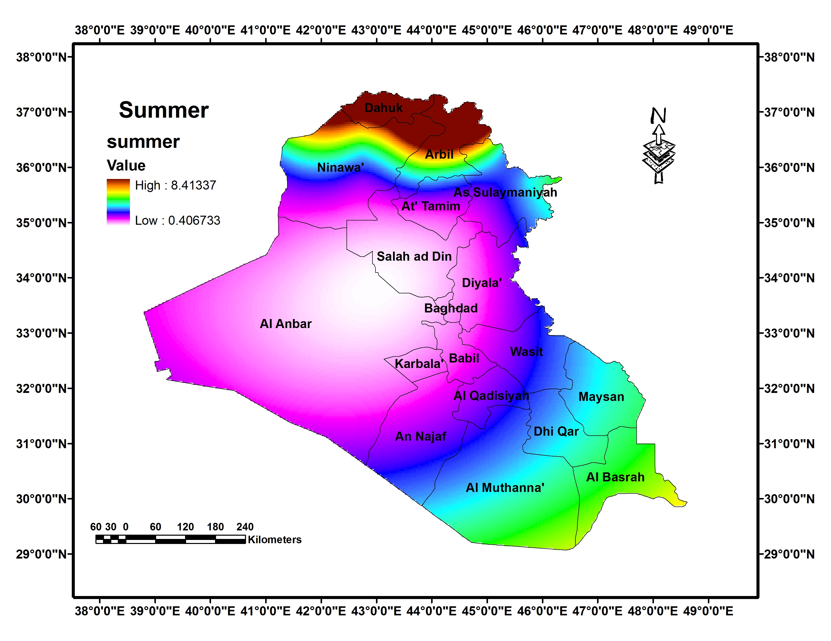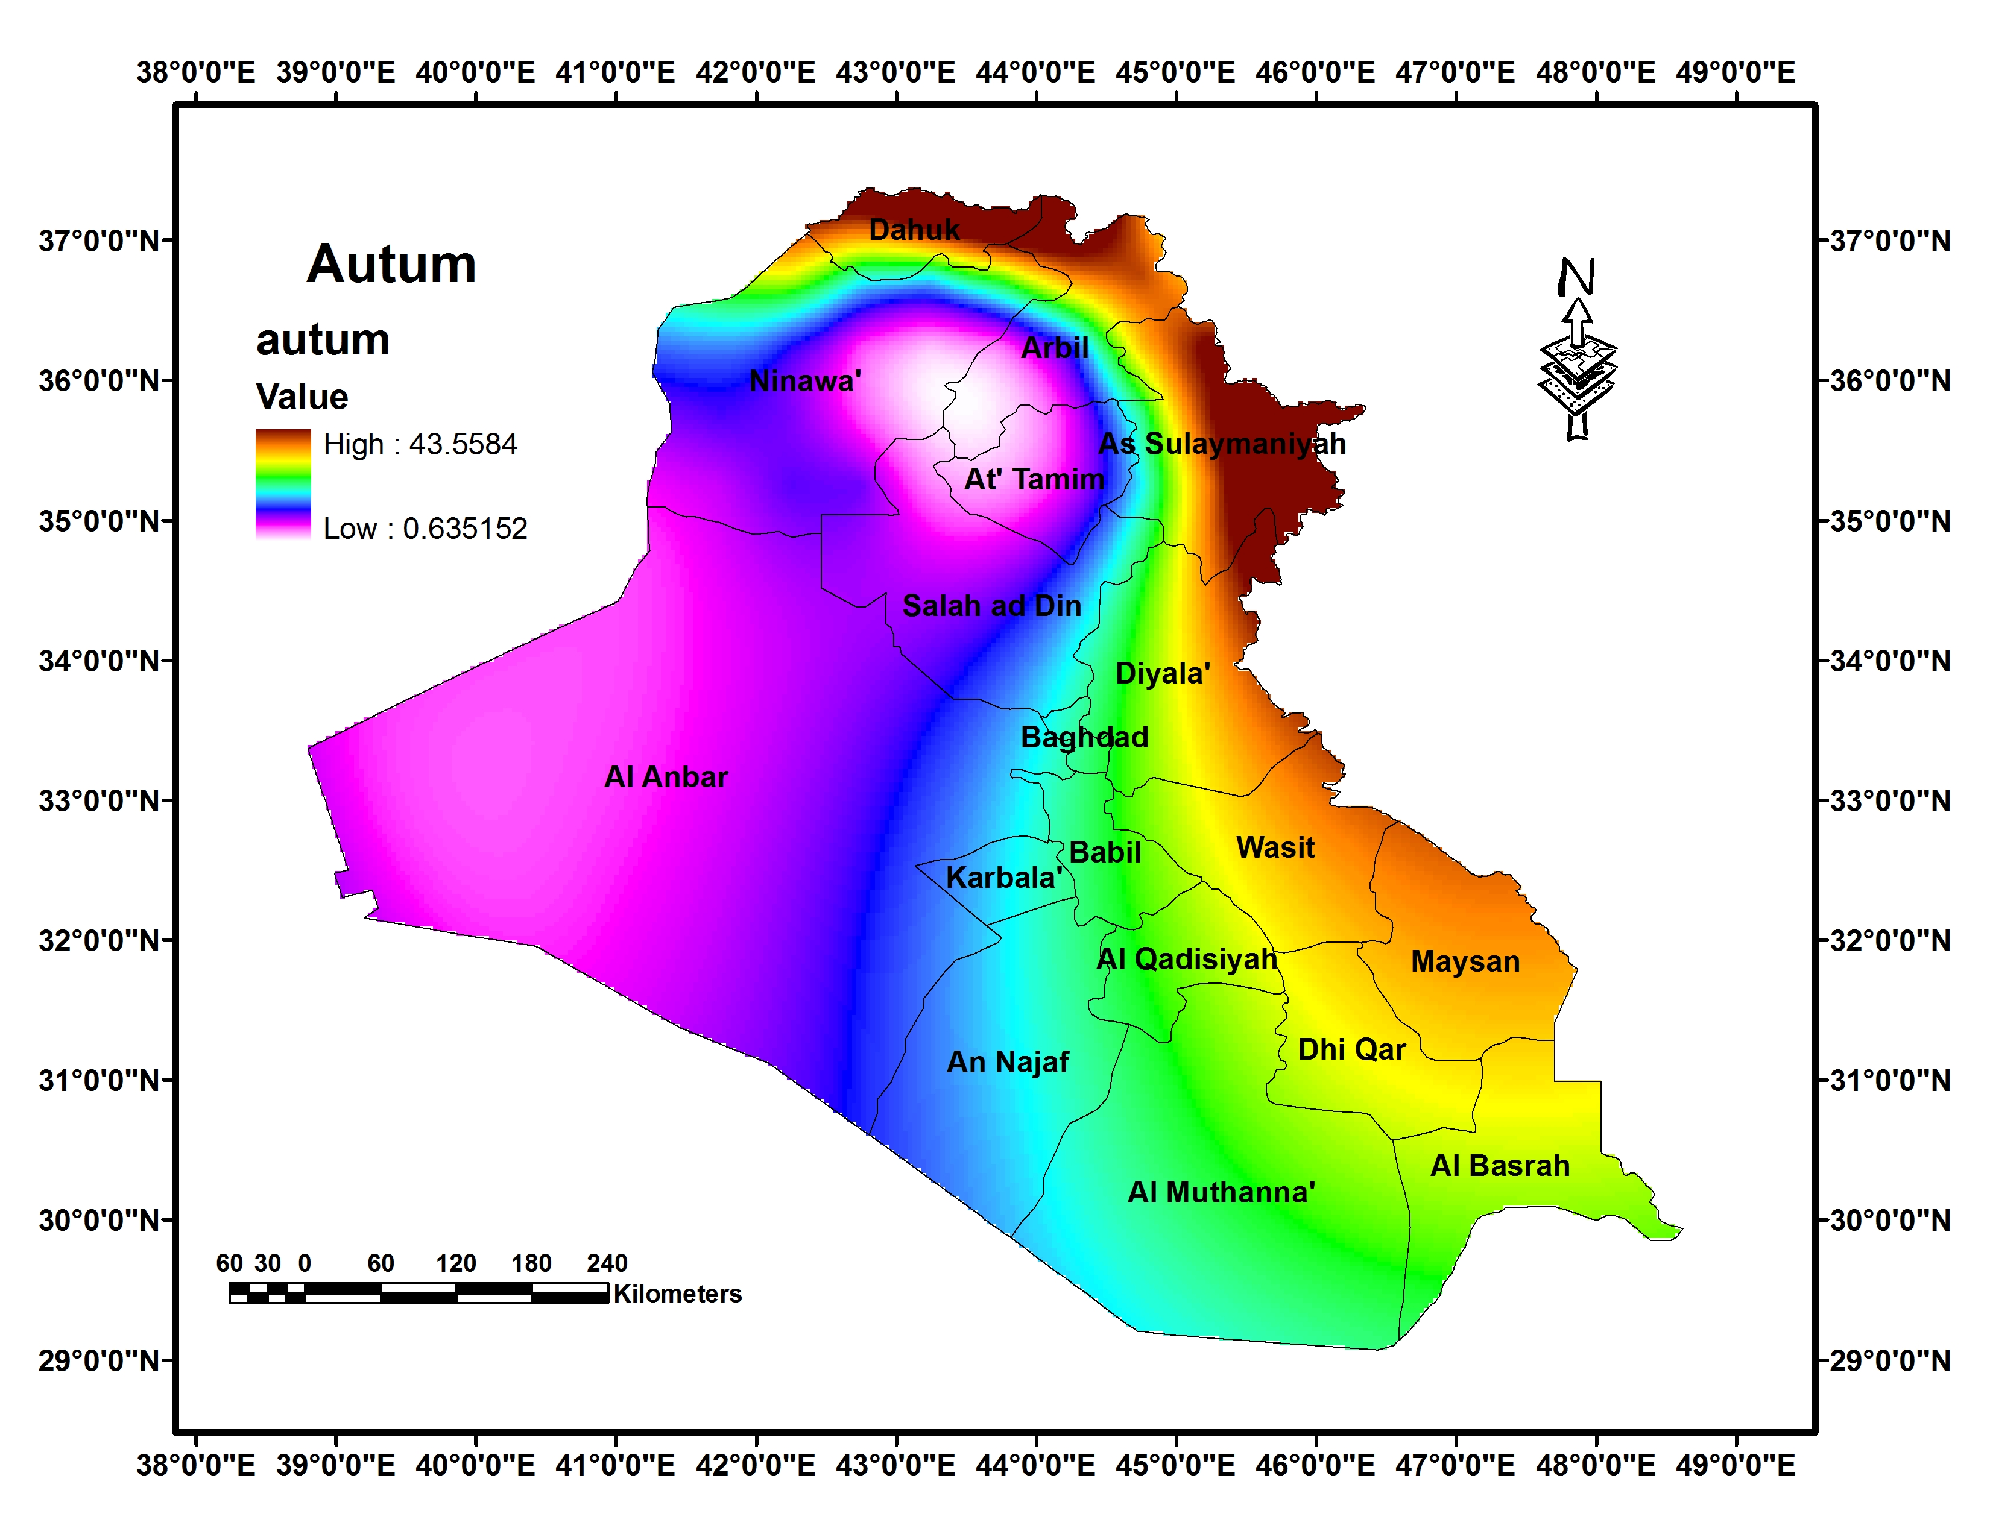

Figure (8): Seasonal precipitation (Winter, Spring, Summer and Autumn)

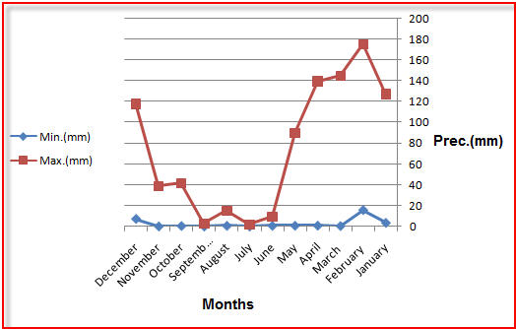

Figure (9): Monthly precipitation between January to December 2010
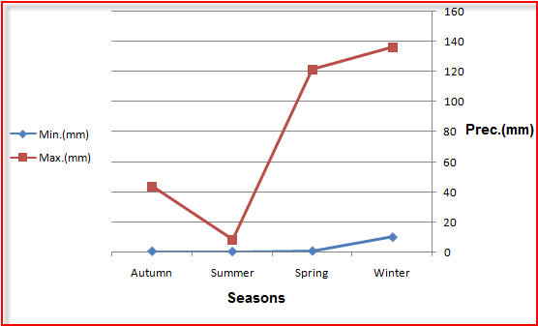

Figure (10): Seasonal precipitation at year 2010
By comparing the output results of the present study with the results obtained from the meteorological data stations, it’s found that there is a convergence in the general climatic characteristics of the precipitation in Iraq, and this leads to the possibility of depending on climate data from internationally accredited Web sites (such as: GPCC VISUALIZER). These dataset can compensate the lack of climate data available from the meteorological stations in Iraq, which is often difficult to obtain from official organizations.

- Conclusion
This study was focused on processing and mapping the precipitation dataset that downloaded from the well-known climatic website. ArcGIS9.3.1/ Kriging interpolation method was applied for extracting the final monthly and seasonal precipitation surface map. It concludes that, there is a general similarities in the precipitation feature in Iraq between the downloaded dataset from the GPCC VISUALIZER web site and those obtained from the meteorological stations. Also it concludes that, the spatial resolution of the monthly and seasonal precipitation maps produced by the Kriging interpolation method for downloaded data was more than those data depending on a limited number of meteorological stations.

References
- C. Daly, G. H. Taylor, W. P. Gibson, T. W. Parzybok, G. L. Johnson, P. A. Pasteris, 2000. HIGH-QUALITY SPATIAL CLIMATE DATA SETS FOR THE UNITED STATES AND BEYOND. Transactions of the ASAE, Vol.43, No.6,PP. 1957-1962.
- http://www.ncdc.noaa.gov/cdo-web/, accessed at: 14Feb.2014.
- http://lib.stanford.edu/stanford-geospatial-center/GIS-%2526-Climate, accessed at: 14Feb.2014.
- E. De Pauw. 2008. Climatic and Soil Datasets for the ICARDA Wheat Genetic Resource Collections of the Eurasia Region Explanatory Notes. Technical Note, ICARDA GIS Unit.
- J. M. Rajab (2012). Analysis of Troposphere Carbon Dioxide in Iraq from Atmosphere Infrared Sounder (AIRS) Data: 2010-2011. Journal of Babylon University/ Pure and Applied Sciences/ No.1, Vol. 22. PP.524-531.
- W. Wei, F. Li, L. Maofen, L. Hongbin, L. Yaoqin, 2012. Sensitivity analysis of crop growth models to multi-temporal scale solar radiation. Transactions of the CSAE, Vol.28, No.3,PP.123-128.
- http://www7.ncdc.noaa.gov/CDO/cdoselect.cmd?datasetabbv=GSOD&countryabbv=&georegionabbv=, accessed at: 22 Feb.2014.
- http://www.fao.org/nr/climpag/pub/EN1102_en.asp, accessed at: 22 Feb.2014.
- http://www.worldclim.org/, accessed at: 25 Feb.2014.
- https://climatedataguide.ucar.edu/climate-data/gpcc-global-precipitation-climatology-centre, accessed at:1 March2014.
11- http://kunden.dwd.de/GPCC/Visualizer, accessed at:1 March2014.
12- A. Becker. 2011. The Global Precipitation Climatology Centre (GPCC) to Support the GCW on ECV Precipitation: Caps and Constrains. 1st GCW Implementation Meeting, 21-24 November 2011, Geneva, PP. 1-40.
13- H. Isaaks, R. Srivastava (1989). Applied Geostatistics. Oxford University Press, New York , Oxford, 1989.
14- Y. K. Al- Timimi, M. H. Al-Jiboori, 2013. Assessment of spatial and temporal drought in Iraq during the period 1980-2010. International J. Energy and Environment, Vol.4, Issue.2, pp.291-302.
15- S. M. Ali, A. S. Mahdi, Q. M. Hussan, F. W. Al-Azawi, 2013. Fluctuating rainfall as one of the important cause for desertification in Iraq. Journal of Environment and Earth Science, vol.3, no. 2, pp. 25-33.

