INVESTIGATING THE PATTERNS IN THE OPENLY ACCESSIBLE SATELLITE-BASED DIGITAL ELEVATION MODELS OVER DIFFERENT LULC CLASSES

Ashutosh Bhardwaj (1), Kamal Jain (2), R.S. Chatterjee (1)

1 Indian Institute of Remote Sensing, Dehradun, 248001, India
2 Indian Institute of Technology Roorkee, Roorkee, 247667, India
Email: ashutosh@iirs.gov.in; kamal.jain@ce.iitr.ac.in; rschatterjee@iirs.gov.in

KEY WORDS: Satellite photogrammetry, InSAR, DEM, DSM, DTM, parallax, phase

ABSTRACT: In recent times, many openly accessible global or regional digital elevation models (DEM) have been released, which enable a large user community to ingest it in various application domains such as hydrological and environmental analysis. Satellite photogrammetry and SAR Interferometry (InSAR) are the basis of most of these DEMs such as SRTM (C-band), ALOS PALSAR RTC HR (L-band), TanDEM-X, ASTER, AW3D30, and CartoDEM. The spatial resolution or posting of these varies mostly between 12.5m for ALOS PALSAR RTC HR (Radiometrically terrain corrected high-resolution) to 90m of TanDEM-X. The earlier openly accessible datasets like GTOPO were at a posting of 1km and SRTM at 90m before the release of SRTM at 30m. The present study delves into extracting the patterns among these recently released DEMs over land use land cover (LULC) classes namely, forest, settlements (urban), and agriculture at the Dehradun experimental site in India. Carto10 and ALOS10 refer to the DEMs generated for the study using satellite photogrammetry (Cartosat-1) and InSAR (ALOS PALSAR) besides the openly accessible DEMs. The patterns found, depict the different behaviour of interaction of electromagnetic radiations (EMR) and the technique used in these DEMs for the computation of the height at each pixel i.e. parallax measurement in satellite photogrammetry and phase difference measurements in InSAR. These patterns can potentially assist in the correction of digital surface models (DSM) and digital terrain models (DTM), which otherwise is usually done manually or using filtering techniques. Some of the inter-comparison of the results depict mixed trends. However, few classes depict clear trends in the behaviour of datasets over various LULC for example; in the case of Forest class, the elevation values in the mean elevation plot have a clear decreasing trend in the elevation values from Carto10, AW3D30, SRTM, and ALOS10. This indicates the hanging mass points above the forest canopy in photogrammetry based DEMs i.e., Carto10, and AW3D30. The Carto10 DEM generated at 10m posting using ground control points (GCPs) also depicts that it has lower elevation values than the opensource CartoDEM V3 R1 in urban regions. The mean elevation plot for urban datasets shows that the elevation values have a clear pattern with increasing values from Carto10, ALOS12.5, and CartoDEM DEMs. However, the mean elevation plot for agriculture datasets on a comparison between Carto10, SRTM, ALOS10, and AW3D30 DEMs shows that there is no single pattern over the region. This can be attributed to the dynamic nature of the agricultural class due to the stages involved in agricultural activities from the sowing of seeds, to the harvesting of the crops in the agricultural plots.

INTRODUCTION

Recently the advancements in various subjects, including modeling of various problems such as environmental, hydrological, geomorphological, and mapping, the interest of the researchers have become wider, which requires platforms for the visualization of large geographical areas with a variety of temporal datasets. Digital elevation model (DEM) is one of the primary requirements for analysis providing the terrain elevation enabling extraction of geomorphological parameters or DEM derivatives for a large number of applications. This makes it essential to have a quality assessment for these DEMs, which either are generated by the user or are available from openly accessible resources. Very limited studies are available on the analysis of patterns in these DEMs over various LULC classes due to difficulty for direct verification of these. Airborne LiDAR is the main advanced technology, which can be useful for validation of such studies; however, the availability of such datasets is scanty. Despite this, there is an ever-growing interest of researchers in this subject due to the requirement of incorporation of DEMs in the environmental and hydrological modeling besides mapping applications.

The terrain has been analyzed extensively based on primary and secondary DEM derivatives (Wilson & Gallant, 2000), surface roughness (Mukherjee et al., 2015; Mukherjee, Mukherjee, Garg, Bhardwaj, & Raju, 2013), and many other techniques using entropy (Wise, 2012) or fractals (Mohamad Hani, Sathyamoorthy, & Sagayan Asirvadam, 2012). The terrain changes as well as landscape evolution is driven by complex dynamic abiotic, biotic, and anthropic factors (Aguado, Del Monte, Moratiel, & Tarquis, 2014). The presence of chaotic surfaces in reality also makes the complete representation of it difficult using a fractional Brownian motion model (isotropic). Besides techniques, the correct representation of landscape will depend on the surveyor’s appreciation or even on his imagination for finer details. However, a stochastic self-similarity called self-affinity is observed for vertical profiles or for the terrain surface itself, as terrain conserve the statistical characteristics over a wide range of scales (Barton, Lovejoy, Schertzer, & Turcotte, 2012; Polidori, Chorowicz, & Guillande, 1991; Vicsek, 1992). The conceptual challenge in positioning is rightly posed by Gilichinsky et al. (2010) as, “The horizontal and vertical errors usually cannot be separated: incorrect elevation could appear at the correct location, or the error may be due to a correct elevation in the wrong location” (Gilichinsky, Melnikov, Melekestsev, Zaretskaya, & Inbar, 2010). Openly accessible DEMs are prone to errors in complex regions and are liable to cause errors in the analysis and affecting the applications adversely. A large number of studies characterizing the mechanisms behind Climate changes over the Himalayan regions, Tibetan Plateau, Swiss Alps are based on multiple observed datasets and model simulations. These include including mechanisms and datasets for elevation-dependent warming (EDW); feedbacks of snow/ice-albedo, cloud, atmospheric water vapor, aerosol; LULC changes, ozone, vegetation, and glaciers changes (Dimri, Kumar, Choudhary, & Maharana, 2018; Gerlitz, Conrad, Thomas, & Böhner, 2014; Rottler, Kormann, Francke, & Bronstert, 2019; Thakur et al., 2020). DEM and orthoimages are required at various steps of visualization and incorporation in the models, wherein the GCPs play a critical role (Bhardwaj, 2013, 2018; Florczyk, Nogueras-Iso, Zarazaga-Soria, & Béjar, 2012). However, the subject of analyzing the DEMs and its improvement remains open for research due to the complexities in the terrain and variations within a DEM over various LULC classes. The study presented here is to analyze the behavior of different openly accessible DEMs along with DEMs generated using satellite photogrammetric and InSAR techniques.

STUDY AREA AND MATERIAL

The study area includes the Dehradun city and its surroundings having general elevation ranging from about 300 m to 2250 m above MSL as shown in Figure 1. Cartosat-1 data lies between 30º 11’ 43’’ N to 30º 30’ 41’’ N latitude and 77º 44’ 32’’ E to 78º 4’ 59’’ E longitude. The openly accessible CartoDEM V3 R1 data utilized in the study lies between 30º 11’ 36’’ N to 30º 26’ 32’’ N latitude and 77º 45’ 18’’ E to 78º 05’ 46’’ E longitude. Dehradun is the provisional capital city of the Uttarakhand state, India. It is located in the Doon valley, 260 km north of India's capital New Delhi. The Dehradun site is characterized by highly rugged terrain comprising of Shivalik hills in the south and higher Himalayas on the north, the river Ganga in the east, and the river Yamuna in the west (Figure 3-1). In the south, it has plain agricultural fields. The study area has a large number of seasonal drainages. The forest area in the study site comprises of Sal (dry deciduous), and Sal mixed (dry deciduous). The forest density in the Dehradun site is are classified into various categories namely, very dense forest, moderately dense forest, open forest, and scrub (Roy et al., 2012). ALOS PALSAR-1, Radarsat-2, and Envisat ASAR InSAR datasets are also utilized in the study for the evaluation of microwave datasets vis-à-vis Cartosat-1 stereo data for various steps of data preparation especially the marking of GCPs.

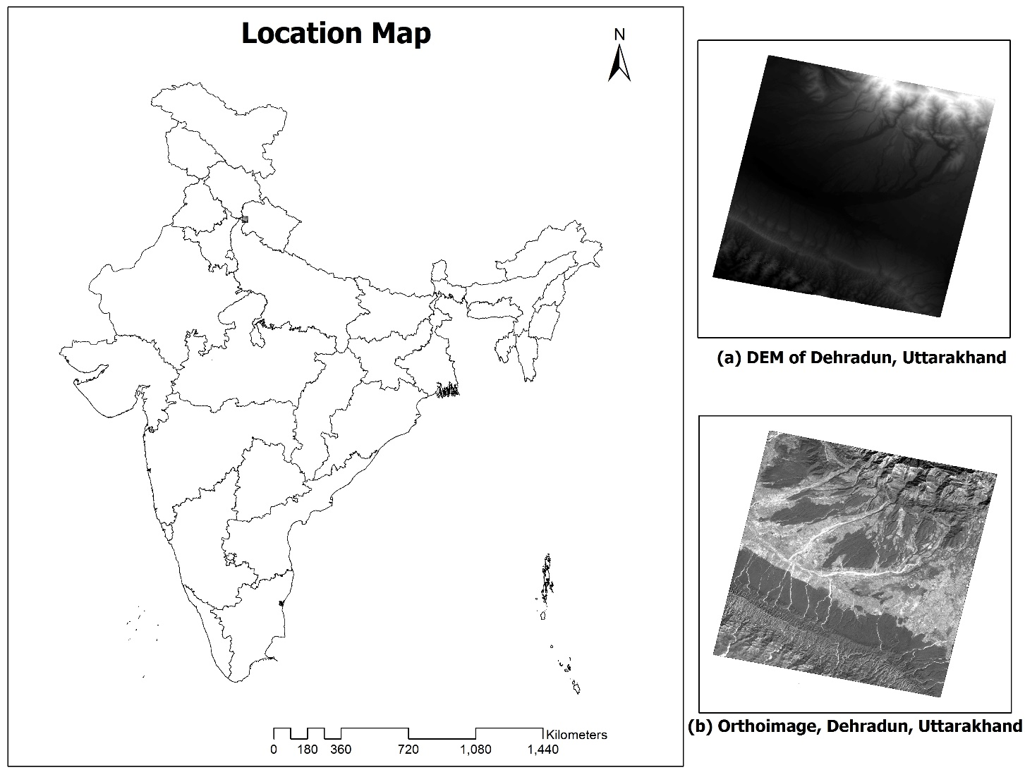
Figure 1: Location Map with DEM and Orthoimage for the experimental site at Dehradun.

METHODS AND MATERIAL

The photogrammetric and SAR interferometric methodologies used for DEM generation are shown in Figure 2. GCPs collected and processed using differential GNSS post-processing methods are used for the processing of optical stereo as well as microwave InSAR datasets. The DEM (referred to as Carto10) and orthoimage are generated from Cartosat-1 stereo data after satellite triangulation as shown in Figure 1. The use of GCPs is an important step in the quality assessment of the generated DEMs as well as openly accessible DEMs in such studies (Bhardwaj, Jain, & Chatterjee, 2019). The preparation of plots of mean elevation for different LULC classes for the assessment and analysis of patterns in elevation values among DEMs generated from Photogrammetry and InSAR technology is the final step. Statistical parameters like minimum elevation and mean elevation are utilized to compare the different behavior of DEMS generated from different techniques using optical datasets, C-band InSAR, and L-band InSAR datasets. The DEM generated from ALOS PALSAR is referred to as ALOS10, whereas the ALOS PALSAR radiometrically terrain corrected (RTC) HR DEM is referred to as ALOS12.5 in the study. ALOS World 3D - 30m (AW3D30) and SRTM 30m DEMs are also downloaded and utilized in the analysis. Visualization of the experimental site can be done by overlaying images and contours on the DEM providing a visual assessment for the quality of DEM and contours. This assists in the process of locating the erroneous locations which need correction in DEM for further product generations. The openly accessible DEMs were thankfully downloaded from the web portals of the visionary space agencies namely, ISRO, NASA, ESA, and JAXA.

Figure 2: Methods for generation of DEMs generated from Photogrammetric, SAR Inteferometric methods and analysis of these DEMs along with openly accessible DEMs

RESULTS AND DISCUSSION

The openly accessible DEMs as well as DEMs generated from satellite photogrammetry and InSAR were compared for individual land use land cover classes at the Dehradun site. The major classes considered in the analysis were forest, urban, and agriculture, for analysis at Dehradun site. Visual interpretation and on-screen digitization were done for creating polygons of different classes for comparison. The extended views of polygons are shown in Figure 3 for agriculture areas, Figure 4 for urban areas, and Figure 5 for forest areas.

DEM was generated from Cartosat-1 stereo data with reference datum as mean sea level (MSL) for heights using the EGM96 model. Tables were prepared with the statistical properties of DEMs used in the study at Dehradun site for minimum, maximum, mean, median, mode, and standard deviations for elevation values. The class-wise statistical variations were derived for DEMs in two categories based on the datum, as follows: (a) Carto10 DEM, ALOS PALSAR RTC HR DEM, and CartoDEM V3 R1 (WGS84 datum); (b) Carto10 DEM, ASTER GDEM, ALOS10 DEM, SRTM DEM, and AW3D30 DEM (MSL datum). The mean elevation plots are generated for class-wise comparison for the first category are depicted in Figure 4(a) for the forest, Figure 4(b) for agriculture, and Figure 4(c) for urban patches. Similarly, the class-wise mean elevation plots depicting statistical class-wise variations for the second category are shown in Figure 5(a) for the forest, Figure 5(b) for agriculture, and Figure 5(c) for urban patches. Figure 4(a) reveals that the ALOS PALSAR RTC HR DEM (referred to as ALOS12.5 in this study), has the lowest elevation values in the forest region due to its capability to penetrate the canopy. The Cartosat-1 i.e. Carto10 DEM generated using GCPs has elevation values close to ALOS PALSAR RTC HR DEM. Whereas the open source CartoDEM V3 R1 has higher elevation values than SRTM DEM and Carto10 DEM due to the presence of floating mass points in most of the forest area. Whereas, figure 4(b) shows that in the urban region, Carto10 DEM has the lowest elevation values due to the presence of digging in mass points. The difference between the openly accessible ALOS PALSAR RTC HR DEM and CartoDEM V3 R1 in urban regions is lesser than that found in forest regions. Figure 4(c) majorly depicts that the ALOS PALSAR RTC HR DEM gives lower elevation values in agriculture areas than optical DEMs due to floating mass points present in the case of optical data and penetration capability of InSAR in an agricultural area. However, the effect is not visible throughout the sample polygons due to different dates of data acquisition in the case of optical and InSAR data.

Figure 5(a) represents the mean elevation plot (forest polygons) indicating the lowest values are from the ALOS10 DEM generated using GCP from ALOS PALSAR InSAR pair due to its high capabilities for canopy penetration. SRTM DEM has a much higher elevation than ALOS10 DEM and has values closest to the tree canopy in the forest. Whereas, AW3D30 DEM shows elevation values close to SRTM DEM and has a lesser floating effect than that present in CartoDEM. AW3D30 DEM shows elevation values close to SRTM DEM and has a much lower floating effect than that present in CartoDEM V3 R1 as observed from Figure 5(b). SRTM DEM has a higher elevation than ALOS10 DEM due to its low penetration into an agricultural region. As seen in figure 4(a), here also the trend or effect is not visible uniformly for all the sample polygons due to different dates of data acquisition in the case of optical and InSAR data. The lack of trend in agriculture class is due to the reason that in agriculture fields, large variations take place from sowing to harvesting of fields and thus the date of data acquisition becomes more relevant here. Figure 5(c), reveals that the ALOS10 DEM has higher values with large variability at places, which can be attributed to its coarser-resolution and the combined effect of scatterers in the urban areas. AW3D30 elevation values are closer to SRTM DEM, whereas Carto10 DEM shows higher values due to floating mass points as observed clearly in a 3D environment of the digital photogrammetric system.

(a) Agricultural Polygons (Yellow colour) | (b) Urban Polygons (red colour)
(c) Forest Polygons (green colour)
Figure 3: depicts extended views of (a) agricultural Polygons (Yellow colour), (b) Urban Polygons (red colour), (c) Forest Polygons (green colour)

The analysis of all the mean elevation plots indicated a higher floating effect of mass points in CartoDEM V3 R1 in the forest region. The variations in ALOS PALSAR DEM also show complex behavior in elevation values and thus do not permit any simple method for filtering or correction in DEM mathematically, for the creation of either of DTM or DSM. This can specifically be attributed to the complex behavior of a large number of scatterers within a pixel and manual editing can improve such errors. It was observed by 3D visualization (stereo viewing) in the digital photogrammetric system, that mostly the DEM elevation values generated using optical DEM are above the canopy (hanging or floating mass points). Additionally, the plots of mean elevation values reveal that the elevation values are lower in DEMs generated using the InSAR technique due to their penetration capability in vegetation cover.
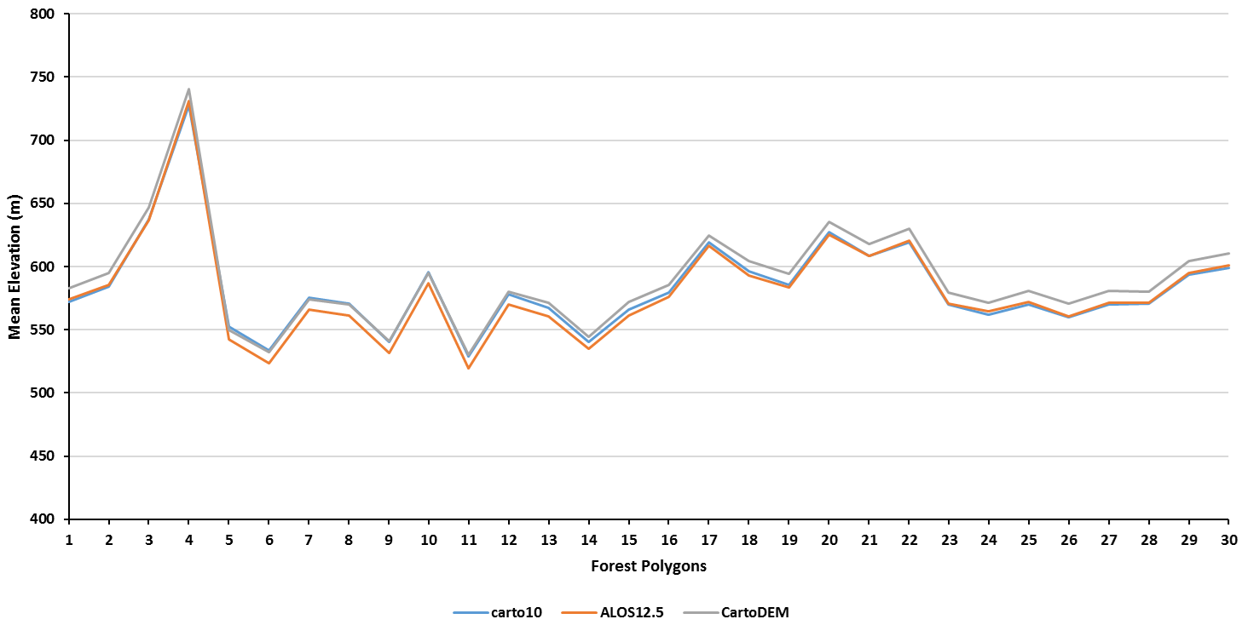
- Forest Polygons (Carto10, ALOS12.5, and CartoDEM)
- Agriculture Polygons (Carto10, ALOS12.5, and CartoDEM)
- Urban Polygons (Carto10, ALOS12.5, and CartoDEM)
Figure 4: comparison between Mean Elevation Plots for various DEMs (a) Forest Polygons (Carto10, ALOS12.5, and CartoDEM), (b) Agriculture Polygons (Carto10, ALOS12.5, and CartoDEM), (c) Urban Polygons (Carto10, ALOS12.5, and CartoDEM)
- Forest Polygons (Carto10, SRTM, ALOS10, and AW3D30)
- Agriculture Polygons (Carto10, SRTM, ALOS10, and AW3D30)
- – Urban Polygons (Carto10, SRTM, ALOS10, and AW3D30)
Figure 5: comparison between Mean Elevation Plots for various DEMs (d) Forest Polygons (Carto10, SRTM, ALOS10, and AW3D30), (e) Agriculture Polygons (Carto10, SRTM, ALOS10, and AW3D30), (f) Urban Polygons (Carto10, SRTM, ALOS10, and AW3D30)

The variations in terrain elevation in the forest zones of Dehradun are difficult to be captured as observed through fieldwork in the forest areas. The complex topography in the forest area does not permit accurate simulation of bare earth DEM in the forest area zones by using ancillary information of tree height or measurement of the average canopy height from the stereo model. Hence, automation is a challenge considering the trade-off between canopy type and canopy representation at a given scale. The datasets available in the microwave region have a comparatively coarser-resolution after the multi-looking operation. Similarly, the DEM generation is highly dependent on the complexity of the urban area and the spatial resolution of the used remote sensing data. Manual editing is an ideal solution to correct the floating and digging of mass points representing terrain height in forest regions and urban areas. After data cleaning the Carto10 DEM results are better than AW3D30 DEM with an RMSE of about 2 pixels. Among the InSAR DEMs, the performance of SRTM DEM is superior to ALOS PALSAR RTC HR DEM due to its smaller wavelength and better S/N ratio. CartoDEM V3 R1 has shown extremely good quality in studies over plain regions such as the Kendrapara site, over all the other openly accessible DEMs generated based on photogrammetric or InSAR technique. The CartoDEM V3 R1 has DEM accuracy within a pixel, implying the high utility of CartoDEM V3 R1 data in flat terrain (Bhardwaj et al., 2019). The ground features on ALOS PALSAR L-band images are more clearly visible than the features on C-band ENVISAT ASAR, and Radarsat-2 images with a similar spatial resolution for the Dehradun site. Thus, some of the GCPs selected for satellite triangulation of Cartosat-1 data are identifiable in ALOS PALSAR data. GCPs leads to a better orbital refinement in InSAR processing, enabling more precise flat-earth phase removal and phase calibration, which can have more enlightening effects in HR or VHR InSAR datasets, such as from aerial platforms. ALOS PALSAR data being in L-Band penetrates vegetation cover much more than the C-band and therefore results in more accurate terrain elevation values at places of sparse vegetation and the elevation values are close to the actual terrain surface. However, in very dense forest areas the SAR sensor receives the backscattering as the coherent sum from the distributed target inside the SAR resolution cell and the SAR sensor cannot resolve individual scatterers. The coherent sum increases the overall phase center height from the ground and thus increases the overall height values in the DEM (Holecz et al., 1997; Moreira et al., 2013). The large differences at places can be attributed to the hilly terrain, dense vegetation, and coarse pixel size of InSAR data as compared to Cartosat-1 stereo data.

CONCLUSION

The patterns observed in this study can aid in the construction of intelligent cognitive and heuristic-based systems. These systems can have the input of field and ancillary datasets for the generation as well as improvements of DSMs and DTMs. ALOS PALSAR data being in L-band can penetrate the vegetation and so the GCP points are identifiable in the ALOS PALSAR dataset. Similarly, the boundary between two LULC classes or features is more prominent in L-band ALOS PALSAR data, allowing precise GCP markings. It was observed that mostly the DEM elevation values generated using optical DEM are above the canopy due to floating mass points, whereas in DEMs generated using InSAR data the elevation values are lower due to their penetration capability in vegetation cover. Quite a few points are available in digging also, i.e. below the ground. It makes the manual editing a very important part while generating a good quality DEM. The manual editing is highly useful to capture correct elevation values in a highly rugged area like Dehradun along with its slope and dense drainage features. The use of GCPs and external DEM improves the DEM generated through InSAR pairs, however, high-quality DEMs are generated by missions like TanDEM-X (Bhardwaj, 2019) using onboard techniques with precise Doppler-range computations particularly. It is observed that in InSAR data pairs acquired from satellites, it is relatively tedious to do GCP pointing accurately due to the coarser spatial resolution of multi-look images and speckle effect. Fine resolution InSAR pairs can produce DEMs that are more accurate, with the utilization of GCPs in the DEM generation procedure. Zoning improves the analysis of DEMs generated using optical stereo and InSAR pairs in different LULC zones.

References
Aguado, P. L., Del Monte, J. P., Moratiel, R., & Tarquis, A. M. (2014). Spatial characterization of landscapes through multifractal analysis of DEM. Scientific World Journal, 2014. https://doi.org/10.1155/2014/563038
Barton, C. C., Lovejoy, S., Schertzer, D. J., & Turcotte, D. L. (2012). Benoit B. Mandelbrot (1924-2010). Eos, Transactions American Geophysical Union, 93(4), 44–44. https://doi.org/10.1029/2012EO040007
Bhardwaj, A. (2013). Evaluation of DEM, orthoimage generated from Cartosat-1 with its potential for feature extraction and visualization. American Journal of Remote Sensing, 1(1), 1–6. https://doi.org/10.11648/j.ajrs.20130101.11
Bhardwaj, A. (2018). Assimilation of Digital Elevation Models Generated from Microwave and Optical Remote Sensing Data. Indian Institute of Technology Roorkee, India.
Bhardwaj, A. (2019). Assessment of Vertical Accuracy for TanDEM-X 90 m DEMs in Plain, Moderate, and Rugged Terrain. Proceedings, 24(1), 8. https://doi.org/10.3390/iecg2019-06208
Bhardwaj, A., Jain, K., & Chatterjee, R. S. (2019). Generation of high-quality digital elevation models by assimilation of remote sensing-based DEMs. Journal of Applied Remote Sensing, 13(04), 1. https://doi.org/10.1117/1.JRS.13.4.044502
Dimri, A. P., Kumar, D., Choudhary, A., & Maharana, P. (2018). Future changes over the Himalayas: Mean temperature. Global and Planetary Change, 162, 235–251. https://doi.org/10.1016/j.gloplacha.2018.01.014
Florczyk, A. J., Nogueras-Iso, J., Zarazaga-Soria, F. J., & Béjar, R. (2012). Identifying orthoimages in Web Map Services. Computers and Geosciences, 47, 130–142. https://doi.org/10.1016/j.cageo.2011.10.017
Gerlitz, L., Conrad, O., Thomas, A., & Böhner, J. (2014). Warming patterns over the Tibetan Plateau and adjacent lowlands derived from elevation- and bias‑corrected ERA-Interim data. Climate Research, 58(3), 235–246. https://doi.org/10.3354/cr01193
Gilichinsky, M., Melnikov, D., Melekestsev, I., Zaretskaya, N., & Inbar, M. (2010). Morphometric measurements of cinder cones from digital elevation models of Tolbachik volcanic field , central Kamchatka. 36(4), 287–300.
Holecz, F., Moreira, J., Pasquali, P., Voigt, S., Meier, E., & Nuesch, D. (1997). Height model generation, automatic geocoding and mosaicing using airborne AeS-1 InSAR data. Proceedings of IGARSS’97 Symposium, 1929–1931. IEEE.
Mohamad Hani, A. F., Sathyamoorthy, D., & Sagayan Asirvadam, V. (2012). Computing surface roughness of individual cells of digital elevation models via multiscale analysis. Computers and Geosciences, 43, 137–146. https://doi.org/10.1016/j.cageo.2011.09.015
Moreira, A., Prats-Iraola, P., Younis, M., Krieger, G., Hajnsek, I., & Papathanassiou, K. P. (2013). A tutorial on synthetic aperture radar. IEEE Geoscience and Remote Sensing Magazine, 1(1), 6–43. https://doi.org/10.1109/MGRS.2013.2248301
Mukherjee, S., Mukherjee, S., Bhardwaj, A., Mukhopadhyay, A., Garg, R. D., & Hazra, S. (2015). Accuracy of Cartosat-1 DEM and its derived attribute at multiple scale representation. Journal of Earth System Science, 124(3), 487–495. https://doi.org/10.1007/s12040-015-0557-x
Mukherjee, S., Mukherjee, S., Garg, R. D., Bhardwaj, A., & Raju, P. L. N. (2013). Evaluation of topographic index in relation to terrain roughness and DEM grid spacing. Journal of Earth System Science, 122(3), 869–886. https://doi.org/10.1007/s12040-013-0292-0
Polidori, L., Chorowicz, J., & Guillande, R. (1991). Description of terrain as a fractal surface, and application to digital elevation model quality assessment. Photogrammetric Engineering & Remote Sensing, 57(10), 1329–1332. Retrieved from https://www.asprs.org/wp-content/uploads/pers/1991journal/oct/1991_oct_1329-1332.pdf
Rottler, E., Kormann, C., Francke, T., & Bronstert, A. (2019). Elevation‐dependent warming in the Swiss Alps 1981–2017: Features, forcings and feedbacks. International Journal of Climatology, 39(5), 2556–2568. https://doi.org/10.1002/joc.5970
Roy, P. S., Kushwaha, S. P. S., Murthy, M. S. R., Roy, A., Kushwaha, D., Reddy, C. S., … Porwal, M. C. (2012). Biodiversity Characterization at Landscape Level: National Assessment. Indian Institute of Remote Sensing, Dehradun, India.
Thakur, P. K., Dhote, P. R., Roy, A., Aggarwal, S. P., Nikam, B. R., Garg, V., … Kumar, A. S. (2020). Significance of Remote Sensing Based Precipitation and Terrain Information for Improved Hydrological and Hydrodynamic Simulation in Parts of Himalayan River Basins. ISPRS - International Archives of the Photogrammetry, Remote Sensing and Spatial Information Sciences, XLIII-B3-2, 911–918. https://doi.org/10.5194/isprs-archives-xliii-b3-2020-911-2020
Vicsek, T. (1992). Fractal Growth Phenomena. In Fractal Growth Phenomena. https://doi.org/10.1142/1407
Wilson, J. P., & Gallant, J. C. (2000). Digital Terrain Analysis. In Terrain Analysis: principles and applications (pp. 1–21). https://doi.org/10.5194/hess-4-225-2000
Wise, S. (2012). Information entropy as a measure of DEM quality. Computers and Geosciences, 48, 102–110. https://doi.org/10.1016/j.cageo.2012.05.011

