LAND SURFACE TEMPERATURE RETRIEVAL AND OVERSATURATION CORRECTION USING LANDSAT 8, MODIS TERRA, AND SENTINEL 3

Yan Akhbar Pamungkas (1), Shou-Hao Chiang (1)

1 Center for Space and Remote Sensing Research, National Central University, 300 Zhongda Road, Zhongli District, Taoyuan City, 320, China Taiwan
Email: yanakhbarpamungkas@g.ncu.edu.tw; gilbert@csrsr.ncu.edu.tw

KEYWORDS: Landsat-quality-assessment-tools; NDVI; emissivity; air temperature

ABSTRACT: The importance of land surface temperature (LST) for local to global scales ecosystem poses as a challenge for developing nations like Indonesia, whereas the insufficient distribution of ground observation to measure LST. Another issue of LST retrieval is the oversaturated pixel of the optical sensor which later causes the abnormal value of NDVI for the LST retrieval. Therefore, the purpose of this study is to retrieve land surface temperature which later will be validated using available weather stations and to correct the oversaturated pixel during the retrieval process. The method used to perform oversaturated pixel of Landsat 8 product is done by using the abnormal NDVI value (below -1 and above 1) as the mask, which later used to remove the oversaturated digital number (DN) value (>65535). Moreover, the method used to retrieve the LST is the conversion of oversaturation corrected DN to radiance combined with surface emissivity for Landsat 8, and LST end-product (level 2) of MODIS Terra and Sentinel 3. The result of the oversaturation correction using the abnormal NDVI value was able to remove the oversaturated DN, thus produced NDVI with quite an acceptable range value which later counts as the crucial part to determine the surface emissivity for LST retrieval. In addition to LST retrieval, LST from Landsat 8 (both in 30m and 1km resampled spatial resolution) has the highest agreement with the ground measurement using air temperature data from the four available weather stations. In conclusion, the oversaturation correction of the Landsat 8 product is crucial for calculating surface emissivity which later used for more reliable LST retrieval. The occurrence of the oversaturated pixel in the optical sensor still presents even the product is passed the Landsat Quality Assessment Tools (cloud-free, no radiometric saturation). Moreover, the available weather station used to measure the air temperature cannot fully validate the LST retrieval from satellite observation, which points out the importance of ground-based LST measurement especially in developing nations for both economic and ecological management.

1. INTRODUCTION

Land surface temperature (LST) has important roles in local to the global scale of the earth’s environment as well as for supporting human welfare. Studies related to the human health related to the urban heat island effects (Laaidi et al. 2011; Sobrino et al., 2013), and related to the agricultural sector for drought, water consumption, and plant stress (Semmens et al., 2016) indicates the importance of LST. Indonesia as one of the developing nations in the Southeast Asia Region with the agricultural sector as its major economic source surely benefits from the information related to LST. However, such benefits may not be fully achieved due to the insufficient distribution of ground observation to measure LST.
Observation of LST with the detailed temporal and spatial resolution with the complexity of surface and atmosphere influence makes the ground measurement cannot be counted as a stand-alone solution. In response to that, satellite-based thermal infrared (TIR) sensor could measure the LST with global coverage and high revisit period by measurement of the radiance emitted from the surface (radiometric temperature or skin temperature) with some limitation of its accuracy due to unwanted atmospheric effects (Prata et al., 1995). Nevertheless, the superiority of LST satellite-based observation still requires in situ LST measurements for validation purposes, which requires the in situ measurement to be able to represent the LST value at the scale of a single-pixel (Li et al., 2013).
LST retrieval from satellite observation still requires careful consideration of its reliability. In terms of Landsat products, a quality assessment tool to evaluate the usefulness of a Landsat product pixel has been published to ensure the reliability of the product (USGS, 2017). Landsat Quality Assessment tool based on the ArcGIS Toolbox provides the possibility to classify each pixel information of the product using the BQA band included within the Landsat 8 product, which later informs the user about the overall summary of each pixel’s usefulness (clear, radiometric saturation, cloud, cloud shadow, and cirrus confidence). Therefore, it is mandatory to conduct the quality assessment before the LST retrieval is performed to ensure the accuracy of the measurement.
Another potential issue that might affect the accuracy of LST retrieval from an optical sensor onboard satellite is the oversaturation. Oversaturation occurs when the object appears brighter than the maximum radiance of the sensor was designed to handle, thus make the detector to record the information larger than 12-bit electronics. This issue makes the target appears as a dark spot within the very bright objects that normally occur within the OLI SWIR Bands 6 and 7 over large fires or volcanic events, but it is still possible to occur on the other land surface object with very strong reflectance. Nevertheless, oversaturation does not cause a potential threat to the instrument such as permanent damage since the detectors could recover immediately without any memory effect. (USGS, 2019).
The purposes of this research are to investigate and overcome the cause of the oversaturation issue, as well as to retrieve and validate the LST derived from satellite observations within the study area. As for the study area focused on the heartland of East Java Province, Indonesia where major cities are located relative to the Landsat 8 path 118 row 65 that was taken on 1st October 2019, and later followed by the other sensors such as Sentinel 3 and MODIS Terra that covers the same date and same coverage. The specific date of 1st October 2019 was taken into consideration because of the occurrence of the oversaturated pixel of Landsat 8 product, since the issue may not always occur overtime and thus considered as a rare case by USGS (Landsat 8 User Guide Handbook).

2. METHODS

2.1 Datasets Used

Multiple thermal sensors onboard the satellite used in this study to retrieve the LST within the same date (1st October 2019) and coverage (East Java Province, Indonesia) which consists of Landsat 8, Sentinel 3, and MODIS Terra as it is explained in details within table 1. As for Landsat 8 datasets used are located in path 118 row 65, with an indication of the oversaturated pixel (DN value reaches the maximum of 65535) within the band 4 (red) and 5 (NIR). Another potential challenge to use 3 different thermal sensors that cover the same date to address the oversaturation issue was founded in the MODIS Terra product. Initially, MOD11A1 Daily LST in the respective date of Landsat 8 and Sentinel 3 product was intended to be used but later exchanged to the following day (2nd October 2019) due to the quality assurance issue such as cloud cover (30%) and fraction not produce other (64,7%) resulted in no coverage of LST value within the study area. Ground-based observation related to the air temperature measured from 4 available weather stations managed by the Meteorological, Climatology, and Geophysics Agency (BMKG) of Indonesia used to validate the LST results as it is explained within table 2.

Table 1 Datasets Used for Satellite Thermal Products
Specifications | Landsat 8 | Modis Terra | Sentinel 3
Sensor | - Operational Land Imager (OLI)  - Thermal Infrared Sensor (TIRS) | Terra (Descending) | Sea and Land Surface Temperature Radiometer (SLSTR)
Spectral | OLI Band (µm)  - B3 (Green) (0.533-0.590)  - B4 (Red) (0.636-0.673)  - B5 (NIR) (0.851-0.879)  1 Thermal Band (µm)  - B10 (10.6-11.19) | 6 Surface/Cloud Temperature Bands (µm)  B20 (3.66 – 3.84)  B21 (3.92 – 3.98)*  B22 (3.92 – 3.98)*  B23 (4.02 – 4.08)  B31 (10.78 – 11.28)  B32 (11.77 – 12.27)  (*different spectral radiance) | 3 Infra-Red Channels*  S7 (3.78µm)  S8 (10.85µm)  S9 (12 µm)  (*central wavelength)
Spatial Resolution | 100m | 1Km | 1Km
Swath | 185Km | 2330Km | 1420Km
Acquisition Hour | 10.00 AM – 10.25 AM local time | 10.00 AM – 11.00 AM local time | 10.00 AM mean local time
LST Product | Manual processing from level 1 (DN) | LST End Product (MOD11A1 Daily LST) | Level 2 LST Product

Table 2 Datasets Used for Ground-Based Observation
Weather Stations | Location (Long, Lat) | Datasets Used
Staklim Perak II | 112.733863, -7.200029 | Air temperature (ºC, daily, maximum)
Stamet Juanda | 112.783761, -7.383718
Stamet Tretes | 112.635073, -7.704895
Staklim Karangploso Malang | 112.598276, -7.900838

2.2 Landsat Quality Assessment Tools

Landsat 8 Level 1 data products contain a 16-bit Band Quality Assessment (BQA) with GeoTIFF format which summarizes the usefulness of each pixel that represents the condition of the sensor, surface, and the atmosphere as well (USGS, 2017). The most beneficial factor to consider this assessment is that pixel contaminated by clouds will show anomalous values for NDVI calculation, thus induces false information and later might cause unnecessary action in response to the result.

2.3 OLI and TIRS at Sensor Spectral Radiance

Digital Number (DN) represents the Level 1 Landsat 8 product both in Operational Land Imager (OLI) and Thermal Infrared Sensor (TIRS) sensors with a range from 0 to 65536. Thus conversion of DN into physical units such as spectral radiance by utilizing the radiance scaling factors as it is explained within the metadata file with equation (1). Conversion of DN to radiance was performed for Landsat 8 TIRS product band 10 to retrieve the brightness temperature.

Lλ = ML * Qcal + AL (1)

where:
Lλ = Spectral radiance (W/(m2 * sr * μm))
ML = Radiance multiplicative scaling factor for the band
AL = Radiance additive scaling factor for the band
Qcal = Level 1-pixel value in DN

2.4 OLI Top of Atmosphere Reflectance

Similar to spectral radiance, the conversion from DN into physical unit such as top atmosphere (TOA) reflectance was performed for Landsat 8 OLI product bands 3, 4, and 5 with equation (2) which later are used to derive the NDVI and NDTI.

ρλ’ = Mρ * Qcal + Aρ

$ρλ=\frac{ρλ'}{cos⁡(θSZ)}= \frac{ρλ'}{sin⁡(θSE)}$ (2)

where:
ρλ' = TOA Planetary Spectral Reflectance, without correction for solar angle. (Unitless)
Mρ = Reflectance multiplicative scaling factor for the band
Aρ = Reflectance additive scaling factor for the band
Qcal = Level 1-pixel value in DN
ρλ = TOA planetary reflectance
θSE = Local sun elevation angle; the scene center sun elevation angle in degrees by metadata
θSZ = Local solar zenith angle; θSZ = 90° - θSE

2.5 TIRS Top of Atmosphere Brightness Temperature

Brightness temperature retrieval can be done by using the radiance value of TIRS thermal band used (band 10) under the assumption that no unity of surface emissivity, instead the surface emissivity is generated by using the NDVI value from the TOA planetary reflectance of the OLI product (band 4 and 5 for Landsat 8). The formula to convert the spectral radiance to the brightness temperature as effective temperature relative to the satellite observation under the assumption of non-unity surface emissivity is described in equation (3).

$T= \frac{K2}{In (\frac{ε*K1}{Lλ}+1)}$ (3)

where:
T = Top of atmosphere brightness temperature (K) where:
Lλ = TOA spectral radiance (Watts/(m2 * srad * μm))
K1 = Band-specific thermal conversion constant from the metadata
K2 = Band-specific thermal conversion constant from the metadata

2.6 Normalized Difference Vegetation Index

NDVI as a numerical indicator that was reported by Rouse et al. (1973) expressed in the equation (4) is useful to distinguish vegetated areas from the other surface types due to the natural capability of leaf cells to scatter near-infrared spectral region, while the absorption occurs on blue and red spectrum. This natural capability makes the green leaves contain high visible light absorption and high reflectance of the near-infrared spectrum resulting in positive NDVI values, while the bare soil, snow, concrete, and cloud have NDVI values close to zero, and NDVI has a negative value for water bodies.

$NDVI= \frac{(NIR-Red)}{(NIR+Red)}$ (4)

2.7 Normalized Difference Turbidity Index

An algorithm developed by Lacaux et al. (2007) as it is known as NDTI has the purpose to estimate the water turbidity for inland waters and ponds alike by utilizing the red and green spectrum as it is expressed within the equation (5). NDTI will be used to confirm whether the oversaturated pixel occurred within the water bodies were caused by water turbidity, which is to confirm the prior findings from the abnormal (below and above threshold) of NDVI value that occurred in the inland water bodies within the study area.

$NDTI= \frac{(Red-Green)}{(Red+Green)}$ (5)

2.8 Emissivity

Land Surface Emissivity (LSE) means the surface ability to transforms the heat energy into the radiant energy, or the ratio of radiance emitted by a black body or surface at a given radiometric or skin temperature. LSE counts as one of the main parameters for LST retrieval since it directly affects its accuracy from remotely sensed retrieval. Semi-Empirical Methods (SEMs) namely to retrieve LSE is used in this study according to the Landsat data capability. LSE can be calculated by using the equation (6) provided by Sobrino et al. (2004) based on the proportion of NDVI in equation (7).

$ε=0.004 x PV+0.986$ (6)

$PV=\left(\frac{NDVI-NDVImin}{NDVImax-NDVImin)}\right)2$ (7)

2.9 Oversaturation Correction

In this study, investigation of the oversaturation issue addressed by using the abnormal NDVI value (below -1 and above +1) throughout the study area, which should be removed in regards to the Proportion of Vegetation (PV) calculation needed for LSE calculation. Therefore, we utilize the raster reclassify tools provided by ArcMap 10.4 software to form a mask that contains the abnormal value of NDVI, then the mask will be used to filtered out the DN Level 1 product OLI bands (3,4 and 5) and TIRS band (10) used in the study. Once the DN product of respective bands has already masked, we recalculate the NDVI, PV, and the LSE to get more reliable results of LST.

3. RESULTS

3.1 Scene Feasibility (Landsat Quality Assessment Tools)

Assessment of scene feasibility as mandatory data preprocessing is critical to be conducted before further analysis to ensure the reliability of the results. Based on figure 1, most of the area within the study area (indicated in square red dashed line) is clear without any disturbance from the cloud, cirrus, and radiometric saturation presence. Thus, no masking is needed to be conducted for further analysis.
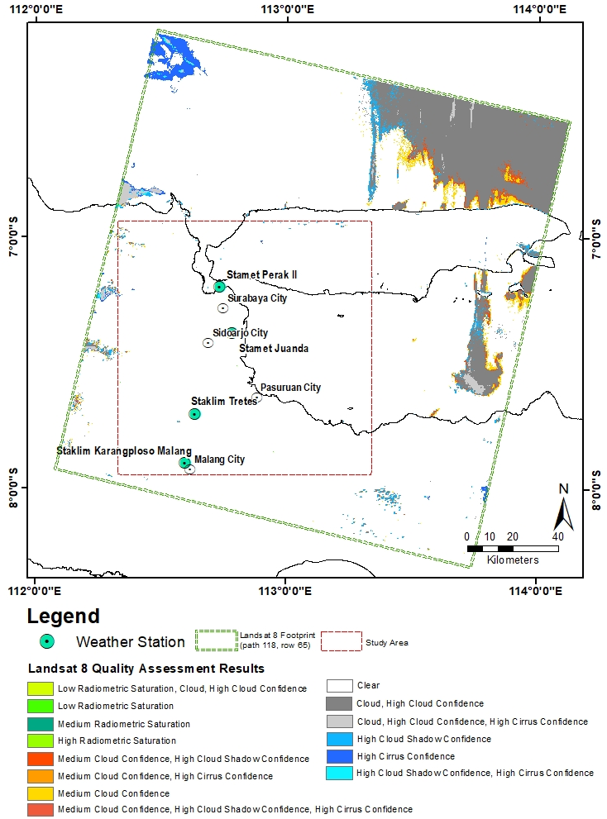
Figure 1 Landsat 8 Scene Feasibility Result

3.2 Oversaturation Correction

Detection of the oversaturated pixel using abnormal NDVI is taken into consideration due to the DN value of band 4 (red) and band 5 (NIR) reaches the maximum value of 65535 which indicates the oversaturation issue (USGS 2019). The detection using abnormal NDVI value resulted in 1.7% (173.744) abnormal pixel of the total pixel in the study area relative to Landsat 8 product, with most of it has < -1 value (173.741 pixels, mostly occurred in inland water bodies and Lusi Mud Volcano) and the rest has > 1 value (3 pixels). This kind of behavior surely hinders the calculation of the Proportion of Vegetation (PV) which utilizes both maximum and minimum value of NDVI in regards to Land Surface Emissivity retrieval to enhance the accuracy of LST. Therefore, we managed to utilize these oversaturated pixels as a mask, then use the produced mask on the DN products, and finally redo the NDVI calculation which resulted in an acceptable range (-0.999 to 0.823) as it is described in figure 1.

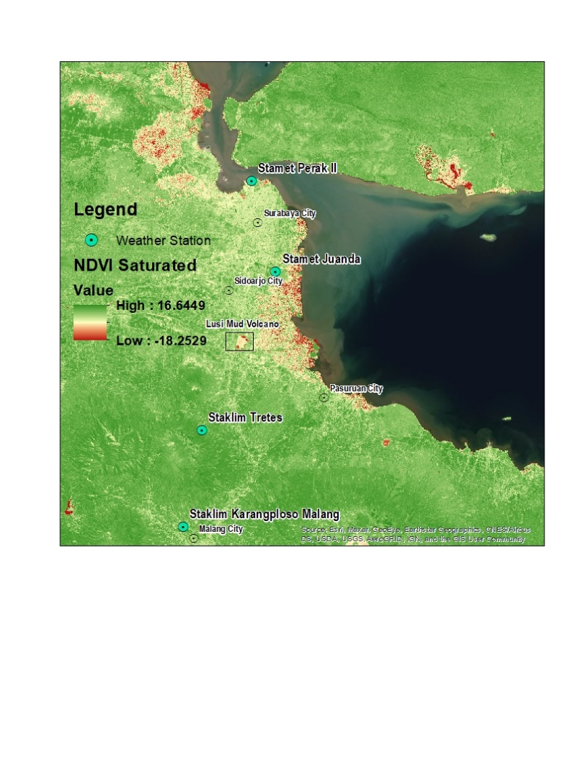
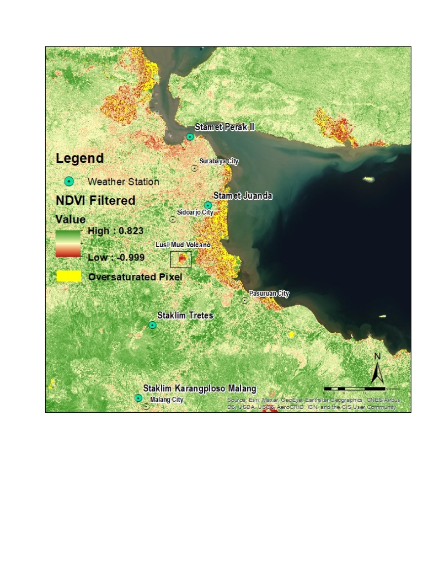

Figure 2 Oversaturation Correction Using Abnormal NDVI Value

3.3 LST Retrieval of Landsat 8, Modis Terra, and Sentinel 3.

Once we managed to resolve the oversaturation issue of the Landsat 8 product, the LST retrieval was accomplished by considering the nonunity of Land Surface Emissivity (LSE) to enhance the reliability of LST for both 30m and 1km Landsat 8 LST results. Different LST products retrieved from the different sensor that consists of Modis Terra and Sentinel 3 were also accomplished using the LST end product with a lower spatial resolution (1km) but the high temporal resolution (daily). Based on figure 2, all the results have similar patterns where the LST tends to get higher in the urban and coastal areas, while it is lower in the mountainous area with different magnitude. The distribution of oversaturated pixel (yellow pixel color) did not appear adjacent to the location of four available weather stations, thus the validation process in the latter part can be carried on.

3.4 Validation of LST Retrieval

LST retrieval based on remotely sensed data through satellite observation needs to be validated with the available instrument on the ground level. Due to the unavailable in-situ measurement of LST in the study area, we managed to use the four weather stations with the daily observation of air temperature. Based on table 1, the acquisition hour of the three different sensors we used is around 10.00 to 11.00 am local time, thus we used the maximum daily air temperature instead of the average daily air temperature. The validation result of LST retrieval is described in table 3.
The validation results showed that the Landsat 8 product in both 30m and 1km spatial resolution has better agreement with air temperature data in every available weather stations. This indicates that the nonunity assumption of Land Surface Emissivity (LSE) retrieved from the Proportion of Vegetation based on NDVI value could have better agreement with air temperature. In terms of the acquisition date, Modis Terra can't have the same date due to the quality assurance issue resulted in no coverage of LST value within the study area, thus we managed to use the following date as the comparison. We realized by using the air temperature to validate the LST cannot be fully guaranteed since both measures different physical meanings, which we have taken into consideration in the later discussion part.

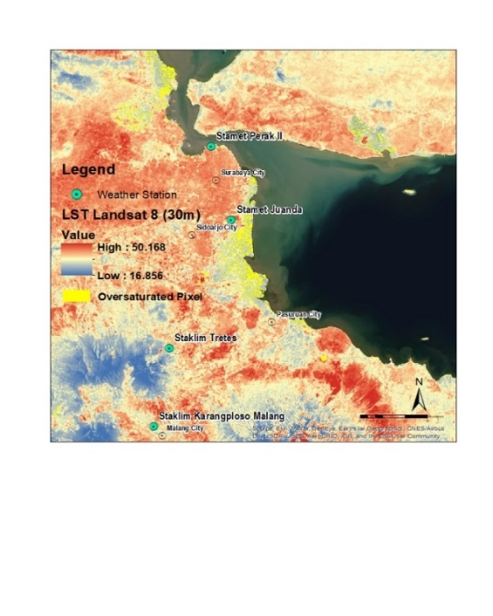
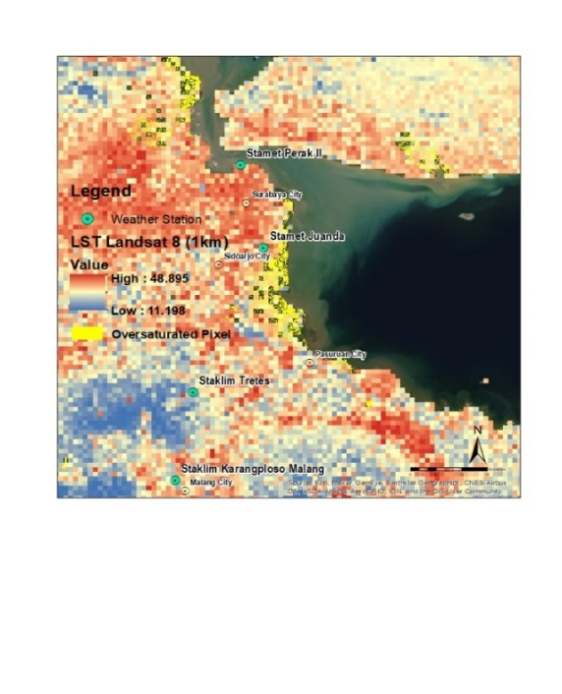
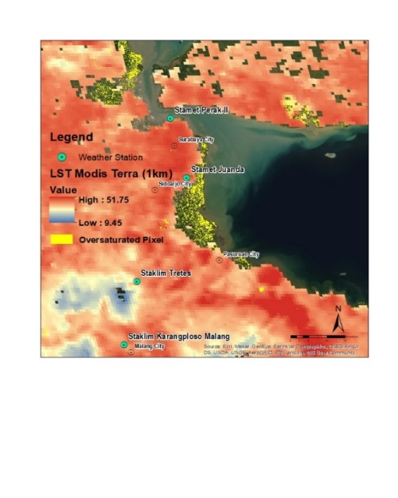
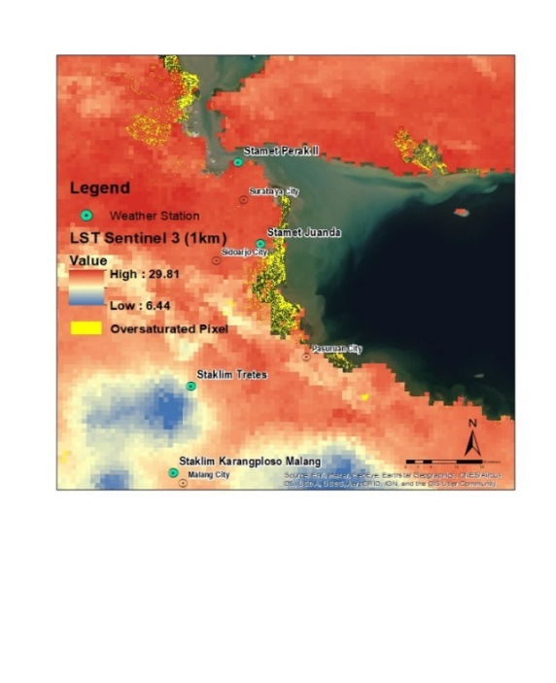

Figure 3 LST Retrieval from Landsat 8 (30m and 1km), Modis Terra and Sentinel 3

Table 3 Validation of LST Retrieval
Weather Station | Air Temp  (ºC Max.) | LST Retrieval (ºC)
 |  | Landsat 8 |  | Modis Terra | Sentinel 3
 |  | 30m | 1Km
Staklim Karangploso Malang | 32.5 | 33.9 | 28.8 | 37.6 | 22.3
Stamet Juanda | 33.4 | 38.6 | 40 | 43.1 | 27.8
Stamet Perak II | 35.4 | 36.2 | 35.2 | 38.4 | 28.1
Staklim Tretes | 31.0 | 33.7 | 32.5 | 36.8 | 19.1
Acquisition Date | 01-10-2019 | 01-10-2019 |  | 02-10-2019 | 01-10-2019
Acquisition Hour | Max. (Daily) | 10.00-10.25 |  | 10.00-11.00 | 10.00

Weather Station | Air Temp  (ºC Max.) | Difference (ºC)
 |  | Landsat 8 |  | Modis Terra | Sentinel 3
 |  | 30m | 1Km
Staklim Karangploso Malang | 32.5 | -1.4 | 3.7 | -5.1 | 10.2
Stamet Juanda | 33.4 | -5.2 | -6.6 | -9.7 | 5.6
Stamet Perak II | 35.4 | -0.8 | 0.2 | -3 | 7.3
Staklim Tretes | 31.0 | -2.7 | -1.5 | -5.8 | 11.9
Acquisition Date | 01-10-2019 | 01-10-2019 |  | 02-10-2019 | 01-10-2019
Acquisition Hour | Max. (Daily) | 10.00-10.25 |  | 10.00-11.00 | 10.00

4. DISCUSSIONS

The clear result (no cloud cover nor radiometric saturation) of the Landsat Quality Assessment process does not guarantee to eliminate the oversaturation issue that occurs within band 4 and 5. Furthermore, the corrected NDVI result still has some uncertainties which the below threshold value is still close to -1 (0,999) based on the histogram. This finding indicates that the NDVI based correction cannot fully eliminate the oversaturated pixel, thus the direct filtering from the oversaturated bands could fully eliminate this issue if only the certain thresholds are known beforehand.
In regards to the occurrence of the oversaturated pixel over inland water bodies, we investigated this issue by measuring the turbidity of the water since the turbid water has higher reflectance over the clear water (Bukata, 1995), this might cause the DN of band 4 and 5 reaches the maximum (65535). We used the Normalized Difference Turbidity Index (NDTI) to investigate this issue as it is explained in figure 4. The result showed that the NDTI value distribution relative to the oversaturated pixel based on NDVI analysis does not indicate any extreme turbidity over inland water bodies. The reason behind this might because the band 3 (green) that is used to calculate the NDTI does not experience any oversaturation issue unlike band 4 and 5 in case of NDVI calculation.

Figure 4 Normalized Difference Turbidity Index (NDTI) for the whole study area and based on oversaturated pixel

Conducting LST retrieval from multiple different sensors of satellite imagery could pose upcoming challenges such as different spatial resolution, different algorithms, and land surface emissivity used, as well as the quality assurance issue. In regards to the quality assurance issue, we experienced this issue within the MOD11A1 Daily LST product used in this study, thus the acquisition date was not possible to be matched with the other sensors and later might cause the unreliable result of the validation process. Moreover, validation of LST derived from the remotely sensed image through satellite observations remains a difficult challenge for developing countries like Indonesia to overcome due to the insufficient distribution of ground observation. This fact leads us to use the daily maximum air temperature data to validate the result. Although the LST and air temperature have different physical meanings, the agreement of time series analysis between LST derived from satellite observation compared to the air temperature resulted in good agreement in several studies (Laaidi et al. 2011; Kawashima et al. 2000; Mutiibwa, Strachan, and Albright 2015).

5. CONCLUSIONS

The occurrence of the oversaturated pixel in the optical sensor still presents even the product is passed the Landsat Quality Assessment Tools (cloud and radiometric saturation free) and NDVI based oversaturation correction by using the abnormal value (<-1 and >1) as the mask. LST retrieval from multiple different satellite observations is possible to conduct in regards to optimize the spatial and temporal resolution but still needs careful consideration in terms of acquisition time as well as the quality issue that differs from each sensor. Although in most cases air temperature has good agreement with LST measurement from satellite observation, the importance of LST in situ measurement especially in Indonesia as a developing nation that mostly relies on the agricultural sector remains a challenge to provide as it is useful to enhance and validate the result of LST derived from the optical satellite.

REFERENCES

Bukata RP, Jerome JH, Kondrateyev KY, Pozdnyakov DV. 1995. Optical Properties and Remote Sensing of Inland and Coastal Waters. Boca Raton, FL: CRC Press.
Dousset, B., Gourmelon, F., Laaidi, K., Zeghnoun, A., Giraudet, E., Bretin, P., Mauri, E., and Vandentorren, S. (2011). Satellite monitoring of summer heat waves in the Paris metropolitan area. International Journal of Climatology, 31, 313-323.
Hain, C.R., Cammalleri, C., Yang, Y., Xia, T., Sanchez, L., Alsina, M.M., and Velez, M. (2016). Monitoring daily evapotranspiration over two California vineyards using Landsat 8 in a multi-sensor data fusion approach. Remote Sensing of Environment, 185:155-170.
Kawashima, Shigeto, Tomoyuki Ishida, Mitsuo Minomura, and Tetsuhisa Miwa. 2000. “Relations between Surface Temperature and Air Temperature on a Local Scale during Winter Nights.” Journal of Applied Meteorology 39: 1570–79.
Laaidi, Karine, Abdelkrim Zeghnoun, Emmanuel Giraudet, and Philippe Bretin. 2011. “Satellite Monitoring of Summer Heat Waves in the Paris.” 323(September 2010): 313–23.
Lacaux, J. P., Tourre, Y. M., Vignolles, C., Ndione, J. A., and Lafaye, M.: Classification of ponds from high-spatial resolution remote sensing: Application to Rift Valley Fever epidemics in Senegal, Remote Sens. Environ., 106, 66–74, 2007.
Li, Zhao Liang et al. 2013. “Satellite-Derived Land Surface Temperature: Current Status and Perspectives.” Remote Sensing of Environment 131: 14–37. http://dx.doi.org/10.1016/j.rse.2012.12.008.
Mutiibwa, Denis, Scotty Strachan, and Thomas Albright. 2015. “Land Surface Temperature and Surface Air Temperature in Complex Terrain.” 8(10): 4762–74.
Prata, A. J., Caselles, V., Coll, C., Sobrino, J. A., & Ottlé, C. (1995). Thermal remote sensing of land surface temperature from satellites: Current status and future prospects. Remote Sensing Reviews, 12, 175–224.
Rouse, J. W., R. H. Haas, J. A. Schell, and D. W. Deering (1973) 'Monitoring vegetation systems in the Great Plains with ERTS', Third ERTS Symposium, NASA SP-351 I, 309-317.
Semmens, K.A., Anderson, M.C., Kustas, W.P., Gao, F., Alfieri, J.G., McKee, L., Prueger, J.H., Hain, C.R., Cammalleri, C., Yang, Y., Xia, T., Sanchez, L., Alsina, M.M., and Velez, M. (2016). Monitoring daily evapotranspiration over two California vineyards using Landsat 8 in a multi-sensor data fusion approach. Remote Sensing of Environment, 185:155-170.
Sobrino, José A., Juan C. Jiménez-Muñoz, and Leonardo Paolini. 2004. “Land Surface Temperature Retrieval from LANDSAT TM 5.” Remote Sensing of Environment 90(4): 434–40.
Sobrino, J. A., Oltra-Carrió, R., Soria G., Jiménez-Muñoz, J. C., Franch, N., Hidalgo, V. et al. (2013). Evaluation of the surface urban heat island effect in the city of Madrid by thermal remote sensing. International Journal of Remote Sensing, 34, 3177-3192.
United States Geological Survey (USGS)., (2017). Landsat Quality Assessment (QA) Tools v1.4. USGS.
United States Geological Survey (USGS)., (2019). Landsat 8 (L8) Data Users Handbook v5.0. USGS.

