Spatial variation in implementation of rural development programmes in various Panchyats of Himachal Pradesh, India
Meher Kaushal (1), Sunil Sharma (2) & Brijesh Saklani (3)
1 Department of Electronics & Communication, SRM Institute for Science & Technology
Chennai, Tamil Nadu, India
2 Haryana Space Application Centre (HARSAC), Hisar, Haryana, India
Aryabhata Geo-informatics & Space Application Centre
3 State Council for Science Technology & Environment, Shimla, Himachal Pradesh, India
Email: meherkaushal15@gmail.com
ABSTRACT

Natural resources are divine and God gifted assets to a region and are significant contributor to development of that region. The infrastructure is treated as an engine of growth and provides a basic framework for economic and social progress. Physical infrastructure strengthens the economy, boosts investment, attracts prospective entrepreneurs and helps alleviation of poverty and reduces unemployment incidence. Similarly social infrastructure like drinking water supply, sanitation, education, health etc helps in improving quality of life of millions of rural inhabitants. Rural Development Department is responsible for implementing various national and state level aimed at improving economic and social status of rural inhabitants, However regional disparities are observed in in implementation of rural development programmes. The Space technologies (Remote Sensing, Geographic Information System (GIS) & Global Positioning System (GPS) in conjunction with Information Technology (IT) are tool par excellence for generating, visualizing and sharing information on distribution of local resources present naturally as well as created under various central and state sponsored development programmes. A project was carried out to map spatial distribution of natural resources and conduct comparative assessment of Development Infrastructure created through rural development programmes in Chamyanna, Malyanna and Pujarali panchyats of Himachal Pradesh using geo-informatics. It aimed at identification and mapping of the local resources spatially and understanding the problems and potentialities of each resource (natural and manmade) of each panchyat. It provides the basic details in GIS format for the planning the development activities of panchyats. The Indian Remote Sensing Satellite Cartosat - 1images are the basic remote sensing data which has been used for mapping the panchyats. The study revealed that in context of overall development and implementation of various development schemes, the Pujarali Panchayat takes lead followed by Chamyanna panchyat. However Malyanna panchyat is least developed in terms of socio-economic infrastructure/implementation of rural development schemes.

INTRODUCTION

The process and practice of planning are getting decentralized to lower area units to make them area specific and responsive to needs of local people. The XIth five year plan (2007-12) lays emphasizes on drawing up of development plans by grass root Institutions, capacity building of these institutions and requirement of sharing
developmental information with the beneficiaries. The Gram Panchayat is the foundation of the Panchayat System and it is extremely important to empower Gram Panchayat in terms of resource database creation and
use of the same for better future. Spatial information of the available resources is a pre-requisite for developing grass root level developmental plans, attaining the goals and for the time bound completion of the developmental-plans. A new wave of technological innovation is allowing us to capture, store, process and display an unprecedented amount of spatial information about natural resources and infrastructure development. Geospatial Resource Information System is designed for the identification and mapping of the local resources spatially and understanding the problems and potentialities of each resource as well as infrastructural development in each panchayat. Geospatial plan helps in upkeep of existing infrastructure, identifying gaps in the existing facilities and planning establishment of an asset based on geospatial analysis of various variables, action plan generation for rural development as well as comparative assessment of Development Infrastructure created through rural development programmes (Ambasta, 2010; Asadi et al., 2011 Manikkumaran, 1997; Mukherjee, 2011; Scaria and Vijayan 2012; Jain K and Subbaiah, 2007). A project was carried out to map spatial distribution of natural resources and conduct comparative assessment of Development Infrastructure created through rural development programmes in Chamyanna, Malyanna and Pujarali panchyats of Himachal Pradesh using geo-informatics.

2. MATERIALS & METHODOLOGY

2.1 Study Area
The Three Panchayats selected for the present study named Chamyanna, Malyanna and Pujarali lie in the

Mashobra block of Shimla district and are adjoining to the Shimla Urban Area. The Shimla District lies between
30°45” to 31°44”N Latitude and 77°0” to 78°19”E Longitude. It has geographical area of 5131 sq. km (Balokhra, 2005: Jeart, 2005).

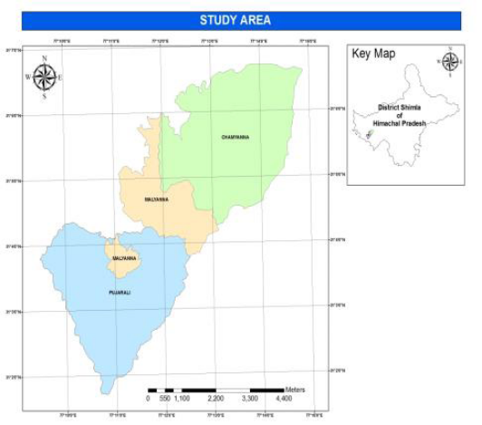

Figure1 Location map of Study Area
2.2 Data Used
The details of various spatial and non-spatial data used in this study area are given below:

2.2.1 Remote Sensing Data
Cartosat - I images are the basic remote sensing data which has been used for mapping the Panchayats.

2.2.2 Ancillary/Collateral Data
Administrative boundary of State, District, Block and Panchayat, Panchayat Asset Registers.

2.2.3 Ground Truth Data
The location of various natural and manmade resources was determined with the help of Maps and Global
Positioning System.

2.2.4. Mapping & Creation of Geo-database
- Field Survey: The Ground Control Points (GCPs) were taken using GPS Mobile (Samsung Wave 525)
- Geo-Referencing: The satellite data was geo-referenced in Arc GIS
- Layer Creation: The following raster and vector layers were created in Arc GIS
- Land use/Land Cover
- Digital Elevation Model,
- Drainage,
- Roads
- Water Tanks
- Educational Facilities,
- Medical Facilities
- Veterinary Institutions
- Anganwaris
- Other Socio-economic structures
- Map Creation:-The map outlay was created in Arc GIS

3. RESULTS & DISCUSSION

3.1 Natural Resources
3.1.1 Land use/Land cover & Digital Elevation Model
The total sprawl of the study area covering three panchyats is 32.07 sq. km. Approximately 14.37 sq. km, 3.63 sq.km., 12.65 sq. km. and 1.42 sq. km area falls under forest, agriculture and grassland and settlements respectively. The catchment area of the Chamyanna Panchayat, Sargheen, Goasn and Beolia Villages of Pujarali Panchayat and the Malyanna village of the Malyanna Panchayat are extensively covered by the rich forests. Vegetables are mainly grown on agriculture area in all the three Panchayats (Figure 2).The elevation in the study area ranges between 1238-2601m in the study area (Figure 3).
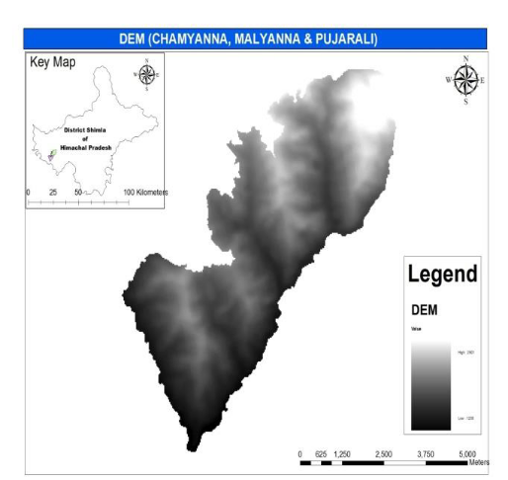
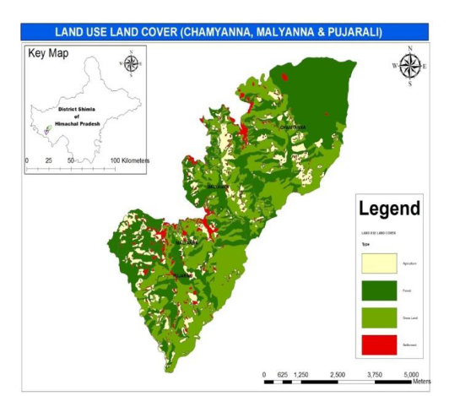

Figure 2 Landuse /Landcover of the study area Figure 3 Digital Elevation Model of the study area

3.1.2 Drainage & Hydrology
There are three main streams in the study area. All these meet at a point called ‘Dogla Nala’. These carry excess rain water from hills in the rainy season. Physiography of the three panchayats separates these from each other and meets near the Sadhupul and Dogla Nala. Figure 5 represents the hydrological system of the study area and includes drainages, water tanks, tubewells, bawadies and hand pumps. Water tanks are mainly constructed under the Mahatma Gandhi National Rural Employment Guarantee Act (MNREGA) scheme. Bawadies are mainly used for drinking water.
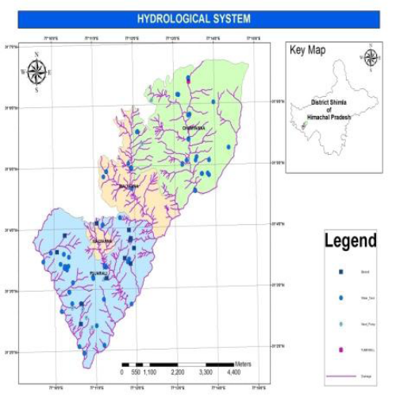
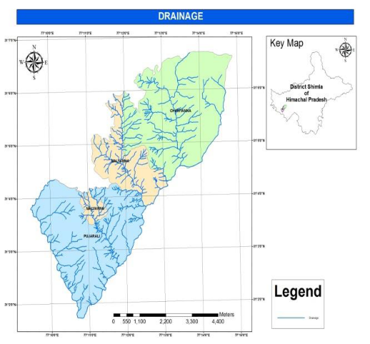

Figure 4 Drainage system in the study area Figure 5 Hydrological system in the study area

3.2 Infrastructure
3.2.1 Medical Institutions & Veterinary Institutions
The primary health centres are the only medical institution in the study area. They provide the basic medical facilities and other medical aids to the villagers. Figure 6 depicts the location of health centres in the study area.
The Chamyanna panchyat has one Primary Health centres while pujarali panchyat has one primary health centre
and one Ayurvedic Health Centres providing the basic medical facilities to the population. There are four Veterinary Institutions in the study area. Two veterinary dispensaries are located in the Pujarali panchayat at Dhamechi and Sargheen village, whereas one veterinary institute is located at Chamyanna and Malyanna Panchayat each (Figure7).
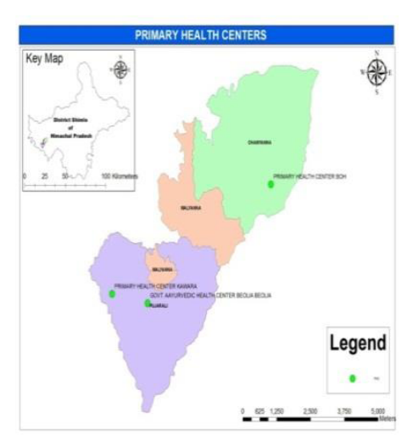
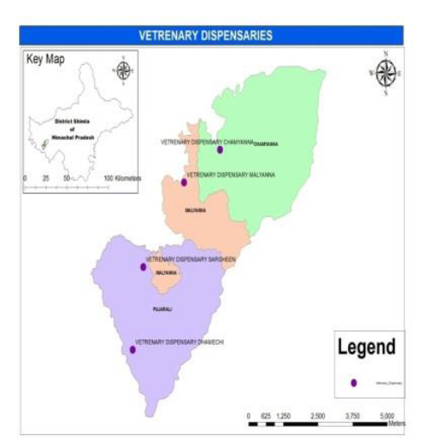

Figure 6 Medical Institutions in Study Area Figure 7 Veterinary Institutions in Study Area
3.2.3 Educational Institutions
The study revealed that there are five Govt. Primary Schools, one Govt. Middle School and one Govt. Senior secondary School in the Chamyanna Panchayat and five Govt. Primary Schools and one govt. senior secondary
school in the Pujarali Panchayat (Figure 8).The study revealed that there are four anganwari centres in the Chamyanna panchayat and two anganwari centres in the Pujarali panchayat (Figure 9).
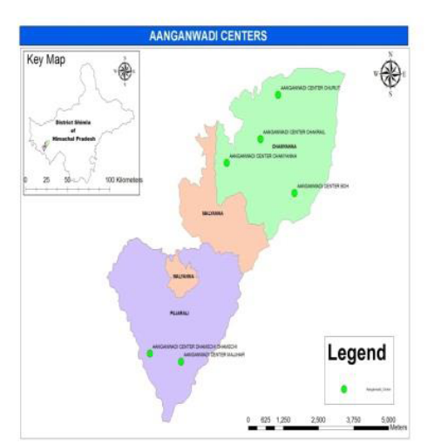
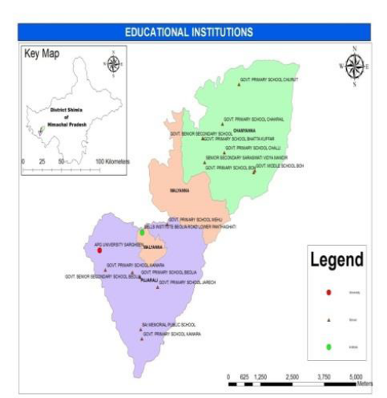

Figure 8 Educational Institutions in study area Figure 9 Aanganwari Centres in the Study Area

3.3 Assets Created Under Various Schemes
The spirit of India lives in villages and only by changing the face of rural areas, there will be better future for the State and nation as a whole. The Rural Development Department is engaged in changing the face of rural Himachal through its many fold development schemes, working in a participatory manner with the rural folks. (Report of National Bank for Agriculture and Rural Development (NABARD), HP, 2009; Annual report of planning department Government of Himachal Pradesh, 2008; Annual Report., 2011; India Infrastructure Report, 2007; Report on Total Sanitation Campaign (TSC) in Himachal Pradesh, 2011).

3.3.1 Pradhan Mantri Gram Sadak Yojna (PMGSY): Rural roads
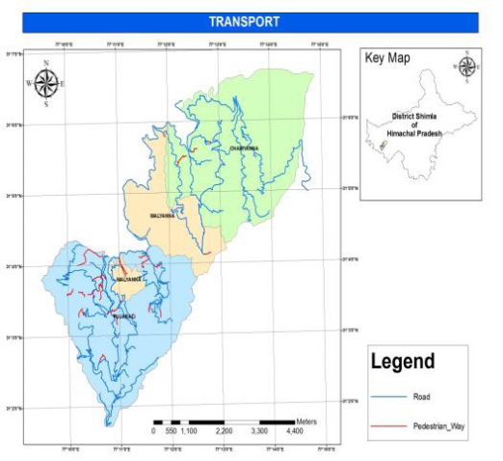
Pradhan Mantri Gram Sadak Yojna (PMGSY) is a centrally sponsored scheme with the primary objective of providing connectivity by way of an all-weather road to the eligible and un-connected habitations in the rural area. The study shows that all the villages are connected through the pedestrian ways. The pedestrian ways are constructed under the MNREGA Scheme (Figure-10 and Figure- 11).

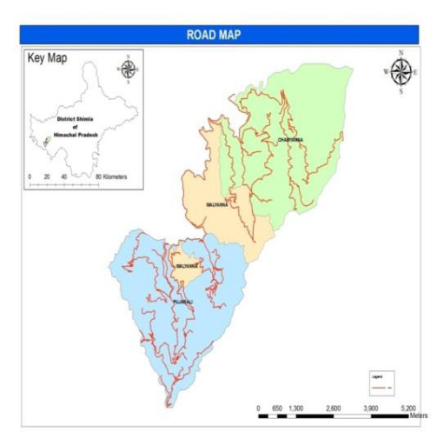

Figure10 Road map of study area Figure11 Distribution of Pedestrian Way in the study area

3.3.2 Indira Awas Yojana/ Indira Awas Yojana: Rural Housing

Indira Awas Yojana (IAY) is a Centrally Sponsored Scheme. Under this Scheme, assistance of Rs. 38,500/- per
beneficiary is being provided to to Rural Below Poverty Line (BPL) families for the construction of new houses
upto 31-3-2010. Atal Awas Yojana (AAY) is a State sponsored scheme aimed at provide housing facility to Rural BPL houseless families. Figure12 shows that four houses are built under Awas yojna in Chamyanna panchyat as compared to one in Pujarali panchyat.

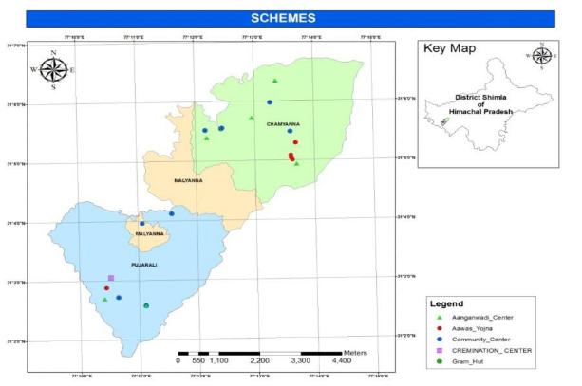

Figure 12 Distribution of Awas Yojna schemes, Aanganwadi Centres, Community Centres, Cremation
Centre and Gram Hut.

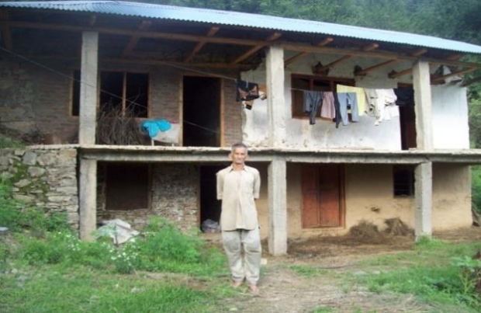
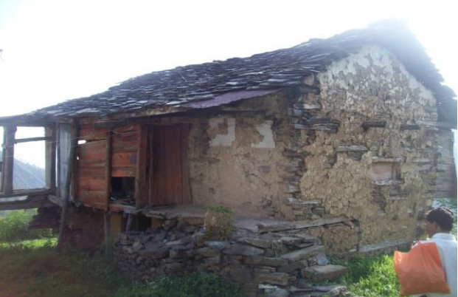

Figure 13 House of Sh.Puran Chand S/O Sh. Chet Ram (Beneficiary) Vill.Kalhali, Chamyana

3.3.3 Mahatma Gandhi National Rural Employment Guarantee Act-2005 (MNREGA):

Employment Generation Schemes
The Mahatma Gandhi National Rural Employment Guarantee Act (MNREGA) aims at better livelihood security of households in rural areas of the country by providing at least one hundred days of guaranteed wage employment to do unskilled manual work permissible under MGNREGA. The water tanks are mainly those spatial features in the study area which are constructed through different programmes like MGNREGA. Vegetables are mainly grown with the help of these water tanks. There are 28 water tanks constructed in Pujarali panchyat as compared to 22 in Chamyanna panchyat. There are 5 water tanks in Malyanna panchyat.
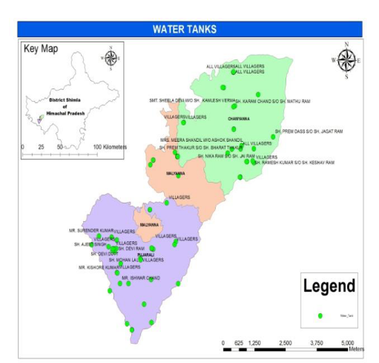
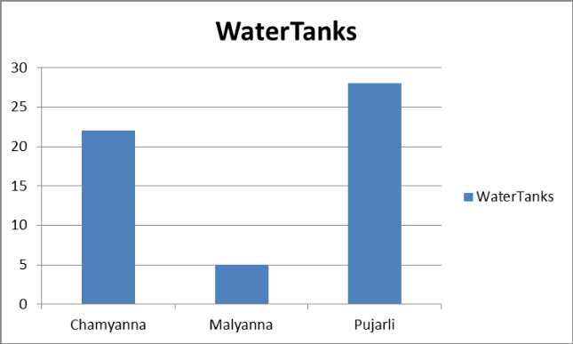

Figure 14 Distribution of water tanks Figure 15 Comparison of establishment of water
tanks
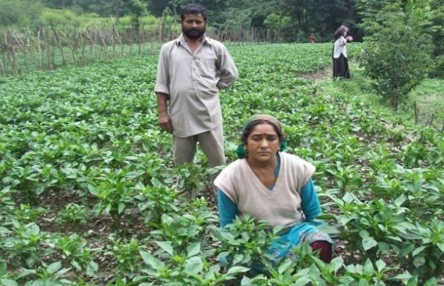
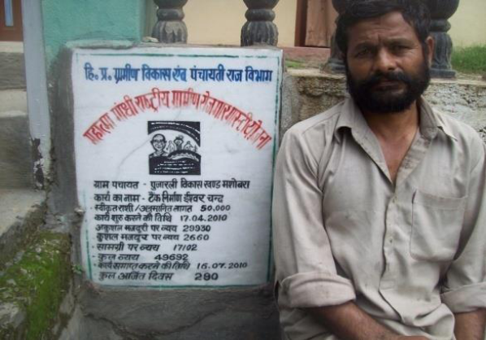

Figure16 Water Tank (Irrigation) Under MNREGA Scheme Beneficiary: Ishwar Chand s/o Late Sh.
Kanshi Ram, Vill. Dhamechi (Sanctioned Amount Rs.50000/- Location N 31° 02’ 46.5’’ E 77° 10’ 25.3”
Alt. 1504m)

3.3.4 Total Sanitation Campaign (TSC): Rural Sanitation
The main objectives of Total Sanitation Campaign (TSC) is to accelerate sanitation coverage, cover all schools
and anganwadis with sanitation facilities and promote hygiene behaviour among students and teachers, encourage cost effective and appropriate technology development and application, and endeavour to reduce water and sanitation related diseases in the study area. Figure 17 show the spatial distribution of sanitation facilities under the TSC programs. Six new toilets in Chamyanna panchyat and 4 new toilets have been built in Pujarali panchyat under TSC programme.However, there is only one garbage collection centre for three panchyats housed at chamyanna panchyat.

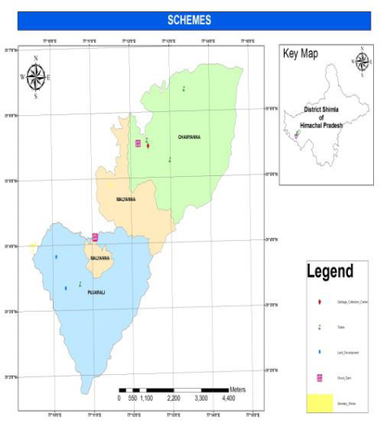

Figure 17 Distribution of Garbage Collection Centre, Toilets, Land Development, Check Dams, Sanitary Works.

7.5 Development of Common Property Resources (CPR) under various schemes
The other schemes include construction of Rain Shelters, Protection/Retaining Wall, Poly Houses, Garbage
Collection Centre, Toilets, Land Development, Check Dams, Sanitary Works & Khel Maidan.
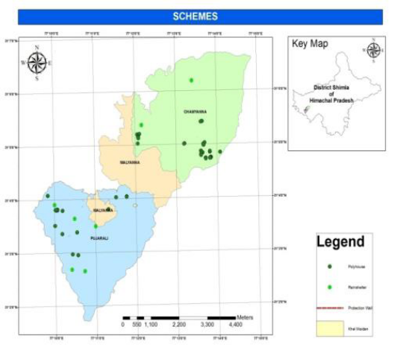

Figure 18 Distribution of Poly houses, Rain shelter, Protection Wall and Khel Maidan
CONCLUSIONS

The effective planning, monitoring and decision making of any developmental activity mainly depends on the reliable, updated and relevant information system. Recent advances in geo-informatics and information technologies is enabling generation/updation of such iformation thereof facilitating planning developmental activites. Based on study, following are the conclusions:

- The Panchayat Resource Information System developed for three Panchayats of Shimla district depicts status of land use, water resources, socio-economic facilities created under various government schemes.

- The study area covering Chamyanna, Malyanna and Pujarali panchyats presents entirely mountainous and valley shaped topography. The highest proportion of land is contributed to forest only. Although the study area is dominated by agricultural activities but the agriculture yield is low which can be attributed to hilly terrain and small size of land holding and insufficient irrigation facilities

- The construction of water tanks under various developmental scheme is enabling villagers to cultivate vegetables and enhance their income.The total number of water tank constructed under the above mentioned programmes is 50 with pujarli taking a lead with 28 water tanks. It is suggested to develop water tanks in both Panchayats to enhance the irrigation facilities. The suitable sites for the same purpose can be suggested with the help of GIS techniques.

- The total population of Chamyanna, Malyanna and Pujarali panchyats is 1821 persons (Male 935, Female 886), 1360 Persons (Male 720, Female 640) and 3450 persons (Male 1750 and Female 1700) respectively.

- The Chamyanna Panchayat (having hilly terrain) has only one primary health centreDue to the hilly terrain of ChamiyanaPanchayatthis medical institution fails to meet the requirements of the villagers because they have to travel more distance to avail medical facility.

- Although both the Panchayats Chamyanna and Pujarali have sufficient educational institutions but it is again necessary to improve the existing infrastructure to meet the basic requirements of the local masses. Due to the hilly terrain of ChamyannaPanchayat the educational institution fails to meet the requirements of the villagers because they have to travel more distance to take the education.

- The various developmental projects running under MNREGA provides employment to the local peoples in all the three panchyats.

- Four houses are constructed under IAY and AAY and in Chamyanna panchayat as compared toone house constructed in Pujarali panchyat.

- Three toilets have been constructed in Chamyanna panchayat as compared to1 constructed in Pujarali panchyat TSC.

- The Pujarali panchyat has built 5 rainshelters as compared to 2 in Chamyanna panchyat.

- In context of overall development and implementation of various development schemes,the Pujarali Panchayattakes lead followed by Chamyanna panchyat. However, Malyana panchyat is least developed in terms of socio-economic infrastructure / implementation of rural development schemes.

REFERENCES

- Ambasta, P., 2010. MENREGA and Rural Governence reform, growth with inclusion through Panchayats’Paper for International Conference on. Dynamics of Rural Transformation in Emerging Economies. Planning Commission, Government of India and Institute for Human Development,. India.

- Annual Report., 2011. Natural Resources Data management System. pp. 157-167.

- Annual Report., 2009. National Bank for Agriculture and Rural Development, H P . Evolution of Rural
- Entrepreneurship Development Programe in Himachal Pradesh.. Evaluation study series, H. P. RO No. 4 pp.43

- Annual Report., 2009. Planning Department Government of Himachal Pradesh. Evolution of Ghandi Kutir Yojana in Himachal Pradesh. pp 42.

- Asadi, S.S., Vasantha Rao, B. V. T., Raju, M. V. and Anji Reddy, M., 2011. Creation of Integrated Rural Development information System using Remote Sensing and GIS – A Model Study on Prakasam District Andhra Pradesh. International Journal on Computer Science and Engineering .3(11):3587-3595.

- Balokhra, J.M., 2006. The Wonderland Himachal Pradesh: An Encyclopedia, H.G Publication. New Delhi, pp 922-927.

- Jain K and Subbaiah Y. V., 2007. Site Suitability Analysis for Urban Development Using GIS. Journal of Applied Science, 7(18): 25-32

- Jeart. M., 2006. Geography of Himachal Pradesh, Indus Publication Company in association with Integrated Institute of Himalayan studies, Himachal Pradesh University, Shimla pp 47-53.

- Manikkumaran, P. 1997. Agricultural Growth, Rural Poverty and Environmental degradation in Tamil Nadu, Annamalai University,Unpublished M. Phil dissertation, Mukherjee, S., 2011. Application of ICT in Rural Development opportunity and Challenges. Global media journal, Indian edition, 2: 1-8.

- Report of Ministry of Earth Science 2011: Establishment of natural GIS under Indian national GIS organization (INGO), submitted to Planning commission. pp.113. Report of the Ministry of Water Resources 2011: Major and medium irrigation and command Area Development for the XII five year Plan (2012-2017), pp 216.

- Report on Total Sanitation Campaign in Himachal Pradesh, 2011. Department of Rural Development, Himachal Pradesh.

- Scaria R., and Vijayan P. K., 2012. Sustainable rural development with the application of Spatial Information Technology and Mahatma Gandhi national rural employment guaranteed scheme. International journal of Geomatices and geosciences. 2(4):1040-1061.

