A Novel Way to Calculate Shortwave Black Carbon Direct Radiative Forcing

Wei Chen (1), Zhe Wang (1), Hengyang Wang(1), Haimeng Zhao(2),Kai Qin(3)

1 College of Geoscience and Surveying Engineering, China University of Mining & Technology, Beijing 100083, China
2 Guangxi Colleges and Universities Key Laboratory of Unmanned Aerial Vehicle (UAV) Remote Sensing, Guilin University of Aerospace Technology, Guilin 541004, China
³ School of Environmental Science and Spatial Informatics, China University of Mining and Technology, Xuzhou 221116, China
Email: chenw@cumtb.edu.cn; wangzhecumtb@gmail.cn;zhaohaimeng@guat.edu.cn;qinkai@cumt.edu.cn

KEY WORDS: empirical formula method; broadband method; multiband synthetic method; narrowband; broadband

ABSTRACT: The direct radiative forcing (DRF) of black carbon (BC) aerosols can change the atmospheric radiative balance, which has important effects on the atmosphere and the environment. At present, MODIS only provides black sky albedo (BSA) and white sky albedo (WSA) products, and lacks true surface albedo products. Therefore, some studies used WSA or BSA products when numerically simulating the shortwave BC DRF, ignoring the influence of atmospheric scattering effects. Some studies use the empirical formula method to calculate the shortwave BC DRF, and the empirical formula method uses the empirical formula to calculate the sky scattered light ratio of the broadband shortwave, thereby obtaining the blue sky albedo. And input the blue sky albedo and black carbon aerosol optical depth (BC AOD) into the 6S radiative transmission model to get the shortwave BC DRF. However, the empirical formula method is not reasonable, and the calculated sky scattered light ratio is easily affected by the solar zenith angle. Therefore, some studies have improved the empirical formula method and adopted a broadband method to consider the influence of atmospheric scattering effects. This method is based on the measured BC concentration data, AERONET data and, MODIS broadband shortwave WSA and BSA data to calculate shortwave BC DRF. According to the aerosol microphysical parameters and 550nm AOD, the sky scattered light ratio of the broadband shortwave is obtained through the 6S model, and the blue sky albedo of the broadband shortwave is calculated. Input the blue sky albedo and BC AOD into the 6S model to numerically simulate the shortwave BC DRF. However, the broadband method does not consider the difference of the sky scattered light ratio at different narrowband. This study improves the broadband method and proposes a multiband synthetic method to calculate shortwave BC DRF, and compares the differences in the BC DRF at the top of the atmosphere (TOA) and at the surface (SFC) of the three methods. The multiband synthetic method inputs the aerosol microphysical parameters, 550nm AOD and, MODIS 6 narrowband WSA into the 6S model to obtain the 6 narrowband sky scattered light ratios, and calculate the 6 narrowband blue sky albedo. According to the formula for synthesizing broadband shortwave albedo in narrow bands, the blue sky albedo of broadband shortwave is synthesized. Input the BC AOD and the synthesized broadband shortwave blue sky albedo into the 6S model to obtain the shortwave BC DRF. This study found that the BC DRF calculated by the three methods at the TOA is significantly different, while the difference between the three methods at the SFC is small. The values of BC DRF calculated by these three methods are multiband synthetic method, broadband method, and empirical formula method from high to low. Therefore, when calculating shortwave BC DRF, the difference in atmospheric scattering effects on narrow bands should be considered.

1.INTRODUCTION

Black carbon (BC) aerosol is produced by incomplete combustion of carbonaceous materials and by the burning of fossil fuels, biofuels, open-air biomass and municipal waste (Venkataraman et al., 2005; Chen et al., 2013). BC aerosols constitute the main component of carbonaceous aerosols. According to the source of BC aerosol, it can be divided into anthropogenic sources and natural sources (Resquin et al., 2018; Kant et al., 2020).BC aerosol, as the main light-absorbing particle in atmospheric aerosols, has a strong absorption capacity for solar radiation in the visible to infrared wavelength range (Yang et al., 2009). It can also change the temperature of the atmosphere and the ground and the stability of the atmosphere (Bibi et al., 2017; Talukdar et al., 2019).In addition, BC aerosol has a very significant effect on global warming and is the second most important factor in global warming, after carbon dioxide (Jacobson, 2001).BC aerosol is also a short-term climate forcing factor, which has important effects on climate change (Menon et al., 2002), the atmospheric environment, and human health (Lin et al., 2019).Currently, East Asia has become the main source of BC aerosols (Sadiq et al., 2015; Kang et al., 2017).
The direct radiative forcing caused by BC aerosols will have a certain impact on regional climate change (Zhuang et al., 2018). The black carbon direct radiative forcing (BC DRF) changes the earth-atmosphere radiative balance through the climate effect and directly generates a radiative effect (Menon et al., 2002). BC DRF is affected by many factors, such as SSA, AOD, asymmetry factors, surface albedo, and main meteorological conditions (Wu et al., 2016; Lu et al., 2020).The BC DRF has a significant influence on the atmospheric radiative balance. Bibi et al. (2017) found that the shortwave BC DRF at the top of the atmosphere (TOA) was positive and the shortwave BC DRF at the surface (SFC) was negative, as measured in Karachi from March 2006 to December 2008. These shortwave BC DRF affect the temperature at the TOA and SFC and within the ATM.
Currently, to calculate BC DRF, it is common to use MODIS broadband shortwave black sky albedo (BSA) or white sky albedo (WSA) to characterize surface reflection. However, these two albedo products are not enough to represent true surface reflection; therefore, it is necessary to use blue sky albedo (true surface albedo), which is not provided in current MODIS products (Schaaf et al., 2002). In some studies, BSA and WSA products are used, or a simple empirical formula is used to calculate the ratio of diffuse to total radiation in the incident light to obtain the true surface albedo. However, the calculated BC DRF will have a certain deviation because they are affected by the solar zenith angle (SZA) (Stokes and Schwartz, 1994). Chen et al. (2020) used the surface albedo of broadband shortwave to calculate BC DRFs. The sky diffuse light ratio in different wavelengths is largely neglected by assuming that the sky diffuse light ratio in the whole shortwave wavelength is a constant, which is not realistic since molecule and aerosol scattering vary greatly with the wavelength.
Therefore, this study proposes a new method to determine the shortwave BC DRF by synthesizing six narrowband blue sky albedos, which are calculated through MODIS narrowband BSA, WSA and AERONET observations. This new method is called the multiband synthetic method. Using microphysical parameters and aerosol optical depth (AOD) provided by the Aerosol Robotic Network (AERONET) and the 6S radiative transfer model, the sky diffuse light ratios of the six narrow bands of MODIS are calculated. Using the microphysical parameters of aerosols can improve the accuracy of the calculated sky diffuse light ratio. The MODIS narrowband BSA and WSA products on the Google Earth Engine (GEE) platform are then used to calculate the blue sky albedo in six narrow bands. The shortwave blue sky albedo is obtained through the formula of narrowband synthesis, and then, the BC AOD is obtained using OPAC software. Finally, the synthesized shortwave blue sky albedo and BC AOD are numerically simulated by the 6S radiative transfer model to obtain the BC DRF.

2.DATA AND METHODS

2.1Study Area

Xuzhou City (33°43′N–34°58′N, 116°22′E–118°40′E) is located in the northwestern part of Jiangsu Province and the southeastern part of the Huanghuai Plain, as shown in Figure 1. An important economic, cultural, financial, and foreign trade center in East China, Xuzhou City is within a warm temperate monsoon climate zone with four distinct seasons, moderate precipitation throughout the year, high temperatures and rain in summer, and susceptibility to cold waves in winter.

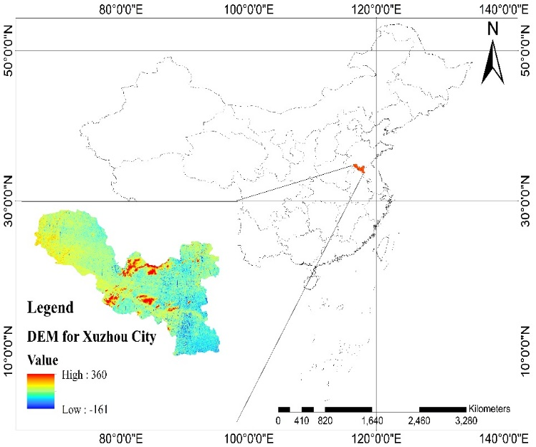
Figure 1 DEM map of the study area

2.2 Methods

2.2.1Empirical Formula Method

Some studies use the empirical formula method to calculate the BC DRF. First, the measured 880nm BC concentration data on the ground is converted into the BC number density, and then the 550nm BC AOD is obtained through the OPAC software package. Then use the empirical formula to calculate the diffuse light ratio. Stokes and Schwartz (1994) provides an empirical formula for calculating the ratio of diffuse light in the sky. And combine the WSA and BSA of broadband shortwave to calculate the blue sky albedo of broadband shortwave. Finally, input 550nm BC AOD and the blue sky albedo of broadband shortwave into the 6S model to obtain BC DRF. The empirical formula method is mainly to approximate the diffuse light ratio k and then obtain the blue sky albedo of broadband shortwave. The blue sky albedo calculated by this method is related to the solar zenith angle (SZA). However, the empirical formula method does not consider the effects caused by different aerosol conditions and is not accurate enough for use in the BC DRF calculation. The major problem of the empirical formula method is that the calculation of k lacks a theoretical basis (Stokes and Schwartz 1994).

2.2.2 Broadband Method

Chen et al. (2020) proposed a broadband method to calculate BC DRF. The broadband method uses the AOD and aerosol microphysical parameters (refractive index and size distribution), which can better estimate k with the help of the 6S radiative transfer model. The broadband method is used to calculate the direct solar radiation and diffuse sky radiation received by the surface in the broadband (0.25 ~ 4μm). The sky diffuse light ratio $(k)$ is calculated by these parameters (Table 1) in the whole broadband wavelength range. The broadband blue sky albedo can be calculated through broadband shortwave WSA and BSA with $k$. Then input 550nm BC AOD and the blue sky albedo of broadband shortwave into the 6S model to calculate the BC DRF of broadband shortwave.

2.2.3 Multiband Synthetic Method

The absorbing and scattering of BC aerosol will change greatly within the range of shortwave lengths. However, the empirical formula method and broadband method fail to consider the difference of the sky diffuse light ratio in different narrow bands, which will cause some errors in calculating blue sky albedo. Considering current problems in calculating BC DRF, this study proposes a multiband synthetic method utilizing AERONET data, aethalometer measurements, and MODIS narrowband BSA and WSA products.
The scheme of the new method is shown in Figure 2. The new scheme is mainly divided into four parts. The first part involves obtaining the measured 880 nm BC concentration from an aethalometer. The second part involves the conversion of the BC concentration into the BC number density to obtain the BC AOD with OPAC software ,assuming that the vertical distribution of the BC number density is exponential at a scale height of 2 km. The third part mainly involves extracting the 550 nm AOD and microphysical parameters from AERONET data and inputting them into the 6S radiative transfer model together with each narrowband WSA. After obtaining the respective sky diffuse light ratio of each narrow band combined with the narrowband BSA and WSA in six bands provided by the GEE platform, the narrowband blue sky albedo in six bands can be obtained. Through the narrowband blue sky albedo in six separate bands (Band 1:620-670 nm, Band 2:841-876 nm, Band 3:459-479 nm, Band 4:545-565 nm, Band 5:1230-1250 nm, and Band 7:2105-2155 nm), the broadband blue sky albedo will be calculated through the synthetic method provided in (Liang, 2001). The fourth part involves obtaining the instantaneous shortwave BC DRF by inputting the BC AOD and shortwave blue sky albedo into the 6S model. The daily average shortwave BC DRF is calculated by integrating the instantaneous shortwave BC DRF.
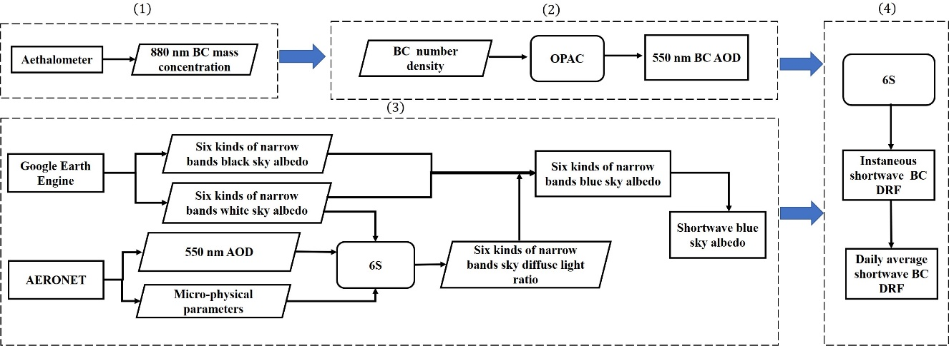
Figure 2. Flowchart for calculating the shortwave BC DRF according to the multiband synthetic method

3.RESULTS AND DISCUSSION

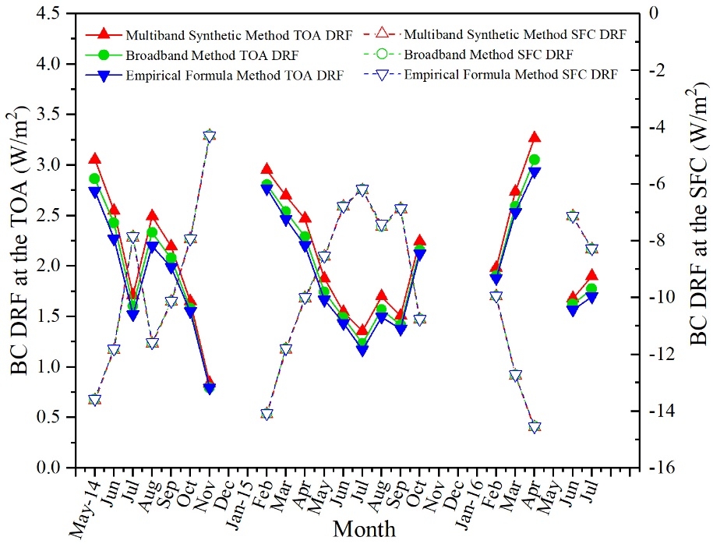
Figure 3. Monthly average shortwave BC DRF at the TOA and SFC calculated by three methods (empirical formula method, broadband method, and multiband synthetic method)

According to Figure 3,there are obvious differences in the shortwave BC DRF based on the Three methods at the TOA. The shortwave BC DRF calculated by the three methods in order from low to high is the empirical formula method, broadband method, multiband synthetic method. As shown in Figure 3,the shortwave BC DRF differences at the SFC are small in the three methods. The shortwave BC DRF calculated by the multiband synthetic method is higher than the broadband method and empirical formula method by 0.11% to 0.36% (at the SFC), 0.14% to 1.4% (at the SFC), 3.4% to 10.1% (at the TOA), 5.5% to 15.8% (at the TOA), respectively. It can be concluded that, among the three methods, shortwave BC DRF shows few changes at the SFC and relatively large changes at the TOA. Shortwave BC DRF at the TOA is directly affected by the reflected signals from the earth and backscattering signals of the atmosphere. BC DRF at the SFC is indirectly affected by the surface. The surface contributes little to sky scattering light, which is mainly affected by direct solar light and atmospheric conditions. Therefore, the BC DRF at the SFC is mainly affected by the atmosphere but not the surface, and the difference in albedo has very little effect on the BC DRF at the SFC. In addition, for the shortwave BC DRF, the diffusion effect of the narrow band is considered in the multiband synthetic method, and the shortwave BC DRF obtained is superior to that of obtained by the other two methods.

4.CONCLUSIONS

This study proposed a new method (multiband synthetic method) to calculate BC DRF by combining narrowband MODIS BSA and WSA products, AERONET data, and BC concentration measurements by an aethalometer. This new method takes the different sky diffuse light ratios in different wavelengths into account. The results of our new method were also compared with a commonly used empirical formula method and a broadband method with real BC aerosol measurements taken in Xuzhou from May 2014 to 2016.The results suggested that the annual average of the shortwave BC DRF at the TOA and SFC by the multiband synthetic method is $2.11±0.65W/{m^{2}}$ and $-9.66±2.96 W/{m^{2}}$,respectively. The shortwave BC DRF at the TOA estimated by the three methods (empirical formula method, broadband method, and multiband synthetic method) has a large difference, while the shortwave BC DRF at the SFC has a small difference. The shortwave BC DRF calculated by the empirical formula method and broadband method is lower than the shortwave BC DRF calculated by the multiband synthetic method. The empirical formula method and broadband method do not consider the scattering effects of different wavelengths, thereby leading to lower shortwave BC DRF than our multiband synthetic method. The shortwave BC DRF results obtained by using the multiband synthetic method are superior to those obtained using the other two methods. The results of this study suggest that it is important to consider the differences between different wavelengths when computing broadband shortwave blue sky albedo.

REFERENCES

Bibi, S., Alam, K., Chishtie, F., Bibi, H. and Rahman, S. (2017). Observations of Black Carbon Aerosols Characteristics over an Urban Environment: Radiative Forcing and Related Implications. Science of the Total Environment 603: 319-329.
Chen, B., Andersson, A., Lee, M., Kirillova, E.N., Xiao, Q.F., Krusa, M., Shi, M.N., Hu, K., Lu, Z.F., Streets, D.G., Du, K. and Gustafsson, O. (2013). Source Forensics of Black Carbon Aerosols from China. Environmental Science & Technology 47: 9102-9108.
Chen, W., Wang, H., Zhao, H. and Qin, K. (2020). Google Earth Engine–Assisted Black Carbon Radiative Forcing Calculation over a Heavy Industrial City in China. Air Quality, Atmosphere & Health.
Jacobson, M.Z. (2001). Strong Radiative Heating Due to the Mixing State of Black Carbon in Atmospheric Aerosols. Nature 409: 695-697.
Kang, L.T., Chen, S.Y., Huang, J.P., Zhao, S.M., Ma, X.J., Yuan, T.G., Zhang, X.R. and Xie, T.T. (2017). The Spatial and Temporal Distributions of Absorbing Aerosols over East Asia. Remote Sensing 9.
Kant, Y., Shaik, D.S., Mitra, D., Chandola, H.C., Babu, S.S. and Chauhan, P. (2020). Black Carbon Aerosol Quantification over North-West Himalayas: Seasonal Heterogeneity, Sourceapportionment and Radiative Forcing. Environmental Pollution 257.
Liang, S. (2001). Narrowband to Broadband Conversions of Land Surface Albedo I: Algorithms. Remote Sensing of Environment 76: 213-238.
Lin, W.W., Dai, J.J., Liu, R., Zhai, Y.H., Yue, D.L. and Hu, Q.S. (2019). Integrated Assessment of Health Risk and Climate Effects of Black Carbon in the Pearl River Delta Region, China. Environ. Res. 176: 9.
Lu, Q., Liu, C., Zhao, D.L., Zeng, C., Li, J., Lu, C.S., Wang, J.D. and Zhu, B. (2020). Atmospheric Heating Rate Due to Black Carbon Aerosols: Uncertainties and Impact Factors. Atmospheric Research 240.
Menon, S., Hansen, J., Nazarenko, L. and Luo, Y.F. (2002). Climate Effects of Black Carbon Aerosols in China and India. Science 297: 2250-2253.
Resquin, M.D., Santagata, D., Gallardo, L., Gomez, D., Rossler, C. and Dawidowski, L. (2018). Local and Remote Black Carbon Sources in the Metropolitan Area of Buenos Aires. Atmospheric Environment 182: 105-114.
Sadiq, M., Tao, W., Liu, J.F. and Tao, S. (2015). Air Quality and Climate Responses to Anthropogenic Black Carbon Emission Changes from East Asia, North America and Europe. Atmospheric Environment 120: 262-276.
Schaaf, C., Gao, F., Strahler, A., Lucht, W., Li, X., Tsang, T., Strugnell, N., Zhang, X., Jin, Y., Muller, J.P., Lewis, P., Barnsley, M., Hobson, P., Disney, M., Roberts, G., Dunderdale, M., Doll, C., d'Entremont, R., Hu, B. and Roy, D. (2002). First Operational Brdf, Albedo Nadir Reflectance Products from Modis. Remote Sensing of Environment 83: 135-148.
Stokes, G.M. and Schwartz, S.E. (1994). The Atmospheric Radiation Measurement (Arm) Program: Programmatic Background and Design of the Cloud and Radiation Test Bed. Bulletin of the American Meteorological Society 75: 1201–1221.
Talukdar, S., Ratnam, M.V., Ravikiran, V. and Chakraborty, R. (2019). Influence of Black Carbon Aerosol on the Atmospheric Instability. Journal of Geophysical Research-Atmospheres 124: 5539-5554.
Venkataraman, C., Habib, G., Eiguren-Fernandez, A., Miguel, A.H. and Friedlander, S.K. (2005). Residential Biofuels in South Asia: Carbonaceous Aerosol Emissions and Climate Impacts. Science 307: 1454-1456.
Wu, Y., Cheng, T.H., Zheng, L.J. and Chen, H. (2016). Black Carbon Radiative Forcing at Toa Decreased During Aging. Scientific Reports 6.
Yang, M., Howell, S.G., Zhuang, J. and Huebert, B.J. (2009). Attribution of Aerosol Light Absorption to Black Carbon, Brown Carbon, and Dust in China - Interpretations of Atmospheric Measurements During East-Aire. Atmospheric Chemistry and Physics 9: 2035-2050.
Zhuang, B.L., Li, S., Wang, T.J., Liu, J., Chen, H.M., Chen, P.L., Li, M.M. and Xie, M. (2018). Interaction between the Black Carbon Aerosol Warming Effect and East Asian Monsoon Using Regcm4. Journal of Climate 31: 9367-9388.

