Investigation the relationship between spatial distribution of vegetation cover and land surface temperature based on remote sensing application: a case study of Langkawi, Malaysia

Amna Omar Swayeb (1), Abdul Rashid Mohamed Shariff (1), Meftah Salem M Alfatni (2)

1 Faculty of Engineering, Universiti Putra Malaysia, 43400, Serdang, Selangor, Malaysia
2 Faculty of Information Technology, Alasmarya Islamic University, Zliten, Libya
Email:aos@yahoo.com; rashidpls@upm.edu.my; meftah_salem@asmarya.edu.ly

KEY WORDS: Langkawi Island, land surface temperature, Getis statistics, logistic regression

ABSTRACT: Tourism has a crucial role in transforming Malaysia into a high-income country. Tourism has been named as one of twelve national key economic areas at the center of Malaysia’s efforts to transform into a high-income nation by 2020. The knowledge on land surface temperature is important for a wide range of applications such as urban climatology, environmental global changes, and human-environment interactions. In this paper, remote sensing application based on an image processing procedure was used to investigate the relationship between the spatial distribution of vegetation cover and land surface temperature in Langkawi Island. A model was developed to predict the spatial distribution of vegetation cover based on surface temperature and NDVI values. The remote sensing data was collected from Landsat 8 sensor, preprocessed and analyzed. The digital numbers ( DNs) were converted into reflectance values. Then the data was corrected for atmospheric and geometric effects. After that, land surface temperature was generated for the study area using the thermal bands of the collected data. On the other hand, the NDVI raster was produced in ENVI software using the red and near infrared bands. Furthermore, a simple threshold was used and applied for the NDVI layer to extract vegetation cover in the study area. The Getis scores were estimated using the spatial autocorrelation tools in ArcGIS. Experimentally, the Getis values and NDVI values were extracted from the original images of 238 samples were randomly selected. The results show that the overall accuracy was found to be 80.28% and the kappa coefficient was 60% based on the developed logistic model for predicting the spatial distribution of vegetation cover based on land surface temperature and NDVI values.

INTRODUCTION

Tourism has a crucial role in transforming Malaysia into a high-income country. Tourism has been named as one of twelve national key economic areas at the center of Malaysia’s efforts to transform into a high-income nation by 2020. Great efforts should be done for Malaysians tourism sector especially to the principles of sustainability, diversification, and the rejuvenation of mature destinations such as Langkawi and Penang. The knowledge on land surface temperature is important for a wide range of applications such as urban climatology, environmental global changes, and human-environment interactions. Impact of urbanization leads to increase in surface temperature in urban areas mainly due to alteration of natural surfaces, which affect the absorption of solar radiation, surface temperature, evaporation rates and can drastically alter the conditions of the near-surface atmosphere (Kant, Bharath et al. 2009).
In addition, spatial relationships between greenspace and LST should never be ignored when making urban greenspace planning and management decisions because configuration of greenspace also affects LST and the effects are comparable to composition (i.e. greenspace cover). Thus, this study aimed to investigate the quantitative relationship between the LST and spatial distribution of vegetation covers in Langkawi Island, Malaysia.
The major goal of this research is to understand the relationship between spatial distribution of vegetation covers and land surface temperature. The specific objectives are as following:
1. To derive land surface temperature for the study area based on Landsat thermal data.
2. To extract vegetation covers from the study area.
3. To develop and analyze a vegetation cover spatial distribution and land surface temperature correlation model.

Summary of the related studies

There are several studies were conducted to study the relationship between the land surface temperature and various land use types.
The relationship between LST and NDVI associated with urban land-use type and land-use pattern is discussed by (Yue, Xu et al. 2007). The result of a regressive analysis showed an inverse correlation relationship between LST and NDVI within all land-use polygons, the same to each land-use type, but correlation coefficients associated with land-use types are different. Surface temperature is a key variable in the surface energy balance. (Parida, Oinam et al. 2008 ; Prakash and Norouzi 2020) investigated the temporal variation of surface temperature in relation to different vegetation types using MODIS data from 2000–04. The authors found that among the different vegetation types, the desert-based agriculture showed the highest surface temperature followed by rainfed agriculture, irrigated agriculture, and forest. The variation in surface temperature indicated that the climatic variation is mostly determined by the different types of vegetation cover on the Earth’s surface rather than rapid climate change attributable to climatic sources. In addition, (Raynolds, Comiso et al. 2008; Wang, Lu et al. 2020) described the spatial relationship between satellite-derived LST, circumpolar arctic vegetation, and NDVI. LST, mapped as summer warmth index (SWI), accurately portrayed temperature gradients due to latitude, elevation, and distance from the coast. The study revealed that a 5 °C increase in SWI along the climate gradient corresponded to an increase in NDVI of approximately 0.07. Furthermore, (Kant, Bharath et al. 2009) investigated the spatial variations of LST over different land use/land cover (LU/LC), and explored the relationship between the spatial distribution of LU/LC and vegetation density with LST. The author observed that fallow land, waste land/ bare soil, commercial/industrial and high dense buildup area have high surface temperature values during daytime, compared to those over water bodies, agricultural cropland, and dense vegetation. On the other hand, nighttime observations revealed that high surface temperature values are found over high dense built-up, water bodies, commercial/ industrial and low dense built-up than over fallow land, dense vegetation and agricultural cropland. In addition, it was found that there is a strong negative correlation between surface temperature and NDVI over dense vegetation, and sparse vegetation.
Several studies have shown that increased percent cover of greenspace can significantly decrease land surface temperatures (LST). (Li, Zhou et al. 2012; Wang, Li et al. 2019) used some configuration metrics to measure the composition and configuration of greenspace. The results showed that greenspace was the most important predictor of LST. A 10 % increase in greenspace cover resulted in approximately a 0.86 Co decrease in LST. Given a fixed amount of greenspace, LST increased significantly with increased patch density. Results from this study can expand our understanding of the relationship between LST and vegetation, and provide insights for improving urban greenspace planning and management.
Previous studies suggested that there exists a strong negative correlation between NDVI and land surface temperature, while NDVI changes greatly with season. (Chen, Li et al. 2013; Malik, Shukla et al. 2019) used urban built-up land area and vegetation cover extracted from Landsat ETM + images acquired in 2002 to study the effect of LST on urban environment. The spatial and temporal pattern and characteristics of NDVI, NDBI and LST and their relationship were analyzed in detail. Results showed that higher NDVI values were mainly distributed in the regions such as along the Han River, the lake beach and the wetlands area in the southwest and central hilly areas, and the maximum NDVI in different seasons was 0.432, 0.564, 0.442 and 0.158 respectively. There existed a strong positive correlation between NDBI and LST in all seasons. The Pearson’s correlation coefficient in four seasons was 0.639, 0.717, 0.807 and 0.762 respectively. The relationship between NDVI and LST changed with season, but without obvious regularity. The correlation between NDVI and LST was weaker in four seasons than that between NDBI and LST. The study suggested that NDBI not only can be used as an important indicator to analyze LST and urban heat island effects, but also will provide a reliable basis for urban construction and planning. (Li, Zhou et al. 2013 ; Jie Yin, Shen et al. 2019) examined whether the spatial resolution of the imagery used to map urban greenspace affect the relationship between LST and spatial pattern of greenspace. Results showed that landscape metrics of greenspace varied by spatial resolution. Imagery with higher spatial resolution could more accurately quantify the spatial pattern of greenspace. The relationship between LST and abundance of greenspace was consistently negative, but the relationship between LST and spatial configuration of greenspace varied by spatial resolution. (Rhee, Park et al. 2014; Tan, Yu et al. 2020) studied the relationship between land cover patterns and surface temperature was examined using random forest as well as simple linear regression for two urban sites in Denver, Colorado, USA. Among four land cover types of buildings, trees, grass, and roads and parking lots, only trees, roads, and parking lots show significant spatial metrics affecting surface temperature using both the methods. Despite some limitations, the findings of this study provided useful information for alleviating urban heat stress especially during summer and reducing adverse impacts of urban drought. (Zhibin, Haifeng et al. 2015; Siddique, Dongyun et al. 2020) investigated the relationship between the LST derived from remote sensing data and urban vegetation configuration. LST in Changchun, China was obtained from Landsat-5 TM data and then correlated to urban vegetation amount and configuration information derived from high-spatial-resolution SPOT satellite data to uncover the relationship between urban vegetation configuration and LST. These results suggest that not only by increasing the amounts of urban vegetation, but also by optimizing their spatial pattern of urban vegetation can decrease LST. Given a fixed amount of urban vegetation, LST can be significantly decreased or increased by different configuration of urban vegetation. . (Asgarian, Amiri et al. 2015; Song, Song et al. 2020) investigated how and to what extent urban LST is affected by spatial pattern of green cover patch in an urban ambient in Isfahan, Iran. Results of the present study have revealed that all the landscape metrics values of the green cover class were significantly correlated to their nearest ULST sample points, amongst which a stronger linkage was observed between ND (r=0.611, p <0.05) and urban LST compared to others. Stepwise generalized additive modeling method-based multiple linear regression model was then fitted to dataset and resulted in developing the model (r2= 0.41, p <0.05), explaining the relationship between spatial pattern of green cover and ULST. Finally, the study concluded that the present study could provide additional level of knowledge through which urban planners can optimize composition, configuration, and structure of green cover patches to mitigate the adverse impacts of LST phenomenon especially where urbanization is still ongoing.

METHODOLOGY

  - Overall Research Activities

In this study, remote sensing data from Landsat OLI sensor was used to generate vegetation greenness and land surface temperature for studying the relationship between the spatial distribution of vegetation covers and land surface temperature. First, the data was preprocessing in two steps, radiometric calibration, and geometric correction. In radiometric correction, both spectral and thermal bands were calibrated using the gain and offset values provided in metadata of the satellite data. The result of this step was the spectral and thermal bands in radiance (physical unit), which reduces the sensor errors from the original data. After that, the data was geometrically corrected and georeferenced to WGS 84 zone (47N). On the other hand, the thermal bands were further processed in order to reduce the effect of atmospheric layer and obtaining accurate near surface temperature. In the early processing of data, the NDVI and land surface temperature were estimated from the spectral and thermal bands. The near infrared (NIR) and red bands were used to estimate the NDVI from spectral bands, while the mean of the band 10 and band 11 was used to generate the land surface temperature. Based on the NDVI layer, the vegetation cover then was extracted using a simple threshold value (NDVI>0.5). Having the two basic layers (vegetation and land surface temperature) was prepared; the random sampling was then carried out to extract tabulated information about land surface temperature. A Getis statistical analysis, which is an analysis to examine the spatial distribution of vegetation cover, was used to estimate the form of spatial distribution of vegetation covers. In Getis analysis, a window of 10×10 in size was used to calculate the form of spatial distribution of vegetation cover. The land surface temperature and Getis index at each sampled points then was prepared for modelling. In the model development, logistic regression analysis was used to construct a model that describes the relationship between the spatial distribution of vegetation cover and land surface temperature. The overall method used for this study is presented in Figure 1.

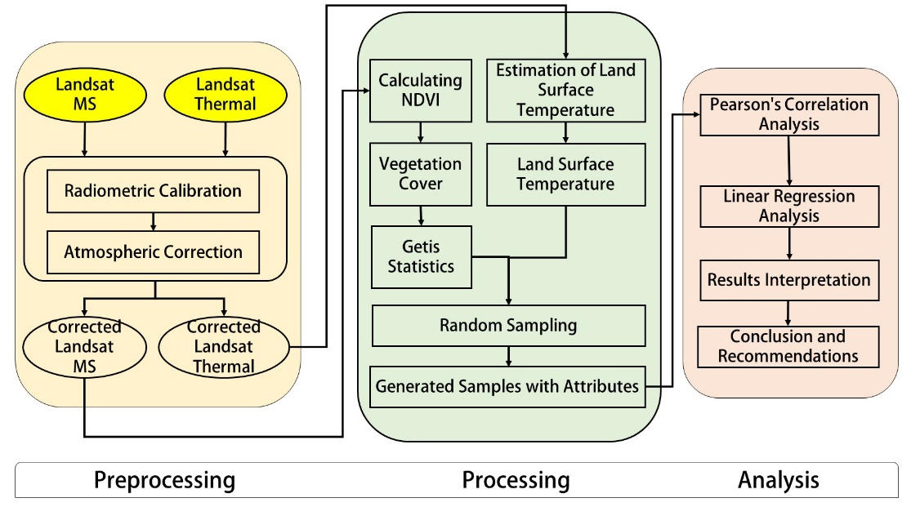

Fig.1. Overall Research Activities.

Study Area

Leave Langkawi Island is one of the most attractive tourist destinations in Malaysia. It is a tropical island located of the north-west coast of Peninsular Malaysia between 6o 10’N and 6o 30’N latitude and 99o 35’E and 100o 0’E longitude. The biggest and most developed island is Langkawi measuring about 47,848 ha (Figure 2). Most islands are uninhabited or sparsely populated. Topography of this island is mountainous covered by forest reserved area of 26,266 ha that is 54.6% of total land area.

Langkawi has become an important tourists’ location since it was given the status of a duty-free island in 1987. Originally, this island is famous for its scenic beauty, natural heritage, and legends. Various tourism products namely underwater world, Bird Park, crocodile farm, and exhibition center were developed throughout the island to promote tourism activity. In addition, hotels and other infrastructures were developed or upgraded in order to satisfy the growing demand from tourism sectors. The island, therefore, is suitable to be used as a study area in order to evaluate the relationship between the spatial distribution of vegetation cover and land surface temperature.
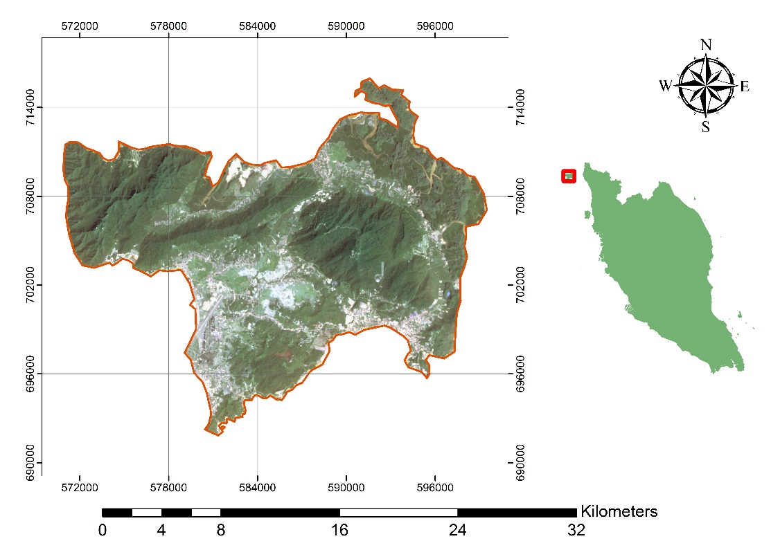

Fig.2. Location of the study area

Material and Data

In this study, a Landsat OLI dataset was used to analyze the relationship between spatial distribution of vegetation cover and land surface temperature in Langkawi Island. The dataset specifically used to extract vegetation cover through NDVI calculation, and to estimate the near surface temperature through thermal bands. The Table 1 shows the characteristics of the Landsat data used.

Table 1. Characteristics of Landsat data used in this study
DATE_ACQUIRED = 2015-01-20
CLOUD_COVER = 9.20
SUN_AZIMUTH = 134.80180833
SUN_ELEVATION = 50.76790257
EARTH_SUN_DISTANCE = 0.9840004
K1_CONSTANT_BAND_10 = 774.8853
K1_CONSTANT_BAND_11 = 480.8883
K2_CONSTANT_BAND_10 = 1321.0789
K2_CONSTANT_BAND_11 = 1201.1442
MAP_PROJECTION = "UTM"
DATUM = "WGS84"
ELLIPSOID = "WGS84"
UTM_ZONE = 47

Preprocessing of the Data

Satellites collect sensed data in raw or unprocessed form. The raw spectral data or radio signals must be processed or enhanced in order to produce images or other products. This typically involves computer-aided digital processing.in addition, remotely sensed data often contain various types of distortions due to less than optimal atmospheric conditions, rotation of the Earth, satellite or aircraft motion, curvature of the Earth, and the exact location of a given point within an image. The remotely sensed data, particularly in higher spatial resolutions, involve enormous amounts of data that often needs to be reduced before image processing. The initial data processing in remote sensing usually called image preprocessing, which has in general three basic steps: radiometric calibration, atmospheric correction, and geometric correction. The following subsequent sections explain these steps in more details.
In this study, first, the data was radiometrically calibrated and the sensor errors were removed. The raw DNs were converted into radiance values using ENVI software. After that, the radiance values were converted into reflectance values for further improvements. The reflectance values were used to remove the atmospheric effects from the data. In the atmospheric correction, dark object subtraction method was used as the study area has good black and white features. Furthermore, the data was geometrically corrected based on Google maps and the coordinate system was assigned for the data in order to make sure the proper fit between the satellite data and the field data.

Derivation of Land Surface Temperature (LST)

In If the area surrounding a target is assumed the same as (or similar to) the target and the target are assumed Lambertian and uniform, the reﬂectance at the target can be expressed conveniently as (Srivastava, Dawei Han et al. 2014):
$$ρ=\frac{π\left(L_{t}-L_{p}\right)}{\left(E_{dir}+E_{diff}\right)τ+πS\left(L_{t}-L_{p}\right)} (3)$$
where $ρ$ is reﬂectance; $L_{t}$is the satellite-based radiance; $S$ is the reﬂectance of the atmosphere; $L_{p}$is the atmospheric path radiance; $E_{dir}$is the direct irradiance at the surface; $E_{diff }$is the diffuse irradiance at the surface; and $τ$is the total diffuse transmittance from the ground to the top of the atmosphere in the view direction of the satellite. The relationship between LST and band integrated radiance $L_{λ(Ts)}$ may be approximated as (Xie, Wang et al. 2013):
:
$$L_{λ(Ts)}=gain×DN+offset (4)$$
$$T_{s}=\frac{k_{2}}{\ln\left(\frac{k_{1}}{L_{λ\left(Ts\right)}}+1\right)} (5)$$
where $T_{s }$is LST in Kelvin; $L_{λ(Ts)}$ is integrated band radiance.
The LST values obtained are referenced to a black body. Therefore, corrections for spectral emissivity become necessary according to the nature of the land cover. The emissivity of a surface is controlled by such factors as content, chemical composition, structure, and roughness. For vegetated surfaces, emissivity can vary signiﬁcantly with plant species, areal density, and growth stage. In the meantime, emissivity is a function of wavelength, commonly referred to as spectral emissivity. However, in this research, the NDVI-based emissivity method was applied using the same software (i.e. ENVI).

Extraction of Vegetation Covers

In order to estimate the spatial distribution of vegetation cover in the study area, first we need to extract the vegetation cover from the satellite image. The well-known approach for extracting vegetated areas from any multispectral image, which has near infrared band, can be used by applying NDVI equation. The NDVI image usually in the range from (-1 to 1), the negative values indicates the less greened surfaces while the positive values indicates the vegetated areas. By applying a simple threshold value to the NDVI image, the vegetation cover could be extracted. In this study, the value of 0.4 of the threshold was used to separate the vegetated areas from other classes. The NDVI and land surface temperature images presented in the Figure 3.

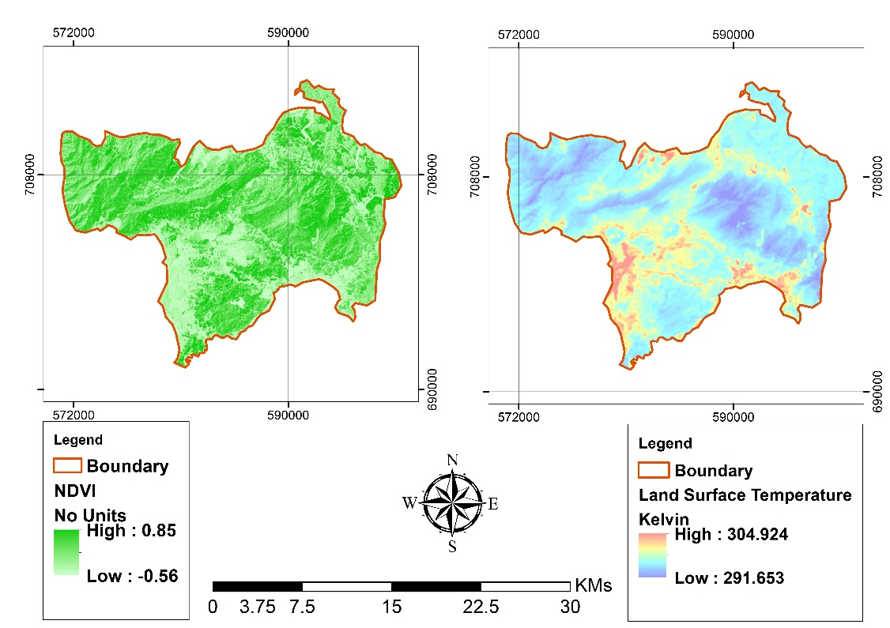
Fig.3. Derived data from the original Landsat imagery, (left side) NDVI, (right side) Land surface temperature

Correlation and Logistic Regression Analysis

In order to find a relationship between a set of independent variables and a dependent variable, correlation analysis or regression analysis usually applied. There is a variety of regression analysis type; the most popular is linear regression analysis. In this study, a logistic regression analysis was used to find the relationship between the spatial distribution of vegetation cover and land surface temperature. The output of regression analysis is a model that can be used to predict the spatial distribution of vegetation cover from the surface temperature values. The details of logistic regression are described below.

- Logistic regression: The logistic regression (LR) is an efficient mathematical model used Logistic regression (Logit) analysis has also been used to investigate the relationship between binary or ordinal response probability and explanatory variables (MPOB 2003). This model is represented as a linear equation as described by (Jebur, Pradhan et al. 2014) as following.

$$Y=b_{0}+b_{1}x_{1}+b_{2}x_{2}+…+b_{n}x_{n} (12)$$

where, $Y$ shows the dependent layer, it could be (1) or (0), $b_{0 }$is the intercept of the model, $b_{i}=\left(i=0,1,2,…,n\right), b_{i}(i=0,2,…,n)$represents the LR coefficients, and $x_{i} (i=0,1,2,…,n)$ denotes the causative factors.

To make predictions on the possibility of an event in each pixel, the probability index can be measured by using Equation 13.
$$p=\frac{1}{1+e^{-Y}} (13)$$
where $p$ is the target probability attained between 0 and 1 on an S-shaped curve.
In order to apply the logistic regression, a random sampling was carried out and the NDVI and LST values at each sample point were extracted. Figure 4 shows the spatial distribution of the sampling points used in this study. Based on the values extracted, the logistic regression was applied in Weka software.

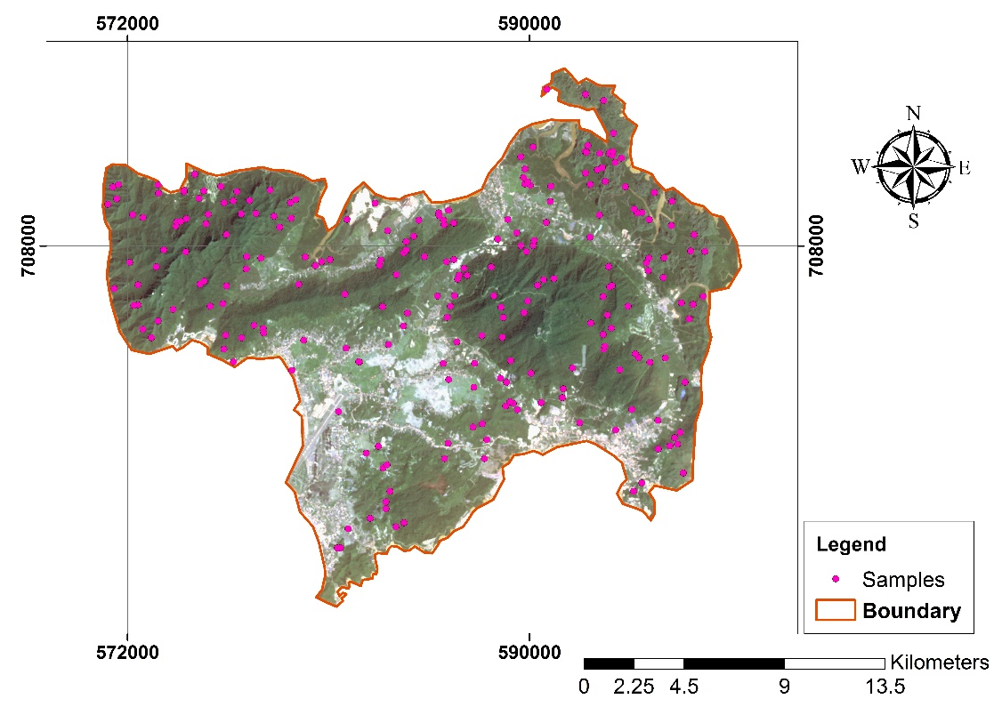

Fig.4. The spatial distribution of sampling points selected to model the relationship between spatial distribution of vegetation cover and surface temperature.

RESULTS AND DISCUSSION

Land Surface Temperature

Landsat thermal bands were used to estimate the near surface temperature and the average temperature for Langkawi Island was found to be (18 -31 degree Celsius) at the date that data collected by the sensor. Figure 5 shows the near surface temperature estimated for Langkawi Island. In the figure, we can observe that the hottest area is those in South or Southeast. After examine the satellite image of this area, we found that the area is mostly urban area, which indicates to the accurate surface temperature estimated. On the other hand, looking at the surrounding areas, the surface temperature found to be less around (18-25 C).
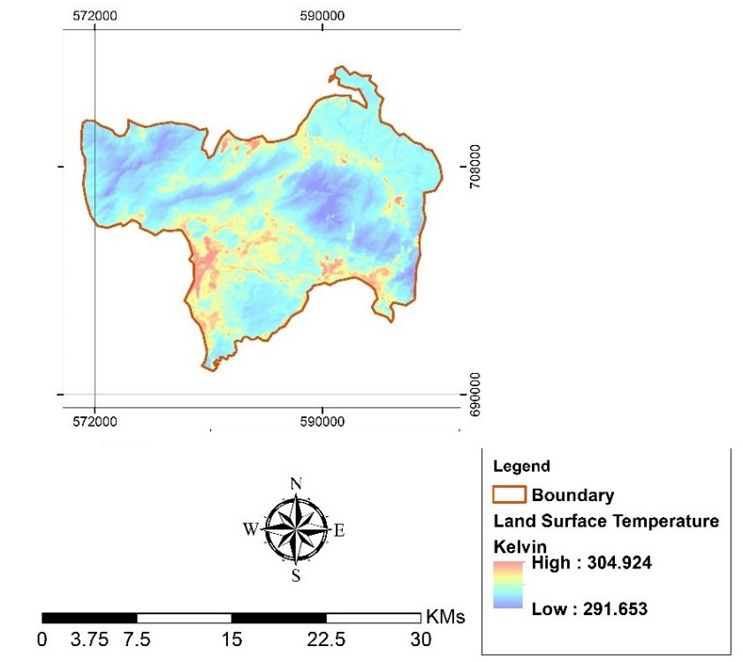

Fig.5. Spatial distribution of surface temperature for the study area estimated from Landsat thermal bands using ArcGIS software

According to the temperature map, the low temperature is due to the dense vegetation found in the study area and the high surface temperature due to the residential urban areas. Because land surface temperature significantly affect the air temperature and thereby the climate of the city, study the spatial distribution of temperature in such Island is important issue. The spatial distribution of vegetation cover could be modified and significant impact could be made for the climate of the Island. In order to achieve this goal, this study investigated the relationship between the land surface temperature and the distribution of vegetation cover in the study area. The next subsequent sections explain the results of the relationship between the land surface temperature and spatial distribution of vegetation cover.

Vegetation Covers

This study used NDVI based method to extract vegetation cover for the study area. The vegetation cover was extracted based on a threshold (NDVI > 0.4). The spatial distribution of vegetation cover in the study area is presented in figure 6. The dark green area (higher NDVI value) indicates dense vegetation (i.e. forest), and bright vegetation (less NDVI value) indicates less dens vegetated areas such as grass and various crops. The vegetation area equipped 81% from the total study area.

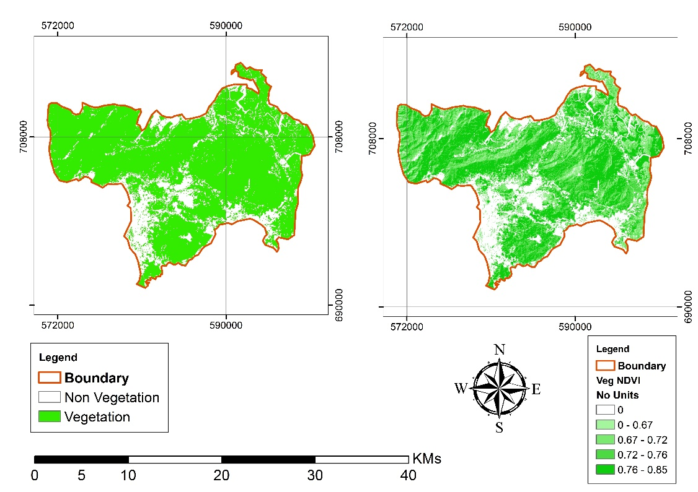
Fig.6. Extracted vegetation covers and NDVI values, (a) Extracted vegetation cover based on NDVI threshold (0.4), (b) extracted NDVI values by applying the vegetation cover mask on NDVI raster data

Spatial Distribution of Vegetation Covers (Getis Scores)

Spatial distribution of vegetation cover in the Langkawi Island was analyzed using Getis statistics. Getis analysis takes point data, which is the NDVI values indicating the presence of vegetation cover and analysis the spatial distribution based on a specific window size. In this study, a window of 10m × 10m was used to counter for small changes in the distribution. The Getis score found varies in the study area from -26 to 20, the negative values indicates the random distribution while the positive values indicate the uniform distribution. Figure 7 shows the Getis scores in raster format for the study area.

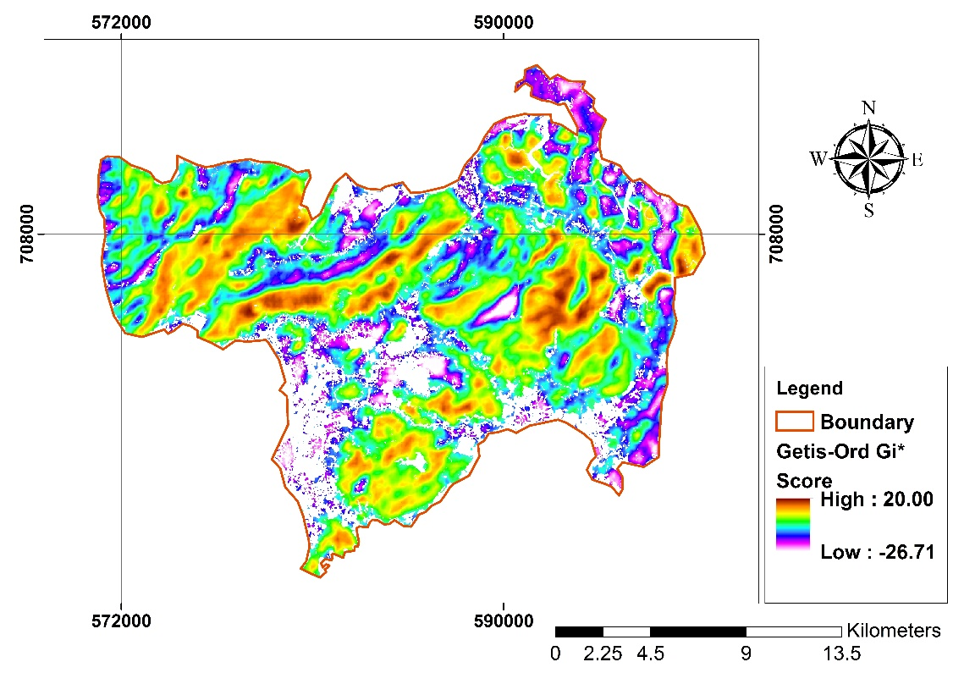
Fig.7. Getis scores of the study area

Based on the map showed in figure 7, it can be observed that in urban areas the vegetation covers are distributed randomly (Getis score <-20). This is because of the fact that the urban vegetation is mostly distributed randomly in islands, which is differ to the developed cities. On the other hand, the map shows that the dense vegetation covers were distributed uniformly in most of the island areas. The most uniform areas was found to be in the east middle part of the study area (Getis score>10). If we compare the spatial distribution of vegetation covers and land surface temperature, we can see that there is a clear relationship between them. For example, we can see that in the urban areas, the random distribution of vegetation makes the surface temperature high while the surface temperature in the other parts of the study area is less due to the uniform distribution of vegetation covers. However, there is a need to investigate further analysis to surely tell that there is a significant relationship between spatial distribution of vegetation cover and land surface temperature. The next section describes the model that developed in this study to predict the spatial distribution of vegetation cover from land surface temperature and NDVI value.

Regression Models

A model was developed for predicting the spatial distribution of vegetation cover from land surface temperature and NDVI values. This model is not only important to predict the distribution form of vegetation cover in Langkawi Island, but it is also important for evaluating the climate of the city and helping in rapid decision-making. Having the surface temperature and NDVI value for any pixel in an image, the developed model can predict at high accuracy level the spatial distribution of vegetation cover in the study area. The model was developed using logistic regression model because this model is based on the probability, which is more suitable than linear regression models. The developed model is presented as in the following equation.

$$Getis Score=16.85+34.16×NDVI-0.142*LST$$

The model was developed based on 238 training samples randomly selected from the raster data in ArcGIS software. The related coefficients then were generated from the logistic regression analysis. The time taken to build the model was 0.05 seconds. The evaluation of this model was based on 30% from the samples collected randomly in ArcGIS software, and the accuracy assessment showed that the model could predict the distribution form of vegetation cover at more than 60%. The detail of accuracy assessment was presented in Table 2.

Table 2. The logistic regression model developed to predict the spatial distribution of vegetation cover in Langkawi Island.
LOGISTIC REGRESSION MODEL
(for predicting vegetation spatial distribution)
Instances: 238
Attributes: 3
NDVI
LST
Class
Coefficients...
Variable
NDVI 34.1611
LST -0.142
Intercept 16.8507
Time taken to build model: 0.05 seconds
Evaluation on test split (30%)
Summary
Correctly Classified Instances 57 80.2817 %
Incorrectly Classified Instances 14 19.7183 %
Kappa statistic 0.604
Detailed Accuracy By Class
TP Rate FP Rate Precision Recall F-Measure ROC Area Class
0.765 0.162 0.813 0.765 0.788 0.838 Uniform
0.838 0.235 0.795 0.838 0.816 0.838 Random

Having the model developed, the spatial distribution of vegetation cover in the study area can be predicted. The model was used in ArcGIS and the predicted spatial distribution of vegetation cover was generated (Figure 8). The map shows the spatial distribution of vegetation cover in the study area, the green color shows the random distribution and the pink color indicates the uniform distribution of vegetation cover. The produced map was visually evaluated and a good matching was found between the estimated spatial distribution and the predicted distribution of vegetation cover.
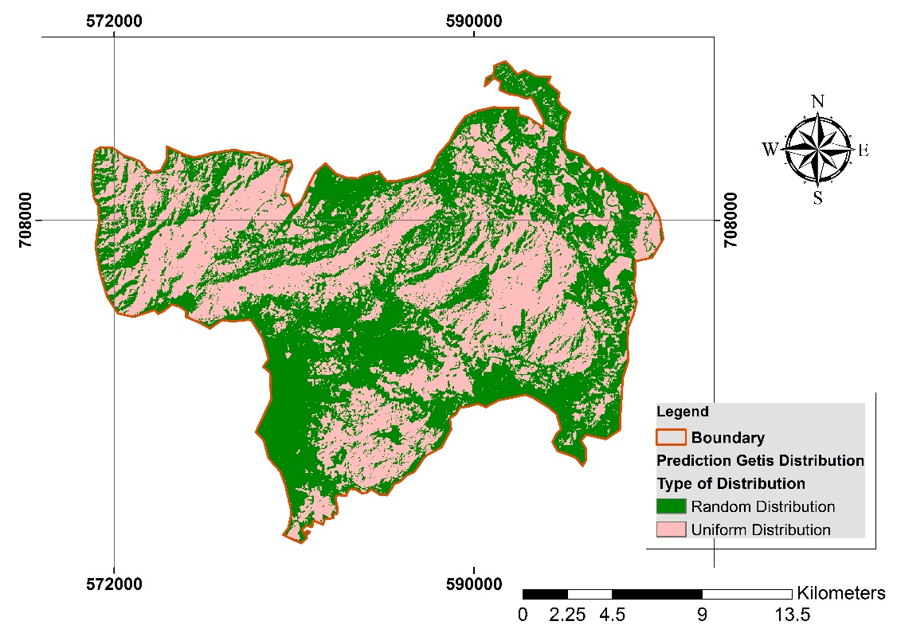
Fig.8. Extracted vegetation covers and NDVI values, (a) Extracted vegetation cover based on NDVI threshold (0.6), (b) extracted NDVI values by applying the vegetation cover mask on NDVI raster data

The produced map from the developed model was evaluated. The evaluation showed that the overall accuracy is 68.8% and the kappa coefficient is 60.2%. The model can be further improved by estimating land surface temperature by using robust ways including the atmospheric effects and emissivity corrections.

CONCLUSION
Major In this study, the relationship between the spatial distribution of vegetation cover and land surface temperature was investigated in Langkawi Island. A model was developed to predict the spatial distribution of vegetation cover based on surface temperature and NDVI values. The remote sensing data was collected from Landsat 8 sensor from USGS official website. The data first was preprocessed and the DNs were converted into reflectance values. Then the data was corrected for atmospheric and geometric effects. After that, land surface temperature was generated for the study area using the thermal bands of the collected data. On the other hand, the NDVI raster was produced in ENVI software using the red and near infrared bands. Then, a simple threshold was used and applied for the NDVI layer to extract vegetation cover in the study area. Next, the Getis scores were estimated using the spatial autocorrelation tools in ArcGIS. After that, 238 samples were selected randomly from the original images and the Getis values and NDVI values were extracted. The sample data was used to develop a logistic model for predicting the spatial distribution of vegetation cover based on land surface temperature and NDVI values. The developed model was evaluated and the overall accuracy was found to be 80.28% and the kappa coefficient was 60%.
This study revealed that the distribution of vegetation cover significantly effect on the climate of the Langkawi island. The study further investigated the relationship between spatial distribution of vegetation cover and land surface temperature and a predictive model was developed. The study also show3d the importance of such models for decision making and evaluating the climate of such important cities and islands.
Landsat thermal bands were used to estimate the near surface temperature and the average temperature for Langkawi Island was found to be (18 -31 degree Celsius) at the date that data collected by the sensor. According to the temperature map, the low temperature is due to the dense vegetation found in the study area and the high surface temperature due to the residential urban areas. Because land surface temperature significantly affect the air temperature and thereby the climate of the city, study the spatial distribution of temperature in such Island is important issue. In addition, spatial distribution of vegetation cover in the Langkawi Island was analyzed using Getis statistics. Getis analysis takes point data, which is the NDVI values indicating the presence of vegetation cover and analysis the spatial distribution based on a specific window size. In this study, a window of 10m × 10m was used to counter for small changes in the distribution. The Getis score found varies in the study area from -26 to 20, the negative values indicates the random distribution while the positive values indicate the uniform distribution. The produced map from the developed model was evaluated. The evaluation showed that the overall accuracy is 68.8% and the kappa coefficient is 60.2%. The model can be further improved by estimating land surface temperature by using robust ways including the atmospheric effects and emissivity corrections.

REFERENCES
Asgarian, A., B. J. Amiri, et al. (2015). "Assessing the effect of green cover spatial patterns on urban land surface temperature using landscape metrics approach." Urban Ecosystems 18(1): 209-222.

Chen, L., M. Li, et al. (2013). "Relationships of LST to NDBI and NDVI in Wuhan City based on Landsat ETM+ image." IEEE 2: 840-845.

Jebur, M. N., B. Pradhan, et al. (2014). "Optimization of landslide conditioning factors using very high-resolution airborne laser scanning (LiDAR) data at catchment scale." Remote Sensing of Environment 152: 150-165.

Jie Yin, X. W., M. Shen, et al. (2019). "Impact of urban greenspace spatial pattern on land surface temperature: a case study in Beijing metropolitan area, China." Landscape Ecology 34: 2949-2961.

Kant, Y., B. D. Bharath, et al. (2009). "Satellite-based analysis of the role of land use/land cover and vegetation density on surface temperature regime of Delhi, India." Journal of the Indian Society of Remote Sensing 37(2): 201-214.

Li, X., W. Zhou, et al. (2013 ). "Relationship between land surface temperature and spatial pattern of greenspace: What are the effects of spatial resolution?. ." Landscape and Urban Planning 114: 1-8.

Li, X., W. Zhou, et al. (2012). "Spatial pattern of greenspace affects land surface temperature: evidence from the heavily urbanized Beijing metropolitan area, China." Landscape Ecology 27: 887-898.

Malik, M. S., J. P. Shukla, et al. (2019). "Relationship of LST, NDBI and NDVI using Landsat-8 data in Kandaihimmat Watershed, Hoshangabad, India." Indian Journal of Geo Marine Sciences 48 (01): 25-31.

MPOB, Ed. (2003). Oil Palm Fruit Grading Manual. Bandar Baru Bangi, Malaysian Palm Oil Board, Ministry of Primary Industries.

Parida, B. R., B. Oinam, et al. (2008 ). "Land surface temperature variation in relation to vegetation type using MODIS satellite data in Gujarat state of India." International Journal of Remote Sensing 29(14): 4219-4235.

Prakash, S. and H. Norouzi (2020). "Land surface temperature variability across India: a remote sensing satellite perspective." Theoretical and Applied Climatology 139: 773-784.

Raynolds, M. K., J. C. Comiso, et al. (2008). "Relationship between satellite-derived land surface temperatures, arctic vegetation types, and NDVI." Remote Sensing of Environment 112(4): 1884-1894.

Rhee, J., S. Park, et al. (2014). "Relationship between land cover patterns and surface temperature in urban areas‏." GIScience & Remote Sensing 51(5): 521-536.

Siddique, M. A., L. Dongyun, et al. (2020). "Assessment and simulation of land use and land cover change impacts on the land surface temperature of Chaoyang District in Beijing, China." PeerJ 8(e9115).

Song, Y., X. Song, et al. (2020). "Effects of Green Space Patterns on Urban Thermal Environment at Multiple Spatial–Temporal Scales." Sustainability 12(17).

Srivastava, P. K., M. A. Dawei Han, et al. (2014). "Estimation of land surface temperature from atmospherically corrected LANDSAT TM image using 6S and NCEP global reanalysis product." Environmental Earth Sciences 72(12): 5183-5196.

Tan, J., D. Yu, et al. (2020). "Spatial relationship between land-use/land-cover change and land surface temperature in the Dongting Lake area, China." Scientific Reports 10(9245 ).

Wang, C., Y. Li, et al. (2019). "Impacts of spatial clustering of urban land cover on land surface temperature across Köppen climate zones in the contiguous United States." Landscape and Urban Planning 192(103668).

Wang, Z., Z. Lu, et al. (2020). "Spatiotemporal Variation of Land Surface Temperature and Vegetation in Response to Climate Change Based on NOAA-AVHRR Data over China." Sustainability 12(3601): 1-16.

Xie, M., Y. Wang, et al. (2013). "Assessment of landscape patterns affecting land surface temperature in different biophysical gradients in Shenzhen, China. Urban Ecosystems." Urban Ecosystems 16(4): 871-886.

Yue, W., J. Xu, et al. (2007). "The relationship between land surface temperature and NDVI with remote sensing: application to Shanghai Landsat 7 ETM+ data." International Journal of Remote Sensing 28(15): 3205-3226.

Zhibin, R., Z. Haifeng, et al. (2015). "Estimation of the Relationship Between Urban Vegetation Configuration and Land Surface Temperature with Remote Sensing." Journal of the Indian Society of Remote Sensing 43(1): 89-100.

