Potential of Lidar Bathymetry Technology for Coastline Large-Scale Mapping Acceleration in Indonesia

Agung Syetiawan¹, Dwi Arini², Ratna Sari Dewi¹, Herjuno Gularso¹, and Wahyudi Nugraha¹

¹Geospatial Information Agency, Jakarta-Bogor Km. 46, Cibinong 16911, Indonesia
²Padang Institute of Technology, Gajah Mada Kandis Nanggalo Street, Padang 25143, Indonesia
E-mail: agung.syetiawan@big.go.id; dwiarini@itp.ac.id

Abstract: Indonesia as a maritime country has the second longest coastline in the world after Canada. Coastlines data information is needed for coastal area management and delimitation of state boundaries. Large scale coastline data is less than 10% in 2018 from all region in Indonesia. Hence, it is necessary to accelerate the provision of coastline data in Indonesia. Previously, coastline was produced by the integration of land and ocean digital elevation model data. The measurements were conducted by topography survey technology and sounding by acoustic technology. Unfortunately, Indonesia has shallow water characteristics so that sounding technology is sometime difficult to reach a very shallow area or the area with coral reefs. An alternative method for coastline mapping is using an Airborne LiDAR Bathymetry. The aim of this research is to explore the potential of LiDAR bathymetry in order to support the acceleration of coastline mapping especially in the remote area that is difficult to be accessed. Method of gap analysis is used by determine of LiDAR bathymetry efficiencies compared to others. As the result, LiDAR bathymetry can produce single seamless land and sea DEM. Furthermore, LiDAR bathymetry produces high-resolution DEM data, making it easier for the extraction process of the coastline. The capacity of coastline mapping of LiDAR bathymetry is 195-line km per day, therefore to finish 108,000 km of national coastline takes only 6 years. Moreover, LiDAR bathymetry is able to cut a half survey time, faster than other technologies. Accordingly, LiDAR bathymetry is completely effectives to accelerate coastline mapping in Indonesia.
Keywords: coastline, large-scale mapping, LiDAR bathymetry.
INTRODUCTION
The beach is part of coastal areas that has a dynamic character with many physical processes (Marfai et al., 2011). Beach profile (shape and location) changes rapidly in response to natural processes and human activities (Beatley et al., 2002; Solihuddin, 2011). Coastline change is a continuously process of sediment transport, current, wave, tide, near-shore current, and land use (Arini, 2016; Vreugdenhil, 1999). Coastline change can indicate that coastline is being eroded to the land or jutting out to the sea (Arief et al., 2011).
Indonesia as a maritime country has the second longest coastline in the world after Canada (Lestari, 2015) which brings a large potential to national economic growth. Coastline and coastal area have an important role since 38% of world population live in these areas within 100 km of the coastline (Cohen et al., 1997; Kay & Alder, 2005). Coastline information is needed in coastal protection design, calibration and numeric model verification, sea level rise assessment, vulnerable zone development, formulating of coastal development regulation policies, defining the property of the boundary, and coastal research (Boak & Turner, 2005). Moreover, an accurate information regarding the area of Indonesia is important, especially for purposes such as calculating parcels of land, village funds, and other boundary demarcation purposes (Syetiawan, 2019). An error in the calculation of village areas will influence the calculation of the enrollment of “Dana Alokasi Desa” (village fund) (Amhar et al., 2017). The spatial resolution of data used will affect the area calculation results. The finer the spatial resolution the lower the error is (Usery et al., 2003). In addition, the finer the spatial resolution, the calculation of coastline (its area and length) may get closer to the true value.
To maintain Indonesia sovereignty and as a reference for regional affirmation data in Indonesia, the availability of coastline data in large-scale is critical. So far, base map of coastline has been provided by Geospatial Information Agency (BIG). The availability of coastline data in BIG is available in Table 1. For large scale needs, there is only 7.81% of coastline data for 10,000 scale map and more than 95,780 km of coastlines are not mapped yet. Indonesia government need to accelerate the providing of these maps so that it can give a significant impact to the society.
Table 1. Coastline large-scale inventory results until 2018.
Location | Coastline length | already mapped (10k scale) | not yet surveyed
Sumatera | 23,334.70 | 517.48 | 22,817.22
Jawa | 6,931.76 | 4,878.52 | 2,053.24
Kalimantan | 9,731.99 | 340.73 | 9,391.26
Bali-Nusa Tenggara | 9,474.04 | 255.14 | 9,218.90
Sulawesi | 18,003.09 | 1,843.06 | 16,160.03
Maluku | 17,979.45 | 194.57 | 17,784.88
Papua | 18,443.43 | 88.41 | 18,355.02
total | 103,898.46 | 8,117.91 | 95,780.55
Percentage |  | 7.81% | 92.19%
So far, the coastline has been generated by integrating the elevation data (DEM) of the land and the sea by using topographic survey technology and bathymetry survey with acoustic or remote sensing technology. In line with the technological developments, the determining of coastlines method is not only obtained from modeling based on direct survey data in the field, but it can be extracted by remote sensing data, or the results of integration survey data and remote sensing.
Indonesia has a shallow water characteristic (Smith & Sandwell, 1997), with an inland sea for ​about 284,210 km² (Ramdhan & Arifin, 2013) that cannot be reached by acoustic technology. Accordingly, a technology that is able to overcome the shortcoming is needed. Conventional technologies such as single beam or multi beam acoustic are also very expensive and time consuming (Sandwell et al., 2006). Then, other technologies are needed to accelerate the provision of the national coastline data. Another alternative method for coastline mapping is LiDAR for bathymetry survey. Airborne LiDAR Bathymetry (ALB) is a LiDAR technology that is effective in mapping and measuring water depth in coastal zones, shallow waters, and inland freshwater bodies, such as rivers and lakes (Allouis et al., 2007). This study aims to determine the potential of LiDAR Bathymetry technology to accelerate coastline mapping in Indonesia.
METHOD
Data and study area
LiDAR bathymetry measurements were carried out in Kolaka, Southeast Sulawesi (Figure 1) using the Leica Chiroptera II sensor. The LiDAR system uses 2 lasers, namely infrared (500 kHz) for topographic mapping and a green laser (35 kHz) for bathymetric mapping with the penetration ability of up to 25 m below sea level. When measuring bathymetry data, the flight height was in an altitude of 500 m above ground level with distance between flight lines was 250 - 300 m. On the other hand, the acquisition of land topography was conducted at the altitude of 1,100 m above ground level with a flight lane interval of 750 m. The sidelap was 20-30%. The data acquisition process was carried out for about 1 flight hour covering the entire area of ​​interest. LiDAR measurements were referenced to the National Geodetic Control Network using the SRGI2013 coordinate system.
Figure 1. LiDAR Bathymetry Area Survey.
Airborne LiDAR Bathymetry
LiDAR (Light Detection and Ranging) is part of a remote sensing system that uses active sensors and works by comparing the characteristics of the transmission signal and its reflection, namely the difference in pulse propagation time, wavelength, and angle of reflection (Wehr & Lohr, 1999). LiDAR transmits laser pulses from the aircraft to the reflected plane to be received back through the receiving sensor. The distance between the aircraft and the reflected plane is calculated from the length of travel time for the laser pulse that is transmitted back to the receiving sensor.
The use of the LiDAR bathymetry system for hydrographic survey has provided more benefits and cost efficiencies compared to the acoustic and satellite imagery technologies (Ebrite et al., 2001; Guenther et al., 2002). The depth measurement system uses LiDAR bathymetry by transmitting a laser to the surface of the water at an angle of 22º to the nadir axis. When the laser hits the surface of the water, part of the laser wave is reflected and refracted in all directions and part of it will penetrate the water. The beam of laser light that penetrates into the water is about 98% of the total energy initially and will be refracted in a direction close to the normal line due to the change in the density of the air medium with water. The beam of laser light will continue propagate in the water until it hits the bottom of the water and is reflected in all directions and one of the beams is reflected back towards the angle of incidence. The beam of light that bounces towards the angle of incidence then continues its propagation journey and penetrates the boundary of the water and air medium. In this condition, the beam will be refracted away from the normal line and propagate in the same direction as when it was first transmitted and received back on the aircraft by the receiver unit. The working principle of LiDAR bathymetry is can be seen in
Figure 2.

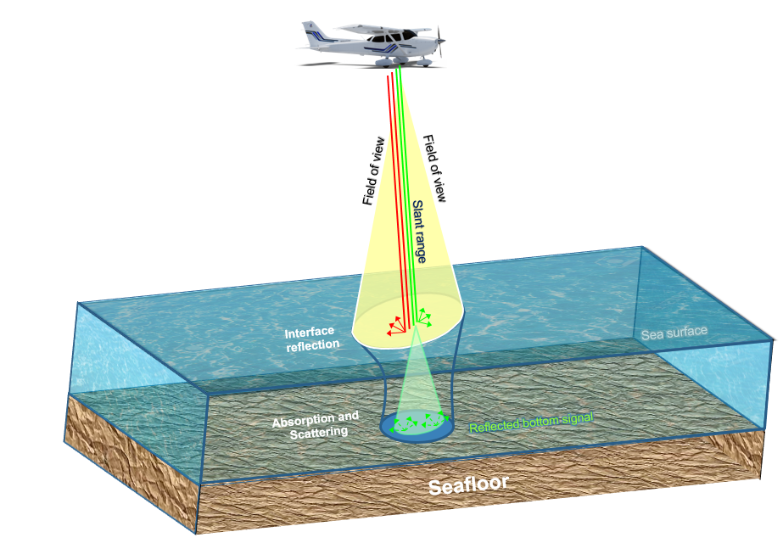
Figure 2. The Working Principle of LiDAR Bathymetry.
The laser transmits data for 3,000 pulses per second and each laser pulse consists of two beams with a wavelength of 1,064 nm (infrared) and 532 nm for green laser (Wozencraft & Millar, 2005). It should be noted that the two laser sensors are independent, it is important to know any information regarding the offsets between the two sensors to minimize errors to get good observational data (Saylam, Hupp, Andrews, et al., 2018). A full discussion regarding the synchronization problem between two different sensors in the LiDAR bathymetry survey can be found in Shin et al. (2016). LiDAR bathymetry measurements produce a footprint width with a diameter of ~2 meters and are able to penetrate the bottom of the water to a depth of 2 - 3 secchi depths (Pastol, 2011).
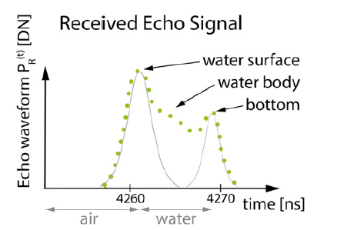
Figure 3. Received Echo Signal by LiDAR Bathymetry Sensor (Doneus et al., 2013).
The waveform received by LiDAR bathymetry observations ideally consists of two different peaks, as can be seen in Figure 3. The first peak is a representation of the energy reflected from the water surface, while the second peak is the energy reflected from the bottom of the water. Time signal, slope, and amplitude from the backscatter provide information related to water depth, diffuse attenuation in the water column, and water properties (Eren et al., 2018; Richter et al., 2017). In certain locations such as rivers and lakes with calm and shallow water conditions, sometimes the laser reflection from the surface is very weak and difficult to distinguish (Saylam, Hupp, Andrews, et al., 2018). For this reason, it requires a decomposition process of the original waveform using a specific function as was done by Zhao et al. (2018).

The LiDAR bathymetry return energy equation is the sum of the echo waves based on the following equation (Guenther, 2007):
(1)
where:
P(t) = total power received | Pb(t) = power returned by the bottom
Pbsc(t) = power returned by the water  column | Pbg(t) = background power returned by the air column
Ps(t) = power returned by the water surface | Pn(t) = noise power

Then to determine the energy received from the surface of the water is as follows (Guenther, 2007):
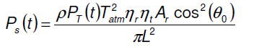 (2)
where:
P_{T}(t) = transmitted pulse by the green laser (W) | ηt, ηr = efficiencies optical transmission and reception
ρ = reflectance at the interface air / water | Ar = area of the receptor (m²)
T²_{atm} = transmission coefficient of the atmosphere | θ₀ = incidence angle of laser (rad)
L = flying height of the sensor in relation to the water surface (m)
Meanwhile, to determine the return energy from the bottom of the waters is using the following equation (Guenther, 2007):
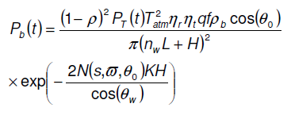 (3)
where
H = water depth (m) | ρb = reflectance of the bottom
q = empirical factor that takes into account fade air and LiDAR system | nw, θw = the refractive index of water and the angle of refraction at the interface air/water
f = factor of loss due to the field of view of the telescope | - = albedo of the bottom
s = diffusion coefficient in the water column | N(s,ϖ,θ) = stretch factor of the pulse depending on the coefficient of diffusion, albedo and angle of incidence nadir Laser
To determine the depth value, the parameters that must be known are the wave transmission angle to the vertical line, the height of the aircraft, and the refractive index / refraction of air with water in the survey area. Equation 3 requires a refractive index, where the index of refraction is highly dependent on water temperature, salinity, and the wavelength of the laser used.

The success of the LiDAR bathymetry survey is highly dependent on environmental conditions (Saylam, Hupp, Averett, et al., 2018), including the presence of vegetation both in the column and the bottom of the water, water turbidity (Saylam, Hupp, Andrews, et al., 2018), composition bottom waters, and weather conditions. Water turbidity is very close to dissolved sedimentary material or organisms in the waters. This causes the laser penetration energy to the bottom of the water to be scattered and attenuated in the water column (Suk et al., 1998), where the particle size, shape, and composition of the laser can affect its amplitude (Baker & Lavelle, 1984; Bhargava & Mariam, 1991).
RESULTS AND DISCUSSION
Level of detail Airborne LiDAR Bathymetry
Figure 4a shows the results of LiDAR Bathymetry processing after combining it with topographic LiDAR results. As can be seen in Figure 4a, LiDAR bathymetry can produce single seamless land and sea DEM. In addition, LiDAR bathymetry is able to reach the difficult areas such as shallow water or coral areas.
- (b)
Figure 4. Digital Elevation Model: (a) LiDAR Bathymetry Result; (b) Multibeam Echo Sounder Result.
According to Pastol (2011), LiDAR bathymetry is able to observe the topography of the seabed at a very shallow depth, which is less than 1 m. In contrast to the multibeam technology which has limitations in reaching shallow water areas due to vessel safety reasons, there is a gap data in the nearshore area as can be seen in Figure 4b.
Figure 5 shows a shallow water area depicted corals very clearly using LiDAR Bathymetry. However, compared to multibeam which results in a low detailed seabed mapping. LiDAR bathymetry produces high-resolution DEM data, making it easier for the extraction process of the coastline. Figure 6 shows the shoreline results from the LiDAR Bathymetry data, the red color is the shoreline at the lowest tide, the yellow color is the shoreline at the mean sea level, while the blue color is the shoreline at the highest tide.
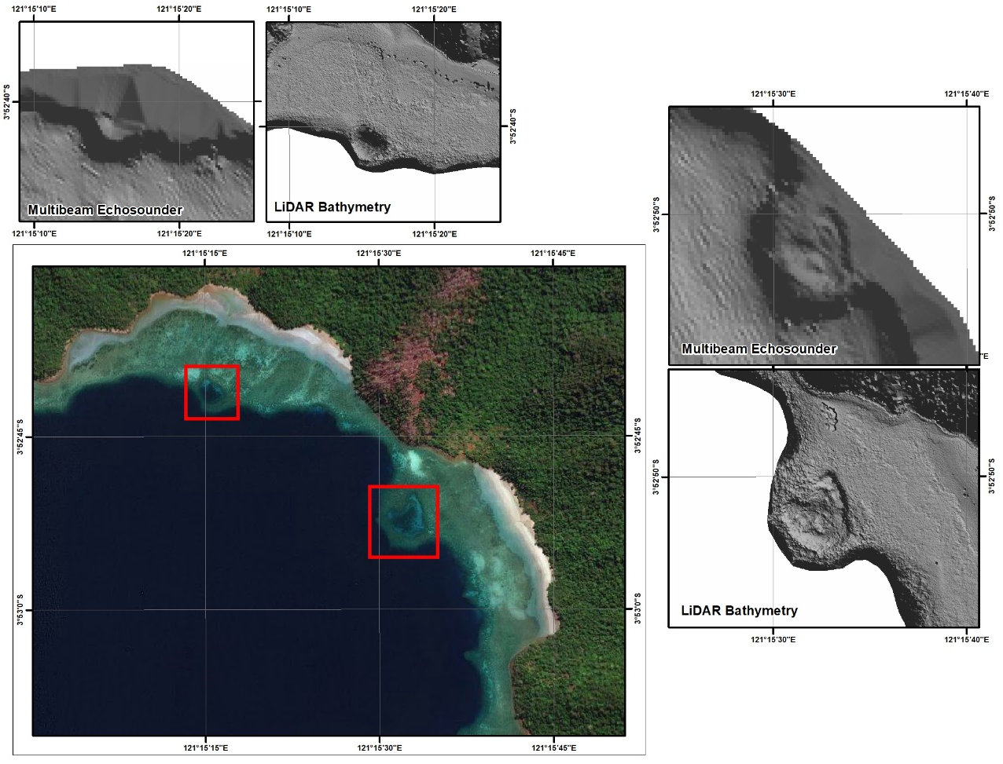
Figure 5. Level of Detail of LiDAR Bathymetry Measurements Compared to Multibeam Echo Sounder.
.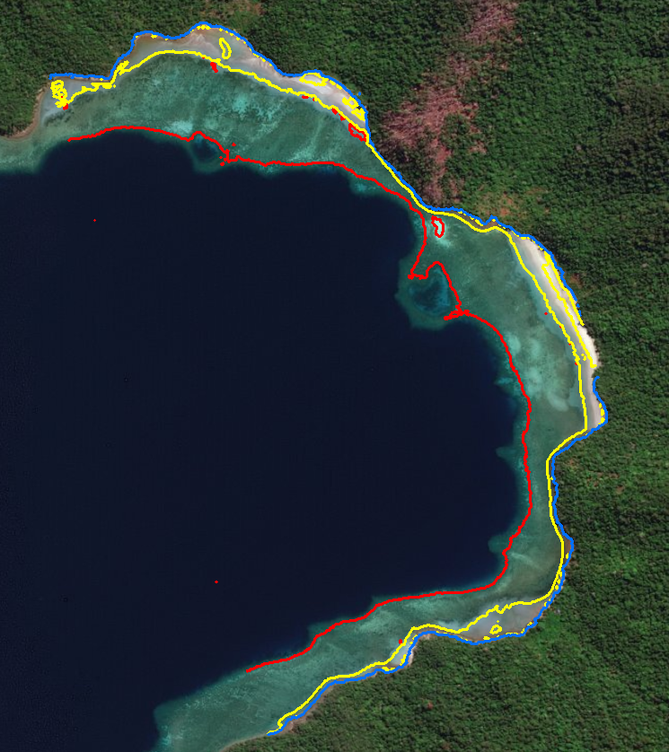
Figure 6. Shoreline from LiDAR Bathymetry Data.
Effectiveness Airborne LiDAR bathymetry
The efficiency analysis is carried out by making several assumptions to see the effectiveness of the LiDAR bathymetry technology to obtain Indonesian coastline data. By assuming that the aircraft is flying at an altitude of 500 m above sea level with a speed of 110 knots, the number of lanes that can be obtained per area is 5 lanes. An illustration for viewing the flight plan during the LiDAR bathymetry data acquisition can be seen at Figure 7.

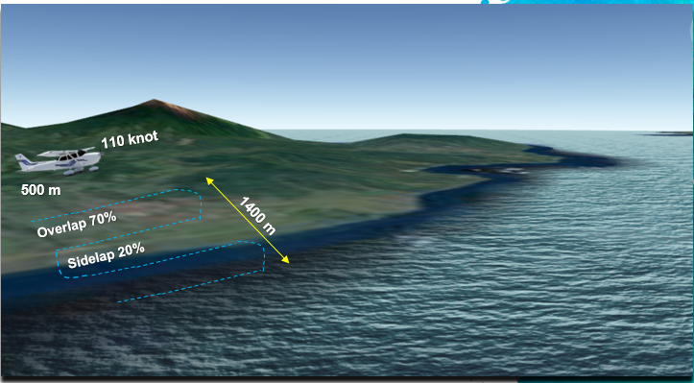
Figure 7. LiDAR Bathymetry Survey Flight Plan.
Another aerial mapping parameter is the use of 20% sidelap as the LiDAR data which is used for strip adjustments so that the resulting DEM data is seamless between lines. Determining the sidelap is an important consideration depending on the variation in ground height at the survey location. The smaller the number of sidelap will potentially create gaps between strips (Shin et al., 2016), that will impact in the resulting point cloud.
With the height and flight parameters, we are able to get an effective sensor swath width of
400 m and a coastline corridor width that can be mapped as far as 1.4 km. Therefore, to map an area like Sulawesi with a coastline of about 8,000 km, it only takes 165 days. The time required includes the flight loop scheme due to bad weather conditions and data, turning time adjustments, ferry flight base to AOI, and productive flight hours per day are about 4 hours. LiDAR bathymetry is very effective for a rapid mapping of the national coastlines.
This sounding technology, can only produce a capacity of about fifty-line km per day to obtain marine DEM data. The integration of marine and land DEM still requires a time consuming topographic measurement. With the existing capacity of the Indonesia government, it will take approximately 14 years to be able to complete the 108,000 km long national coastlines. Not to mention the problem occurred during the DEM integration processes between land and sea. Problems arise due to the use of different technologies and different measurement conditions when collecting the data. In addition, the problem of seamless land and sea data occurs due to differences in the references used, so that the DEM elevation values ​​are not the same.
To conclude, LiDAR bathymetry has the capacity to map the coastline 195-line km per day, so to complete the 108,000 km national coastline only takes for about 6 years. LiDAR bathymetry technology is able to cut survey times in half faster than the technology currently used, namely the integration of topographic and sounding surveying, which is very effective for the acceleration of topographic mapping.
CONCLUSIONS
The LiDAR bathymetry capability of providing land and sea DEM data can greatly facilitates the data integration process. Land and sea seamless data refers to the same reference system. In addition, LiDAR bathymetry is able to reach the remote areas using an acoustic technology. In fact, LiDAR bathymetry can make acquisitions for a large area in one flight, it is very efficient in terms of time. Therefore, LiDAR bathymetry technology is can be considered as a method of accelerating a large-scale shoreline provision.
Apart from the advantages offered by LiDAR Bathymetry, there are also several limitations. Since LiDAR bathymetry is an active sensor, the results of its acquisition are highly dependent on the ability of green laser penetration in the water column, so that the level of water clarity is greatly influence the results. In the coastal areas that have a poor water quality, the penetration ability of the LiDAR bathymetry system to the bottom will decrease, so that in these conditions data collection using the sounding and terrestrial methods is necessary. This technology combination can be done to get maximum results.
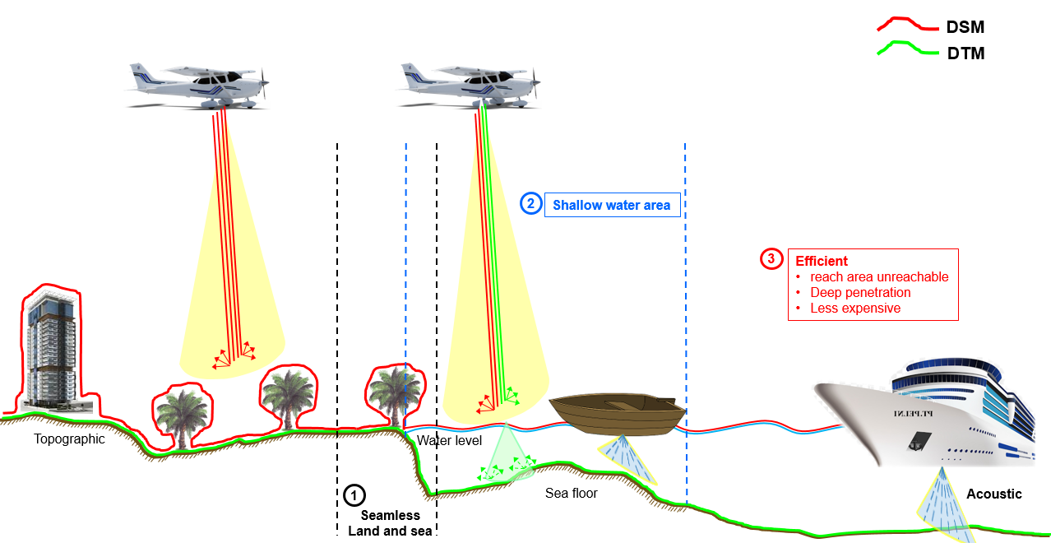
Figure 8. The Advantages of LiDAR Bathymetry Technology.
ACKNOWLEDGMENTS
The author would like to thank the Center for Marine and Coastal Environment Mapping, Geospatial Information Agency for providing support in writing this research. In addition, the authors also thank PT. Map Tiga International for LiDAR bathymetry data was used in this study.
REFERENCES
Allouis, T., Bailly, J. S., Lesaignoux, A., & Feurer, D. (2007). Assessing water surface effects on LiDAR bathymetry measurements in very shallow rivers: theoretical study. 2nd Space for Hidrology Workshop.
Amhar, F., Syetiawan, A., Lumban-gaol, Y. A., & Hartanto, P. (2017). Akurasi Perhitungan Luas untuk Perhitungan Dana Desa. Seminar Nasional Geomatika 2017: Inovasi Teknologi Penyediaan Informasi Geospasial Untuk Pembangunan Berkelanjutan, 471–476. https://doi.org/10.24895/SNG.2017.2-0.443
Arief, M., Winarso, G., & Prayogo, T. (2011). Kajian Perubahan Garis Pantai Menggunakan Data Satelit Landsat Di Kabupaten Kendal. Jurnal Penginderaan Jauh, 8, 71–80.
Arini, D. (2016). Shoreline Change Analysis for Aia Bangih Beach Mapping, West Pasaman. International Conference on Technology, Innovation, and Society (ICTIS), 627–635. https://doi.org/10.21063/ICTIS.2016.1055
Baker, E. T., & Lavelle, J. W. (1984). The effect of particle size on the light attenuation coefficient of natural suspensions. J. Geophys. Res., 89, 8197–8203.
Beatley, T., Brower, D. J., & Schwab, A. K. (2002). An introduction to coastal zone management (2nd ed.). Washington: Island Press.
Bhargava, D. S., & Mariam, D. W. (1991). Light penetration depth, turbidity and reflectance related relationship and models. ISPRS J. Photogramm. Remote Sens., 46, 217–230.
Boak, E. H., & Turner, I. L. (2005). The Shoreline Detection-Definition Problem: A Review. Journal of Coastal Research, 21(4), 688–703.
Cohen, J. E., Small, C., Mellinger, A., Gallup, J., Sachs, J., Vitousek, P., … Mooney, H. (1997). Estimates of coastal populations. Science, 278(5341), 1209–1213.
Doneus, M., Doneus, N., Briese, C., Pregesbauer, M., Mandlburger, G., & Verhoeven, G. (2013). Airborne laser bathymetry e detecting and recording submerged archaeological sites from the air. Journal of Archaeological Science, 40, 2136–2151.
Ebrite, S., Pope, B., & Lillycrop, W. J. (2001). A multi-agency solution for coastal surveys—SHOALS in the Pacific. Marine Technology Society, 1204–1211.
Eren, F., Pe’eri, S., Rzhanov, Y., & Ward, L. (2018). Bottom characterization by using airborne Lidar bathymetry (ALB) waveform features obtained from bottom return residual analysis. Remote Sensing of Environment, 206, 260–274.
Guenther, G. C. (2007). Airborne lidar bathymetry. Digital Elevation Model Technologies and Applications: The DEM Users Manual, 2, 253–320.
Guenther, G. C., Lillycrop, W. J., & Banic, R. J. (2002). Future advancements in airborne hydrography. International Hydrographic Review, 3, 67–90.
Kay, R. C., & Alder, J. (2005). Coastal Planning and Management (2nd ed.). London: Spon Press.
Lestari, D. (2015). Garis pantai Indonesia terpanjang kedua di dunia. Retrieved 11 February 2020, from Antara News website: https://www.antaranews.com/berita/487732/garis-pantai-indonesia-terpanjang-kedua-di-dunia
Marfai, M. A., Pratomoatmojo, N. A., Hidayatullah, T., Nirwansyah, A. W., & Gomareuzzaman, M. (2011). Model Kerentanan Wilayah Pesisir Berdasarkan Perubahan Garis Pantai dan Banjir Pasang (Studi Kasus: Wilayah Pesisir Pekalongan). Yogyakarta: RedCarpet Studio.
Pastol, Y. (2011). Use of Airborne LIDAR Bathymetry for Coastal Hydrographic Surveying: The French Experience. Journal of Coastal Research, Special Is, 6–18.
Ramdhan, M., & Arifin, T. (2013). Aplikasi Sistem Informasi Geografis dalam Penilaian Proporsi Luas Laut Indonesia. Geomatika, 19(2), 141–146.
Richter, K., Maas, H.-G., Westfeld, P., & Weiß, R. (2017). An Approach to Determining Turbidity and Correcting for Signal Attenuation in Airborne Lidar Bathymetry. PFG J. Photogramm. Remote Sens. Geoinf. Sci., 85, 31–40.
Sandwell, D. T., Smith, W. H. F., Gille, S., Keppel, E., Jayne, S., Soofi, K., … Geli, L. (2006). Bathymetry from space: Rationale and requirements for a new, high-resolution altimetric mission. C. R. Geoscience, 338, 1049–1062.
Saylam, K., Hupp, J., Averett, A., Gutelius, B., & Gelhar, B. (2018). Airborne Lidar bathymetry: Assessing quality assurance and quality control methods with Leica Chiroptera examples. International Journal of Remote Sensing, 2518–2542.
Saylam, K., Hupp, J. R., Andrews, J. R., Averett, A. R., & Knudby, A. J. (2018). Quantifying Airborne Lidar Bathymetry Quality-Control Measures: A Case Study in Frio River, Texas. Sensors, 18(4153).
Shin, M. S., Yang, I. T., & Lee, D. H. (2016). A Study on Airborne Lidar Calibration and Operation Techniques for Bathymetric Survey. Journal Korean Soc. Geosp. Inf. Syst., 24, 113–120.
Smith, W., & Sandwell, D. (1997). Global sea floor topography from satellite altimetry and ship depth soundings. Science, 277.
Solihuddin, T. (2011). Karakteristik Pantai dan Proses Abrasi di Pesisir Padang Pariaman, Sumatera Barat. Majalah Ilmiah Globe, 13(2), 112–120.
Suk, N. S., Guo, Q., & Psuty, N. P. (1998). Feasibility of using a turbidimeter to quantify suspended solids soncentration in a tidal saltmarsh creek. Estuar. Coast. Shelf Sci., 46, 383–391.
Syetiawan, A. (2019). Perhitungan Luas Wilayah dan Panjang Garis Pantai Indonesia Menggunakan Sistem Proyeksi Distorsi Minimal. Prosiding Seminar Nasional Pendidikan Geografi UPI, 305–315.
Usery, E. L., Finn, M. P., Cox, J. D., Thomas, Beard, Ruhl, S., & Bearden, M. (2003). Projecting Global Datasets to Achieve Equal Areas. Cartography and Geographic Information Science, 30(1), 69–79.
Vreugdenhil, C. B. (1999). Transport Problems in Shallow Water, Bottlenecks and Appropriate Modelling. Enschede: University of Twente.
Wehr, A., & Lohr, U. (1999). Airborne laser scanning – an introduction and overview. ISPRS J. Photogramm. Remote Sens., 54, 68–82.
Wozencraft, J., & Millar, D. (2005). Airborne Lidar and Integrated Technologies for Coastal Mapping and Nautical Charting. Marine Technology Society Journal, 39(3), 27–35.
Zhao, X., Zhao, J., Zhang, H., & Zhou, F. (2018). Remote Sensing of Suspended Sediment Concentrations Based on the Waveform Decomposition of Airborne Lidar Bathymetry. Remote Sensing, 10(247).

