INVESTIGATION OF THE COSMIC RAY
EFFECTS ON SENTINEL-1 SAR IMAGES

Hakan Köksal (1), Nusret Demir (1), Ali Kılçık (1), Fahriye Ceren Ağca (1), Dilara Solmaz (1)

1 Akdeniz University, Faculty of Science, Space Science and Technologies, Antalya, 07058, Turkey
Email: koksalhakan@outlook.com; nusretdemir, alikilcik@akdeniz.edu.tr, ceerenagcaa@gmail.com, mermaid.dilara@gmail.com

KEY WORDS: Cosmic Ray, SAR, Sentinel, Space Weather, Google Earth Engine

ABSTRACT: Cosmic rays are various subatomic particles that continuously enter the Earth's atmosphere from outside the Solar System and can reach the Earth. They are examined in two groups as primary and secondary. Primary cosmic rays are very high-energy cosmic rays that can reach the earth directly and are usually composed of Hydrogen (Proton) or Helium (Alpha Particle) nuclei. As cosmic rays pass through the atmosphere, they collide with the gas atoms in the atmosphere, and in this case, the particle reacts and becomes other particles. In this case, cosmic rays with lower energy reaching the ground are secondary cosmic rays.). Primary cosmic rays can affect the reflection values of the images by affecting the electronic system (CCD) of the satellites. In the study, temporal variation in speckle values in radar images was compared with cosmic beam intensity data to examine this effect. In this study, the study area is selected from Baksan-Russia where there is a cosmic ray station. It is Located at 43.25 ° north latitude and 42.69 ° east longitude, the station has a cut-off rigidity value of 5.6 GV. Baksan Neutron Monitor has been operated since 2003 by the Russian Academy of Nuclear Physics Institute. For the data obtained between January 2015 and December 2019, the graph of the monthly median and cosmic ray intensity values were plotted. The correlation between noise and cosmic ray count is calculated as 72%. Google Earth Engine is used to derive the results.

INTRODUCTION

Cosmic rays are various atomic and subatomic particles that continuously enter the Earth's atmosphere from the Sun and outside the Solar System and reach the Earth. They are examined in two groups as primary and secondary. Primary cosmic rays are very high energy cosmic rays that can reach the earth directly and consist of approximately 83% protons, 13% alpha particles, 1% nuclei with atomic number> 2 and 3% electrons (Smart and Shea, 1985).

Cosmic rays have high enough energy to affect the electronic circuit components and optical materials of satellites. It can cause signal weakening, deterioration of GPS calibration, complete loss of the signal, incorrect operations, equipment damage, and thus undesirable effects on communication and image acquisition (Horne et al., 2013). In the study, the temporal variation of the speckle values in the radar images was compared with the cosmic beam intensity / count data in order to examine such an effect.

Radar (Radio Detection And Ranging) is a device used to determine the speed and distance of distant objects and objects by the reflection of electromagnetic waves (Skolnik, 1981). The source of the speckle effect is explained by the random interaction between the coherent return from a large number of scatterers on a surface, the scale of a wavelength of the random radar wave (i.e. a resolution cell) (Gagnon & Jouan, 1997).

Severe irregularities in the ionosphere will affect the propagation of HF radio waves by altering the usable frequencies, and can cause signals that produce plasma irregularities, radio interference, and other communication difficulties. At frequencies above 30 MHz, unexpected reflections of radio waves from the ionosphere may also cause radio interference (Radicella, 2007).

In the study, temporal variation in speckle values in radar images was compared with cosmic beam intensity data to examine this effect. , the study area is selected from Baksan-Russia where there is a cosmic ray station.

MATERIAL AND METHODS

Test Area

The cosmic ray intensity data are provided from Baksan station, Russia. The station has 6NM64, 5.6 GV cut-off rigidity, and it has started operation in 2003. The Baksan Station is located at 39°38'32.91"E ve 43°35'7.50"N geographical coordinates. The location of the station can be found in Figure 1.

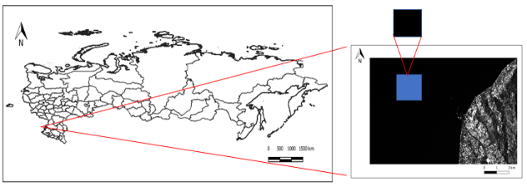
Figure 1. The location of Baksan Station (left), the selected samples from SAR image (right)

SAR Data

To be used in the study, the data with the same scanning angle, GRD (Ground Range Detected) format, and VH polarization were filtered to be used in the analysis. Approximately 304 radar images were processed between February 2015 and December 2019 for Baksan (Russia) station work area, the average speckle back scatter values of all images in each month were considered monthly data and compared with the monthly data of the cosmic ray station. The used SAR data are from Sentinel 1A&1B satellites with C band Radar sensor and 6 days temporal resolution.

Cosmic Ray Data

Cosmic beam intensity data for the analysis date range were obtained from the Athens Neutron Monitor Station (A.NE.MO.S), and the cosmic ray count rate data were obtained from the Oulu Cosmic Ray Station official website. Efficiency and pressure corrected, cosmic beam intensity / count values with monthly temporal resolution were used in the study.

Processing of the Datasets

Lee filter was used in the study to eliminate the speckle effect. As an adaptive filter, Lee takes into account a speckle distribution pattern, calculates local statistics in a moving window, and assign values of pixels accordingly, often providing better results than non-adaptive filters (Dong et al., 2000). The Lee filter (Lee, 1981) is based on the assumption that the mean and variance of the respective pixel are equal to the local average and variance of all pixels within the mobile core selected by the user. Pixel values are calculated using the equation given below.

DNout = [ Mean ] + K[ Dnin – Mean ] (1)

Here; K = Var (x) / ([Mean] ²σ² + Var (x)), Dnout = filtered pixel DN value, Mean = mean of pixels inside the kernel and Dnin = pixel value of interest.

The medians of the difference values between the raw radar image data and the filtered image data were calculated and using these values monthly mean median values were obtained. Google Earth Engine and IBM SPSS software package was used for this purpose.

The JavaScript code editor for the interface is an interactive environment for developing Earth Engine applications. For Baksan (Russia) test area, Earth Engine interactive development environment analysis example is shown in Figure 2.

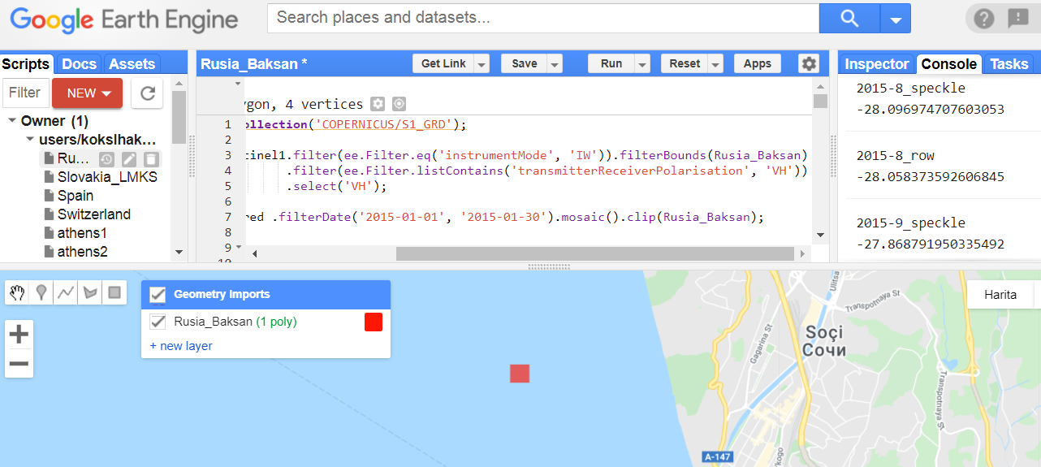
Figure 2. The Data Processing in Google Earth Engine Platform

Thanks to the code developed in the Earth Engine interface, the images were opened in digital form and the differences between the scattering values were examined. Speckle filter applied data and raw data scatter values were subtracted from each other and the median of the differences was calculated.

GUI Development

Radar image preprocessing steps can be fulfilled with the code designed in the Google Earth Engine interface; Using the Python software language, an interface has been designed that enables the pre-analysis result file to be read in CSV file format, the application of statistical analysis processes, and the graphics to be obtained directly in the quality we have obtained in our work.

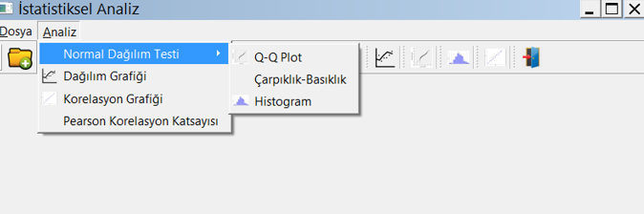
Figure 5. GUI and related buttons.

RESULTS

Monthly values were obtained by calculating the average of the median values of all data within each month. When these monthly median values and the cosmic beam intensity / count data obtained from the stations are plotted over time, it has been observed that each data set has a rising trend (Figure 3).

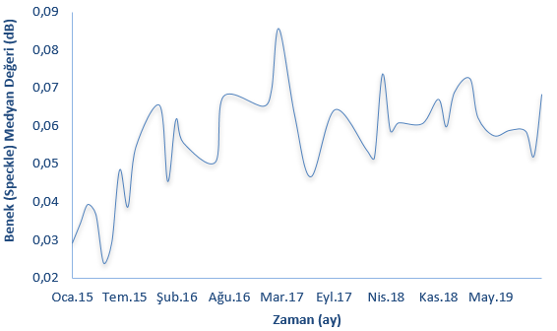 | 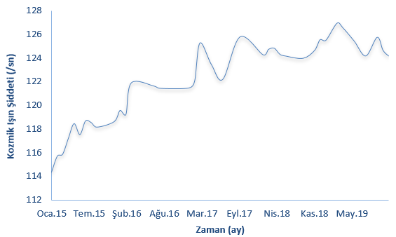
(a) | (b)
Figure 3. Temporal variation graphs of monthly noise (speckle) and cosmic beam intensity / count values obtained for Baksan (Russia) test area (Jan15-Jul15-Feb16-Aug16-Mar17-Sept17-Apr16-Nov18-May19).

IBM-SPSS software was used to test whether the data set (s) show normal distribution or not. The point to note in the final report is that the skewness and kurtosis values are in the range of +1.5 -1.5, and the skewness and kurtosis indices calculated by dividing these values by their standard errors are close to 0 within ± 2 limits is considered as evidence for the existence of normal distribution (Tabachnick & Fidell, 2013).

Dataset | (skewness) | (kurtosis) | Skewness std.dev. | Kurtosis std.dev.
Monthly speckle amount | -0,504 | 0,026 | 0,388 | 0,759
Cosmic Ray Intensity | -0,393 | -0,802 | 0,347 | 0,681

The correlation coefficient between the two data sets was calculated by applying Pearson correlation analysis method to monthly speckle median and cosmic ray intensity / count data, and as a result, a significant positive correlation was obtained (Figure 4).

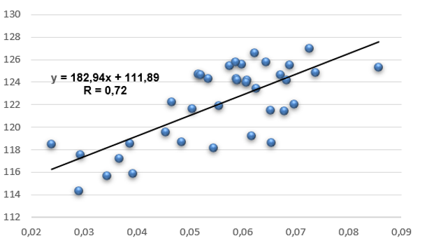
Figure 4. The variation of monthly speckle median and cosmic beam intensity / count values according to each other obtained for Baksan (Russia) test area. In the graph, the equation is the equation of the best linear fit between the two data sets and R is the Pearson correlation coefficient between the two data sets.

CONCLUSIONS

In this study, temporal variation of speckle values in radar images was compared with cosmic beam intensity / count data in order to examine the effect of cosmic rays on Sentinel 1 satellite images.

When the analysis results were examined, it was found that the values obtained showed approximately normal distribution. On the other hand, when the graph of the data is plotted with specific time range, it has been shown that it has an increasing trend, and a similar trend has been observed in the cosmic ray intensity data. Pearson correlation analysis was applied to determine the degree and direction of agreement between the two data sets, and significant positive correlation 72 % was obtained for the examined station.

ACKNOWLEDGEMENT

This work was supported by the Scientific and Technological Research Council of Turkey (TÜBİTAK), Grant No: 119Y072.

REFERENCES

Gagnon, L., Jouan, A. 1997. Speckle Filtering of SAR Images: A Comparative Study Between Complex-Wavelet-Based And Standard Filters. SPIE Proc. #3169, Conference "Wavelet Applications in Signal and Image Processing V", San Diego, pp. 199.
Horne, R., Glauert, S., Meredith, N., Boscher, D., Mıknatıs, V., Heynderickx, D., 2013. Space Weather Impacts On Satellites And Forecasting The Earth’s Electron Radiation Belts With SPACECAST. Advancing Earth And Space Science, 11, pp.1-18.
Lee, J. S. 1981. Refined filtering of image noise using local statistics. Computer Graphics and Image Processing, 15, pp. 380-389.
Radicella, SM. 2007. Sayfa SPACE WEATHER Research Towards Applications in Europe, edited by Lilensten, J., USA: Springer, pp. 125-127.
Smart, D.F., Shea, M.A., 1985. Galactic cosmic radiation and solar energetic particles, Handbook of Geophysics and the Space Environment. Air Force Geophysics Laboratory, 6-(1), pp. 6-29.
Skolnik, M. 1981 Introduction to Radar Systems. Edit: Cerra, FJ., Singapur: McGraw-Hill Book Company, pp. 1-2.
Tabachnick, BG., Fidell, LS., 2013. Using Multivariate Statistics (sixth ed.) Pearson, Boston, 983 pages.

