Monitoring Channel Shifting Pattern and Dynamics of River Channel Width using Remote Sensing Data

Kusumbor Bordoloi (1)*, Bhaskar Ramachandra Nikam (2), S. K. Srivastav (2), Dhrubajyoti Sahariah(1)

¹Department of Geography, Gauhati University, Jalukbari, Guwahati, Assam 781014, India
²Indian Institute of Remote Sensing, Indian Space Research Organisation, Dehradun, Uttarakhand 248 001, India
Email: kusumbor@gauhati.ac.in; bhaskarnikam@iirs.gov.in; sksrivastav@iirs.gov.in; dhrubajyoti@gauhati.ac.in

Abstract: Riverbank erosion and channel shifting is a common phenomenon faced by alluvial rivers. Through these processes, river channel regulates its morphometry to transport water and sediment flow from its source to mouth. In consequence of this fluvial activity, inhabitants in the adjoining areas of rivers have to endure loss of lives, households, properties, fertile agricultural lands, etc. The floodplain dwellers of Subansiri River, the largest right-bank tributary of the river Brahmaputra have been witnessing similar consequences of fluvial activities from the last few decades and hence incessant monitoring is indispensable for concerned authorities. In this study, a highly dynamic and unsteady stretch of Subansiri River in Assam (India) is considered for assessing the Spatio-temporal variation of channel shifting pattern, river channel width and high erosion/accretion zones from 1989 to 2017 using Earth Observation (EO) data. Landsat time-series EO datasets of Landsat 5 TM and Landsat 8 OLI are used as an input. To quantify the Spatio-temporal changes total 203 nos. of cross-sections and 105 nos. of square grids are generated. Analysis using the cross-section method gives the rate of channel shift as well as channel width. It is found that during 28 years (1989-2017), 50.70% of the right bank of the river Subansiri shifted towards the western side and 10.79% shifted towards the eastern side. Similarly, 29.10% left bank shifted towards the eastern side and 32.39% shifted towards the western side of the river. Dynamics of the channel width along 213 nos. of cross-sections depicts that 31.45% of cross-section width reduced and 30.04% of cross-section width increased during the measured period. The erosion/accretion analysis indicates the westerward shift of the Subansiri River during the considered period.
Keywords: Channel shift, river-channel width, erosion/ accretion, Subansiri River, Landsat data

Introduction
The alluvial rivers are dynamic entities over earth surface which frequently changes its course, morphology and the associated processes ( Lanzoni et al., 2018). Although in geomorphic time scale the channel shifting and associated changes in morphology are normal, yet it creates discomfort, loss of properties and life to the human settlements nearby. Due to the need for water in agriculture, transport and other uses, human settlement tends to largely rely on river waters and settles in nearby regions. However, the sudden changes of river course make them vulnerable to physical, economic and other disasters. Recurring high flood has been regarded as a dominating contributing factor for channel widening (Schumm, 1968) and channel shifting (Schumm & Lichty, 1963). However, tectonic forces, change in the climatic parameters and change in many other human-induced factors like embankments, dams, deforestation, land-use change, etc. contribute for the channel shifting, bank line migration.
Although to understand the hydrological processes of rivers fieldwork is must, yet in the last two decades, people have shifted towards the blended model in an investigation where remote sensing and GIS play as an aided tool to understand the process. The river Subansiri, the largest tributary of the Brahmaputra system covers a big area with sharp contrast of slope, climate and vegetation. To understand fluvial processes in such a basin with contrasting landscape need an understanding of parameters where field-based data collection is near impossible. Therefore Earth Observation (EO) data become handy in providing synoptic view of a large area at the fixed time interval for the continuous monitoring and assessing the changes in the river systems (Sarkar et al., 2012; Rozo et al., 2014; Bordoloi et al., 2020).
The objectives of this study are (i) to quantify the right bank, left bank shift and to monitor the direction of shift; (ii) quantification of river channel width; (iii) identification of high erosion/aggradation zones, of the Subansiri River using EO data. The outcome of this study will be helpful to understand the channel shifting behaviour of the river.

Study Area
The Trans- Himalayan snow-fed river Subansiri is one of the major tributaries of the mighty Brahmaputra River in North-East India. The river has the drainage area of ~35966 km² and the length of ~520 km. It originates from the confluence of three streams in Tibetan Plateau, namely Tsari Chu, Chayal Chu, and Lokong Chu (Char Chu) in the western part of mount Porom (5340 m AMSL). Flowing through the Himalayan mountain range, the river reaches India through Miri Hills of Arunachal Pradesh and joins the river Brahmaputra at Badati-ghat in the Lakhimpur district of Assam (Goswami et al., 1999; Goyal et al., 2018; Bordoloi et al., 2020). In this study, a highly dynamic and geomorphologically active stretch (~100 km upstream from its confluence with the Brahmaputra River; as shown in Figure 1) of the Subansiri River, Assam, India is considered. The selected section of the Subansiri River is extremely unstable and the riverbank erosion process is very active.

2.1 Data Used
A time-series datasets of cloud-free, standard terrain corrected (L1T), optical images from Landsat-5 Thematic Mapper (TM) and Landsat-8 Operational Land Imager (OLI) were downloaded from the USGS Earth Explorer site (https://earthexplorer.usgs.gov/) for the years 1989, 1994, 1998, 2002, 2006, 2010, 2014 & 2017. To maintain the consistency in the data, the satellite images used for the present work with temporal repetition of 4 to 5 years are of the post-monsoon month (December).
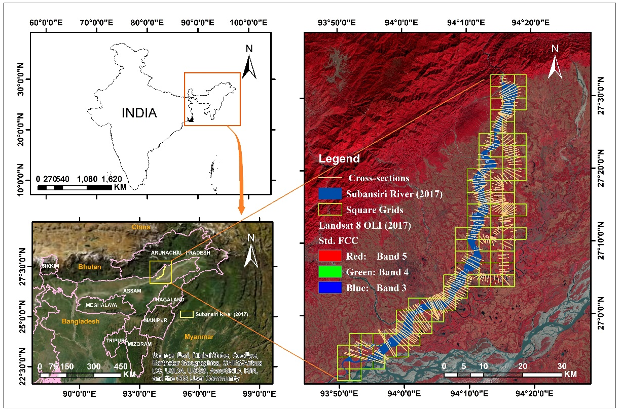

Figure 1: Location of the study area
Table 1: Satellite data used in the study
Sl. No. | Data and sensor | Date of acquisition | Row/Path | Cloud Cover (%) | Spatial resolution
1 | Landsat 5 TM | 08-12-1989 | 41/135 | 7.0 | 30 m
2 | Landsat 5 TM | 22-12-1994 | 41/135 | 4.0 | 30 m
3 | Landsat 5 TM | 17-12-1998 | 41/135 | 4.0 | 30 m
4 | Landsat 5 TM | 12-12-2002 | 41/135 | 5.0 | 30 m
5 | Landsat 5 TM | 07-12-2006 | 41/135 | 6.0 | 30 m
6 | Landsat 5 TM | 18-12-2010 | 41/135 | 7.0 | 30 m
7 | Landsat 8 OLI | 29-12-2014 | 41/135 | 3.1 | 30 m
8 | Landsat 8 OLI | 05-12-2017 | 41/135 | 5.7 | 30 m
2.2 Methodology
Multispectral images of Landsat 5 TM and Landsat 8 OLI of 8 different years are considered for this study. As discussed above to minimize the problem of cloud hindrance, seasonal variations in river channel all the selected imageries belong to the month of December i.e., post-monsoon season, of the respective year. During this season, large numbers of sand bars appear to be scattered within the river channels due to the low discharge in the river channels. Considering this, the riverbanks, i.e., active flood plain/river channel (including the channel bars), are digitized manually as a polygon feature within the GIS environment. The flow of this methodology is represented in Figure 2.
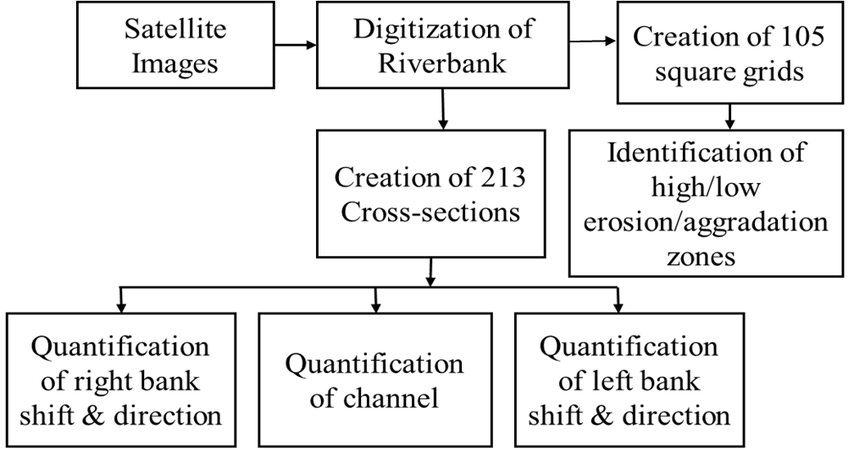
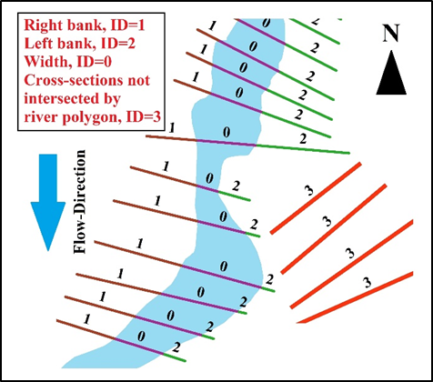
After digitizing river channels for all the years the behaviour of selected stretch of the river channel has been analysed by generating 213 cross-sections placed randomly from north to south as shown in Figure 1. The total number of the cross-sections are considered by overlaying all the river channel polygon shapefiles from 1989-2017 to cover a maximum portion of each river channel. Intersecting the cross-sections with the polygon shapefiles of the river channels, each cross-section gets split into 3 sub-sections. Since the Subansiri River is flowing from the north to the south direction, therefore the left sub-sections marked as the right bank (Id=1) of the channel, middle sub-sections marked as the width (Id=0) and right sub-section considered as the left bank (Id=2) of the river channel (refer Figure 3). For quantification and to monitor the shifting direction, the arithmetic difference of cross-section length (right bank, left bank and width) between two consecutive years gives the bank line shift as well as the change the river channel width. Due to the Spatio-temporal variation of the river stretch, all 213 nos. of cross-sections are not intersected by each river channel polygon and as a result, some cross-sections are not split into 3 sub-sections for every single year. Therefore, for the simplification during analysis, length of such cross-sections (Id=3) is considered as ‘0’. If the shifting distance is ‘+ve’ in case of the right bank, then the direction of the shift is marked towards the west and for ‘- ve’ shifting distance, the direction of the shift is considered towards the east. On the other hand, ‘+ve’ shifting distance in the left bank indicates the eastern movement of the bank line and ‘-ve’ distance indicates the shift towards the west. Succeeding all the aforesaid phases, the right bank shift, left bank shift and change in channel width for the periods of 1989-1994, 1994-1998, 1998-2002, 2002-2006, 2006-2010, 2010-2014, 2014-2017 and 1989-2017 are quantified.
Figure 2: Methodology flow chart

Figure 3: Schematic diagram showing sub-cross-sections (right bank, Id=1; left bank, Id=2; width, Id=0; not intersected cross-section, Id=3)
For the identification of high erosion/aggradation zones, the complete extent of the study area (i.e., 93º49’46’’ E/ 26 º51’3” N and 94 º19’14” E/ 27 º33’ N) is discretised in square grids of 3km×3km using ‘Fishnet’ function of ArcGIS. The symmetric difference between the square grid and active river channel polygons of each year gives us the area of each grid occupied by the active river channel. The comparison of symmetric difference output of each year with the presiding and succeeding year gives the change in the active river channel in each particular grid happened in these two-time steps. The identification and quantification of the erosion/aggradation zones are done using such temporal analysis of all the aforementioned 8-time steps.

Results and Discussion

Quantification of the river bank line shift and river channel width
As mentioned in the methodology part, the arithmetic difference of cross-section length (right bank, left bank and width) between two consecutive years gives the shifting distance and direction of riverbank line shift during the period under consideration. It is seen from Figure 4 and Figure 5 that during 1989-1994, right bank line is shifting towards the western direction with an average of 0.636 km in 171 nos. of cross-sections and in 37 nos. of cross-sections the average shift is 0.107 km towards the east. Similarly, during the same period, the left bank line is shifting towards the east with an average of 0.212 km in 85 nos. of cross-sections. On the other hand, in 46 nos. of cross-sections the left bank line is shifting towards the west with an average of 0.195 km. It is found that during 1989-1994, in 73 nos. of cross-sections, the channel width has increased at an average of 0.296 km and in 135 nos. of cross-section, the average width has calculated as 0.318 km. There are 5 cross-sections in both banks (right & left), and the width of the river channel not intersected by the river polygon in 1994. Therefore the bank shifting distance and width length is considered as ‘0’ for these 5 cross-sections.
During 1994-1998, in 129 cross-sections of right bank line shifted towards the right side, i.e., towards the western direction. The average shift is 0.184 km. On the other hand, in 56 cross-sections, the line shifted towards the east (average shift 0.145km). It is important to mention that, the maximum occurrence of the change may be seen from the cross-sections 29 to 205. Similarly, in the left bank of the river channel, bank line in 103 nos. of cross-sections shifted at an average of 0.144 km towards the east. In 82 nos. of cross-sections, bank line shifted at an average of 0.421 km towards the west. Here, a lower cross-section i.e., from 184 to 190, left bank line showing the higher rate of the shift towards the west. Similarly, during 1994-1998, the average width increased by 0.593km (in 59 nos. of cross-sections) and decreased by an average of 0.251 km (in 126 nos. of cross-sections). There are 28 cross-sections not intersected by river polygon in 1998, so no significant difference may be seen in those sections in 1994-1998.
Between 1998 and 2002 changes in the right bank line are maximum from the cross-sections 34 to 213. Out of 213 cross-sections, in 88 cross-sections bank line shifted towards the west with an average of 0.402 km, In 43 nos. of cross-sections, bank line shifted towards the east with an average of 0.469 km. Similarly, in case of the left bank in 104 cross-sections, bank line shifted at an average of 0.462 km towards the east. In 27 nos. of cross-sections, bank line shifted an average of 0.099 km towards the western direction. Though the changes have been seen in the complete stretch of the river, from the cross-section no 32, the variation is prominent. In 1998-2002, in 125 nos. of cross-section, the width has been increased at an average of 2.314 km and only in 6 nos. of cross-sections, the width has been decreased by an average of 0.83 km. It is important to mention that in 2002 one major section of river channel changed its course towards the west and which leads to the highest rate of increase in channel width in this span. From 2002 onwards, there are 82 nos. of cross-sections not intersected by the river polygon and therefore the length is considered as ‘0’ for all remaining calculations.
During 2002-2006, in 99 nos. of cross-sections, right bank line shifted at an average of 0.135 km towards the west. In 32 nos. of cross-sections, right bank line shifted at an average of 0.143 km towards the east. Similarly, in case of left bank line, out of 213 nos. of cross-sections, in 79 cross-sections, riverbank line shifted at an average of 0.228 km towards the east and in 52 nos. cross-sections, bank line shifted at an average of 0.301 km towards the west. Between 2002 and 2006, the average width increased by 0.358 km in 44 cross-sections and decreased in 87 cross-sections by an average of 0.31 km.
In 85 nos. of cross-sections, right bank line has been shifted at an average of 0.185km towards the west during 2006-2010. In the same period, in 46 nos. of cross-sections the right bank line shifted to 0.160 km towards the east. On the other hand, in 2006-2010, the left bank line shifted at an average of 0.212 km towards the east in 85 nos. of cross-sections. An average of 0.195 km length of left bank line in 46 nos. of cross-sections shifted towards the west during the same period. During 2006-2010, the average width increased in 29 cross-sections by 0.307 km and decreased by 0.258 km in 102 cross-sections
In 2010-2014 and 2014-2017, in 98 and 111 nos. of cross-sections, at an average of 0.135 km and 0.094 km, respectively, the right bank line of the Subansiri River has shifted towards the western direction. Similarly, during the same time, in 33 and 20 nos. of cross-sections, the right bank line shifted towards the east at an average of 0.203 km and 0.017 km, respectively. On the other hand, in the left bank line, out of 213 nos., in 80 nos. of the cross-section, left bank line shifted by an average of 0.108 km in 2010-2014 and at an average of 0.139 km in 91 nos. of cross-sections during 2014-2017 towards the east. Similarly, an average of 0.332 km and 0.139 km left bank line shifted towards the west in 51 and 40 nos. of cross-sections during 2010-2014 and 2014-2017, respectively. In 2010-2014, in 40 cross-sections, average width increased by 0.424 km and in 91 cross-sections, average width decreased by 0.181 km. From 2014-2017, the increased average width in 21 cross-sections are calculated as 0.189 km and in 110 cross-sections, the average width decreased by 0.193 km.

Figure 4: Temporal variations (average) of bank line shift (right & left) and river channel width

Figure 5: No. of cross-sections in each process of in riverbank shift and channel width
The comparison between the years 1989 to 2017 depicts that during this 28 years of span, the right bank line of the river Subansiri shifted at an average of 0.695 km towards the west (in 108 nos. of cross-sections) and shifted by an average of 0.583 km towards the east (in 23 nos. of cross-sections). In case of the left bank line, during this span, the bank shifted at an average of 0.662 km (in 62 nos. of cross-sections) towards the east and at an average of 0.909 km (in 63 nos. of cross-sections) towards the west, respectively. In the case of river channel width during 1989-2017, in 67 cross-sections, the average width of the Subansiri River has increased by an average of 1.818 km and decreased by an average of 0.806 km in 64 cross-sections.
In 28 years, it is evident that during 1989-1994, the western shift (average) of the right bank, as well as left bank of the Subansiri river, is prominent. Because from 1994, one separate course of river Subansiri started flowing (cross-section no. 30 to 129) in the western section of the main river channel. Later this course of the river channel becomes the main channel (from 1998-2002). The eastern shift of the river banks (right & left) is maximum during 1998-2002. During the same phase, the highest/lowest rates of average increased/decreased channel width have been recorded (Figure 4). The main river channel of the Subansiri River shifted its course during 1989-2002 (from cross-section 29 to 131) as a result of this fluvial changes, variations in the right river channel shift have been seen towards the eastern side by the process of channel widening. It is observed that the river has been expanding its width over the years which may lead to the increasing rate of riverbank erosion and channel shifting in the considered stretch of the river channel. On the other hand, for the considered section of the river, the middle part and mouth portion of the river is the most dynamic part in terms of channel shifting and channel widening throughout the years.

Identifications of high erosion/aggradation zones
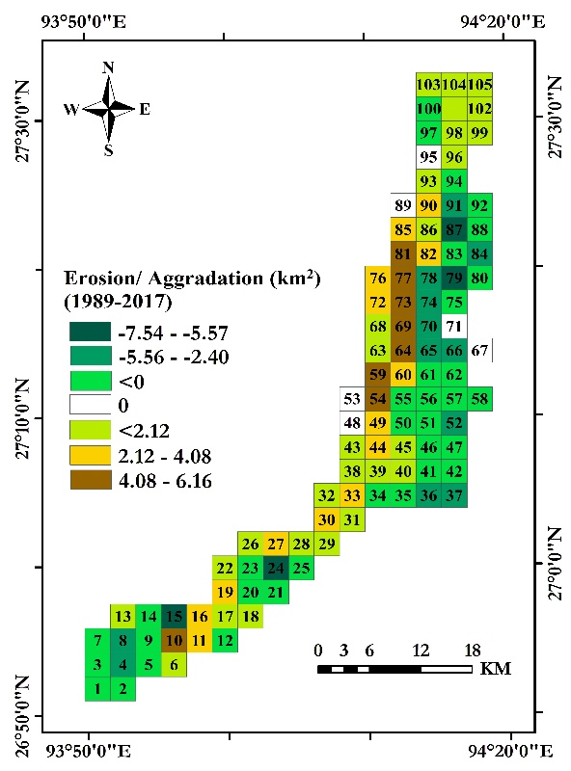
The comparison of ‘symmetrical difference’ of square grids and river channel polygon of each year under consideration gave us the erosion/aggradation in each active channel grid (square grid through which the active river channel passes). In Figure 6, the high erosion/ aggradation zones are presented, the dark brown grids portray the highest erosion zones, while dark green denotes the high aggradation zones. White colour depicts the stable/unaffected zones where neither erosion nor aggradation has taken place or the net erosion/aggradation is zero due to shifting of the river course. It is witnessed that during 1989–1994, grid no. 23, 44, 62, 66 have undergone high riverbank erosion. On the other hand, grid no. 35, 36, 37, 42 show maximum aggradation during the same period. Similarly, during 1994–1998, grid no. 16, 85, 90 are indicated as high erosion zones and maximum aggradation has taken place in the grid no. 24. From 1998 to 2002, identified high erosion zones include grid nos. 54, 64, 69, 73, 77, and 81. During the same period, maximum aggradation is recorded in grid nos. 66, 74, 79, 87, and 91. During 2002–2006, grid nos. 73 and 77 have experienced high erosion and grid nos. 11, 17, 33, and 93 show higher aggradation. During 2006–2010, identified high erosion zones were at grid nos. 10, 39, and 64. During the period of 2010–2014, grid nos. 10, 33, 38, 81, 82, and 85 are under high erosion. Grid no. 45, 81, and 85 show high erosion during 2014–2017, whereas maximum aggradation occurred in grid nos. 4, 11, 12, 77, and 78. The comparison between the year 1989 and 2017 revealed that grid nos. 54, 59, 64, 69, 73, 77, and 81 are the zones with maximum erosion (Bordoloi et al., 2020).
Figure 6: Erosion/Aggradation zones from 1989-2017
This temporal analysis of high erosion/ aggradation zones specifies the shifting of the Subansiri River towards the western side. This result highly supports the findings of section 3.1 Quantification of the river bank line shift and river channel width that the right bank and the left bank of the river is migrating towards the western side of the Subansiri River during 1989-2017. The cross-sections lie on the square grids showing the high erosion zones also indicates the high fluctuation in terms of bank line shifting and dynamics of the channel width. The outcome of the study also matches the published works. Goswami et al. (1999) emphasised that during 1970-1990, unequal shifting of both bank lines in both directions leads to the increased of the channel width. In that study, it was mentioned that the river shifted 6km towards western side near Chauldhoaghat during 1920–1970. Gogoi & Goswami (2014) has also shown that the river consistently migrating towards the western direction.

Conclusion
In this work, a highly dynamic and unsteady ~100 km stretch of the Subansiri River is studied using multispectral-temporal remote sensing data from Landsat 5 TM and Landsat 8 OLI of the period 1989-2017. To monitor the channel shifting pattern and dynamics of river channel width, quantification of the right bank, left bank and channel width has been done by drawing 213 cross-sections along the river path and 105 of square grids (3 km x 3km). Results show that during 28 years from 1989-2017 with a time gap of 4-5 years, 50.70% of the right bank shifted towards the western direction at an average of 0.695 km. 10.79% right bank shifted towards the east (average of 0.583km). Similarly, 29.10 % left bank line shifted towards the east at an average of 0.662 km and 32.39% left bank shifted towards the west at an average of 0.909 km. In the considered span, the migration of both the bank towards the western side was maximum during 1989-1994 due to the origin of a new channel in the upper middle section of the river stretch and later it becomes the main course of the Subansiri river. Dynamics of the channel width also depicts that in 31.45% cross-sections (67 nos.) has been increasing at an average of 1.818 km and decreasing at an average of 0.806 km (in 64 cross-sections i.e., 30.04%) over the years (1989-2017). The variation in terms of channel width is maximum during 1998-2002. It is evident that, during 1998-2002, the course of the river channel that formed during 1994 becomes the main course of the Subansiri River and the older channel left abonnedoned. Therefore right bank shifting towards the east (average of 0.469 km) and channel widening (average of 2.314 km) was maximum during that period. It is noteworthy that the maximum changes in terms of channel shifting pattern have been seen during 1989-1994 and 1994-1998. The result of identification of high erosion/ aggradation zones also portrays that the westward shift of the high erosion zones within the considered period (Bordoloi et al., 2020). Variations in terms of channel shift and channel width analysed with the cross-section method correlates the findings in identification of high erosion/ aggradation zones spatially and temporally. It is evident from the literature that the from 1920, the river channel has been widening its course and due to the increased amount of sediment load the process of mid-channel bar formation was seen (Goswami et al., 1999). Therefore, it can be concluded that in the case of the Subansiri River, the dynamics of channel shifting and channel width largely depending on the formation of mid-channel bars. As a result of which, the river channel changes is course as well as width over the years.

Acknowledgement
This study is part of the PhD research work (Department of Geography, Gauhati University, Assam, India) carried out by the first author. Thanks to the United States Geological Survey for providing Landsat data required for this study.

Reference
Bordoloi, Kusumbor; Nikam, Bhaskar Ramachandra; Srivastav, S. K.; Sahariah, D. (2020). Assessment of riverbank erosion and erosion probability using geospatial approach : a case study of the Subansiri River, Assam, India. Applied Geomatics. https://doi.org/10.1007/s12518-019-00296-1
Gogoi, C., & Goswami, D. C. (2014). A Study on Channel Migration of the Subansiri River in Assam using Remote Rensing and GIS Technology. Current Science, 106(8), 1113–1120. https://doi.org/10.1002/asi.23046.2.
Goswami, U., Sarma, J. N., & Patgiri, A. D. (1999). River channel changes of the Subansiri in Assam, India. Geomorphology, 30(3), 227–244. https://doi.org/10.1016/S0169-555X(99)00032-X
Goyal, M. K., Shivam, Sarma, A. K., & Singh, D. Sen. (2018). Subansiri: Largest Tributary of Brahmaputra River, Northeast India. In D. Sen Singh (Ed.), The Indian Rivers (pp. 523–535). Springer. https://doi.org/10.1007/978-981-10-2984-4_36
Lanzoni, S., Ferdousi, A., & Tambroni, N. (2018). River banks and channel axis curvature: Effects on the longitudinal dispersion in alluvial rivers. Advances in Water Resources, 113(October 2017), 55–72. https://doi.org/10.1016/j.advwatres.2017.10.033
Rozo, M. G., Nogueira, A. C. R., & Castro, C. S. (2014). Remote sensing-based analysis of the planform changes in the Upper Amazon River over the period 1986–2006. Journal of South American Earth Sciences, 51, 28–44. https://doi.org/https://doi.org/10.1016/j.jsames.2013.12.004
Sarkar, A., Garg, R. D., & Sharma, N. (2012). RS-GIS Based Assessment of River Dynamics of Brahmaputra River in India. Journal of Water Resource and Protection, 04(02), 63–72. https://doi.org/10.4236/jwarp.2012.42008
Schumm, S. A. (1968). River adjustment to altered hydrologic regimen, Murrumbidgee River and paleochannels, Australia (Vol. 598). US Government Printing Office.
Schumm, S. A., & Lichty, R. (1963). Channel widening and floodplain construction along Cimarron River in southwestern Kansas. US Geol. Surv. Prof. Pap.

