EMERGING GEOPORTAL PLATFORMS FOR GEOSMART AGRICULTURAL PLANNING

G.P. Obi Reddy (1), Nirmal Kumar (1) and P. Chandran (1)

¹ICAR-National Bureau of Soil Survey & Land Use Planning, Amravati Road, Nagpur-440033

Email: obireddygp@gmail.com

KEYWORDS: BHOOMI geoportal, remote sensing, GIS, geosmart agricultural planning

ABSTRACT: In the context of global food security and climate change, optimum utilization and sustainable management of agricultural resources assumes a greater importance in achieving some of the Sustainable Development Goals (SDGs) like no poverty, zero hunger and life on land as proposed by United Nations. The emerging geoportal platforms and web-based applications have redefined the efficient planning, management, monitoring and implementation of agricultural land use plans at different levels. The Web-based geoportal technologies have immense potential in sustainable management of agricultural resources. Web based geoportal is essentially a master web site, connected to a web server, which contains diversified thematic databases derived from various sources like remote sensing, GIS, GPS and field surveys with metadata information about geographic data and services. BHOOMI geoportal platform developed by ICAR-NBSS&LUP provide various thematic services of land and allied resources as Web Map Services and facilitates to visualize, access, query and dissimilate the land resource information. The important Web Map Services of BHOOMI geoportal encompasses various thematic services like socio-economics, terrain, satellite data based derived products, agro-ecology, soils, land degradation, soil erosion and crop suitability. The user-friendly BHOOMI geoportal platform facilitates the users to visualize various cross-domain applications in land resource management, land degradation assessment and geosmart agricultural planning in India.

INTRODUCTION

The availability of reliable site-specific information on land resources play an important role in agricultural planning and selection of appropriate land uses based on the potential and constraints of the available land resources (Reddy et al., 2017a). In the recent decades, soil information systems (Maji et al., 2002b; Reddy 2012, 2016a) has become increasingly important in many agricultural resources planning, management and applications it includes estimation of soil loss (Das et al., 2013; Sahoo et al., 2014; Reddy et al., 2016b; Mahapatra et al., 2018), assessment of land degradation (Reddy et al., 2002; Maji et al., 2010) and crop planning (Walke et al., 2012; Kumar et al., 2017; Ramamurthy et al., 2020). In India, attempts have been made in development of soil information systems to generate various soil based thematic maps and land use plans (Maji et al., 2001; 2002a,b,c; Reddy et al., 2014a,b; 2016a). The comprehensive soil information systems provides geographic distribution of terrain attributes, soil types, soil physical and chemical properties, which immensely helps in agricultural planning (Reddy et al., 2014a,b). Therefore, the knowledge on soils, in respect of their extent, distribution, characterization and use potential, is extremely important for sustained agricultural development (Bhattacharyya et al., 2014). The emerging capabilities of geospatial technologies has greatly enhanced the capabilities to develop robust geoportals and manage voluminous geospatial data on soils and allied resources for effective integration, analysis, visualization, and presenting the spatial data in agricultural planning (Reddy et al., 2016c; Reddy et al., 2017b; Reddy and Singh, 2018a).

Geoportals have become the important source of spatial information to the researchers, planners and policy makers. The ‘geoportal’ refers to a web environment that acts as a gateway to Spatial Data Infrastructure (SDI) (Tumba and Ahmad 2014). Further, the term ‘spatial web portals’ is also synonymously used in the literature for defining web-based gateways to access and manipulate the geospatial data through the Internet (Yang et al., 2007). In the recent years, the growing trend of geoportals was observed in spatial data integration, spatial analysis and visualization through data analytics tools. Geoportals have the capabilities to provide various functions for the users to explore and analyze the spatial data, thematic mapping, visualization and reporting. The advent of web-based geoportals provides a powerful online platform to collect, integrate, discover, use, and share geospatial data, information, and services related to agriculture development (Arozarena et al., 2016; Maguire and Longley 2005). Web-based GIS systems are extending the gamut of geospatial data uses and helping in improving the update and distribution of geospatial data. However, due to considerations in data policy and system performance, many of the geoportals still use their own ways of integrating, managing and dissemination of spatial data (Sinnott et al., 2011).

2.EMERGING GEOPORTAL PLATFORMS

Geoportal is a powerful web-based platform and it provide services for finding and accessing the geospatial information and various geographic services such as displaying, editing, analyzing, and publishing geographic information. In the recent years, many institutions across the globe are adopting the use of geoportals to facilitate the geospatial data storage, discovery, dissemination along with the theme-based services and applications (Maguire and Longley, 2005; Fritz et al., 2012). The geoportal-based integration of web map services, spatial visualization, and analysis have potential to support the various agricultural applications. Many international organizations developed geoportals to share Earth observation data and various geospatial datasets. The popular geoportals such as INSPIRE provide the geospatial datasets to member states of the European Union. The Global Earth Observations System of Systems (GEOSS) Portal developed in the context of the Group on Earth Observations (GEO) and the Committee on Earth Observation Satellite (CEOS) portal (Anderson et al., 2017). The present study aimed to describe the development, important functionalities and the important services of BHOOMI geoportal developed by ICAR-National Bureau of Soil Survey and Land Use Planning (ICAR-NBSS&LUP), Nagpur, India.

3.DEVELOPMENT OF BHOOMI GEOPORTAL

BHOOMI geoportal was designed and developed by ICAR-NBSS&LUP, Nagpur India to organize, catalogue, store, search and visualize information on land and allied resources and provide various thematic services as Web Mapping Services (Reddy and Singh, 2018b). The spatial layers were processed and developed for geoportal as map package. The map package was accessed through geoportal and published to the server by hosting the Web Mapping Services. HTML and JavaScript were used to develop the frontend of the BHOOMI geoportal. QGIS was used to develop legend styles and exported as SLD’s for usage with GeoServer. The services have been grouped based on their nature, content and published as bundle of layers as a service. In BHOOMI geoportal APIs were used to build 2D web applications with capabilities such as query and viewing. In BHOOMI geoportal, various spatial layers on land allied resources were deployed and provided as Web Mapping Services (WMS) by using the Geoserver platform (Reddy and Singh, 2018b). Various user-friendly utility tools, like data query, extract and legend development were developed in the geoportal. The service metadata has been provided to majority of the geoportal services to provide the useful information for the users. Spatial Database Management System (SDMS) is essential part of geospatial data storage, management and query various services. In BHOOMI geoportal the postgre SQL data management system was used for effective store geospatial data store, query and management.

Geoportal technology has indeed advanced dramatically over the past decade and now provides an effective mechanism for dissemination of various geospatial information and services. However, the success of any geoportal is dependent on the availability of the standardized data and services on the web portal and the frequency at which the data is being updated. Majority of geospatial datasets are being processed for geoportals comes in the form of vector and raster formats with georeferenced to a specific location on the earth’s surface. In BHOOMI geoportal various metadata standards were followed in providing the services, reduce the redundancy in data storage and provide the services interoperability. The integration of simulation and process models into the internal architecture of the geoportal services can provide impetus to the interoperability of models, services and applications.

4.BHOOMI GEOPORTAL PLATFORM AND SERVICES

BHOOMI geoportal provide various thematic services of land and allied resources as Web Map Services and facilitates to visualize, access, query and dissimilate the land and allied resource information. The important Web Map Services of BHOOMI geoportal encompasses various thematic services like socio-economics, terrain, satellite data based derived products, agro-ecology, soils, land degradation, soil erosion and crop suitability. BHOOMI geoportal platform supports the development of dynamic web applications by providing libraries, packages and templates into a single connected piece of software, thus alleviating the tasks of dealing with low-level details. The BHOOMI geoportal framework allows to combine, publish and visualize various services as Web Map Services without having to deal with every single detail regarding projection and interactivity functions. BHOOMI geoportal also offers basic graphical user interface (GUI) that can be extended and modified with additional functions and plugins. They usually offer an API (application programming interface) to allow an easier use and access to the libraries. The Catalogue Service component provides the underlying database, and it enables users to discover metadata records. BHOOMI geoportal provide access to web map services, data discovery, and dynamic visualization tools for query the geospatial data.

4.1Agro-ecology

Agro-ecology encompasses the relationship between agricultural production systems and ecological processes. The agro-ecological approach was considered based on climatic conditions, length of growing period (LGP), physiography and soils for agricultural land use planning and agro-technology transfer. The crop planning, based on total rainfall alone may be erroneous because the availability of moisture for crops depends on soil depth and texture even under similar precipitation condition. Thus, agro-ecological approach in identification of homogeneous units by integrating the relevant parameters like LGP, bio-climate and soil parameters such as texture, depth, mineralogy and available water holding capacity (AWC) form a strong foundation for crop planning and agro-technology transfer. BHOOMI geoportal provide the services on agro-ecology it includes agro-ecological regions and sub-regions of India, mean annual rainfall, water storage, water deficit, potential and actual evapo-transpiration for the specific periods. The available thematic services on agro-ecology play an important role in agricultural planning and agro-technology transfer at national, regional, local level in India. The web map service of agro-ecological sub-regions of India on BHOOMI geoportal is shown in fig.1.

4.2 Soil information

BHOOMI geoportal provide Web Map Services on soils at 1:1 m and 1:250 k, 1:50k soil data for selected districts, soil loss status and land degradation status of India. The point database at national level on benchmark soil information of India, state wise soil series of India for the selected states, soil series database for the selected districts, grid point data on soil fertility has been processed and deployed in BHOOMI geoportal. BHOOMI geoportal platform has the ability to systematically organize, search, discover, access, visualize and update soil and allied geospatial data and services. The Web Map Service of soils of India (1:1m) on BHOOMI geoportal is shown in fig.2.

4.3 Crop suitability

Assessing the crop suitability is an important component and assumed a greater importance for sustainable agricultural development under changing climate in the coming decades. Land suitability assessment provides a mechanism to measures the degree of land usefulness for potential land use by land requirement and qualities and helps to assess the intrinsic and potential capabilities of land resources (FAO, 1976). The Web Map Services on land management units and core crop growing areas were available on BHOOMI geoportal. The Web Map Services on crop suitability for about seventeen crops at national and state level were available on BHOOMI geoportal. The Web Map Service of highly and moderately suitable areas for maize in India on BHOOMI geoportal is shown in fig.3.

4.4 Spatial data query

In BHOOMI geoportal, services can be viewed and queried at different administrative levels like national, state and district level. Spatial data queries through geoportals can be divided as spatial, non-spatial and mixed. The query languages like SQL was used to build query modules to query the structured data. In BHOOMI geoportal, search functions were developed as aggregations of building block tools, which can be executed in sequential steps. The spatial query can be executed to locate a place through selecting a place by using the query tool, or using a geocode tool or simply selecting a location from a list. Geoportal applications can be executed for a particular set of features that are usually the main focus of the geoportal. This search could be for a particular location based geographic web services with coverage of a particular location, and it allows to query both geographic attribute and content metadata.

4.5 Spatial data visualization

Visualization interfaces of any geoportals can be a very powerful tool for spatial data, which can aid the users with information to visualize and explore the associated data. A thematic service is an example of information visualization, a specific type of map and attribute database that is designed to communicate information about a single topic or theme (Wade and Sommer 2006). BHOOMI geoportal allows the user to visualize, explore and examine the published services and their content. Additional functions like pan, zoom and feature that identify capabilities aid the user in more thoroughly evaluating the published content. It also supports the ability to view multiple map services in single or combination map service. BHOOMI geoportal provides an easy-to-use interface for users to access and visualize resources to obtain the information for use in their own applications. A well-designed GUI is beneficial for interacting with the user and providing an easy-to-use tools for powerful visualization.

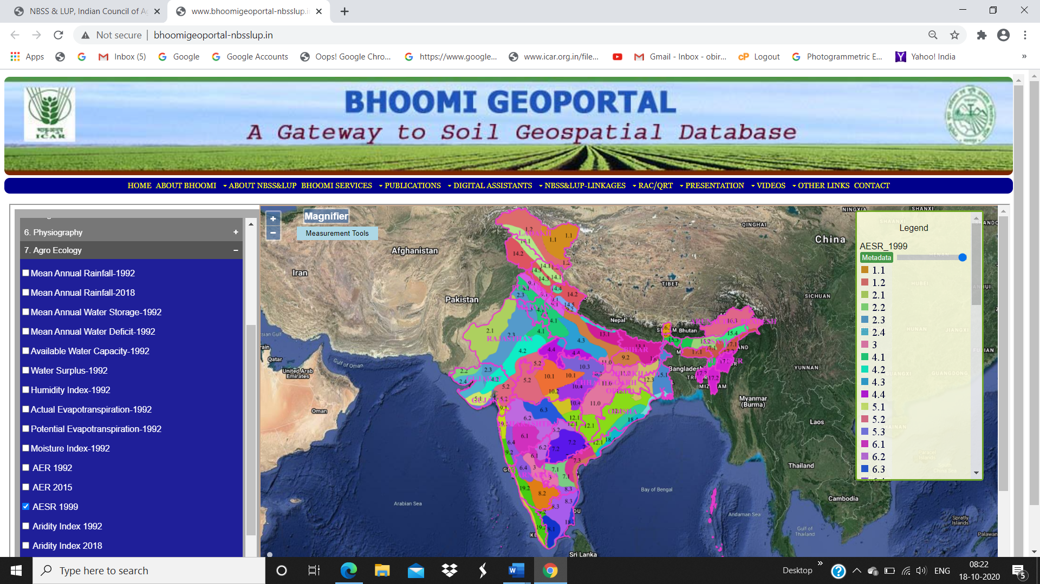

Fig.1. Web Map Service of agro-ecological sub-regions of India on BHOOMI geoportal

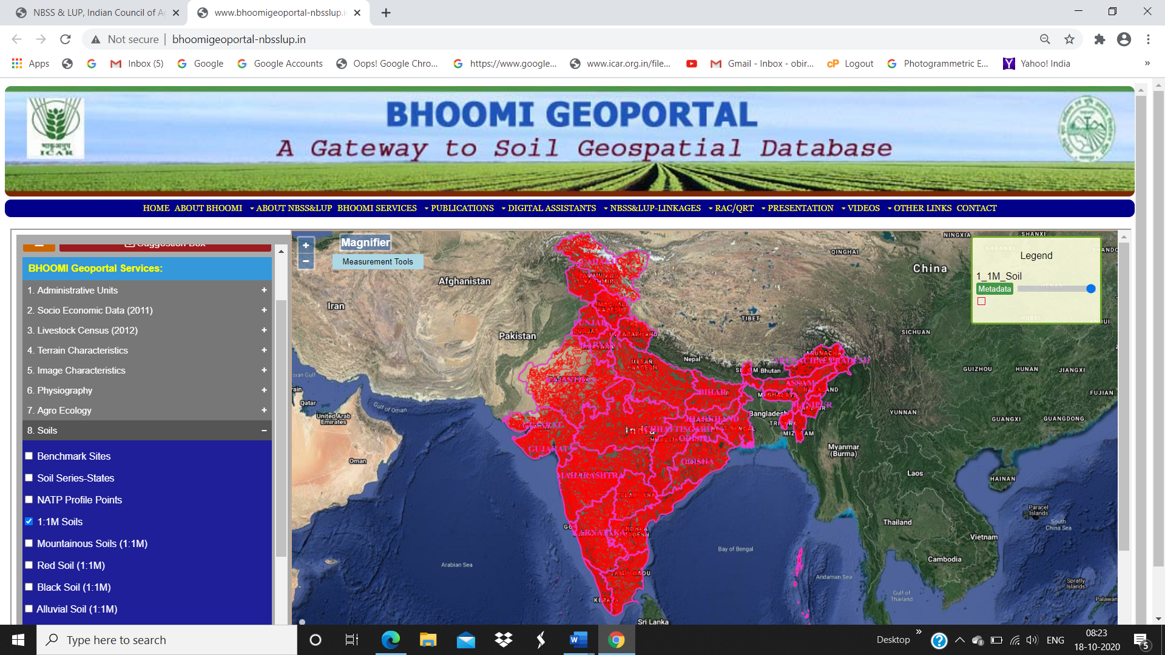

Fig.2. Web Map Service of soil information of India (1:1m) on BHOOMI geoportal

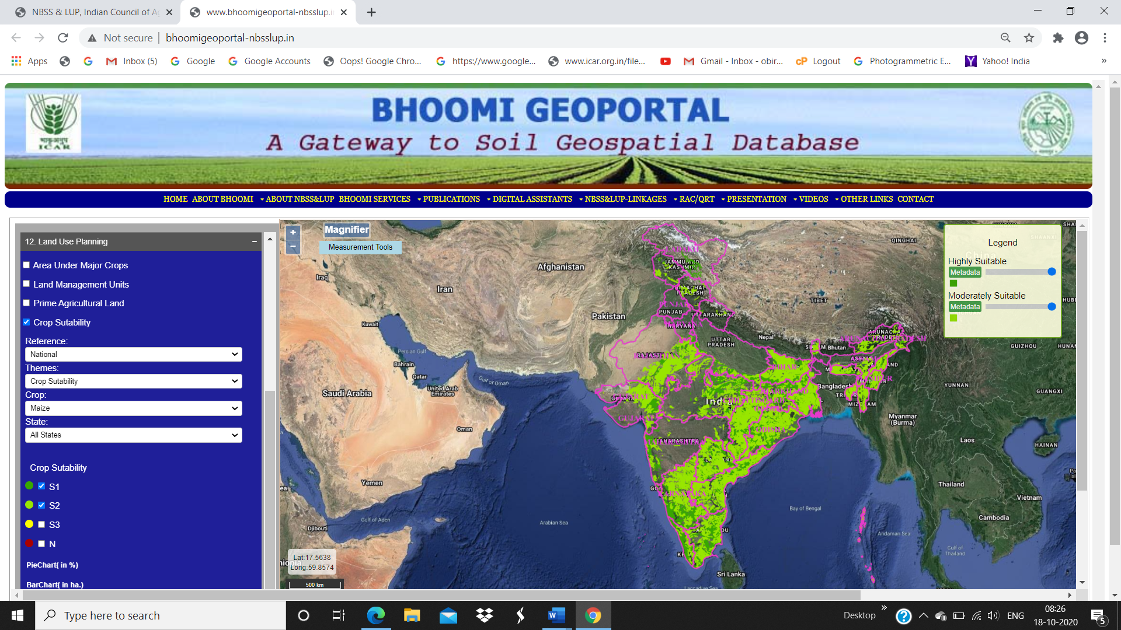

Fig.3 Web Map Service of highly and moderately suitable areas for maize in India on BHOOMI geoportal

5. CHALLENGES AND FUTURE DIRECTIONS

There are many challenges in providing the effective services and applications through geoportals. The potential of standardized web services lies in the flexible integration and reuse of services and computational power from different providers. The important mechanism would be distributed geospatial information processing (Yang et al., 2008), it refers to geospatial information processing in a distributed geoportal ecosystem. The advancements in the world wide web and geoportal architecture enable us to develop distributed geospatial information processing mechanism. Decentralization and cross-domain geoportal architecture under a loosely coupled environment has become an emerging trend. Adoption of service-oriented architecture (SOA) and cloud computing is a promising solution to enhance the capabilities of geoportal infrastructure. Future work of BHOOMI geoportal orients towards enhancing the analytical capabilities, visualization, metadata cataloguing, enhancement of geospatial data query and user feedback functionalities.

6. CONCLUSIONS

The developed BHOOMI geoportal enables to catalogue, store, manage, process and analyse large volume of land resource databases. In this framework, identification of spatial land and allied databases and development of a schema for describing the databases are the crucial. BHOOMI geoportal offer various capabilities for providing wide range of services, ranging from thematic service to attribute information that are usually required for decision-making purposes at various level. BHOOMI geoportal also provide a platform to leverage geospatial technology, avoid the development of duplicate datasets, reduce data management costs and present cost-effective way of access to geospatial information and services. The designed and implemented overall service-oriented architecture of BHOOMI geoportal and the ecosystem of tools help to deliver Web Map Services to the planners, decision-makers and land users at different levels for various land resource management and land use planning applications. The user-friendly BHOOMI geoportal platform facilitates the users to visualize various cross-domain applications in land resource management and geosmart agricultural planning in India.

ACKNOWLEDMENTS

The authors would like thank to Abhishek C., Turkar, S.Y., Dinesh, R., Thakare, V., Arun Kumar, K.C., Sandeep, S., and Sukesini, N., project staff for their contributions and support.

REFERENCES

Anderson, K., Ryan, B., Sonntag, W., Kavvada, A., Friedl, L., 2017. Earth observation in service of the 2030 Agenda for Sustainable Development. Geo-Spatial Information Science, 20, 77–96.
Arozarena, A., Villa, G., Valcárcel, N., Pérez, B., 2016. Integration of remotely sensed data into geospatial reference information databases. UN-GGIM National Approach. International Archives of Photogrammetry, Remote Sensing and Spatial Information Sciences, 41. 721-725.
Bhattacharyya, T., Chandran, P., Ray, S.K., Tiwary, P., Dharmik, A., Mandal, D.K., Mandal, C., Chatterji, S., Pal, D.K., Reddy, G.P.O., Sarkar, D., Singh, S.K., 2014. WebGeoSIS as soil information technology: A conceptual framework, Agropedology, 24 (2), 222-233.
Das, T.H., Dutta, D., Reddy, G.P.O., Singh, S.K., Sarkar, D., Dhyani, B.L., Mishra, P.K., 2013. Soil Erosion of Sikkim, by NBSS Publ.164, NBSS&LUP, Nagpur, p 42.

FAO, 1976. A framework for land evaluation, Soil Bulletin 32. Food and agriculture organization of the United Nations, Rome.

Fritz, S., McCallum, I., Schill, C., Perger, C., See, L., Schepaschenko, D., Van Der Velde, M., Kraxner, F., Obersteiner, M., 2012. Geo-Wiki: An online platform for improving global land cover. Environmental Modeling and Software, 31, 110–123.

Kumar, N., Reddy, G.P.O., Chatterji, S., Srivastava, R., Singh, S.K., 2017. Land suitability evaluation for soybean using temporal satellite data and GIS a case study from central India. In: Sustainable Management of Land Resources: An Indian Perspective, edited by G.P.O. Reddy., N.G. Patil., Chaturvedi, A.). Apple Acade. Press, USA, pp. 387-410.

Maguire, D.J., Longley, P.A., 2005. The emergence of geoportals and their role in spatial data infrastructures. Computers, Environment and Urban Systems, 2005, 29, 3–14.
Mahapatra, S.K., Reddy, G.P.O., Nagdev, R., Yadav, R.P., Singh S.K., Sharda V.N., 2018. Assessment of soil erosion in fragile Himalayan ecosystem of Uttarakhand using USLE and GIS for sustainable productivity, Current Science, 115(1), 108-121.
Maji, A.K., Nayak, D.C., Krishna, N.D.R., Srinivas, C.V., Kamble, K., Reddy, G.P.O., Velayutham, M., 2001. Soil information system of Arunachal Pradesh in a GIS environment for land use planning. International Journal of Applied Earth Observation and Geoinformatics, 3, 69–77.
Maji, A.K., Srinivas, C.V., Thamgadge, D.B., Reddy, G.P.O., Velayutham, M., 2002a. Soil information of baster district in GIS for land use planning. In: Patil, V.C., et al (eds) Proceedings of the first national conference on Agro-informatics. NCAI, Dharwad, pp 30–33.
Maji, A.K., Tamgadge, D.B., Reddy, G.P.O., Gajbhiye, K.S., 2002b. GIS based soil information system of Bilaspur district for land use planning, In: Navalgund, R.R., et. al (eds) Proceedings of the ISPRS commission VII symposium on resources and environmental monitoring, Dec, 3–6, NRSA, Hyderabad, pp 746–749.
Maji, A.K., Srinivas C.V., Dubey, P.N., Reddy, G.P.O., Kamble, K.H., Velayutham, M., 2002c. Soil resources information of Nagaland in GIS for land use planning in mountainous region. GIS India, 11(4),13–16
Maji, A.K. Reddy, G.P.O., Sarkar, D., 2010. Degraded and Wastelands of India, Status and Spatial Distribution, Directorate of Information and Publications of Agriculture. Indian Council of Agricultural Research, New Delhi, p.158.

Ramamurthy, V., Reddy, G.P.O., Kumar, N., 2020. Assessment of land suitability for maize (Zea mays L) in semi-arid ecosystem of Southern India using integrated AHP and GIS approach, Computers and Electronics in Agriculture, 179, 105806, 1-11.
Reddy, G.P.O., 2012. Conceptual design of soil information system – a geoportal. In: Reddy GPO, Sarkar D (eds) Remote sensing and GIS in digital terrain analysis and soil-landscape modeling, NBSS & LUP Publication no. 152, pp 217–226.
Reddy, G.P.O., Sarkar, D., Mandal, C., Srivastava, R., Bhattacharyya, T., Naidu, .L.G.K, Sidhu, G.S., Baruah, U., Singh, S.K., Singh, R.S., Nair, K.M., Sen, T.K., Chandran, P., Sahoo, A.K., Srinivas, S., Kumar, N., Sapana, C., 2016a. Digital soil resource database and information system. In: Dwivedi, R.S., Roy, P.S., (eds) Geospatial technology for integrated natural resources management. Yes Dee Publishing Pvt Ltd, Chennai, pp 321–351.
Reddy, G.P.O., Kurothe, R.S., Sena, D.R., Harindranath, C.S., Niranjana, K.V., Naidu, L.G.K., Singh, S.K., Sarkar, D., Mishra, P.K., Sharda, V.N., 2016b. Assessment of soil erosion in tropical ecosystem of Goa, India using Universal Soil Loss Equation, geostatistics and GIS, Indian Journal of Soil Conservation, 44(1), 1-7.
Reddy, G.P.O., 2016c. Soil geoportal developmental and its applications. In: Singh SK, Bhatta RK, Chatterji S (eds) Land use planning for arresting land degradation, combating climate change and ensuring food security - a training manual, NBSS & LUP Publication No.171, pp 50–56.
Reddy, G.P.O., Mondal, C., Srivastava, R., Bhattacharyya, T., Naidu, L.G.K., Sidhu, G.S., Baruah, U., Singh, R.S., Kumar, N., Singh, S.K., Sarkar, D., 2014a. Development of Indian soil information system–A Geoportal, NBSS&LUP, Nagpur, Project Report, pp. 34.
Reddy, G.P.O., Singh, S.K., Mondal, C., Srivastava, R., Bhattacharyya, T., Naidu, L.G.K., Sidhu, G.S., Baruah, U., Singh, R.S., Kumar, N., Sarkar, D. (2014b) Development of district soil information system (DSIS) on 1:50,000 scale (50 districts). NBSS&LUP, Nagpur, Project Report, p 160.
Reddy, G.P.O., Patil, N.G., Chaturvedi, A., (Eds.) 2017a. Sustainable Management of Land Resources- An Indian Perspective, Apple Academic Press Inc., Canada, pp. 796.
Reddy, G.P.O., Singh, S.K., Kumar, N., Mondal, C., Srivastava, R., Maji, A.K., Sarkar, D., 2017b. Geospatial technologies in development of soil information system and prototype geoportal. In: Reddy, G.P.O., Patil, N.G., Chaturvedi., A (eds) Sustainable management of land resources-An Indian perspective. Apple Academic Press, Waretown, pp 411–442.

Reddy, G.P.O., Singh, S.K., 2018a. Geospatial technologies in land resources mapping, monitoring, and management, Geotechnologies and the Environment 21, Springer, pp 638.

Reddy, G.P.O., Singh, S.K. 2018b. Land Resources Information System and NBSS BHOOMI Geoportal for land resource monitoring and management, In: Reddy, G.P.O., Singh, S.K., (eds) Geospatial Technologies in Land Resources Mapping, Monitoring and Management. Geotechnologies and the Environment, 21. Springer, Cham, pp. 451-468.

Reddy, G.P.O., Maji, A.K., Srinivas, C.V., Velayutham, M., 2002. Geomorphological analysis for inventory of degraded lands in a river basin of basaltic terrain, using remote sensing data and Geographical Information Systems, Journal of the Indian Society of Remote Sensing, 30(1&2), pp.15 -31.
Sahoo, A.K., Sarkar, D., Singh, S.K., Reddy, G.P.O., Dhyani, B.L., Mishra, P.K., Sharda, V.N., 2014. Soil Erosion in Jharkhand, NBSS Publ.159, NBSS&LUP (ICAR), Nagpur, 39 p.
Sinnott, R.O., Galang, G., Tomko, M., Stimson, R. 2011. Towards an e-infrastructure for urban research across Australia. 2011 IEEE Seventh International Conference on eScience, 295–302. Stockholm, Sweden.
Tumba, A.G., Ahmad, A., 2014. Geographic Information System and Spatial Data Infrastructure: A Developing Societies’ Perception. Universal Journal of Geoscience, 2(3), 85-92.
Wade, T.W., Sommer, S. 2006. A to Z GIS. ESRI Press, Redlands Weerawarana, S, Curbera, F., Leymann, F., Storey, T., Ferguson, D.F., (2005) Web services platform architecture. Prentice Hall PTR, Upper Saddle River.
Walke, N. Reddy, G.P.O., Maji, A.K., Thayalan, S., 2012. GIS based multi-criteria overlay analysis in soil- suitability valuation for Cotton (Gossypium spp.): A case study in black soil region of Central India, Computers and Geosciences, 41, 108-118.
Yang, C., Li, W., Xie, J., et al (2008) Distributed geospatial information processing: sharing distributed geospatial resources to support digital earth. International Journal of Digital Earth, 1(3), 259–278.
Yang, P., Evans, J., Cole, M., Marley, S., Alameh, N., Bambacus, M., 2007. The emerging concepts and applications of the spatial web portal. Photogrammetric Engineering & Remote Sensing, 73(6), 691–698.

