GIS-BASED APPROACH FOR VULNERABILITY ASSESSMENT OF THE MUNICIPALITY OF CANDELARIA, ZAMBALES, PHILIPPINES
A.M. Paz-Alberto (1), E.E. Camaso(1), K.M. Mapana(2) and C.R. Genaro(2)
¹Institute for Climate Change and Environmental Management, Central Luzon State University. Science City of Muñoz, Nueva Ecija, Philippines (anniealberto@clsu.edu.ph, eecamaso@clsu.edu.ph)
²Project Technical Staff, Institute for Climate Change and Environmental Management, Central Luzon State University. Science City of Muñoz, Nueva Ecija, Philippines (mapanao.kathrina@gmail.com; christophergenaro@clsu.edu.ph)

KEYWORDS: Flood vulnerability assessment, Landslide vulnerability assessment, Storm surge vulnerability assessment

ABSTRACT: Different kinds of hazards bring serious consequences on community well-being and health. This study was conducted to address awareness in hazard prone areas in the municipality of Candelaria. The study participants were randomly drawn from 16 barangays in Candelaria, Zambales. Flood, landslide and storm surge vulnerability were assessed in terms of sensitivity, exposure and adaptive capacity. The findings showed that all Barangays in Candelaria were found to be moderately vulnerable to flooding with an average flood vulnerability of 0.62. The study also showed that nine (9) barangays are moderately vulnerable to landslide, while the rest of the barangays in the municipality have low vulnerability to landslide. Most of the Barangays in Candelaria are situated near the coastal area. Six (6) Barangays in Candelaria were found to be highly vulnerable to storm surge, two (2) Barangays have moderately vulnerabile to storm surge and all non-coastal barangays were found to be low vulnerable to storm surge. The study concludes that the housing structures and roads near the river and creeks were vulnerable to flooding. Highly elevated areas of the municipalities are more vulnerable to landslide. Coastal communities are the most vulnerable to storm surge. These kind of study helps to increase the resilience of community to fight the hazard in all possible, so as to ensure the safety and sustainability of the people.

INTRODUCTION
The Philippines is one of the most hazard prone or vulnerable countries in the world due to its geographical location (Garcia and Hernandez, 2017). Vulnerability is defined as the characteristics of a structural, person or group and their situation that influences their capacity to anticipate, cope with, resist and recover from the impact of a hazardous event. Vulnerability is a function of exposure, sensitivity and lack of hazard adaptive capacity to hazardous events. It directly affects disaster preparation, response and recovery. Hazardous event can result in a detrimental impact to individual and/or their asset (Du et al., 2015).The country has suffered from an inexhaustible number of deadly natural hazards such as floods, landslides, storm surge etc. Together with rapidly increasing population growth and urbanization, large-scale natural phenomena have resulted in unprecedented scales of devastation. Due to its geographical location and physical environment the Philippines is the most exposed to tropical storms in the world. For the last decade, the country experienced some of the most destructive tropical storms often accompanied by storm surges, flooding and landslides including typhoon Yolanda in 2013, typhoon Pablo in 2012 and the Bohol Earthquake in 2013 (Luchi et al., 2019). Hence, the objective of this study was to generate flood, landslide and storm surge vulnerability maps of Candelaria, Zambales.

STUDY AREA
The town of Candelaria, a third-class municipality, is approximately 42 kilometers from the capital town of Iba. It is nestled at the foot of the Zambales Range in the East and lies along the coast of the South China Sea in the West. It is the third largest town in terms of land area in the entire province of Zambales. Candelaria land areas are rolling hills, rugged and mountainous. Along both sides of the national highway are extensive flat lands suitable for agriculture, and 11% of its total area covers residential, commercial and industrial lands (CLUP, Candelaria, Zambales).
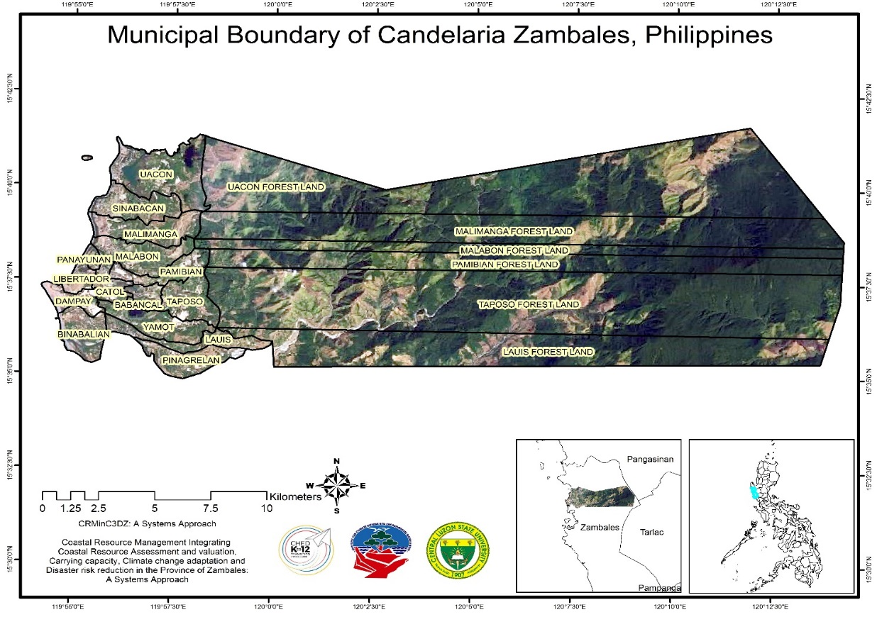

Figure 1.The administrative boundary of the municipality of Candelaria, Philippines

METHODOLOGY

Vulnerability Assessment

Vulnerability assessments estimate the degree of loss or damage that would result from the occurrence of a natural phenomenon of given severity. The study participants were randomly drawn from 16 barangays in Candelaria, Zambales. Flood, Landslide and Storm Surge vulnerability were assessed in terms of sensitivity, exposure and adaptive capacity using the methodology developed by Espaldon et al. (2016). A vulnerability assessment checklist was prepared and used to assess the vulnerability of the study site. Vulnerability index score was computed using equation devised by Hoeurn (2013). Categories and scale range used for sensitivity, exposure and adaptive capacity was developed by Alberto et al., (2018) (Table 1 and 2). Primary data were collected using questionnaires and Key Informant Interviews (KII).

Table 1. Scale for sensitivity, exposure and vulnerability indices

CATEGORIES |  | SCALE RANGE
Very Low | VL1 | 0.20-0.25
 | VL2 | 0.26-0.30
Low | L1 | 0.31-0.40
 | L2 | 0.41-0.50
Moderate | M1 | 0.51-0.60
 | M2 | 0.61-0.70
High | H1 | 0.71-0.80
 | H2 | 0.81-0.90
Very High | VH1 | 0.91-0.95
 | VH2 | 0.96-1.00

Table 2. Scale for adaptive capacity
CATEGORIES |  | SCALE RANGE
Very Low | VL1 |  | 0.96-1.00
 | VL2 |  | 0.91-0.95
Low | L1 |  | 0.81-0.90
 | L2 |  | 0.71-0.80
Moderate | M1 |  | 0.61-0.70
 | M2 |  | 0.51-0.60
High | H1 |  | 0.41-0.50
 | H2 |  | 0.31-0.40
Very High | VH1 |  | 0.26-0.30
 | VH2 |  | 0.20-0.25

RESULTS AND DISCUSSION

Flood Vulnerability Mapping
There are 16 Barangays in Candlaria, Zambales and all of these barangays were found to be moderately vulnerable to flooding with an average flood vulnerability of 0.62. Moderate flooding in the area indicates that there are some inundation of structures and roads near the river and creeks. Moreover, rising of water level in the municipality results from the insufficient drainage and irrigation canals during unusual heavy rainy day and typhoon periods.
However, the municipality has the ability to adapt to flooding due to the presence of updated maps of flood prone areas and coastal habitats that are at risk to better identify the priority areas. They also have access to flood forecasting information and early warning system. Moreover, the forest land parts of Barangays Uacon, Malimanga, Malabon, Pamibian, Taposo and Lauis have low vulnerability to flood due to high elevation of the forest or mountainous part of the municipality.
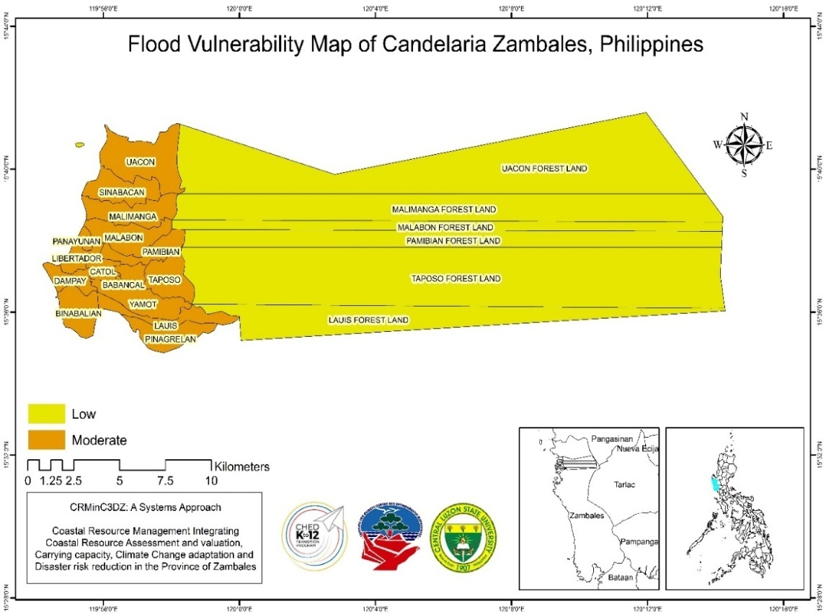
Figure 2. Flood vulnerability map of Candelaria, Zambales

Table 3. Flood vulnerability assessment of the municipality of Candelaria, Zambales, Philippines
Barangay | FS | FE | FAC | FV | SCALE: | VA
Babancal | 0.60 | 0.63 | 0.53 | 0.58 | Low | 0.20-0.50
Binabalian | 0.69 | 0.90 | 0.53 | 0.70 | Moderate | 0.51-0.70
Catol | 0.60 | 0.63 | 0.53 | 0.58 | High | 0.71-1.0
Dampay | 0.63 | 0.68 | 0.54 | 0.61
Lauis | 0.56 | 0.48 | 0.56 | 0.53 | SCALE: | AC
Libertador | 0.68 | 0.78 | 0.53 | 0.65 | Low | 0.71-1.0
Malabon | 0.71 | 0.78 | 0.53 | 0.66 | Moderate | 0.51-0.70
Malimanga | 0.66 | 0.78 | 0.56 | 0.66 | High | 0.20-0.50
Pamibian | 0.56 | 0.70 | 0.53 | 0.59
Panayunan | 0.75 | 0.68 | 0.53 | 0.65
Pinagrealan | 0.60 | 0.63 | 0.56 | 0.59
Poblacion | 0.62 | 0.80 | 0.56 | 0.65
Sinabacan | 0.69 | 0.85 | 0.53 | 0.68
Taposo | 0.60 | 0.75 | 0.56 | 0.63
Uacon | 0.66 | 0.75 | 0.53 | 0.64
Yamot | 0.53 | 0.65 | 0.53 | 0.56
FS-Flood Sensitivity; FE- Flood Exposure; FAC-Flood Adaptive Capacity; FV- Flood Vulnerability; VA- Vulnerability Assessment; AC- Adaptive Capacity

Landslide Vulnerability Mapping
Figure 3 presents the landslide vulnerability map of Candelaria. The table shows that nine (9) barangays are moderately vulnerable to landslide. These are Barangays Babancal (0.51), Lauis (0.55), Malimanga (0.57), Pamibian (0.54), Sinabacan (0.56), Taposo (0.59), Uacon (0.57) and Yamot (0.54) while the rest of the barangays in the municipality have low vulnerability to landslide. However, it can be observed in the figure below that the forest land part of the area including Uacon, Malimanga, Malabon, Pamibian, Taposo and Lauis are highly vulnerable to landslide probably due to steep slopes and presence of human activities such as mining and building construction.
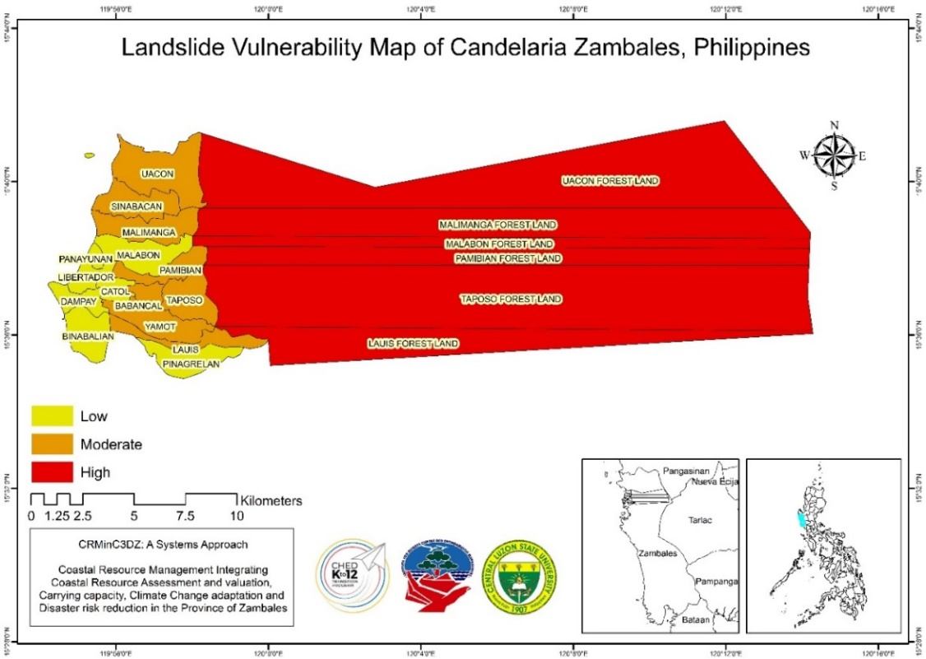
Figure 3. Landslide vulnerability map of Candelaria, Zambales

Table 3. Landslide vulnerability assessment of the municipality of Candelaria, Zambales, Philippines
Barangay | LS | LE | LAC | LV | SCALE: |  | VA
Babancal | 0.44 | 0.67 | 0.43 | 0.51 | Low |  | 0.20-0.50
Binabalian | 0.48 | 0.33 | 0.43 | 0.41 | Moderate |  | 0.51-0.70
Catol | 0.48 | 0.47 | 0.47 | 0.47 | High |  | 0.71-1.0
Dampay | 0.44 | 0.47 | 0.43 | 0.44
Lauis | 0.44 | 0.80 | 0.43 | 0.55 | SCALE: | AC
Libertador | 0.48 | 0.20 | 0.47 | 0.38 | Low | 0.71-1.0
Malabon | 0.52 | 0.33 | 0.47 | 0.44 | Moderate | 0.51-0.70
Malimanga | 0.52 | 0.73 | 0.47 | 0.57 | High | 0.20-0.50
Pamibian | 0.44 | 0.73 | 0.47 | 0.54
Panayunan | 0.48 | 0.20 | 0.47 | 0.38
Pinagrealan | 0.52 | 0.53 | 0.47 | 0.50
Poblacion | 0.44 | 0.20 | 0.47 | 0.37
Sinabacan | 0.56 | 0.67 | 0.47 | 0.56
Taposo | 0.52 | 0.80 | 0.47 | 0.59
Uacon | 0.52 | 0.73 | 0.47 | 0.57
Yamot | 0.48 | 0.73 | 0.43 | 0.54
LS-Landslide Sensitivity; LE- Landslide Exposure; LAC-Landslide Adaptive Capacity; LV- Landslide Vulnerability; VA- Vulnerability Assessment; AC-Adaptive Capacity

Storm Surge Vulnerability Mapping
The Candelaria storm surge vulnerability map is shown in Figure 4. The vulnerability index of the municipality of Candelaria was present in Table 4. Most of the barangays in Candelaria are situated near the coastal area. Barangays Dampay (0.75), Libertador (0.75), Malimanga (0.81) Panayonan (0.75) Sinabacan (0.81) and Uacon (0.78) were found to be highly vulnerable to storm surge(Table 31). Two barangays have moderate vulnerability to storm surge and these are Barangays Binabalian (0.63) and Uacon (0.70). All the non-coastal barangays were found to be low vulnerable to storm surge. The area with high vulnerability to storm surge was observed to have lack of mangroves in the coastal area that serve as barrier for storm surge. The rehabilitation of mangroves was focused only in the Uacon Lake.
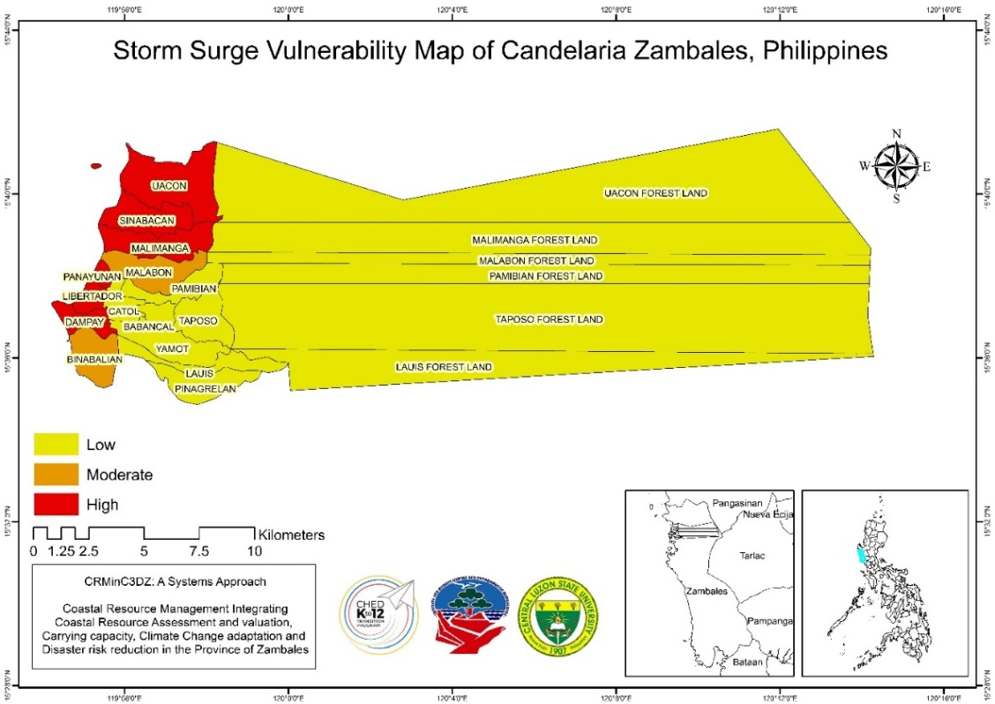
Figure 4. Storm surge vulnerability map of Candelaria, Zambales, Philippines

Table 4. Storm surge vulnerability assessment of the municipality of Candelaria, Zambales, Philippines
Barangay | SSS | SSE | SSAC | SSV | SCALE: |  | VA
Babancal | 0.20 | 0.8 | 0.48 | 0.49 | Low |  | 0.20-0.50
Binabalian | 0.84 | 0.6 | 0.48 | 0.63 | Moderate |  | 0.51-0.70
Catol | 0.20 | 0.6 | 0.52 | 0.44 | High |  | 0.71-1.0
Dampay | 0.84 | 1 | 0.44 | 0.75
Lauis | 0.20 | 0.4 | 0.52 | 0.37 | SCALE: | AC
Libertador | 0.96 | 0.8 | 0.52 | 0.75 | Low | 0.71-1.0
Malabon | 0.84 | 0.75 | 0.52 | 0.70 | Moderate | 0.51-0.70
Malimanga | 0.92 | 1 | 0.52 | 0.81 | High | 0.20-0.50
Pamibian | 0.20 | 0.55 | 0.52 | 0.42
Panayunan | 1.00 | 0.8 | 0.48 | 0.75
Pinagrealan | 0.20 | 0.25 | 0.48 | 0.31
Poblacion | 0.20 | 0.4 | 0.52 | 0.37
Sinabacan | 0.92 | 1 | 0.52 | 0.81
Taposo | 0.2 | 0.25 | 0.52 | 0.32
Uacon | 0.84 | 1 | 0.52 | 0.78
Yamot | 0.2 | 0.25 | 0.48 | 0.31

SSS-Storm surge Sensitivity; SSE- Storm surge Exposure; SSAC-Storm surge Adaptive Capacity;SSV- Storm surge Vulnerability; VA- Vulnerability Assessment; AC-Adaptive Capacity

CONCLUSION
The findings of the study show that the housing structures and roads near the river and creeks were vulnerable to flooding. In addition, insufficient drainage and irrigation canals of the municipality may contribute to the rising of water level during unusual heavy rainy day and typhoon periods. Predicting where and when landslides are going to occur is not possible. However, it is possible to identify landslide-susceptible areas, such as areas with very high in slope; areas with near to major faultlines; awareness to landslide risk etc. were classified as vulnerable to landslide. Storm surge hazard occurs frequently due to strong storms in coastal areas on the otherhand, coastal communities are the most vulnerable to this kind of hazard. These kind of study helps to increase the resilience of community to fight the hazard in all possible, so as to ensure the safety and sustainability of the people.

RECOMMENDATION
It is recommended for the local government units to take some preparation techniques like providing accurate flood early warning systems as well as providing or equipping households with skills of how to respond before, during and after to these kind of hazards.

ACKNOWLEDGMENT
We gratefully thank the Commission on Higher Education (CHED)-DARE-TO K12 Program for financial support. Sincere gratitude also to LGUs and coastal communities in Palauig, Zambales for the support and secondary data provided in conducting the study.

REFERENCES
Du Y., Y. Ding, Z. Li and G. Cao (2015). The Role of Hazard Vulnerability Assessments in Disaster Preparedness and Prevention in China. DOI: 10.1186/s40779-015-0059-9. https://www.ncbi.nlm.nih.gov/pmc/articles/PMC4657270/
Garcia, M.E.J.N., A.A. Hernandez (2017). Pattern Analysis of Natural Disasters in the Philippines. Conference: 8th EAI International Conference on Big Data Technologies and Applications (BDTA 2017), At Gwangju, South Korea. https://www.researchgate.net/publication/324692045_Pattern_Analysis_of_Natural_Disasters_in_the_Philippines.
Luchi K., Y. Jabiki, R. Solidum and R. Santiago (2019). Natural Hazards Governance in the Philippines. DOI: 10.1093/acrefore/9780199389407.013.233. https://oxfordre.com/naturalhazardscience/view/10.1093/acrefore/9780199389407.001.0001/acrefore-9780199389407-e-233

