Case study of the social and information technological difficulties of the learners during the COVID-19 period.
T.S Rathnayake¹, D.S. Matharaarachchi²
¹Computer teaching Unit, University of Colombo, Sri Lanka
Email: thilinisr@arts.cmb.ac.lk
²Department of Geography, University of Colombo, Sri Lanka
Email: mataraarachchids@gmail.com
Abstract:
Geographic Information Systems (GIS) can be used as a powerful tool in many aspects of handling geospatial data. By considering the modern geospatial approaches, this research is focused on evaluation spatial difficulties for education sector during the COVID-19 situation, with the objective of identification of existing resources. Data and information collected by using cloud-based tools such as ArcGIS Survey123 web form. Both academic staff and university students were focused for this survey during that period. A detailed cloud survey was conducted and identified their issues with the online learning method. This information was used to improve the spatial distribution of the social difficulties and learning difficulties of the students and lectures. Type of learning difficulties incidents were categorized according to the severity level by the considering the relationship to each social and technical factor. Maps were created and data was uploaded to the ArcGIS online cloud platform. Web services were hosted using this cloud infrastructure. Field data layer has been given web-based editing capabilities for field monitoring using GPS enabled mobiles. Updated information was conducted and locations of the technical and social difficulties were uploaded into web maps form the field with related attributes. The hotspots analysis and defined Interval classification techniques were used to get better understanding of the social and technical difficulties of the students and academic staff during the lockdown period and online distance learning method of the country. As the results, incidents were identified and there was a significant effect to the technical and telecommunication difficulties to the participant. Furthermore, majority of the participant suffer those difficulties with the increasing distance from the town area. As example most of the interviewers of rural area were loss their internet facilities and computer facilities. The cloud infrastructure, helped to bring down the barriers of data sharing and the incident reporting mechanism become more convenient during the survey.
Key Words: Cloud mapping, Social Vulnerability, COVID-19
Introduction
The COVID-19 is a highly infectious disease or illness caused by severe acute respiratory syndrome coronavirus 2 (SARS-CoV-2), originated in Wuhan city of China, has already taken on pandemic proportions, affecting across all the continents (Remuzzi & Remuzzi, 2020), mostly spread among individuals during close contact now resulting in millions of deaths. COVID-19 is referred as pandemic due to its sternness and violence also as the greatest global health crisis since after centuries in human civilization. The pandemic situation of coronavirus made devastated everything form word economies to social network. With this situation education sector also devastated. The temporary closure of educational institutions during the coronavirus disease (COVID-19) pandemic has abruptly transformed the global landscape in favor of distance learning (UN, 2020). With the pandemic outbreak many schools and colleges to remain closed temporarily. Several areas are affected worldwide and there is a fear of losing this whole ongoing semester or even more in the coming future (Dhawan, 2020). Anyway, Educational sectors are struggling to find possibilities to deal with this challenging condition.
Online learning is the newest and most popular form of distance education today. With the current pandemic situation Sri Lankan education sector also entered to the online teaching for students. In year 2006, Swedish International Development Agency (Sida) funded the University of Colombo School of Computing in Sri Lanka to establish the National e-Learning Centre (NeLC) through 4-year project. The main objective of this project is to establish “Open, Flexible and Distributed e-Learning Environment to provide effective, efficient, scalable and economical learning opportunities to stakeholder communities in Universities, Schools, the Public Sector and Society at large” (Hewagamage,2010). Several activities and courses offered as free and open for the community. With the pandemic situation the country shut down schools and universities nationwide on March 2020. Many Sri Lankan public schools, learning during the pandemic has mostly occurred via online channels. School teachers sent learning materials as PDF or Word Document to student via Social Medeia. But the Universities started to use online learning techniques such as Learning Management System (LMS). Online Learning refers to instructional environments supported by the Internet (E-Learning Center, 2010). Online learning can be fully online or blended with face-to-face interactions. The fully online learning is a form of distance education in which all instruction and assessment are carried out using online, Internet-based delivery (Picciano and Seaman 2009; U.S. Department of Education 2007). Blended learning allows students to receive significant portions of instruction through both face-to-face and online means (Graham, Allen, and Ure 2005; U.S. Department of Education 2007; Watson et al. 2010). Many online learning techniques were used for delivered lectures during the pandemic situation. Such as Zoom video, Google class room, video etc. with this research is focused on evaluation spatial difficulties for education sector during the COVID-19 situation, with the objective of identification of existing resources.
Data collection and Methodology
Data and information collected by using cloud-based tools such as ArcGIS Survey123 web form (Figure 1). Created web form vivid in figure 2. Both academic staff and university students were focused for this survey during that period. A detailed cloud survey was conducted and identified their issues with the online learning method.
View and Analysis
Collect Data
Web form design and Publish

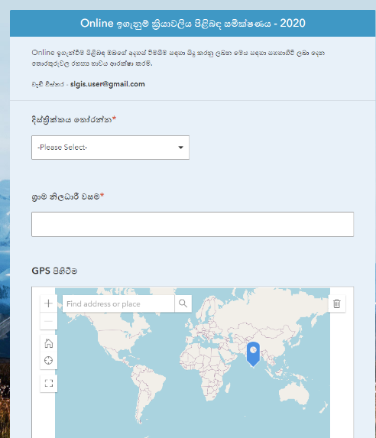
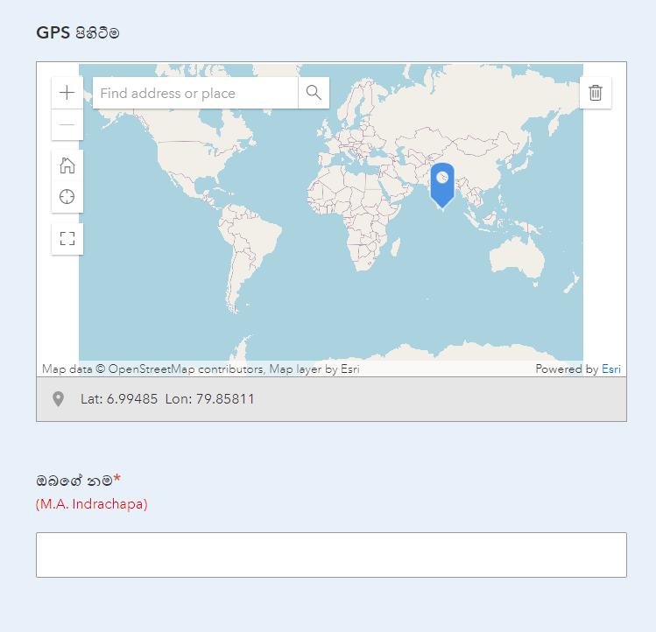
Figure 1: Data collection process

Figure 2: Data collection web form
Under this survey, type delivered online lectures, Type of presenting lectures, status of lecture and difficulties and student attention are exam. Figure 3 vivid spatial distribution of participants.
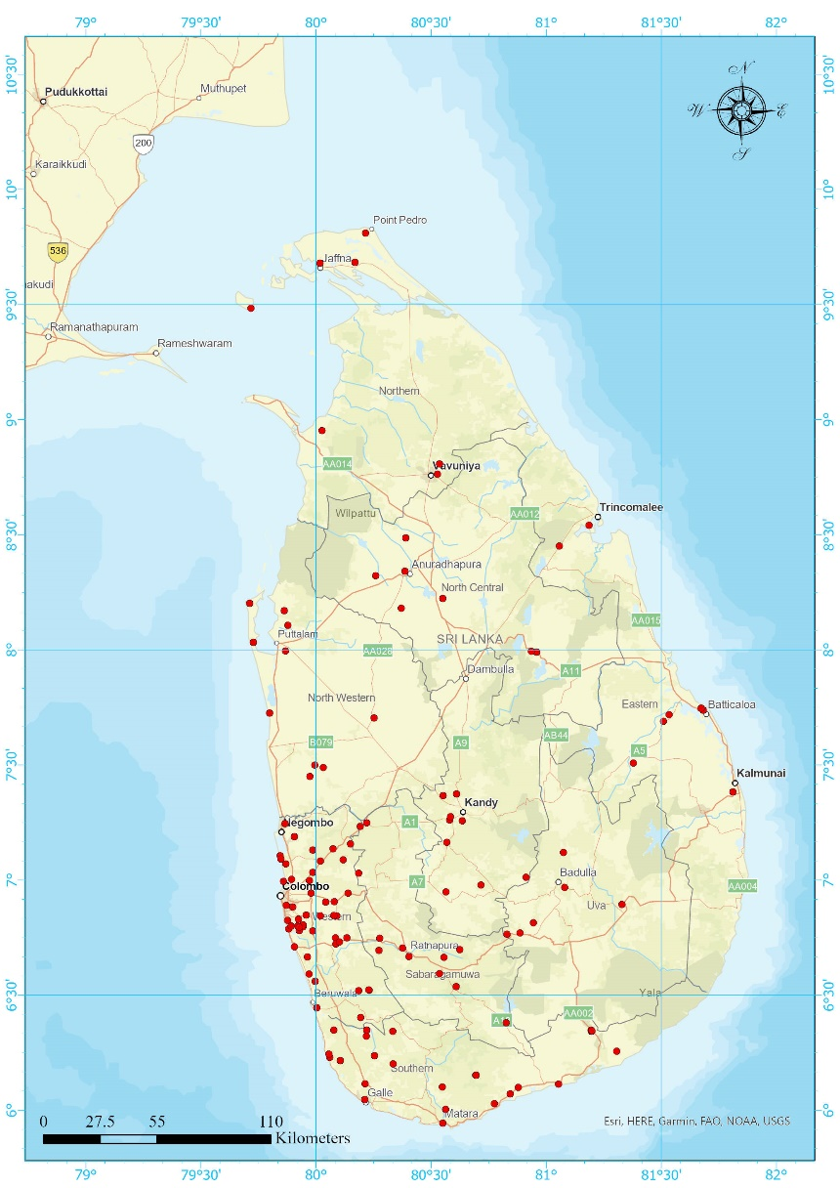

Figure 3: Spatial distribution of participants
Results and Discussion
According to the survey most of the university staff were used online zoom lectures, zoom lectures with activities, video lecture and activities also. More than 38% of student prefer Online zoom lecture with activities as most effective for online learning. Figure 4 vivid student reference on online lectures. Also 32% of the student suggest that online zoom lectures and video lecture with activities both are very useful. the video lecture accepted only 6% of the participant students.

Figure 4: Student suggestions about online lectures
According to the examine of ability to assessment submission of the students more than 18% of the student haven’t internet signals, and 36% are felt with low signal strength and data issues. And also 45% haven’t computer, mobile data and signal strength. Furthermore, examine of the satisfaction of online learning, 40% are like to learn online, because of that it low coast according to the student opinion (figure 5).

Figure 5: Student satisfaction of the online learning
Finally, most of rural student are not like to learning online. Because of that some rural areas not 3G or 4G coverage. With this situation they can’t attend lectures. With this situation most of lectures like to classroom education method.

References
Center, e.-L. (2010-2011). FOOE: Free and Open Online Education. Retrieved from e-learning.lk: http://www.e-learning.lk/node/96
Dhawan, S. (2020). Online Learning: A Panacea in the Time of COVID-19 Crisis. Journal of Educational Technology System, 49(1), 5-22. Retrieved 10 2020, from https://journals.sagepub.com/doi/full/10.1177/0047239520934018
Graham, C. R., Allen, S., & Ure, D. (2005). Benefits and challenges of blended learning environments. (M. Khosrow-Pour, Ed.) Idea Group.
Hewagamage, K. P. (2010). FOOE: Empowering Free and Open Online Education through e-Learning. 16th International Conference on Technology Supported Learning and Training (Online Educa 2010). Berlin.
Nations, U. (2020). Policy Brief: Education during COVID-19 and beyond. New York: United Nations. Retrieved 10 2020, from https://www.un.org/development/desa/dspd/wp-content/uploads/sites/22/2020/08/sg_policy_brief_covid-19_and_education_august_2020.pdf
Picciano, A. G., & Seaman, J. (2009). K–12 Online Learning: A 2008 Follow-up of the Survey of U.S. School District Administrators. Retrieved 10 2020, from https://files.eric.ed.gov/fulltext/ED530104.pdf
Remuzzi, A., & Remuzz, G. (2020). COVID-19 and Italy: what next? The lancet, pp. 1225-1228. doi:https://www.sciencedirect.com/science/article/pii/S0140673620306279
Watson, J., Murin, A., Vashaw, L., Gemin, B., & Rapp, C. (2010). Keeping pace with K–12: Online learning: An annual review of policy and practice. Durango: Evergreen Education Group.

